**Graffity Run**

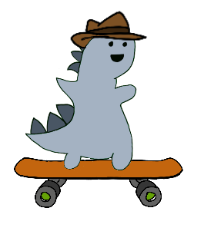Introduction

Graffity Run is Platform Game for PC, where a small dinosaur must recolor the world, using gravity control.

Description

The year is 1984.

Big Brother has come to power. We live in a bleak, gray-on-grey world. Fun and joy have long since ceased to exist - only work. It is your job as AgentD to put an end to it all. Bring color back into the world! And defeat the big brother.

You have a magic skateboard, with which you have control over gravity. So, you can make your way to the front of the line.

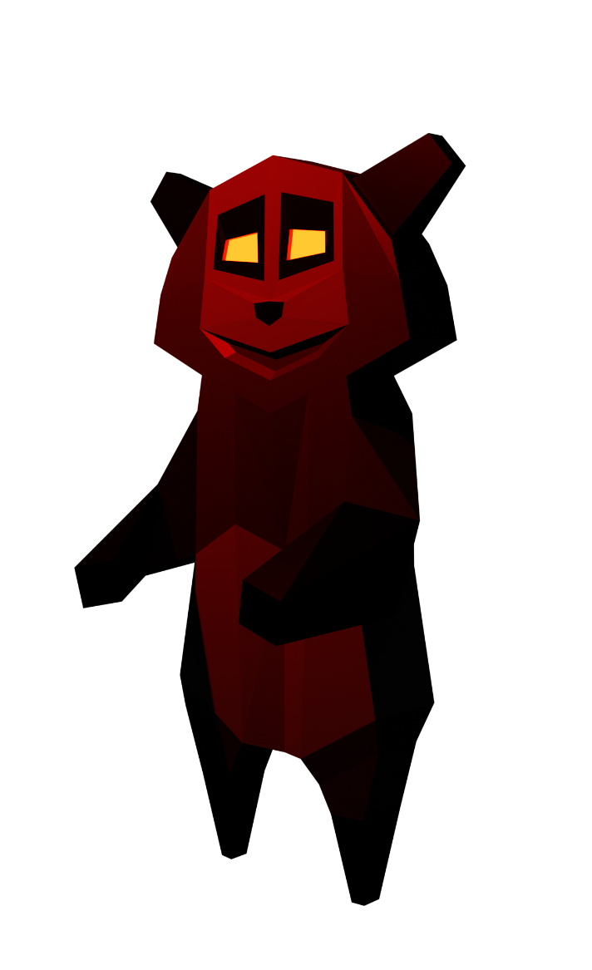Beware: on your journey you will have to be cautious of traps, holes, or projectiles.

Key Features

Dino with hat AND magic skateboard

Genre

Platform Runner

Platforms

PC