Introduction:

* ~~Problem with VANET is wireless links and strengths constantly changing. Example: Bumper to bumper highway traffic has highly dense networks, night time and rural area experience network fragmentation.~~
* ~~Focusing on “disconnected network” situation which deserves more attention.~~
* Three questions straight from the paper:
  + ~~Is the network disconnection problem a severe problem prohibiting vehicles from successfully delivering safety messages to other vehicles?~~
  + ~~What are the key characteristics of the network disconnection in VANETs and how do they affect the network performance?~~
  + ~~How can we solve or mitigate this disconnected VANET problem?~~
* ~~Will show that network fragmentation is a real issue, but will show some solutions (“store-carry-forward” mechanism)~~
* ~~Look at some traffic models (inter-arrival time and inter-vehicle spacing between roads and vehicles) from I-80 freeway on June 27, 2006.~~
* ~~Stats: Inter-vehicle spacing is exponential distribution when effective traffic volume is less than 1000 veh/hr. Even with 100% market penetration, network disconnection is 35% during night but well connected network during rush hour. Small market penetration then network disconnection is a problem during rush hour too.~~
* ~~Characteristics to analyze:~~
  + ~~Probability of disconnection from another vehicle~~
  + ~~Cluster size~~
  + ~~Cluster lengths~~
  + ~~Intra- and inter-cluster spacing~~
* Show how re-healing time affects safety applications based on how well connected a network is.
* Key Contributions of this study:
  + Observed that inter-arrival time and inter-vehicle spacing can be approximated by exponential distributions. Validates network fragmentation conjecture about VANETs.
  + Quantify metric of re-healing time, quantifying average delay needed to deliver messages between disconnected vehicles.
  + Potential Solution: “store-carry-forward” for disconnected VANETs. Use Monte Carlo simulations. Use store-carry-forward with broadcast mechanisms in disconnected VANET then the average re-healing time is on the order of a few to several seconds.

II: Related Work

* ~~The data is collected in real-world setting~~
* Most existing models not mathematically tractable.
  + Random Way Point (RWP) mobile nodes randomly select destinations with a randomly chosen velocity. Doesn’t capture all characteristics of true traffic.
  + Reference Point Group Mobility (RPGM) emulates grouping behavior of battlefield scenarios.
  + Freeway/Manhattan model captured impact of geographic restriction (ie road) on vehicular mobility
  + Simplified car-following model is used to restrict vehicular movements on a road at lane-level defined by real map data.
* Most models are over simplified with assumptions necessary to make the analysis tractable which results in models that fail to adequately represent the extreme complexity of the real-world mobility patterns.
* Emphasis on fact that VANETs are prone to network fragmentation due to uneven nature of vehicle traffic and market penetration.
* Delay Tolerant Networks (DTN) is synergistic with the problem formulation of disconnected VANETs.
* DTN framework proposed to analyze and interconnect challenged networks where end-to-end routes between mobile nodes may not exist:
  + Wildlife tracking sensor networks
  + Inter-planetary networks
  + Military ad hoc networks
* Requires asynchronous message forwarding paradigm based on **“store-carry-forward”** concept to achieve interoperability among different challenged networks.
* Some models that fall into DTN framework
  + DataMules: mobile messengers which promote the network connectivity in a sensor network by providing access between the virtual backbone and sensor nodes
  + Epidemic Routing: relies on mobile nodes to exchange they data they possess whenever they encounter new neighbors
  + Role-based multicast approach: proposed to achieve maximum reach ability in a sparsely connected or fragmented network by using the store-carry-forward mechanism
  + Single-copy and Multi-copy “Spray and Wait” are shown to be efficient alternatives for message delivery
* **Focus on network fragmentation scenarios of VANETs with realistic vehicular mobility models. Main objective in this paper is to establish comprehensive analytical framework for understanding the fundamental characteristics of disconnected VANETs in addition to studying the feasibility of the store-carry-forward approach.**
* Developed analytical framework which can be used to derive several network characteristics and key routing performance metrics such as per-hop delay (re-healing time) in sparsely connected VANETs

III. Vehicle Traffic Model

* ~~Car following model, single-lane behavior under both free-flow and congested traffic conditions. Assumes drivers maintains safe distance from leading vehicle. Takes into account deceleration factor for braking performance and drivers behavior.~~
  + ~~Complete mathematical model:~~ 
    - ~~S’ headway spacing between rear bumper to rear bumper~~
    - ~~L effective vehicle length in meters~~
    - ~~V vehicle sped in meters/second~~
    - ~~driver reaction time in seconds~~
    - ~~reciprocal of twice the max average deceleration of a following vehicle (ie approximately 0.075 )~~
  + ~~and introduced to ensure sufficient spacing so that following vehicle can come to a complete stop if the leading vehicle suddenly brakes.~~
  + ~~Simplified Model: Good driving assumption, similar braking performance () 🡺~~
* Limitations of the car following model:
  + ~~Describes headway spacing between 2 adjacent vehicles in same lane (lane level spacing). From network perspective most relevant metric is spacing from leading vehicle to the nearest following vehicle on a multi-lane road (road level spacing), regardless if following vehicle is in same or different lane. Distance to nearest neighbor determines whether wireless link between vehicles exist or not.~~
  + ~~Car following model appropriate under free flow traffic or heavy traffic scenarios where~~ **~~driver reaction time~~** ~~is believed to be a dominant factory.~~
    - ~~typically small that represents reaction time of driver following a log-normal distribution~~
    - ~~can be large as 50-100 seconds in light to moderate traffic,~~ **~~CAN NOT~~** ~~be interpreted as driver reaction time. In this case,~~ **~~inter-arrival time~~** ~~is used to describe vehicle spacing. Represented by exponential distribution (not sure if there is evidence to justify the distribution)~~
  + ~~Address both limitations by replacing with road-level inter-arrival time . Reduces model to . By focusing on road-level inter-vehicle spacing S, proposed model accounts for rush-hour heavy traffic and captures sparse or intermediate traffic.~~
    - ~~inter-arrival time of vehicles on any lane from fix observation point~~
    - ~~is minimum spacing between any two adjacent vehicles~~

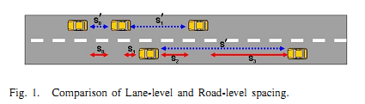

* Incorporate empirical data into traffic model from Berkeley Highway Laboratory (BHL)
  + Shows when network disconnection occurs.
  + How serious the disconnected network problem could be in real traffic situations.

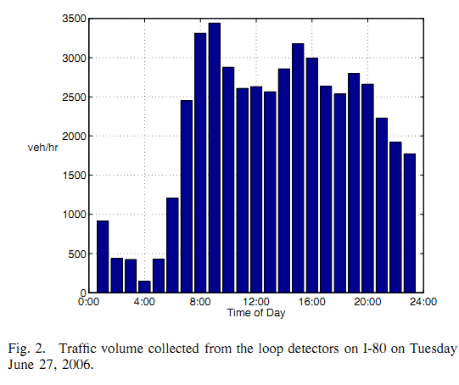

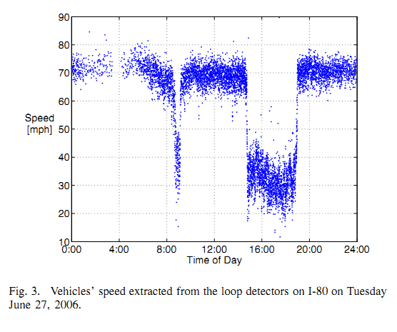

IV: Road-Level Traffic Model: Empirical Study

1. Measurement of Empirical Data
   1. ~~To calculate analyze data from dual-loop detector on eastbound I-80 which is a 5-lane highway immediately east of SF/Oakland Bay Bridge between Emeryvill, CA and Berkeley.~~
   2. ~~Collected 24 hours by using 1/60 second timestamps starting at midnight June 27, 2006.~~
   3. ~~Figures 2,3 show results for~~
   4. ~~3 time periods~~
      1. ~~Night traffic low volume high speed (1am – 3am)~~
      2. ~~Free flow non rush hour, moderate volume and high speed (10am-12pm)~~
      3. ~~Rush hour low speed intermittent congestion, high traffic volume (3pm-5pm)~~
   5. Interested particularly in the time frame from 1am-3am. Normally vehicles viewed as disconnected if separated by more than 250 meters.
2. Inter Vehicle Spacing Distribution
   1. Observed that **inter-arrival time distribution**  seems exponential during early mornings (low traffic high speed time)
   2. Assume where can be derived from the average traffic volume 🡺
   3. Use Kolmogorov-Smirnov test (K-S test) which measures the goodness-of-fit in terms of where is hypothesized distribution and is empirical distribution.
   4. During early hours, inter-arrival time approximated by exponential distribution with D statistics less than 3% when traffic volume is below 1000 veh/hr.
   5. Similarly, inter-vehicle spacing can also be characterized with exponential distribution given by , where . As before, fits empirical data when traffic volume is below 1000 veh/hr. Deviation of 3% when under 1000 veh/hr.
3. Impact of Market Penetration Rate on Inter-Vehicle Spacing Distribution
   1. Don’t expect every car to have the proper equipment. Low market penetration can exacerbate severity of disconnected problem since network can be fragmented even during rush hour.
   2. PDF of spacing between equipped vehicles with x% market penetration can be approximated 🡺 , then corresponding CDF is
   3. Observed that as market penetration decreases, empirical distribution converges to exponential. K-S test approximately within 5% during rush hour and is within 3% during non-rush hour for a given 10% market penetration.
   4. Disconnected VANET problem caused by low market penetration is sthe same as disconnected VANET problem caused by sparse density.
   5. This model is good for both cases then. Via rigourous analysis of empirical highway traffic data we find that VANETs may experience network fragmentation either due to sparse traffic density and/or because of low market penetration of wireless devices.

V: Characteristics of disconnected vehicular ad hoc network: Preliminaries

* Definition 1: “Vehicles in the same direction are said to be within the same cluster if and only if they can communicate with one another in a one-hop or multi-hop fashion. Otherwise, vehicles are said to be in different clusters. From a networking standpoint, any two adjacent vehicles belong to the same cluster if they directly communicate with one another (ie within the transmission range); otherwise, these two belong to different clusters.”
* Clusters minimal separation R (ie 250 meters)
* Will show probability of being the last vehicle in the cluster, average intra-cluster spacing, average inter-cluster spacing, average cluster size, and average cluster length.

1. Probability of being the last vehicle in a cluster
   * Source vehicle can detect hazards and then transmit. If cluster boundary greater than R (250 m), then we’d want the last vehicle to transmit.
   * is the probability that there are no following vehicles within the transmission ranger R of the last vehicle.
   * Given PDF of inter-vehicle spacing ,
     + is the CDF of inter-vehicle spacing
   * is the metric used to calculate many other important characteristics of a disconnected VANET, such as, average cluster size, average cluster length, and average re-healing time.
2. Average Intra-cluster Spacing
   * intra-cluster spacing
   * Lemma 1: If inter-vehicle spacing exponentially distributed then average intra-cluster spacing is
3. Average Inter-cluster spacing
   * is expected spacing between the last vehicle of the leading cluster and first vehicle of the following cluster. Impacts re-healing times.
   * Given PDF
   * Then
4. Average cluster size
   * Expected number of nodes within a cluster
   * If inter-vehicle spacing is exponentially distributed
   * Proof 
5. Average Cluster length
   * Size of cluster can also be described by the length between the first and last vehicle. Hence is a function of and .
     + 

IV: Analysis of disconnected networks with two directional traffic

* With conventionally routing protocol, it is almost impossible for clusters to communicate with one another as there is virtually no network connectivity.
* Topology of a VANET network, passing by vehicles in the opposite direction can sometimes help to restore the network at expense of additional message delays.
* 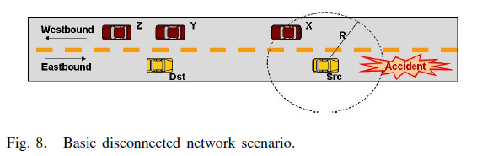
* Src wants to broadcast a message to Dst, but not in range (Network disconnection). Can make use of vehicles travelling in the opposite direction either X Y Z.
* If no vehicles are in Range, then need to store the message and forward it on later when the network is connected.
* Refer to “store-carry-forward” mechanism as “temporal relay” (indirect packet relay)
* When Dst gets the message, it behaves like a source and broadcasts the message.
* **Important characteristics:** end-to-end packet delay, number of spatial and temporal relay
* **Definition 2:** For a road that has traffic moving in two opposite directions, a vehicle is said to be disconnected in the opposite direction if there are no vehicles within its transmission range in the opposite direction.
* Probability of disconnection on two directional road:
* la

**Re-Healing Time Analysis**

* Time to deliver a message across two adjacent clusters, i.e. from the last vehicle in a cluster to the first vehicle in the following cluster.
* Spatial relay is if there is a following vehicle that is within range in either direction
* Temporal relay when following vehicle is out of range from either direction
* Assuming that spatial delay is negligible, the end-to-end delay (is simply the sum of all the re-healing time along the route.

**Case I: Best-Case Scenario**



* Corollary 1.1 suggests the average re-healing time in best case scenario depens only on the traffic density of the message-forwarding direction, i.e. on . As the density becomes sparse the re-healing time becomes large

**Case 2: Worst-Case Scenario**



* In the worst case scenario average re-healing time depends on density from both directions because Src has to buffer the message until it finds a vehicle in the opposite direction that can carry the message.
* 

**Theorem 3**

* If SRC is disconnected from DST, expected per gap healing time approximated by:
* 
* 
* When are small, the average re-healing time is only slightly less than the worst case re-healing time from Corollary 2.1. SRC runs into the worst case scenario with high probability in a sparse network
* Next section shows the developed analytical framework is a good approximation for disconnected VANETs. For the cases where will show that the best case probability is near 0 and that the worst case probability is near 1. As expected the worst-case re-healing time tends towards infinity.

**VII: Disconnected Networks: Simulation Study**

* Will show how the store-carry-forward mechanism works in a disconnected VANET system.
* **Network Topology**: Straight segment of freeway that is bi-directional. Distribution of freeway given by . Overall number of vehicles can implicitly be determined by
* **Mobility Pattern**: All vehicles are traveling at a constant network. No lane passing or changing. Last vehicle in a cluster disconnected from the first in another cluster until they exit the network. Open system network, vehicles exiting don’t re-enter the network
* **Data Traffic Model**: Assume at most 1 packet in the system at any time. Assume a new packet is generated when the destination vehicle exits the network. This ensures that the topology seen by packet j is different than packet j+1. In this simulation generate packets at 0.01 packets/min (One broadcast every 100 minutes). This way topology seen by any two packets are different.
* **Network Communication Model:** Transmission Range is 250m (FCC Regulations). Source and destination cars are picked randomly on westbound road. Must pick vehicles at least X km apart. Implements a store-carry-forward mechanism when the network is disconnected. Westbound vehicles facilitate this. Emphasis is on situation with low connectivity, so assuming ideal MAC and PHY layers. Delay from MAC/PHY layers in this situation will be much smaller when compared to the temporal delay. Assume spatial delay due to direct wireless transmission is zero.
* 
* Validates the framework through analytical and simulation results.

**Simulations Results with a more defined setup**

* 50 km road
* Source is approximately 10km away from destination, all vehicles traveling at a constant 30m/s.
* Vehicles enter network with Poisson distribution with ranging from 0.05 to 0.55 veh/s (traffic from 200 to 2000 vehicles/hour)
* Vary traffic volume here to see the results
* Figure 11 shows probability of disconnection in 1-d and 2-d traffic. Analytical, simulation, and empirical results match.
* Example: probability of being disconnected is 35% during late night hours when traffic is 429 veh/hr.
* Probability of being disconnected is much lower in 2 way traffic. A routing protocol can benefit from using opposite traffic to populate network and increase network connectivity.
* As traffic volume increases, become smaller. Cluster length also increases.
* Clearly, the larger the cluster length, the higher the spatial hop and the lower the temporal hop count.

**Routing Performance in Disconnected Networks**

* Will focus on the intermediate metrics to understand a disconnected VANET.
* Per-gap healing time: duration of time a packet needs to be stored at a relay node. Impacts buffer to know how long to store messages to relay.
* Assume distance from SRC to DST to be 1 to 30km
* Routing delay depends on transmission range, vehicle’s speed, and most importantly network density and market penetration.
* Transmission power is already regulated, and market penetration can be modeled by traffic density, so will focus on speed of vehicles and traffic densities.

**Impact of speed**

* Fix density of to 0.003 to match late night empirical data
* : Longer in the low mobility scenario
* For a VANET, the delay can be up to 2 minutes, but is acceptable for it’s purposes. If there network is fully connected the message should take less than 1 second

**Impact of Network density**

* Will fix the speed and vary
* As density decreases, the temporal hop count increases while spatial hop decreases
* Figure 13b and 14b, temporal hop count decreases when traffic volume decreases below 300 veh/hr. Average per-gap re-healing time is longer with lower traffic volume. There are fewer but larger gaps in the network.
* Figure 15b, expected per-gap healing time almost doubled when volume drops from 300veh/hr to 150veh/hr. Result is end-to-end delay is longer with low volume even though the temporal hop count is lower Figure 16b.
* Worst case scenario, 162veh/sec, a vehicle that is 10km away from RSU (Road side unit) will receive the message in 2.5minutes, when he will be approximately 5.5km away from the RSU.

**Microscopic analysis of per-gap healing time**

* To understand better the VANET disconnected problem, need to understand:
  + How messages get relayed to the final destination
  + How long it takes for disconnected vehicles to discover relay networks
  + How fast relay vehicles can get message to destination vehicles
* Figure 17
* Importance of per gap re-healing time
  + Use average re-healing time to determine needed buffer space
  + Acknowledge network disconnection to know if the data is overloading the disconnected VANET

**CONCLUSIONS and Future work**

* Extensive simulations and empirical data validate the framework proposed in this paper
* Provides good estimates to key characteristics of disconnected VANETs
* Store-carry-forward is a viable solution to routing in disconnected VANET
* In future, want to develop protocols to handle the 2 extremes of well connected and sparse networks.

## Solution

## Analysis

## Performance Results

## Discuss Results

## Suggestion

# References

## Routing in Sparse Vehicular Ad Hoc Wireless Networks

Authors: Nawaporn Wisitpongphan, Fan Bai, Priyantha Mudalige, Varsha Sadekar, and Ozan Tonguz

Publication: IEEE Journal on selected areas in communications, Vol. 25, No. 8 October 2007