**Renovación de certificados Kubernetes 1.14.10**

**En todos los nodos Masters comenzando por master01:**

# cd /etc/kubernetes/pki/



# mkdir -p /opt/pki



# mv {apiserver.crt,apiserver-kubelet-client.crt,front-proxy-ca.crt,front-proxy-client.crt,front-proxy-client.key,front-proxy-ca.key,apiserver-kubelet-client.key,apiserver.key,apiserver-etcd-client.crt} /opt/pki



# ls -l

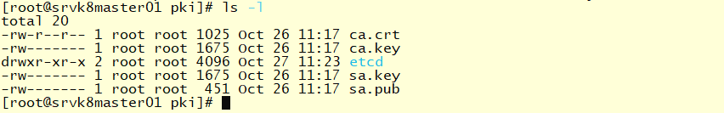

# kubeadm init phase certs all --apiserver-advertise-address 169.61.3.78

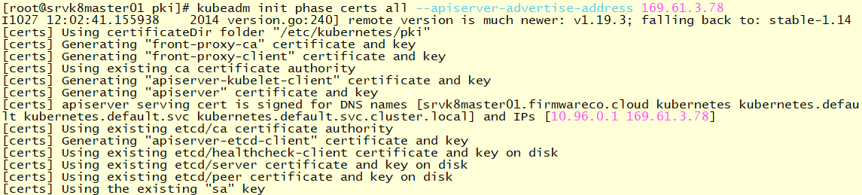

# mv apiserver-etcd-client.* /opt/pki



# cd /etc/kubernetes/



# mv {admin.conf,controller-manager.conf,kubelet.conf,scheduler.conf} /opt/pki



# kubeadm init phase kubeconfig all



# cp admin.conf /root/.kube/config



# reboot



# find /etc/kubernetes/pki/ -type f -name "*.crt" -print|egrep -v 'ca.crt$'|xargs -L 1 -t -i bash -c 'openssl x509 -noout -text -in {}|grep After'

