**Upgrade kube* 1.13.5 ---- 1.14.10**

**Upgrade de los Nodos Masters**:

# yum list --showduplicates kubeadm --disableexcludes=kubernetes

# yum install -y kubeadm-1.14.10-0 --disableexcludes=kubernetes



# kubeadm version



# kubeadm upgrade plan

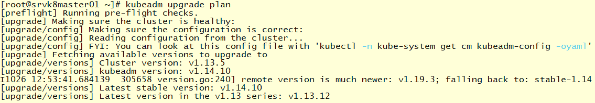

# kubeadm upgrade apply v1.14.10

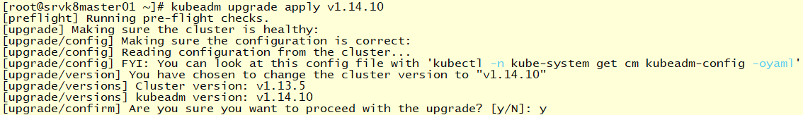

# kubectl get nodes

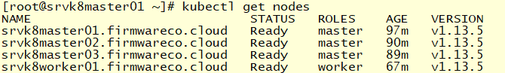

# yum install kubelet-1.14.10-0.x86_64

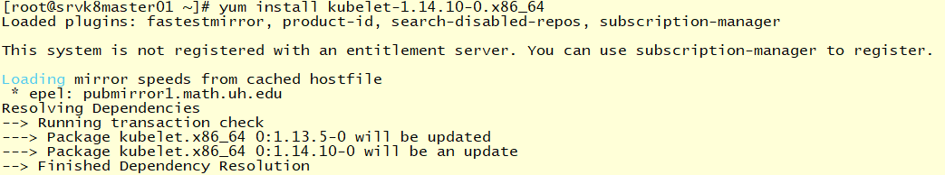

# systemctl daemon-reload

# systemctl restart kubelet



# kubectl get nodes

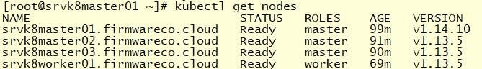

# yum install kubectl-1.14.10-0.x86_64

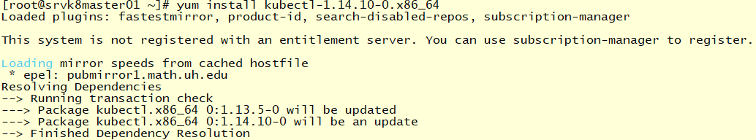

# kubeadm upgrade node experimental-control-plane

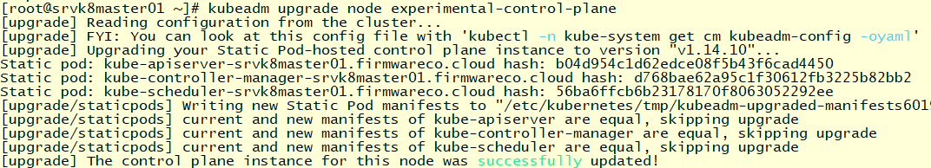

# kubectl get pods -n kube-system

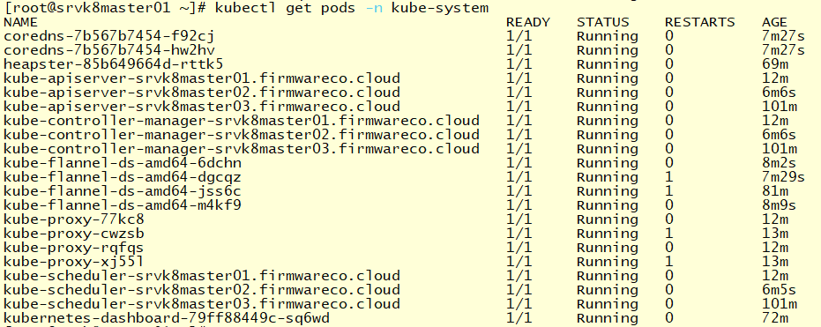

**Upgrade de los nodos Workers**:

# yum install -y kubeadm-1.14.10-0 --disableexcludes=kubernetes

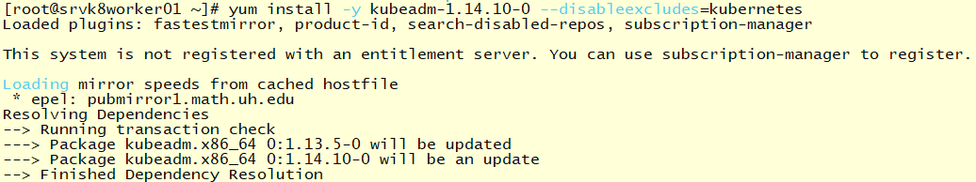

**\*\*\*\* Desde Master01 para continuar el upgrade de los Workers:**

# kubectl get nodes

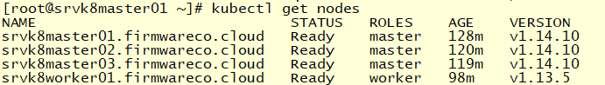

# kubectl drain srvk8worker01.firmwareco.cloud --ignore-daemonsets



**\*\*\*\* Nuevamente en el Worker:**

# kubeadm upgrade node config --kubelet-version v1.14.10



# yum install -y kubelet-1.14.10-0 kubectl-1.14.10-0 --disableexcludes=kubernetes

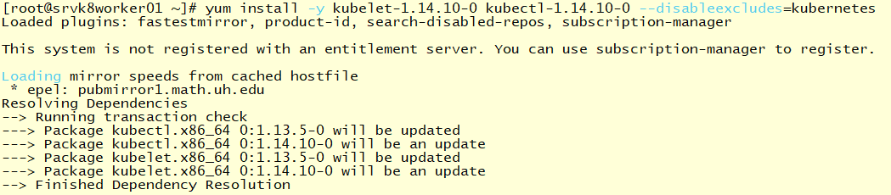

# systemctl daemon-reload

# systemctl restart kubelet



**\*\*\*\* Desde Master01 para terminar el upgrade del Worker** :

# kubectl uncordon srvk8worker01.firmwareco.cloud



# kubectl get nodes

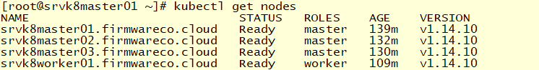

# kubectl get pods -n kube-system

