Title: DIO programming on the Puppeteer
Author: Craig Duffy 20/02/06
Module: Embedded Real-time Systems Programming
Awards: CRTS 2, CSE2, C&T 2, BSc Computing (Part-Time)
Prerequisites: Linux kernel source, ARM assembler, a ported Linux kernel.

The purpose of this worksheet is to introduce you to the programming of the digital input/output (DIO) facilities on the Puppeteer board. DIO is basically the same as a parallel port that you will find on a standard PC, although, as we will later see, the implementation details on the Puppeteer are very board specific. We will look at the general functioning of the DIO and learn how to write simple routines that will work under the Linux kernel. Finally, we will integrate this code into a DIO device driver for Linux.

What you need to proceed!

In order to undertake this worksheet you will need a Puppeteer with the Atmel ATF158AS CPLD expansion card attached. You can tell by looking at the end of the board and seeing if the connector slot has a mini D Type connector or is empty. Beware of trying to use Jeff’s (black) Puppeteer boards, they have an expansion card, but it is different and none of the code in this worksheet will work with them. Check with your tutor if in doubt.

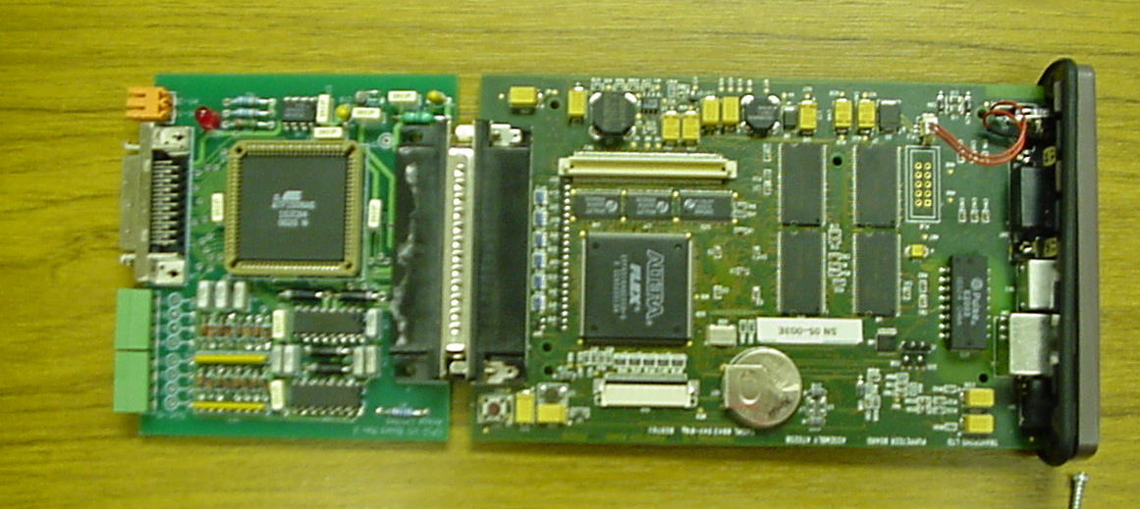
Puppeteer plus CPLD expansion card

In order to check that there is output it is a good idea to have something to control. Therefore, you should also attach a special connecting cable and one of the FAB application boards.

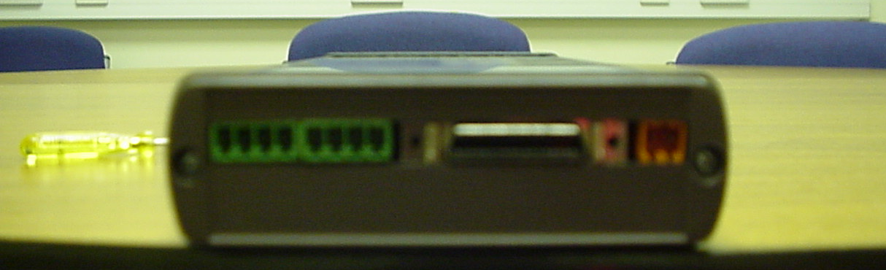
The Puppeteer expansion card connectors
Mini D Type Connector
DIO on the Puppeteer

The set up of the DIO on the Puppeteer is quite Byzantine, to say the least! The SA1110 has a series of general purpose input/output pins (GPIO), these are connected to the Altera Flex 6K FPGA, which holds the implementation of the DIO. These connectors then go off board, via the large end connector, and through to the CPLD connecting board, the signal is then routed off the board through the small, black, N-way connector.

SA1110
StrongARM

Altera FLEX
6k FPGA

CPLD
Board

GPIO and Data
Lines

DIO implementation

Attached to this sheet you will find a header file with some details for the FPGA implementation. As the FPGA implementation is basically undocumented by the original developer, more or less all the information regarding the FPGA implementation of the DIO is to be found in this worksheet. Below is the memory map for the Puppeteer. We know that the FPGA is mapped into address 0x140400000, one of the static banks on the memory map below.

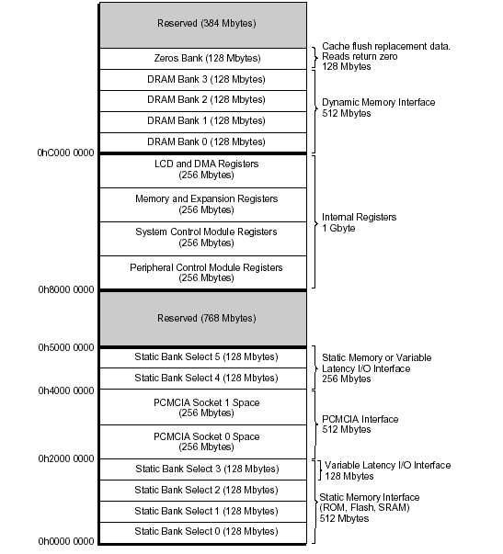
StrongArm SA1110 Memory Map

We can also glean from the header file that the registers for the DIO are located at the following addresses and we can make a guess at their function from their names.

Register | Address
FPGA_6K_BASE | 0x10400000
FPGA_6K_DIO_REG_BASE | 0x10400700
FPGA_6K_DIO_DATA_REG | 0x10400700
FPGA_6K_DIO_DIR_REG | 0x10400728
FPGA_6K_DIO1_REG_BASE | 0x10400600
FPGA_6K_DIO1_DATA_REG | 0x10400600
FPGA_6K_DIO1_DIR_REG | 0x10400628
FPGA_6K_DIO2_REG_BASE | 0x10400680
FPGA_6K_DIO2_DATA_REG | 0x10400680
FPGA_6K_DIO1_DIR_REG | 0x104006A8
OB_LED_ADDRESS | 0x10400680

From the programmers’ point of view the DIO is organised into 3 register banks – Port A, Port B and Port C. As we won’t be programming the device with lots of different modes, for example interrupts, we will be able to ignore quite few registers and settings. The DIO, and all FPGA, registers are 16 bit/word addressed. The DIO registers we are looking at map onto the external ports A, B and C as follows:

0x10400600

0x10400600

0x10400680

0x10400680

Port B

Port A

Port C

On board LEDS

FPGA_6K_DIO1 bits 15..08

FPGA_6K_DIO1 bits 07..00

FPGA_6K_DIO2 bits 07..00

OB_LED_ADDRESS bits 08..11

For the purposes of our application board we will need the ports set up as follows:

Port B | Outputs to LEDS | latched
Port A | Inputs from switches | -
Port C | Outputs to motor | latched

In order to use the DIO ports we need to initialise the device with direction of the data. Is it going to be an input or an output port? This is done using the data direction registers (DIO_DIR_REG_OFFSET in the header file), setting the Data Direction Register to 1 means that bit is an output, setting it to 0 means it is an input. This must be done before we can read or write data to the application board.

Part of Port C is also a set of latches for the device. This allows us to inform the device that we wish to implement a setting. So if we wrote 0xFF to Port B, 0X00 to Port A, to make them the correct inputs and outputs for our application, we would then need to ensure that the device implements these changes. The latch bits on Port C are as follows:

Bit | Latches
6 | Port C
7 | Port B
8 | Port A

Therefore, in order to change the data direction for Port B we would need to write the correct bit data to the data direction register (DIO1_DIR_REG_OFSFSET), we would then need to take the latch bit high and then low. If we are writing data to a port we will need to similarly set the latch line to ensure a write, for reading it is sufficient to simply read the input pin.

Port A

Port B

Port C
inputs
outputs
Inputs & outputs

Switches
LEDS andDAC
Motor &
Heater
Relationship of ports and application board functions

A simple test

You may have noticed that there are some on board LEDs, which are used by the Transpond boot process and the Ethernet chip. We can use these to run a very simple test to see if we can output some data. As the control for the LEDs do not really go out through the DIO chip, but directly to the board, we don’t need to set up the latches and data direction registers.

In order to run this code you will have to be able to have a kernel which accepts loadable modules and also have worked through the kernel module programming worksheet. I am going to assume both of these things to be true.

#include <linux/delay.h>
#include <linux/module.h>
#include <linux/ioport.h>
#include <asm/io.h>
#include <asm/arch/io.h>
#include <asm/arch/hardware.h>
#include <asm/uaccess.h>

#define DRIVER_AUTHOR "craig duffy craig.duffy@uwe.ac.uk"
#define DRIVER_DESC "FPGA DIO driver"

#define LED_ADDRESS 0xf2400680
#define RGGG 0xf000

static int fpga_dio_init(void)
{
static int fpga_j;
static short unsigned pattern;
printk(KERN_ALERT "fpga dio loaded\n");
pattern=RGGG;
pattern = pattern >> 4;
for ( fpga_j=0; fpga_j != 16 ; fpga_j++)
{
printk("pattern %x\n",pattern);
udelay(400);
writew(pattern,LED_ADDRESS);
pattern = pattern >> 8;
pattern--;
pattern = pattern << 8;
}

return 0;

}

static void fpga_dio_exit(void)
{
printk(KERN_ALERT "fpga dio unloaded\n");
}

module_init(fpga_dio_init);
module_exit(fpga_dio_exit);

MODULE_LICENSE("GPL");
MODULE_AUTHOR(DRIVER_AUTHOR);
MODULE_DESCRIPTION(DRIVER_DESC);
MODULE_SUPPORTED_DEVICE("fpga_dio");

The program is a very simple module. It should be loaded using insmod and removed using rmmod. On loading it will flash the on board LEDs once. It uses the system function udelay to introduce a small delay, otherwise the LEDs would flash really quickly and not really be visible. You will notice that I am using the memory mapped version of the FPGA address rather than the physical one. This is to avoid using the ioremap function, as the FPGA is already mapped for us in arch/arm/mach-sa1100/pangolin.c (in the kernel sources).

You will notice that the output routine is writew, write a word (16 bits). As the ARM just has directly memory mapped IO we don’t require any special port access routines, we can just output the correct data to the address. Obviously if we use an incorrect address when we are in kernel mode then we could cause problems, potentially a kernel panic.

What you should do

Build the FPGA DIO flashing LEDs program and load it as a module. You will require the makefile at the end of this worksheet to build the module. It is your responsibility to make sure that the include files all refer to your downloaded kernel source.

Creating some DIO primitives

Now we will need to create a small set of primitives to control our DIO driver. The 3 functions I created were

static unsigned short DIOSetDirection(unsigned int bank, unsigned int Mask, unsigned int Data);
static unsigned char DIOGetInputs(unsigned int bank, unsigned int * Result);
static unsigned short DIOSetOutputs(unsigned int bank ,unsigned int Mask, unsigned int Data);

These routines are used to set up the inputs and outputs on the Ports A, B and C. They are: an set the data direction register, to set up the ports as inputs and outputs; an input routine to read the values on the port; and a set output routine which outputs data to the port. The first parameter (bank) for each routine is the actual register (and therefore port) we are accessing, this will only be 1 or 2 for the applications we are writing. The DIOGetInputs has a parameter which is to hold the 8 bits of port data – the read returns the state of the whole port, not just one bit. DIOGetInputs returns a Boolean true or false showing whether it succeeded in reading the register or not.

The other 2 routines, DIOSetDirection and DIOSetOutputs have 2 extra parameters. In the case of the SetDirection call, this call simply sets the Data Direction Register to intialise the ports to inputs and outputs. By writing a 1 to the Data Direction Register we make it an output, by writing 0 we make it an input. The SetOutputs is really just a data outputroutine, sending data to particular pins on the port, the pins can be written as 0s or 1s. The mask and data variables allow us to mask out specific bits, so if we wanted to set the low byte to 0/input and the high byte to 1/output we could write:

DIOSetDirection(1, 0xffff, 0x00ff); // want to read from IN8-IN15, write to IN0-IN7
// now waggle bits 7 & 8 of port C
DIOSetOutputs(2, 0x000C0, 0); // set bit 7 & 8 low
for (i=0; i < 150; i++); // a delay
DIOSetOutputs(2, 0x000C0, 0xC0); // set bit 7 & 8 high

Note that we must then take the latch control bits in port C high and then low to make the settings take effect.

If we then wanted to turn the motor on we could use the following code.

// now waggle bits 7 & 8 of port C
DIOSetOutputs(2, 0x000C0, 0); // set bit 7 & 8 low
for (i=0; i < 150; i++); // a delay
DIOSetOutputs(2, 0x000C0, 0xC0); // set bit 7 & 8 high

If you look at the routines you will notice that we are doing direct reads from memory addresses, so in DIOGetInputs we have

u16InputReg = *p6KDIODataReg;

This works for the StrongARM because of the way the fpga is mapped into memory, however this is generally frowned upon in the Linux community, and access through memory reading function calls is preferred. So you are encouraged to use forms such as

u16InputReg = readw(p6KDIODataReg);

instead, especially if you wish to submit your code for a kernel release!

What you should do

Modify the DIO primitives so that they use the correct readw/writew interfaces. At the end of this worksheet there is a test program for the DIO primitives, I want you to build and download this program as a kernel module which can call the primitives to test out the board. You can change the code to allow the user to input numbers to be outputted to the LEDs or output the state of the switches in decimal.

Writing the driver

Having worked through the Linux Kernel Module Programming Guide, then you should know how to write and interface your low level DIO routines to the virtual file system calls, open, read, write and so on. You will need to create a pseudo device file, in /dev, for each of the ports. In order to do this you will require a device major number from the kernel, which can then be used with the mknod system function/call. You should be able to find this number out by using register_chrdev with a major number as 0, so that the kernel will request a number and dynamically allocate a major number for the device. You can then just do a mknod for the device and create a file system representation for the device driver. The minor numbers will be up to you as the device implementer. Alternatively, you can write into the module_init code a direct call to the mknod system call and create the pseudo device files in the driver.

The driver should support the standard open, close, read, write functions. You won’t need lseek! You need to consider the format for the data in read and write, as normally you would have the following prototype:

unsigned int read(int file_des, char * buffer, int no_of_bytes);

However, this may not be the best way to pass the data. I will leave you to solve that problem as best you can.

You will also need to provide some ioctl calls for the device. These should be for setting the data direction register and perhaps giving direct access to the port latches.

What you should do

To test your device driver you should write a simple program to test all the input and outputs on the application board.

You should find a tar file with Rob Williams’ washing machine simulator, from the first year architecture course. I want you to port this code to your Puppeteer board.
FPGA DIO Registers header file

#define FPGA_6K_BASE 0x10400000

#define FPGA_6K_DIO_REG_BASE_OFFSET 0x00000700
#define FPGA_6K_DIO_DATA_REG_OFFSET (FPGA_6K_DIO_REG_BASE_OFFSET + 0x000)
#define FPGA_6K_DIO_OUTPUT_REG_OFFSET (FPGA_6K_DIO_REG_BASE_OFFSET + 0x000)
#define FPGA_6K_DIO_INPUT_REG_OFFSET (FPGA_6K_DIO_REG_BASE_OFFSET + 0x010)
#define FPGA_6K_DIO_INPUT_FILTER_REG_OFFSET (FPGA_6K_DIO_REG_BASE_OFFSET + 0x012)
#define FPGA_6K_DIO_INT_STATUS_REG_OFFSET (FPGA_6K_DIO_REG_BASE_OFFSET + 0x020)
#define FPGA_6K_DIO_INT_ENABLE_REG_OFFSET (FPGA_6K_DIO_REG_BASE_OFFSET + 0x022)
#define FPGA_6K_DIO_INT_POLARITY_REG_OFFSET (FPGA_6K_DIO_REG_BASE_OFFSET + 0x024)
#define FPGA_6K_DIO_INT_EDGE_REG_OFFSET (FPGA_6K_DIO_REG_BASE_OFFSET + 0x026)
#define FPGA_6K_DIO_DIR_REG_OFFSET (FPGA_6K_DIO_REG_BASE_OFFSET + 0x028)

#define FPGA_6K_DIO1_REG_BASE_OFFSET 0x00000600
#define FPGA_6K_DIO1_DATA_REG_OFFSET (FPGA_6K_DIO1_REG_BASE_OFFSET + 0x000)
#define FPGA_6K_DIO1_INT_STATUS_REG_OFFSET (FPGA_6K_DIO1_REG_BASE_OFFSET + 0x020)
#define FPGA_6K_DIO1_INT_ENABLE_REG_OFFSET (FPGA_6K_DIO1_REG_BASE_OFFSET + 0x022)
#define FPGA_6K_DIO1_INT_POLARITY_REG_OFFSET (FPGA_6K_DIO1_REG_BASE_OFFSET + 0x024)
#define FPGA_6K_DIO1_INT_EDGE_REG_OFFSET (FPGA_6K_DIO1_REG_BASE_OFFSET + 0x026)
#define FPGA_6K_DIO1_DIR_REG_OFFSET (FPGA_6K_DIO1_REG_BASE_OFFSET + 0x028)

#define FPGA_6K_DIO2_REG_BASE_OFFSET 0x00000680
#define FPGA_6K_DIO2_DATA_REG_OFFSET (FPGA_6K_DIO2_REG_BASE_OFFSET + 0x000)
#define FPGA_6K_DIO2_INT_STATUS_REG_OFFSET (FPGA_6K_DIO2_REG_BASE_OFFSET + 0x020)
#define FPGA_6K_DIO2_INT_ENABLE_REG_OFFSET (FPGA_6K_DIO2_REG_BASE_OFFSET + 0x022)
#define FPGA_6K_DIO2_INT_POLARITY_REG_OFFSET (FPGA_6K_DIO2_REG_BASE_OFFSET + 0x024)
#define FPGA_6K_DIO2_INT_EDGE_REG_OFFSET (FPGA_6K_DIO2_REG_BASE_OFFSET + 0x026)
#define FPGA_6K_DIO2_DIR_REG_OFFSET (FPGA_6K_DIO2_REG_BASE_OFFSET + 0x028)

#define FPGA_6K_DIO_DATA_REG (FPGA_6K_BASE + FPGA_6K_DIO_DATA_REG_OFFSET)
#define FPGA_6K_DIO_OUTPUT_REG (FPGA_6K_BASE + FPGA_6K_DIO_OUTPUT_REG_OFFSET)
#define FPGA_6K_DIO_INPUT_REG (FPGA_6K_BASE + FPGA_6K_DIO_INPUT_REG_OFFSET)
#define FPGA_6K_DIO_INPUT_FILTER_REG (FPGA_6K_BASE + FPGA_6K_DIO_INPUT_FILTER_REG_OFFSET)
#define FPGA_6K_DIO_INT_STATUS_REG (FPGA_6K_BASE + FPGA_6K_DIO_INT_STATUS_REG_OFFSET)
#define FPGA_6K_DIO_INT_ENABLE_REG (FPGA_6K_BASE + FPGA_6K_DIO_INT_ENABLE_REG_OFFSET)
#define FPGA_6K_DIO_INT_POLARITY_REG (FPGA_6K_BASE + FPGA_6K_DIO_INT_POLARITY_REG_OFFSET)
#define FPGA_6K_DIO_INT_EDGE_REG (FPGA_6K_BASE + FPGA_6K_DIO_INT_EDGE_REG_OFFSET)
#define FPGA_6K_DIO_DIR_REG (FPGA_6K_BASE + FPGA_6K_DIO_DIR_REG_OFFSET)
#define FPGA_6K_DIO1_DATA_REG (FPGA_6K_BASE + FPGA_6K_DIO1_DATA_REG_OFFSET)
#define FPGA_6K_DIO1_INT_STATUS_REG (FPGA_6K_BASE + FPGA_6K_DIO1_INT_STATUS_REG_OFFSET)
#define FPGA_6K_DIO1_INT_ENABLE_REG (FPGA_6K_BASE + FPGA_6K_DIO1_INT_ENABLE_REG_OFFSET)
#define FPGA_6K_DIO1_INT_POLARITY_REG (FPGA_6K_BASE + FPGA_6K_DIO1_INT_POLARITY_REG_OFFSET)
#define FPGA_6K_DIO1_INT_EDGE_REG (FPGA_6K_BASE + FPGA_6K_DIO1_INT_EDGE_REG_OFFSET)
#define FPGA_6K_DIO1_DIR_REG (FPGA_6K_BASE + FPGA_6K_DIO1_DIR_REG_OFFSET)
#define FPGA_6K_DIO2_DATA_REG (FPGA_6K_BASE + FPGA_6K_DIO2_DATA_REG_OFFSET)
#define FPGA_6K_DIO2_INT_STATUS_REG (FPGA_6K_BASE + FPGA_6K_DIO2_INT_STATUS_REG_OFFSET)
#define FPGA_6K_DIO2_INT_ENABLE_REG (FPGA_6K_BASE + FPGA_6K_DIO2_INT_ENABLE_REG_OFFSET)
#define FPGA_6K_DIO2_INT_POLARITY_REG (FPGA_6K_BASE + FPGA_6K_DIO2_INT_POLARITY_REG_OFFSET)
#define FPGA_6K_DIO2_INT_EDGE_REG (FPGA_6K_BASE + FPGA_6K_DIO2_INT_EDGE_REG_OFFSET)
#define FPGA_6K_DIO2_DIR_REG (FPGA_6K_BASE + FPGA_6K_DIO2_DIR_REG_OFFSET)

#define OB_LED_ADDRESS 0xf2400680 //on board led address for debug
Set, input and output routines

/******************************************************************************/
/* */
/* DIOGetInputs() */
/* */
/******************************************************************************/
u8 DIOGetInputs(unsigned u32Bank, unsigned int* pu32Result)
{
static u8 RetVal = 1; /* Initialise to success */
static volatile unsigned short * p6KDIODataReg;
static unsigned short u16InputReg;

/************************************************************/
/* */
/* Set the data register. */
/* */
/************************************************************/
switch(u32Bank)
{
case 0:
p6KDIODataReg = (volatile unsigned short*) FPGA_6K_DIO_INPUT_REG;
break;
case 1:
p6KDIODataReg = (volatile unsigned short*) FPGA_6K_DIO1_DATA_REG;
break;
case 2:
p6KDIODataReg = (volatile unsigned short*) FPGA_6K_DIO2_DATA_REG;
break;
case 3: // COM1 handshake lines
p6KDIODataReg = (volatile unsigned short*) (FPGA_6K_BASE + 0x300);
break;
case 4: // COM2 handshake lines
p6KDIODataReg = (volatile unsigned short*) (FPGA_6K_BASE + 0x380);
break;
}

/************************************************************/
/* */
/* Read the data register. */
/* */
/************************************************************/
u16InputReg = *p6KDIODataReg;

if (pu32Result)
*pu32Result = (unsigned int) u16InputReg;
else
RetVal = 0;

return RetVal;
} /* DIOGetInputs */

/******************************************************************************/
/* */
/* DIOSetDirection() */
/* */
/******************************************************************************/
unsigned short DIOSetDirection(unsigned int u32Bank, unsigned int u32Mask, unsigned int u32Data)
{
static unsigned short OldRegVal; /* save and return old register value */
static volatile unsigned short* p6KDIODirReg;
static unsigned short u16DirReg;

/************************************************************/
/* */
/* Set the direction register and its shadow. */
/* */
/************************************************************/
switch(u32Bank)
{
case 0:
p6KDIODirReg = (volatile unsigned short*) FPGA_6K_DIO_DIR_REG;
break;
case 1:
p6KDIODirReg = (volatile unsigned short*) FPGA_6K_DIO1_DIR_REG;
break;
case 2:
p6KDIODirReg = (volatile unsigned short*) FPGA_6K_DIO2_DIR_REG;
break;
}

/************************************************************/
/* */
/* Set the direction register. */
/* */
/************************************************************/
u16DirReg = *p6KDIODirReg;
OldRegVal = u16DirReg;
u16DirReg &= (unsigned short) (~u32Mask);
u16DirReg |= (unsigned short) (u32Mask & u32Data);

*p6KDIODirReg = u16DirReg;
u16DirReg = *p6KDIODirReg;
return OldRegVal;
} /* DIOSetDirection */

/******************************************************************************/
/* */
/* DIOSetOutputs() */
/* */
/******************************************************************************/
unsigned short DIOSetOutputs(unsigned int u32Bank, unsigned int u32Mask, unsigned int u32Data)
{
static unsigned short OldRegVal; /*return old register value */
volatile unsigned short* p6KDIODataReg;
static unsigned short u16OutputReg;

/************************************************************/
/* */
/* Set the data register. */
/* */
/************************************************************/
switch(u32Bank)
{
case 0:
p6KDIODataReg = (volatile unsigned short*) FPGA_6K_DIO_OUTPUT_REG;
break;
case 1:
p6KDIODataReg = (volatile unsigned short*) FPGA_6K_DIO1_DATA_REG;
break;
case 2:
p6KDIODataReg = (volatile unsigned short*) FPGA_6K_DIO2_DATA_REG;
break;
case 3: // COM1 handshake lines
p6KDIODataReg = (volatile unsigned short*) (FPGA_6K_BASE + 0x300);
break;
case 4: // COM2 handshake lines
p6KDIODataReg = (volatile unsigned short*) (FPGA_6K_BASE + 0x380);
break;
}

/************************************************************/
/* */
/* Read and update the data register. */
/* */
/************************************************************/
u16OutputReg = *p6KDIODataReg;
OldRegVal = u16OutputReg;
u16OutputReg &= (unsigned short) (~u32Mask);
u16OutputReg |= (unsigned short) (u32Mask & u32Data);

*p6KDIODataReg = u16OutputReg;
u16OutputReg = *p6KDIODataReg;

return OldRegVal;
} /* DIOSetOutputs */
Makefile for building loadable modules

You will probably have to change the INCLUDE path for your kernel’s includes.

#makefile for loadable modules. 2.4.N kernels

TARGET := fpga_dio
WARN := -W -Wall -Wstrict-prototypes -Wmissing-prototypes -fvolatile -mshort-load-words
INCLUDE := -isystem /usr/local/src/linux/include
CFLAGS := -O2 -DMODULE -D__KERNEL__ -mtune=strongarm -march=armv4 ${WARN} ${INCLUDE}
ASFLAGS := -fverbose-asm -S
CC := arm-linux-gcc

${TARGET}.o : ${TARGET}.c

.PHONY: clean

clean:
rm -rf ${TARGET}.o
Test program for DIO primitives

#include "fpga_dio.h"
/* test for modules
*/

static int fpga_dio_init(void)
{
static int fpga_j, i;
static unsigned int fpga_in;
static short unsigned pattern;

printk(KERN_ALERT "FPGA DIO loaded #1 \n");

// set the I/O up for input and output
// IO0 to IO7 is Port B on the CPLD, all outputs
// IO8 to IO15 is Port A, all inputs
// IO22 is the latch for Port B and A
// IO23 is the IORW
// first set directions

DIOSetDirection(1, 0xffff, 0x00ff); // we're reading from IN8-IN15, writing to IN0-IN7
DIOSetDirection(2, 0x0fff, 0x0ff); // set 20, 21, 22 and 23, 19-16, as o/p
DIOSetOutputs(2, 0x000C0, 0xC0); // set bits 22 & 23 high

// on the CPLD, set high for an input, low for output
// setting CPLD, first set all inputs, to get to a known state
DIOSetOutputs(1, 0xff, 0xff);
// now waggle IO23
DIOSetOutputs(2, 0x000C0, 0); // set bit 23 low
for (i=0; i < 150; i++);
DIOSetOutputs(2, 0x000C0, 0xC0); // set bit 23 high

// now waggle the output line to prove it is outputting

for (fpga_j = 0 ; fpga_j < 8; fpga_j++)
{
printk(KERN_ALERT "%d\n",fpga_j);
DIOSetOutputs(1, 0x0ff, (1 << fpga_j));
DIOSetOutputs(2, 0x000C0, 0); // set bit 23 low
for (i=0; i < 150; i++);
DIOSetOutputs(2, 0x000C0, 0xC0);// set bit 23 high

// try reading in case it is input
DIOGetInputs(1, &fpga_in);
fpga_in >>= 8;
fpga_in = (fpga_in & 0xff);
printk(KERN_ALERT "in:%x\r\n", fpga_in);
for (i = 0; i < 400000; i++);
}

for (fpga_j = 127 ; fpga_j < 255; fpga_j++)
{
printk(KERN_ALERT "bar %x\r\n", fpga_j);
DIOSetOutputs(1, 0x0ff, fpga_j);
DIOSetOutputs(2, 0x000C0, 0); // set bit 23 low
for (i=0; i < 300; i++);
DIOSetOutputs(2, 0x000C0, 0xC0); // set bit 23 high

// try reading in case it is input
DIOGetInputs(1,&fpga_in);
fpga_in >>= 8;
fpga_in = (fpga_in & 0xff);
printk(KERN_ALERT "in:%x\n", fpga_in);
for (i=0; i < 200000; i++);
}

printk(KERN_ALERT "heater on\n");
DIOSetOutputs(2, 0x00027, 4); // set bit 21 low & 18 high
for (i=0; i < 300; i++);
DIOSetOutputs(2, 0x00020, 0x20); // set bit 21 high
for (i=0; i < 3000000; i++);
printk(KERN_ALERT "heater off\n");
DIOSetOutputs(2, 0x00027, 0); // set bit 21 low & 18 low
for (i=0; i < 300; i++);
DIOSetOutputs(2, 0x00020, 0x20); // set bit 21 high
for (i=0; i < 3000000; i++);

printk(KERN_ALERT "motor on forward\n");
DIOSetOutputs(2, 0x00027, 1); // set bit 21 low & 16 high
for (i=0; i < 300; i++);
DIOSetOutputs(2, 0x00020, 0x20); // set bit 21 high
for (i=0; i < 1000000; i++);

printk(KERN_ALERT "motor off\n");
DIOSetOutputs(2, 0x00027, 0); // set bit 21 low & 16 low
for (i=0; i < 300; i++);
DIOSetOutputs(2, 0x00020, 0x20); // set bit 21 high
for (i=0; i < 300000; i++);

printk(KERN_ALERT "motor on reverse\n");
DIOSetOutputs(2, 0x00027, 2); // set bit 21 low & 17 high
for (i=0; i < 300; i++);
DIOSetOutputs(2, 0x00020, 0x20); // set bit 21 high
for (i=0; i < 100000; i++);

printk(KERN_ALERT "motor off\n");
DIOSetOutputs(2, 0x00027, 0); // set bit 21 low & 16 low
for (i=0; i < 300; i++);
DIOSetOutputs(2, 0x00020, 0x20); // set bit 21 high
for (i=0; i < 100000; i++);

return 0;
}

static void fpga_dio_exit(void)
{
printk(KERN_ALERT "fpga dio unloaded\n");
}

module_init(fpga_dio_init);
module_exit(fpga_dio_exit);

MODULE_LICENSE("GPL");
MODULE_AUTHOR(DRIVER_AUTHOR);
MODULE_DESCRIPTION(DRIVER_DESC);
MODULE_SUPPORTED_DEVICE("fpga_dio");

