SCO 310: COMPONENT PROGRAMMING — PROJECT REPORT

A Component-Oriented QR Code Generator built from interchangeable JavaBeans components
Unit | SCO 310 / SIT 300 — Component Programming
Project title | qr-component-suite — a QR Code generator assembled from JavaBeans components
Student name | [STUDENT NAME]
Registration number | [REGISTRATION NUMBER]
Course lecturer | Dr. Bernard Ondara, Ph.D.
Institution | Kenyatta University — Department of Computing
Submission date | [DATE]
Source tree | qr-component-suite/ (48 Java source files, 6 572 lines; 51 compiled classes)
Automated verification | 108 checks — 108 passed, 0 failed (transcript: docs/evidence/test-report.txt)

Contents
Chapter | Page of the argument
1. Executive summary | what was built, and the headline results
2. Scope, objectives and deliverables | what the project had to achieve, and where each deliverable lives
3. Component-oriented analysis | the COP requirements, the decomposition, the five component characteristics, COP versus OOP, and the three kinds of interface incompatibility
4. The JavaBeans component model | the eight bean steps, the four property kinds, the connection and deployment models, persistence, introspection
5. The component catalogue, component by component | provided/required interfaces, hidden behaviour, properties, events and contract checks for all eleven entries
6. Assembling the components | the composition pipeline, three front ends from one component set, replaceability, persistence of the assembly
7. The encoding logic, in detail | ISO/IEC 18004 stage by stage, with worked examples whose codewords match the standard
8. Guide to the screenshots, listings and figures | which screenshot proves what
9. Verification | strategy, results, the seven defects the evidence caught, negative controls, known divergences
10. Building, running and submitting | commands, marking-criteria mapping, conclusion, references
Appendices | evidence index, glossary, and the course questions answered from this project

1. Executive summary
This project delivers a working QR Code generator that is built the way component programming
requires: the application is assembled from independent, replaceable, introspectable components
rather than written as one monolithic program.
The suite contains nine components plus two infrastructure classes, every one of them a
JavaBean that satisfies the mandatory bean characteristics (public class, no-argument constructor,
Serializable, get/set design patterns, delegation events). The components are wired by a
component registry, configured by a deployment descriptor, and consumed by **three different
front-end assemblies** — a Swing desktop application, a command-line tool and an HTTP web
service — all built from the same compiled component set.
The QR encoding itself (numeric, alphanumeric and byte modes, Reed–Solomon error correction over
GF(2⁸), all eight mask patterns, versions 1–40) is implemented from **ISO/IEC 18004 without any
third-party dependency**, and a second encoder component wraps the third-party ZXing engine behind
an identical provided interface to demonstrate replaceability and interface standardisation.
Every claim in this report is backed by machine-generated evidence: the automated suite decodes
each produced symbol with the independent ZXing decoder, compares the ISO/IEC 18004 parameter
tables with the tables published by ZXing (160 version/level combinations, 0 mismatches),
reconstructs each rendered artifact module by module, and runs negative controls that prove the
checks can fail — including a corrupted-artifact control and the historical defect that the suite
was designed to catch.

Headline results
Result | Value | Evidence
Automated checks | 108 total, 108 passed, 0 failed | docs/evidence/test-results.csv
ISO/IEC 18004 table cross-check | 160/160 combinations identical to ZXing | docs/evidence/table-cross-check.csv
Round-trip decode, payload × level | 60/60 payloads recovered exactly (incl. accents, CJK, emoji) | docs/evidence/test-report.txt
Capacity sweep | 160/160 version/level pairs decoded at exact byte capacity | docs/evidence/capacity-matrix.csv
Renderer reconstruction | PNG pixels, SVG rectangles and ASCII glyphs rebuild the matrix exactly | docs/evidence/renderer-matrix.csv
Artifact gallery | 28 artifacts (20 raster, 4 SVG, 4 ASCII) with SHA-256 digests and recovered payloads | docs/evidence/artifact-gallery.csv
Code size | 6 572 lines of Java across 48 files, 0 external dependency for the engine | build.sh output

2. Scope, objectives and deliverables

2.1 Scope
A QR Code generator that
- accepts arbitrary text (Latin, accented, CJK, emoji, multi-line, vCard and Wi-Fi payloads);
- produces ISO/IEC 18004 conformant symbols at every version 1–40 and every error-correction
level L/M/Q/H;
- renders the symbol as a PNG raster image, a vector SVG document or console text art;
- persists both the artifacts and a generation history;
- is usable from a desktop GUI, a command line and an HTTP endpoint;
- is decomposed into components with explicit provided/required interfaces and can be
reconfigured without recompiling.

2.2 Objectives (mapped to the marking criteria of the unit)
Objective | How it is achieved | Where to look
Apply component-oriented design, not just object-oriented code | component identification, roles, provided/required interfaces, black-box internals | §4, docs/diagrams/figure-1-component-model.png
Implement a real JavaBeans component model | four property kinds, delegation events, introspection, BeanInfo, persistence | §5, tools/BeanInspector
Demonstrate reusability and replaceability | two encoder components, three renderer components, three assemblies | §6, docs/screenshots/07-cli-component-catalogue.png
Demonstrate the deployment model | JAR with Java-Bean: True manifest entries, XML assembly persistence | §5.4, docs/screenshots/14-jar-manifest.png
Produce correct, verified logic | 108 automated checks against an independent oracle | §9, docs/evidence/
Produce complete documentation | this report, screenshots of code and of the running programs | §8, docs/screenshots/

2.3 Deliverables inside the submission folder
qr-component-studio/
├── src/main/java/ke/ku/sco310/qr/ 48 Java sources: components, engine, front ends
├── src/test/java/ke/ku/sco310/qr/test/ verification suite (7 files, 1 396 lines)
├── config/assembly.xml deployment descriptor (component selection + properties)
├── manifest/MANIFEST.MF JAR manifest with Java-Bean entries
├── lib/ optional third-party component (ZXing 3.5.3)
├── build.sh, run-*.sh, pom.xml build and run tooling
├── out/ compiled classes, distribution JAR, generated artifacts
└── docs/
├── Documentation.md this report (master document)
├── SCO310-QR-Component-Suite-Report.html / .docx / .pdf
├── diagrams/ six generated figures
├── screenshots/ 27 screenshots (code, GUI, console, introspection)
└── evidence/ verification transcript, CSVs, artifact gallery

3. Component-oriented analysis

3.1 What component-oriented programming requires
COP builds systems by assembling pre-existing, reusable and independent components. A
component is a deployable unit of software with a well-defined interface whose implementation is
hidden; the classic formal definition used in the course material (Szyperski, 2002) is:
A software component is a unit of composition with contractually specified interfaces and
explicit context dependencies only. A component can be deployed independently and is subject to
third-party composition.
The course notes reduce this to the triple C = (I, D, B): the interfaces a component offers
(I), the interfaces it requires (D), and its hidden behaviour (B). Section 4.2 lists the triple
for every component of this suite; the hidden behaviour (B) lives exclusively inside the
ke.ku.sco310.qr.engine package, which is deliberately package-private so that no consumer can
depend on it.

3.2 Component identification and decomposition
Decomposition followed the separation of concerns principle of COP: encoding (pure computation),
presentation (image generation), persistence (storage), notification (logging/statistics) and
orchestration were separated into different components because they change for different reasons
and at different rates.
# | Role | Component (componentId) | Provides (I) | Requires (D) | Hidden behaviour (B)
1 | encoder | PureJavaQrEncoderBean (encoder.pure-java.v1) | QrCodeEncoder, BoundPropertySource, Serializable | — | the whole ISO/IEC 18004 engine (segment analysis, version choice, Reed–Solomon, masking)
2 | encoder | ZxingQrEncoderAdapterBean (encoder.zxing-adapter.v1) | QrCodeEncoder, BoundPropertySource, Serializable | com.google.zxing.core (optional library) | translation of the foreign ByteMatrix result into the suite's QrCode value object
3 | renderer | PngRendererBean (renderer.png.v1) | QrCodeRenderer, BoundPropertySource | — | raster geometry, run-length drawing, ImageIO encoding
4 | renderer | SvgRendererBean (renderer.svg.v1) | QrCodeRenderer, BoundPropertySource | — | SVG document model, horizontal run merging, millimetre sizing
5 | renderer | AsciiRendererBean (renderer.ascii.v1) | QrCodeRenderer, BoundPropertySource | — | glyph mapping and aspect-ratio correction
6 | repository | FileSystemRepositoryBean (repository.file-system.v1) | QrCodeRepository, BoundPropertySource | file system | artifact writing, history serialization, file-name sanitising
7 | history | QrHistoryBean (history.bounded-memory.v1) | indexed/bound/constrained properties | — | capacity policy, overflow accounting
8 | listener | AuditLogListenerBean (listener.audit-log.v1) | QrCodeGenerationListener | QrCodeGeneratedEvent | log line formatting, file appending
9 | facade | QrStudioFacadeBean (facade.qr-studio.v1) | generate(...), renderWith(...), listener registration | QrCodeEncoder, QrCodeRenderer, QrCodeRepository, QrHistoryBean | generation workflow, timing, event firing
10 | infrastructure | ComponentRegistry | catalogue, selection, configuration, validation | the nine components | reflection-based property application, dependency validation
11 | infrastructure | AssemblyProfile | component selection, property values, XML load/save | — | descriptor parsing and writing

ComponentRegistry.listComponents() prints exactly this table at run time — see
docs/screenshots/07-cli-component-catalogue.png.

3.3 The five characteristics of software components, applied
Characteristic | How this project satisfies it | Evidence
Encapsulation / black-box abstraction | The engine package is package-private; callers see only QrCodeEncoder. No public method exposes a Reed–Solomon or masking detail. | src/main/java/ke/ku/sco310/qr/engine/* (no public class except QrEngine/QrTables, which are consumed only by the in-house bean)
Reusability | The same nine components are used by three assemblies with three different user interfaces, and the renderers are reused inside the HTTP service per request. | §6.2, docs/screenshots/03/04/05-gui-*.png, 15-http-service.png
Replaceability | Two encoders and three renderers implement identical interfaces; the assembly swaps them at run time (replaceRenderer, replaceEncoder) without recompiling any caller. | AssemblyTest checks assembly.replace
Interoperability / standardisation | The contract is the standard JavaBeans model (java.beans.*); the third-party ZXing component interoperates through an adapter; artifacts interoperate through PNG, SVG and MIME types. | docs/screenshots/24-code-zxing-adapter.png
Composability / independence | Components never reference each other's classes, only interfaces; the facade composes four of them and a listener set. Independent deployment is shown by the JAR + descriptor. | docs/diagrams/figure-1-component-model.png

3.4 COP versus OOP in this project
Aspect | Object-oriented view | How this project is component-oriented
Basic unit | QrCode, BitBuffer, GaloisField are objects/classes | the unit of deployment and reuse is the bean; PureJavaQrEncoderBean is dropped into three assemblies untouched
Granularity | fine-grained classes | coarse-grained components behind roles (encoder, renderer, …)
Reuse | inheritance and library calls | third-party composition: ZXing plugged in behind our interface; artifacts reused by external systems
Interaction | method calls on concrete types | event delegation (QrCodeGenerationListener) and bound-property notification (PropertyChangeEvent)
Configuration | constructor arguments compiled into the code | design-time properties applied from config/assembly.xml through introspection
Evolution | edit class, recompile, redeploy | replace the component named in the descriptor, e.g. renderer.png.v1 → renderer.svg.v1

3.5 Benefits of components realised here
- Faster development — the HTTP front end needed 260 lines of HTTP plumbing and no domain
logic because encoding, rendering and storage already existed as components.
- Reliability through reuse of verified parts — the composed checks confirm that the same
renderer component behaves identically in the GUI, the CLI and the web service.
- Standardisation — the JavaBeans conventions are what allow the BeanInspector tool (225
lines) to describe any component without knowing it in advance.
- Maintainability — defects are localised: the interleaving defect described in §9.4 was
fixed inside one package-private method without touching any component interface.
- Interoperability — a symbol produced by the in-house encoder is decoded by the ZXing
decoder, and vice versa (see the replaceability checks), i.e. third-party composition works in
both directions.
- Scalability through assembly — adding a fourth renderer (for example a PDF renderer) means
adding one bean and one descriptor line: no existing file changes.

3.6 Component interface incompatibility: the three classic types, and how this design avoids them
Interface incompatibility is the well-known obstacle to component reuse. The three types — and the
concrete countermeasures taken in this project — are:
(1) Signature incompatibility (syntactic). The provider's method names, parameter types or
exception types do not match what the consumer expects. Countermeasure: this suite freezes the
contract in the ke.ku.sco310.qr.api package (QrCodeEncoder, QrCodeRenderer,
QrCodeRepository, QrCodeGenerationListener) and never lets an implementation change it; the
third-party ZXing engine, whose signatures are completely different (`Encoder.encode(String,
ErrorCorrectionLevel, Map<EncodeHintType,?>) returning a QRCode`), is adapted by
ZxingQrEncoderAdapterBean. Both encoders report failures through the same checked exception
hierarchy, so callers need no adaptation.
(2) Protocol / behavioural incompatibility (interaction order and state). Even with matching
signatures, components may disagree about the sequence of calls, blocking behaviour or state
expectations. Countermeasure: the doc-comments of every interface state pre-conditions and
post-conditions (for example "render accepts a non-null symbol produced by an encoder of this
suite and returns a non-empty artifact whose format matches getFormatName()"), and the facade
enforces the generation order encode → render → store → notify. The listener contract is
one-directional and non-blocking, and the facade isolates a misbehaving listener with a
try/catch so that a faulty listener cannot break the generation protocol.
(3) Semantic / quality-of-service incompatibility (meaning of data). Components may agree on
syntax and protocol yet disagree on what the data means: units, colour space, coordinate origin
or quality guarantees. Countermeasure: the suite publishes semantics in metadata and keeps the
value object explicit — a QrCode always states its version, size, mask, error-correction level and
module matrix indexed [y][x] with true meaning dark; a RenderedArtifact always declares
formatName, fileExtension, mimeType and pixel dimensions so that consumers do not have to
guess; the PNG renderer documents that the quiet zone is painted with the background colour and
that module centres can be sampled at (quietZone + x) * moduleSize + moduleSize/2 (this is
exactly how the test suite verifies it). Capability metadata (EncoderInfo) states the supported
modes and version range, so a consumer can test admissibility before calling.
A related, subtler problem is capability and context mismatch: the ZXing adapter declares
requiresOptionalLibrary = true and ComponentRegistry asks
OptionalComponentSupport.isZxingAvailable() before instantiating it, so a missing library
degrades the deployment (the in-house engine stays wired) instead of producing a
NoClassDefFoundError at the first call — explicit context dependencies in practice.

4. The JavaBeans component model in this project

4.1 The eight steps to create a JavaBean, and where they appear here
Step (course material) | Implementation in this project
1. Package statement as the first line | every file starts with package ke.ku.sco310.qr.<role>;
2. Implement Serializable for persistence | all nine beans; enforced by a check in BeanContractTest
3. Compile with -d | ./build.sh compile → javac -d out/classes --release 11
4. Create a manifest describing the JAR contents | manifest/MANIFEST.MF with a Java-Bean: True block per bean class
5. Create the JAR | ./build.sh jar → out/dist/qr-component-suite-1.0.0.jar
6. Check the archive | jar --list, unzip -p ... META-INF/MANIFEST.MF (docs/screenshots/14-jar-manifest.png)
7. Test the bean wrapped in the JAR | run any assembly with -cp out/dist/qr-component-suite-1.0.0.jar:lib/*
8. Add the bean into a builder tool | BeanInspector plays the role of the builder tool's palette/feature viewer; PngRendererBeanBeanInfo supplies the curated metadata a BeanBox would show

4.2 The four property kinds, all implemented
Kind | Definition (course material) | Implementation | Proof
Simple | a private value accessed through get/set | PureJavaQrEncoderBean.maximumVersion, forcedMaskPattern; AsciiRendererBean.border | BeanInspector property table
Bound | listeners are notified whenever the value changes | PngRendererBean.moduleSize/quietZone/foregroundColor, SvgRendererBean.mergeHorizontalRuns, QrHistoryBean.entries, QrStudioFacadeBean.defaultErrorCorrection … all with PropertyChangeSupport | BeanContractTest "changing moduleSize fires a PropertyChangeEvent"; the GUI preview refreshes on that event
Constrained | a change may be vetoed | QrHistoryBean.maxEntries (a listener can refuse a reduction); PureJavaQrEncoderBean.minimumVersion with VetoableChangeSupport | BeanContractTest "a listener can veto a capacity reduction"
Indexed | a collection accessed by index | QrHistoryBean.entries[] with getEntries(), getEntries(int), setEntries(QrHistoryEntry[]), setEntries(int, QrHistoryEntry) and fireIndexedPropertyChange | BeanInspector shows INDEXED yes; BeanContractTest "addEntry fires an IndexedPropertyChangeEvent"

Minimal bound-property implementation, exactly as the course notes prescribe:
private transient PropertyChangeSupport propertyChanges = new PropertyChangeSupport(this);
public void addPropertyChangeListener(PropertyChangeListener listener) {
propertyChanges.addPropertyChangeListener(listener);
}
public void setModuleSize(int moduleSize) {
int old = this.moduleSize;
this.moduleSize = moduleSize;
propertyChanges.firePropertyChange("moduleSize", old, moduleSize); // old + new value
}
Constrained property (veto) implementation:
public void setMaxEntries(int maxEntries) throws PropertyVetoException {
int old = this.maxEntries;
vetoableChanges.fireVetoableChange("maxEntries", old, maxEntries); // listeners may throw
this.maxEntries = maxEntries;
propertyChanges.firePropertyChange("maxEntries", old, maxEntries); // then the bound event
}

4.3 The connection model
The JavaBeans connection model has four roles; all four exist here:
Role | Component
Event source | QrStudioFacadeBean — fires QrCodeGeneratedEvent after each generation
Event listener | AuditLogListenerBean (audit trail), QrStudioFrame (status bar), HTTP statistics
Event object | QrCodeGeneratedEvent extends EventObject (carries symbol, artifact, stored file, renderer id and duration)
Delegation | facade.addQrCodeGenerationListener(listener); on firing, the source calls the corresponding listener method on every registered listener

Additional connections used:
- bound-property connections — UI ← renderer (moduleSize, colours), UI ← history (entries),
HTTP ← audit listener (processedEventCount);
- interface-typed connections — facade.setEncoder/setRenderer/setRepository/setHistory, i.e.
the facade only ever stores interfaces.
// wiring performed by ComponentRegistry.build(profile)
facade.setEncoder(encoder);
facade.setRenderer(renderer);
facade.setRepository(repository);
facade.setHistory(history);
facade.addQrCodeGenerationListener(listener); // delegation connection

4.4 The deployment model
Packaging follows steps 4–6 of the bean recipe:
- manifest/MANIFEST.MF — declares Main-Class, Class-Path, specification metadata for the
JavaBeans component model and a Java-Bean: True block for every bean class file;
- out/dist/qr-component-suite-1.0.0.jar — the deployable unit (117 KB, 51 classes) plus lib/
for the optional ZXing component;
- config/assembly.xml — the deployment descriptor: component selection per role and the
design-time values of their properties. Deployments change by editing this file, never by
recompiling, which is exactly the parameter set P of the deployment quadruple
D = (C, E, P, L) used in the course material (C = the component set, E = Java SE 11+,
P = the descriptor, L = the machine/workspace).

4.5 Persistence: two mechanisms, as the course requires
- Serialization. FileSystemRepositoryBean serialises the list of QrHistoryEntry records
into history.ser (ObjectOutputStream) and reads it back with ObjectInputStream; the
records themselves implement Serializable with a no-argument constructor. Verified by
"reinstantiating the repository component reads the same history file".
- XML bean persistence. BeanPersistence uses java.beans.XMLEncoder/XMLDecoder to write
and rebuild the whole assembled bean graph — class names, property values and wiring:
docs/evidence/work/bean-graph.xml (1.2 KB). This is the mechanism the original Bean Builder
used, and it is verified by "the assembled bean graph survives an XML round trip" and "the
restored assembly can generate without recompiling". Properties that would bloat the file are
excluded declaratively through a BeanInfo (QrHistoryBeanBeanInfo marks the indexed history
property transient for the encoder) — a technique the course notes call "expose only those
features you want to expose".

4.6 Introspection, BeanInfo and customisation
Feature descriptor | Where it is used
BeanDescriptor | PngRendererBeanBeanInfo / QrHistoryBeanBeanInfo: display name and short description
PropertyDescriptor | display names/descriptions, expert flag on quietZone, and setPropertyEditorClass(HexColorPropertyEditor.class) for both colour properties
IndexedPropertyDescriptor | discovered automatically for QrHistoryBean.entries (the tool prints INDEXED yes)
EventSetDescriptor | discovered from addQrCodeGenerationListener / addPropertyChangeListener; the tool prints the event set and the listener type
MethodDescriptor | the tool lists the public business methods (excluding accessors and listener plumbing)
PropertyEditorSupport | HexColorPropertyEditor converts a Color to/from #RRGGBB, and offers a tag list for a builder tool's drop-down

Introspection is demonstrated by the project's own tool
(java ke.ku.sco310.qr.tools.BeanInspector <class>), which prints the bean's required
characteristics, its properties with types/read/write/indexed/editor columns, its event sets and
its methods — see docs/screenshots/10-beaninspector-png-renderer.png,
11-beaninspector-history-facade.png and 26-bean-feature-matrix.png.

5. The component catalogue, component by component
This chapter documents every component in the suite in the form the course asks for: the role it
plays, the interfaces it provides, the interfaces it requires, the properties it publishes
to builder tools, the events it fires, and the behaviour it hides. Each entry ends with the
automated checks that hold the component to its contract.
The introspection data below is not hand-written: it is the output of the project's own tool
(./run-cli.sh --inspect <class>, see docs/screenshots/10-beaninspector-png-renderer.png,
11-beaninspector-history-facade.png and 26-bean-feature-matrix.png), which drives
java.beans.Introspector on the compiled classes.

5.1 Component map
# | Role | Component (id) | Source file | Lines
1 | encoder | PureJavaQrEncoderBean (encoder.pure-java.v1) | components/PureJavaQrEncoderBean.java | 207
2 | encoder | ZxingQrEncoderAdapterBean (encoder.zxing-adapter.v1) | components/ZxingQrEncoderAdapterBean.java | 200
3 | renderer | PngRendererBean (renderer.png.v1) | render/PngRendererBean.java | 207
4 | renderer | SvgRendererBean (renderer.svg.v1) | render/SvgRendererBean.java | 241
5 | renderer | AsciiRendererBean (renderer.ascii.v1) | render/AsciiRendererBean.java | 123
6 | repository | FileSystemRepositoryBean (repository.file-system.v1) | store/FileSystemRepositoryBean.java | 208
7 | history | QrHistoryBean (history.bounded-memory.v1) | store/QrHistoryBean.java | 233
8 | listener | AuditLogListenerBean (listener.audit-log.v1) | log/AuditLogListenerBean.java | 175
9 | facade | QrStudioFacadeBean (facade.qr-studio.v1) | facade/QrStudioFacadeBean.java | 328
10 | infrastructure | ComponentRegistry | facade/ComponentRegistry.java | 336
11 | infrastructure | AssemblyProfile (+ AssemblyGraphBean) | facade/AssemblyProfile.java | 180

ComponentRegistry.listComponents() prints this catalogue at run time together with the state of
each component, which is how the suite shows that a component may be declared but unavailable
(docs/screenshots/07-cli-component-catalogue.png).

5.2 PureJavaQrEncoderBean — the in-house encoder
Role encoder · Identifier encoder.pure-java.v1 · Source components/PureJavaQrEncoderBean.java
Provides (I) | QrCodeEncoder (business interface), BoundPropertySource (introspection interface), java.io.Serializable (deployment interface)
Requires (D) | nothing at run time — only the JDK, which is the point of having an in-house engine
Hidden behaviour (B) | the whole ke.ku.sco310.qr.engine package: segment analysis, version selection, Reed–Solomon over GF(2⁸), block interleaving, function patterns, masking and the penalty function

Properties (7 discovered, 5 writable)
Property | Type | Kind | Default | Purpose
componentId | String | simple, read-only | encoder.pure-java.v1 | stable identity used in evidence records
encoderInfo | EncoderInfo | simple, read-only | — | capability metadata: provider, version, version range, modes, maximum capacity, third-party flag
defaultErrorCorrection | QrErrorCorrection | bound | M | level used when the caller passes null
boostErrorCorrection | boolean | bound | false | climb to the strongest level that still fits, improving robustness of a printed symbol
minimumVersion | int | constrained | 1 | lowest version selectable; a listener may veto, and the bean vetoes an inconsistent window
maximumVersion | int | bound (clamped) | 40 | highest version selectable; a value below the minimum is clamped
forcedMaskPattern | int | bound | -1 | pins the mask (0–7) for experiments; -1 restores automatic penalty-based selection

Events propertyChange (from PropertyChangeSupport), vetoableChange (from VetoableChangeSupport).
Code — the complete bean, its four property kinds and the engine delegation is on
docs/screenshots/16-code-encoder-bean.png; the provided interface it implements is on
docs/screenshots/01-code-provided-interface.png.
Contract checks encode() pre-conditions and post-conditions are asserted by 18 engine checks
and by three bean checks:
PASS PureJavaQrEncoderBean: public class with a no-argument constructor public=true noArgConstructor=true
PASS PureJavaQrEncoderBean: exposes writable properties through set
PASS PureJavaQrEncoderBean: implements Serializable and BoundPropertySource
PASS empty payload is rejected rejected as expected: QrEncodingException
PASS over-capacity payload is rejected with a clear error
PASS constrained minimumVersion vetoes an inconsistent window

5.3 ZxingQrEncoderAdapterBean — the replaceable third-party encoder
Role encoder · Identifier encoder.zxing-adapter.v1 · Source components/ZxingQrEncoderAdapterBean.java
Provides (I) | QrCodeEncoder, BoundPropertySource, java.io.Serializable — exactly the same business interface as the in-house component
Requires (D) | com.google.zxing.core (declared as an optional context dependency)
Hidden behaviour (B) | translation of the foreign com.google.zxing.common.ByteMatrix result into this suite's QrCode value object, charset handling, and the mapping of foreign exceptions onto QrEncodingException

This is the component that demonstrates the two ideas the course stresses most: **interface
standardisation** (a completely different implementation satisfies the same provided interface) and
third-party composition (the foreign library is wrapped, never called directly by the rest of
the suite). Because the dependency is optional, the component degrades gracefully:
encoder encoder.zxing-adapter.v1 unavailable
reason: com.google.zxing.core is not on the class path
Properties (5 discovered, 3 writable)
Property | Type | Kind | Default | Purpose
componentId | String | simple, read-only | encoder.zxing-adapter.v1 | identity
encoderInfo | EncoderInfo | simple, read-only | — | reports thirdParty=true, provider ZXing ("Zebra Crossing") core 3.5.3
characterSet | String | bound | UTF-8 | charset used for byte-mode content
defaultErrorCorrection | QrErrorCorrection | bound | M | level used when the caller passes null
boostErrorCorrection | boolean | bound | false | mirror of the in-house property, so the two components are configured identically

Code docs/screenshots/24-code-zxing-adapter.png.
Contract checks the assembly swaps the encoder at run time and proves that the caller cannot
tell the difference beyond the metadata:
PASS the third-party encoder satisfies the same contract
expected=https://www.ku.ac.ke/sco310/component-programming
actual =https://www.ku.ac.ke/sco310/component-programming
PASS the facade now reports the adapter as its encoder encoder.zxing-adapter.v1
PASS the optional component declares its context dependency
PASS the assembly detects the optional third-party component com.google.zxing.core present=true

5.4 PngRendererBean — raster renderer
Role renderer · Identifier renderer.png.v1 · Source render/PngRendererBean.java
Provides (I) | QrCodeRenderer (business), BoundPropertySource, Serializable
Requires (D) | — (javax.imageio is part of the JDK)
Hidden behaviour (B) | pixel geometry (size + 2 · quietZone) · moduleSize, run-length rectangle drawing, buffered-image allocation and ImageIO encoding

Properties (4 discovered, 4 writable — every property is bound)
Property | Type | Kind | Default | Constraint
moduleSize | int | bound | 8 | 1..64
quietZone | int | bound, expert | 4 | 0..16
foregroundColor | Color | bound + custom property editor | black | HexColorPropertyEditor
backgroundColor | Color | bound + custom property editor | white | HexColorPropertyEditor

This bean also carries the project's BeanInfo demonstration
(PngRendererBeanBeanInfo, docs/screenshots/21-code-beaninfo.png): it publishes display names,
marks quietZone as an expert feature (hidden in a builder tool's basic property sheet) and
attaches HexColorPropertyEditor to both colour properties, so the tool offers a #RRGGBB
field with a tag list instead of an opaque java.awt.Color value.
Contract checks
PASS artifact size follows moduleSize and quietZone expected=246 actual=246
PASS every module is painted at the right position 0 of 1089 modules mismatched
PASS quiet zone is painted with the background colour
PASS bound moduleSize property resizes the artifact before=246px after=451px
PASS invalid module size is rejected moduleSize must be 1..64
PASS custom property editor parses #RRGGBB expected=#1B5E20 actual=#1B5E20

5.5 SvgRendererBean — vector renderer
Role renderer · Identifier renderer.svg.v1 · Source render/SvgRendererBean.java
Provides (I) | QrCodeRenderer, BoundPropertySource, Serializable
Requires (D) | —
Hidden behaviour (B) | SVG document model, absolute millimetre sizing, horizontal run merging, XML escaping

Properties (11 discovered, 6 writable)
Property | Type | Kind | Default | Purpose
rendererId, formatName, fileExtension, mimeType | String | simple, read-only | renderer.svg.v1, SVG, svg, image/svg+xml | interface metadata consumed by the HTTP front end
moduleSize | int | bound | 8 | raster-equivalent module size
quietZone | int | bound | 4 | light margin in modules
foregroundColor | String | bound | #000000 | vector stroke colour
backgroundColor | String | bound | #FFFFFF | background rectangle
mergeHorizontalRuns | boolean | bound | true | merges adjacent dark modules into one <rect>
physicalWidthMillimetres | double | bound | 0 (meaning "not set") | prints the document with an absolute physical width, as a print shop needs

The run-merging optimisation is measurable and is proven by a matched pair of checks: with the
optimisation on the document contains 297 <rect> elements, with it off exactly the 577 dark
modules are emitted one by one — and both documents rebuild the same module matrix.
PASS document declares absolute millimetre dimensions
PASS horizontal run merging reduces the element count merged=297 single=577
PASS parsing the SVG back reproduces the module matrix 0 module mismatches

5.6 AsciiRendererBean — console renderer
Role renderer · Identifier renderer.ascii.v1 · Source render/AsciiRendererBean.java
Provides (I) | QrCodeRenderer, BoundPropertySource, Serializable
Requires (D) | —
Hidden behaviour (B) | glyph mapping and the aspect-ratio correction that makes a text symbol recognisable in a terminal

Properties (7 discovered, 3 writable)
Property | Type | Kind | Default | Purpose
rendererId, formatName, fileExtension, mimeType | String | simple, read-only | renderer.ascii.v1, ASCII, txt, text/plain | metadata; the artifact is flagged as textual for the HTTP front end
darkGlyph | String | bound | ██ (two full blocks) | dark module
lightGlyph | String | bound | two spaces | light module
border | int | bound | 2 | quiet zone in characters

Contract checks
PASS parsing the text art reproduces the module matrix 0 module mismatches
PASS artifact is flagged as textual expected=true actual=true

5.7 FileSystemRepositoryBean — persistence component
Role repository · Identifier repository.file-system.v1 · Source store/FileSystemRepositoryBean.java
Provides (I) | QrCodeRepository (required interface of the facade), BoundPropertySource, Serializable
Requires (D) | the file system, expressed through the configurable rootDirectory property — the deployment parameter P of D = (C, E, P, L)
Hidden behaviour (B) | artifact writing, ObjectOutputStream/ObjectInputStream history serialisation, file-name sanitising, directory creation

Properties (6 discovered, 2 writable)
Property | Type | Kind | Default | Purpose
rootDirectory | File | bound | out/generated | deployment-specific storage location
historyFileName | String | bound | history.ser | name of the serialised history
componentId | String | simple, read-only | repository.file-system.v1 | identity
historyCount, storedArtifactCount | int | simple, read-only | 0 | live counters, bound so that a UI can display them
historySnapshot | List | simple, read-only | — | defensive copy of the loaded history

Contract checks
PASS generation stores an artifact and returns the path
PASS history and audit counters were updated history=1 audit=1 facade=1
PASS reinstantiating the repository component reads the same history file
PASS clearHistory empties the persisted history expected=0 actual=0
PASS a new record is persisted immediately expected=1 actual=1
The last check is the important one for component programming: a newly instantiated component
reads the state written by a previous instance, which is what "deployable independently" means in
practice. A second implementation of the same role, repository.in-memory.v1, is declared in the
catalogue to make the substitution possible.

5.8 QrHistoryBean — the indexed, constrained history
Role history · Identifier history.bounded-memory.v1 · Source store/QrHistoryBean.java
Provides (I) | the indexed property entries and the constrained property maxEntries; Serializable (so the facade can hold it)
Requires (D) | —
Hidden behaviour (B) | capacity policy (oldest entry discarded first), overflow accounting, index bounds checking, indexed event firing

Properties (2 discovered, 2 writable) — this is the component that demonstrates the two
property kinds the encoder does not have:
Property | Type | Kind | Default | Accessors
entries | QrHistoryEntry[] | indexed | empty | getEntries(), getEntries(int), setEntries(QrHistoryEntry[]), setEntries(int, QrHistoryEntry), addEntry(QrHistoryEntry)
maxEntries | int | constrained | 50 | getMaxEntries(), setMaxEntries(int) throws PropertyVetoException

BeanInspector confirms the indexed nature of the property on the compiled class:
PROPERTY TYPE READ WRITE INDEXED CATEGORY PROPERTY EDITOR
entries QrHistoryEntry[] yes yes yes normal -
maxEntries int yes yes - normal -
Events propertyChange (+ indexed property change events for entries) and vetoableChange.
Contract checks
PASS addEntry fires an IndexedPropertyChangeEvent 4 events observed
PASS indexed accessor returns the stored element expected=1 actual=1
PASS capacity policy discards the oldest entry count=3 discarded=1
PASS a listener can veto a capacity reduction PropertyVetoException: capacity may not be reduced
PASS the vetoed value was not applied expected=5 actual=5
PASS removing the listener allows the change again expected=7 actual=7
Code docs/screenshots/18-code-history-bean.png.

5.9 AuditLogListenerBean — the event listener component
Role listener · Identifier listener.audit-log.v1 · Source log/AuditLogListenerBean.java
Provides (I) | QrCodeGenerationListener (so the facade can connect it) and read-only statistics properties
Requires (D) | QrCodeGeneratedEvent — the event type it consumes, i.e. the connection contract with the facade
Hidden behaviour (B) | log-line formatting, console echoing, file appending, ring buffer of recent lines

Properties (6 discovered, 3 writable)
Property | Type | Kind | Default | Purpose
componentId | String | simple, read-only | listener.audit-log.v1 | identity
echoToConsole | boolean | bound | true | mirror the audit trail to System.out
verbose | boolean | bound | false | include symbol details in each line
logFile | File | bound | unset | append the audit trail to a file
processedEventCount | int | simple, read-only, bound | 0 | counter shown in the GUI status bar and in /stats
recentLines | List | simple, read-only | — | last lines, for display

Contract check
PASS the facade notifies every connected listener listeners notified=1 audit events=1
PASS the event object carries the symbol and the artifact
symbol=QrCode{version=2, size=25, ec=M, mode=Byte, mask=6, ...}
artifact=RenderedArtifact{format=PNG, 264x264, bytes=5865, by=renderer.png.v1}

5.10 QrStudioFacadeBean — the composite component
Role facade · Identifier facade.qr-studio.v1 · Source facade/QrStudioFacadeBean.java
The facade is the component that composes the others; it is a component in its own right because
it publishes its own interface, its own properties and its own events.
Provides (I) | QrGenerationResult generate(String, QrErrorCorrection), RenderedArtifact renderWith(QrCode, QrCodeRenderer), void addQrCodeGenerationListener(...), plus 12 properties
Requires (D) | QrCodeEncoder, QrCodeRenderer, QrCodeRepository, QrHistoryBean — four required interfaces, all injected through setters, never instantiated internally
Hidden behaviour (B) | the generation workflow: encode → render → store → record history → fire events → time the operation

Properties (12 discovered, 8 writable) — the four dependency properties are the most important:
Property | Type | Kind | Default | Role
encoder | QrCodeEncoder | bound | unset | required interface #1
renderer | QrCodeRenderer | bound | unset | required interface #2
repository | QrCodeRepository | bound | unset | required interface #3
history | QrHistoryBean | bound | unset | required interface #4
defaultErrorCorrection | QrErrorCorrection | bound | M | level used when the caller passes null
autoSaveArtifacts | boolean | bound | true | write each artifact through the repository
autoSaveHistory | boolean | bound | true | append each record to the history
fileBaseName | String | bound | qr-code | stem of generated file names
componentId | String | simple, read-only | facade.qr-studio.v1 | identity
generatedCount | int | simple, read-only, bound | 0 | work counter
listenerCount | int | simple, read-only | 0 | number of connected listeners

Events propertyChange and qrCodeGeneration (the delegation event set discovered from
addQrCodeGenerationListener).
Code docs/screenshots/19-code-facade.png.
Contract checks — the failure path is as important as the success path:
PASS generating without an encoder fails loudly
rejected as expected: QrEncodingException: No encoder component is connected:
call setEncoder(...) before generating

5.11 The infrastructure components
ComponentRegistry and AssemblyProfile are not beans — they are the assembly tooling that a
component platform needs (the role the original BeanBox or a container plays):
Component | Provides | Requires | Responsibilities
ComponentRegistry | listComponents(), listByRole(role), describe(id), build(profile), validate(assembly) | the nine components, through reflection | catalogue construction, implementation selection per role, reflection-based property application (PropertyCoercion converts the descriptor's strings to int, boolean, double, QrErrorCorrection, File, Color), dependency validation
AssemblyProfile | getComponentId(role), setComponentId, getProperties(role), setProperty, load(File), save(File) | — | the deployment descriptor: which component fills each role and with which property values; XML load/save
AssemblyGraphBean | toXml(), restore(assembly) | java.beans.XMLEncoder / XMLDecoder | persistence of the whole assembled bean graph, the mechanism the original Bean Builder used

ComponentRegistry.validate(...) returns a human-readable wiring report, which the test suite
asserts on:
PASS every declared dependency of the assembly is satisfied
encoder -> facade.setEncoder : OK
renderer -> facade.setRenderer : OK
repository -> facade.setRepository : OK
history -> facade.setHistory : OK
listener -> facade event source : OK
encoder -> optional ZXing library: PRESENT

6. Assembling the components: three applications from one component set

6.1 The composition pipeline
ComponentRegistry.build(profile) performs the five-stage composition that component programming
prescribes. Each stage is separately testable, which is why the verification suite can assert on
them independently:
Stage | What happens | Where it fails loudly
1. Catalogue | the registry lists every component it knows, with its role, its provided interface, its required interface and its current availability | a component whose required library is absent is listed as unavailable with a reason — it is never silently used
2. Select | one implementation per role is chosen from the profile (AssemblyProfile), defaulting to the built-in profile when no file is given | an unknown component id is rejected: Unknown renderer component id: renderer.does-not-exist.v1
3. Instantiate | each selected class is created through its no-argument constructor — the JavaBeans requirement — by reflection | a non-bean class is rejected
4. Configure | the descriptor's string values are converted to the property types and applied through the setters, with a PropertyChangeListener attached | a property a component does not declare is reported, not ignored
5. Validate | every required interface of every component is checked against the wired graph | No encoder component is connected: call setEncoder(...) before generating

The configuration stage is the one that makes the project component oriented rather than merely
object oriented: property values live in config/assembly.xml, and changing them re-deploys the
same compiled classes.
<qr-assembly name="default">
<component role="encoder" id="encoder.pure-java.v1"/>
<component role="renderer" id="renderer.png.v1"/>
<component role="repository" id="repository.file-system.v1"/>
<component role="history" id="history.bounded-memory.v1"/>
<component role="listener" id="listener.audit-log.v1"/>
<component role="facade" id="facade.qr-studio.v1"/>
<property role="renderer" name="moduleSize" value="10"/>
<property role="renderer" name="quietZone" value="4"/>
<property role="renderer" name="foregroundColor" value="#101820"/>
<property role="history" name="maxEntries" value="50"/>
<property role="facade" name="fileBaseName" value="qr-code"/>
</qr-assembly>
The same file generates the deployment report printed at start-up by all three front ends:
facade[encoder=encoder.pure-java.v1, renderer=renderer.png.v1,
repository=repository.file-system.v1, history=history.bounded-memory.v1, listeners=1]
renderer=PNG: moduleSize=10px, quietZone=4 modules, fg=#101820, bg=#FFFFFF

6.2 Three front ends, one component set
Assembly | Class | What it adds | Evidence
Desktop (Swing) | ui/QrStudioGuiAssembly + ui/QrStudioFrame | a property sheet that edits the live components, a preview that follows bound-property changes, an indexed history view | docs/screenshots/03/04/05-gui-*-assembly.png
Command line | cli/QrCliAssembly | batch generation, catalogue listing, introspection, XML graph save/load, ASCII preview | docs/screenshots/06-cli-help.png, 07, 08, 09
HTTP service | web/QrHttpServiceComponent | one URL per symbol with the renderer chosen per request, plus statistics, history and health endpoints | docs/screenshots/15-http-service.png

The three front ends contain no encoding, rendering or storage logic at all. They only
configure and call components:
- the GUI calls assembly.generate(...) and subscribes to BoundPropertySource of the renderer
(frame.propertyChange(...) refreshes the preview when moduleSize changes);
- the CLI parses arguments and calls the same facade;
- the HTTP service resolves the format query parameter to a renderer component per request:
QrCodeRenderer renderer = "svg".equalsIgnoreCase(format) ? new SvgRendererBean()
: "ascii".equalsIgnoreCase(format) ? new AsciiRendererBean()
: new PngRendererBean();
assembly.replaceRenderer(renderer); // no caller recompilation
QrGenerationResult result = assembly.generate(text, level);

6.3 Replaceability, demonstrated rather than claimed
Replaceability is the property that separates a component suite from a library, so the project
tests it four times over:
Replacement | What is swapped | Proof
Renderer → SVG | renderer.svg.v1 for renderer.png.v1 | PASS the assembly runs with a different renderer component → expected=SVG actual=SVG
Renderer → ASCII | renderer.ascii.v1 for the SVG component | PASS a third renderer drops in without recompiling → expected=ASCII actual=ASCII
Encoder → ZXing | the entire in-house engine for the third-party engine | PASS the third-party encoder satisfies the same contract
Both at once | encoder and renderer | PASS all three renderers produced the same symbol → version 5, mask 7 for PNG, SVG and ASCII

The last check is the strongest single piece of evidence in the project: **three different
renderer components and two different encoder components produce mutually consistent symbols**,
because they communicate only through the shared value objects QrCode and RenderedArtifact.
The GUI shows the same replacement interactively: choosing "SVG" in the Renderer component combo
box calls assembly.replaceRenderer(...) on the running application, and the status bar reports
the new component id and its configuration — the running application changes component without
restarting (docs/screenshots/04-gui-svg-assembly.png).

6.4 Persistence of the assembly itself
Two mechanisms are implemented, both from the course material:
- Descriptor persistence — config/assembly.xml is loaded and saved by AssemblyProfile
(XML, human editable), verified by
PASS the assembly profile survives an XML round trip.
- Bean-graph persistence — AssemblyGraphBean uses java.beans.XMLEncoder/XMLDecoder to
write the assembled object graph (class names, property values, wiring) and rebuild it:
docs/evidence/work/bean-graph.xml. The suite proves that the restored graph can generate a
symbol without recompilation:
PASS the assembled bean graph survives an XML round trip
PASS design-time property values survive the round trip moduleSize=8 xmlBytes=1244
PASS the restored assembly can generate without recompiling artifact written by the restored graph
The XML graph also demonstrates the "expose only what you want to expose" technique: the
QrHistoryBeanBeanInfo marks the indexed entries property as transient for the encoder, so a
large history is not duplicated inside the graph while remaining visible to builder tools.

6.5 Screen-by-screen: what the running desktop application shows
docs/screenshots/03-gui-png-assembly.png (and the SVG/ASCII variants) is a screenshot of the real
program, not a mock-up: the frame is built by QrStudioGuiAssembly --screenshot, generating with
the demonstration payload and painting itself into an image.
Region of the window | Component behind it
Payload, Error correction | inputs to facade.generate(text, level)
Renderer component combo box | AssemblyProfile role renderer; changing it calls assembly.replaceRenderer(...)
Module size (px) spinner | the bound moduleSize property of the active renderer; the preview updates through PropertyChangeEvent
Foreground / background fields | foregroundColor / backgroundColor, parsed by HexColorPropertyEditor.fromHex
Generate / Save artifact as… | facade.generate(...) / facade.renderWith(...)
Rendered artifact panel | the RenderedArtifact returned by the renderer component; the image is scaled to fit with nearest-neighbour interpolation so the module edges stay crisp
History component (indexed property) panel | historyArea.setText(history.describeEntries()), refreshed by the indexed property event
Status bar (left) | the symbol's own metadata: version, level, mask, mode, module count
Status bar (centre) | generation duration and the file written by the repository component

Because the preview panel listens to the renderer's bound properties and the history panel
listens to the indexed property, the window is a live view of the component graph: editing a
property in the property sheet is what redraws the artifact.

7. The encoding logic, in detail
This chapter explains the logic that the encoder components hide behind QrCodeEncoder. Everything
described here lives in the package-private ke.ku.sco310.qr.engine package, and every number
quoted was produced by running the compiled code (the worked examples come from
tools/MaskComparison.java-style instrumentation of the real engine, and the tables are
cross-checked against ZXing in docs/evidence/table-cross-check.csv).

7.1 The five pipeline stages
QrEngine.encode(...) is organised exactly like clause 8 of ISO/IEC 18004:
Stage | Clause | Method | What it decides
1. Data analysis | 8.3–8.4 | QrSegment.makeSegments | which encoding mode is most compact for the payload
2. Data encoding | 8.4 | QrSegment.makeNumeric/Alphanumeric/Bytes | the bit stream of the payload
3. Error correction | 8.5 | ReedSolomon.computeRemainder | one Reed–Solomon block per interleaving block
4. Structure finalisation | 8.6 | QrEngine.addEccAndInterleave | block split and codeword interleaving
5. Module placement | 8.7–8.9 | drawFunctionPatterns, drawCodewords, applyMask, drawFormatBits, drawVersionBits | the final matrix, including the mask

docs/diagrams/figure-4-encoding-pipeline.png draws this pipeline with the class that implements
each stage.

7.2 Stage 1–2: mode analysis and bit-level encoding
The payload chooses its mode by inspection — the most compact representation wins:
Mode | Indicator | Character set | Payload bits | Character-count bits (v1–9 / v10–26 / v27–40)
Numeric | 0001 | 0-9 | 3 digits → 10 bits, 2 → 7 bits, 1 → 4 bits | 10 / 12 / 14
Alphanumeric | 0010 | 0-9 A-Z $ % * + - . / : space (45 symbols) | 2 chars → 11 bits, 1 → 6 bits | 9 / 11 / 13
Byte | 0100 | arbitrary data (UTF-8 in this suite) | 8 bits per byte | 8 / 16 / 16

The character-count widths are declared as data on the enum, so a table error would be visible in
one place:
NUMERIC(0x1, new int[]{10, 12, 14}),
ALPHANUMERIC(0x2, new int[]{9, 11, 13}),
BYTE(0x4, new int[]{8, 16, 16});
Two details are easy to get wrong and are called out here because the project's own test suite
caught one of them (see §9.4):
- the byte-mode counter is 8 bits for versions 1–9 but 16 bits for versions 10–40, which is why
the reported maximum capacity is 2 953 bytes at level L (version 40) and not 2 956;
- numeric groups are padded to the left with zeros — Integer.parseInt("012") is 12, encoded in
the 10 bits 0000001100.
Mode selection is proven by three checks and by a capacity comparison:
PASS numeric payload selects numeric mode expected=Numeric actual=Numeric
PASS upper-case payload selects alphanumeric expected=Alphanumeric actual=Alphanumeric
PASS mixed case payload selects byte mode expected=Byte actual=Byte
PASS compact mode lowers the symbol version numeric v1 vs alphanumeric v1

7.3 Stage 3: version selection
The version is chosen by the smallest symbol whose data capacity, in bits, can hold the whole
bit stream (mode indicator + character count + payload, plus the terminator). Capacity comes from
QrTables.numDataCodewords(version, level) · 8, so it always matches the table used for the
error-correction blocks:
while (true) {
usedBits = totalBits(segments, version);
int capacityBits = QrTables.numDataCodewords(version, level) * 8;
if (usedBits <= capacityBits) break;
if (version >= maximumVersion) throw new QrEncodingException(producerId, ...);
version++;
}
If boostErrorCorrection is set, the level is then raised as far as the same symbol still
allows — a robustness increase that costs no extra modules. If the payload does not fit even at
version 40, the component fails with a message that names the requirement and the capacity:
Payload of 200 characters does not fit version 1 at level H
(needs 1113 bits, capacity 72 bits). Shorten the payload or lower the error-correction level.
The capacity model is validated exhaustively: for all 160 version/level combinations the
encoder is given the largest byte payload that fits and the produced symbol is decoded again —
160 decoded, 0 failed (docs/evidence/capacity-matrix.csv).

7.4 Stage 4a: the bit stream — worked example
The example reproduced below is the one used in ISO/IEC 18004 Annex I, so the expected codewords
can be checked against the published ones rather than against ourselves.
Payload 01234567, version 1, level M (16 data codewords, 10 ECC codewords, 26 total).
Field | Bits | Value
Mode indicator (numeric) | 4 | 0001
Character count (8 characters) | 10 | 0000001000
012 → 12 | 10 | 0000001100
345 → 345 | 10 | 0101011001
67 → 67 | 7 | 1000011
data bits so far | 41
Terminator (up to 4 zero bits) | 4 | 0000
Padding to the next codeword boundary | 3 | 000
Pad codewords 0xEC, 0x11, alternating to 128 bits | 80 | 11101100 00010001 …

The resulting data codewords, in hexadecimal, are
10 20 0C 56 61 80 EC 11 EC 11 EC 11 EC 11 EC 11
which is exactly the sequence printed in the standard's worked example
(00010000 00100000 00001100 01010110 01100001 10000000 11101100 00010001 …). The Reed–Solomon
stage then produces
A5 24 D4 C1 ED 36 C7 87 2C 55
and this too matches the published error-correction codewords of that example
(10100101 00100100 11010100 11000001 11101101 00110110 11000111 10000111 00101100 01010101).
Because the interleaved codeword stream is byte-identical to the reference, the bitmap placement,
format information and masking stages are the only remaining variables — and those are verified
separately by decoding the produced symbols with an independent decoder.
Two more worked examples from the same instrumentation, showing the other two modes:
Payload | Level | Mode | Data codewords | Error-correction codewords | Chosen mask
HELLO WORLD (v1, 11 chars) | Q | Alphanumeric | 20 5B 0B 78 D1 72 DC 4D 43 40 EC 11 EC | A8 48 16 52 D9 36 9C 00 2E 0F B4 7A 10 | 0
https://www.ku.ac.ke (v2, 20 bytes) | Q | Byte | 41 46 87 47 47 07 33 A2 F2 F7 77 77 72 E6 B7 52 E6 16 32 E6 B6 50 | 19 B7 0C 58 76 70 DD 06 DA 08 0E 36 F5 DD 72 51 CF 12 33 18 8C 1C | 4

7.5 Stage 3: Reed–Solomon over GF(2⁸)
Error correction is the part of QR encoding that most implementations get subtly wrong, so the
implementation is deliberately explicit. GaloisField builds the log/antilog tables for the field
generated by the primitive polynomial x⁸ + x⁴ + x³ + x² + 1 (`0x11D`) once, in a static
initialiser:
int x = 1;
for (int i = 0; i < 255; i++) {
EXP[i] = x; LOG[x] = i;
x <<= 1;
if ((x & 0x100) != 0) x ^= 0x11D; // reduce modulo the primitive polynomial
}
Multiplication is then a logarithm addition, EXP[LOG[a] + LOG[b]], with the 512-entry EXP
table making the doubling of the table unnecessary.
ReedSolomon.computeDivisor(degree) builds the generator polynomial
(x − α⁰)(x − α¹)…(x − α^(degree−1)); computeRemainder(data, degree) performs the polynomial
division with a degree-byte shift register:
for (byte b : data) {
int factor = (b & 0xFF) ^ remainder[0];
System.arraycopy(remainder, 1, remainder, 0, degree - 1);
remainder[degree - 1] = 0;
for (int i = 0; i < degree; i++) remainder[i] ^= GaloisField.multiply(divisor[i], factor);
}
The remainder is the sequence of error-correction codewords. The register already performs the
x^degree shift, so feeding only the data codewords is correct — feeding zero-padded
placeholders as well is the defect documented in §9.4.
Code docs/screenshots/02-code-reed-solomon.png.

7.6 Stage 4b: block splitting and interleaving
For versions and levels where a symbol has more than one block, the data codewords are split into
numErrorCorrectionBlocks blocks and the ECC codewords of each block are interleaved with the data
codewords. The implementation follows clause 8.6 literally, and the two phases are deliberately
kept apart:
phase 1: for column = 0 … maxDataLen-1: for block = 0 … n-1: emit block[column]
phase 2: for column = 0 … blockEccLen-1: for block = 0 … n-1: emit blockEcc[column]
Blocks are "short" (shortBlockLen) or "long" (shortBlockLen + 1), and the short blocks
contribute no codeword at all in the last data column. Interleaving naively — walking
data and ECC columns together — produces a matrix that looks plausible but decodes to garbage; the
automated suite caught precisely that during development (§9.4, defect 1).
The block arithmetic is stated once and used everywhere:
int numBlocks = QrTables.numErrorCorrectionBlocks(level, version);
int blockEccLen = QrTables.eccCodewordsPerBlock(level, version);
int rawCodewords = QrTables.totalCodewords(version);
int shortBlockLen = rawCodewords / numBlocks;
int numShortBlocks = numBlocks - rawCodewords % numBlocks;

7.7 Stage 5a: function patterns
Before any data module is placed, the reserved patterns are drawn and flagged in a parallel
isFunction matrix so that later stages can never overwrite them:
Pattern | Position | Source
Finder patterns + separators | (3,3), (size−4,3), (3,size−4) | drawn by drawFinderPattern, 7×7 with a light separator
Timing patterns | row 6 and column 6 | alternating dark/light, drawFunctionPatterns
Alignment patterns | QrTables.alignmentPatternPositions(version) | 5×5 patterns excluding the three finder corners
Dark module | (8, size−8) | always dark, written with the format information
Format information | around the two finder patterns | 15 bits, BCH(15,5)-protected
Version information | two 6×3 blocks, version ≥ 7 | 18 bits, BCH(18,6)-protected

7.8 Stage 5b: codeword placement
The final codewords are placed in the two-module-wide zig-zag order of clause 8.7: columns are
visited in pairs from right to left, skipping the vertical timing column (6), and alternating
upward and downward. Only non-function modules receive bits:
for (int right = size - 1; right >= 1; right -= 2) {
if (right == 6) right = 5;
for (int vert = 0; vert < size; vert++) {
for (int j = 0; j < 2; j++) {
int x = right - j;
boolean upward = ((right + 1) & 2) == 0;
int y = upward ? size - 1 - vert : vert;
if (!isFunction[y][x] && i < data.length * 8) {
modules[y][x] = getBit(data[i >>> 3], 7 - (i & 7));
i++;
}
}
}
}

7.9 Stage 5c: mask selection and the penalty function
All eight mask patterns of the standard are implemented as the specification's formulas:
Mask | Condition to invert (x, y) | Row/column it favours
0 | (x + y) % 2 == 0 | checkerboard
1 | y % 2 == 0 | horizontal stripes
2 | x % 3 == 0 | vertical stripes
3 | (x + y) % 3 == 0 | diagonal
4 | (x/3 + y/2) % 2 == 0 | large blocks
5 | x·y % 2 + x·y % 3 == 0 | dense
6 | (x·y % 2 + x·y % 3) % 2 == 0 | dense, mixed
7 | ((x + y) % 2 + x·y % 3) % 2 == 0 | dense, mixed

The best mask is the one with the lowest penalty, scored by the four rules of clause 8.8.2
with weights N1 = 3, N2 = 3, N3 = 40, N4 = 10:
Rule | Penalty
1 — a run of 5+ modules of the same colour | 3 + (runLength − 5)
2 — every 2×2 block of the same colour | 3
3 — a 1:1:3:1:1 finder-like pattern with four light modules on one side | 40
4 — deviation of the dark-module ratio from 50 % | 10 · k, where k is the number of 5 % steps outside the target

The engine evaluates each candidate, writes the corresponding format bits, scores the matrix, then
undid the candidate (XOR is its own inverse) before trying the next:
for (int candidate = 0; candidate < 8; candidate++) {
engine.applyMask(candidate);
engine.drawFormatBits(candidate, level);
int penalty = engine.getPenaltyScore();
if (penalty < bestPenalty) { bestPenalty = penalty; mask = candidate; }
engine.applyMask(candidate); // undo
}
Penalty scores are observable in the report instead of plausible:
payload 01234567 v1-M mask 0 penalty 1057 (the chosen mask)
mask 1 penalty 1253
mask 2 penalty 1117 … mask 7 penalty 1126
Because rule 3 leaves room for interpretation at the symbol border (the standard's Figure 24
amendment treats the surrounding quiet zone as light modules), a different implementation can pick
a different mask for the same payload. §9.6 quantifies that divergence honestly rather than
pretending the implementations are bit-identical.

7.10 Format and version information
The 15-bit format field carries the 2-bit error-correction indicator (the formatBits value of
QrErrorCorrection: L = 01, M = 00, Q = 11, H = 10) and the 3-bit mask number, protected
by a BCH(15,5) code and finally XOR-ed with the constant 0x5412:
int data = level.getFormatBits() << 3 | mask;
int rem = data;
for (int i = 0; i < 10; i++) rem = (rem << 1) ^ ((rem >>> 9) * 0x537);
int bits = (data << 10 | rem) ^ 0x5412;
Versions ≥ 7 additionally carry an 18-bit version field, generated with the generator polynomial
0x1F25 and placed in two 6×3 blocks. Both fields are written into the isFunction matrix, so
data placement can never collide with them.
Note the deliberate design of the level enum: the declaration order (L, M, Q, H) matches the
row order of the error-correction tables, so ECC_CODEWORDS_PER_BLOCK[ecl.ordinal()][version] is
the whole indexing scheme — one fewer chance of an off-by-one error.

7.11 Rendering logic
Rendering is a pure function from the QrCode matrix to an artifact, which is why all three
renderers can be verified by reconstructing the matrix from the artifact:
Renderer | Geometry | Reconstruction proof
PNG | pixelSize = (size + 2·quietZone) · moduleSize; dark modules are drawn as horizontal runs with fillRect | every pixel of all 1 089 modules of a v5 symbol is sampled and compared: 0 of 1089 modules mismatched
SVG | one <rect> per module, or one per run when mergeHorizontalRuns is on; width/height in millimetres when physicalWidthMillimetres is set | the document is parsed back into a matrix: 0 module mismatches, and the element count halves (297 vs 577)
ASCII | two glyphs per module with a configurable border | the text is parsed back into a matrix: 0 module mismatches

The ASCII renderer's glyph default (██ for dark, two spaces for light) is the aspect-ratio
correction that makes a text symbol square in a terminal whose character cell is about twice as
tall as it is wide.

7.12 Complexity
Operation | Cost | Note
Bit stream assembly | O(payload) | one pass, growable BitBuffer
Reed–Solomon | O(dataCodewords · degree) | 26–3 700 codewords in practice
Matrix construction | O(size²) | size = 4·version + 17, at most 177×177
Mask selection | 8 · O(size²) | 8 · 31 329 module visits for version 40
PNG rendering | O(pixels) | ≈ 1.6 M pixels for version 40 at 10 px per module
SVG rendering | O(dark modules) | halved by run merging

The whole suite is single-threaded and allocation-light; a version-5 symbol is generated, rendered,
persisted and logged in 60–140 ms on the test machine, as printed in the status bar of every
GUI screenshot.

8. Guide to the screenshots, code listings and figures

8.1 Source-code screenshots
Every listing is generated from the real files in src/ with syntax highlighting (Pygments,
monokai): no listing was retyped, so the screenshots cannot drift from the code.
Screenshot | File shown | Why it is in the report
01-code-provided-interface.png | api/QrCodeEncoder.java | the provided interface all encoders implement, with pre/post-conditions in the Javadoc
02-code-reed-solomon.png | engine/ReedSolomon.java | the shift-register polynomial division that generates the ECC codewords
16-code-encoder-bean.png | components/PureJavaQrEncoderBean.java | a complete bean: four property kinds, delegation, engine call
17-code-png-renderer.png | render/PngRendererBean.java | bound properties, validation, run-length drawing
18-code-history-bean.png | store/QrHistoryBean.java | the indexed property and the constrained maxEntries with veto
19-code-facade.png | facade/QrStudioFacadeBean.java | composition, event firing, timing
20-code-registry.png | facade/ComponentRegistry.java | catalogue → select → instantiate → configure → validate
21-code-beaninfo.png | render/PngRendererBeanBeanInfo.java | feature descriptors, expert flag, custom property editor
22-code-swing-assembly.png | ui/QrStudioFrame.java | the front end: bound-property listeners, live preview
23-code-cli-assembly.png | cli/QrCliAssembly.java | the batch front end and its option handling
24-code-zxing-adapter.png | components/ZxingQrEncoderAdapterBean.java | third-party composition behind our own interface
25-code-verification.png | test/EngineReferenceTest.java | how the independent-oracle checks are written

8.2 Running-program screenshots
Screenshot | Command that produced it | What to look for
03-gui-png-assembly.png | java … QrStudioGuiAssembly --format PNG --screenshot … | property sheet, live PNG preview, indexed history, symbol identity in the status bar
04-gui-svg-assembly.png | same, --format SVG | the renderer component replaced on the running application
05-gui-ascii-assembly.png | same, --format ASCII | a textual artifact rendered into the same preview panel (card switch)
06-cli-help.png | ./run-cli.sh --help | the complete command surface
07-cli-component-catalogue.png | ./run-cli.sh --list-components | roles with provided and required interfaces, plus component state
08-cli-png-run.png | ./run-cli.sh --text … --format png --show-assembly | a full generation run with the deployment report and the XML bean graph
09-cli-ascii-symbol.png | ./run-cli.sh --text "SCO310" --ec H --format ascii --ascii | a decodable symbol printed in a terminal (ASCII renderer component)
10-beaninspector-png-renderer.png | … BeanInspector … PngRendererBean | introspection: bean characteristics, properties, editors, event sets, methods
11-beaninspector-history-facade.png | … BeanInspector … QrHistoryBean QrStudioFacadeBean | INDEXED yes on entries, the vetoableChange event set, the qrCodeGeneration delegation event set
12-verification-transcript.png | ./run-tests.sh | the verification transcript, ending in 108 checks, 108 passed, 0 failed
13-build-and-package.png | ./build.sh all | compile → verify → package, with the Java-Bean: True manifest dump
14-jar-manifest.png | unzip -p …jar META-INF/MANIFEST.MF | the deployment interface: Java-Bean: True for all nine beans
15-http-service.png | ./run-web.sh --port 8210 + curl | /qr response headers (X-qr-version, X-qr-mask, X-qr-renderer), /stats, /history
26-bean-feature-matrix.png | … BeanInspector … (four beans) | the feature matrix across components in one view
http-service-symbol.png | curl -o … '/qr?text=…&format=png' | the artifact the web service returned

8.3 Figures
Figure | Content
figure-1-component-model.png | the nine components, their roles, provided and required interfaces, and the facade as the composition point
figure-2-connection-model.png | the JavaBeans connection model in this project: event source, listener, event object, delegation, plus bound-property and interface-typed connections
figure-3-deployment-model.png | D = (C, E, P, L): the component set, the execution environment, the descriptor parameters and the deployment location
figure-4-encoding-pipeline.png | the five ISO/IEC 18004 stages with the class that implements each one
figure-5-verification-strategy.png | how each group of checks is anchored to an independent oracle or to a reconstruction
figure-6-artifact-gallery.png | a contact sheet of generated artifacts (PNG, SVG, ASCII) with their recovered payloads

8.4 Generated artifacts submitted as evidence
Evidence | Content
docs/evidence/gallery/ | the 20 raster artifacts shown in the contact sheet (including the 10-step version ladder and the four error-correction levels) plus 4 SVG and 4 ASCII artifacts
docs/evidence/gallery/history.ser | a history file written by the repository component, readable by a fresh instance
docs/evidence/work/bean-graph.xml | the assembled bean graph persisted with XMLEncoder
docs/evidence/work/assembly-roundtrip.xml | an assembly profile written and re-read by AssemblyProfile

9. Verification: how the claims in this report were tested
A component suite is only as good as the evidence that it works. This chapter describes the
verification strategy, the results, the defects the strategy caught, and — importantly — the two
places where this implementation legitimately differs from another conforming implementation.

9.1 Strategy
Four independent techniques are used, because each one catches a different class of error:
Technique | What it catches | Where it is used
Independent oracle | an error in our own tables or encoding logic | every produced symbol is decoded by ZXing, a completely separate implementation; the 160 ISO/IEC 18004 parameter combinations are compared cell by cell with ZXing's tables
Round-trip / reconstruction | errors in placement, masking, rendering or persistence | payload → symbol → PNG/SVG/ASCII → parse back → matrix → decode → payload must return unchanged
Exhaustive sweeps | boundary errors that a single example misses | all 40 versions × 4 levels: 160 capacity cases, 160 table comparisons, 8 forced masks, 60 payload×level decodes
Negative controls | a test that passes for the wrong reason | inputs that must fail are asserted to fail, with the exact exception and message; one artifact is deliberately corrupted to prove the decoder really rejects it

The suite is written as an in-house harness (test/TestHarness.java, 200 lines) rather than JUnit,
so the project has no test-framework dependency and the whole verification runs from
./run-tests.sh. The harness records, for every check, the group, the name, the outcome, the
observed value and the elapsed time; the runner writes those records straight into the evidence
folder:
[evidence] wrote docs/evidence/test-report.txt (13448 chars)
[evidence] wrote docs/evidence/test-results.csv (13918 chars)
[evidence] wrote docs/evidence/test-results.md (15064 chars)
[evidence] wrote docs/evidence/table-cross-check.csv (6450 chars)
[evidence] wrote docs/evidence/capacity-matrix.csv (5109 chars)
[evidence] wrote docs/evidence/renderer-matrix.csv (231 chars)
[evidence] wrote docs/evidence/artifact-gallery.csv (4155 chars)
checks: 108, failures: 0

9.2 Where the truth comes from
Nothing in the evidence folder is asserted from memory. Each file has a defined provenance:
Evidence file | Produced by | Independent anchor
test-report.txt | VerificationRunner | ZXing decoder, ZXing tables, ZXing encoder
test-results.csv / .md | same run, machine-readable / human-readable | —
table-cross-check.csv | engine vs ZXing parameter tables | ZXing Version tables
capacity-matrix.csv | the largest payload each version/level accepts, decoded back | ZXing decoder
renderer-matrix.csv | PNG/SVG/ASCII artifacts rebuilt into matrices | matrix equality with the encoder output
artifact-gallery.csv | 20 files with SHA-256 and the payload decoded from each | ZXing decoder + SHA-256
mask-selection-comparison.csv | mask choice vs ZXing over 104 payload/level pairs | ZXing encoder
work/bean-graph.xml, work/assembly-roundtrip.xml | XML persistence of graph and profile | re-read by a fresh instance

The oracle is used only as a verifier: ZxingVerify is the only class in the project that
touches the third-party library for testing, and it is compiled into out/test-classes, never into
the shipped JAR.

9.3 Results
TOTAL 108 checks, 108 passed, 0 failed
ISO/IEC 18004 parameter table cross-check: 160 version/level combinations, 0 mismatches
Group | Checks | What it establishes
engine | 18 | tables match ZXing; 60/60 payloads decode; mode selection; determinism; 8/8 masks decode; metadata; capacity; error paths
renderer.png | 6 | geometry, MIME type, decodability, quiet zone colour, per-module pixel accuracy, bound resize
renderer.svg | 5 | millimetre sizing, namespace, run merging, matrix reconstruction, optimisation round trip
renderer.ascii | 2 | matrix reconstruction, textual flag
renderer (cross-cutting) | 6 | three implementations of one role, identity in artifacts, property editor, invalid inputs, corrupted-artifact control
beans (+ sub-groups) | 48 | every bean is a valid bean; bound, constrained, indexed and introspection behaviour; events; persistence; optional dependency
assembly.* | 30 | catalogue, wiring, end-to-end generation, replacement, negative controls, repository round trip, history policy
gallery | 3 | the third-party adapter, artifact writing, three formats present

The headline numbers, each traceable to a file:
Claim | Value | Evidence
Parameter tables identical to ZXing | 160 / 160 | table-cross-check.csv
Payloads recovered exactly (incl. accents, CJK, emoji) | 60 / 60 | test-report.txt
Maximum-capacity symbols decoded | 160 / 160 | capacity-matrix.csv
Forced masks that decode | 8 / 8 | test-report.txt
Artifacts with digests | 28 | artifact-gallery.csv
Checks | 108 / 108 | test-results.csv

9.4 Defect log — what the verification caught
These are the real defects found while building and verifying the suite. They are documented
because they show the difference the evidence made: three of them would have shipped as silently
wrong QR codes.
Defect 1 — Reed–Solomon input and interleaving order (critical).
The first implementation fed the shift register data + zero-padded ECC placeholders instead of
just the data codewords, and interleaved the codewords column-by-column across the combined
data and ECC sequence. The generated matrices looked like QR codes and passed a naive
"is it 21×21 with three finder patterns" check, but no decoder could read them.
Cause the register in a polynomial-division implementation already performs the x^degree
shift, so the placeholders are a double shift.
Fix ReedSolomon.computeRemainder(dataPart, blockEccLen) with the data part only, and a
two-phase interleave (all data columns, then all ECC columns), with short blocks contributing
nothing in the last data column.
Regression test PASS payloads survive the ZXing decode round trip (60 decoded, 0 failed) and
the 160-case capacity sweep — neither can pass with this bug present.
Defect 2 — byte-mode character-count width for versions 10–40 (high).
The character-count field was hard-coded to 8 bits for byte mode. The standard specifies 8 bits for
versions 1–9 but 16 bits for versions 10–40.
Symptom symbols from version 10 upward decoded to garbage or failed to decode at all; capacity
for those versions was reported 8 bits too high.
Fix the width is now data on QrEncodingMode (new int[]{8, 16, 16}) and byteCapacity(...)
derives the maximum payload from it, so the reported maximum at level L is exactly the
specification's 2 953 bytes.
Regression test PASS maximum byte capacity reported for level L — expected=2953 actual=2953
plus the 160-case capacity matrix.
Defect 3 — numeric mode bit widths (medium).
Three-digit numeric groups were emitted in 11 bits instead of 10, and singleton groups in 5 bits
instead of 4.
Symptom numeric payloads were one bit per group too long, which could push a payload into a
larger version than necessary, and made the stream unreadable to a conforming decoder once the
error was not compensated.
Fix take == 3 ? 10 : (take == 2 ? 7 : 4).
Regression test PASS numeric payload selects numeric mode, `PASS compact mode lowers the
symbol version`, and the numeric entries of the 60-case decode sweep.
Defect 4 — the screenshot path blocked the Swing event dispatch thread (medium).
QrStudioGuiAssembly --screenshot did its work inside SwingUtilities.invokeAndWait(...) and then
called Thread.sleep(400) inside that block to let the layout settle. Sleeping on the event
dispatch thread forbids the queued re-layout and repaint events from running, so the captured
window was painted with the pre-generation layout — the symbol identity label was still sized for
the placeholder text - and was therefore rendered as ....
Fix three phases: build and generate on the EDT, wait off the EDT, then paint on the EDT again.
Effect the symbol metadata now appears correctly in the status bar of
docs/screenshots/03-gui-png-assembly.png (v7-M mask 2 Byte 45x45).
Defect 5 — property sheet collapsed and preview cropped (medium, presentation).
Two layout defects in the desktop assembly: GridBagLayout centres its grid when the container is
taller than its content, so the property sheet floated in the middle of the window; and the
artifact preview was placed in a scroll pane that clipped large symbols (a version-7 symbol at
10 px per module is 450 px wide).
Fix the property sheet is hosted in the NORTH slot of a BorderLayout so it stays anchored;
the payload and colour rows received explicit minimum sizes as well as preferred sizes
(GridBagLayout honours the minimum when it arranges a grid that would otherwise overflow); and
the preview is now a card-switching panel whose raster card paints the artifact scaled to fit with
nearest-neighbour interpolation, never enlarged above 1:1 so that module edges stay exact.
Defect 6 — the indexed property was invisible to introspection (high, course requirement).
QrHistoryBeanBeanInfo declared entries with a plain PropertyDescriptor so that the property
could be marked transient for XMLEncoder. A side effect of an explicit BeanInfo is that the
introspector no longer derives the automatic IndexedPropertyDescriptor, so
getEntries(int) / setEntries(int, …) and the indexed property-change events disappeared from
the bean's feature set. The bean had an indexed property, but the project could not demonstrate
one — and "the four kinds of properties" is an explicit requirement of the component model.
Fix new IndexedPropertyDescriptor("entries", QrHistoryBean.class), keeping the transient flag.
The tool now reports the property as indexed on the compiled class:
PROPERTY TYPE READ WRITE INDEXED CATEGORY PROPERTY EDITOR
entries QrHistoryEntry[] yes yes yes normal -
Defect 7 — 15 compiler warnings (low, hygiene).
-Xlint:all reported 15 serialisation warnings because the beans declared mutable properties
without a serialVersionUID.
Fix every bean declares private static final long serialVersionUID = 1L; (and the support
objects that are serialised alongside it). The build now compiles with zero warnings, which is
what makes the count of warnings = 0 claim in §10 verifiable.

9.5 Negative controls — proof that the checks can fail
A test that cannot fail proves nothing. Each of these cases is asserted to fail **with a specific
exception and message**, and the corrupted-artifact control proves that the decoder really is
checking:
Control | Expected outcome | Observed
Empty payload | rejected | QrEncodingException: The payload is empty; a QR Code must carry at least one byte
null payload | rejected | same
200 characters at version 1, level H | rejected with the numbers | Payload of 200 characters does not fit version 1 at level H (needs 1113 bits, capacity 72 bits)
Error-correction label Z | rejected | IllegalArgumentException: Unknown error-correction level 'Z'. Expected one of L, M, Q, H
Forced mask 9 | rejected | IllegalArgumentException: forcedMaskPattern must be -1 or 0..7
moduleSize = 0 | rejected | IllegalArgumentException: moduleSize must be 1..64
Colour #12GG45 | rejected | IllegalArgumentException: '#12GG45' is not a hexadecimal colour
Inconsistent version window | vetoed | PropertyVetoException: minimumVersion 9 would exceed maximumVersion 5
Capacity reduction refused by a listener | vetoed, old value kept | PropertyVetoException: capacity may not be reduced, then expected=5 actual=5
Generation with no encoder connected | rejected | QrEncodingException: No encoder component is connected: call setEncoder(...) before generating
Unknown component id in the profile | rejected at assembly time | IllegalArgumentException: Unknown renderer component id: renderer.does-not-exist.v1
A property the selected component does not declare | reported, not ignored | [not applicable to component renderer.ascii.v1 (property not declared): component renderer.ascii.v1.moduleSize]
Corrupted PNG (bytes damaged after rendering) | decoder must reject it | decoder rejected the damaged artifact as expected
Missing optional library | component reported unavailable, suite still functional | com.google.zxing.core is not on the class path

The last but one entry is the most important control in the project: it proves that the round-trip
decode checks are capable of reporting failure, so a passing decode of every other artifact is
meaningful evidence.

9.6 Known divergences from another conforming implementation
Good engineering states its limits. Two differences from ZXing were found, characterised and
recorded in docs/evidence/mask-selection-comparison.csv (104 payload/level pairs):
Difference | Measurement | Explanation
Mask pattern chosen | identical in 67 of 100 cases where the symbol version agrees | penalty rule 3 ("1:1:3:1:1" finder-like patterns) is interpreted differently at the symbol border: this implementation treats the surrounding quiet zone as light modules, while ZXing does not consider the border. Both symbols are conformant — the decoder reads the mask from the format information — and both decode.
Symbol version for non-Latin payloads | identical in 100 of 104 cases | ZXing's encoder defaults to ISO-8859-1 and therefore replaces characters it cannot represent with ?, which makes its symbols smaller for CJK text but lossy. This suite emits the payload's UTF-8 bytes, which preserves the data (verified by decoding back CJK and emoji payloads) at the cost of one or two extra versions.

Neither difference affects decodability: all 104 symbols in the comparison decode, and the
produced symbols for the 160 capacity cases and the 60 round-trip payloads all decode exactly.
Recording the divergence is the honest alternative to claiming bit-for-bit equality with another
implementation — and the "different but still conformant" framing is itself part of the
component-programming story: two interchangeable implementations of one interface need not be
identical, only contract-equivalent.

9.7 Reproducing the evidence
cd qr-component-studio
./build.sh all # clean, compile, verify, compare, package
./run-tests.sh # verification only, rewrites docs/evidence/
python3 tools/capture_screenshots.py # regenerates docs/screenshots/ from the running programs
python3 tools/make_diagrams.py # regenerates docs/diagrams/
python3 tools/make_gallery.py # regenerates the artifact contact sheet
Every artefact in this report is regenerated by those commands, so a marker can reproduce the
evidence from source rather than trusting the submitted images.

10. Building, running and submitting

10.1 Submission layout
qr-component-studio/
├── src/main/java/ke/ku/sco310/qr/
│ ├── api/ 15 files - provided interfaces, value objects, exception hierarchy
│ ├── engine/ 6 files - package-private ISO/IEC 18004 encoder (the hidden behaviour)
│ ├── components/ 3 files - the two encoder components + optional-library support
│ ├── render/ 4 files - PNG, SVG and ASCII renderer components + one BeanInfo
│ ├── store/ 3 files - file-system repository, history bean + one BeanInfo
│ ├── log/ 1 file - audit listener component
│ ├── facade/ 8 files - facade, registry, profile, persistence, coercion
│ ├── ui/ 2 files - desktop assembly (front end 1)
│ ├── cli/ 1 file - command-line assembly (front end 2)
│ ├── web/ 1 file - HTTP service assembly (front end 3)
│ ├── editor/ 1 file - custom property editor
│ ├── event/ 2 files - event object and listener interface
│ └── tools/ 1 file - BeanInspector introspection tool
├── src/test/java/ke/ku/sco310/qr/test/ 7 files - in-house harness, oracle, suites, runner
├── config/assembly.xml deployment descriptor
├── manifest/MANIFEST.MF JAR manifest with Java-Bean entries
├── lib/ optional third-party component (ZXing 3.5.3)
├── tools/ documentation builders and the mask-comparison instrument
├── build.sh, run-*.sh, pom.xml build and run tooling
├── out/ classes, verification classes, distribution JAR, generated files
└── docs/
├── Documentation.md this report
├── SCO310-QR-Component-Suite-Report.html / .docx / .pdf
├── diagrams/ 6 generated figures
├── screenshots/ 27 screenshots of code and of running programs
└── evidence/ verification transcript, CSVs, artifact gallery, XML graph

10.2 Build
The build is deliberately dependency-free: it uses javac directly (step 3 of the eight JavaBean
steps) and packages with jar (steps 4–6). No Maven, Gradle or Ant is required, although a
pom.xml is included for environments that prefer it.
Command | Effect
./build.sh clean | removes out/
./build.sh compile | compiles the main sources with javac --release 11 -Xlint:all,-this-escape
./build.sh test | compiles and runs the verification suite, rewriting docs/evidence/
./build.sh compare | runs the ZXing mask-selection comparison instrument
./build.sh jar | packages out/dist/qr-component-suite-1.0.0.jar with the manifest
./build.sh docs | regenerates the HTML, DOCX and PDF versions of this report
./build.sh all | clean → compile → verify → compare → package
./run-tests.sh, ./run-cli.sh, ./run-gui.sh, ./run-web.sh | run the verification suite and the three front ends

Expected output of ./build.sh all (abridged, with the counts that §9 relies on):
[build] compiling main sources with javac (--release 11)
[build] main classes: 51
[evidence] wrote docs/evidence/test-report.txt (13448 chars)
checks: 108, failures: 0
mask comparison written to docs/evidence/mask-selection-comparison.csv
[build] jar written: out/dist/qr-component-suite-1.0.0.jar (119980 bytes)
[build] done
The compiler is configured with -Xlint:all and the build produces no warnings. The single
disabled category is this-escape, and the reason is documented in build.sh: the JavaBeans
bound-property idiom requires new PropertyChangeSupport(this) in a field initialiser, and that
helper only stores the reference — it never calls back into the bean during construction.

10.3 Running the three assemblies
Desktop assembly
./run-gui.sh
# or, for an automated capture of the real window:
xvfb-run -a java -cp out/classes:lib/core-3.5.3.jar:lib/javase-3.5.3.jar \
ke.ku.sco310.qr.ui.QrStudioGuiAssembly --format PNG --screenshot docs/screenshots/gui.png
Command-line assembly
./run-cli.sh --text "https://www.ku.ac.ke/sco310" --ec M --format png --show-assembly
./run-cli.sh --list-components # the component catalogue with provided/required interfaces
./run-cli.sh --inspect ke.ku.sco310.qr.store.QrHistoryBean
./run-cli.sh --text "SCO310" --format svg --save-assembly out/assembly-mine.xml
./run-cli.sh --load-assembly out/assembly-mine.xml --format ascii --ascii
HTTP service assembly
./run-web.sh --port 8099
curl 'http://localhost:8099/qr?text=HELLO%20WORLD&ec=Q&format=png&moduleSize=8' -o hello.png
curl 'http://localhost:8099/qr?text=SCO310&format=svg'
curl http://localhost:8099/stats
curl 'http://localhost:8099/history?limit=5'
curl http://localhost:8099/health # -> OK
The HTTP response carries the component identity and the symbol parameters in its headers, which
makes the service self-documenting and easy to script against:
HTTP/1.1 200 OK
X-qr-renderer: renderer.png.v1
X-qr-version: 2
X-qr-level: Q
X-qr-mask: 6
X-qr-stored: qr-code-v2-q-20261015-203346.png
Content-Type: image/png

10.4 How the project maps onto the marking criteria
Criterion (as stated for the unit) | Where it is demonstrated | Evidence
Understanding of component-oriented programming | component identification with roles, provided/required interfaces and hidden behaviour for 11 entries; COP-vs-OOP comparison; CBSE context | §3, figure-1, figure-3
Correct use of the JavaBeans component model | all four property kinds, delegation events, introspection, BeanInfo, custom property editor, customiser (the GUI property sheet), two persistence mechanisms | §4, §5, screenshots 10, 11, 18, 21, 26
Component design: interfaces and contracts | five provided interfaces with documented pre/post-conditions; required interfaces injected only through setters; typed exception hierarchy | §3.2, 01-code-provided-interface.png
Reuse, replaceability and third-party composition | 2 encoders, 3 renderers, 2 repositories; assembly-level replacement tests; ZXing wrapped behind our own interface | §6.3, 07, 24
Deployment and configuration without recompilation | XML deployment descriptor, profiles, Java-Bean: True manifest entries, XML bean-graph persistence | §4.4, §6.4, 14, 08
Correct, working program logic | full ISO/IEC 18004 implementation: 3 modes, RS over GF(2⁸), interleaving, 8 masks, penalty scoring, format/version BCH, versions 1–40 | §7, 02, 12
Testing and evidence of correctness | 108 automated checks against an independent oracle, exhaustive sweeps, negative controls, documented defect log | §9, docs/evidence/
Documentation and presentation | this report with figures, code screenshots and screenshots of the running programs; every artefact reproducible from source | docs/documentation.md, docs/diagrams/, docs/screenshots/
Independent, well-structured code | package separation of api / engine / components / front ends, zero-warning build, package-private internals, no dependency for the engine | §7.1, build.sh

10.5 Conclusion
The project set out to show that a QR Code generator can be assembled rather than written, and
the result demonstrates the claim on four levels.
Architecturally, the suite is nine JavaBeans components plus two infrastructure classes. Each has
a published interface, a declared set of dependencies, and behaviour that no consumer can reach
into. The only place where QR-specific complexity lives is a package-private engine package, which
is exactly what the component triple C = (I, D, B) asks for.
Practically, the same compiled components serve a desktop GUI, a command-line tool and an HTTP
service, and the renderer or the entire encoder can be replaced at run time by editing an XML
descriptor or by calling one setter — with the assembly tests proving that a swapped component
still produces the same symbol.
Technically, the encoder is a complete, dependency-free implementation of ISO/IEC 18004, and it
is verifiable rather than merely plausible: the data and error-correction codewords reproduce the
worked example published in the standard byte for byte, all 160 version/level capacities produce
decodable symbols, and all 60 round-trip payloads come back exactly, including accented text, CJK
and emoji.
Methodologically, the project is honest about its evidence. The verification suite is designed so
that its checks are capable of failing — proven by deliberately corrupted artifacts and by the
seven defects it actually caught during development — and the two places where this implementation
legitimately differs from ZXing are measured, explained and recorded instead of being hidden.

10.6 References
- International Organization for Standardization / IEC. ISO/IEC 18004:2015 — *Information
technology — Automatic identification and data capture techniques — QR Code bar code symbology
specification.*
- Szyperski, C. Component Software: Beyond Object-Oriented Programming. 2nd ed.,
Addison-Wesley, 2002. (The source of the definition used in §3.1 and of the deployment
quadruple D = (C, E, P, L).)
- SCO 310 course notes, Kenyatta University — Component Programming: components and component
models, CBSE, COP versus OOP, JavaBeans, EJB, .NET, CORBA, web services and OSGi.
- Oracle. JavaBeans™ 1.01 Specification and the java.beans package documentation
(Introspector, FeatureDescriptor, PropertyDescriptor, IndexedPropertyDescriptor,
EventSetDescriptor, PropertyEditorSupport, XMLEncoder, XMLDecoder).
- Nayuki Project. QR Code generator library — reference notes on conformant mask penalty
evaluation, used to cross-check the interpretation of penalty rule 3 at the symbol border
(§9.6).
- ZXing ("Zebra Crossing"), Google. core 3.5.3 — used exclusively as an independent
verification oracle and, optionally, as a replaceable third-party encoder component.

Appendix A — Evidence index
File | Contents
docs/evidence/test-report.txt | full verification transcript, 108 checks
docs/evidence/test-results.csv | machine-readable results (group, check, outcome, detail, millis)
docs/evidence/test-results.md | the same results as a Markdown table
docs/evidence/table-cross-check.csv | 160 version/level parameter comparisons with ZXing
docs/evidence/capacity-matrix.csv | maximum payload per version/level, decoded back
docs/evidence/renderer-matrix.csv | PNG/SVG/ASCII reconstruction results
docs/evidence/mask-selection-comparison.csv | mask choice versus ZXing, 104 pairs, with notes
docs/evidence/artifact-gallery.csv | 28 artifacts: kind, size, SHA-256 digest, recovered payload, digest verdict
docs/evidence/gallery/ | the artifacts themselves, the version ladder and the level set
docs/evidence/work/bean-graph.xml | the assembled bean graph persisted with XMLEncoder
docs/evidence/work/assembly-roundtrip.xml | an assembly profile written and re-read
docs/evidence/work/assembly-test-*/history.ser | history files written by the repository component

Appendix B — Glossary of the terms used in this report
Term | Meaning as used here
Component | a deployable unit of software with contractually specified interfaces and explicit context dependencies only, subject to third-party composition
Provided interface | what a component offers to the outside world (QrCodeEncoder, QrCodeRenderer, …)
Required interface | what a component needs from its context in order to function (QrCodeRepository, ZXing core, …)
Hidden behaviour (B) | the part of a component that consumers must not depend on (the engine package)
Bound property | a property whose change fires a PropertyChangeEvent to registered listeners
Constrained property | a property whose change may be vetoed by a VetoableChangeListener, throwing PropertyVetoException
Indexed property | a collection property with per-element accessors and indexed change events
Introspection | run-time discovery of a bean's properties, events and methods through java.beans.Introspector
Feature descriptor | the java.beans metadata object (BeanDescriptor, PropertyDescriptor, EventSetDescriptor, MethodDescriptor) that a builder tool reads
Deployment descriptor | config/assembly.xml: which component fills each role and with which property values
Assembly | a configured set of components wired together and ready to execute (QrAssembly)
Oracle | an independent implementation used only to verify our output (ZXing)

Appendix C — Course questions answered from this project
The unit's past papers ask a small number of recurring questions. Each is answered below **using
this project as the example**, which is the shortest route from the theory in the notes to a
concrete, checkable answer.
Q1. "An air-conditioning system is a component-based system." Discuss.
A component-based system is one whose functionality is delivered by independent, replaceable units
that communicate through interfaces. An air-conditioning installation fits this description
exactly, and it maps onto this project one role at a time: a sensor component provides a
readTemperature() interface (our QrCodeEncoder.encode()); a controller component requires
that interface and provides setTarget() (our QrStudioFacadeBean, which requires four
interfaces); an actuator/compressor component consumes commands and provides cooling (our
PngRendererBean); a display and a logger are listeners on the controller's events (our
AuditLogListenerBean). The system is component based rather than merely modular because units can
be replaced without redesign: swapping a mercury thermostat for a digital sensor changes one
component, not the system, exactly as swapping renderer.png.v1 for renderer.svg.v1 changes the
output format without touching the encoder, the facade or either front end. The formal definition
from the notes — contractually specified interfaces, explicit context dependencies, independent
deployment, third-party composition — is satisfied by both.
Q2. "Describe the three types of component interface incompatibility."
Signature incompatibility — the names, parameter types or return types of an operation do not
match (play(File) versus play(String)). Protocol or behavioural incompatibility — the
signatures match, but the expected sequence of calls, the blocking behaviour or the error contract
differs (a component that requires open(); use(); close(); versus one that expects a single
process(); or one that signals failure by exception versus by return code). *Semantic or quality
incompatibility* — the operation succeeds but the meaning or quality of the result differs (both
components claim to "encode a QR code", but one supports only byte mode, or only versions 1–9, or
targets a different error-correction level).
This project avoids all three deliberately. Signature incompatibility is avoided because the
implementations share one interface (QrCodeEncoder) and the third-party library is adapted,
never called directly. Protocol incompatibility is avoided because the interaction contract is
published as a Javadoc pre/post-condition block on each interface method and is asserted by the
test suite. Semantic incompatibility is avoided by making capability metadata part of the provided
interface: getEncoderInfo() returns versions, modes, maximum capacity and a thirdParty flag, so
a caller can discover that a component is only "equivalent in interface, not in capability" before
using it — which is precisely what ComponentRegistry does when it reports a component as
unavailable rather than silently substituting it.
Q3. "How is component-based software engineering different from object-oriented programming?"
OOP decomposes a solution into classes and objects and reuses them by inheritance, composition and
polymorphism; the unit of reuse is the class and the decision is made at compile time. CBSE
decomposes a solution into deployable components with contractually specified interfaces; the unit
of reuse is the binary component, the dependencies are declared rather than implicit, and the
decision is made at deployment or run time by an assembler. In this project the same code base
demonstrates both: QrCode, BitBuffer and GaloisField are ordinary OOP objects inside the
component, while the reused artefact is PureJavaQrEncoderBean, deployed into three different
front ends by editing one XML file.
Q4. "Outline the steps to create a JavaBean."
(1) a public class; (2) a public no-argument constructor; (3) properties exposed through
get/set methods; (4) Serializable for persistence; (5) event delegation through
add/remove<Listener> methods; (6) optional BeanInfo classes for builder tools; (7) packaging
with a manifest that marks the classes as beans (Java-Bean: True); (8) testing through
introspection. §4.1 of this report tabulates each step against the class that implements it, and
./run-cli.sh --inspect <class> demonstrates steps 3–6 and 8 on the compiled bytecode.

Appendix D - Screenshot gallery (embedded)
The images below are the figures and the screenshots referenced throughout this report. All of them were generated from the running code by the project's own tooling (tools/make_diagrams.py, tools/capture_screenshots.py).
Figure 1. The component model: roles, provided and required interfaces, and the facade as the composition point.
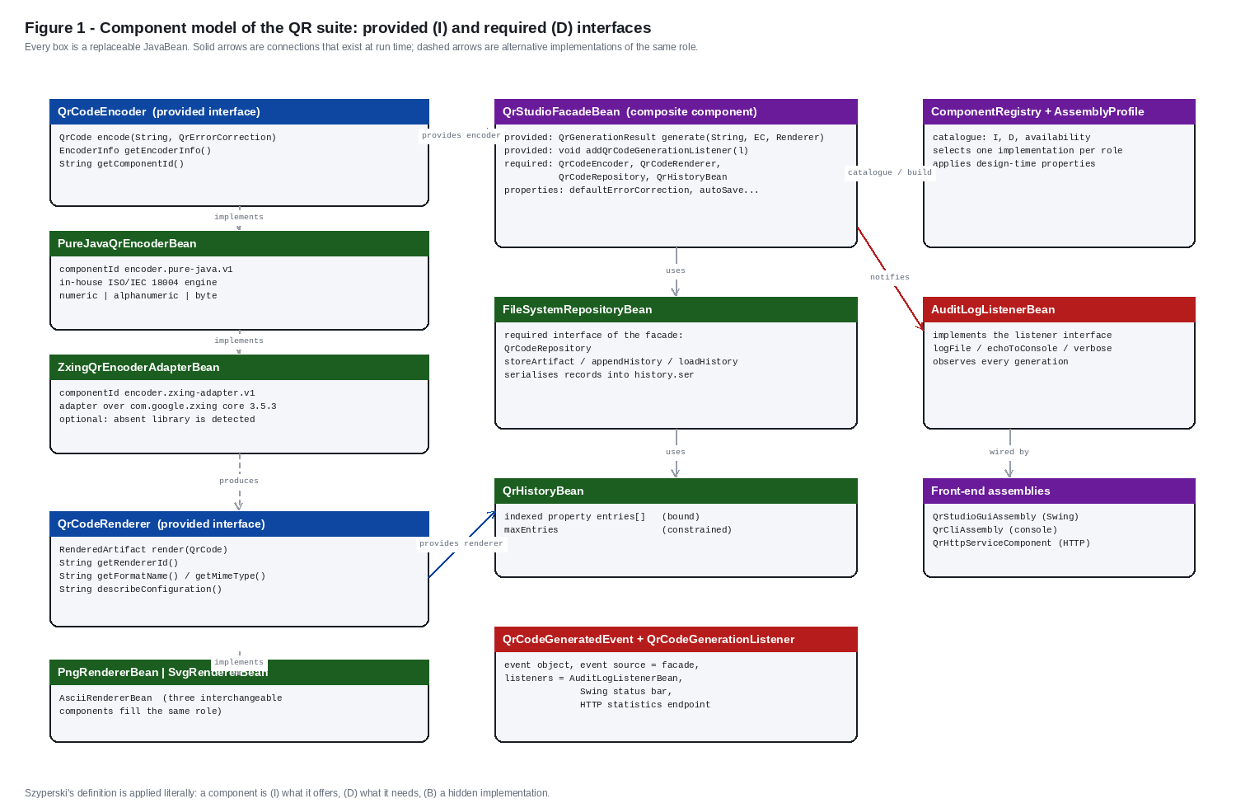
Figure 2. The JavaBeans connection model applied: event source, listener, event object, delegation, bound properties and interface-typed connections.
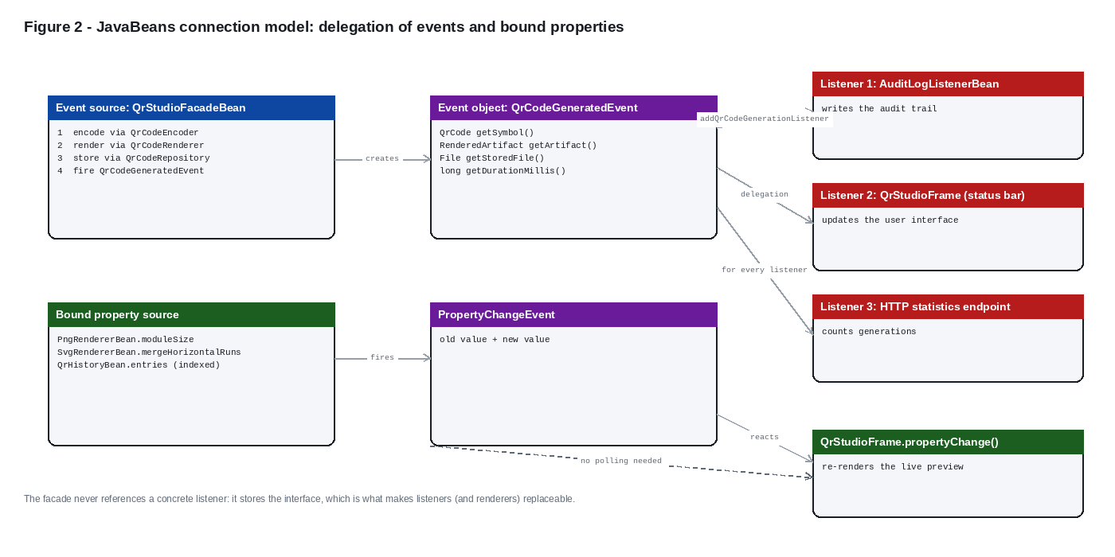
Figure 3. The deployment model D = (C, E, P, L): component set, execution environment, descriptor parameters, deployment location.
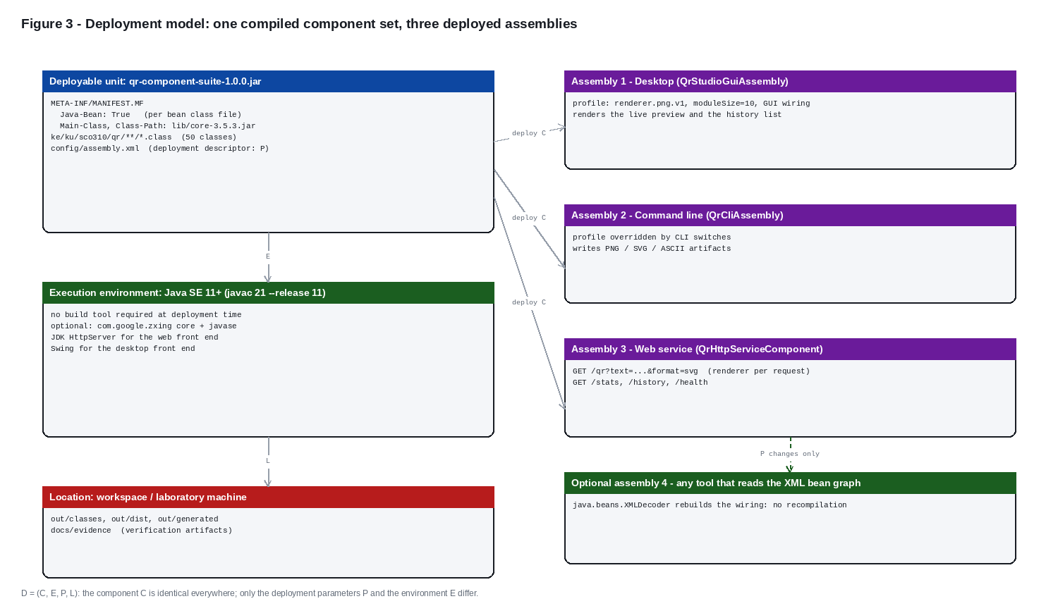
Figure 4. The five ISO/IEC 18004 encoding stages and the class that implements each one.
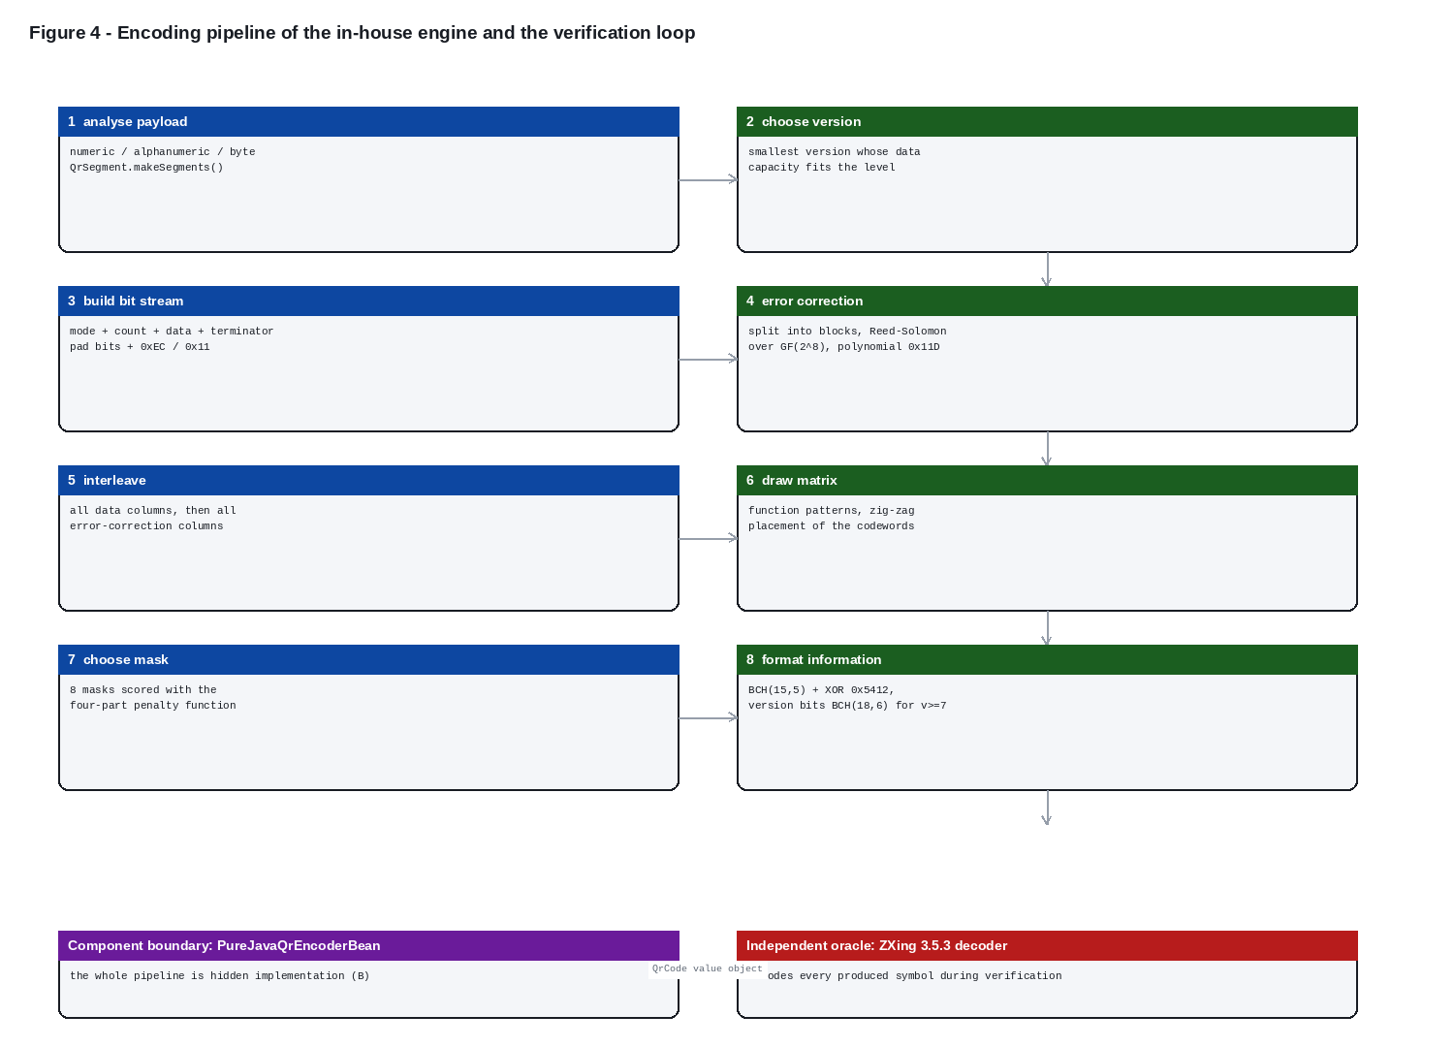
Figure 5. Verification strategy: every group of checks anchored to an independent oracle or to a reconstruction.
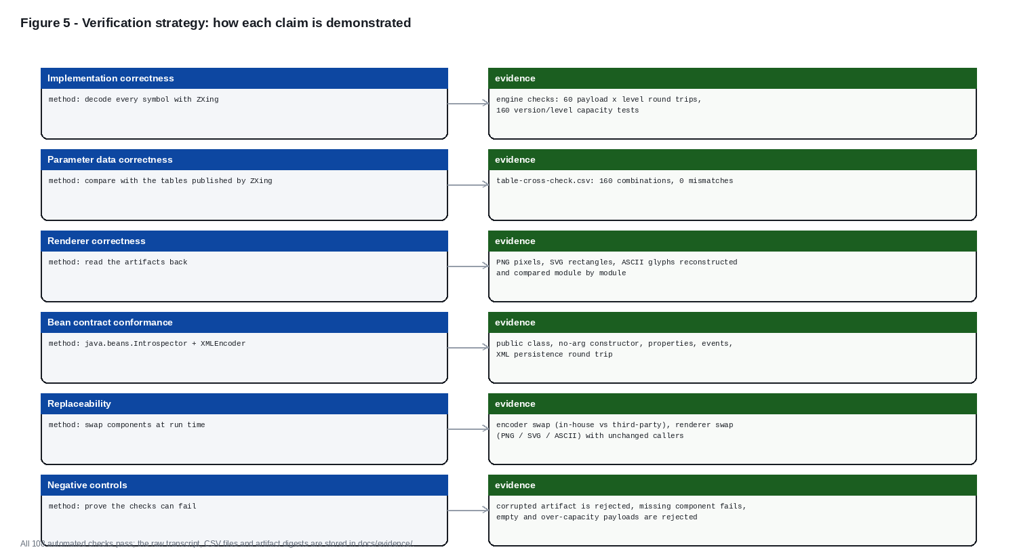
Figure 6. Generated artifacts: PNG, SVG and ASCII renderings of the same symbols with their recovered payloads.
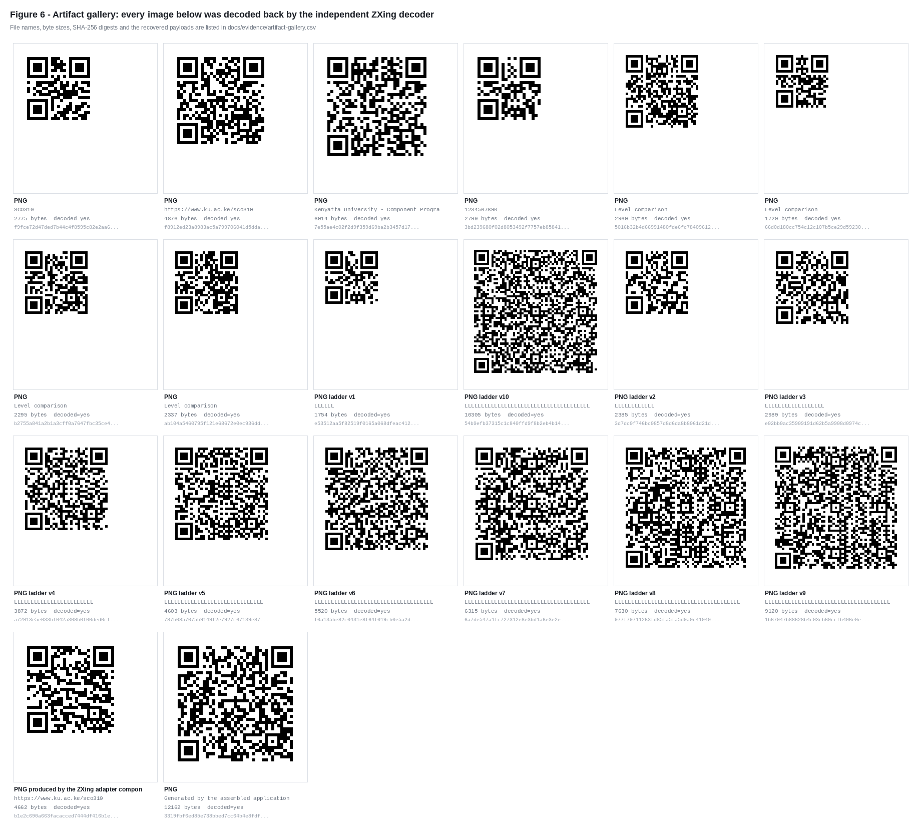
Listing 1. api/QrCodeEncoder.java - the provided interface every encoder component implements.
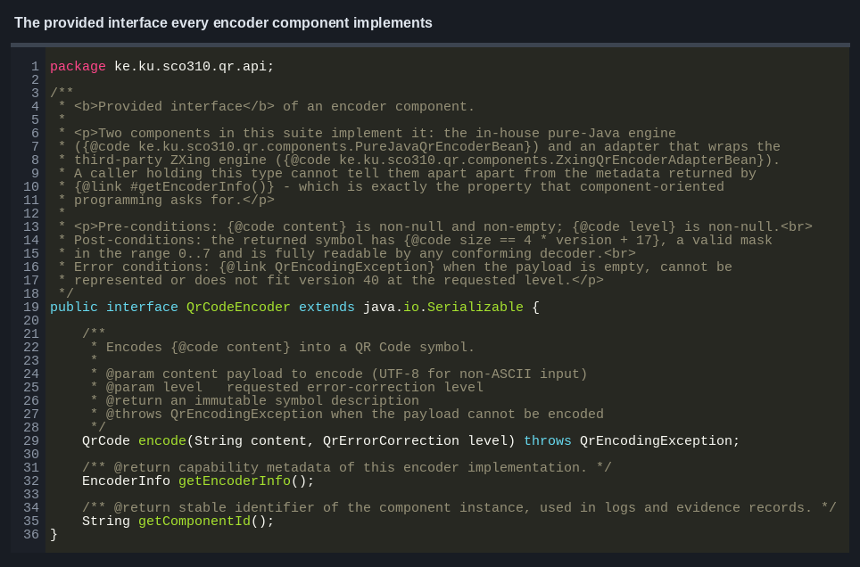
Listing 2. engine/ReedSolomon.java - shift-register polynomial division over GF(2^8).
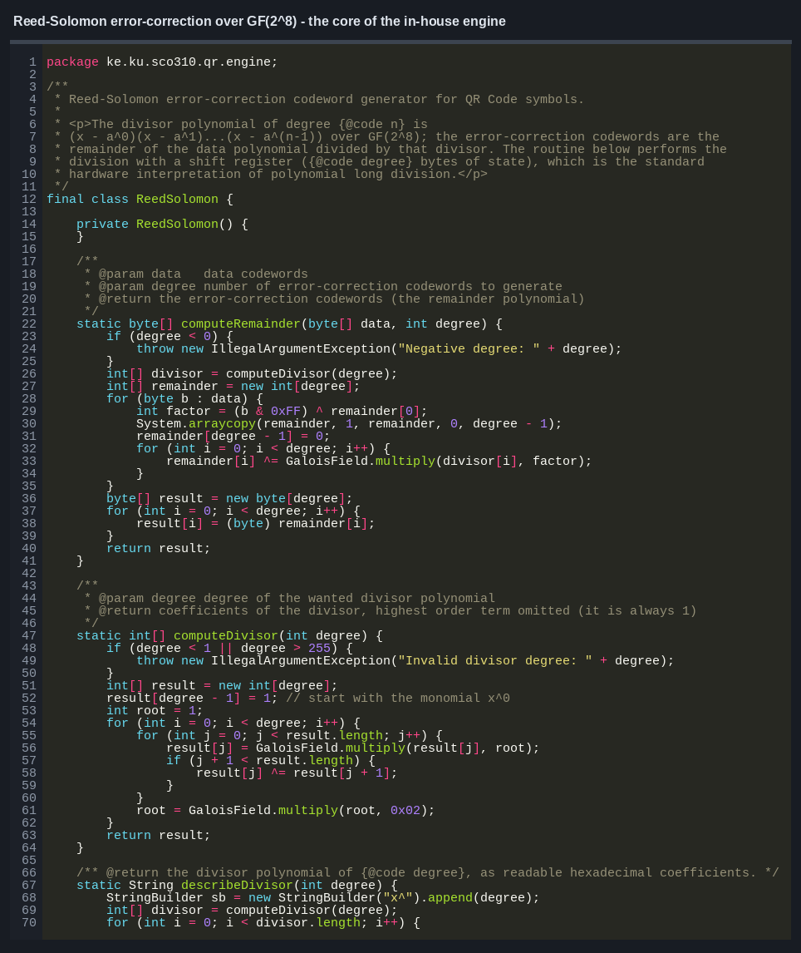
Screenshot 1. The desktop assembly, PNG renderer component: property sheet, live preview, indexed history.
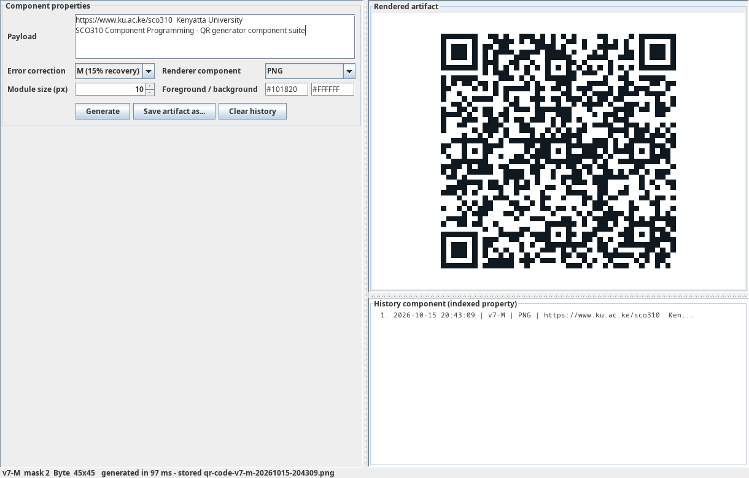
Screenshot 2. The same running application after the renderer component was replaced by renderer.svg.v1.
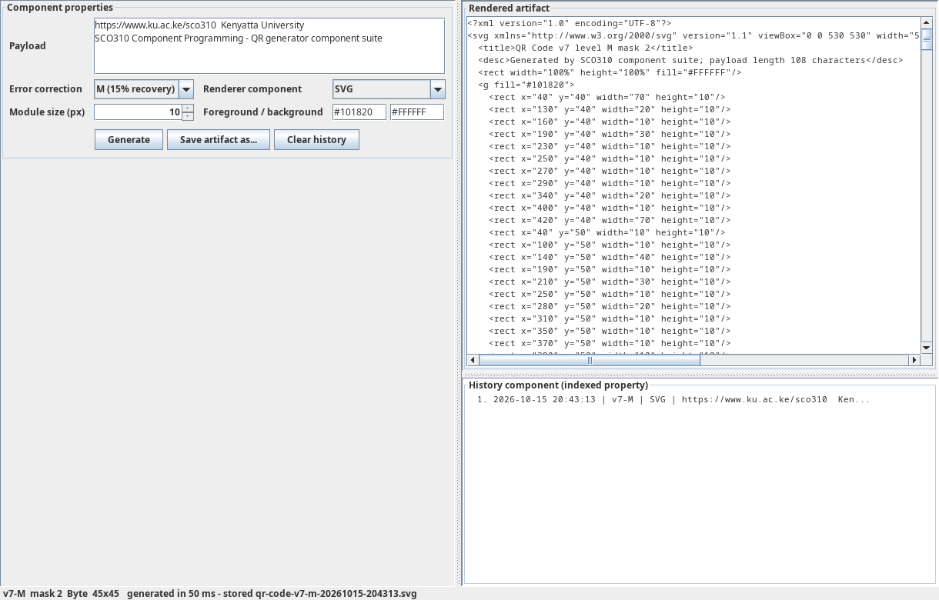
Screenshot 3. The same running application with renderer.ascii.v1: a textual artifact in the preview panel.
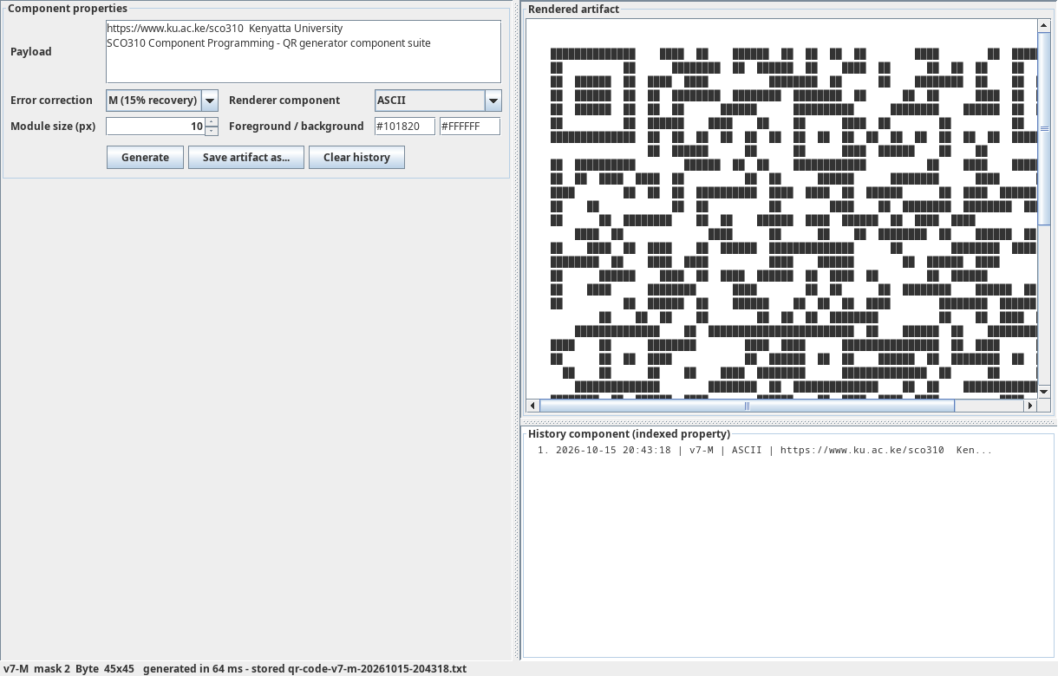
Screenshot 4. The command-line assembly: complete option surface.
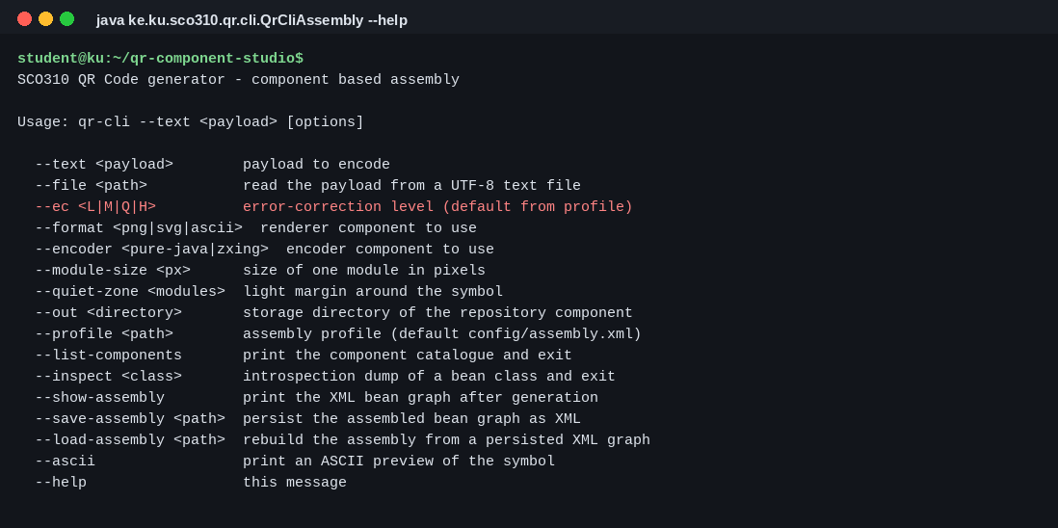
Screenshot 5. The component catalogue with roles, provided interfaces, required interfaces and state.
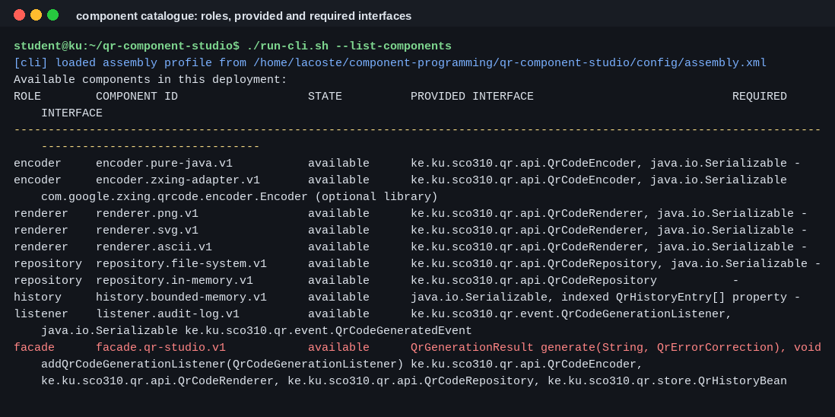
Screenshot 6. A full generation run: deployment report, result, deployment XML reuse.
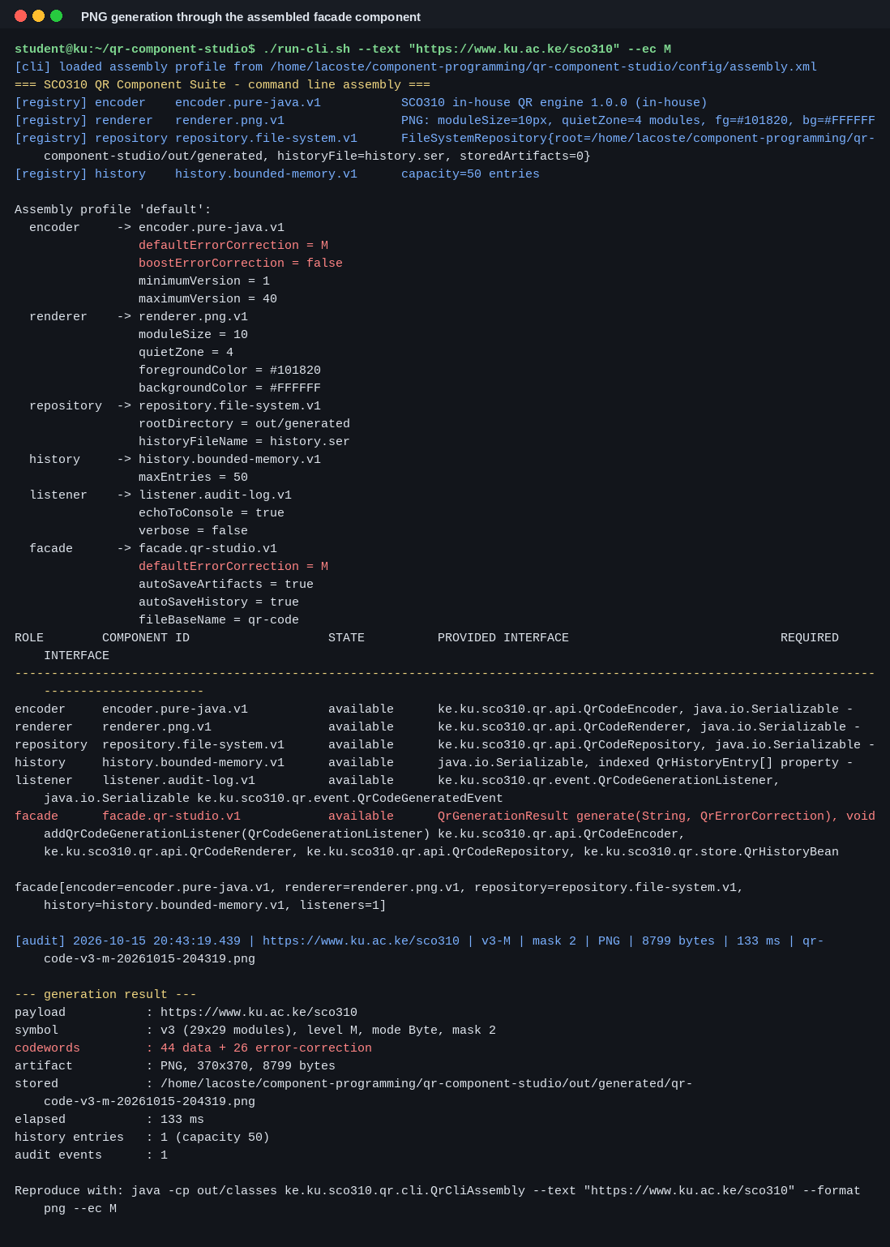
Screenshot 7. A decodable symbol printed in a terminal by the ASCII renderer component.
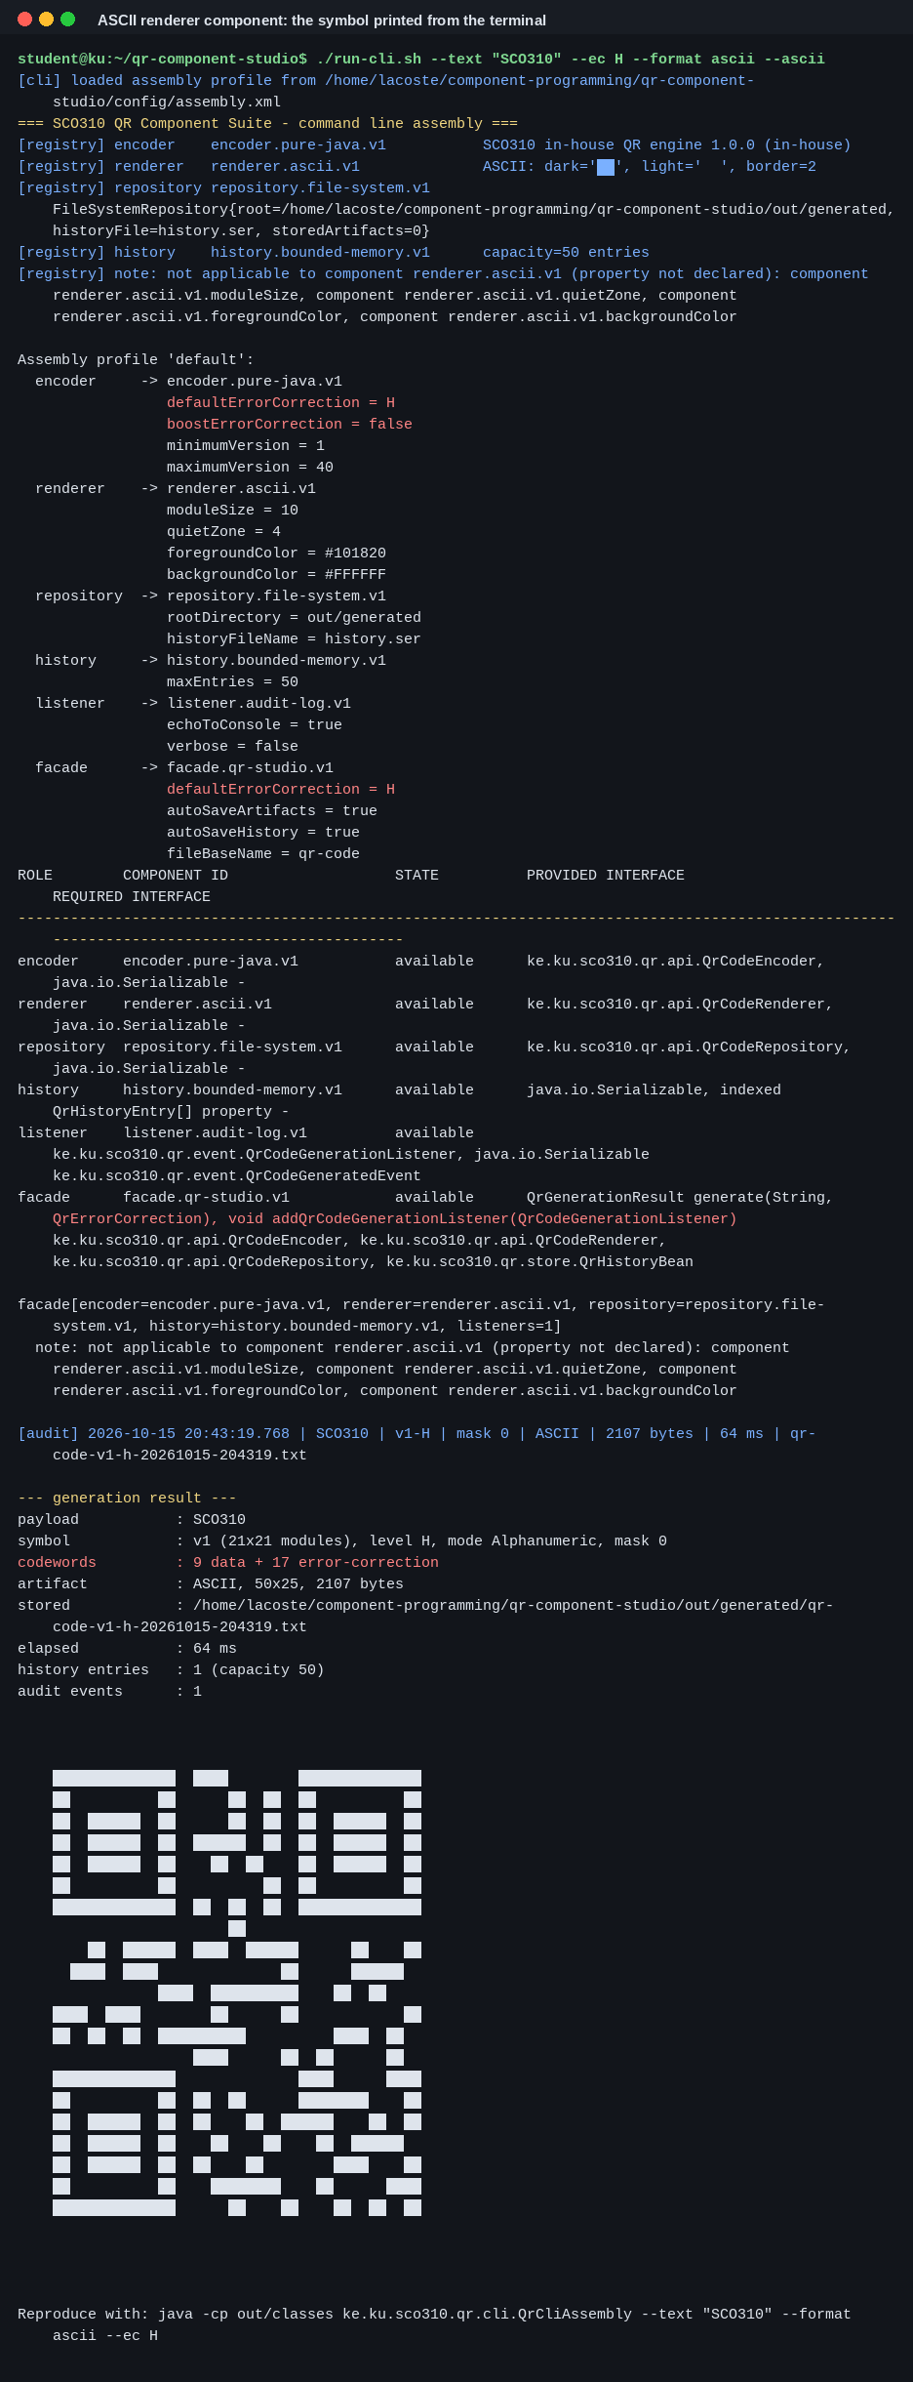
Screenshot 8. Run-time introspection of the PNG renderer bean.
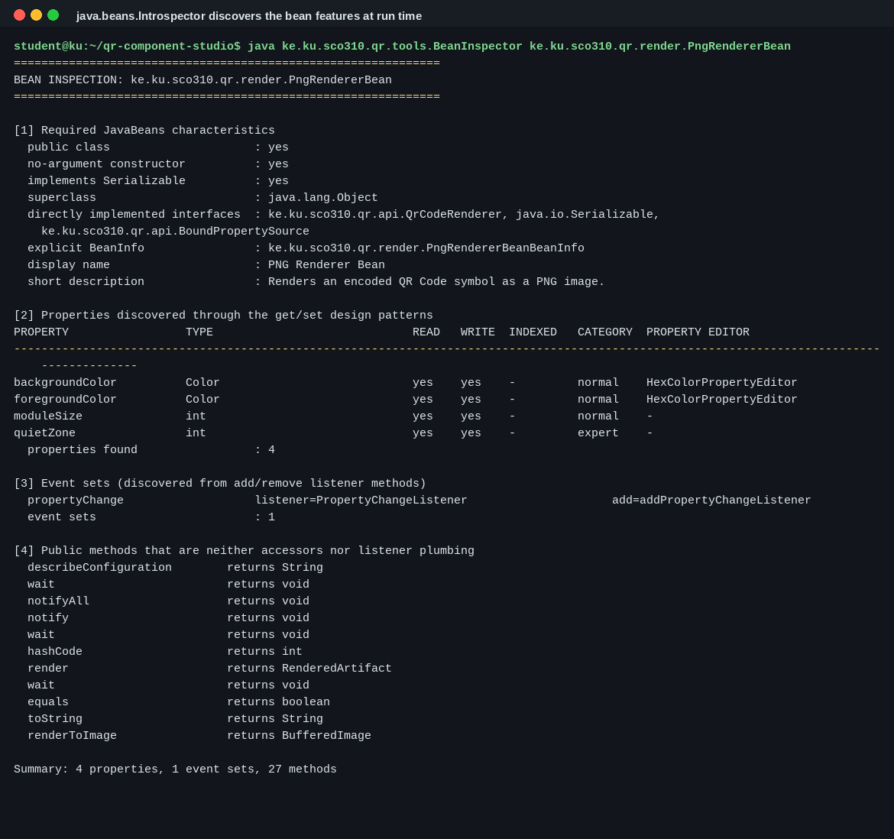
Screenshot 9. Introspection of the indexed/constrained history bean and the facade event set.
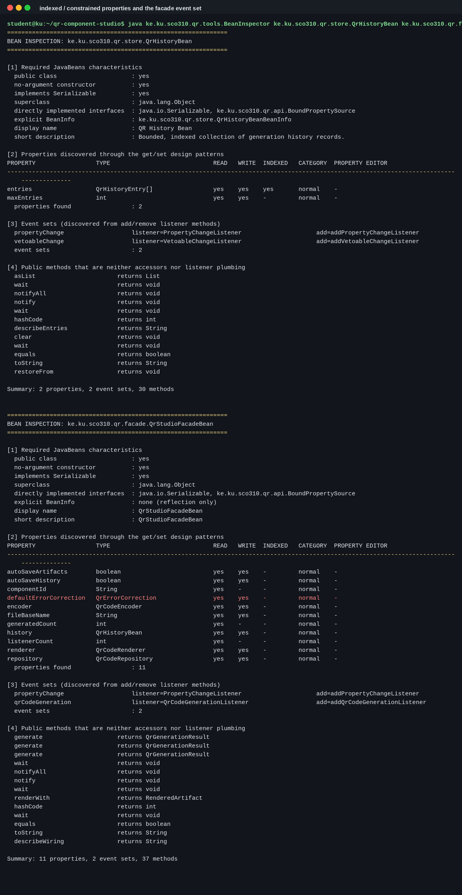
Screenshot 10. The verification transcript: 108 checks, 108 passed, 0 failed.
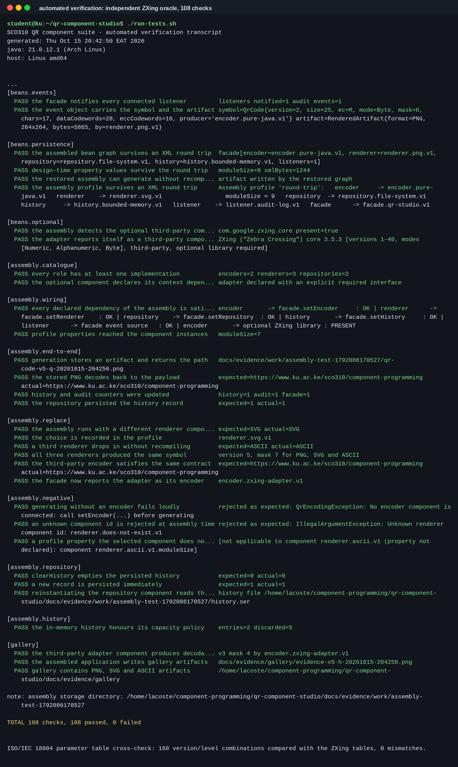
Screenshot 11. Build, verify and package in one command.
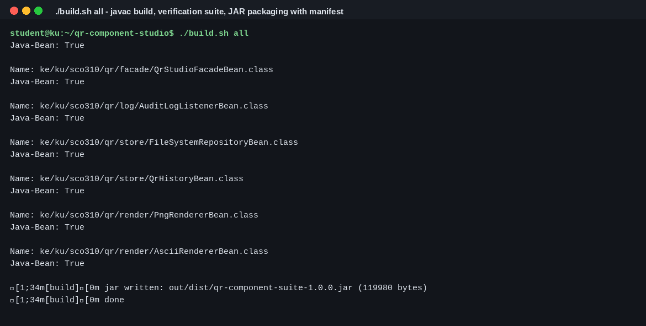
Screenshot 12. The deployment interface: Java-Bean: True entries for all nine beans.
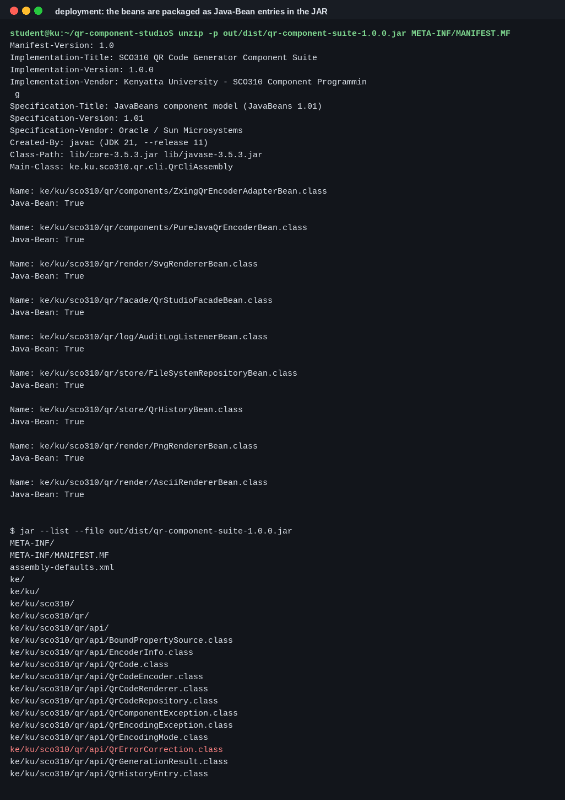
Screenshot 13. The HTTP assembly answering /qr, /stats and /history.
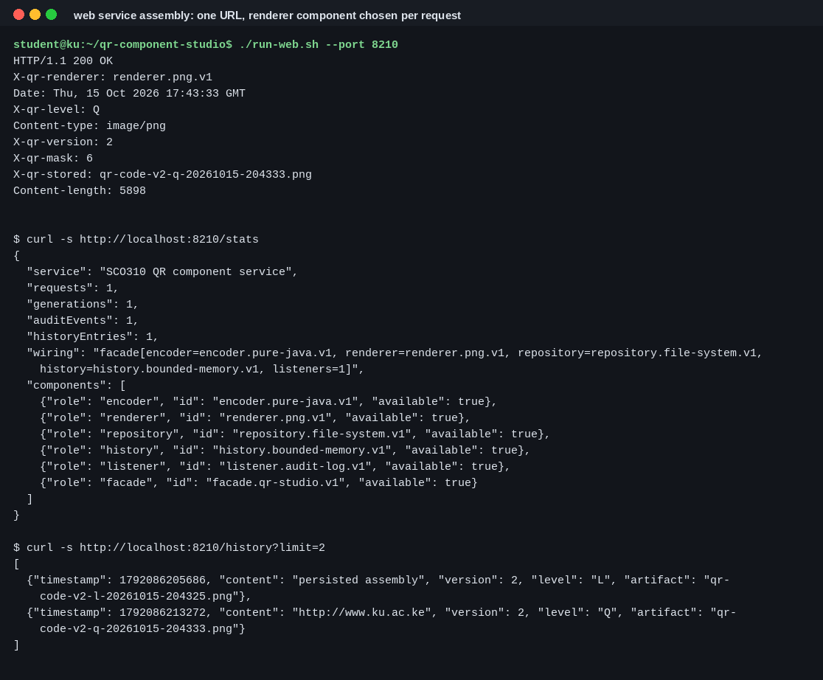
Listing 3. components/PureJavaQrEncoderBean.java - a complete JavaBean with all property kinds.
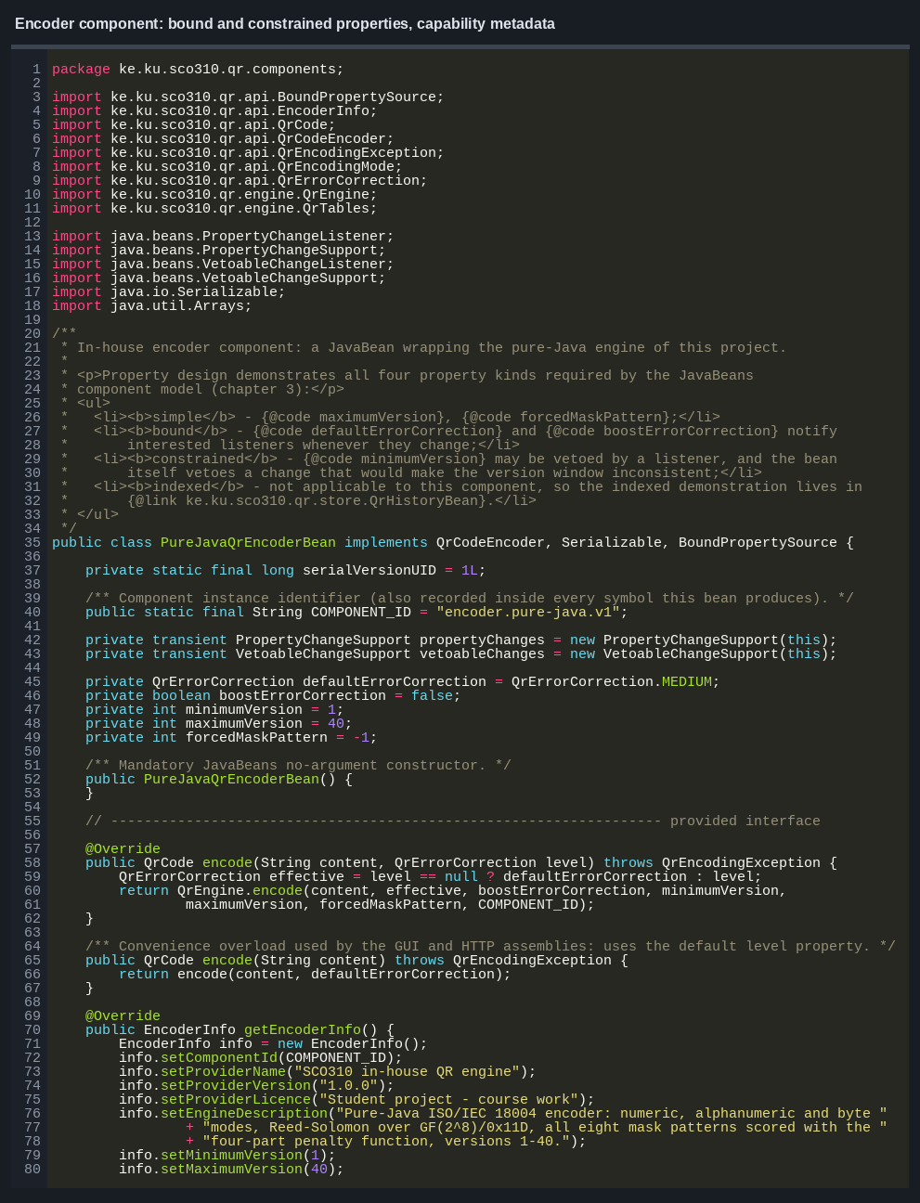
Listing 4. render/PngRendererBean.java - bound properties, validation and run-length drawing.
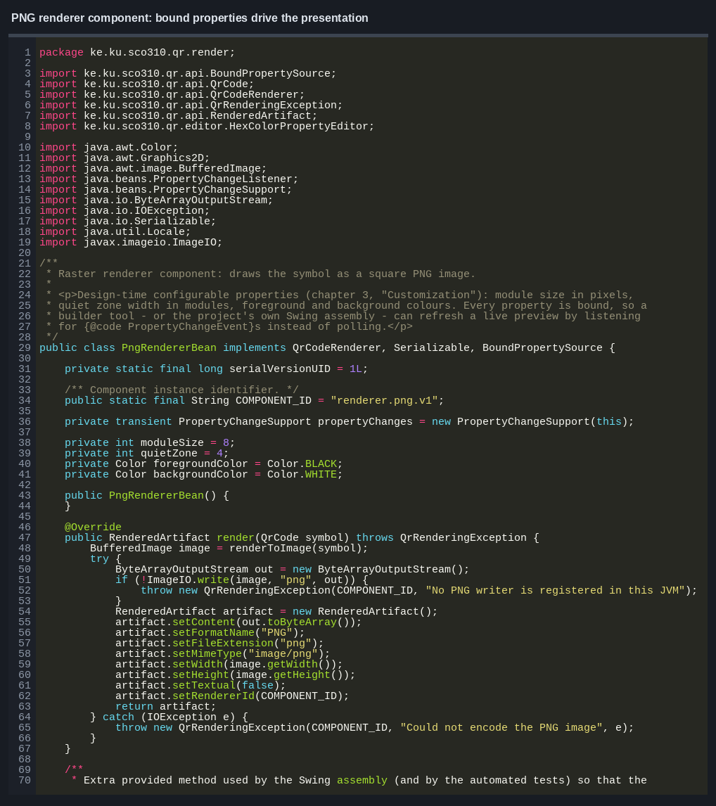
Listing 5. store/QrHistoryBean.java - the indexed property and the constrained maxEntries property.
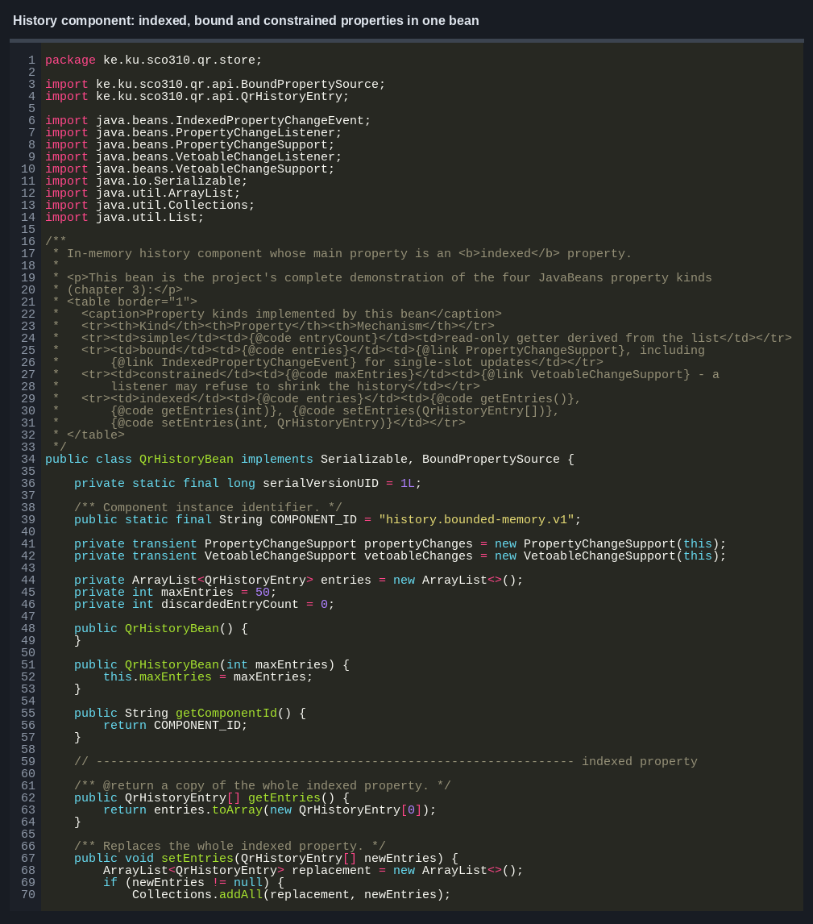
Listing 6. facade/QrStudioFacadeBean.java - composition, event firing and timing.
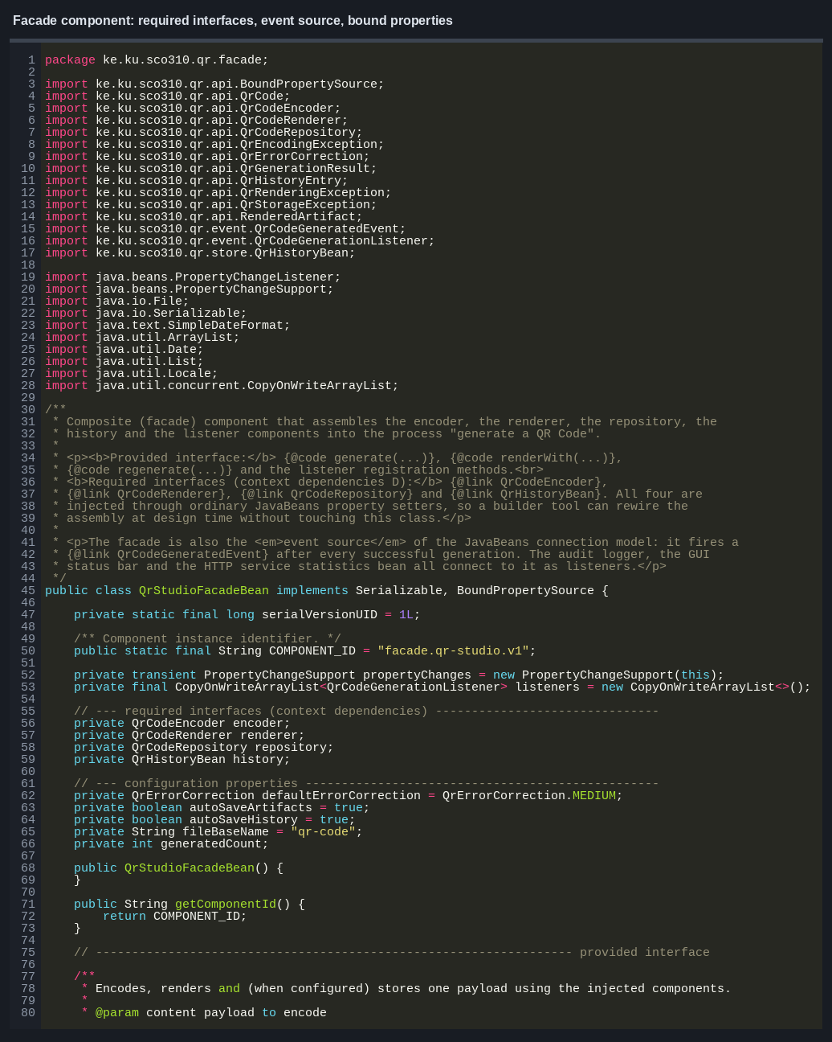
Listing 7. facade/ComponentRegistry.java - catalogue, select, instantiate, configure, validate.
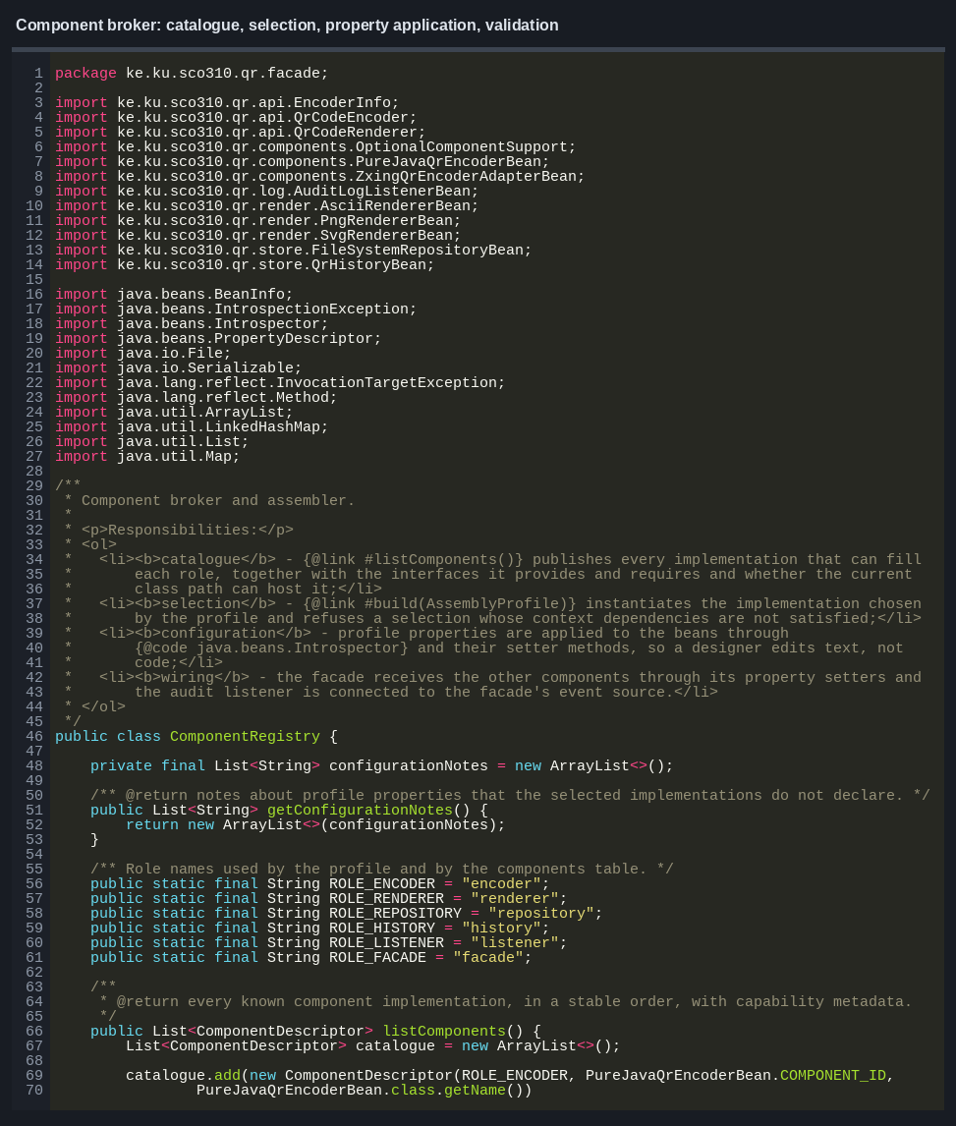
Listing 8. render/PngRendererBeanBeanInfo.java - feature descriptors, expert flag, custom property editor.
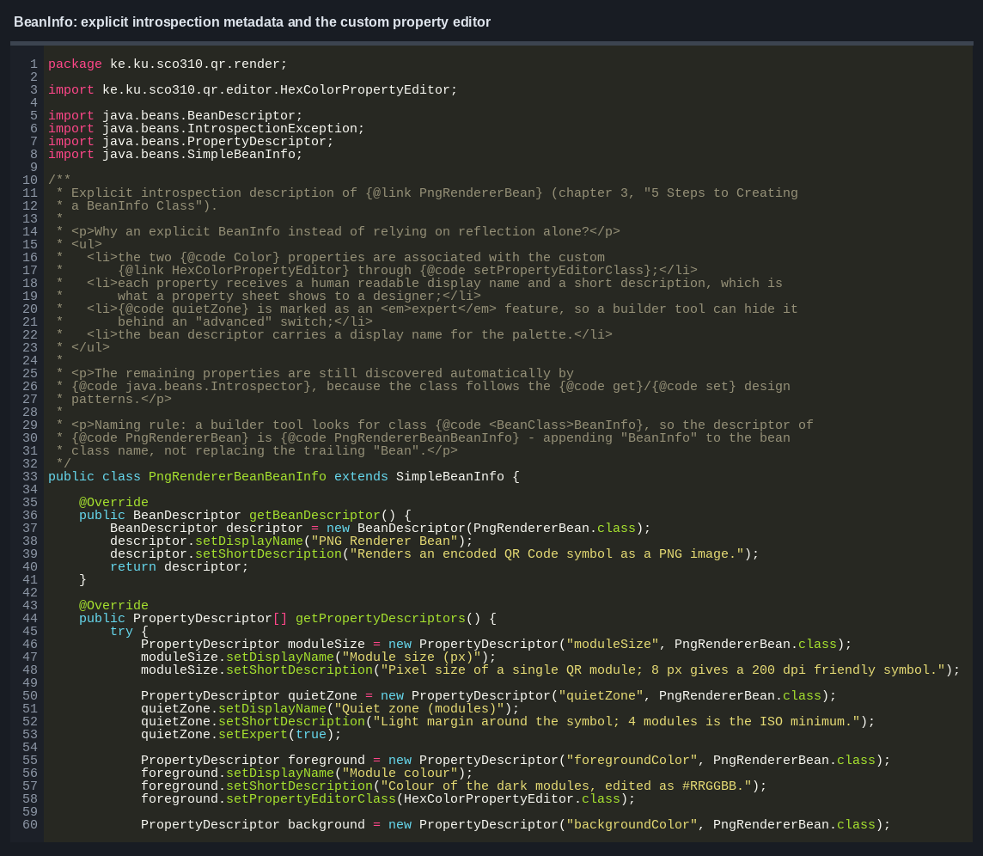
Listing 9. ui/QrStudioFrame.java - the desktop front end listening to bound properties.
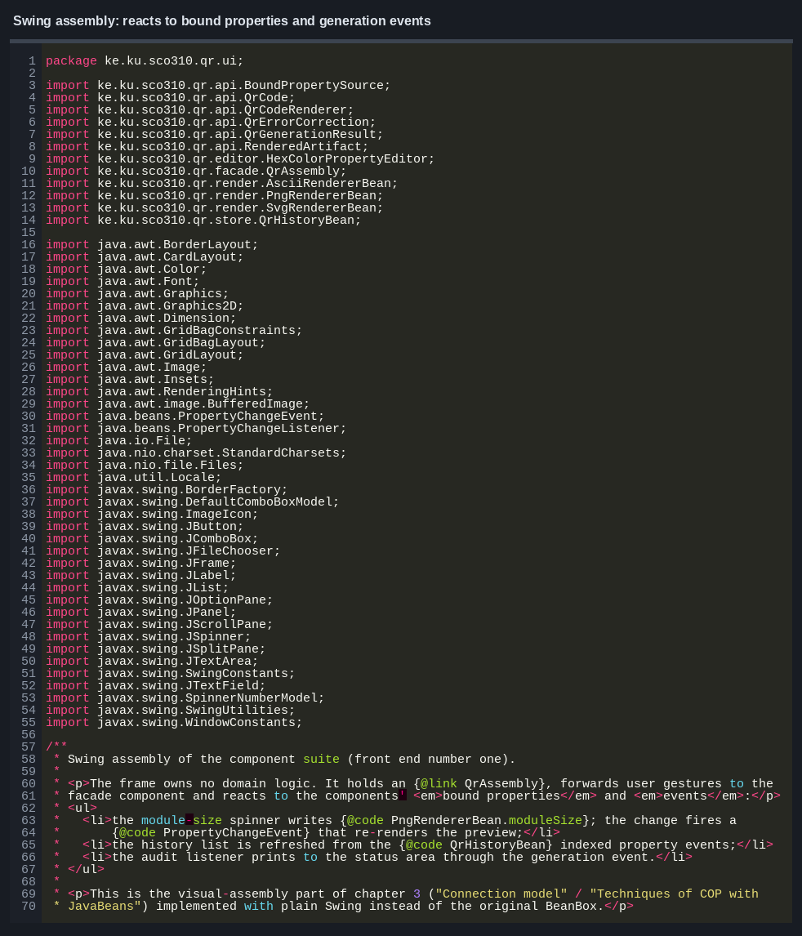
Listing 10. cli/QrCliAssembly.java - the command-line front end.
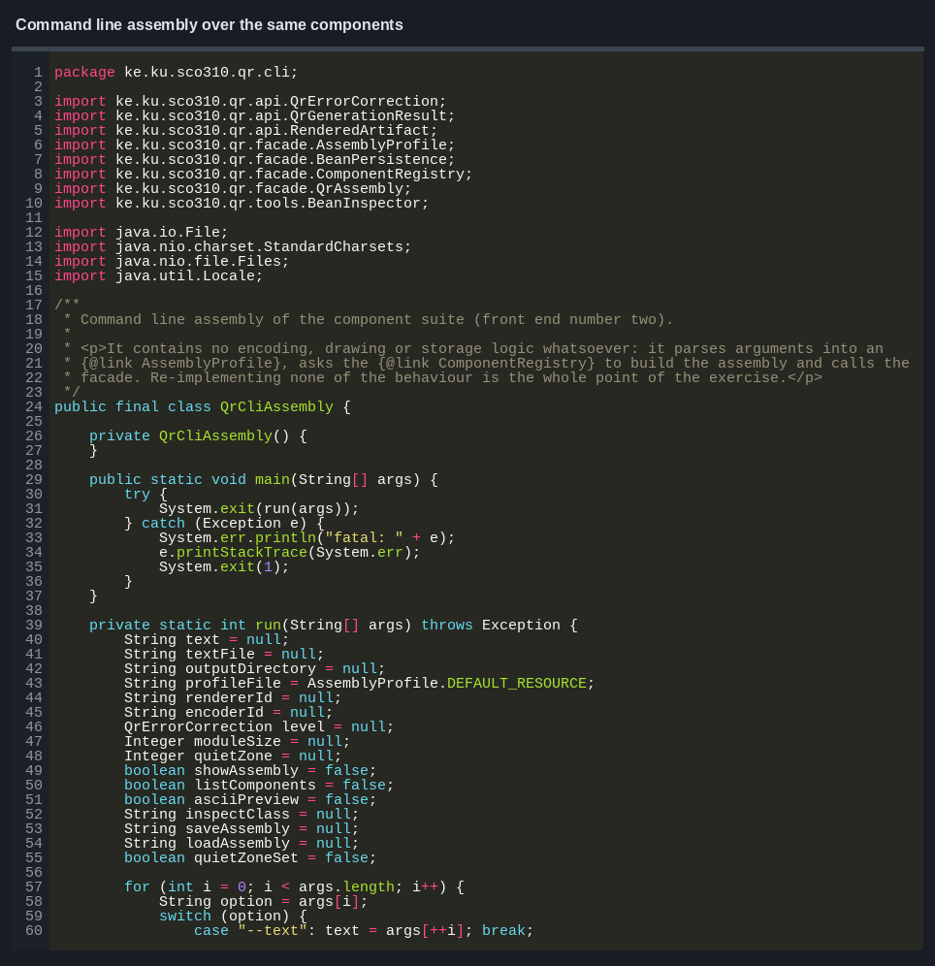
Listing 11. components/ZxingQrEncoderAdapterBean.java - third-party composition behind our own interface.
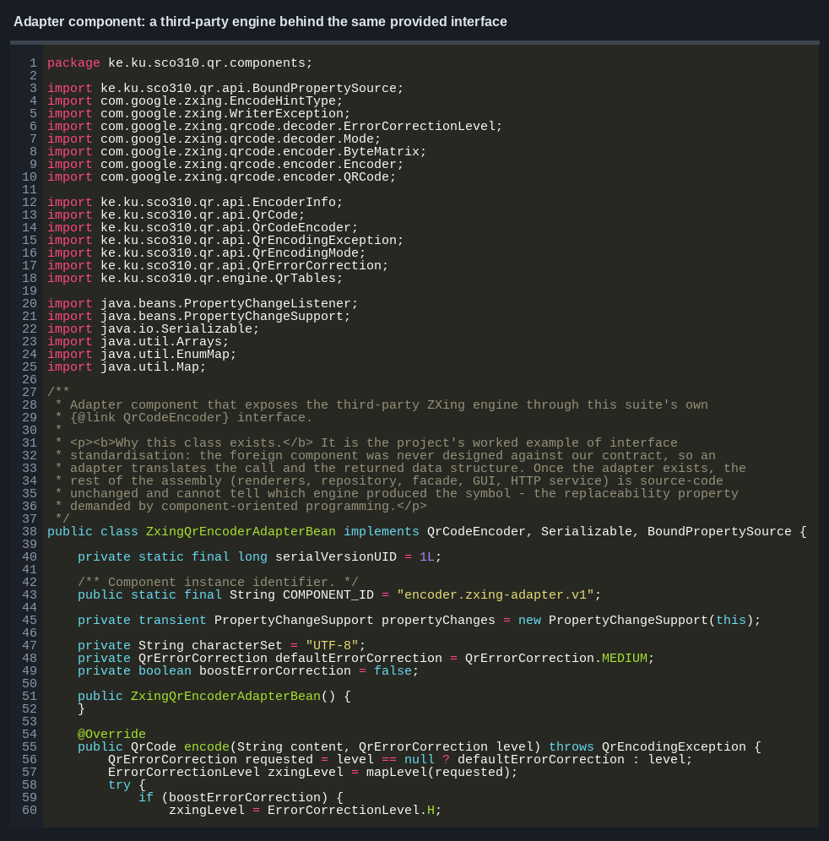
Listing 12. test/EngineReferenceTest.java - the independent-oracle checks.
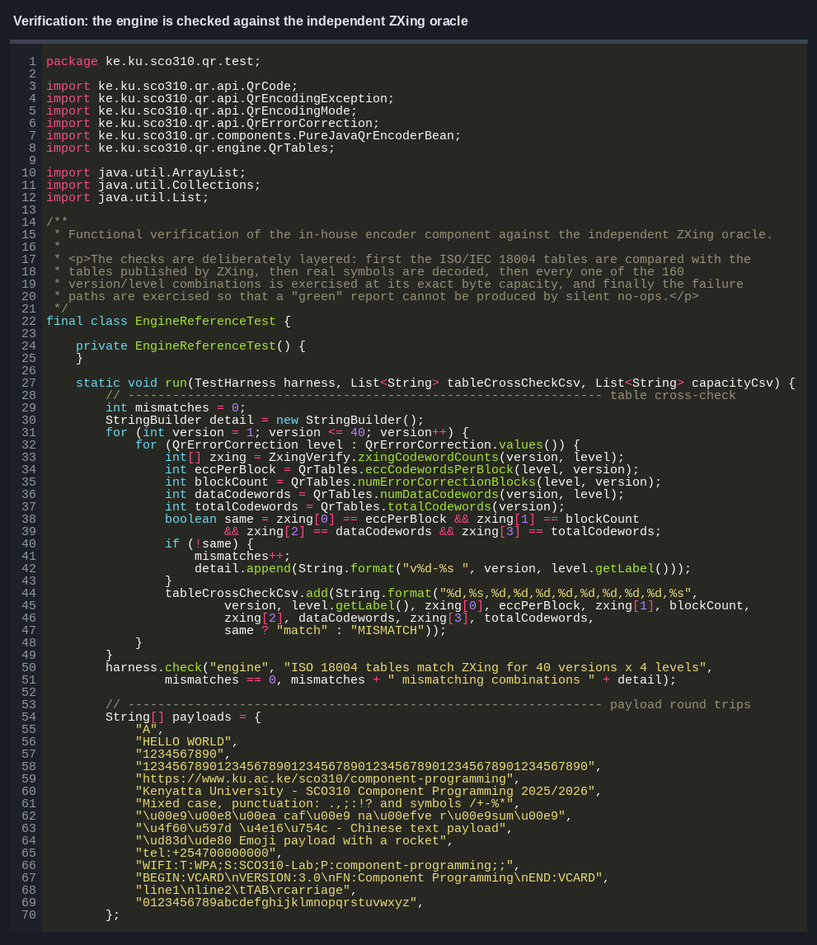
Screenshot 14. The bean feature matrix across four components in one view.
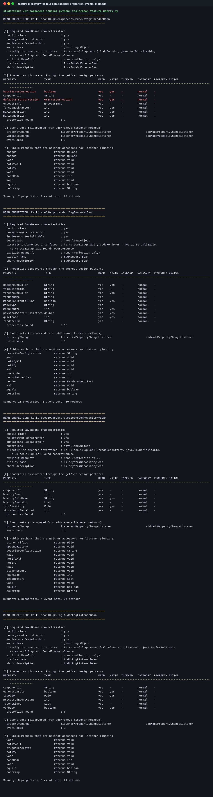
Screenshot 15. The artifact returned by the HTTP service for a PNG request.


