1041501_hw2

黃威竣

建置環境為Anaconda Nacigatot Jupyter Notebook



下圖為kaggle上的評分

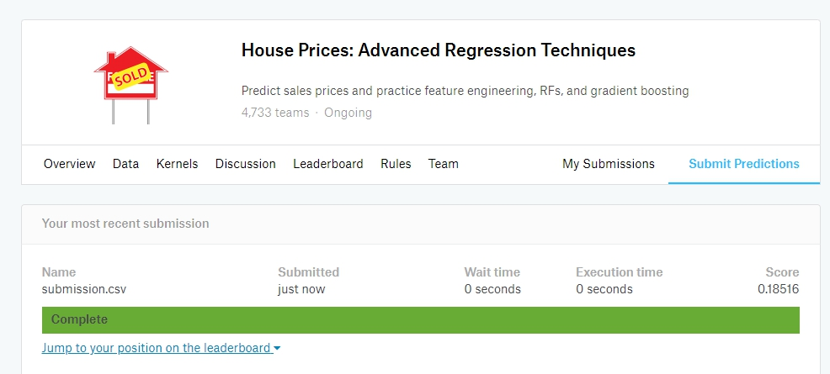

我是使用Gradient decent的方法去找出權重，以及刪除某些很明顯無關的特徵以及補Nan

以下為程式碼 有註解

使用到的函式庫有 pandas,numpy , sklearn.preprocessing

#!/usr/bin/env python

# coding: utf-8

# In[68]:

import matplotlib.pyplot as plt

import pandas as pd

import numpy as np

import random

import math

from sklearn.preprocessing import StandardScaler

train_csv = pd.read_csv('train.csv') #read CSV檔 file

test_csv = pd.read_csv('test.csv')

train_df = pd.DataFrame(train_csv) #to panda dataFrame

test_df = pd.DataFrame(test_csv)

train_df = train_df.drop('Alley',1) ##以下移除的這4筆column很明顯與資料結果無關係

train_df = train_df.drop('PoolQC',1)

train_df = train_df.drop('MiscFeature',1)

train_df = train_df.drop('Fence',1)

train_df["GarageYrBlt"].fillna(0,inplace = True)

train_df["Utilities"].fillna("None",inplace = True) #把這幾筆Column的Nan補上None值

train_df["Exterior1st"].fillna("None",inplace = True)

train_df["Exterior2nd"].fillna("None",inplace = True)

train_df["FireplaceQu"].fillna("None",inplace = True)

test_df = test_df.drop('Alley',1) ##以下移除的這4筆column很明顯與資料結果無關係

test_df = test_df.drop('PoolQC',1)

test_df = test_df.drop('MiscFeature',1)

test_df = test_df.drop('Fence',1)

test_df["GarageYrBlt"].fillna(0,inplace = True)

test_df["Utilities"].fillna("None",inplace = True) #把這幾筆Column的Nan補上None值

test_df["Exterior1st"].fillna("None",inplace = True)

test_df["Exterior2nd"].fillna("None",inplace = True)

test_df["FireplaceQu"].fillna("None",inplace = True)

test_df = test_df.fillna(value=0)

train_df = train_df.fillna(value=0)

y_train = train_df["SalePrice"].values #轉成np

t = y_train

X_train = train_df = train_df.drop('SalePrice', 1)

for col_name in X_train.columns:

if(X_train[col_name].dtype == 'object'):

X_train[col_name]= X_train[col_name].astype('category')

X_train[col_name] = X_train[col_name].cat.codes

for col_name in test_df.columns:

if(test_df[col_name].dtype == 'object'):

test_df[col_name]= test_df[col_name].astype('category')

test_df[col_name] = test_df[col_name].cat.codes

X_test = test_df.values #轉成np

X_train = X_train.values

# In[ ]:

# In[69]:

## 先讓X與y去作標準化 使用StandardScaler()

y_train = y_train.reshape(1460,1)

SC_X = StandardScaler()

SC_y = StandardScaler()

X_train = SC_X.fit_transform(X_train) ##原本是int標準化會有小數點自然會有數字會遺失出現警告

y_train = SC_y.fit_transform(y_train)

X_test = SC_X.transform(X_test)

for i in range (len(X_train)):

X_train[i][0] = 1

for i in range (len(X_test)):

X_test[i][0] = 1

# ### 我寫的Gradient_desent function theta為要找出的角度,alpha為learning rate, num_iters為次數

# In[63]:

def gradient_Descent(X, y, theta, alpha, num_iters):

m = len(y)

n = len(theta)

tmp = theta

theta.reshape(n,1)

y_pred = np.dot(X,theta)

for i in range(num_iters):

for j in range(n):

tmp[j] = tmp[j] - alpha * (1/m)*sum((y_pred - y)*X[:,j]) ##計算theta最關鍵的就是這一行，也是微分過後的公式帶進去一直算

y_pred = np.dot(X,theta)

cost = (1.0 / (2.0 * m)) * sum((y_pred-y)*(y_pred-y)) #這邊的Y都是標準化過後的Y

print ("iteration {}, cost {}".format(i,cost))

return theta

# In[ ]:

# In[64]:

y_train = y_train.flatten() #我丟進去的y要是一維,原本二維用這個涵式降維

theta = np.random.rand(len(X_train[0])) #theta我採用隨機的數值

gradient_Descent(X_train,y_train,theta,0.1,500) #呼叫Gradient_descent #看紀錄大致上500次就差不多了 alpha=0.1的原因是只要讓他可以穩定就好

# In[65]:

ANS = np.dot(X_test,theta) #找出來的theta值與需要預測的資料內積

ANS_inv = ANS.reshape(1459,1) ## 由於前面的"Price"有作標準化，在這邊要把預測出的結果給inverse回去

ANS_inv = SC_y.inverse_transform((ANS_inv))

ANS_inv = ANS_inv.flatten()

Id = np.zeros(len(X_test))

for i in range(len(X_test)): ##寫檔用的Id

Id[i]=i+1461

Id = Id.astype(np.int32)

f = open("submission.csv", "w") ##寫檔

f.write("{},{}\n".format("Id", "SalePrice"))

for x in zip(Id, ANS_inv):

f.write("{},{}\n".format(x[0], x[1]))

f.close()

# In[67]:

print(ANS_inv)

# In[ ]: