**HW2**

0856703 黃威竣

1. **Github link**

This is my homework2 for github: <https://github.com/f51980280/DLCV_hw2>

1. **Introduction**

I used keras to build my DCGAN model

And I used helper.py for get_batches, grid_images, get_images….. some useful function. This function make me convenience to used celeba image set for scaling and output images.

Below is my code:

I use 64 x 64 pixel for training

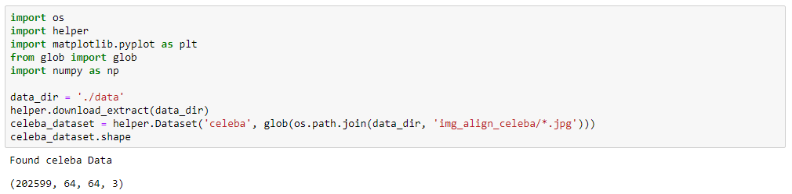

Class init

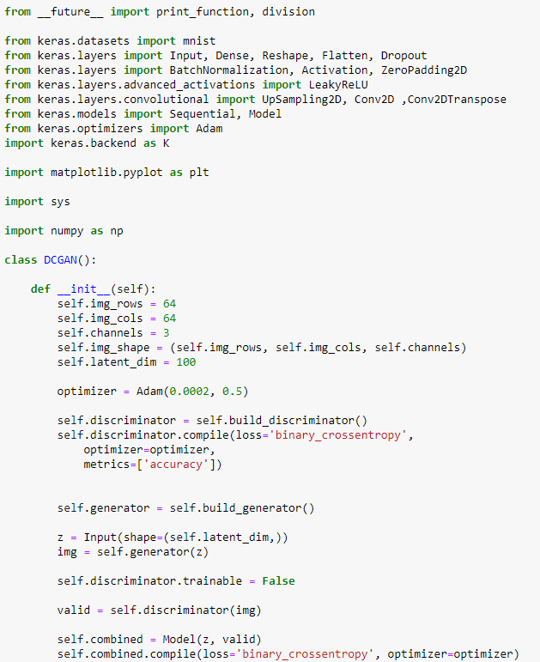

Generator

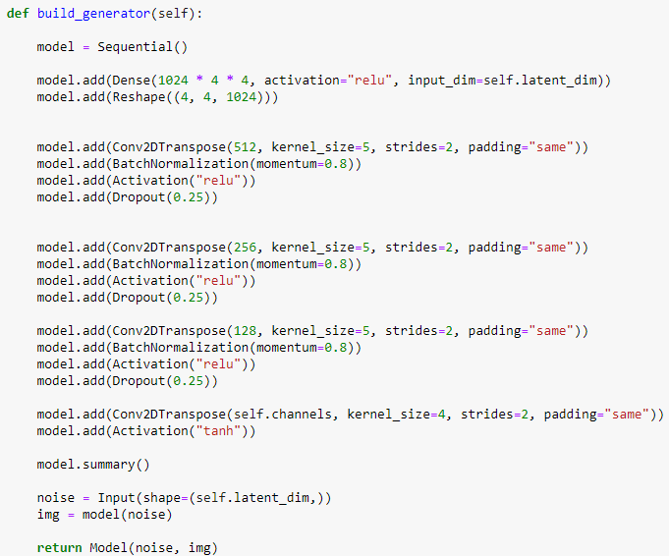

Discriminator

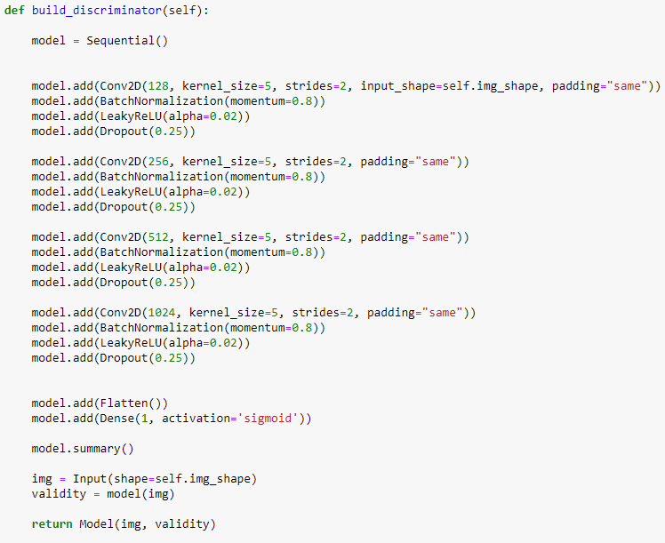

For train

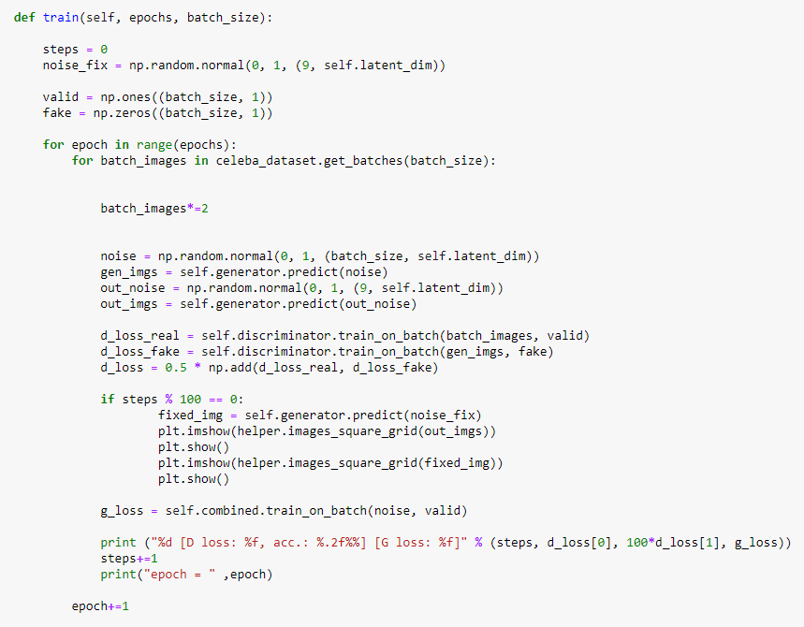

Use for GPU

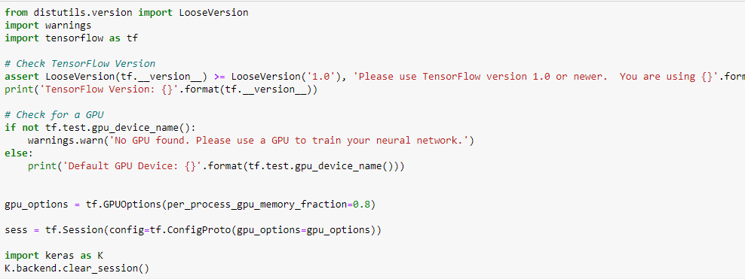

Main function



Save for image png

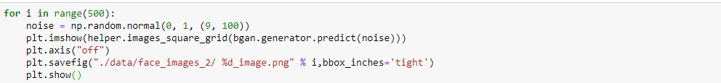

1. **Summary and Finding**

I build DCGAN with Adam optimizer ( learning rate = 0.0002, beta1 = 0.5)

I tried use some learning rate like 0.0001 or 0.00015…. and beta1 tried to use 0.9、0.8、0.7. but when training the model, the images looks no good, and I also tried to add some extra layer, but model is easy to unbalance, like discriminator become strong than generator. Obvious, the control of parameter or some model topology is very important, so I think the GAN model is difficult to build. At last, I only modified some DCGAN code.

I modified the Conv2D with Unpooling to Conv2DTranspose in generator, and also add Dropout(0.25) to discriminator and generator, I tried to add more conv layer or reduce conv layer, but result is seems bad. So finally my model is

Discriminator model:

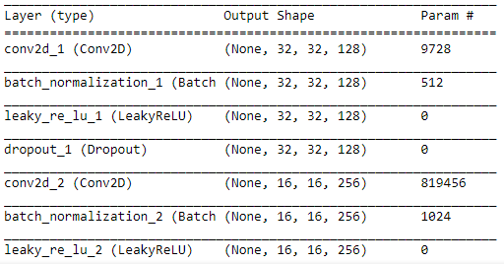

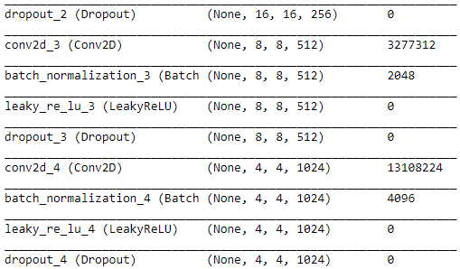

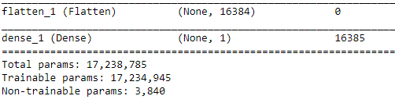

Generator model:

