Scality RING Cluster with F5 BIG-IP Local Traffic Manager
This guide explains how to deploy F5 BIG‑IP Local Traffic Manager (LTM) in front of a Scality RING cluster. It covers the network configuration, custom S3 health monitor, pool definition, and virtual server setup required to expose the cluster behind a single, highly available S3 endpoint.
This guide is intended for network engineers, system administrators, and storage operators who run a Scality RING cluster and want to use F5 BIG-IP LTM to improve the performance, availability, and scalability of the S3 service. Readers should be familiar with basic L2/L3 networking concepts and have administrative access to both BIG-IP and the Scality RING cluster.
Note: This document is demonstration content intended to illustrate a reference deployment. Adapt it to your organization’s standards and needs by substituting your own addresses, naming conventions, security policies, and operational practices before applying any of these steps in a production environment.

Table of Contents
- 1. Setup
  - 1.1 Overview
  - 1.2 Networking
- 2. BIG-IP Configuration
  - 2.1 VLAN Configuration
  - 2.2 Configure Self IPs
  - 2.3 HTTP/HTTPS Custom S3 Health Monitor
  - 2.4 Pool
  - 2.5 Optimization for S3 Traffic
  - 2.6 Virtual Server
  - 2.7 Test the Virtual Server
    - 2.7.1 Configure the RING Cluster
    - 2.7.2 Use Warp to Test Connectivity to the RING S3 Cluster Through the BIG-IP Virtual Server
  - 2.8 Automation with Ansible

1. Setup

1.1 Overview
The lab environment used throughout this guide consists of the following components:
- F5 BIG-IP 21.1.0
- Scality RING cluster
- Warp CLI tool for load testing
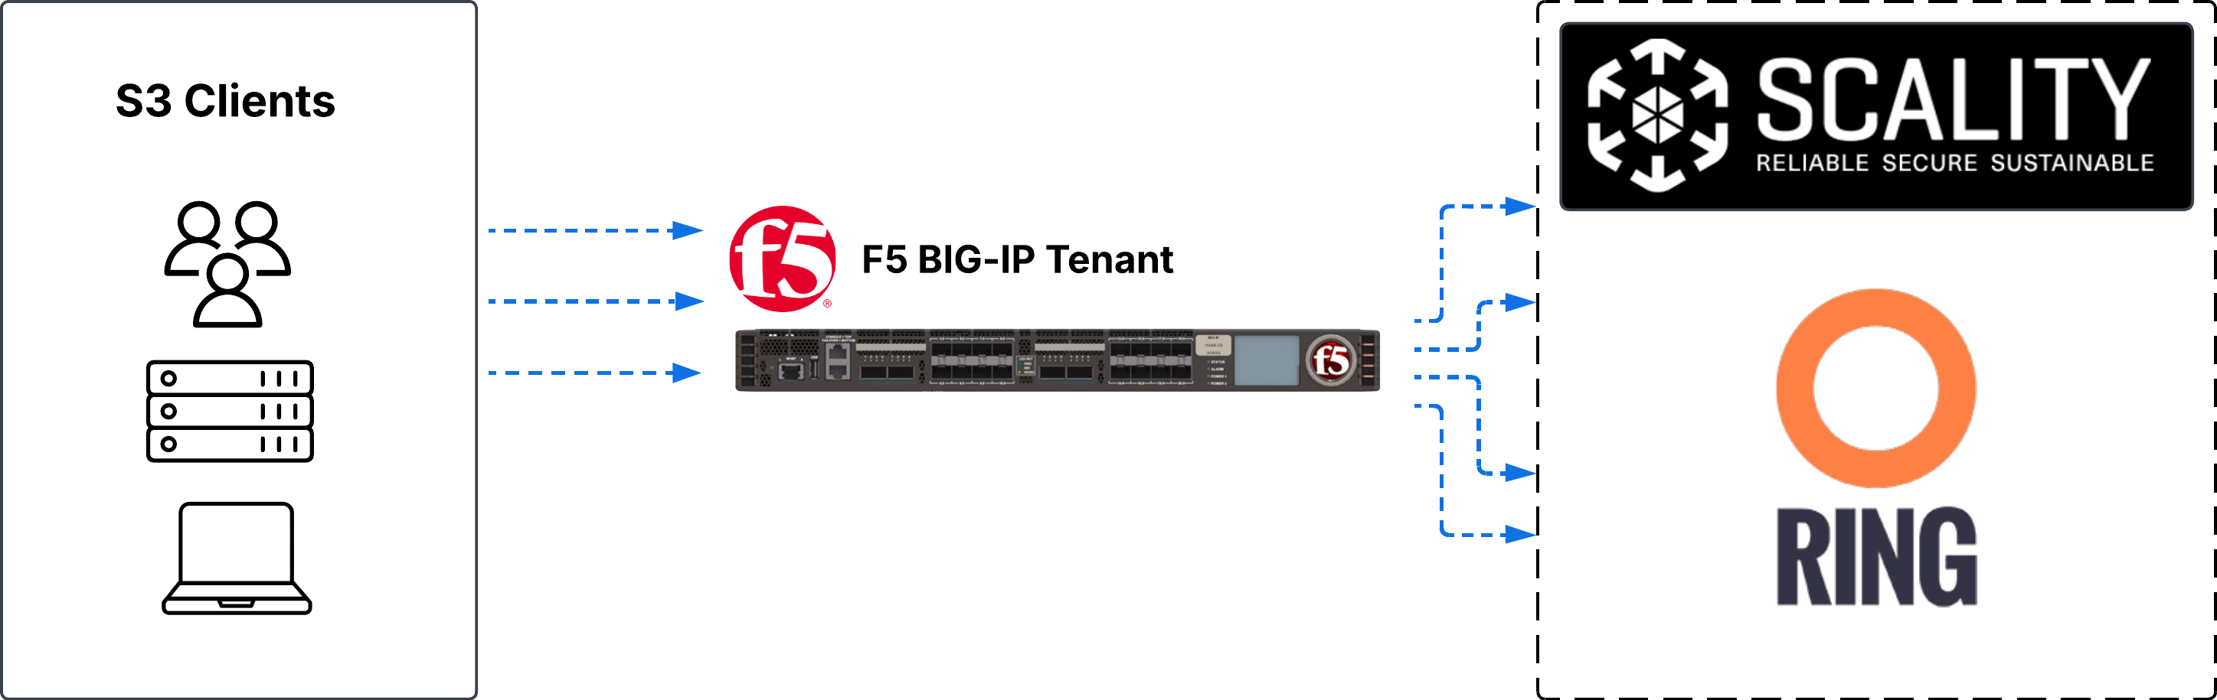
Lab setup overview showing BIG-IP, Scality RING cluster, and S3 clients

1.2 Networking
The table below lists the addresses used in the examples. Substitute your own addresses where appropriate.
Component | VLAN | Address | Interface
BIG-IP | internal | 10.150.91.145/24 | 1.1 (untagged)
BIG-IP | external | 10.150.92.145/24 | 1.2 (untagged)
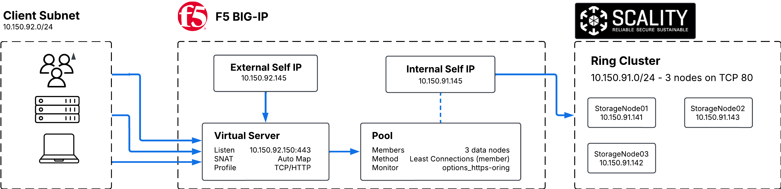
Lab network topology with BIG-IP internal and external VLANs connecting clients to the RING cluster

2. BIG-IP Configuration

2.1 VLAN Configuration
Begin by adding VLANs to the BIG-IP. In the BIG-IP Configuration utility, go to Network (1) > VLANs (2) and click Create (3). 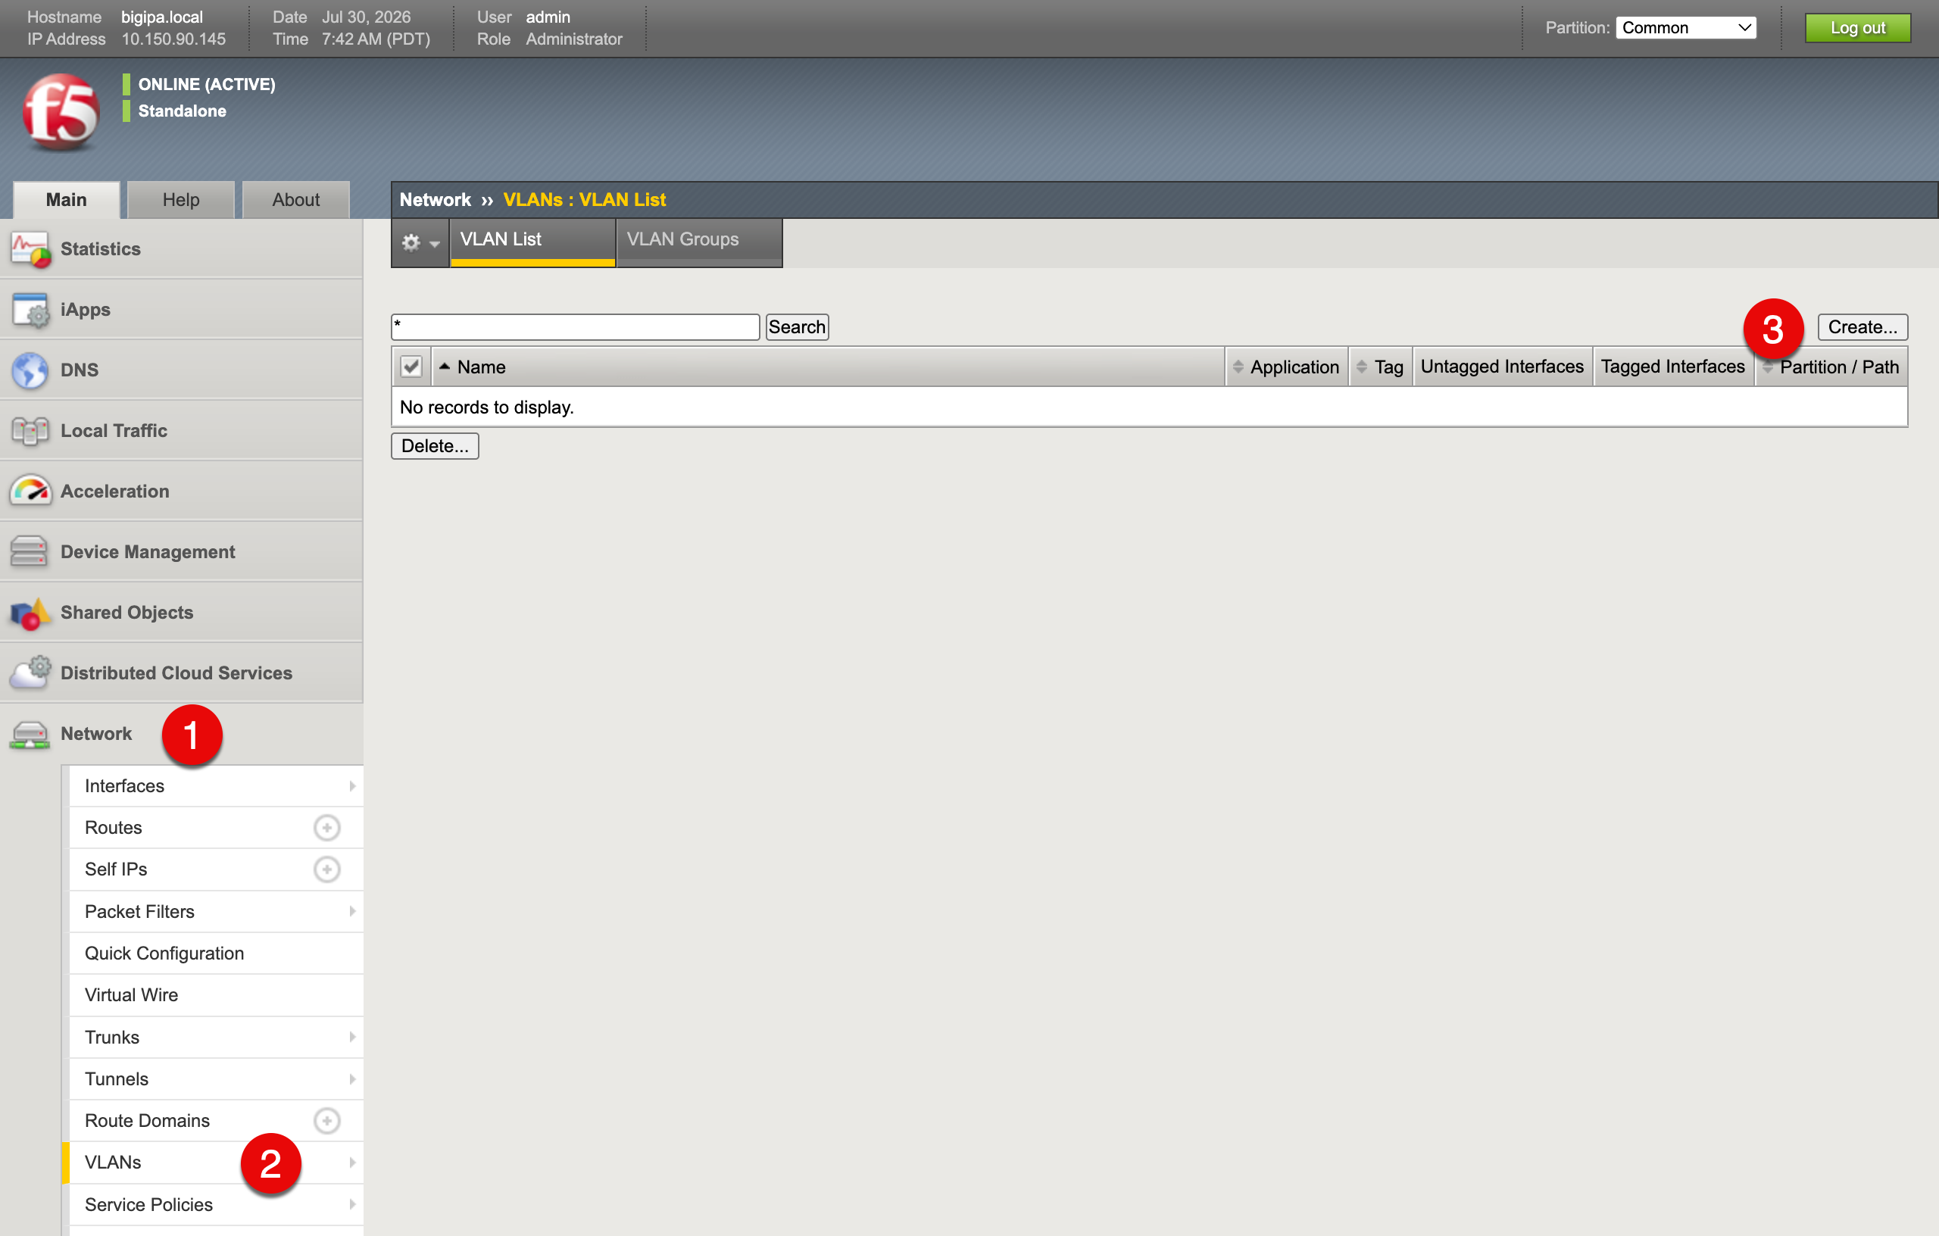
Create the internal VLAN: 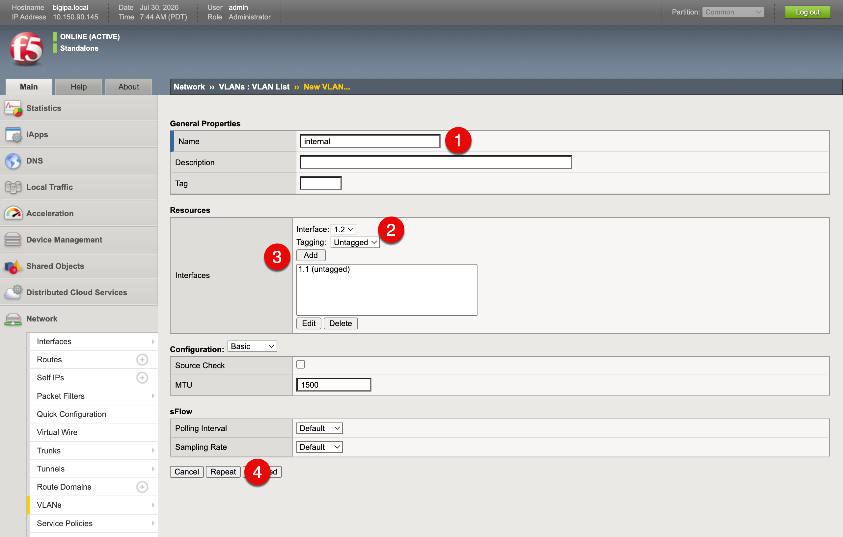
- Name (1): internal
- Interface (2): 1.1
- Tagging (2): Untagged
- Click Add (3)
- Click Repeat (4)
This adds the internal VLAN. Now add the external VLAN in the same window:
- Name: external
- Interface: 1.2
- Tagging: Untagged
- Click Add
- Click Finished
The VLAN list should look like this: 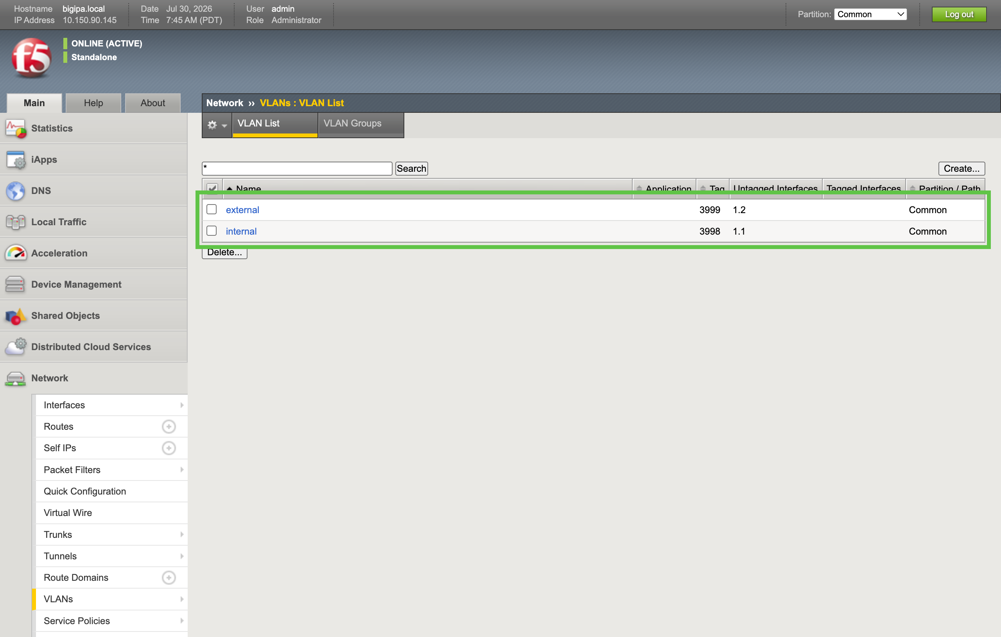

2.2 Configure Self IPs
A Self IP is an IP address assigned to the BIG-IP on a specific VLAN. The BIG-IP uses Self IPs to source traffic and respond to ARP requests. Every VLAN that participates in client or server traffic needs at least one Self IP. Because this lab has two participating VLANs, internal (facing the RING cluster) and external (facing S3 clients), it requires two Self IPs, one per VLAN.
Continue by adding Self IPs that anchor the BIG-IP to each VLAN. In the BIG-IP Configuration utility, go to Network (1) > Self IPs (2) and click Create (3).
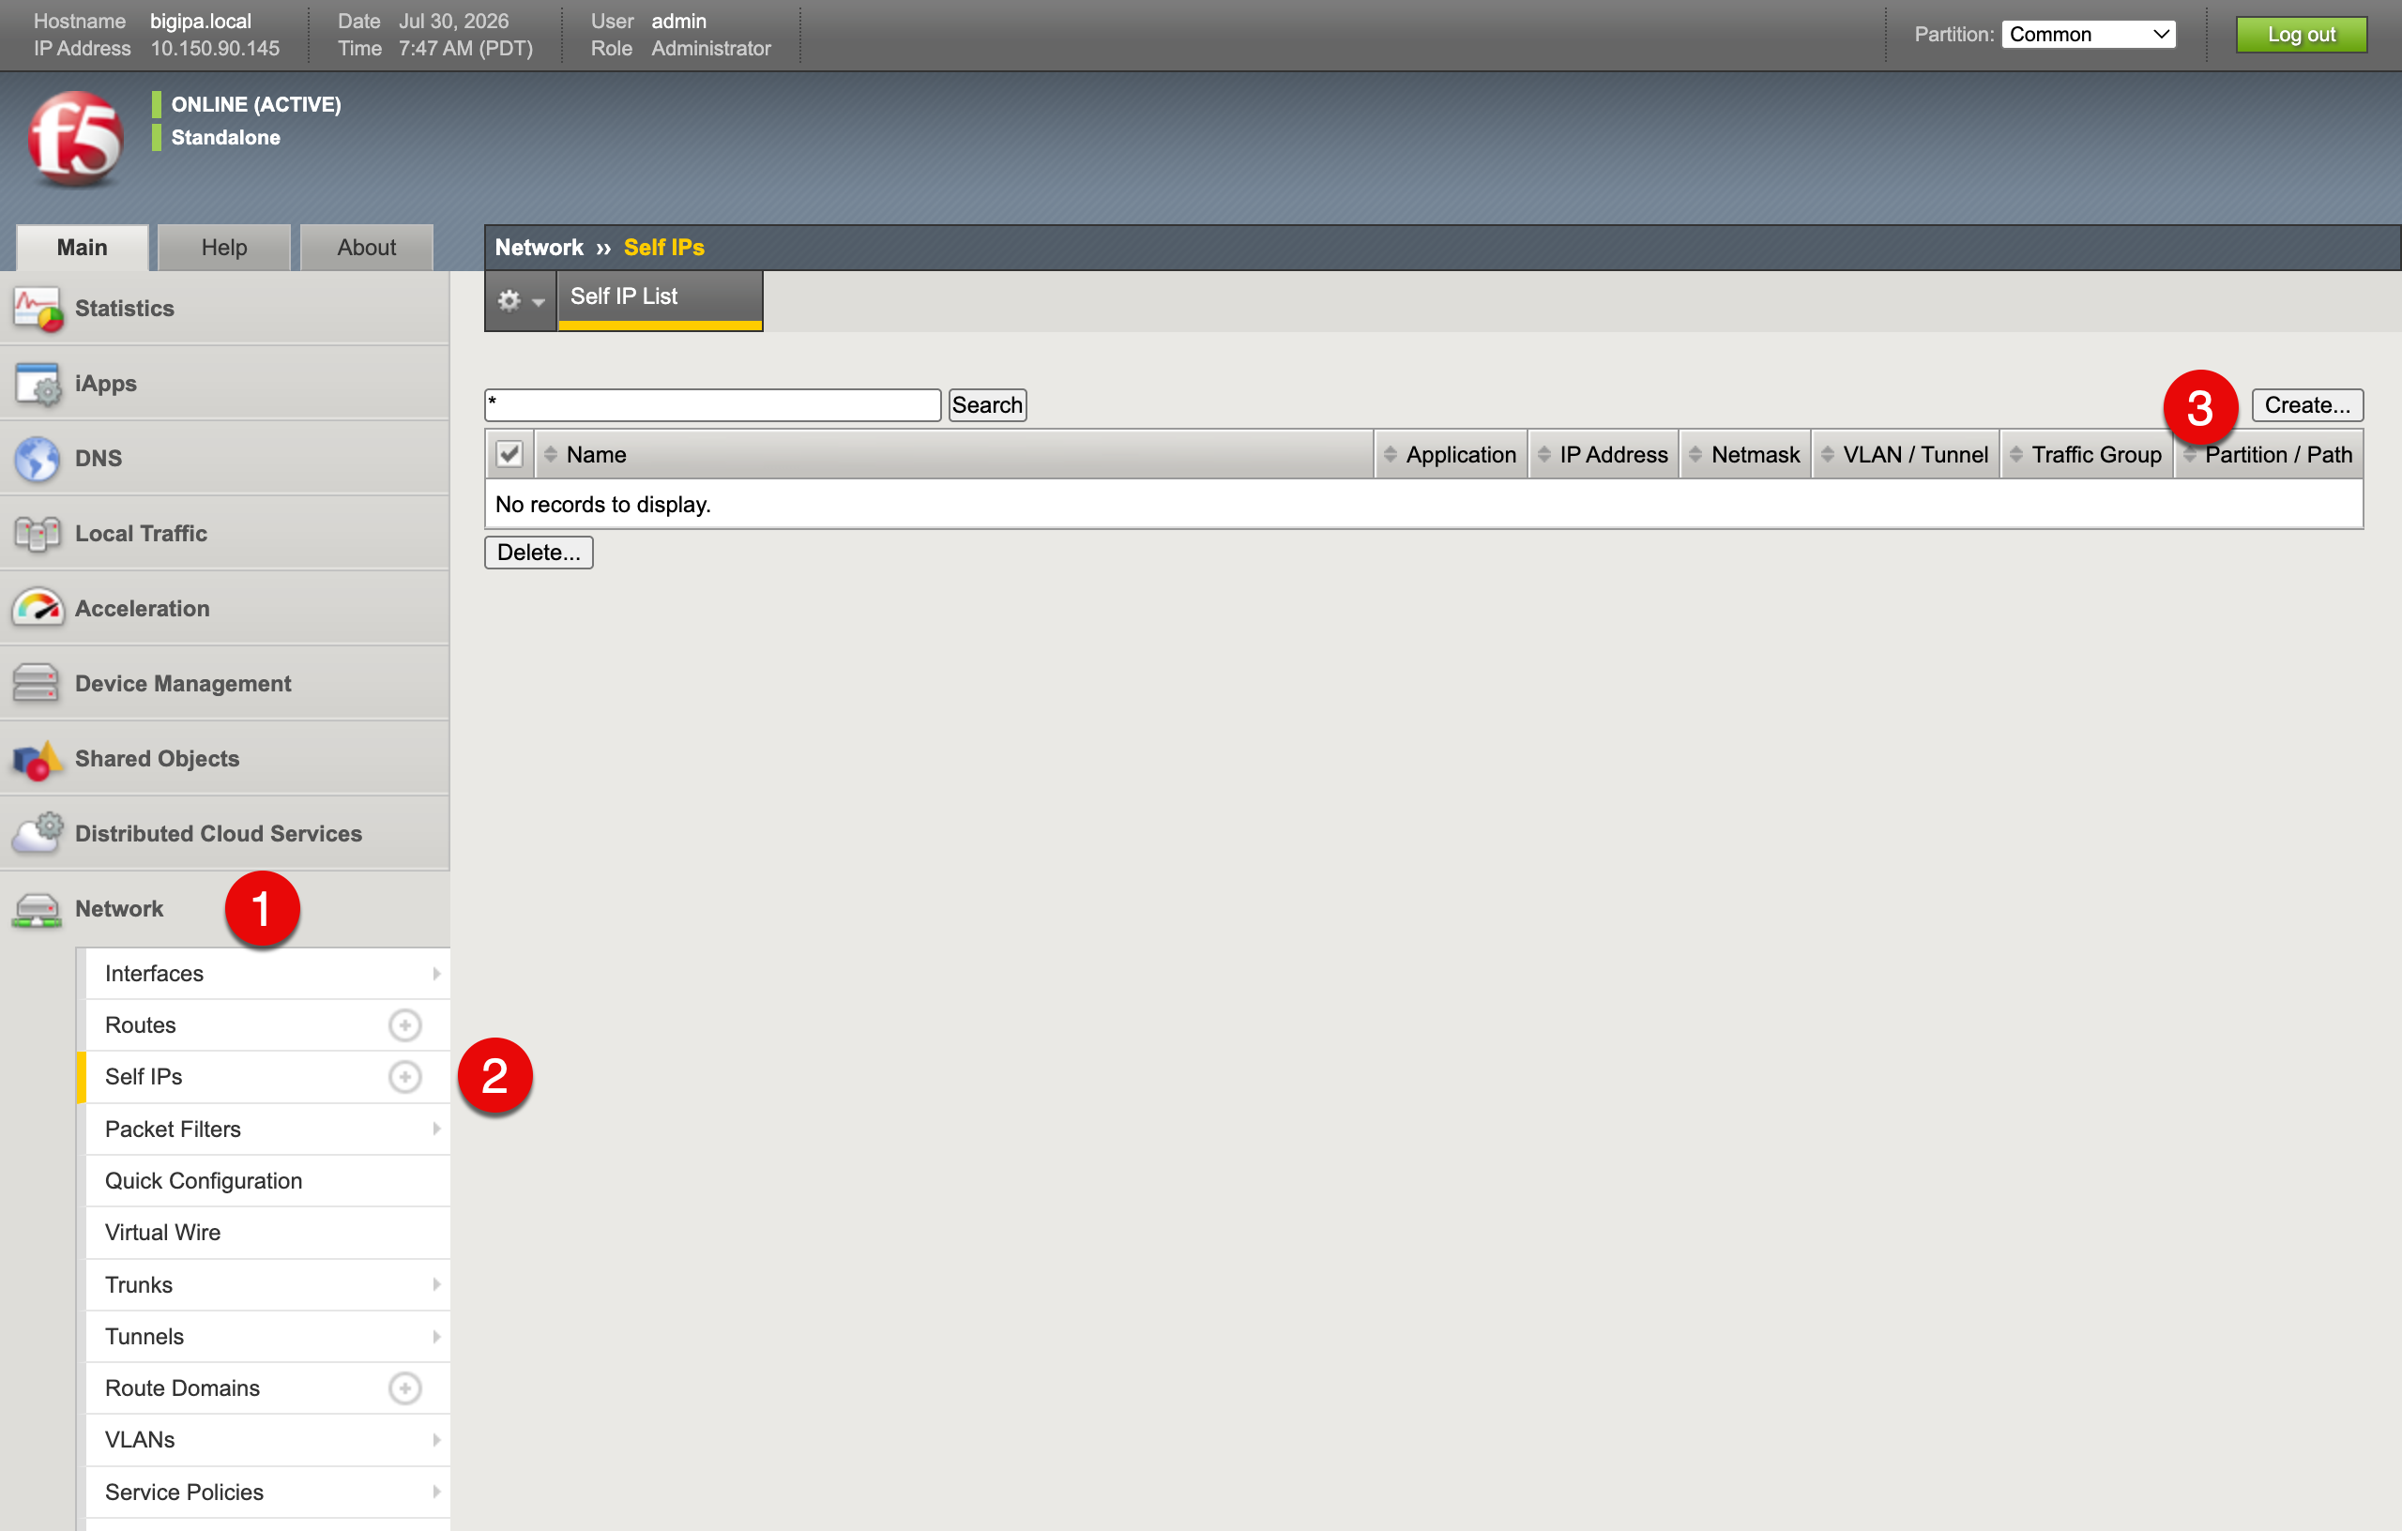
BIG-IP Self IPs list page with the Create button highlighted
First, create a Self IP for the internal network using the following values:
- Name (1): internal_self_ip
- IP Address (2): 10.150.91.145
- Netmask (3): 255.255.255.0
- VLAN (4): internal
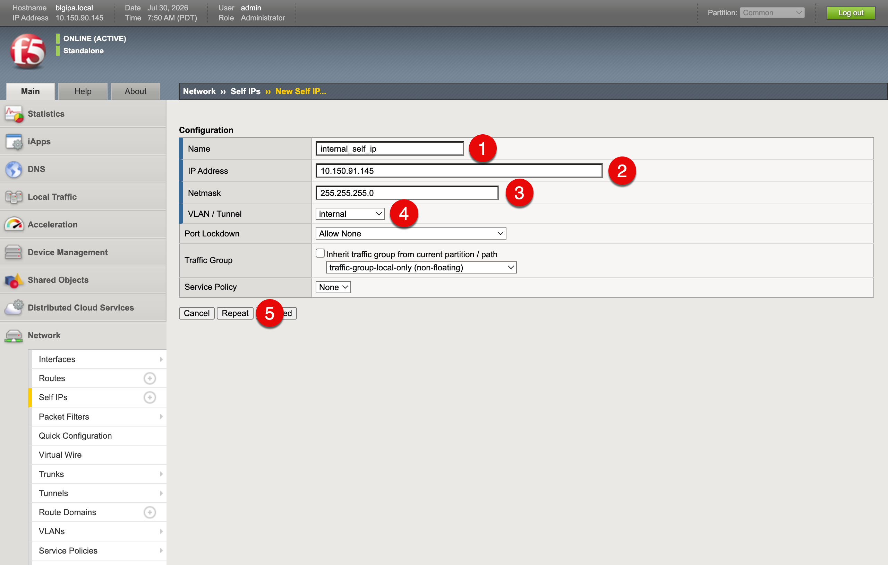
New Self IP form populated with the internal interface values
Click Repeat (5) to save the internal Self IP and open a fresh form for the external one, then fill in the following values:
- Name (1): external_self_ip
- IP Address (2): 10.150.92.145
- Netmask (3): 255.255.255.0
- VLAN (4): external
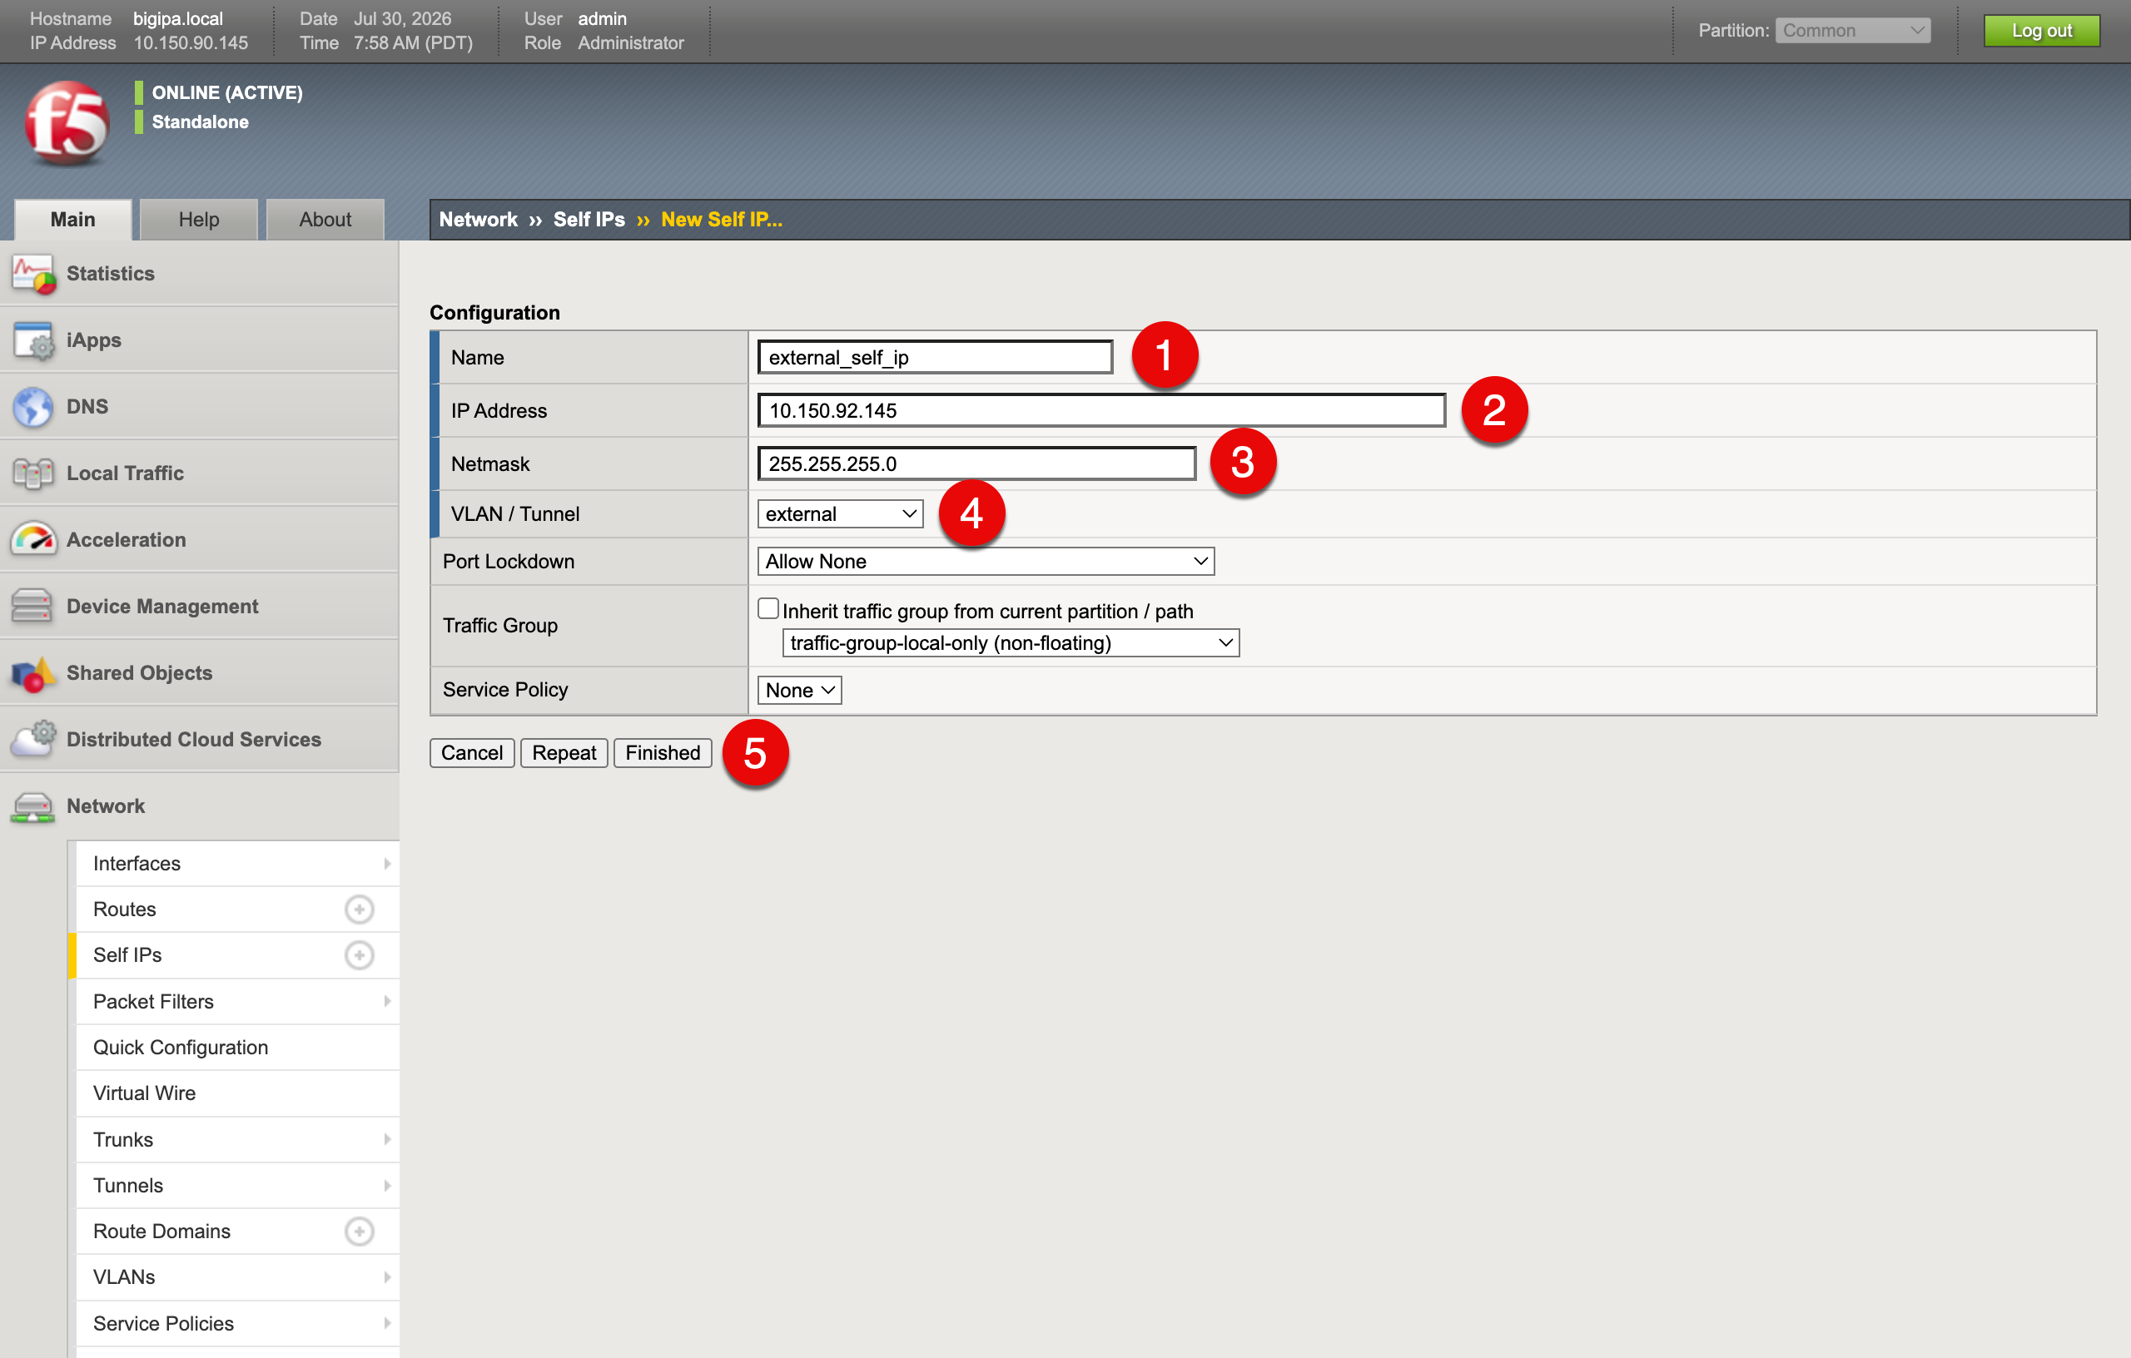
New Self IP form populated with the external interface values
Click Finished (5) to save. Both Self IPs now appear on the list.
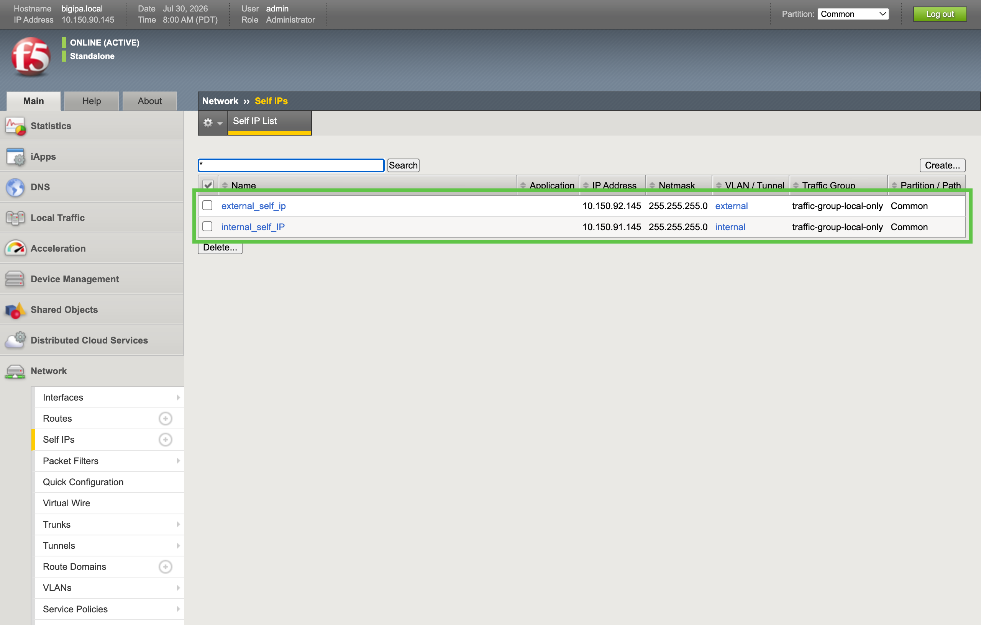
Self IPs list showing both internal and external entries created

2.3 HTTP/HTTPS Custom S3 Health Monitor
To verify that the RING endpoint is reachable, create a custom monitor in BIG-IP. Go to Local Traffic (1) > Monitors (2) and click Create (3). 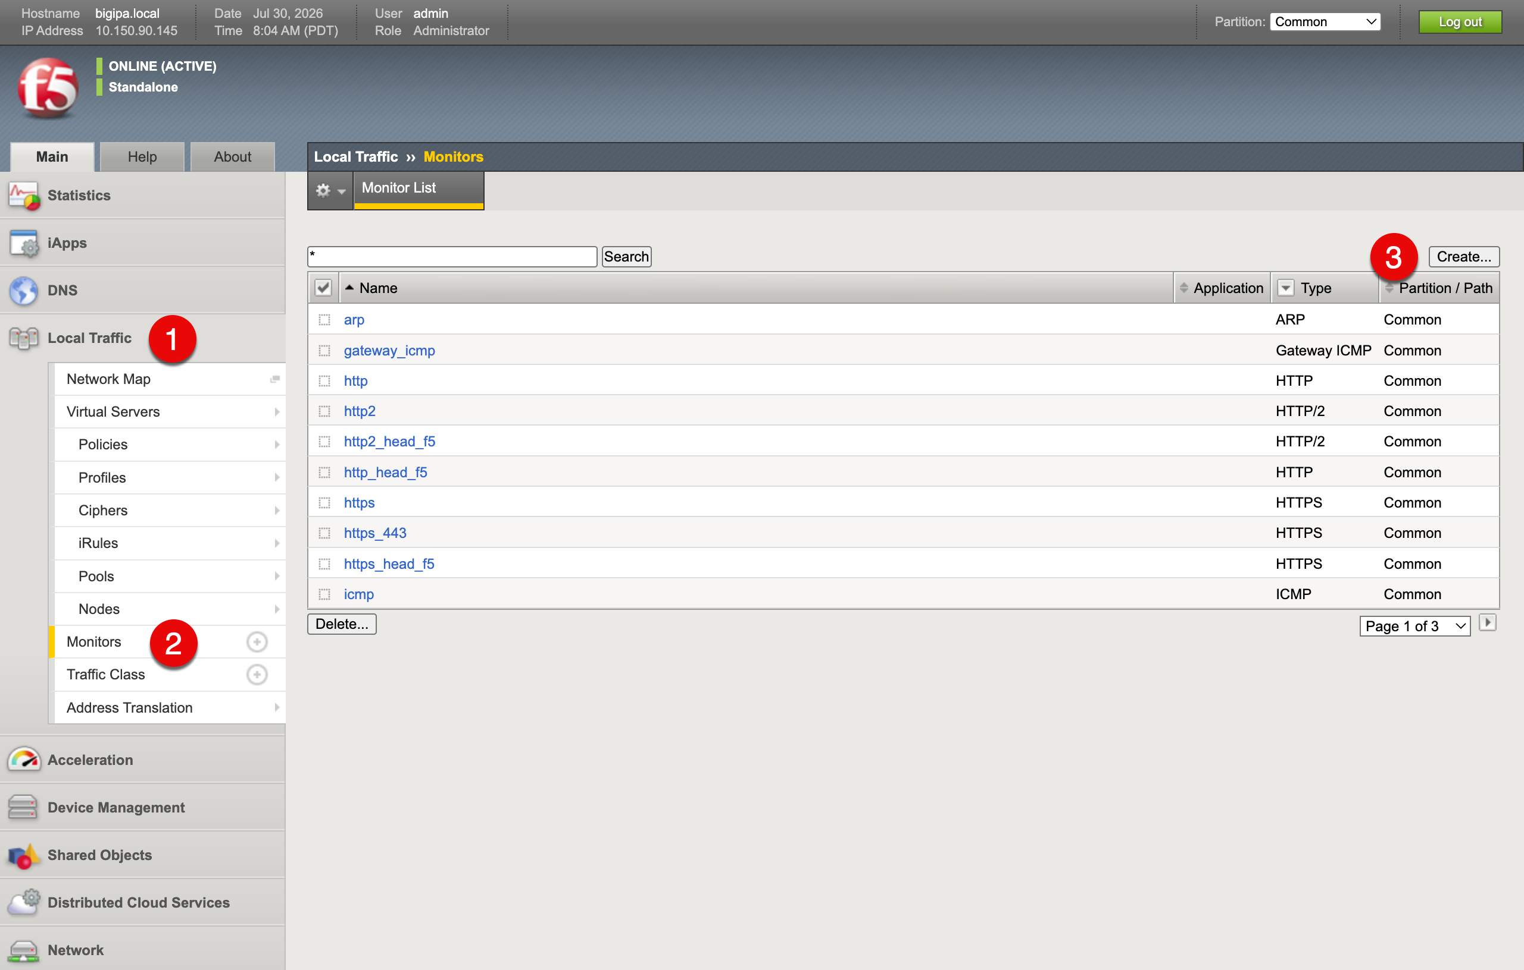
- Type (1): HTTPS or HTTP, depending on how your RING endpoint is configured.
- Name (2): Health_HTTP_RING
- Send String (3): GET /_/healthcheck/deep HTTP/1.1\r\nHost: localhost\r\nConnection: close\r\n\r\n
- Receive String (4): HTTP/1.1 200 OK
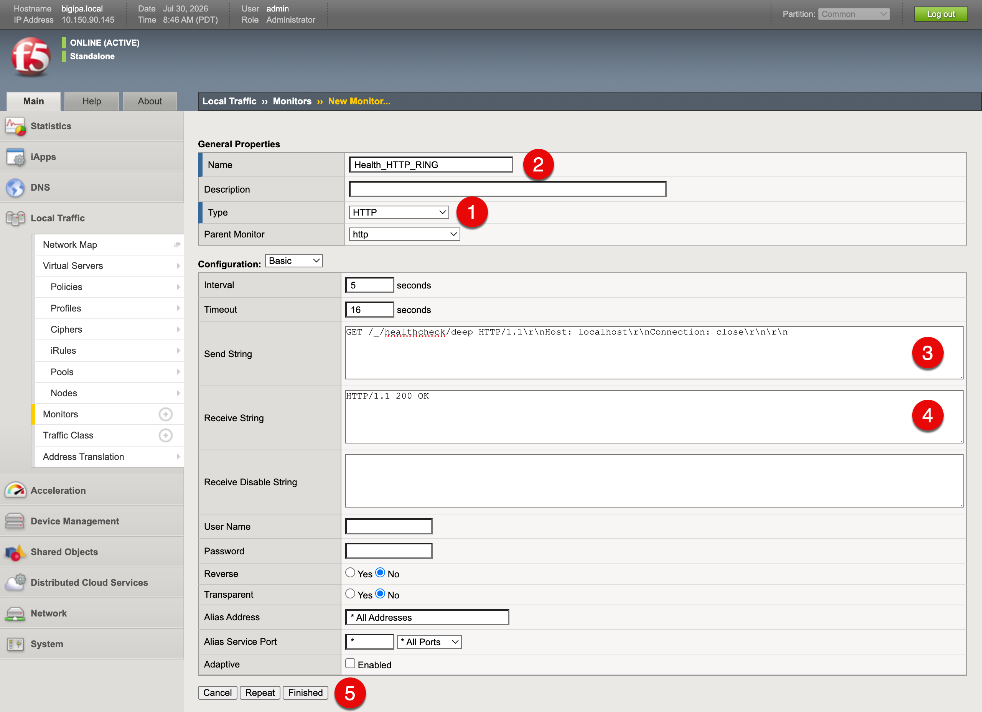
BIG-IP custom monitor form populated with the RING health check values
Click Finished (5) to save the new custom monitor.

2.4 Pool
A pool is a logical group of backend servers, called pool members, across which the BIG-IP load balances traffic. The BIG-IP runs a health monitor against each member and forwards traffic only to members that pass the monitor. In this guide, the pool members are the Scality RING data nodes, and the BIG-IP distributes incoming S3 requests across them.

Lab setup overview showing BIG-IP, RING cluster, and S3 clients
In the diagram above, the blue lines on either side of the BIG-IP represent the two S3 traffic segments. The lines on the left side show traffic between S3 clients and the BIG-IP. The lines on the right side show traffic between the BIG-IP and the Scality RING nodes. Each segment can be unencrypted or encrypted, and you can decide this for each segment independently. Some organizations require storage traffic to be encrypted all the way from the S3 client to the S3 storage node, while others do not.
The pool configuration in this section controls the right-side segment: traffic between the BIG-IP and the Scality RING data nodes. The left-side segment, between the S3 client and the BIG-IP, is controlled by the virtual server (see 2.6 Virtual Server). This guide provides steps for both unencrypted and encrypted options on each segment, so you can choose the combination that meets your organization’s requirements.

2.4.1 Pool for S3 Traffic from BIG-IP to the Scality RING Cluster
Now, define the pool that represents the cluster. Navigate to Local Traffic (1) > Pools (2) and click Create (3).
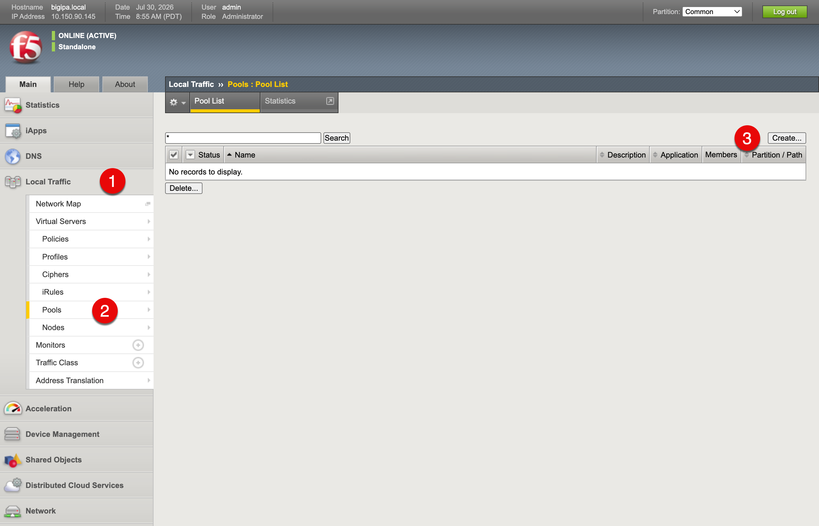
BIG-IP Pools list page with the Create button highlighted
Fill in the pool-level details:
- Name (1): Scality_Pool
- Health Monitor (2): Health_HTTP_RING
- Load Balancing Method (3): Least Connections (member)
The Health_HTTP_RING monitor created earlier sends a GET request to each node’s _/healthcheck/deep URL and marks the node healthy when it receives HTTP/1.1 200 OK.
In the New Members (4) section, add the first RING node:
- Name: StorageNode01
- Address: 10.150.91.141
- Service Port: 80 (the HTTP S3 data service port for the RING cluster; specify 443 for an HTTPS endpoint)
Click Add (4) to save it to the member list. Then enter the next node’s details and click Add (4) again until all nodes are added. In this example, the RING cluster has three nodes, so add all three nodes in the cluster range 10.150.91.106 through 10.150.91.108 before completing the pool. Once every node appears in the member list, click Finished (5).
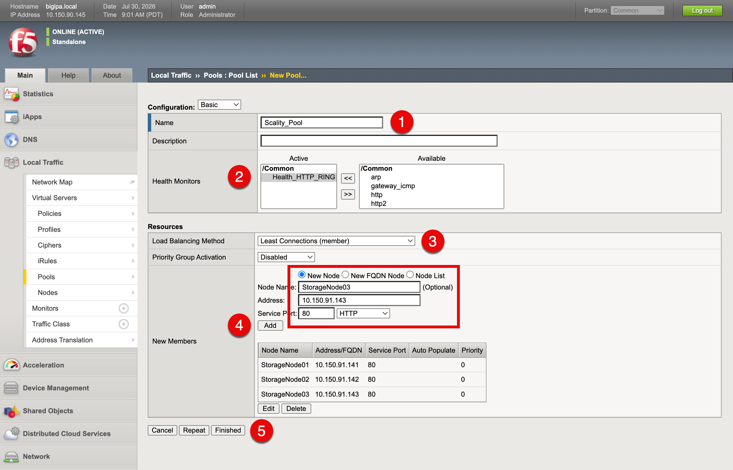
New Pool form with the custom health monitor and RING node members added
The new pool now appears in the Pools list.
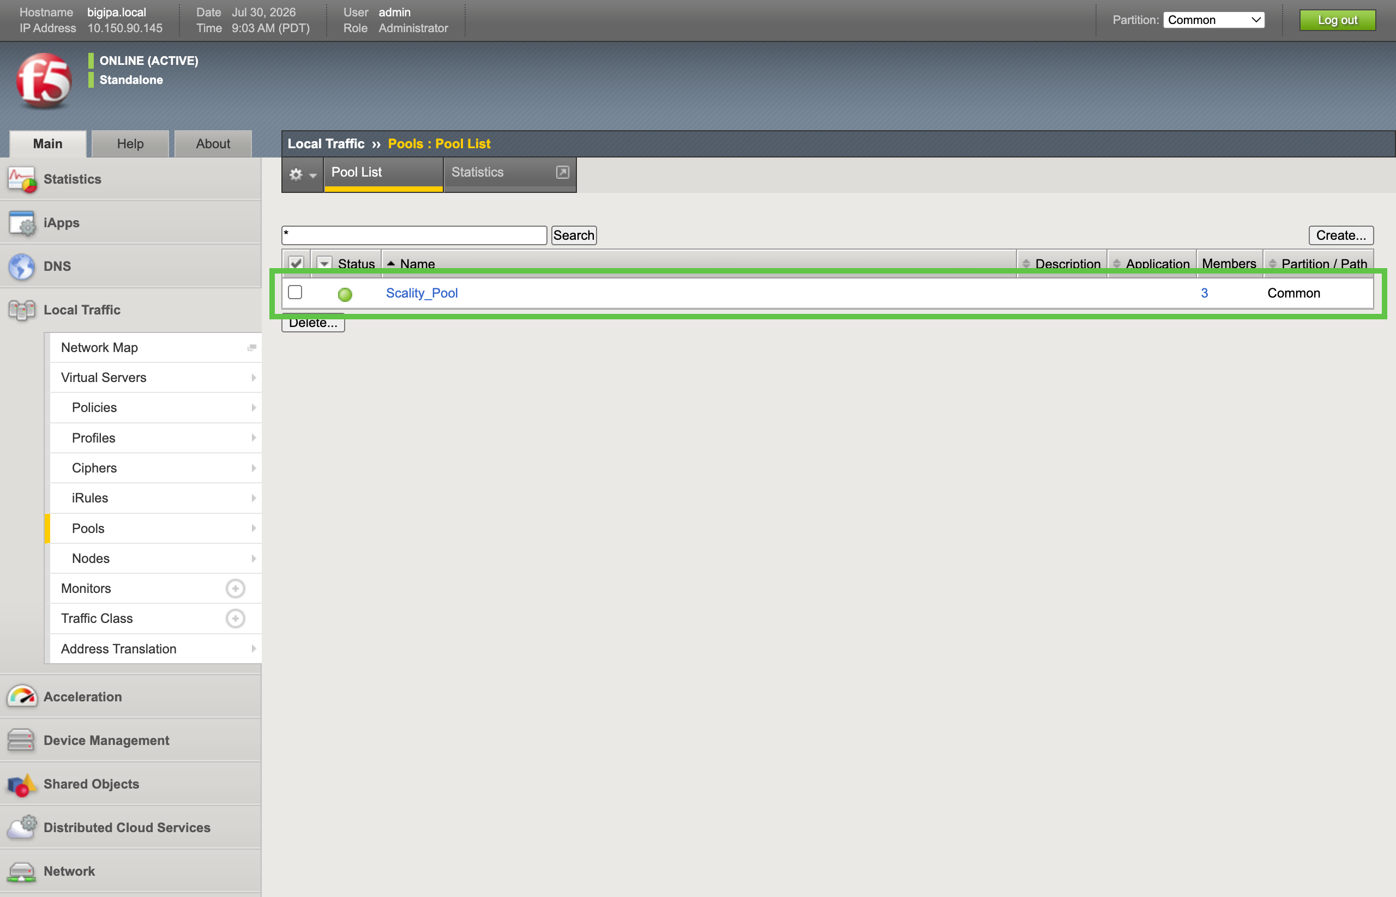
Pools list showing the new ring-cluster pool

2.5 Optimization for S3 Traffic
Tuning the BIG-IP configuration for the specific characteristics of S3 traffic can improve performance and efficiency. This section outlines some of the key optimizations to consider for an S3 workload, including connection limits and TCP profile settings. These optimizations are optional but can help you get the most out of your BIG-IP deployment in front of a Scality RING cluster.

2.5.1 TCP Profiles
A TCP profile controls how the BIG-IP manages TCP connections, such as timers, buffer sizes, and congestion control. The BIG-IP ships with built-in profiles, but the default values are not ideal for RING S3 traffic. For better performance, F5 engineers recommend creating two custom profiles: one for the client side (between the S3 client and the BIG-IP) and one for the server side (between the BIG-IP and the RING nodes). Each side has different needs, so the settings are tuned separately.
The following sections walk through both profiles. Start by navigating to Local Traffic (1) > Profiles (2) > Protocol (3) > TCP (4) and clicking Create (5).
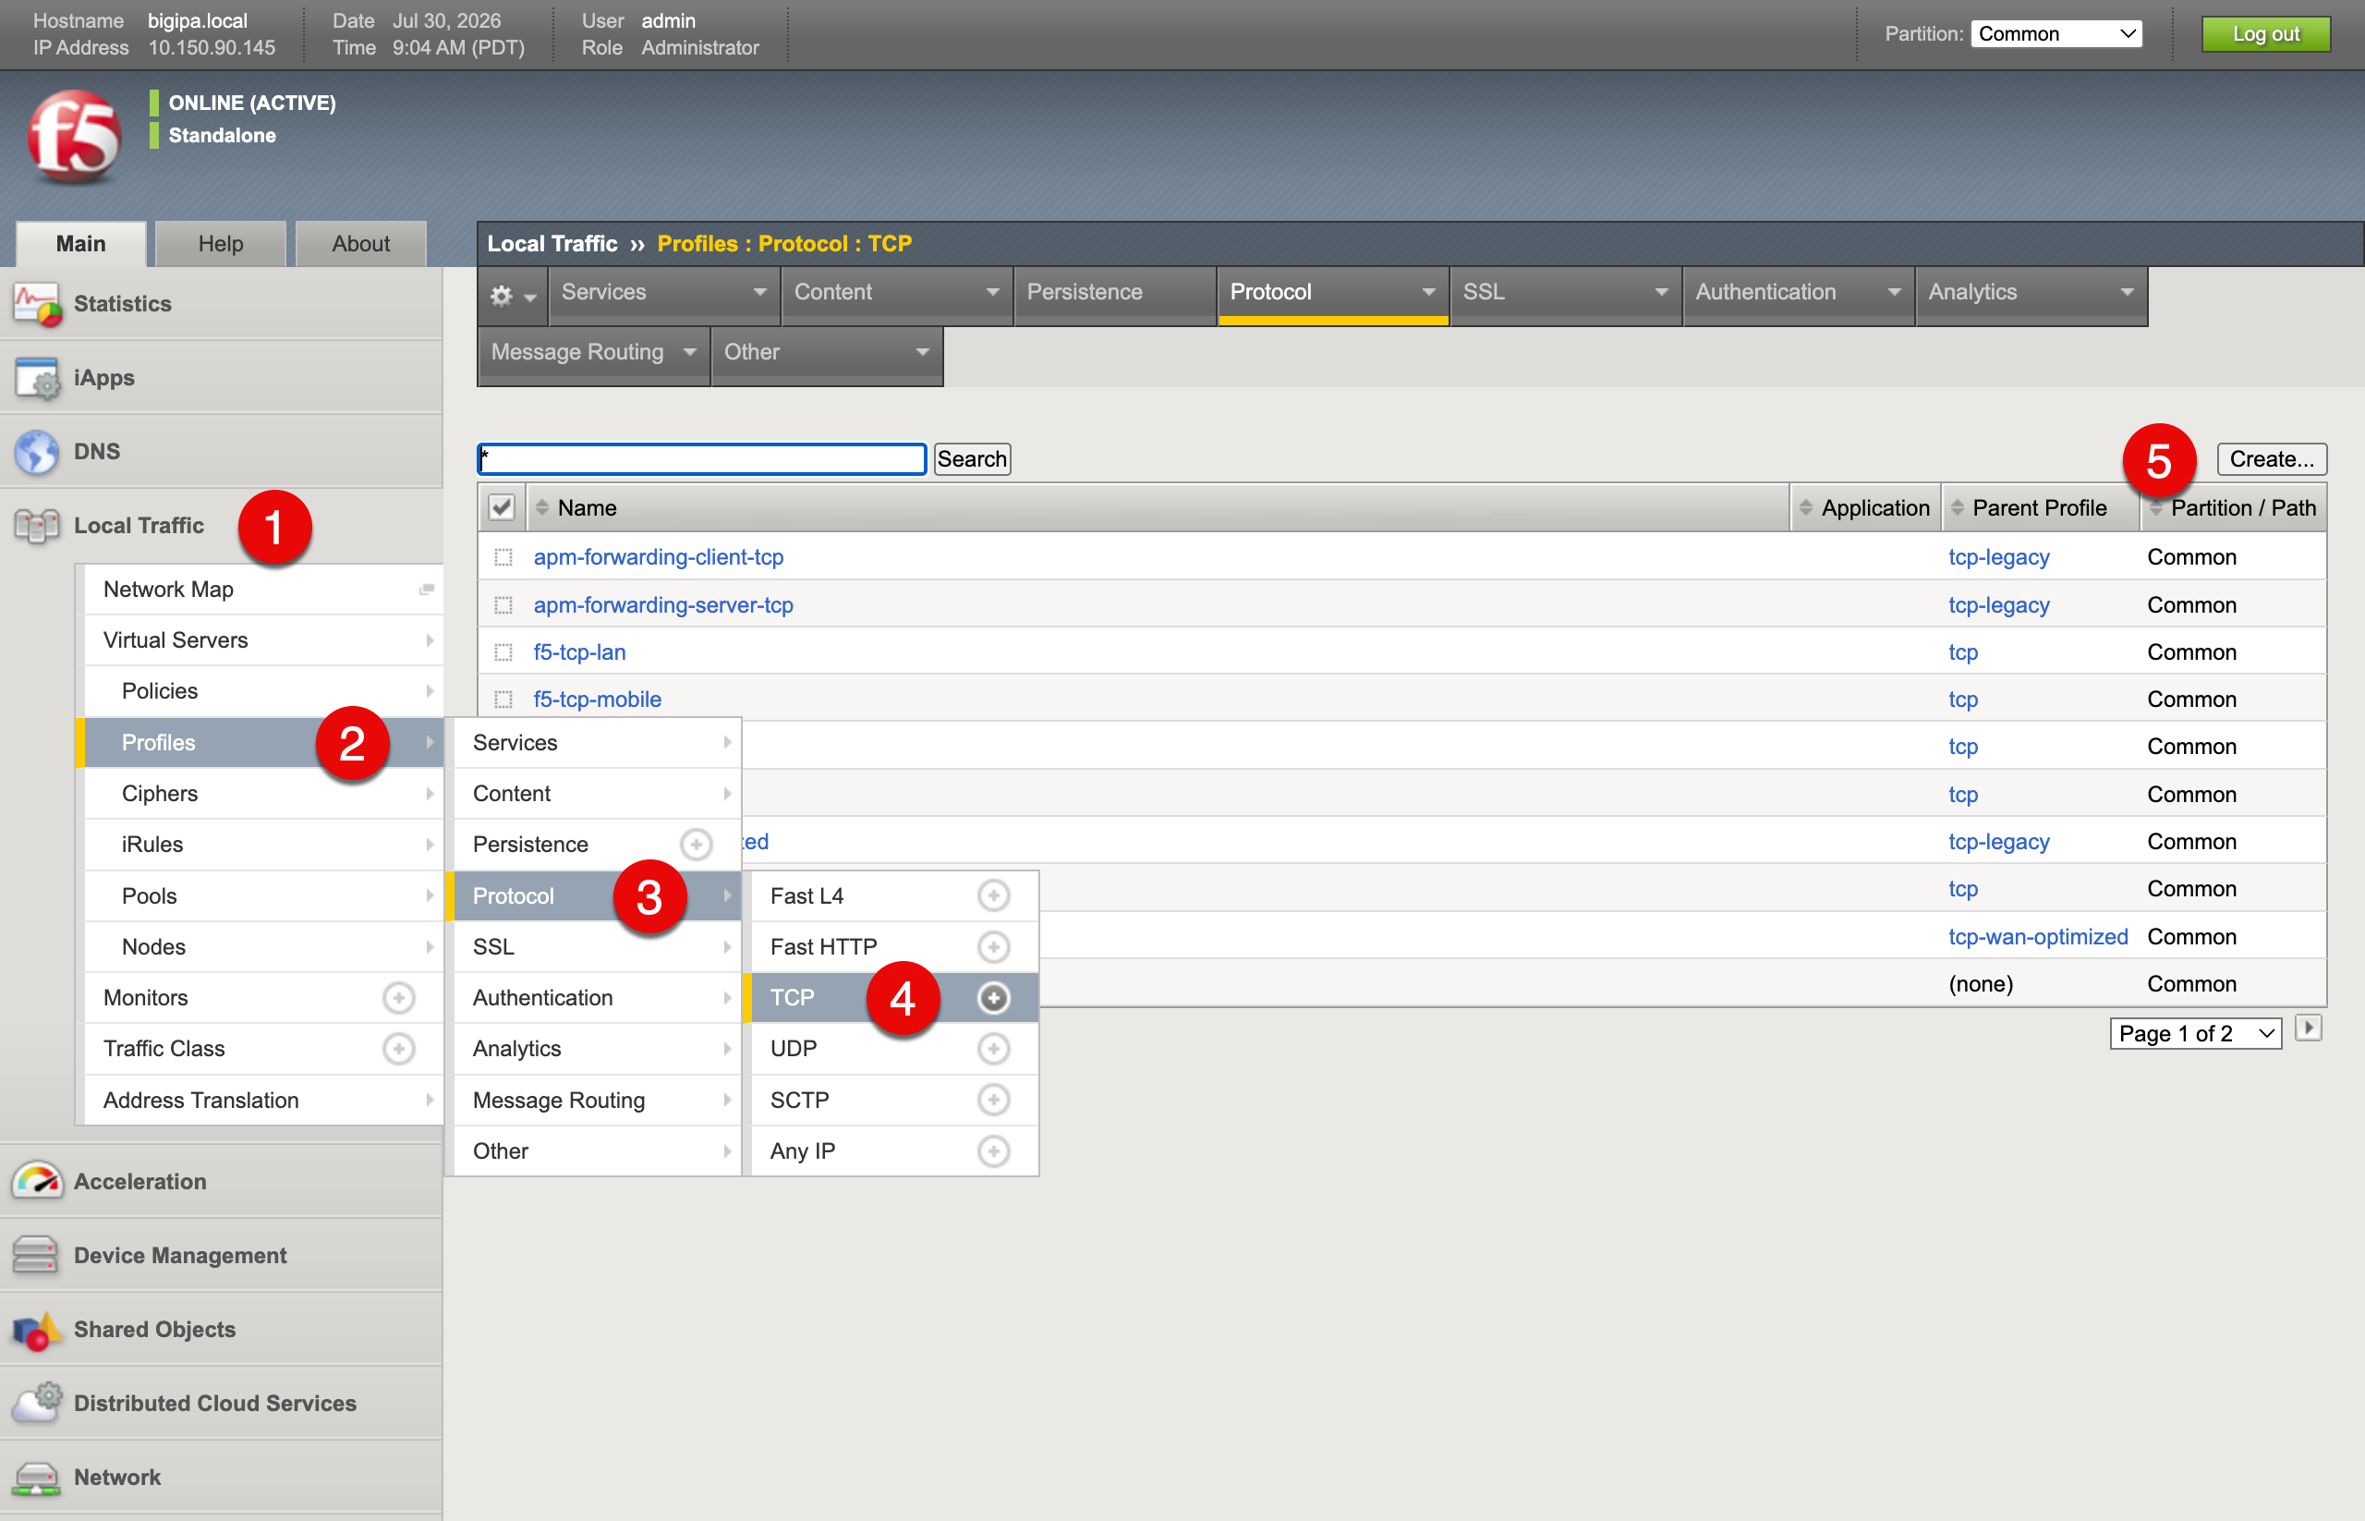
BIG-IP TCP profiles list page with the Create button highlighted

2.5.1.1 Client TCP Profile
Set the Name (1) to s3-tcp-custom-client and set the Parent Profile (2) to s3-tcp. This creates a new TCP profile that inherits all settings from the s3-tcp profile, which is optimized for S3 workloads, and allows you to customize selected values.
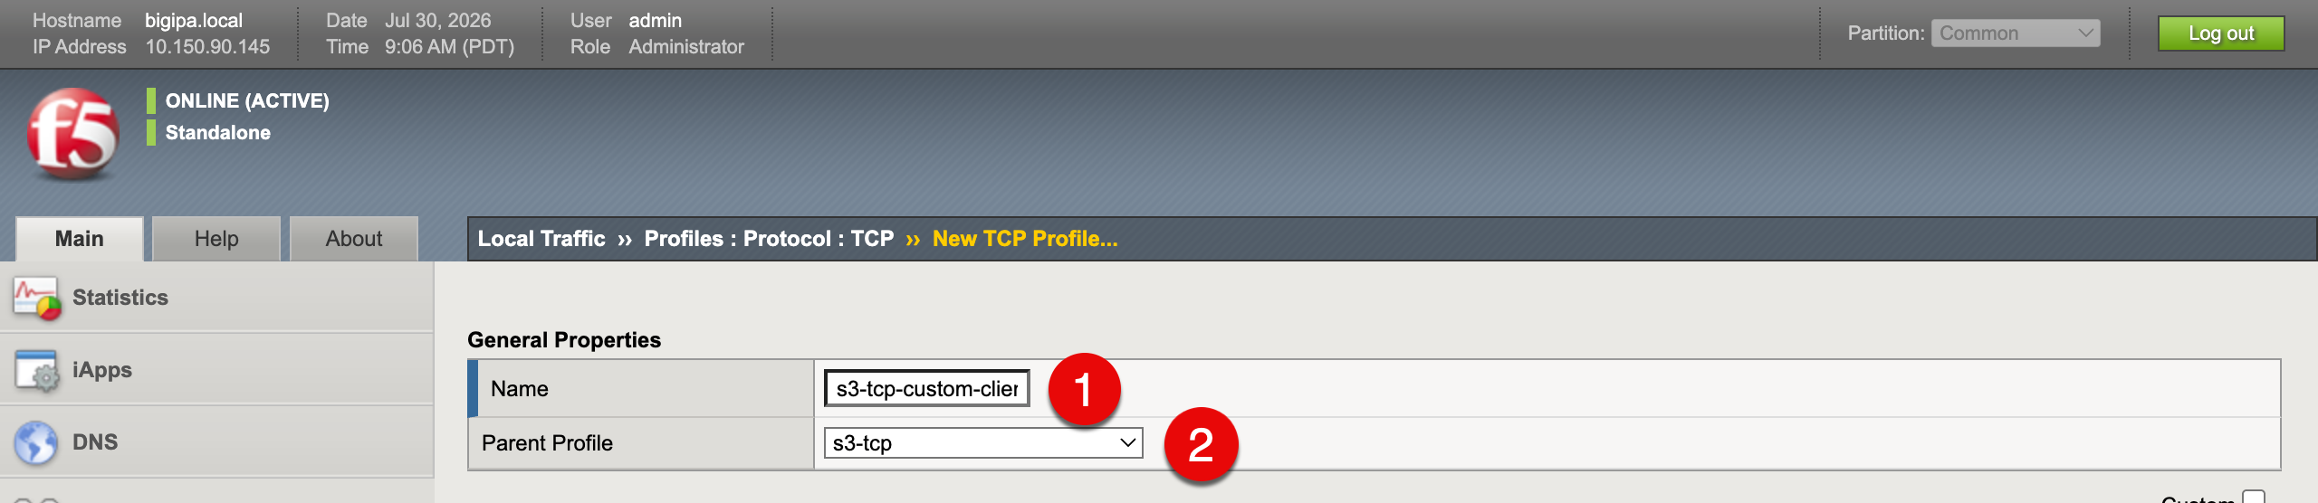
New TCP profile form with the name s3-tcp-custom-client and the s3-tcp parent profile
In the Timer Management section, enable Minimum RTO (1) and set it to 200 milliseconds (2). This reduces the minimum retransmission timeout, which can improve performance for S3 workloads that are sensitive to latency.
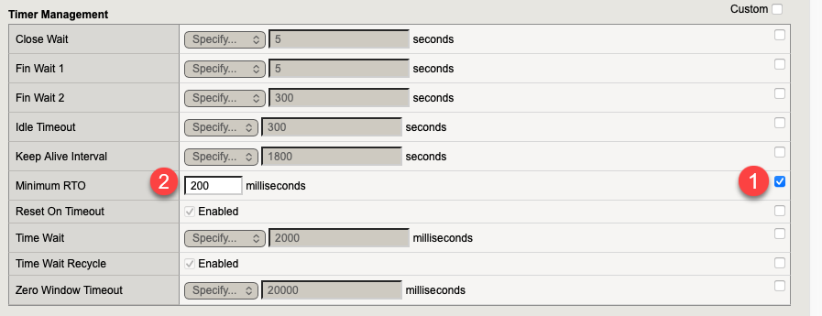
Client TCP profile Timer Management section with Minimum RTO set to 200 milliseconds
In the Data Transfer section, enable Nagle’s Algorithm (1) and set it to Auto (2). This allows the BIG-IP to decide when to enable or disable Nagle’s algorithm based on traffic patterns, which can help optimize throughput for S3 workloads.
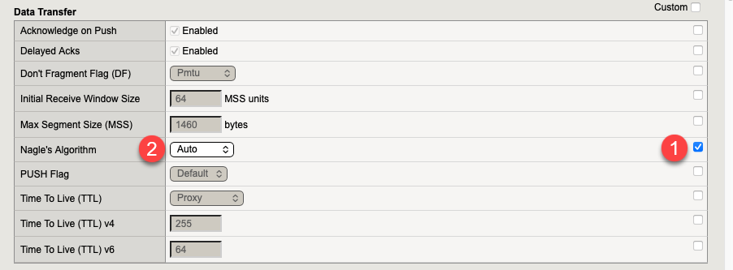
Client TCP profile Data Transfer section with Nagle’s Algorithm set to Auto
In the Congestion Control section, enable Congestion Control (1) and set it to CUBIC (2). CUBIC is a modern congestion control algorithm that can improve performance in high-bandwidth, high-latency networks, which can benefit S3 traffic.
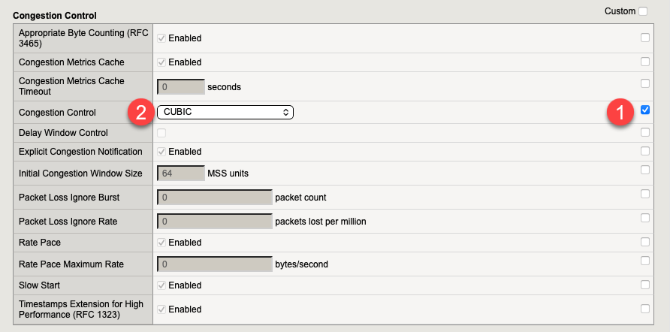
Client TCP profile Congestion Control section set to CUBIC
Click the Finished button at the bottom of the page to save the client’s TCP profile.

2.5.1.2 Server TCP Profile
Create another TCP profile for the server side with the Name (1) s3-tcp-custom-server and the Parent Profile (2) set to f5-tcp-lan.
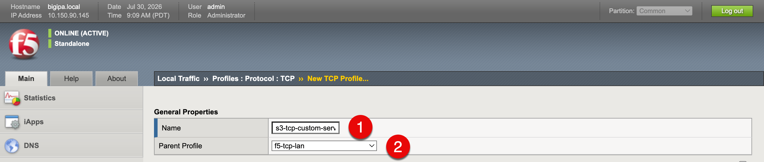
New TCP profile form with the name s3-tcp-custom-server and the f5-tcp-lan parent profile
In the Memory Management section, set the following values:
- Auto Receive Window to Enabled
- Auto Send Buffer to Enabled
- Proxy Buffer High to 5200000 bytes
- Proxy Buffer Low to 5100000 bytes
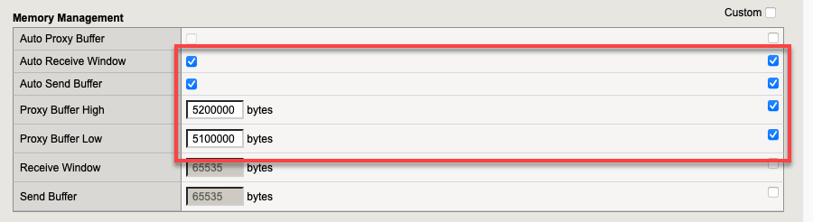
Server TCP profile Memory Management section with the auto window and proxy buffer values set
In the Loss Detection and Recovery section, turn on Tail Loss (1) and set it to Disabled (2).
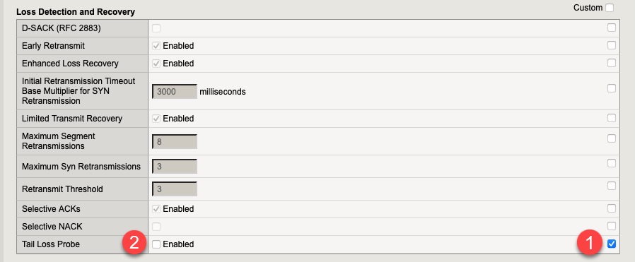
Server TCP profile Loss Detection and Recovery section with Tail Loss disabled
Click Finished at the bottom of the page to save the server’s TCP profile.

2.6 Virtual Server
A virtual server is the listener that clients connect to. It binds an IP address and port on the BIG-IP to a pool, applies any configured profiles and policies, and forwards traffic to a healthy pool member according to the load balancing method. For this S3 deployment, the virtual server is the single endpoint that S3 clients target instead of talking to individual RING nodes.
As shown in the setup diagram in the Pool section, the virtual server controls the left segment of traffic, between the S3 client(s) and the BIG-IP. Like the pool, the virtual server can be configured for unencrypted (HTTP) or encrypted (HTTPS) traffic, and this guide provides the steps for both. The two segments are independent: you can, for example, terminate TLS from clients at the BIG-IP while sending either encrypted or unencrypted traffic onward to the RING cluster.

2.6.1 Virtual Server for S3 Client Traffic to BIG-IP
With the pool in place, create the virtual server that exposes it. Navigate to Local Traffic (1) > Virtual Servers (2) and click Create (3).
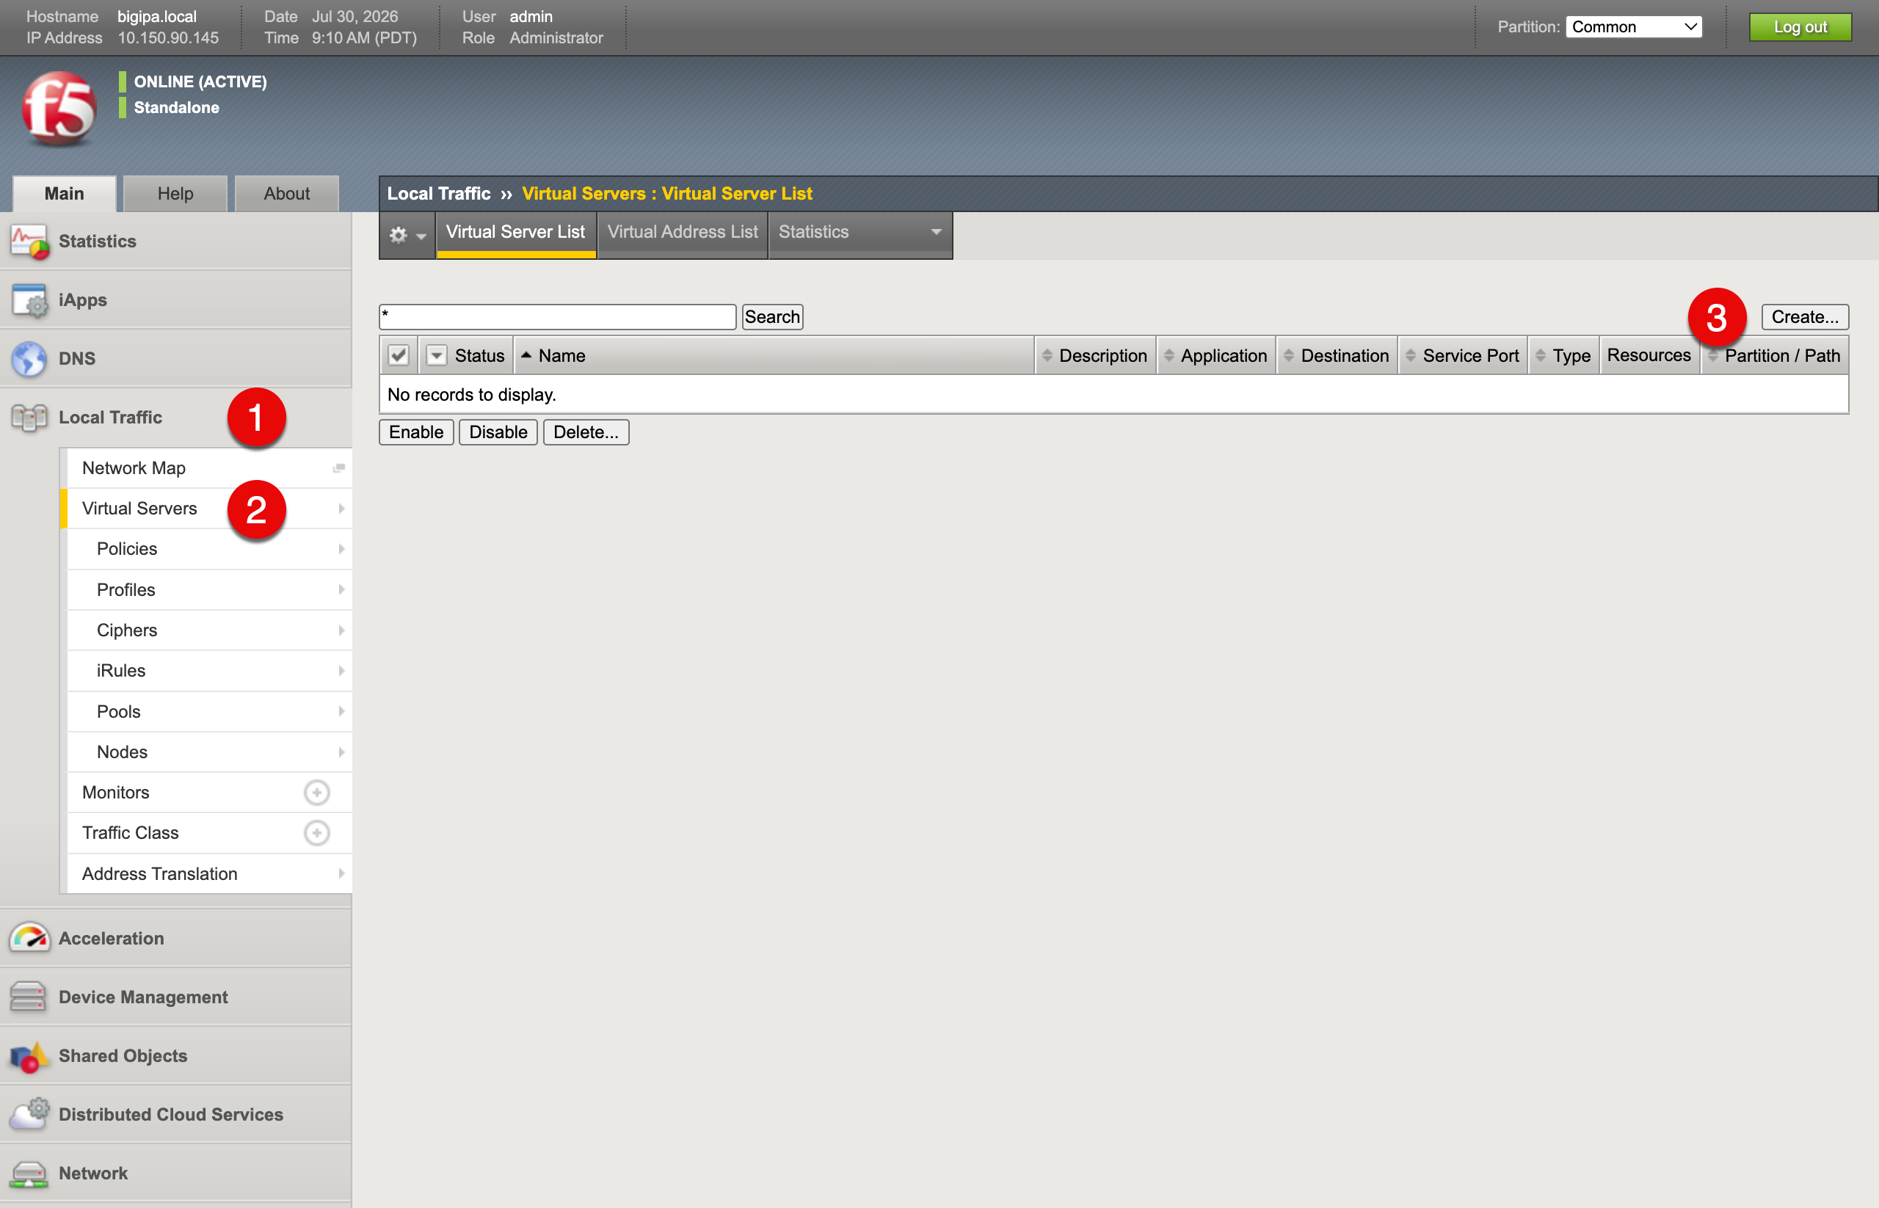
BIG-IP Virtual Servers list page with the Create button highlighted
Fill in the basic details:
- Name (1): RING_Virtual_Server
- Source Address (2): 0.0.0.0/0
- Destination Address/Mask (3): 10.150.92.150 - the virtual IP (VIP) that S3 clients connect to
- Service Port (4): 443 (HTTPS)
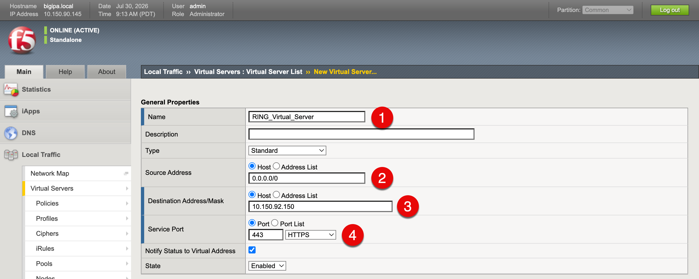
New Virtual Server form with name, destination address, and service port filled in
Next, configure the virtual server details:
- 1. Protocol (1): Set to TCP
- 2. Protocol Profile (Client) (2): Set to the custom client TCP profile you created earlier (s3-tcp-custom-client)
- 3. Protocol Profile (Server) (3): Set to the custom server TCP profile you created earlier (s3-tcp-custom-server)
- 4. HTTP Client Profile (4): Set to HTTP
- 5. SSL Profile (Client) (5): Set to the default client SSL profile (clientssl). Skip this if you want to use unencrypted HTTP between S3 clients and the BIG-IP.
- 6. SSL Profile (Server) (6): Set to the default server SSL profile (serverssl) if your RING cluster serves encrypted S3 traffic. Skip this if it serves only HTTP on port 80.
- 7. Source Address Translation (7): Set to Auto Map to allow the BIG-IP to manage source address translation for return traffic.
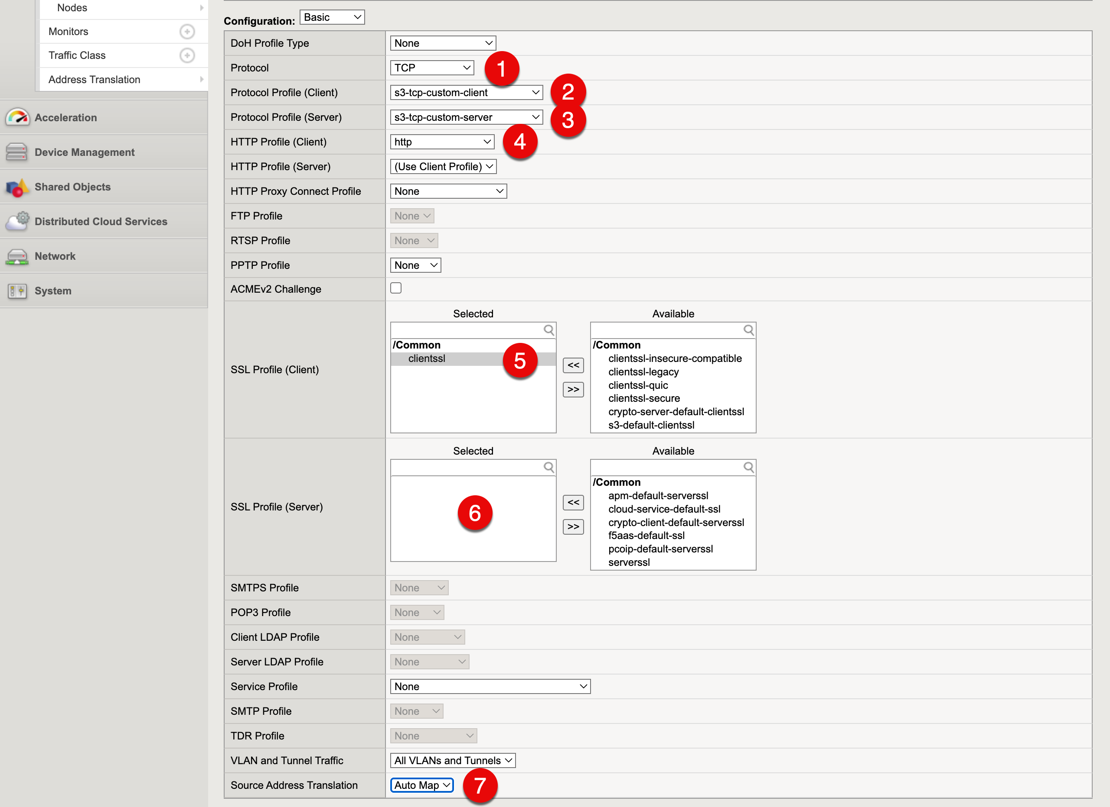
Virtual Server form with Source Address Translation set to Auto Map
In the Resources section, select the Scality_Pool pool from the Default Pool (1) dropdown to bind the virtual server to the backend nodes.
Click Finished (2) to save the virtual server. 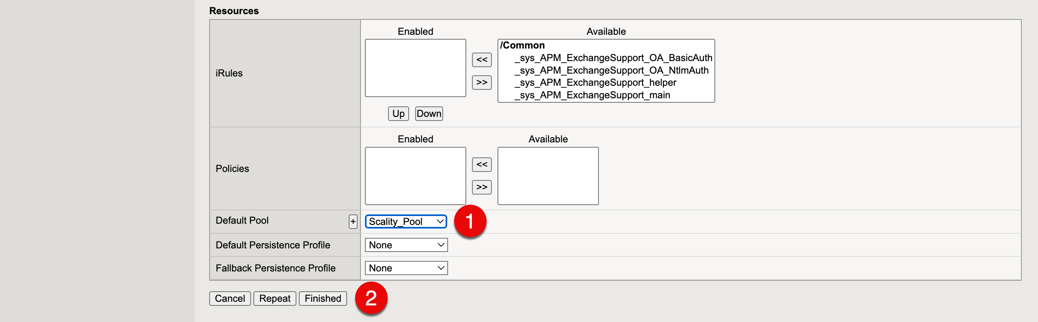
The virtual server now appears in the list. A green circle next to its name indicates that the virtual server is up and at least one pool member is passing health checks.
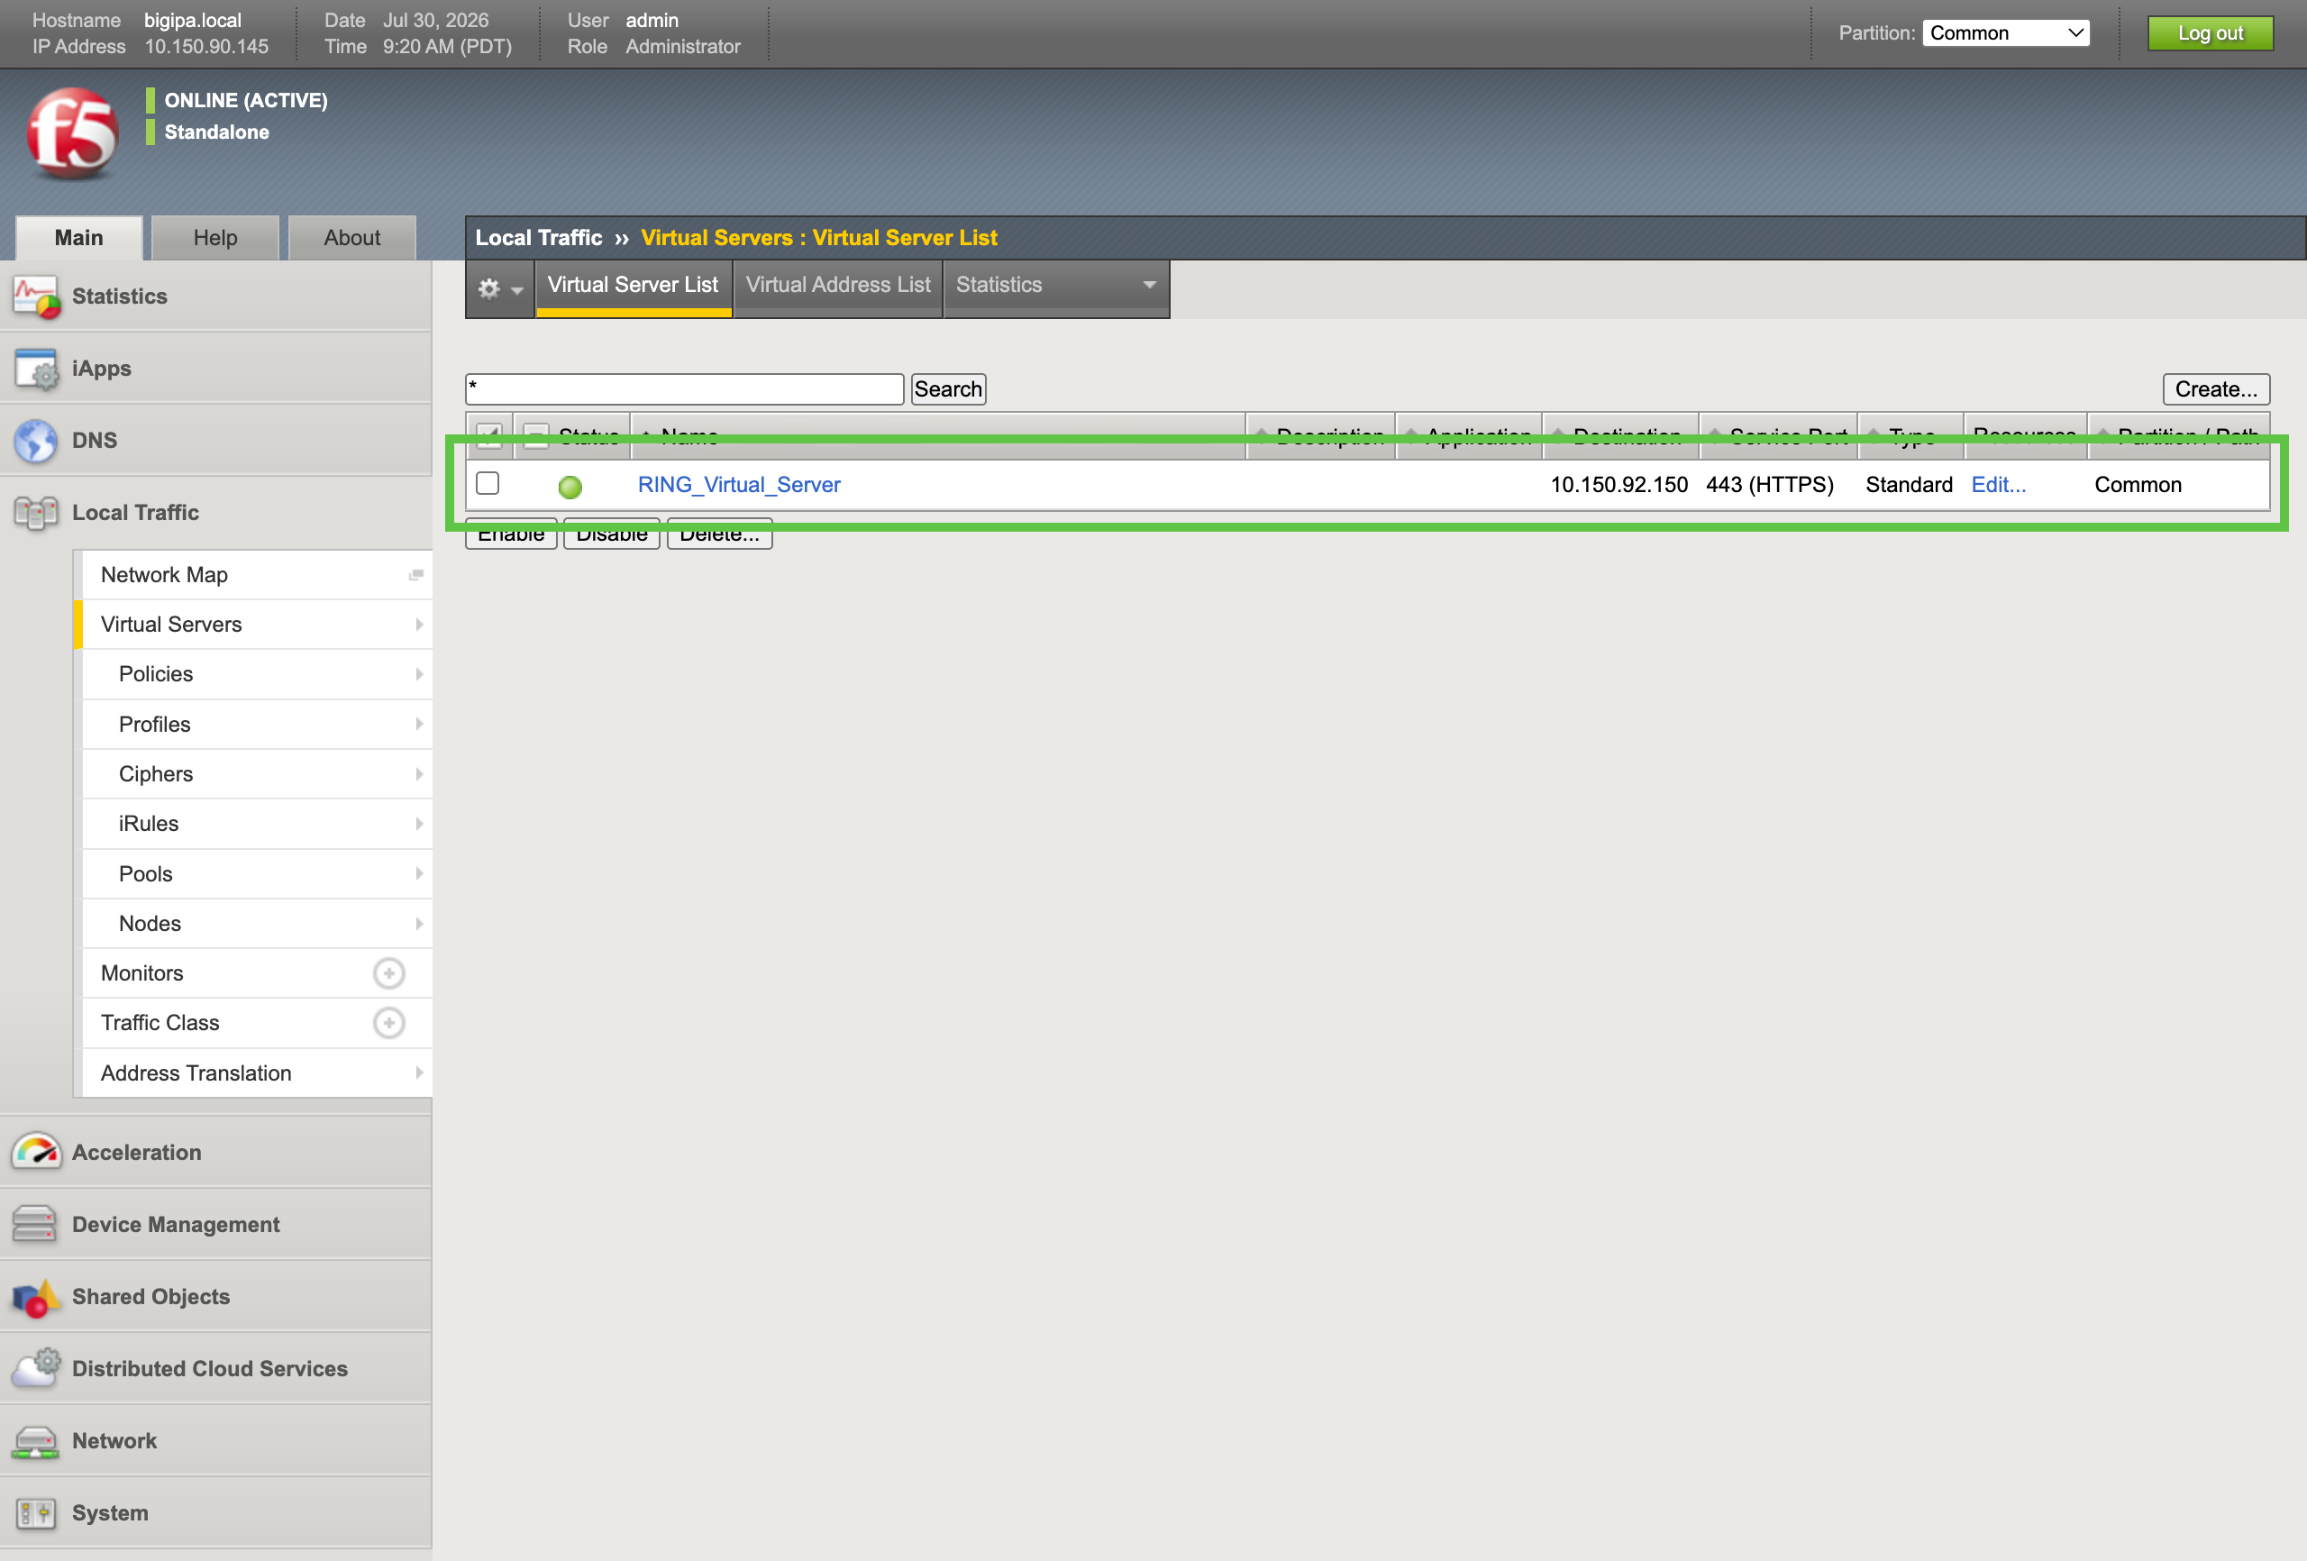
Virtual Servers list showing ring-cluster-vs with a green available status

2.7 Test the Virtual Server
With the virtual server up and at least one healthy pool member, validate that S3 traffic flows end to end through the BIG-IP.

2.7.1 Configure the RING Cluster
Before you test traffic, create an S3 bucket, a user, and an access key in the Scality RING cluster. After logging in, click S3 Services.
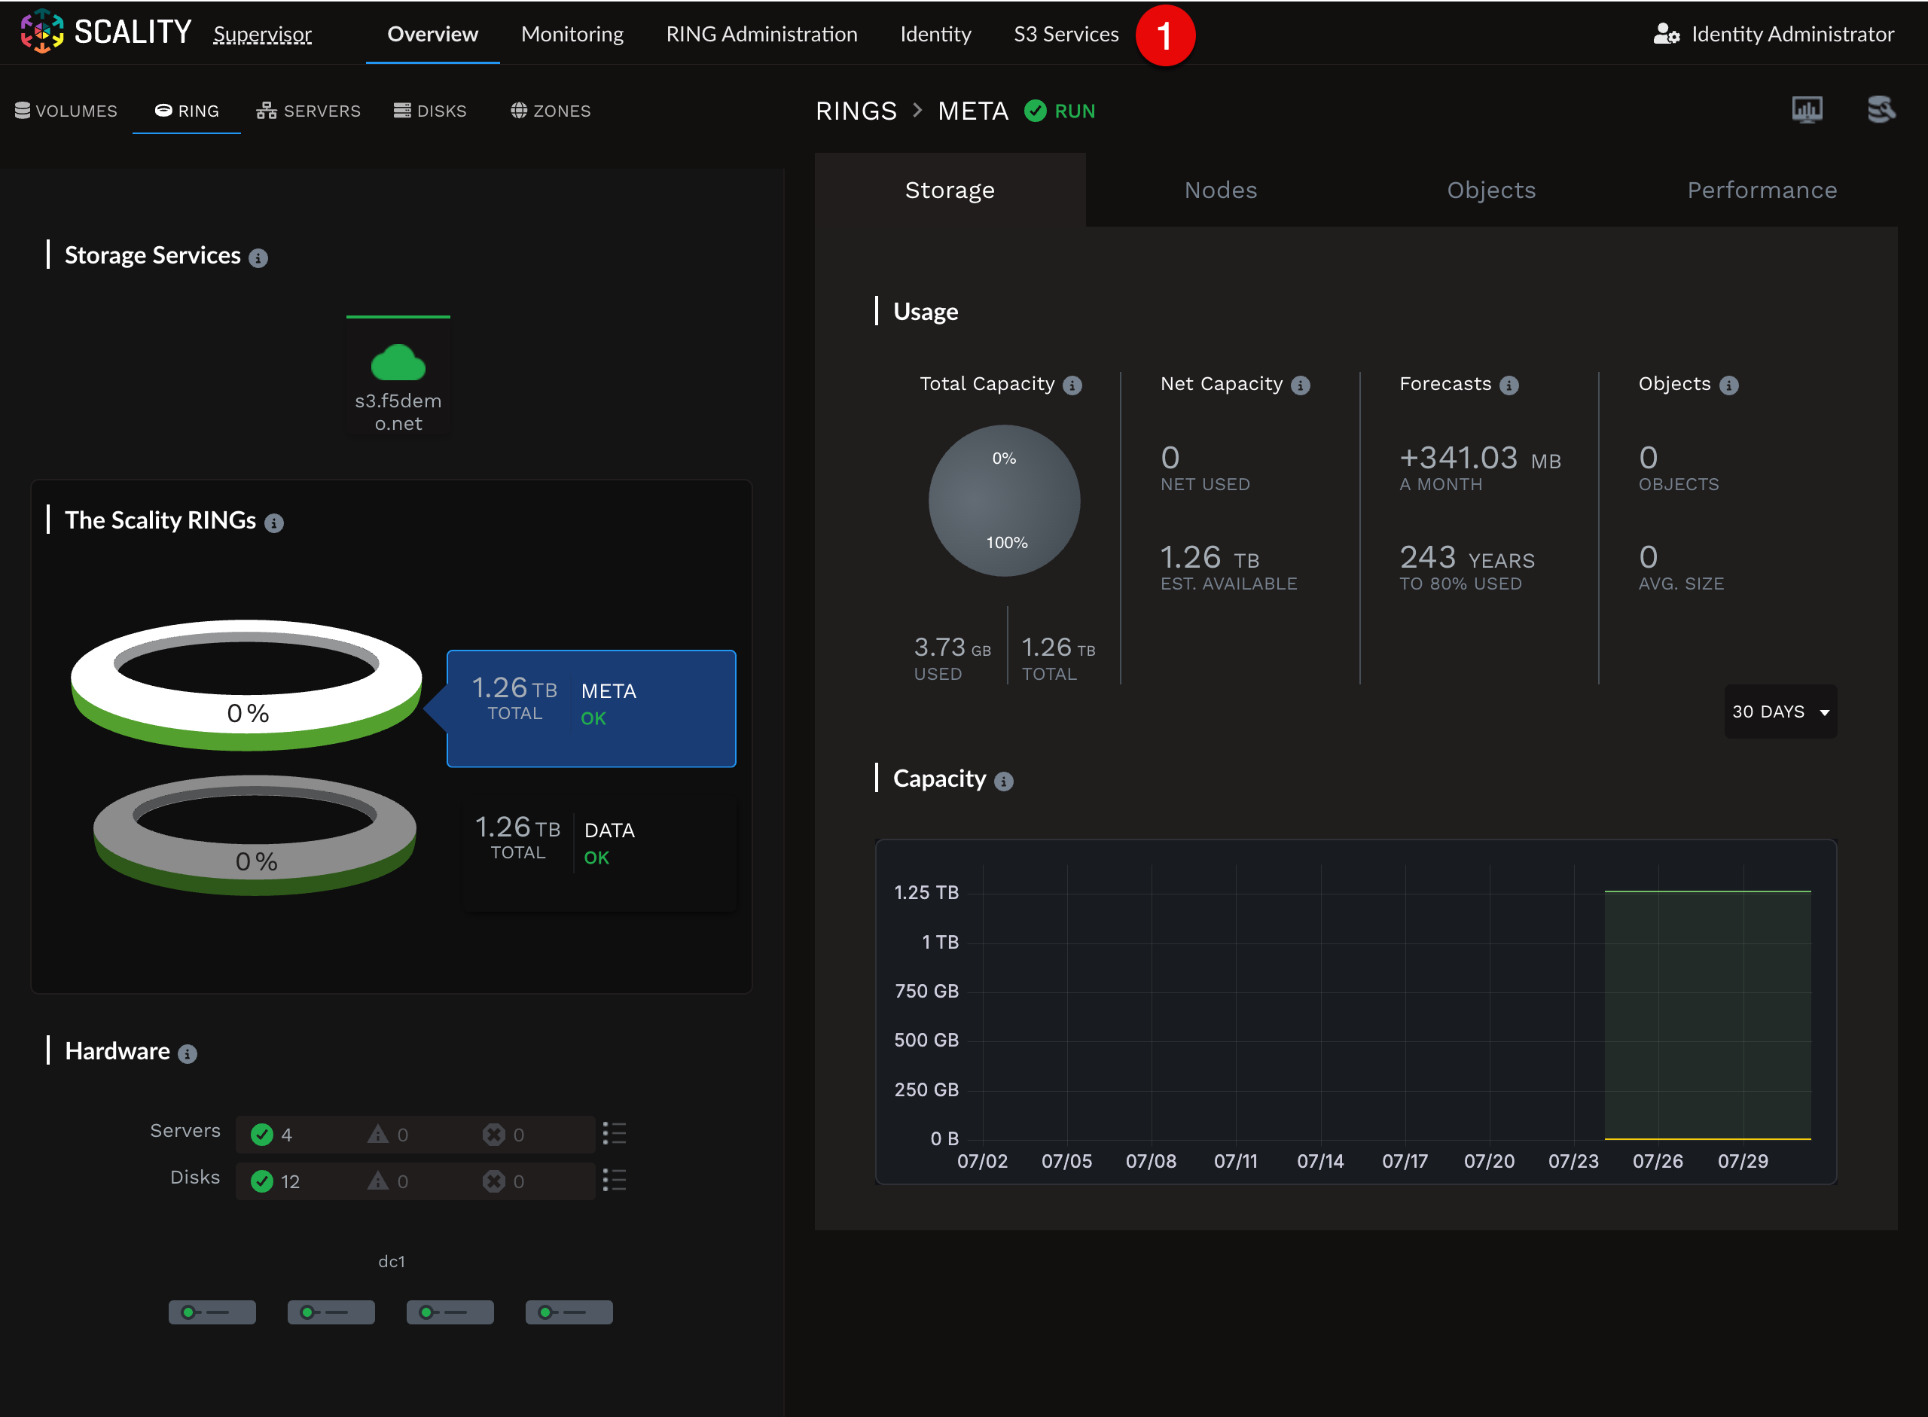
RING Dashboard

2.7.1.1 Create Account
The S3 Services page provides access to Scality UI services. To create a user, bucket, access key, and secret key, use the S3 Console. Click the Log in (1) button. 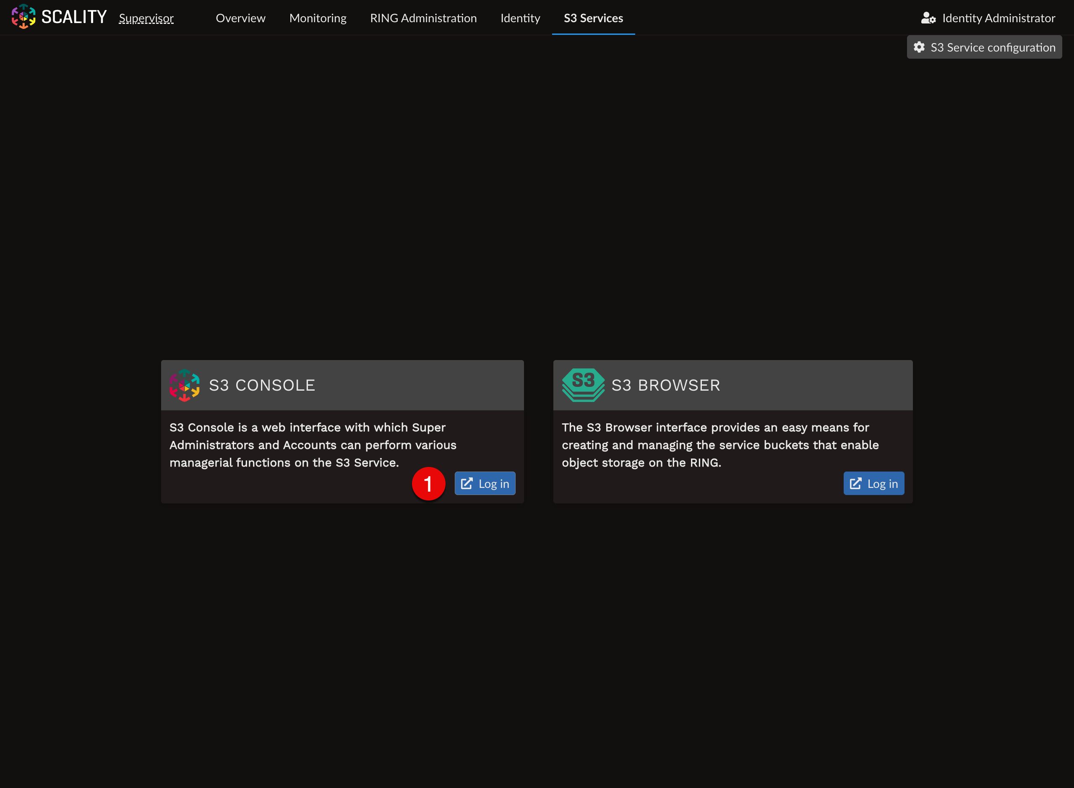
To create a test user, click the Create account (1) button on the Accounts page. 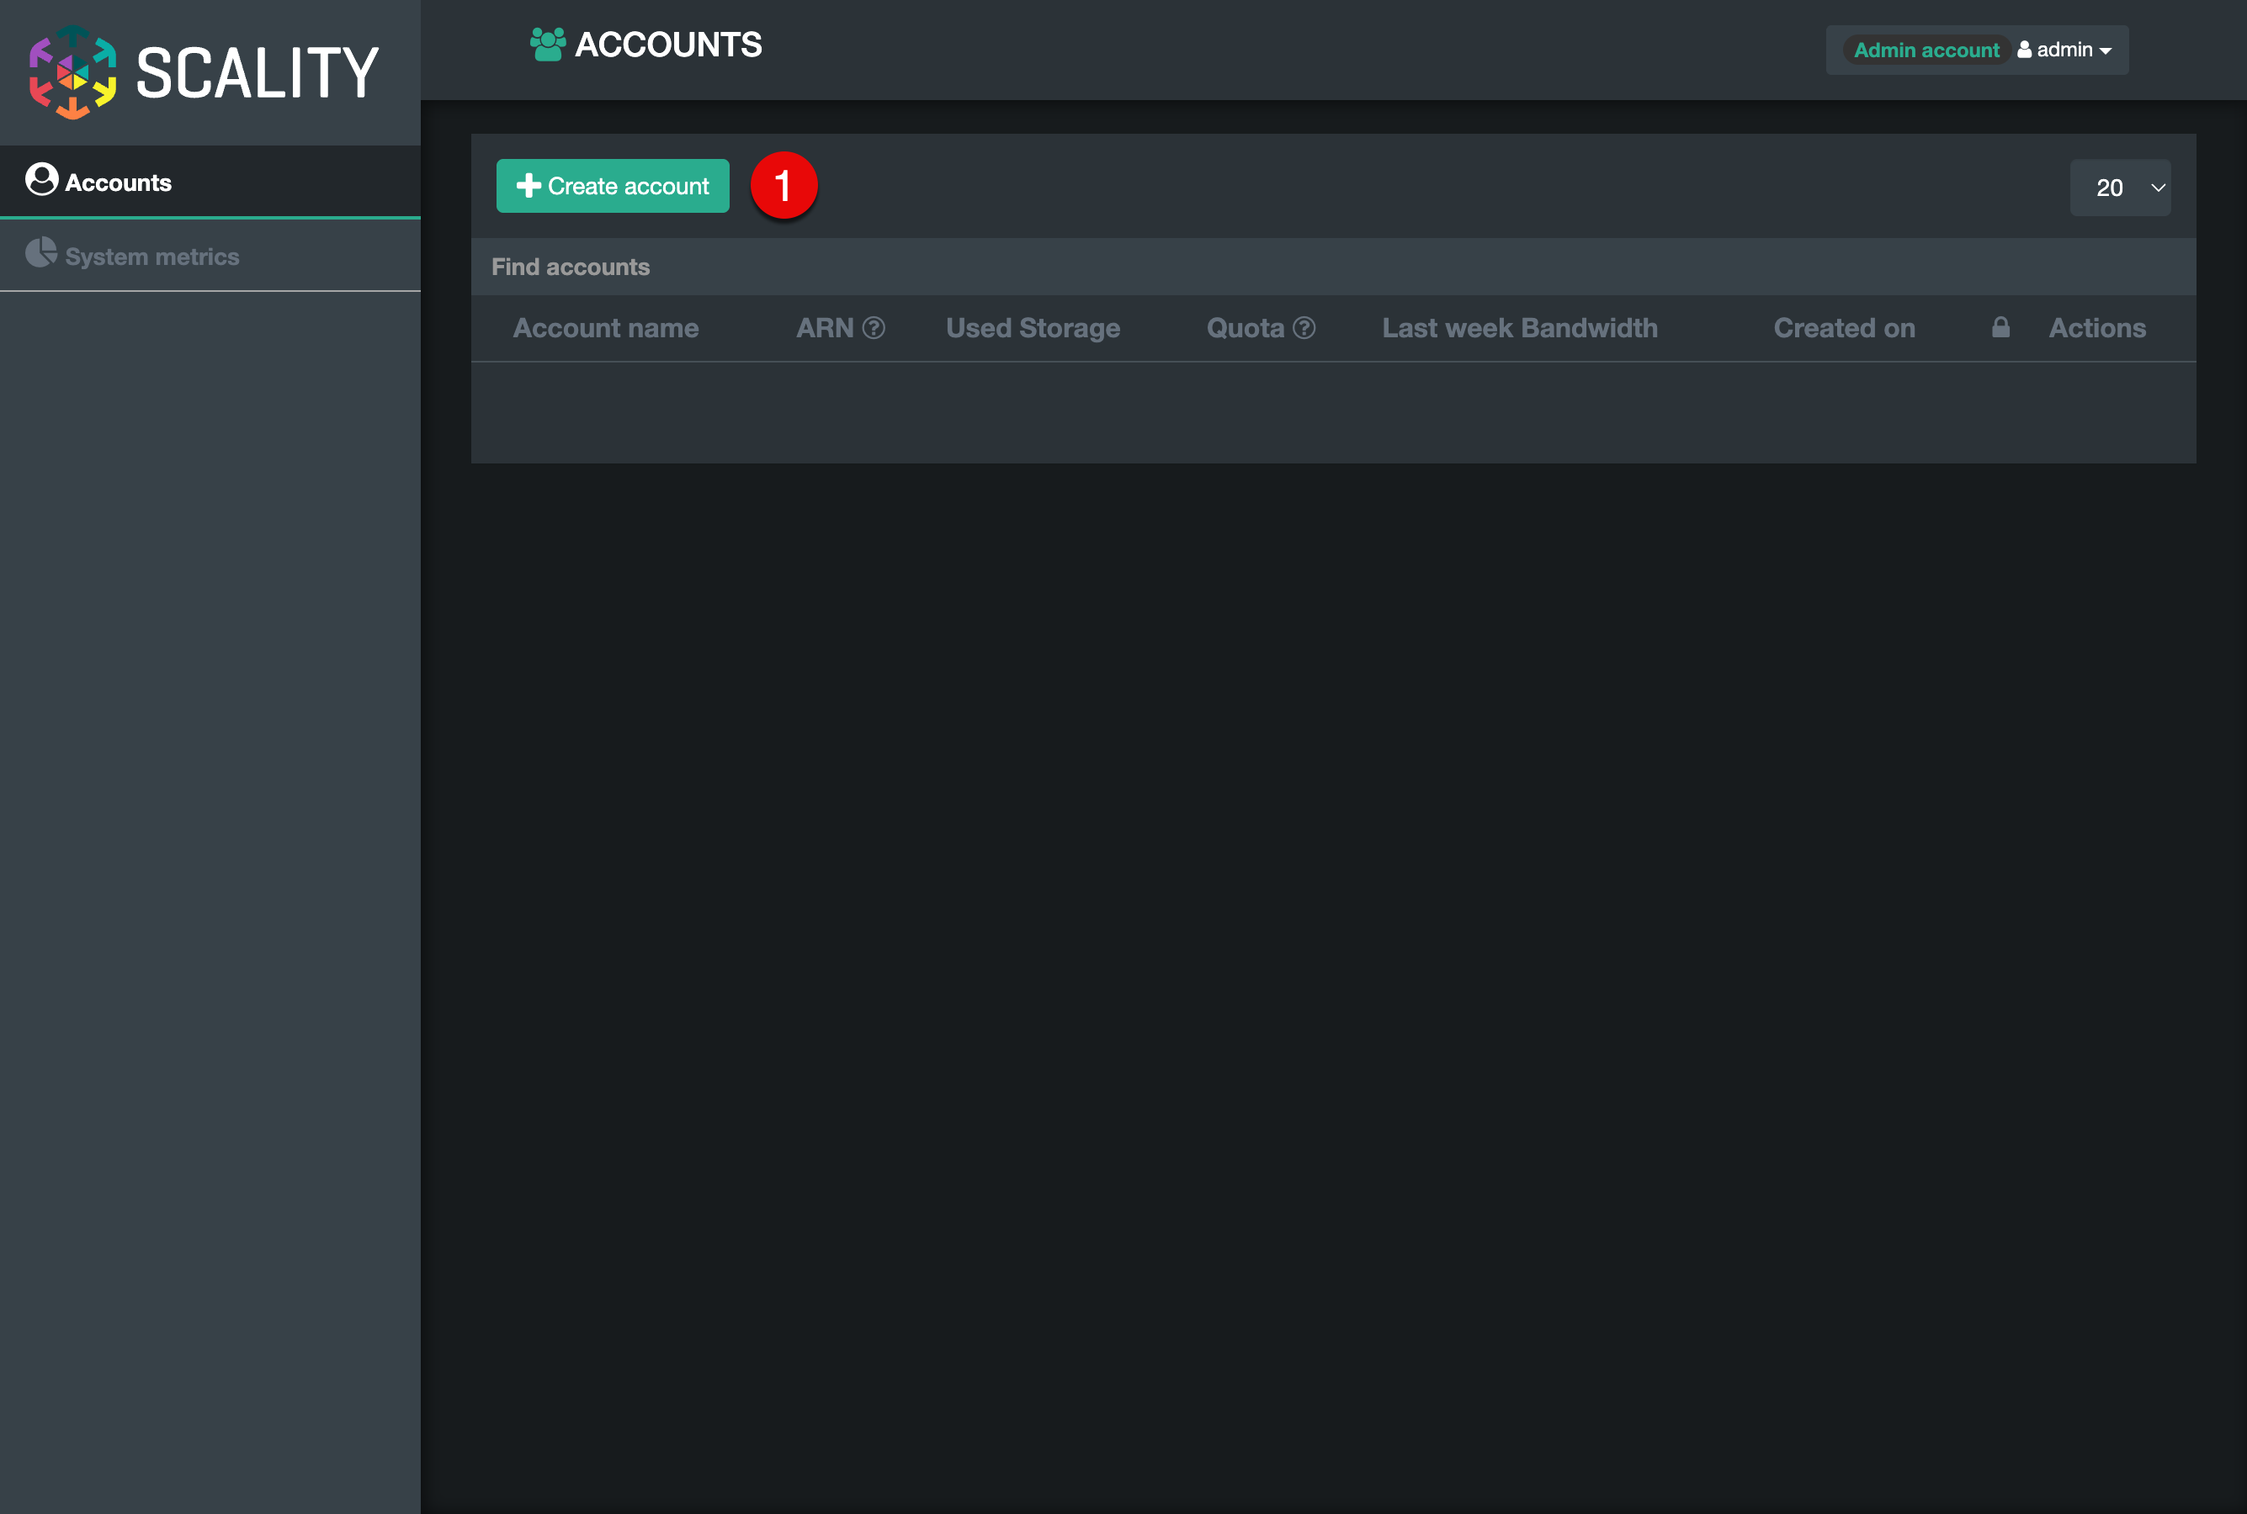
A dialog with user information will appear. Enter the following details:
- Account name (1): warpuser
- Email address (2): warpuser@test.domain
- Password (3): specify a password here
- Password confirmation (4): confirm the password specified before
Remember the password and account name. We will need them later. 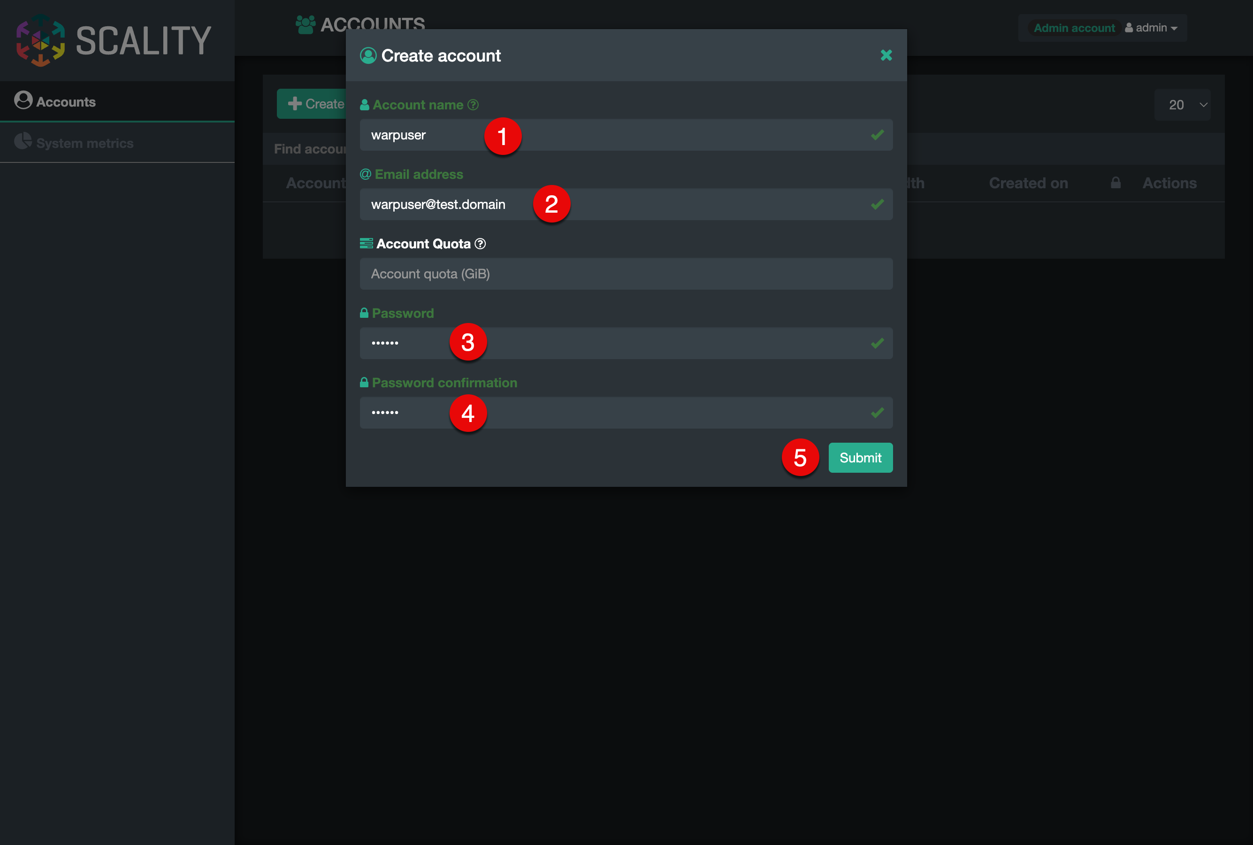
Click the Submit (5) button to create a user.
The successfully created account will be added to the accounts list: 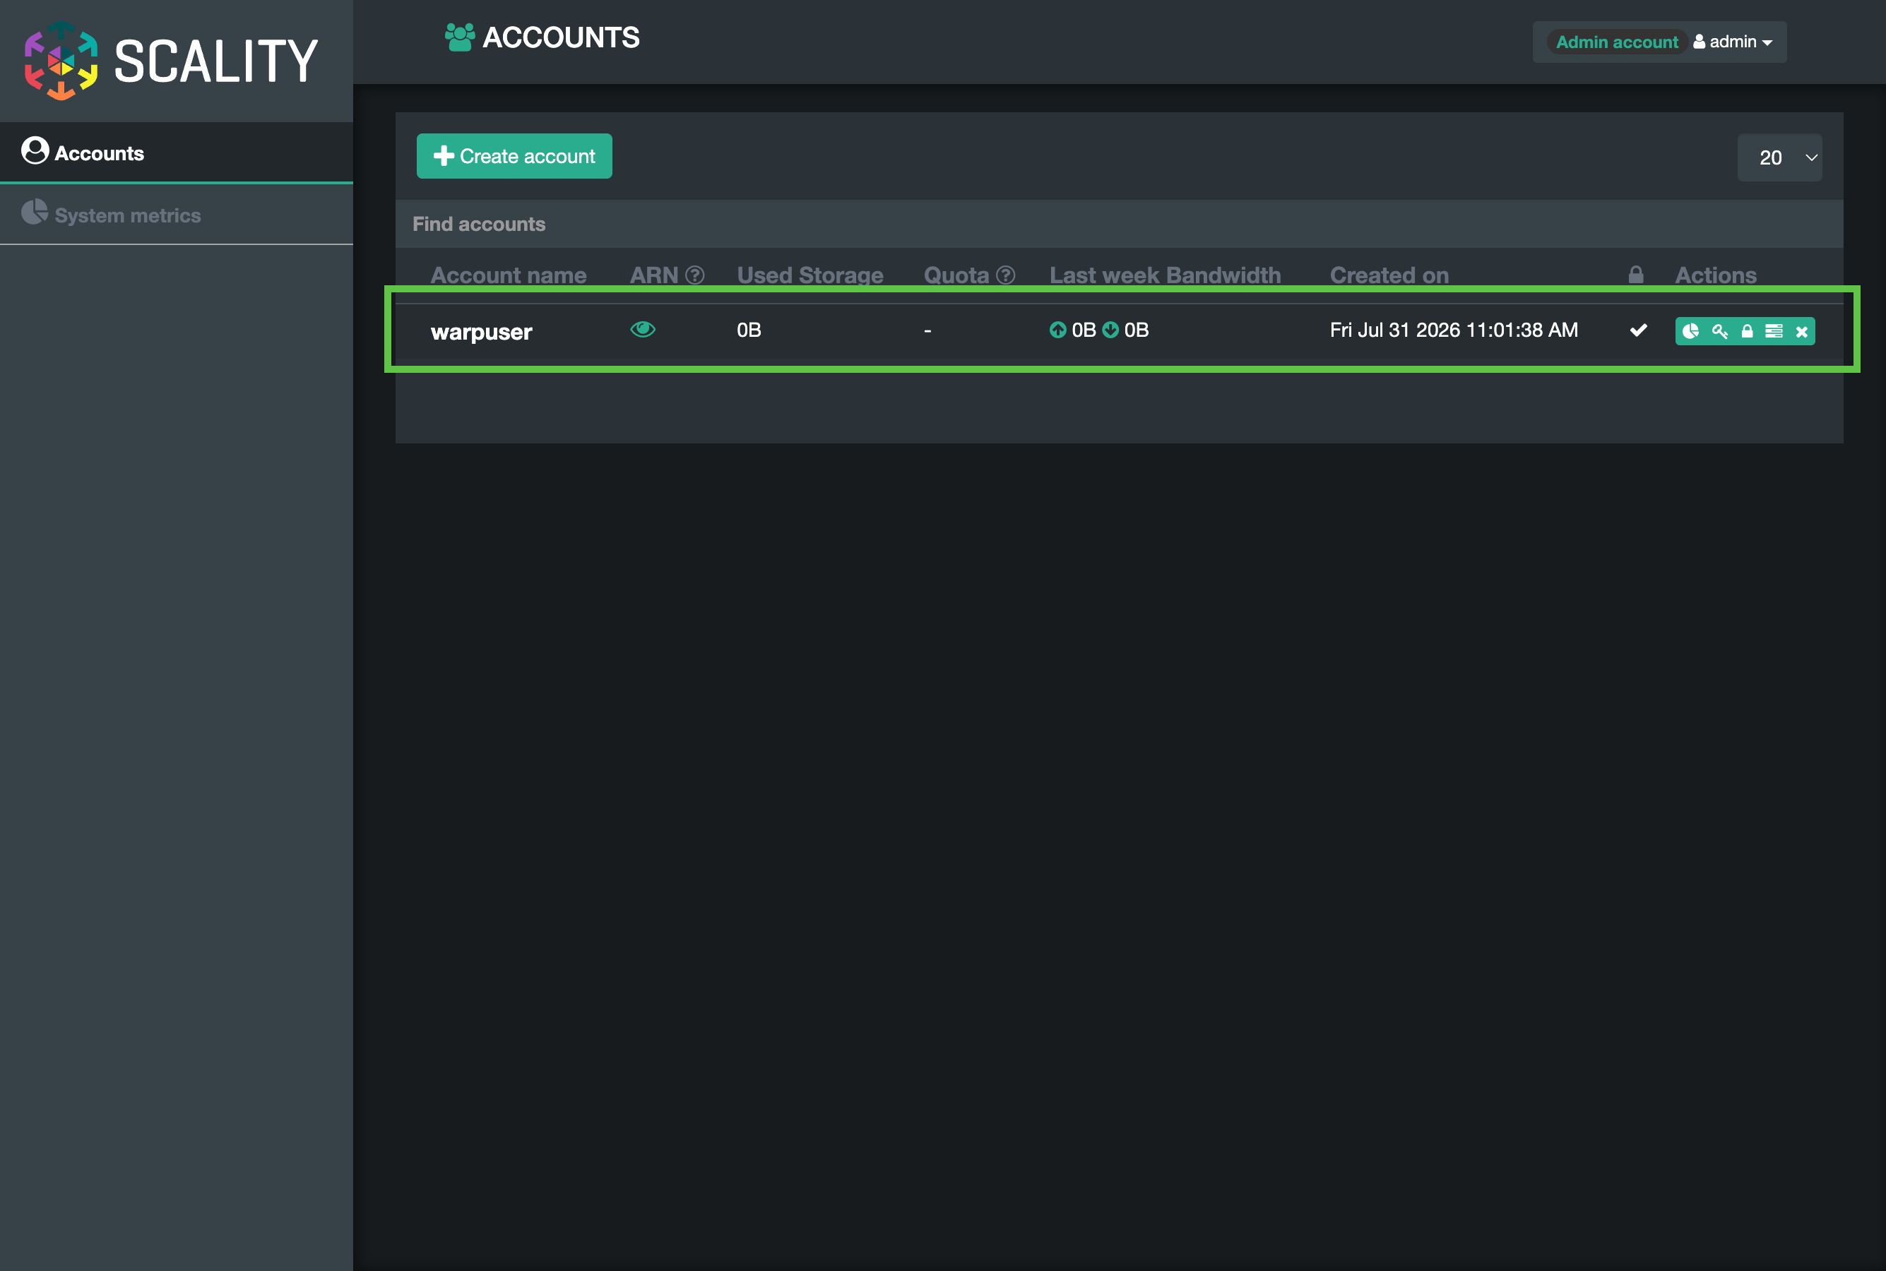
As a next step, to create resources under the new account, the current account needs to be logged out. Click Admin account (1) profile at the top right part of the screen. Select Log out (2). 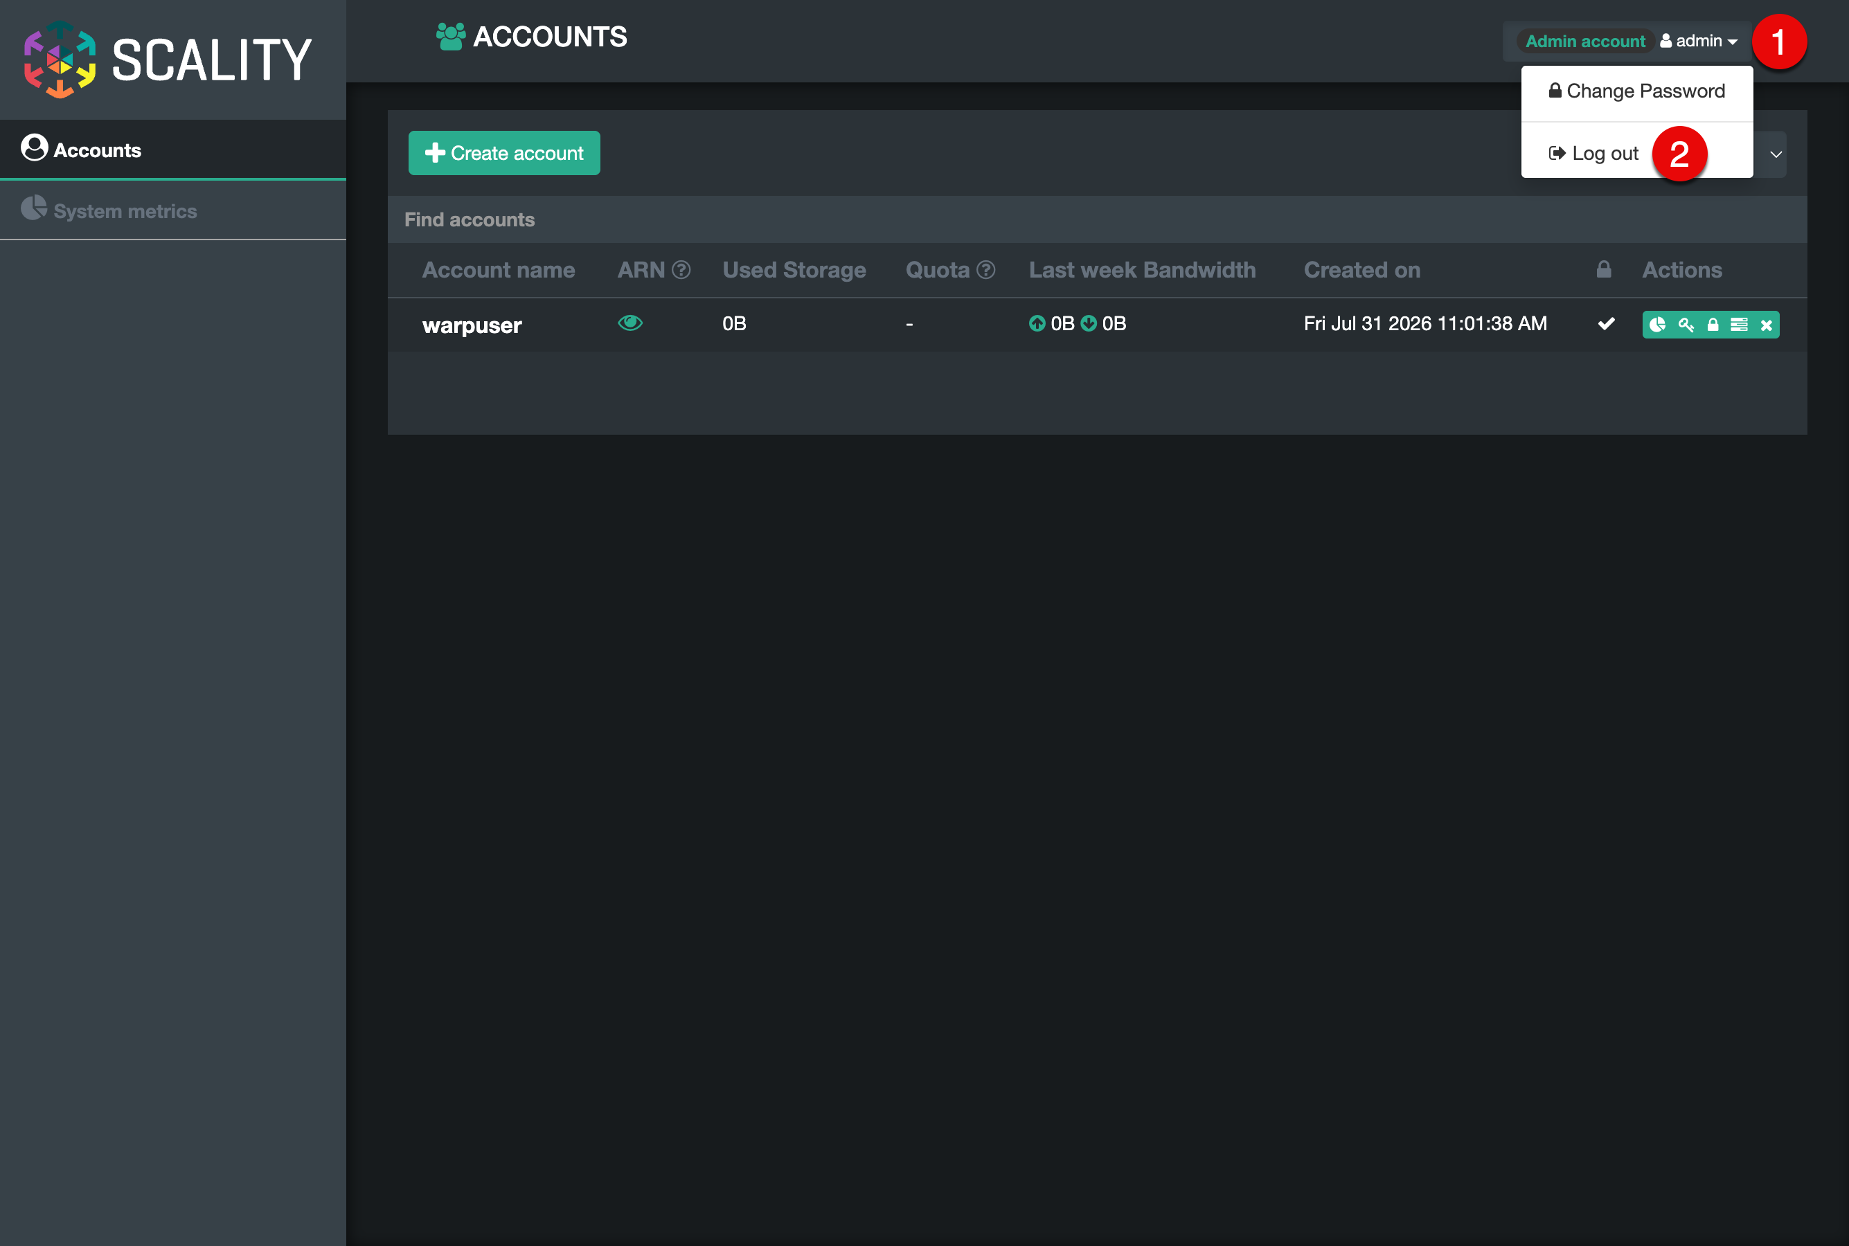
In the login form, enter the newly created user’s credentials:
- USERNAME: (1) warpuser
- PASSWORD: (2) password specified during account creation
Click Submit (3) button.
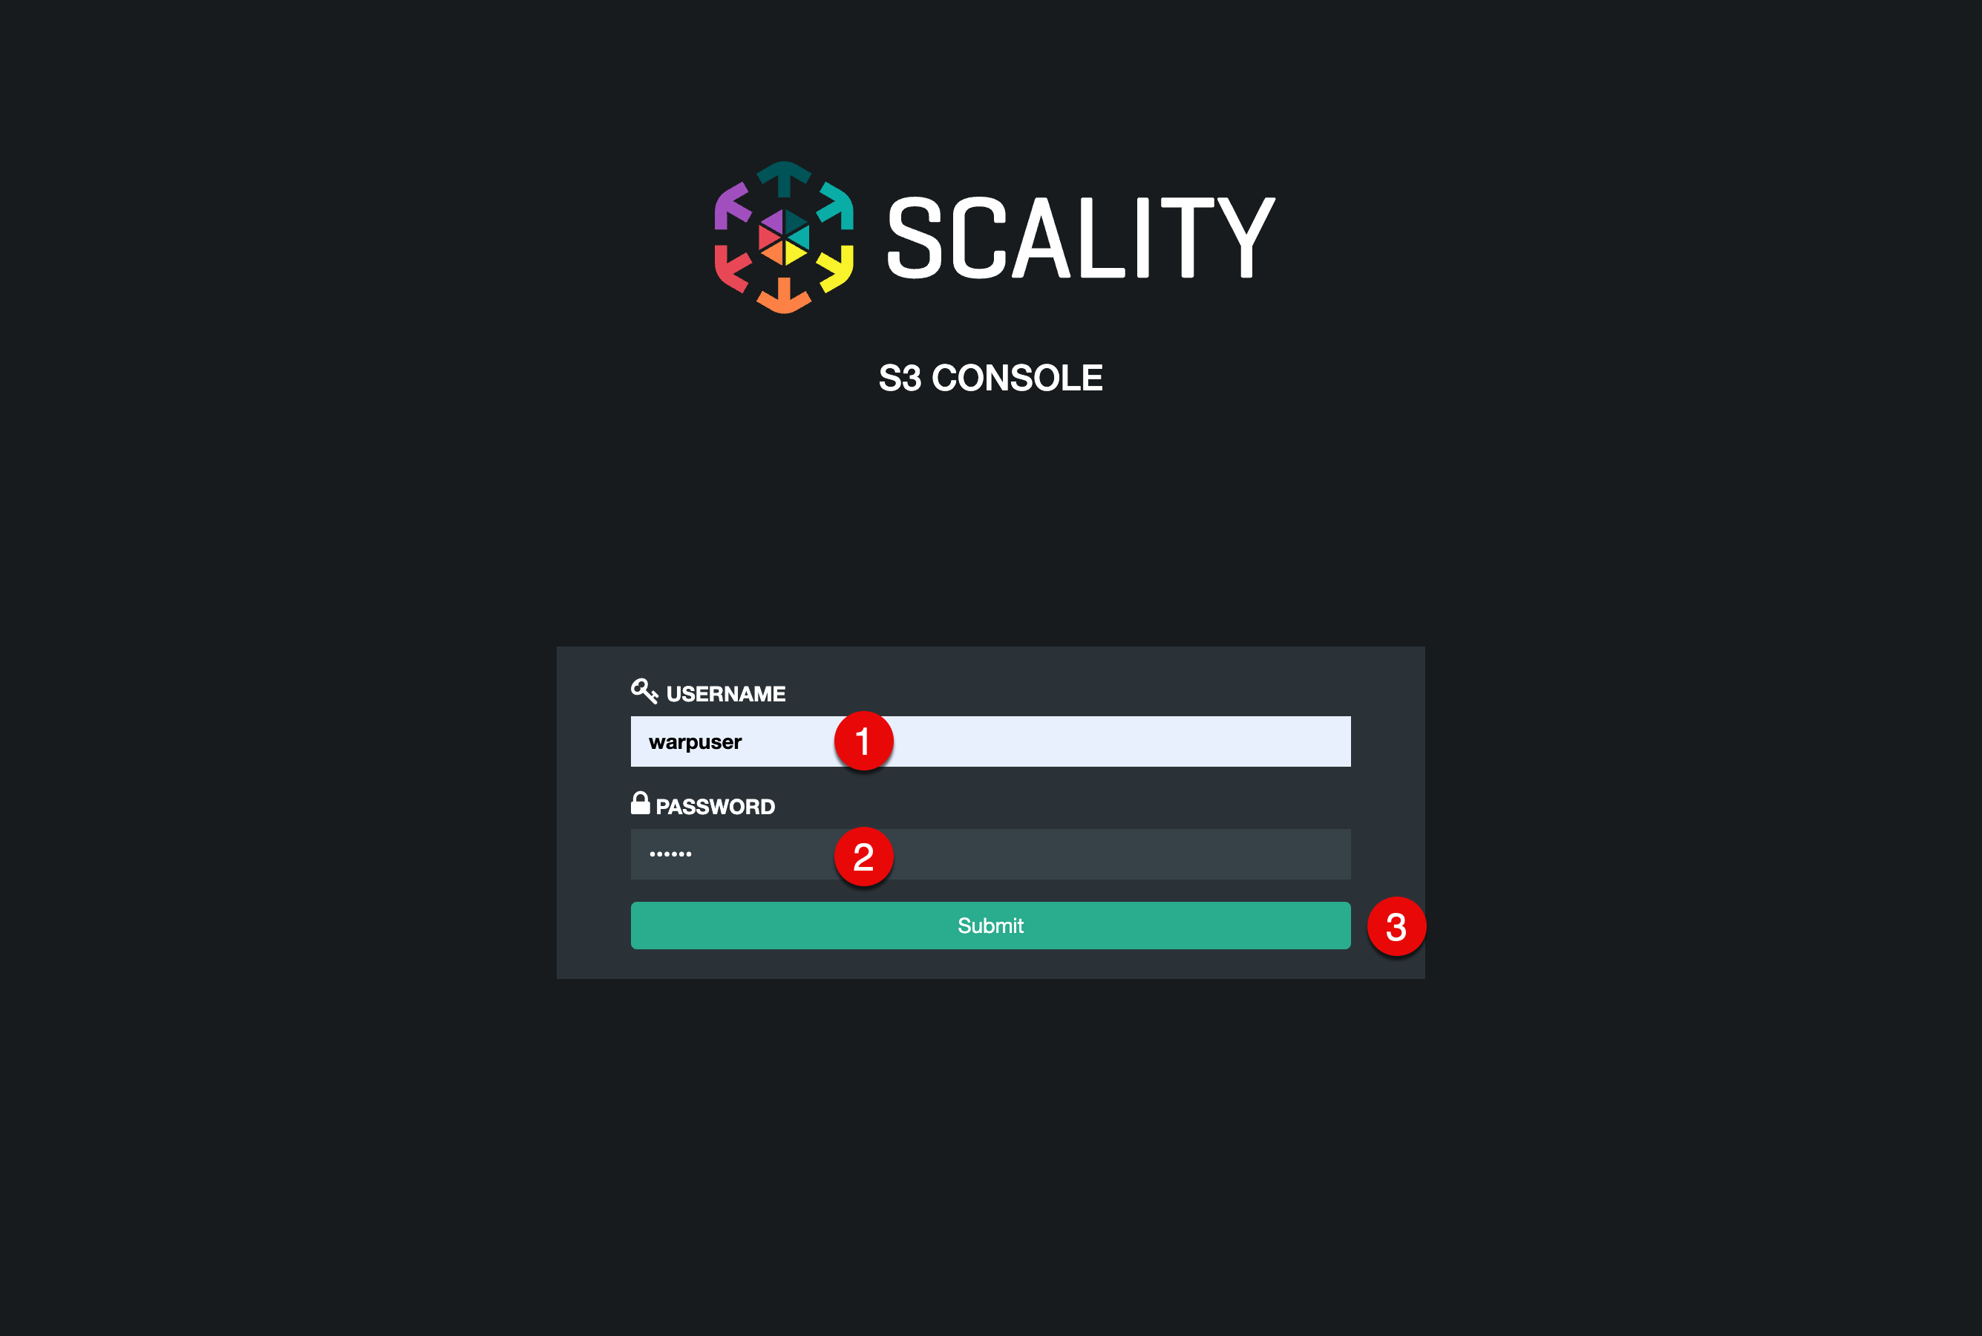
warpuser login

2.7.1.2 Create S3 User
After logging in to the account, you can create an S3 user. Click the + (1) button. 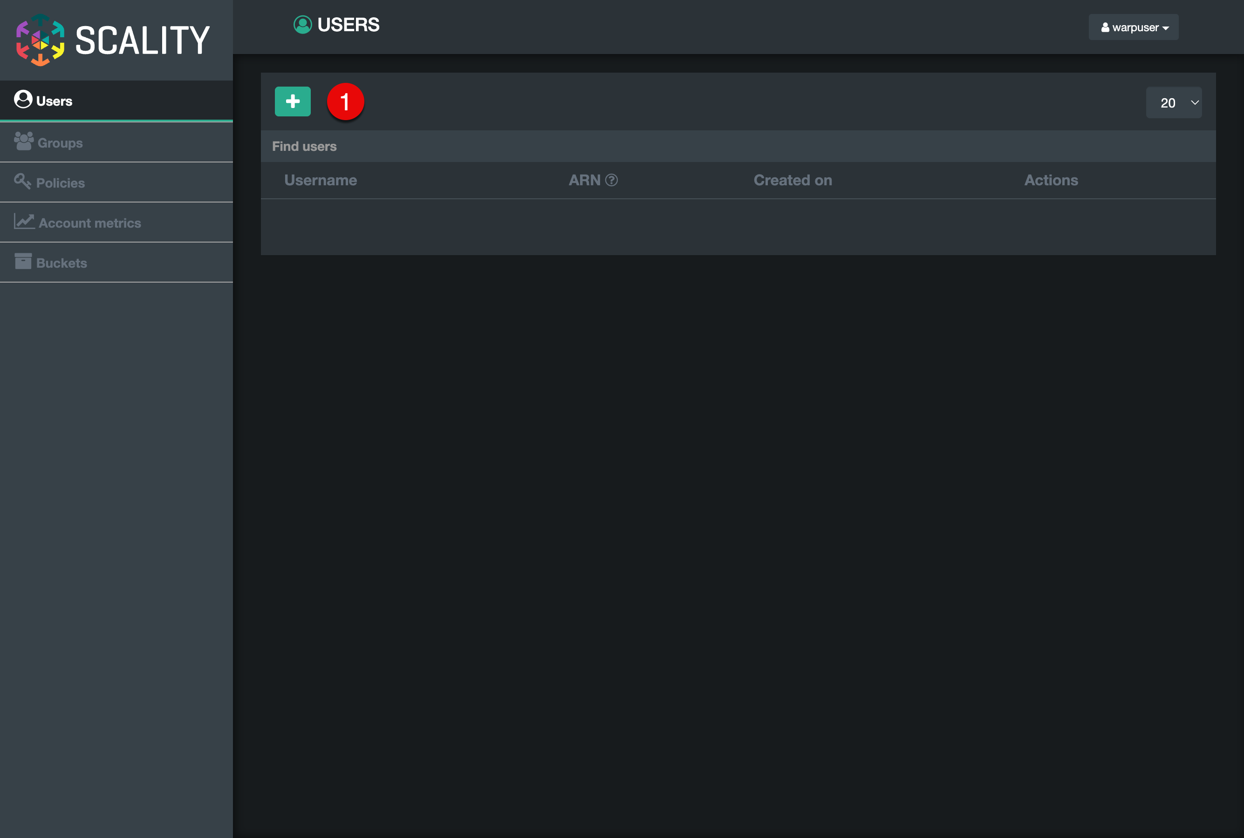
In the dialog that appears:
- Username: (1) warp-s3-user
- Select FullAccessGroup (2)
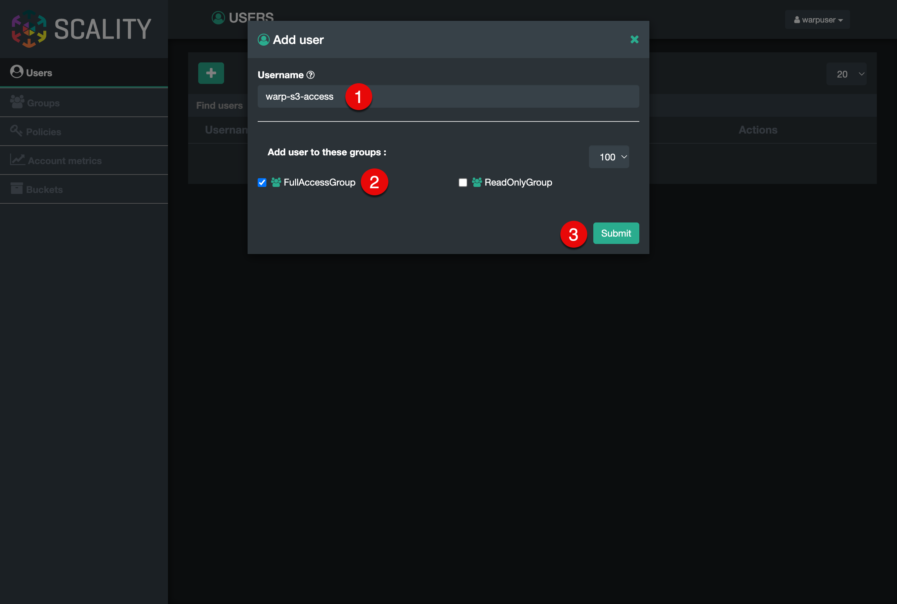
Create S3 user
Click Submit (3) button.
The created user will be shown in the users list. Select the Key (1) button in the actions list. 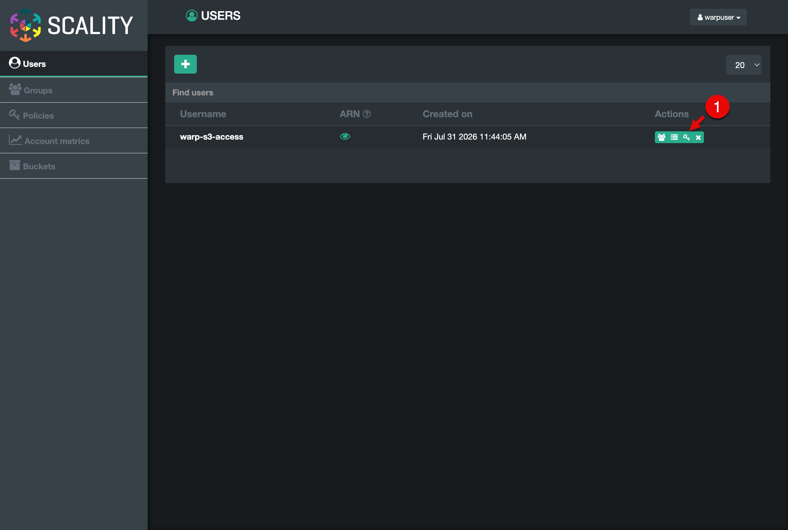
To connect to the S3 environment, the user needs an Access Key and a Secret. Click the + Generate a new key (1) button. 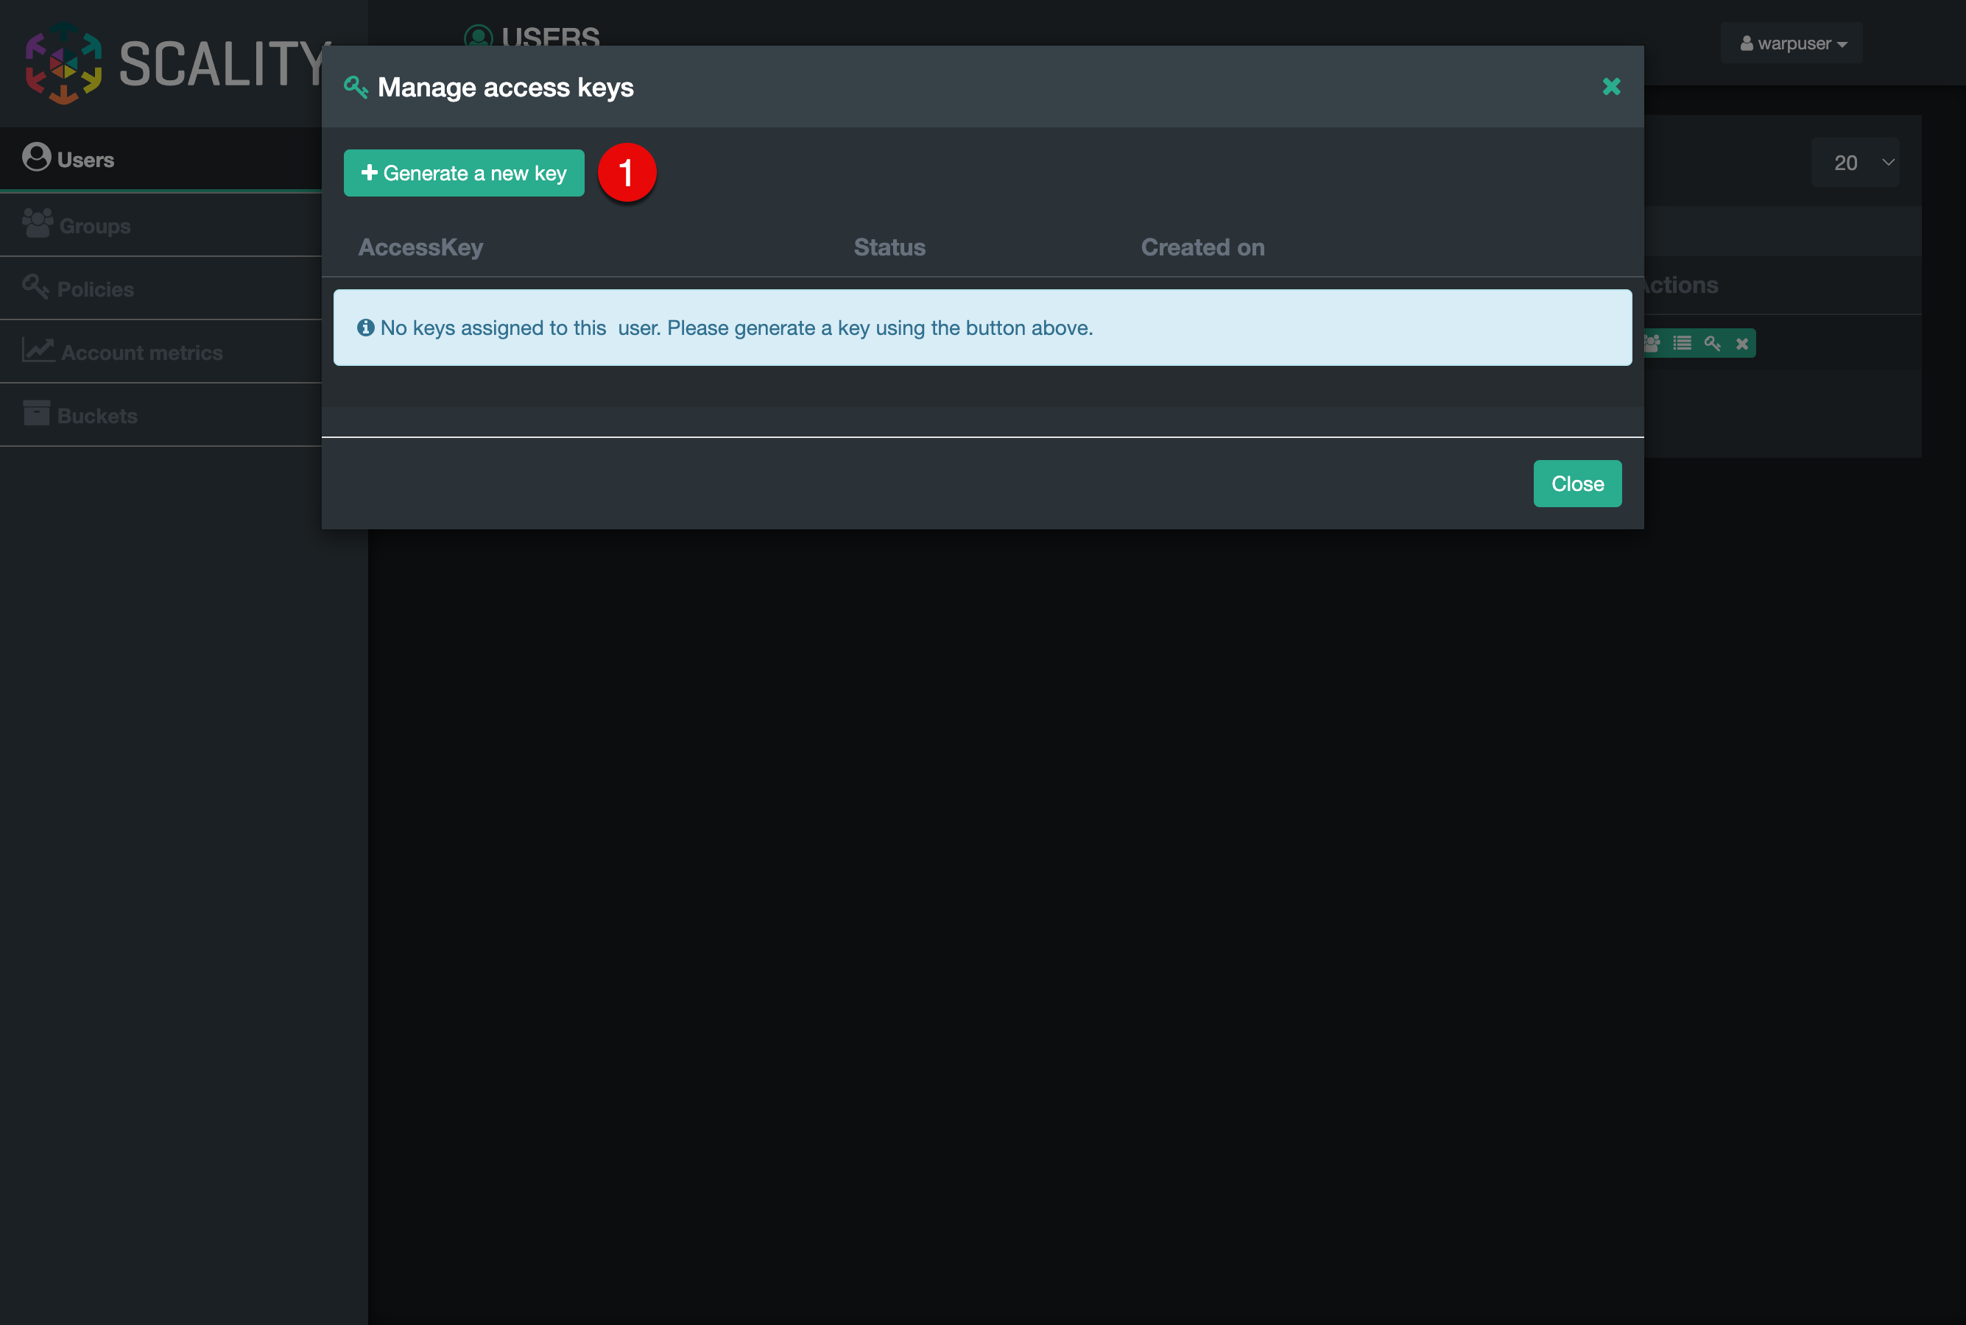
A new Access Key will be generated. Save the AccessKey (1) and click the Show (2) button next to the SecretAccessKey. Save the Secret too. You will need both later. Do not share these credentials with anyone.
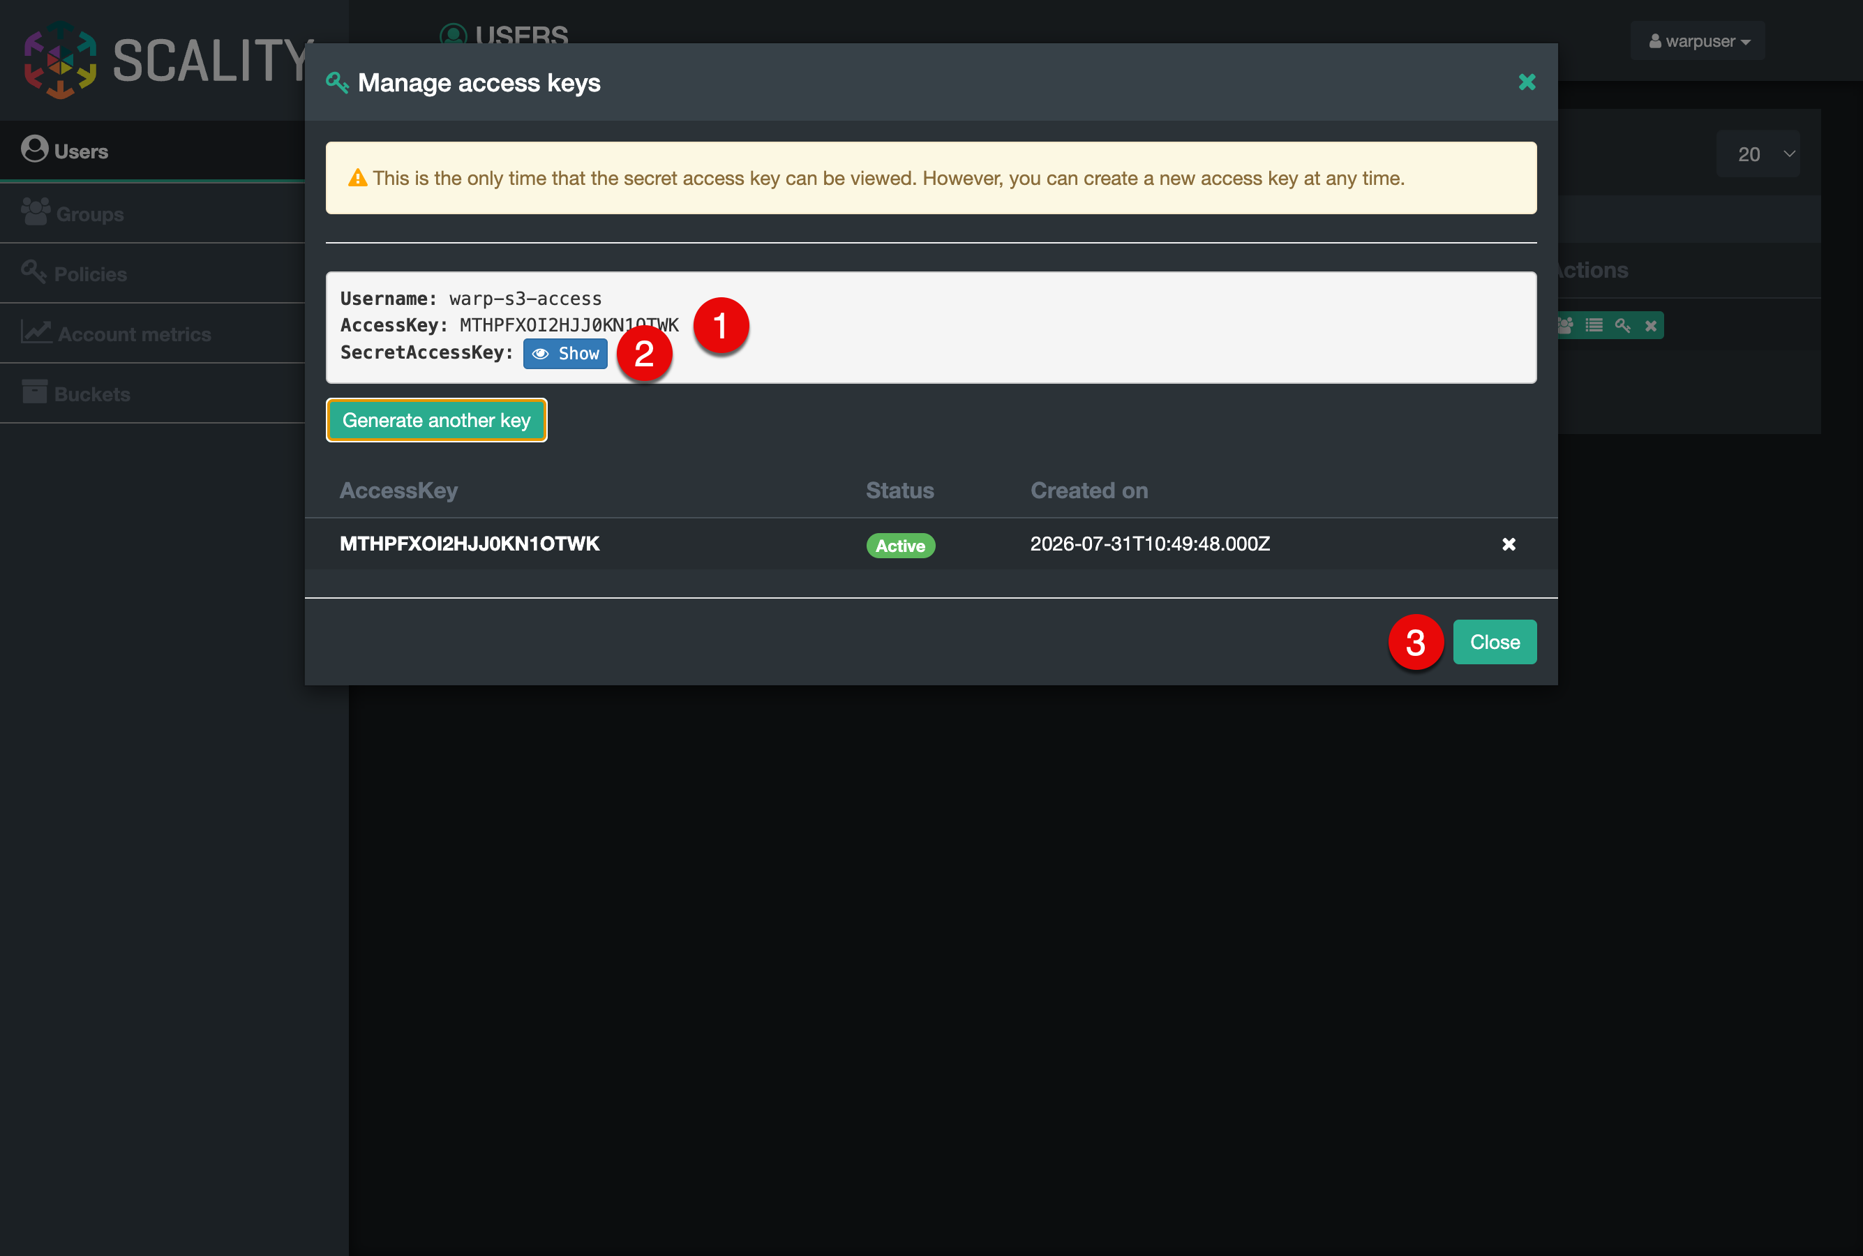
S3 user access credentials
Click Close (3) button to close the current dialog.

2.7.1.3 Create S3 Bucket
In the Scality RING administration console, select S3 Services (1) and click Login (2) to open the S3 Browser. 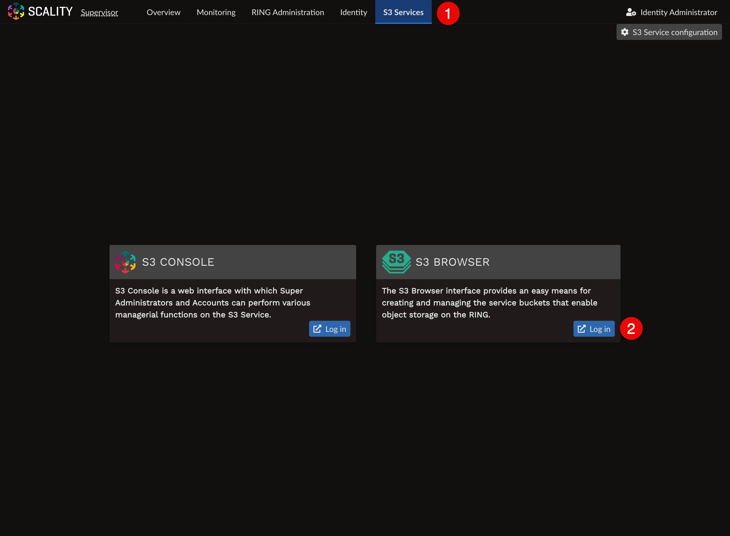
Then use the saved Access key and Secret key to log in. Enter them in the Access Key (1) and Secret key (2) fields.
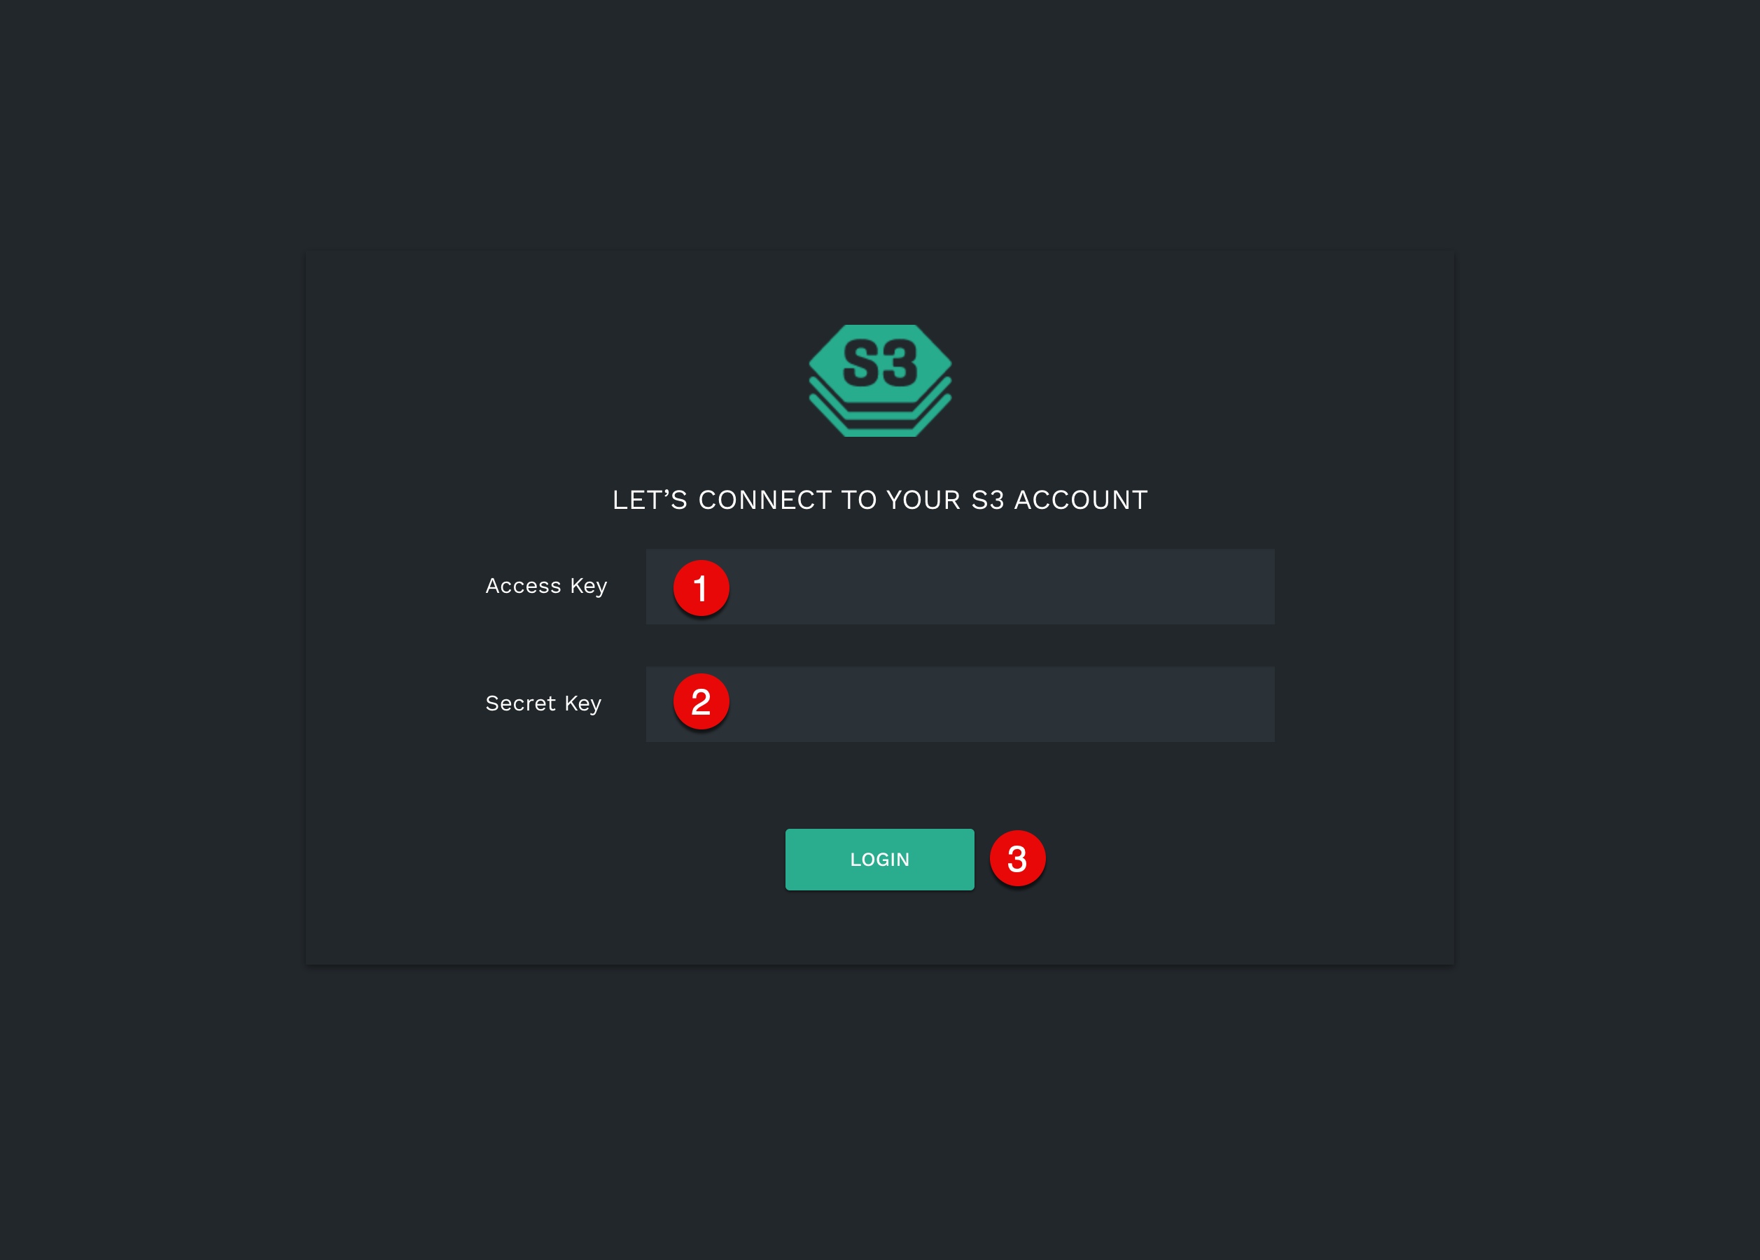
Scality Ring S3 Browser Login
Click LOGIN (3) button.
Click CREATE BUCKET (1) button. 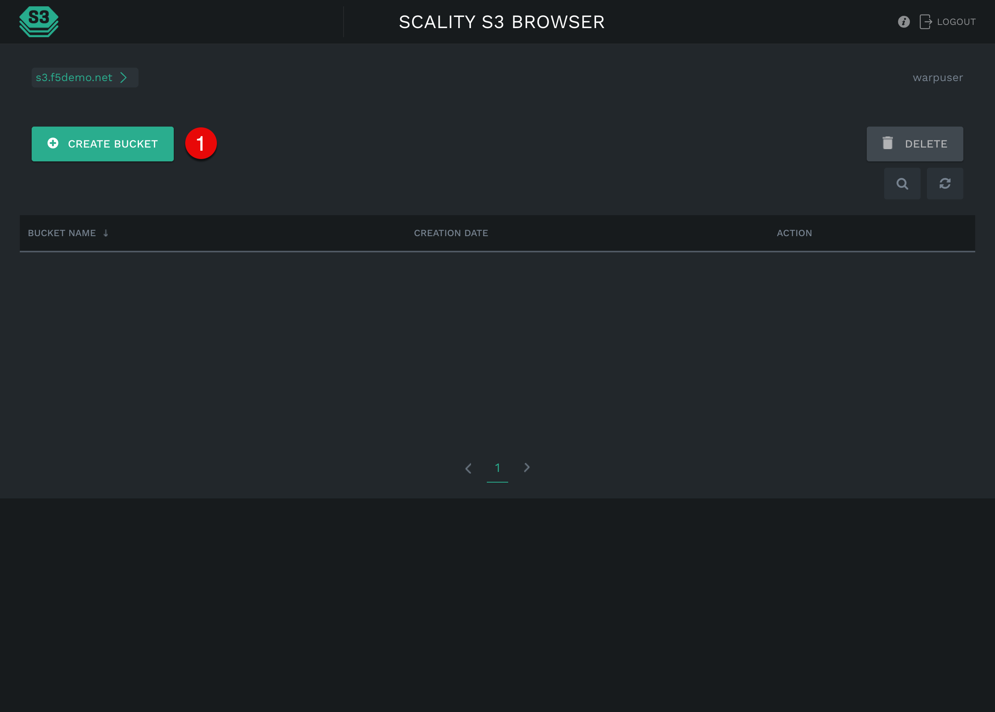
The create bucket dialog will appear. Specify warp-connectivity-test for Bucket Name (1) and click CREATE (2) button. 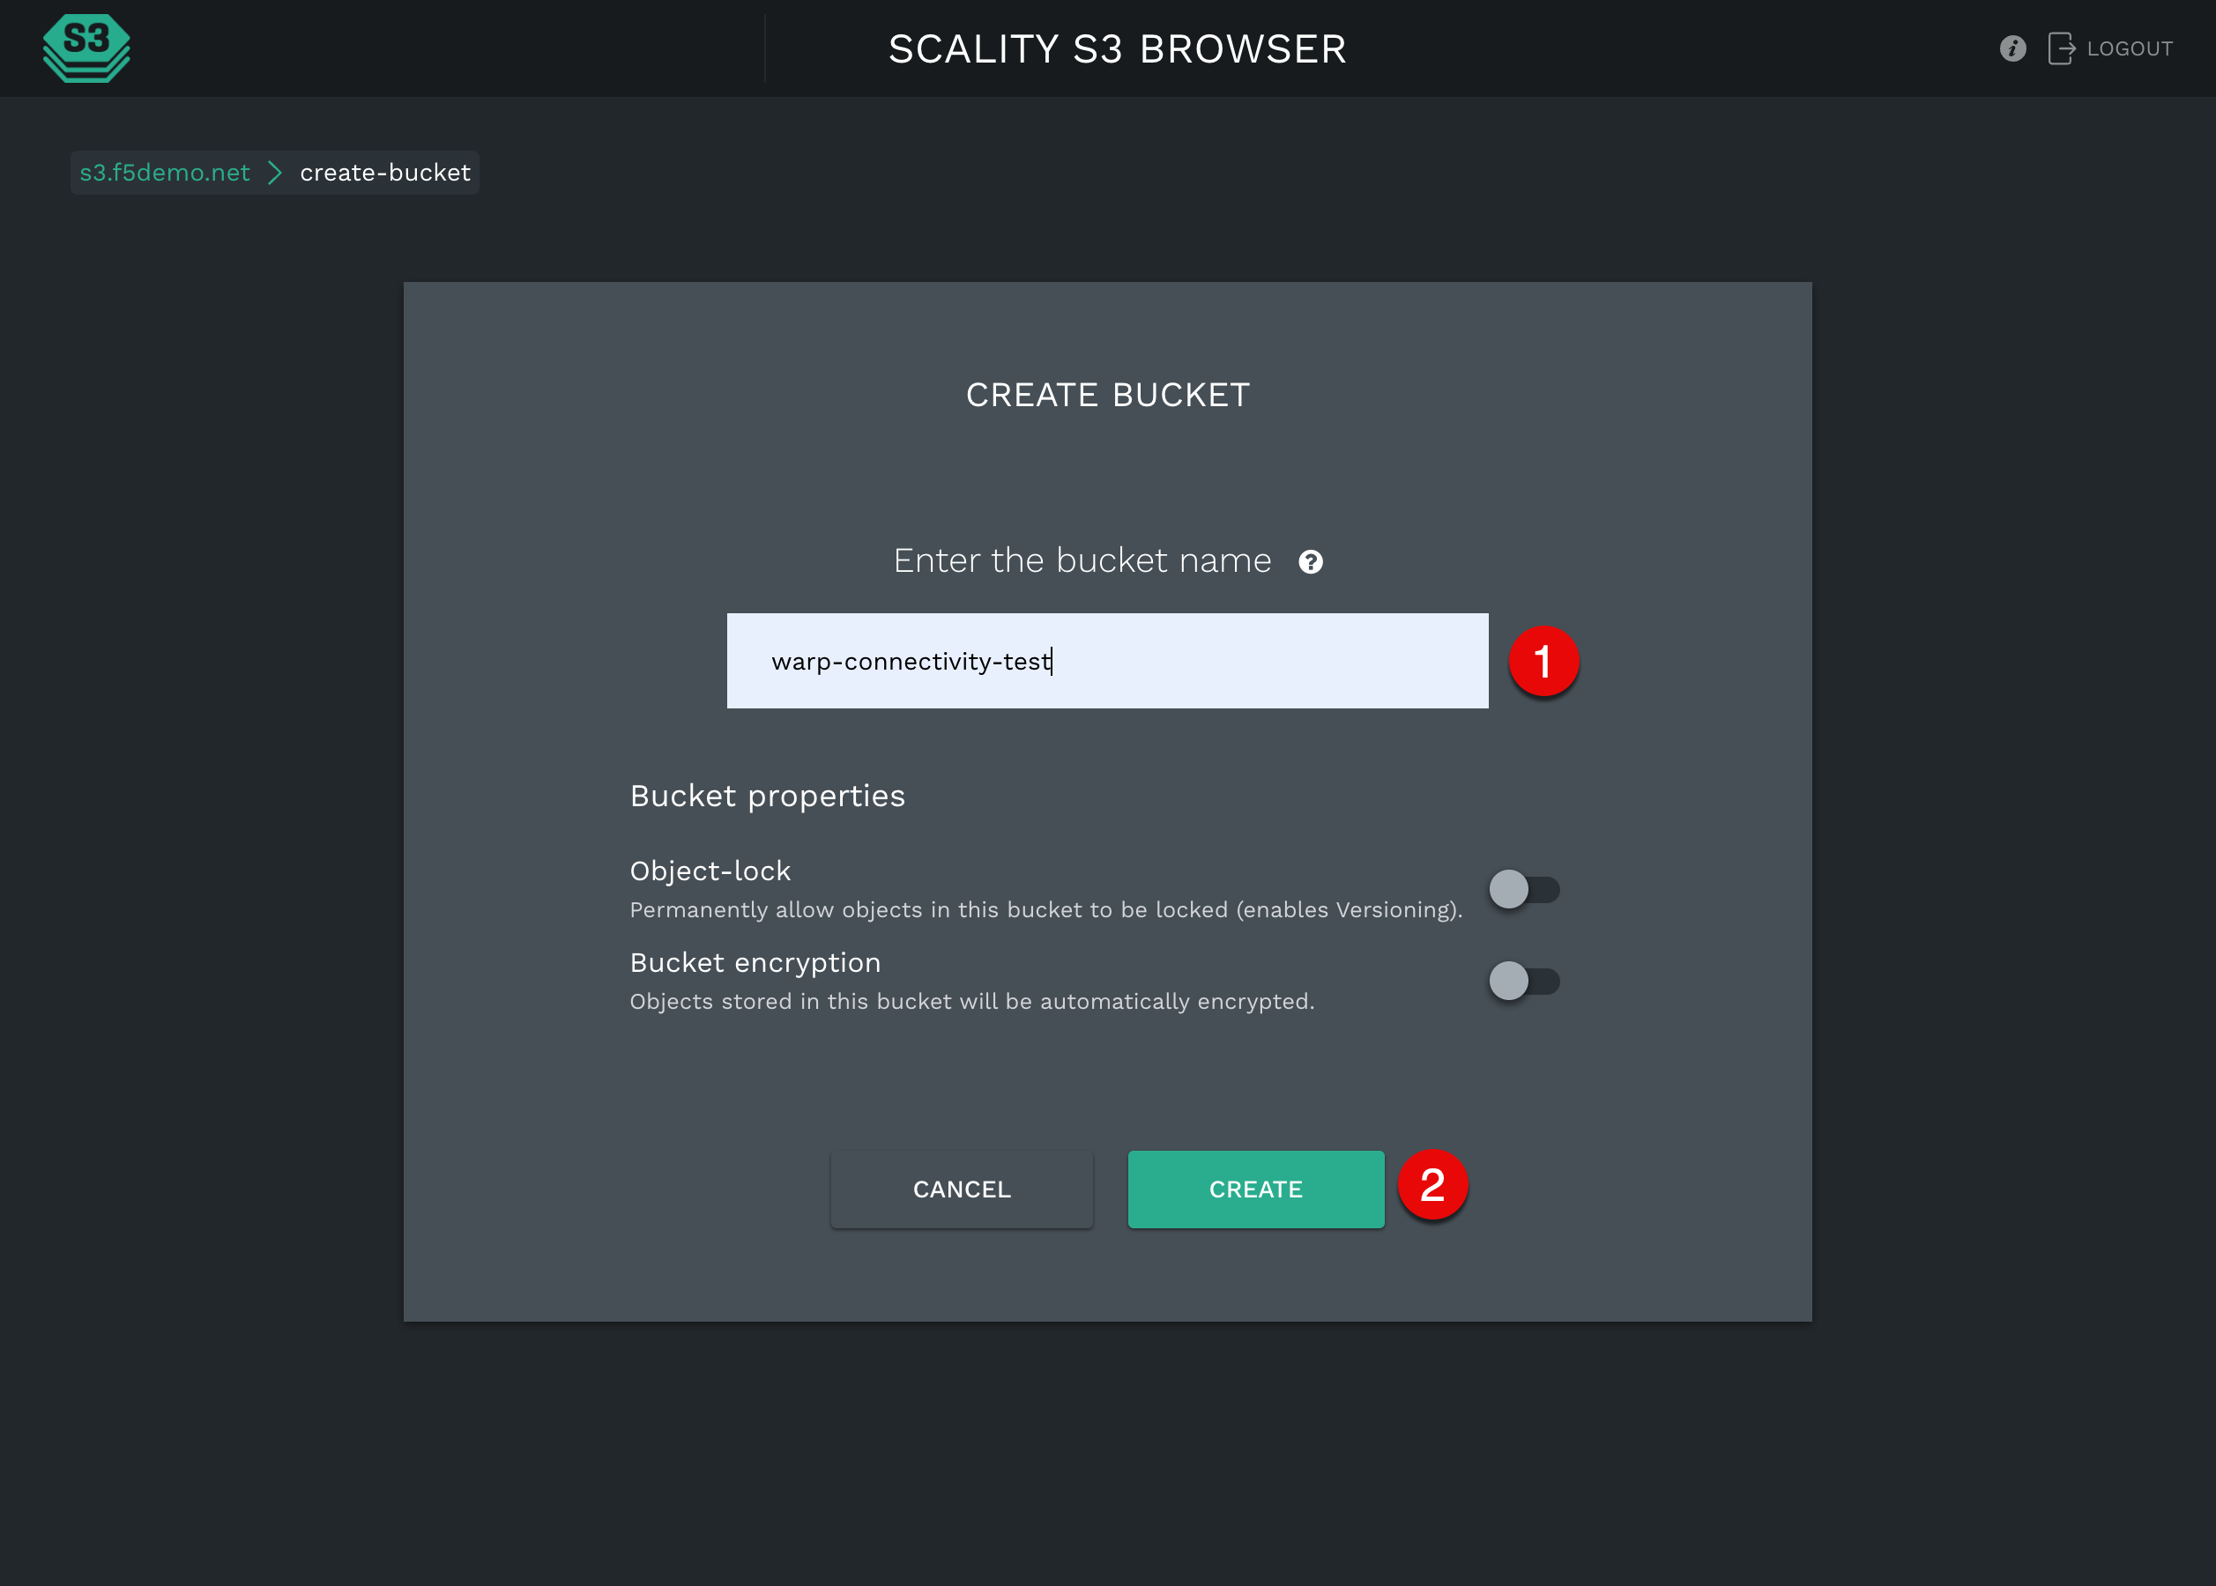
Bucket will be created: 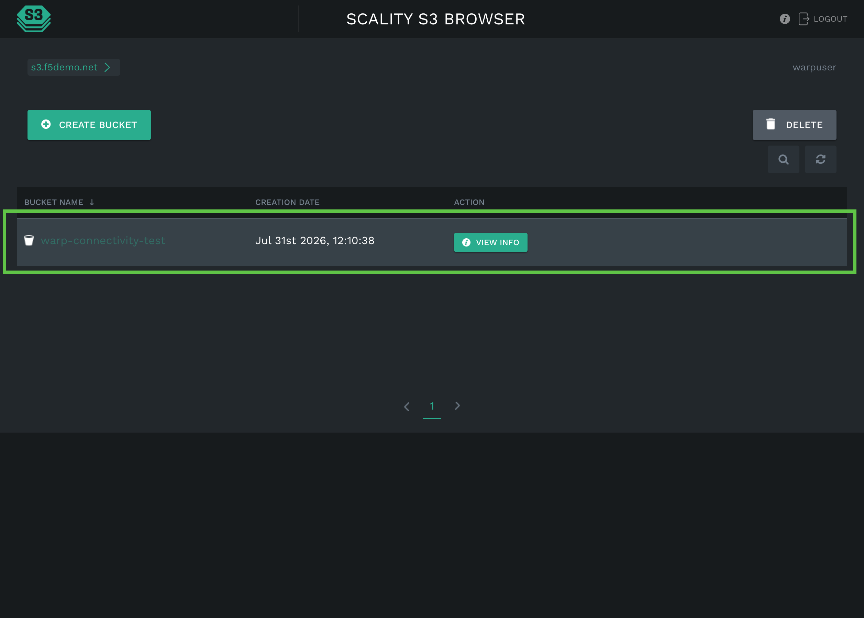

2.7.2 Use Warp to Test Connectivity to the RING S3 Cluster Through the BIG-IP Virtual Server
Warp is an S3 benchmarking tool. It drives a representative S3 workload (mixed PUT, GET, DELETE, and STAT operations) against an endpoint and reports throughput, latency, and error counts. Pointing Warp at the BIG-IP virtual server address, rather than at an individual RING node, confirms that traffic flows end to end through the load balancer and gives a baseline measurement of the cluster’s performance behind the BIG-IP.
Download and install the Warp CLI from the official download page:
https://www.min.io/download/minio-warp
Configure Warp with the BIG-IP virtual server address as the S3 endpoint, along with the access key ID and secret access key generated on the RING cluster, and run a short mixed-workload test:
export WARP_HOST=10.150.92.150:443 # the BIG-IP virtual server address and port
export WARP_ACCESS_KEY=your-access-key-id # the access key ID saved earlier
export WARP_SECRET_KEY=your-secret-access-key # the secret access key saved earlier
./warp mixed \
--host "$WARP_HOST" \
--access-key "$WARP_ACCESS_KEY" \
--secret-key "$WARP_SECRET_KEY" \
--bucket warp-connectivity-test \
--objects 10 \
--obj.size 1KiB \
--concurrent 1 \
--duration 2s \
--tls \
--insecure \
--json > test_result.json
When the run finishes, use jq to summarize the totals from the JSON report. Inspect the full output with cat test_result.json if you need a detailed breakdown.
jq -r '
.total |
"Requests: \(.total_requests) | Objects: \(.total_objects) | Bytes: \(.total_bytes) | Errors: \(.total_errors)"
' test_result.json
Requests: 11 | Objects: 11 | Bytes: 11264 | Errors: 0
An error count of zero confirms that every request reached the RING cluster and returned a successful response through the virtual server.

2.8 Automation with Ansible
The manual steps above can be reproduced declaratively with Ansible. Playbooks, roles, and inventory live in automation/. See automation/README.md for installation, credentials, and usage.

