# Manual Zoom for students

Dear Students,

If you participate to a lecture with zoom please review this document before the lecture.

## Instructions to start zoom before the lecture start

1. Use a **computer/laptop** with **audio and mic**. The mic of your computer/laptop are sufficient, but the use of ear pods or a headphone is useful to limit the background noise. Zoom can also be used with a smartphone or tablet upon installing the Zoom-app (via the App Store of Google Play), but they might lead to a suboptimal readability of the slides

1. Start your laptop at least 5 minutes before the start of the lecture.
2. Use a good WIFI connection or a wired network.
3. Check your settings e.g. on <https://support.zoom.us/hc/en-us/articles/115002262083>.

1. Surf to ufora.ugent.be and log in. Use the latest version of Chrome, Firefox or Edge (Chromium-versie). Also on mac you have to use Chrome, Firefox or Edge.

1. Go to the Ufora course site.

1. Click on the Zoom-link that has been communicated, e.g. through the Agenda-tool. If it is the first time that you setup a Zoom meeting, you will have to dowmload and install the Zoom Client for Meetings-app on <https://zoom.us/download>.
2. Install Zoom
   1. Open installation file

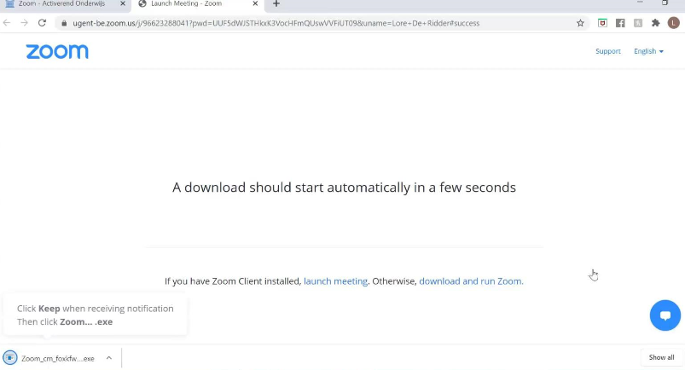

* 1. Select Sign in

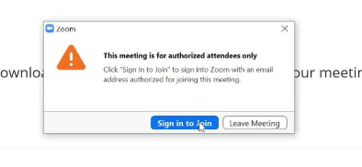

* 1. Fill in your UGent e-mailaddress and your password
  2. Select Sign in with SSO

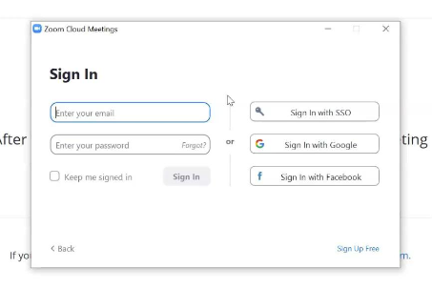

* 1. Use ugent-be as *company domain* (ugent-be.zoom.us)

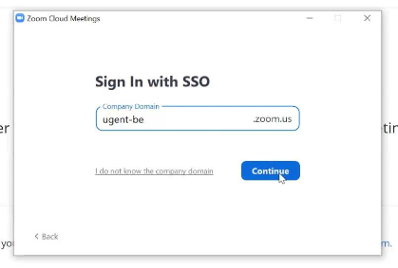

* 1. Select Continue
  2. Toggle the field Remember and click on Yes, continue.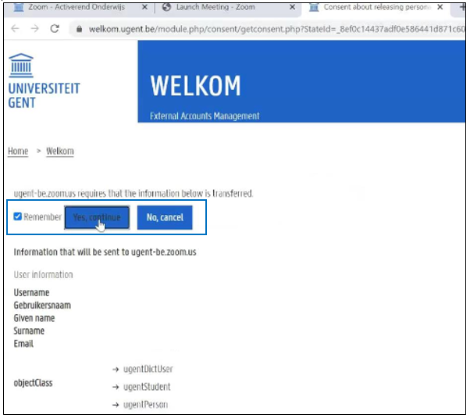
  3. Click on Launch Zoom

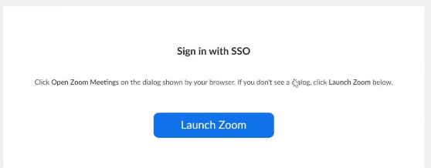

(Take notice of updates of the app to optimize your security and performance)

* 1. Put your mic on mute so to avoid background noise for your fellow students.

1. Check your account:

* Click on your name (top right corner) in the Zoom Client App.
* Check if your profile is assigned to Basic.

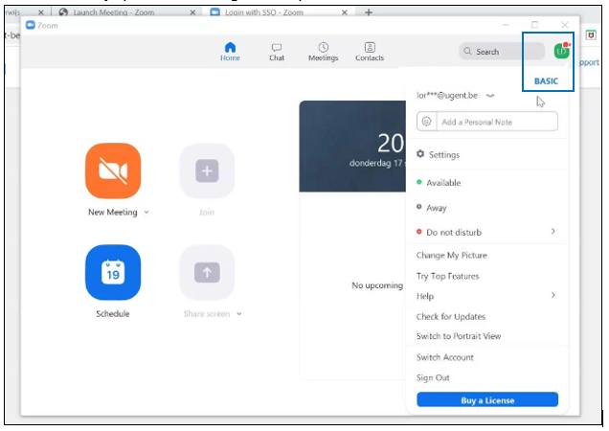

1. You can now follow the lecture. **Switch your mic off and your camera on**, unless the lecturer gives another instruction.

## During the lectures

1. Make sure that the video feed of the lecturer is always on top. You can do this by pinning the view of the lecturer. Click on the three dots in the top right corner and “Pin Video”.

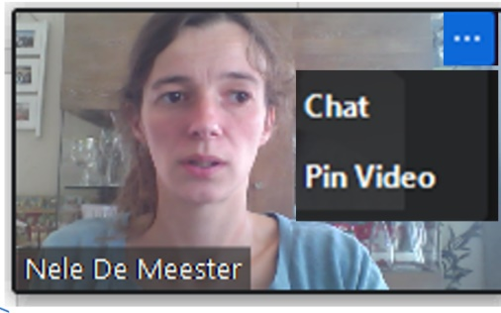

1. It is optimal if the video of the lecturer and the presentation are side by side. Click on “Side-by-side mode” in the “View Options”. You can play with the size of the presentation and video by draging the ruler in the middle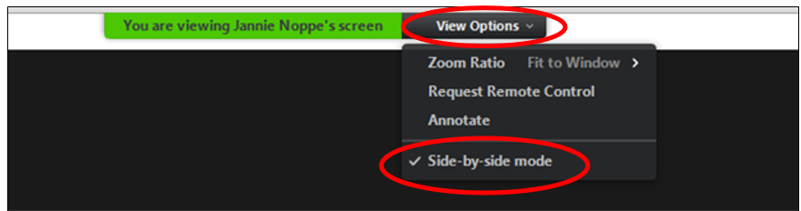
2. If you want to switch on/off your mic you can click on the mic icon at the bottom “Unmute/Mute”. You can do the same with your video feed click “Start/Stop video”.

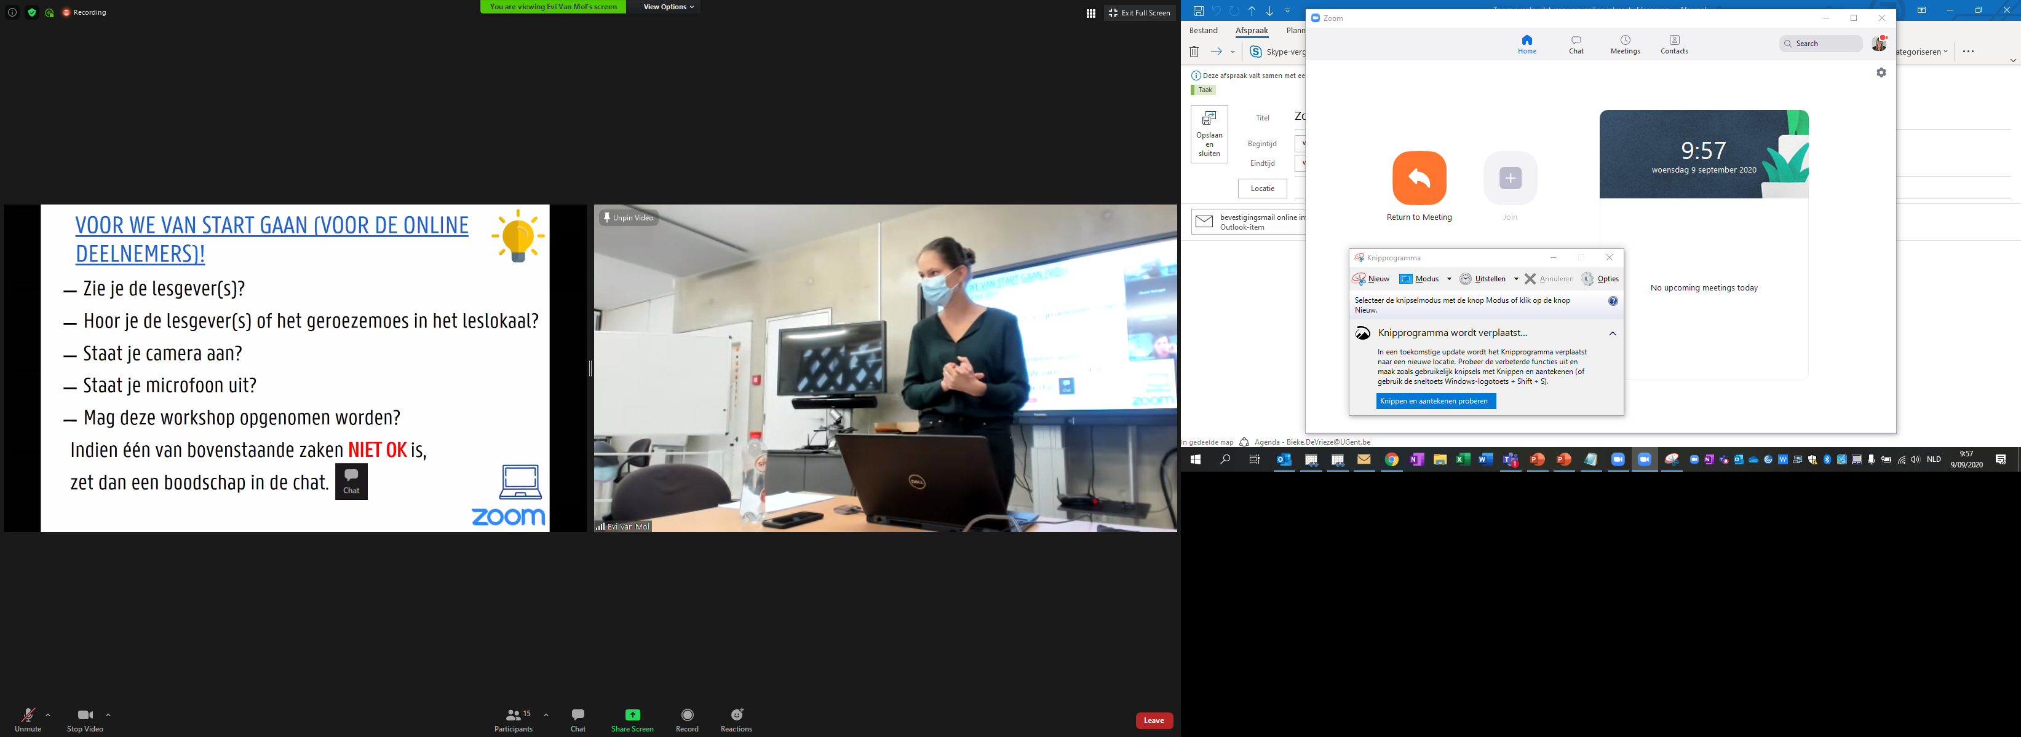

1. Remember that all fellow students can hear and see you if your mic/video are on and that the lecture is recorded.

How do you pose a question during the lecture?

The lecturer will announce at the start of the lecture how you can pose questions. There are two possibilities:

* You can ask a question in the chat

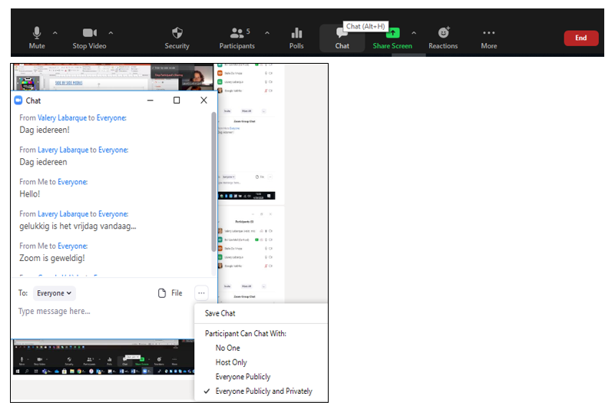

* Or you can raise your hand virtually. You do this by clicking raise hand in the participants menu. The lecturer will announce when you can ask your question. **Do not forget to switch on your mic**. Wait 2 seconds before asking your question. Talk clear and at an easy pace. **Switch your mic upon asking your question.**

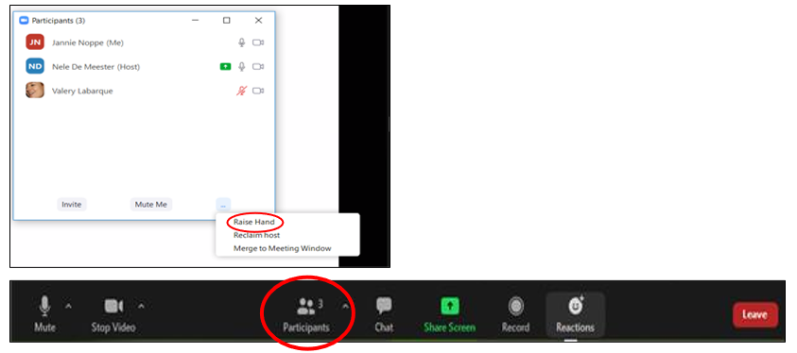

How do you use the break-out room?

The lecturer can divide the learners in groups, e.g. for discussions, to solve a question, … This is done in breakout rooms. You will get an invitation to join the room

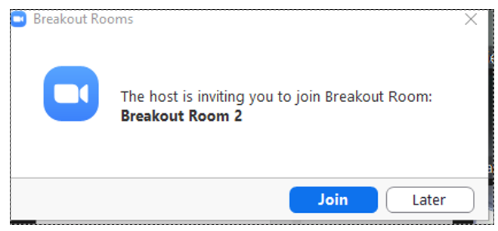

In the *breakout room*  you will see multiple options at the bottom of your screen, e.g. share screen, chat, ask help. With the latter button you can interact with the lecturer ..

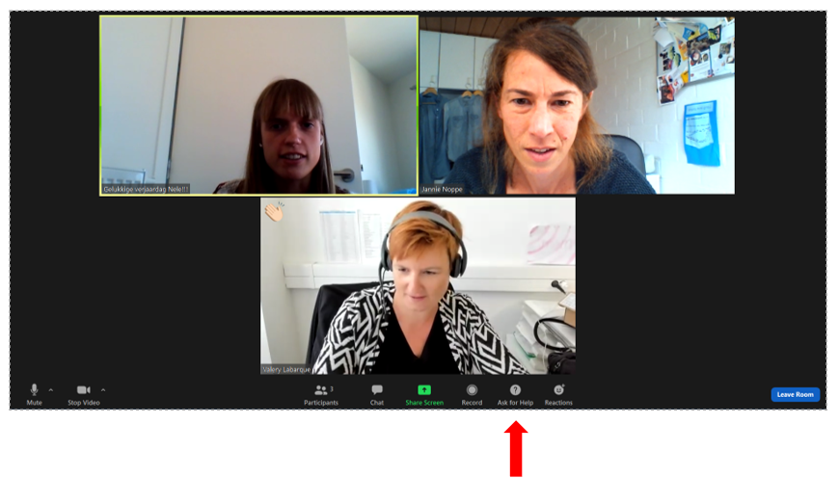

You will get a warning when the breakout room will end and when you will switch to the main session

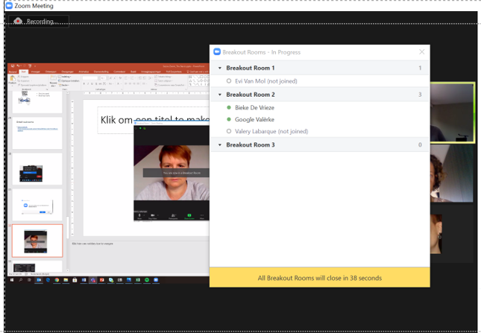

## Upon the lecture

A recording will be available on the ufora-course site. The lecturer will communicate where you can find the recording.