AngryBirds Report
姓名:楊凱強
學號: F74039059

The program is Qt Gui Application, using c++ to design it , and Box2D to be physic engine.

Environment
OS: ubuntu 14.04 LTS
gcc version: 4.9.1
QMake version: 4.0
Qt version: 5.6.0

UML Diagram:
All:
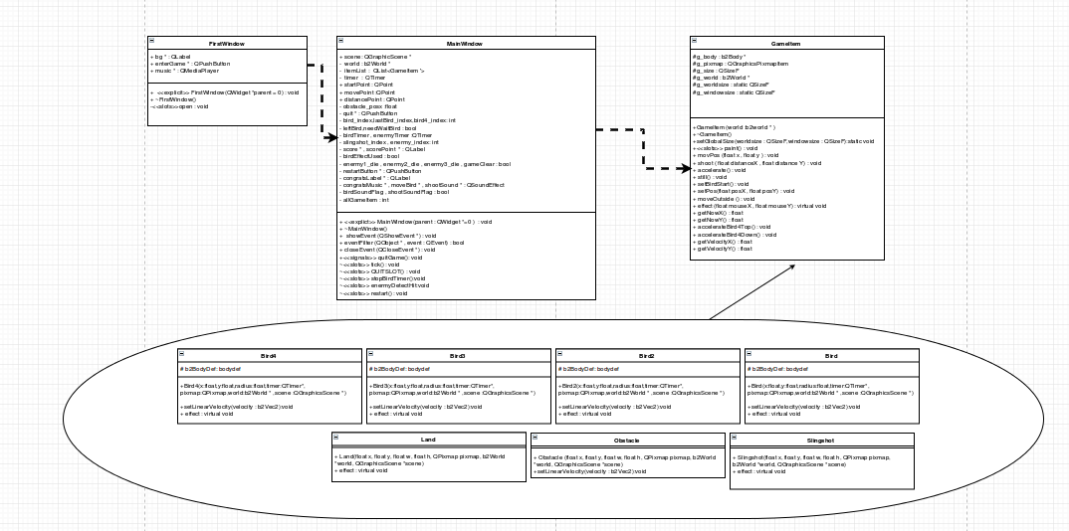
part1:
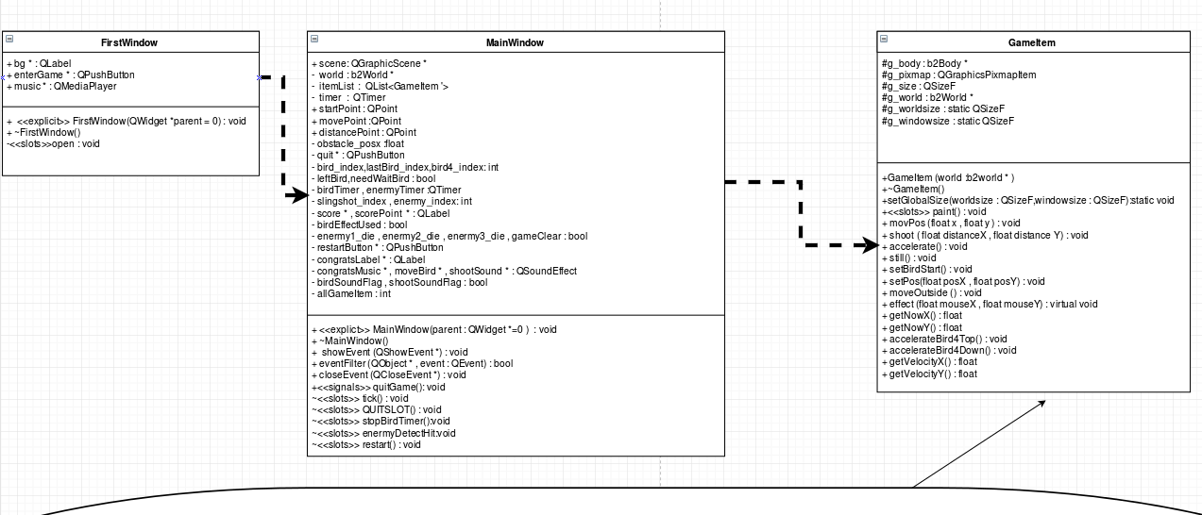
Part2:
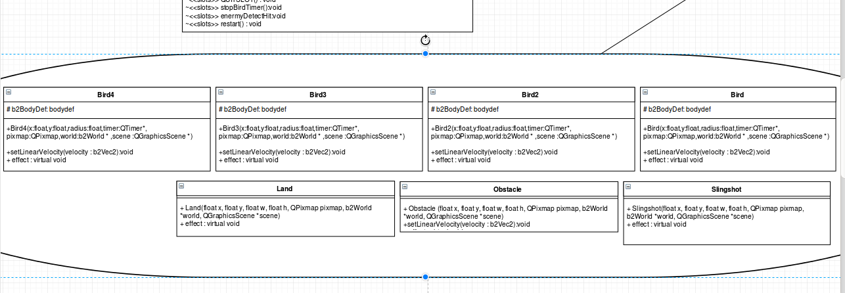

Architecture
FirstWindow
Design for entering game , and click Start to enter MainWindow.

Mainwindow
Handle whole game here , including all GameItems , and deal with all mouse click , move , release events , and if end game will call gameSet . We can restart and quit game in this window.
GameItem
Bird, Bird2, Bird3, Bird4, Obstacle, Land, Slingshot all derived from this base class , and we deal with left click in Polymorphism here , and control the box2D items moving correctly same with picture , dealing with collide here.

Land
derived from GameItem , and it's static body , cant move even in collide.
Slingshot
derived from GameItem , and it's static body , cant move even in collide.
Obstacle
derived from GameItem , and it's dynamic body , can move in colliding.
Bird, Bird2 , Bird3 , Bird4
derived from GameItem , and it's dynamic body , can move in colliding.We can set the velocity to birds also.

How to play it :
Start game:
this is FirstWindow , clicking Start to enter game.
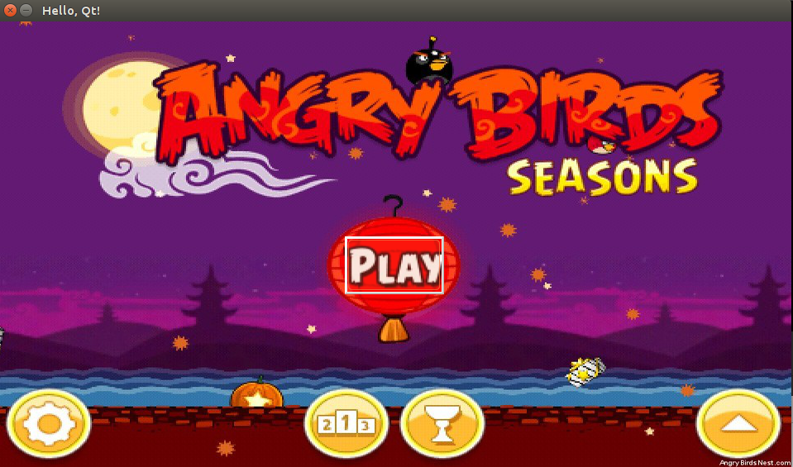
MainWindow:
All birds can use effect after shooting in leftClick in 3secds , but the first bird(red bird) has no effect in left click.
Second bird's (yellow) effect is shooting in high speeds horizontally .

Third bird's (green) effect is shooting in your mouse position while you click.

Forth bird's (white) effect is shooting dividing to three birds .

All enermy (green in the right side) will detect the collide , and will gone after get hit .

One enermy die add 1000 Points , if all enermy dead and we remain birds , the score will add 2000 points for one remaining bird. EX: I use 2birds to destroy all enermy , all enermy dead +3000 Points , and I left 2birds +4000 Points . Total I will get 7000Points.

We can restart game after clicking restart button , and quit game after clicking quit button.

