**Zayd Ahmed**

**1BM21CS254**

**Week 5 & 6 Bank Savings/Current Account Program**

**Input:-**

import java.util.Scanner;

class account {

String name;

int account_num;

String acc_type;

}

class sav_acct extends account {

double balance;

sav_acct(String n, int ac, String actype, Double bl) {

name = n;

account_num = ac;

actype = acc_type;

balance = bl;

}

Scanner sc = new Scanner(System.in);

void deposit(int val) {

balance += val;

}

void display_bal() {

System.out.println("Balance is: " + balance);

}

void deposit_interest() {

double int_rate = 0.05;

double time = 0;

System.out.println("enter the time period");

time = sc.nextDouble();

double amount;

amount = balance * Math.pow((1 + int_rate), time);

balance = amount;

}

void withdraw(int val) {

if (val > balance) {

System.out.println("out of funds, withdraw lesser");

} else {

balance -= val;

System.out.println("withdrawal successful");

System.out.println("new balance: " + balance);

}

}

void check_min() {

Double min_bal = 1000.00;

Double penalty = 100.00;

if (balance < min_bal) {

System.out.println("balance lesser than minimum balance, penalty imposed");

balance -= penalty;

}

else{

System.out.println("balance higher than minimum balance");

}

}

}

class cur_acct extends account {

double balance;

cur_acct(String n, int ac, String actype, Double bl) {

name = n;

account_num = ac;

actype = acc_type;

balance = bl;

}

void deposit(int val) {

balance += val;

}

void display_bal() {

System.out.println("Balance is: " + balance);

}

void deposit_interest() {

System.out.println("Current account doesnt provide any interest");

}

void withdraw(int val) {

System.out.println("Current account doesnt provide withdrawal facility");

}

void check_min() {

Double min_bal = 1000.00;

Double penalty = 100.00;

if (balance < min_bal) {

System.out.println("balance lesser than minimum balance, penalty imposed");

balance -= penalty;

}

else{

System.out.println("balance higher than minimum balance");

}

}

void cheque_withdrawal(int val) {

balance -= val;

System.out.println("withdrawal successful");

System.out.println("new balance: " + balance);

}

}

class bank {

public static void main(String args[]) {

Scanner sc = new Scanner(System.in);

System.out.println("enter your name, account number, aacount type(savings/current), balance");

String name = sc.nextLine();

int account_num = sc.nextInt();

String acc_type = sc.next();

double balance = sc.nextDouble();

if (acc_type.equals("savings")) {

sav_acct a1 = new sav_acct(name, account_num, acc_type, balance);

int choice = 0;

while (choice != 6) {

System.out.println(

"1.deposit\n2.display balance\n3.compute and deposit interest\n4.withdraw\n5.check for minimum balance\n6.exit");

choice = sc.nextInt();

switch (choice) {

case (1):

System.out.println("enter the value to deposit");

int val = sc.nextInt();

a1.deposit(val);

break;

case (2):

a1.display_bal();

break;

case (3):

a1.deposit_interest();

break;

case (4):

System.out.println("enter the value to withdraw");

int withd = sc.nextInt();

a1.withdraw(withd);

break;

case (5):

a1.check_min();

break;

case (6):

System.out.println("exited");

break;

default:

System.out.println("enter a valid choice");

break;

}

}

} else {

cur_acct a1 = new cur_acct(name, account_num, acc_type, balance);

int choice = 0;

while (choice != 6) {

System.out.println(

"1.deposit\n2.display balance\n3.compute and deposit interest\n4.withdraw using cheque\n5.check for minimum balance\n6.exit");

choice = sc.nextInt();

switch (choice) {

case (1):

System.out.println("enter the value to deposit");

int val = sc.nextInt();

a1.deposit(val);

break;

case (2):

a1.display_bal();

break;

case (3):

a1.deposit_interest();

break;

case (4):

System.out.println("enter the value to withdraw");

int withd = sc.nextInt();

a1.cheque_withdrawal(withd);

break;

case (5):

a1.check_min();

break;

case (6):

System.out.println("exited");

break;

default:

System.out.println("enter a valid choice");

break;

}

}

}

}

}

**Output for Savings Account-**

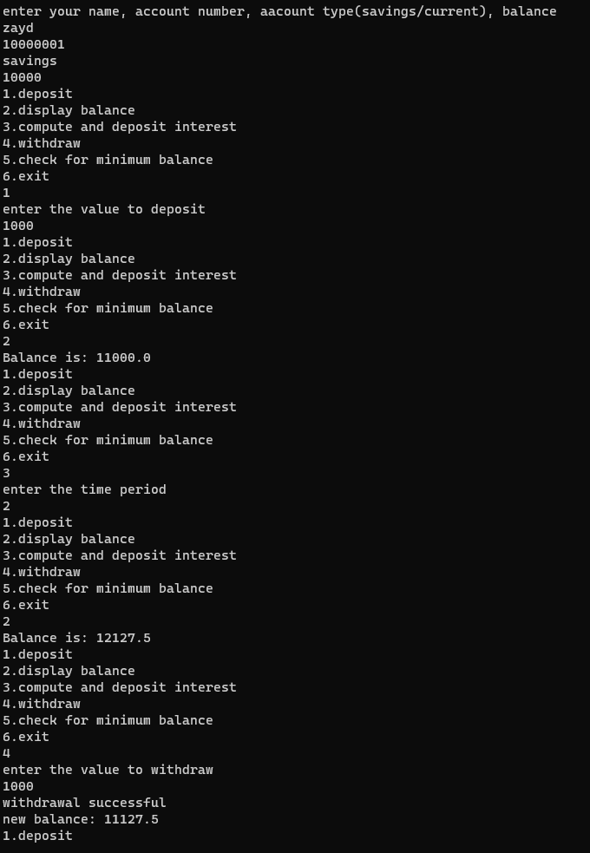

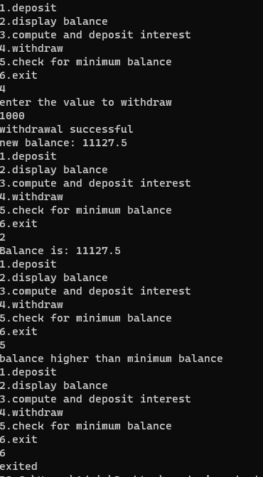

**Output for Current Account:-**



