**Zayd Ahmed**

**1BM21CS254**

**DBMS WEEK 4**

**Q4: Find the names of all branches that have greater assets than all branches located in Bangalore.**

select branch_name from branch where assets_in_lakhs>(select sum(assets_in_lakhs) from branch where branch_city='Bangalore');



**Q5: Demonstrate how you delete all account tuples at every branch located in a specific city (Ex. Bombay).**

delete from bank_account where branch_name in (select branch_name from branch where branch_city='Bombay');

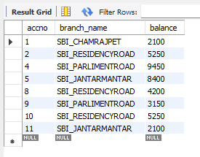

**Q6: Update the Balance of all accounts by 5%**

update bank_account

set balance = balance*1.05

