Troubleshooting MPLAB ICD 2
Some MPLAB ICD 2 units that are returned that have no problems. Before reporting a problem with your unit, please check these common issues. For more detailed troubleshooting, more information follows.
Common MPLAB ICD 2 Problems That You Should Consider Before Contacting Technical Support
What device are you working with?  If the device shows “yellow light” support in your version, often an upgrade to a newer version of MPLAB will provide “green light” support. “Yellow light” indicates early release, and later releases may address issues that you are encountering. Check to see the latest version of MPLAB at www.microchip.com/mplab. | 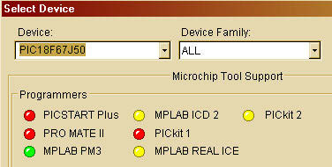
Are you using a Microchip demo board or your own design?  Microchip demo and evaluation boards have properly designed interfaces for MPLAB ICD 2. Make certain you followed the guidelines for resistors/capacitors on the MPLAB ICD 2 communications connections (in manual and on the poster). | 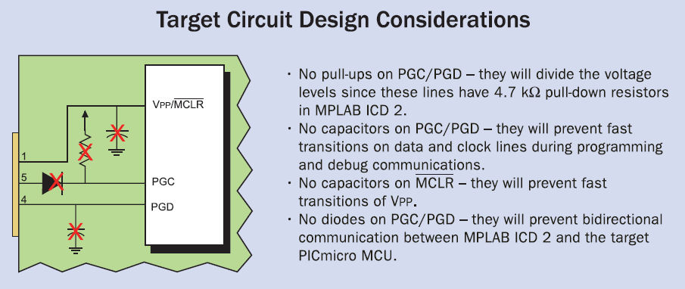
Is the target powered or are you powering from the MPLAB ICD 2?  Best results are with target power, since MPLAB ICD 2 can supply only a limited amount of current. | 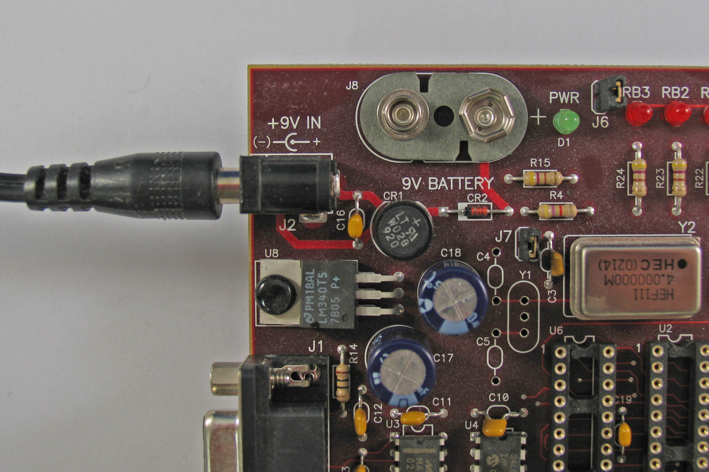
Are you using a USB hub?  Is it powered? Try using without the hub by plugging the MPLAB ICD 2 USB cable directly into the USB port of your PC. | 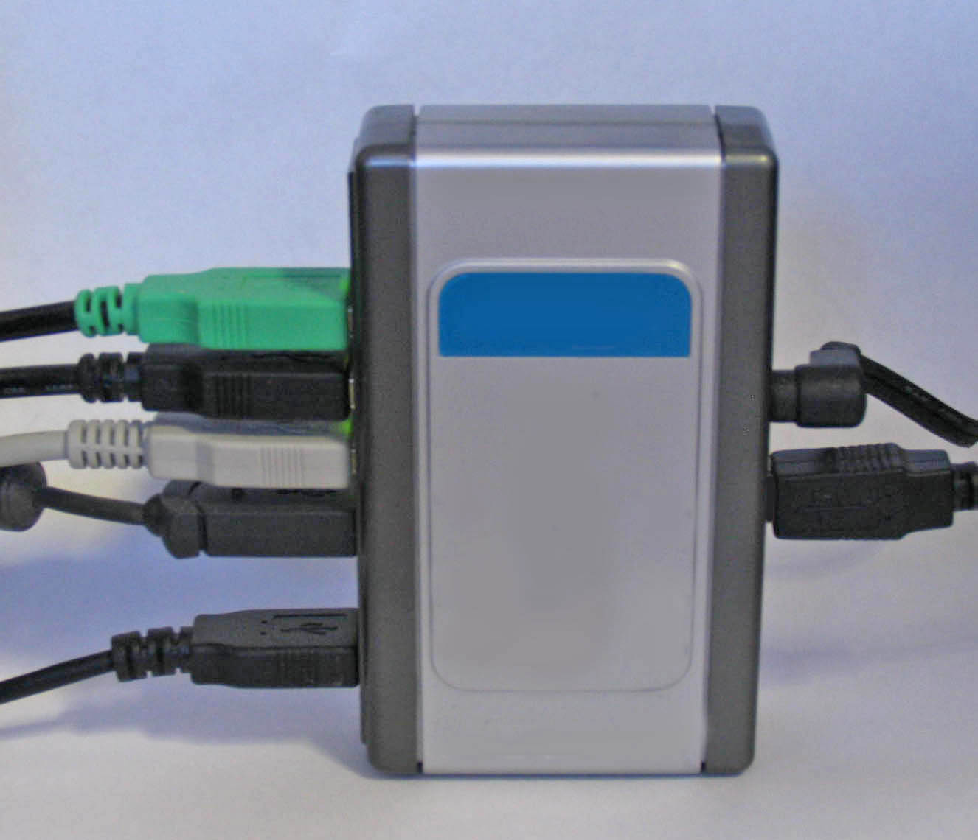
Are you using the RJ-11 cable shipped with MPLAB ICD 2?  Some people make longer cables, and these can introduce noise or cross-talk. If longer cables are required, you should consider MPLAB REAL ICE with the high-speed option. | 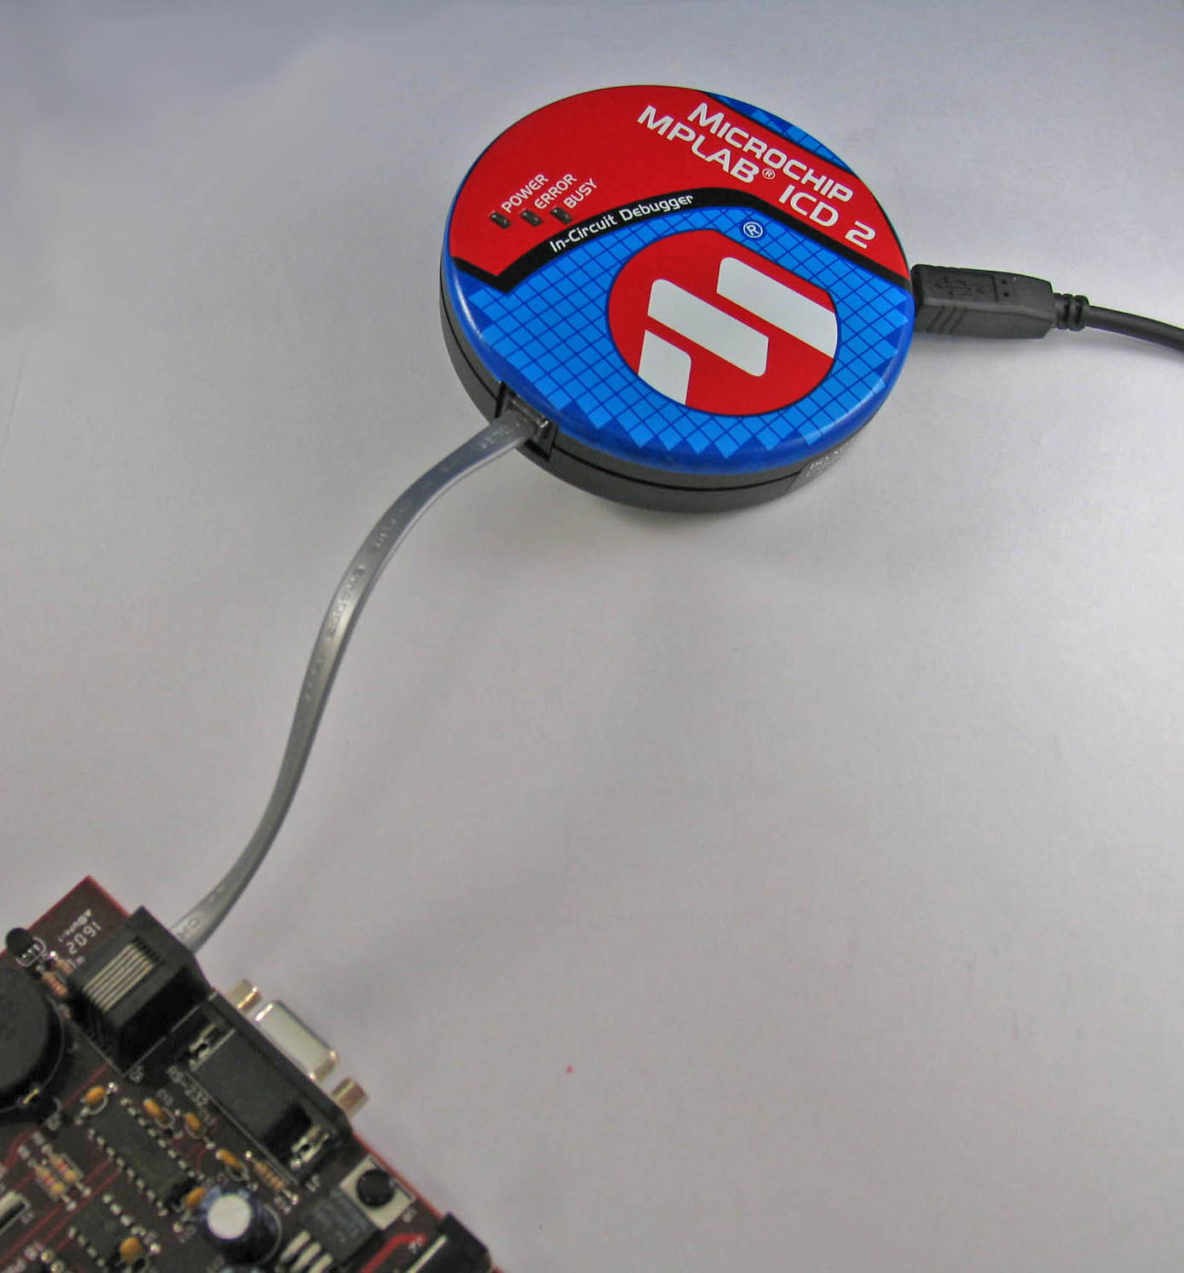

Remember: MPLAB ICD 2 relies upon a target properly executing code and communicating through the interface to function. In order for this low-cost debugger to be effective, building the project, setting the proper configuration bits, and effective communications protocols must be understood in the design of the target circuit and in the use of the MPLAB IDE and its software suite of tools. Read Chapter 6 in the MPLAB ICD 2 In-Circuit Debugger User’s Guide (DS-51331) for more information on the hardware and software resources that are required for MPLAB ICD 2 to communicate with the PC.
You can use this flow chart or look at the items below to help diagnose problems.
Here are some common problems that have been encountered using MPLAB ICD 2 and some tips for fixing them:
- MPLAB ICD 2 Driver Issues
- MPLAB ICD 2 Connection Issues
- Invalid Device ID
- Watch Window
- MPLAB IDE Installation with MPLAB ICD 2
- Other Errors
- MPLAB ICD 2 Does Not Work in Programming Mode
- Programming/Verification Failed
- MPLAB ICD 2 Debug Mode Issues

MPLAB ICD 2 Driver Issues:
- The busy LED of MPLAB ICD 2 is always on. When trying to download the firmware to reset, a message shows: "INVALID MPLAB ICD 2 module product ID (0)".

Resolution: Check that you do not have MPLAB ICD 2 connected to a powered target board when you plug it into the USB port. This can sometimes result in an invalid ID because the USB interface chip is partially powered.
Try disconnecting both the USB cable and the target board cable, and then connect the USB cable again.
If that does not help, remove and reinstall the USB drivers. You can use MPUsbClean.exe to remove the driver and MPUsbIRU.exe to preinstall the driver prior to plugging in MPLAB ICD 2.
C:\Program Files\Microchip\MPLAB IDE\Utilities\MPUsbClean\MPUsbClean.exe
C:\Program Files\Microchip\MPLAB IDE\Utilities\MPUsbIRU\MPUsbIRU.exe
When you connect MPLAB ICD 2 to the USB port, ensure that Windows does not select a driver file that is named OEMxx.INF. The correct files are MPLAB ICD 2W2KL.INF and MPLAB ICD 2W2K.INF, or something similar depending on your operating system.
- After a few hours in use, the PC cannot recognize MPLAB ICD 2. If the USB cable is disconnected then reconnected, the PC says that it senses a new device but cannot find the driver.
Resolution: The PC may be configured to put the USB port to sleep when it goes idle.
Go to the PC's Device Manager, and check the Properties of the USB Root Hub that MPLAB ICD 2 is attached to. Click on the "Power Management" tab and make sure the checkbox to turn off the USB hub is NOT checked.
Make sure when connecting MPLAB ICD 2 to the USB port that the power supply is not connected. MPLAB ICD 2 may not enumerate properly if a power supply is connected first, causing the Device Manager to appear.
- Unable to install the driver for MPLAB ICD 2 in Win XP Home Edition. Both ways have been tried:
  - Include this location ...: C:\Program Files\MPLAB IDE\DriversXP\ MPLAB ICD 2_USB. This results in this error: - "The wizard could not find the software on your computer".
  - Don't Search. I will ... This yields this error: - "The Specified location does not contain information about your hardware".
Resolution: Be sure you aren't connecting the USB through an un-powered hub, and that MPLAB ICD 2 doesn't have a separate power supply connected, as this can cause installation/enumeration problems. Also, read the .htm file in your Program Files/Microchip/MPLAB IDE/ICD2/Drivers folder. This gives exact installation instructions. Also check the device manager to see if an unknown USB device is shown under "Other Devices" and remove this.
- When installing, there is a message that the drivers are not found, even though they are in the driver folders, and the driver wizard is pointed to the correct folder?
Resolution: This problem can be solved by exiting from the driver install wizard, and going to the control panel “Add New Hardware” selection. After the system searches for new hardware, choose, “No, the device isn’t in the list.” Then choose “No, I want to select the hardware from a list.” And when the Have Disk… button appears, browse to the driver folder in the Program Files/Microchip/MPLAB IDE/ICD2/Drivers folder and select the proper driver.
Table of Contents

MPLAB ICD 2 Connection Issues:
- Can't establish communications to MPLAB ICD 2.
Resolution: Is MPLAB ICD 2 power light on? The LED should shine brightly. If it is dim, you may need to connect the power supply. The RS-232 connection from the PC cannot supply power to MPLAB ICD 2, but a USB connection can. Note that some USB hubs cannot supply power. Check the on-line help for current troubleshooting hints.
Are the USB drivers installed properly? MPLAB ICD 2 USB driver should be visible in the Windows Device Manager dialog. Some USB hubs cannot supply power to the attached USB devices. A power supply will need to be connected to MPLAB ICD 2 with these hubs.
Table of Contents

Invalid Device ID:
- Invalid target device ID messages appear when connecting to MPLAB ICD 2 header board for the PIC16F676. The header board is not connected to a target board, it is simply connected to MPLAB ICD 2 debugger.
Resolution: The debugger device on MPLAB ICD 2 header must have power supplied to it in order for it to be recognized by MPLAB ICD 2. If the header board is used outside of a demo board, MPLAB ICD 2 must supply power to it. In order to provide enough current MPLAB ICD 2 to power an external circuit, it needs to be powered by a 9V external supply.
- The target ID always reads 0x00.
For some reason, MPLAB ICD 2 cannot read the device properly. Check the connections from MPLAB ICD 2 to the device:
○ MCLR = 0.5 volts (too hi) - looks like bad driver in MPLAB ICD 2. Light load = 51k pup on target!
○ Vdd= 5v from target, ok
○ Vss= 0 ok
○ PGD = 0 volts
○ PGC= 2.0 volts. It doesn’t seem to move much. It just spikes around 2 V when, I try to program.
Resolution: The 6-pin cable connector may be backwards. Try rotating the cable 180 degrees and put the 6-pin connector on the other side or change the wiring on the other side.
Take a look at MPLAB ICD 2 Users Guide, or better – MPLAB ICD 2 poster included with your MPLAB ICD 2 or on our website for pinout and connector information.
- When using a PICDEM 4 demo board and MPLAB ICD 2 package everything works fine with the two chips supplied -18F1320 and 16F628.. The problem is when a 16F684 is inserted into the 14 pin socket of the PICDEM 4 and starting MPLAB IDE the message appears:
ICDWarn0020:Invalid Target device id(expected=0x84,read=0x0).
Resolution: A header AC162055 must be used to support this device with MPLAB ICD 2. The header is plugged in the socket instead of the PIC16F684.
- MPLAB ICD 2 stopped working. The following message is shown in the output window:
Auto-connect not enabled - Not connecting (Try enabling auto-connect on MPLAB ICD 2 settings pages.)
Connecting to MPLAB ICD 2 ...Connected
Setting Vdd source to MPLAB ICD 2
ICDWarn0020: Invalid target device id (expected=0x30, read=0x0)
...Reading ICD Product ID
Running ICD Self Test ...Passed
MPLAB ICD 2 Ready
Resolution: Here is an explanation of this message:
MPLAB ICD 2 is communicating with the PC just fine. The message is saying that it is not reading the device ID of the PIC that you have selected in MPLAB IDE (which in this case happens to be 0x30) and it didn't read the chip’s memory properly, so the returned value was 0.
The connections to the device have either failed or have some other interference, such as being too long. Keep the total length of the MPLAB ICD 2 cable and your board under 18 inches. There must be no pull-ups or series resistors of significance on the PGC and PGD lines. Caps on MCLR should be 0.1 uf or less. Vdd will need to be supplied by the target from an external power supply unless you choose "Power Target from MPLAB ICD 2" in Debugger>Settings or Programmer>Settings menu in MPLAB IDE.
MPLAB ICD 2 can't read the PIC device to verify that it is the proper part before programming. Check connections. Also, be sure all power and ground pins are connected on the part. Some PICs –especially those with A/Ds-- have more than one Vss and/or Vdd pin (usually labeled AVss and AVdd). Each of these should be connected. They should not be left floating.
Table of Contents

Watch Window:
- When using the MPLAB C30 C compiler with MPLAB ICD 2 and adding a variable to the watch window, the locations are stated to be reserved memory.
Resolution: Make sure that the "Link for MPLAB ICD 2" check box is checked in the linker build options.
Table of Contents

MPLAB IDE Installation with MPLAB ICD 2:
- When trying to install MPLAB IDE on Windows XP Professional for use with an MPLAB ICD 2, there is an error message saying that it has not been tested for 'logos' and is therefore may be unsafe.
Resolution: The MPLAB ICD 2 USB drivers are not registered with Microsoft, but they have been tested and verified by Microchip Technology. Proceed with the installation, ignoring this Microsoft warning message.
Table of Contents

Other Errors:
- MPLAB ICD 2 issues a warning (ICDWarn0033).
Resolution: This error may result when programming a device configured for internal MCLR and the internal oscillator. This mode is selected by the associated device configuration bits.
When Internal MCLR is used with MPLAB ICD 2 for programming, both Vpp and Vdd are powered together, and then Vpp is pulled high to Vihh to enter programming mode. This means that code will be running before Vpp goes to Vihh. If that code makes use of port pins that correspond to Clock and Data pins in programming mode, there is a chance their values may not be 0, as necessary to enter programming mode. Therefore, the device could not be reprogrammed.
Click OK to continue programming or click Cancel to cancel the programming operation.
Work-Around:
When External MCLR is configured, this is not a problem, as Vpp can go directly to Vihh. Also, if External Oscillator is configured, the external oscillator can be kept from running, thus keeping the code from running until Vpp is at Vihh.
Table of Contents

MPLAB ICD 2 Does Not Work in Programming Mode:
- MPLAB IDE will not connect to the Microchip MPLAB ICD 2 while MPLAB ICD 2 is connected to the Universal Programming Module. In some cases MPLAB ICD 2 works fine as a debugger (such as connected to the PICDEM 2 Plus demo board), however when trying to use it as a programmer (connected to the Universal Programming Module), it fails to connect.
Resolution: When using a target, MPLAB ICD 2 can supply a limited amount power to your target board (not usually recommended) or the board can have it's own power supply (recommended).
In the case of the Universal Programming Module, you cannot apply external power to it. So MPLAB ICD 2 must provide power to the UPM.
Any time you choose to have MPLAB ICD 2 supply target power, a power supply (9V DC) must be connected to MPLAB ICD 2.
  - Go to MPLAB ICD 2 settings (found under Programmer>Settings) and click on the Power tab.
  - Make sure the checkbox "Power Target Circuit from MPLAB ICD 2" is checked, and then press Apply.
  - Update the Voltage measurements in this window.
  - Make sure Vdd is around 5.0V and Vpp is roughly 13V.
- When using the QEI module, all works fine with MPLAB ICD 2 connected and configured as a debugger. But after programming and testing the chip without MPLAB ICD 2 connected, it appears that the QEI module no longer functions.
Resolution: In debugger-mode the Debug Executive is configuring some pins to be digital I/O. In programmer mode this is not the case, which leaves the QEA and QEB in (default) analog mode. Make sure that your program properly configures this peripheral and pins.
Table of Contents

Programming/Verification Failed:
- MPLAB ICD 2 gets a failed message after programming.
Resolution: Check PGC, PGD and VPP connections and voltages. Make sure the target PICmicro MCU has power applied. If the target PIC MCU has AVss and AVdd pins, verify that these are all connected properly. They must not be allowed to float unconnected.
- The boot code protection and write boot protection are enabled. When programming is attempted, read or verify, the answer is still 'Verify failed' (all positions read as '0'). The target operates with a supply of 2.8V.
Resolution: To disable the protection bits, MPLAB ICD 2 may need to do a bulk-erase, which requires higher voltage than 2.8V, typically 4.5V or higher (check the programming specification for the correct data). Try changing to "Power target circuit from MPLAB ICD 2 (5V)" in the setup configuration. Use this method to erase or later program the chip. After that, switch back to "target has its own power supply" and program/erase/play as usual (until you set the protection mode/bits again and then need to set "Power target circuit from MPLAB ICD 2" to program).
Table of Contents

MPLAB ICD 2 Debug Mode Issues:
- MPLAB ICD 2 responds with "Target not in debug mode” error.
Resolution: Usually this means that MPLAB ICD 2 cannot communicate with the debug executive (the small program programmed into the target device that allows communication with MPLAB ICD 2 –see Chapter 6 in MPLAB ICD 2 User’s Guide). This debug executive is downloaded when programming the target PIC MCU with the user's application from the Debugger>Program menu selection. There are other reasons that the debug executive might not be able to communicate, such as target clock or power supply problems. Check the configuration bits to see that "Background Debug" is enabled –MPLAB IDE should enable these automatically. Look at Configure>Configuration Bits to make sure that
  - Watchdog Timer is disabled,
  - code protection is turned off and
  - the oscillator setting is correct.
- Unable to enter debug mode.
Resolution: MPLAB ICD 2 is unable to establish communications with the debug software on the target. This will prevent all debug operations (run, step, halt, breakpoint, etc.).
Debug Failure Actions:
MPLAB ICD 2 was unable to perform a debugging operation. There are numerous reasons why this might occur.
Common Reasons Why MPLAB ICD 2 Is Unable To Debug:
1. The oscillator is not working. Check the configuration bits setting for the oscillator.
2. The target board is not powered. Check the power cable connection.
3. MPLAB ICD 2 has somehow become physically disconnected from the PC. Check the USB or COM communication cable connection.
4. MPLAB ICD 2 has somehow become physically disconnected from the target board. Check the communications cable connection.
5. The device is code-protected. Make sure that the Configure>Configuration Bits code protection settings are off.
6. You are trying to rebuild the project while in Release mode (which does not download the debug executive). Select Project>Build Configurations>Debug, then rebuild the project.
7. MPLAB ICD 2 is selected as a programmer, and not as a debugger in MPLAB IDE.
8. MPLAB ICD 2 to PC communications has somehow been interrupted. Select Debugger>Reconnect in MPLAB IDE.
9. The target application has somehow become corrupted or contains errors. For example, the regular linker script was used in the project instead of the MPLAB ICD 2 version of the linker script (e.g., 18F8722.lkr was used instead of 18F8722i.lkr). Try rebuilding and reprogramming the target application. Then initiate a power-on-reset of the target.
10. Other configuration settings are interfering with debugging. Any configuration setting that would prevent the target from executing code will also prevent MPLAB ICD 2’s debug executive from functioning..
11. MPLAB ICD 2 cannot always perform the action requested. For example, a breakpoint can’t be set if the target application is currently running.
Other Things to Consider:
1. It is possible the error was a one-time glitch. Try the operation again.
2. There may be a problem programming in general. As a test, switch to Programmer>Select Programmer>MPLAB ICD 2 mode and program the target with the simplest application possible (e.g., a program to blink an LED.) If the program will not run, then you know that something is wrong with the target setup.
3. It is possible that the target device has been damaged in some way (e.g., over current.) Development environments are notoriously hostile to components. Consider trying another target device.
4. Microchip Technology Inc. offers demonstration boards to support most of its microcontrollers. Consider using one of these applications, which are known to work, to verify correct MPLAB ICD 2 functionality.
5. Review the operational theory of MPLAB ICD 2 operation to ensure proper application setup. (MPLAB ICD 2 In-Circuit Debugger User’s Guide)
Table of Contents

