FINAL EXPERIMENTAL
RESULTS REPORT
IMU-Based Cable-Driven Rehabilitation Assistance System
Final-session evaluation of Following-only, PID-assisted, and LADRC-assisted control modes
Dataset: 15 final trials (5 trials per mode)
Reference trajectory: approximately 5-s sinusoidal elbow-angle target

1. Executive Summary
Key findings
LADRC produced the lowest overall tracking-error metrics: RMSE 10.36 ± 1.28°, MAE 8.88 ± 1.29°, and maximum absolute error 20.43 ± 2.97°.
PID produced the highest movement completion (ROM 91.7 ± 18.6%) but also the largest estimated phase delay (0.774 ± 0.215 s), which inflated time-synchronized tracking error.
LADRC maintained similarly high ROM completion (90.5 ± 3.5%) while reducing RMSE by 39.7% relative to PID.
Following-only showed lower temporal delay (0.304 ± 0.107 s) but substantially lower ROM completion (63.4 ± 6.0%).

Overall interpretation. The final-session data support LADRC as the best overall balance between trajectory accuracy and movement completion within the tested system. PID delivered strong movement assistance but showed a clear phase-lag trade-off. Following-only preserved temporal responsiveness but did not provide comparable movement completion.

2. Experimental Design and Data Processing
- Three operating modes were evaluated: Following only, PID-assisted following, and LADRC-assisted following.
- Five trials were recorded for each mode, yielding 15 final-session trials in total.
- The fitted target period across the final dataset was approximately 5.001 s, consistent with the nominal 5-s sine trajectory.
- The first 1.5 s of every trial were excluded from primary analysis to reduce the influence of startup transient mismatch.
- For trajectory figures, each trial was aligned to the fitted sine phase and processed independently before equal-weight averaging across trials. Periodic smoothing was used only for display.
- All primary RMSE, MAE, maximum-error, tracking-rate, delay, and ROM values were calculated from the original post-transient samples; true dynamic extrema were not deleted from the primary statistics.
- Tracking rate was recomputed as the percentage of post-transient samples satisfying |tracking error| ≤ 5°, matching the ±5° tolerance band used in the figures.
- A separate 5% absolute-error trimming analysis was performed only as a sensitivity check and is reported in Appendix B.

3. Final Performance Summary
Mode | RMSE (°) | MAE (°) | Max error (°) | ±5° rate (%) | Delay (s) | ROM (%)
Following only | 11.13 ± 1.41 | 9.21 ± 1.43 | 22.67 ± 2.14 | 32.7 ± 6.7 | 0.304 ± 0.107 | 63.4 ± 6.0
PID-assisted | 17.18 ± 3.52 | 14.65 ± 3.07 | 31.65 ± 5.18 | 17.6 ± 5.8 | 0.774 ± 0.215 | 91.7 ± 18.6
LADRC-assisted | 10.36 ± 1.28 | 8.88 ± 1.29 | 20.43 ± 2.97 | 28.7 ± 6.4 | 0.453 ± 0.076 | 90.5 ± 3.5
Table 1. Final post-transient performance, reported as mean ± SD across five trials per mode.
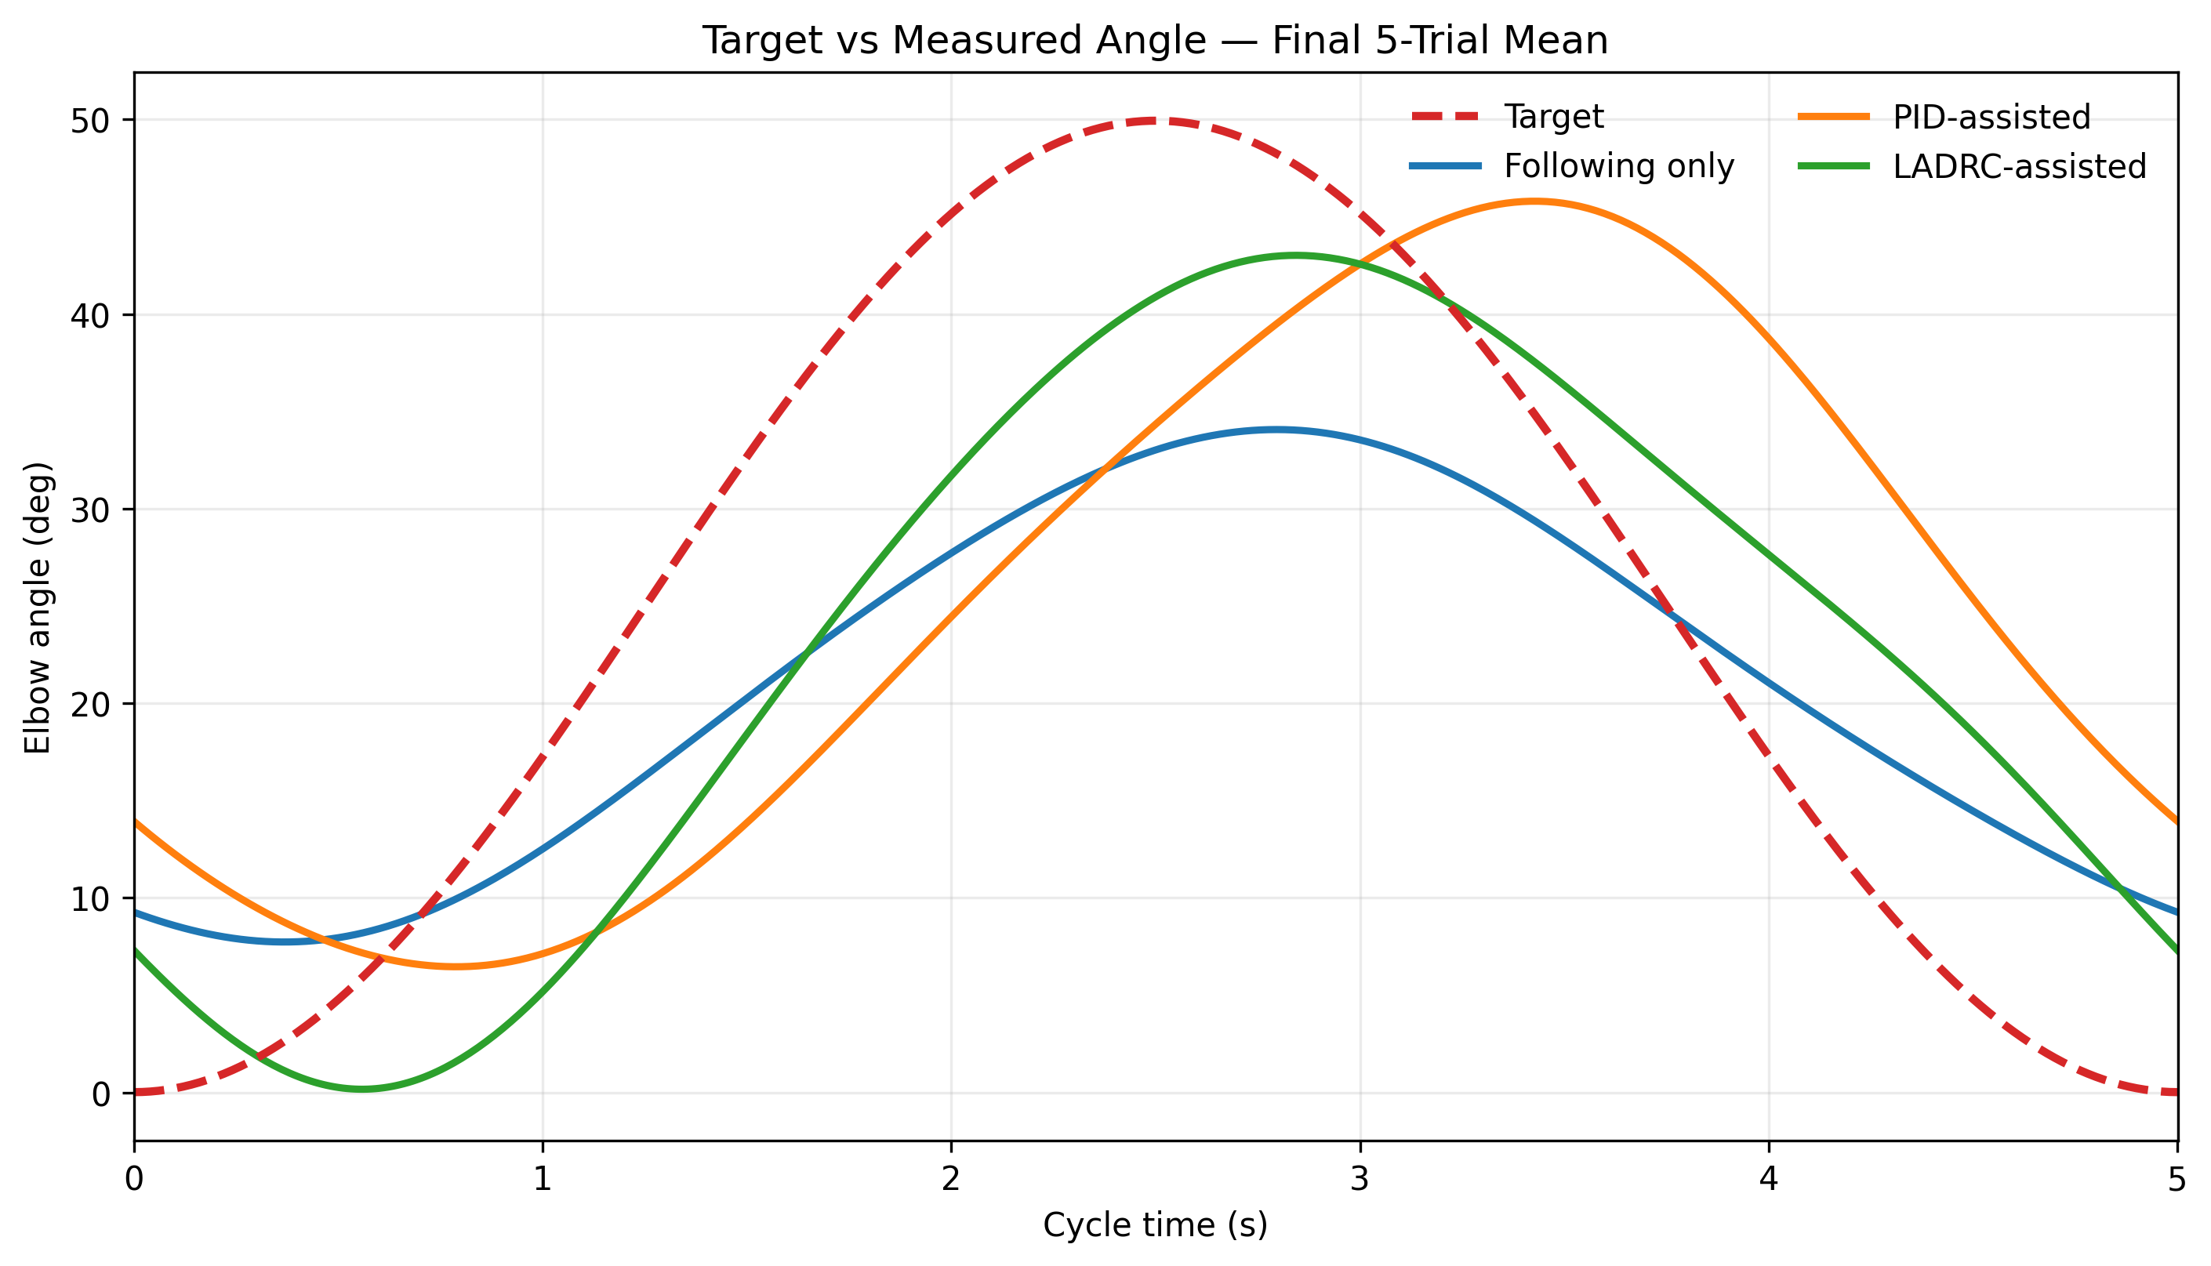
Figure 1. Phase-aligned mean target and measured elbow-angle trajectories across five final trials per mode.
Trajectory interpretation. The PID trajectory shows a pronounced temporal shift relative to the target, whereas LADRC maintains high movement amplitude with less overall tracking deviation. Following-only exhibits lower movement amplitude, consistent with its lower ROM-completion result.
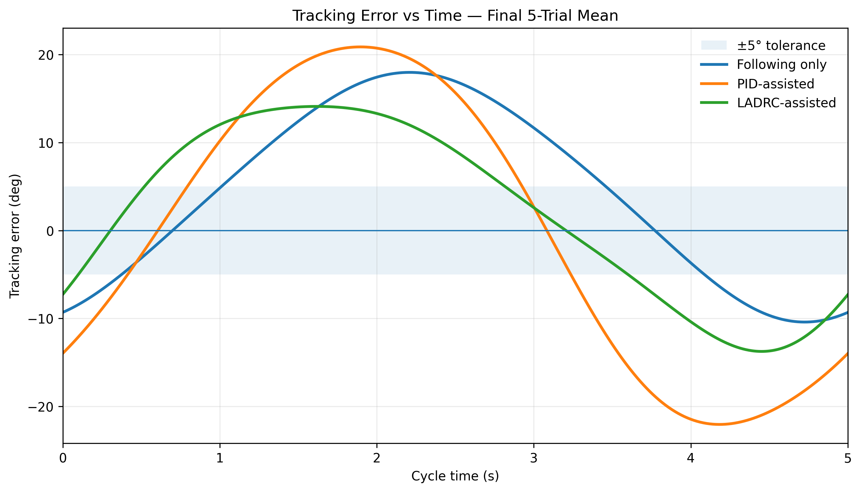
Figure 2. Phase-aligned tracking error over one normalized sine cycle. The shaded band represents ±5° tolerance.

4. Tracking Accuracy
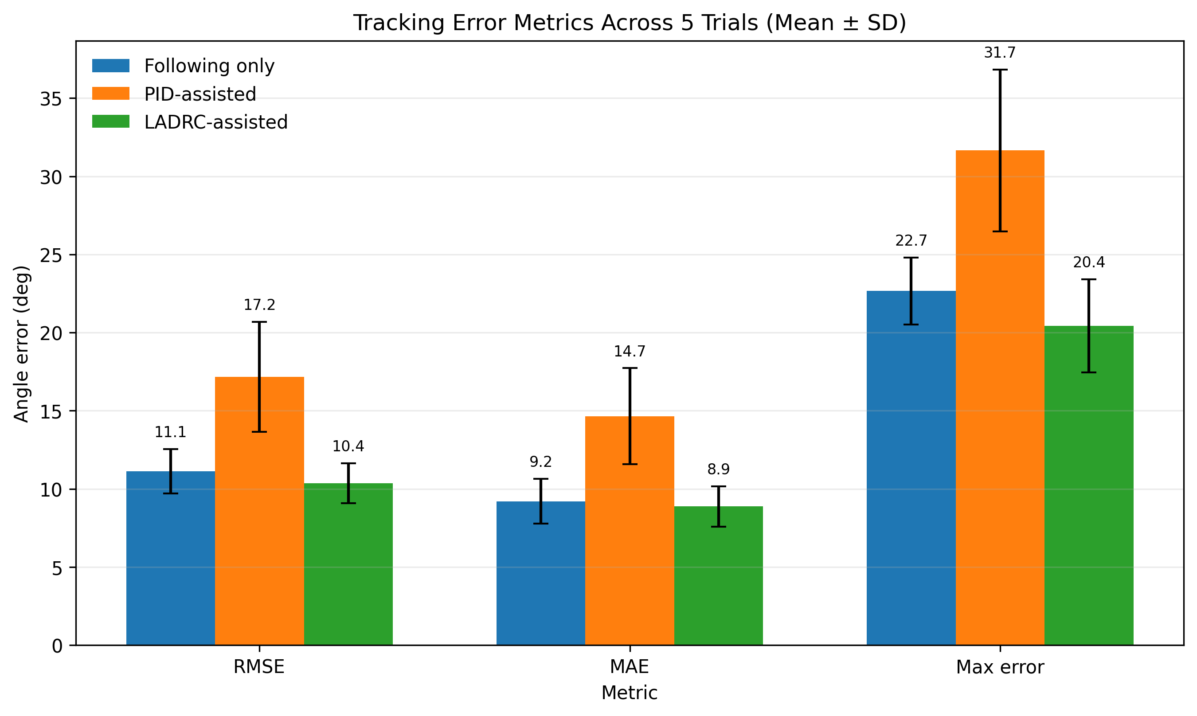
Figure 3. RMSE, MAE, and maximum absolute tracking error across five final trials (mean ± SD).
- LADRC achieved the lowest RMSE (10.36°), compared with Following only (11.13°) and PID (17.18°).
- Relative to PID, LADRC reduced RMSE by 39.7%, MAE by 39.4%, and maximum error by 35.5%.
- PID therefore did not provide the best time-synchronized trajectory tracking in this final dataset, despite producing strong movement assistance.
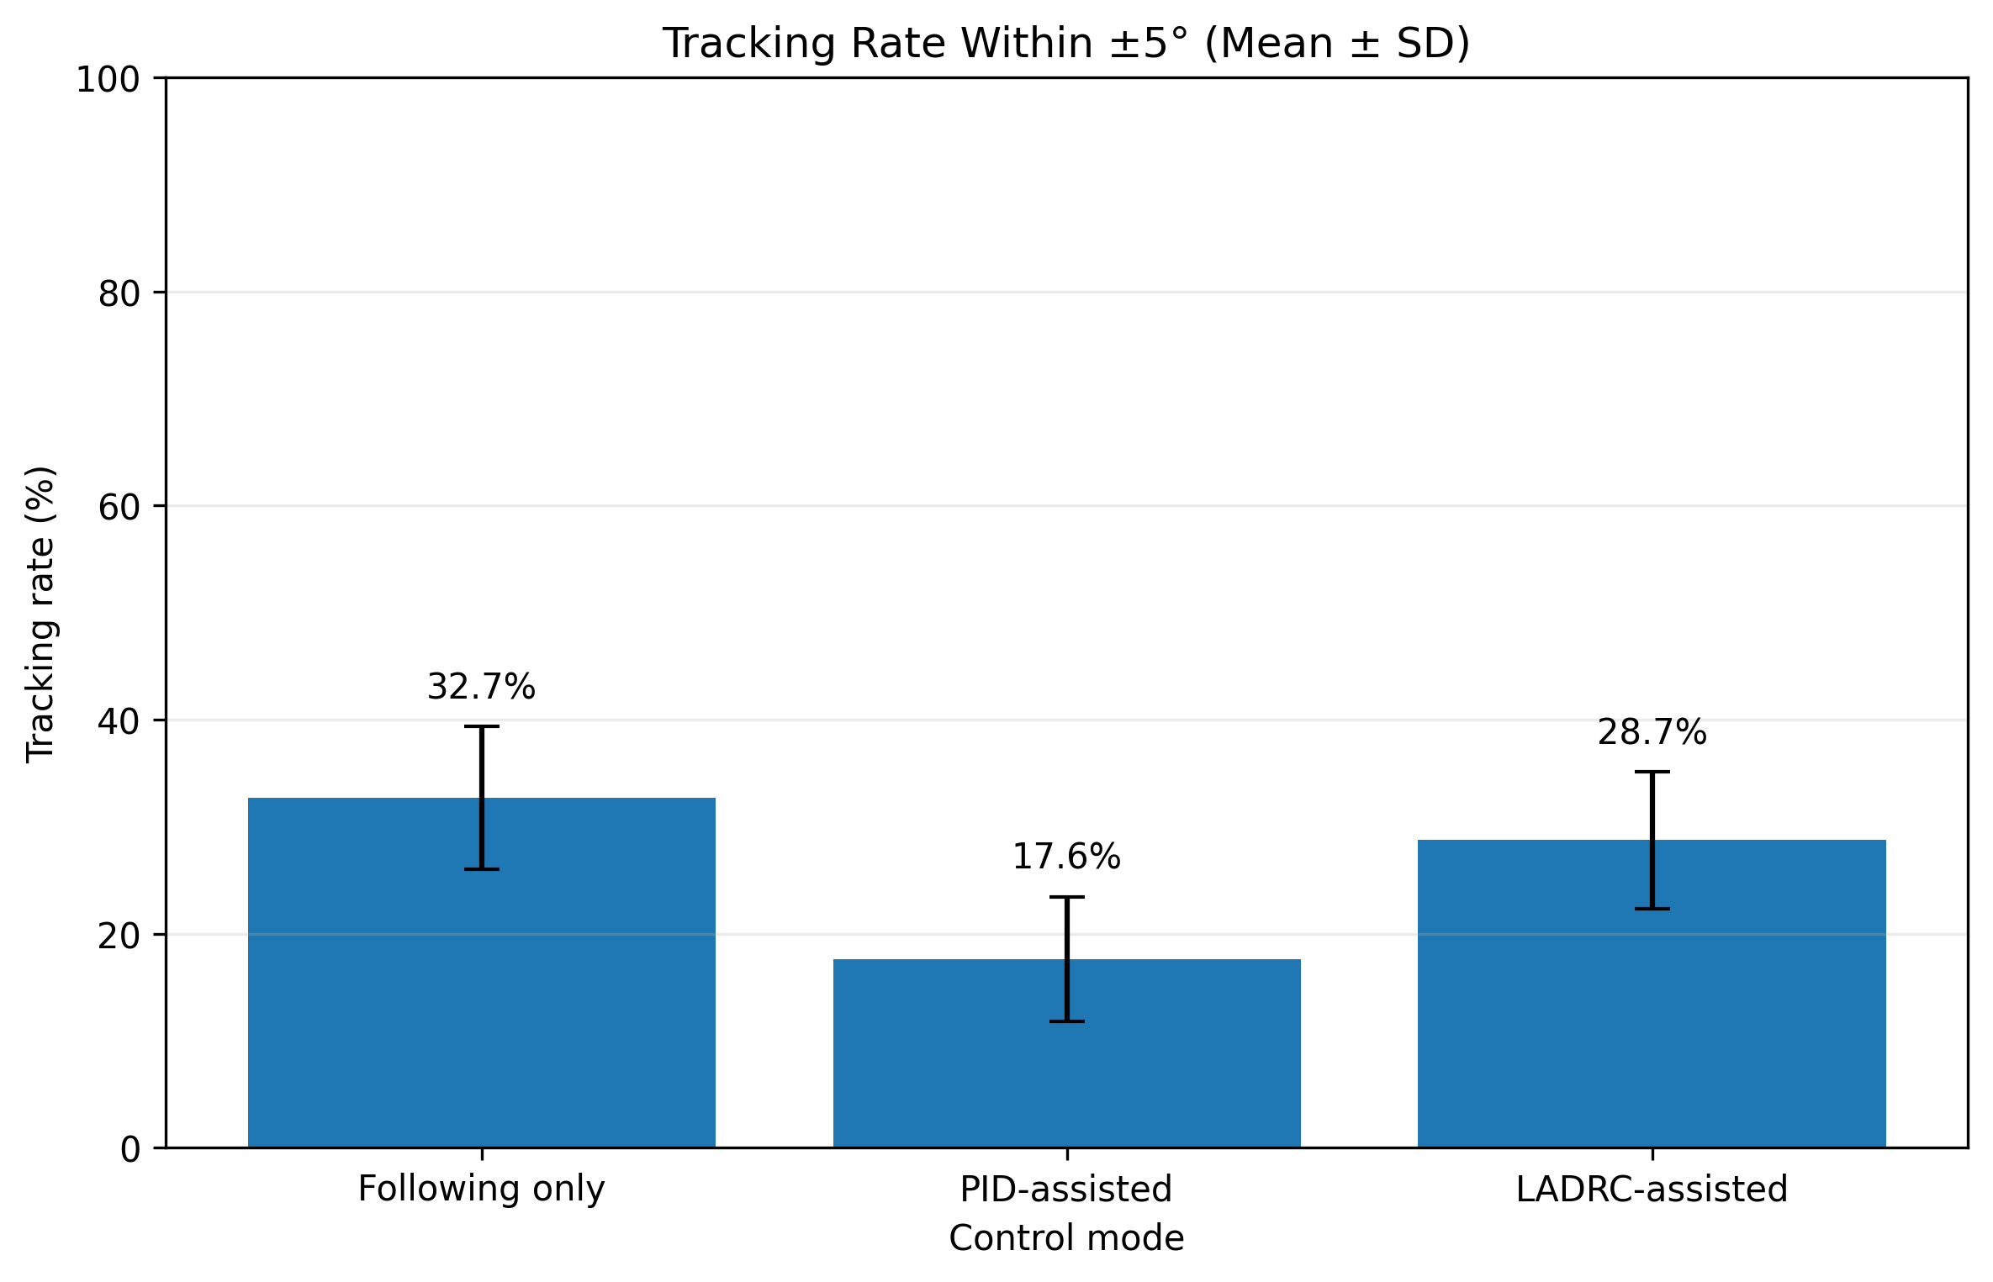
Figure 4. Percentage of post-transient samples within ±5° of the reference target.
Important nuance. Following-only produced the highest ±5° sample rate (32.7%), followed by LADRC (28.7%) and PID (17.6%). This metric should therefore be interpreted together with ROM and delay rather than as a standalone ranking of assistance quality.

5. Movement Completion and Temporal Response
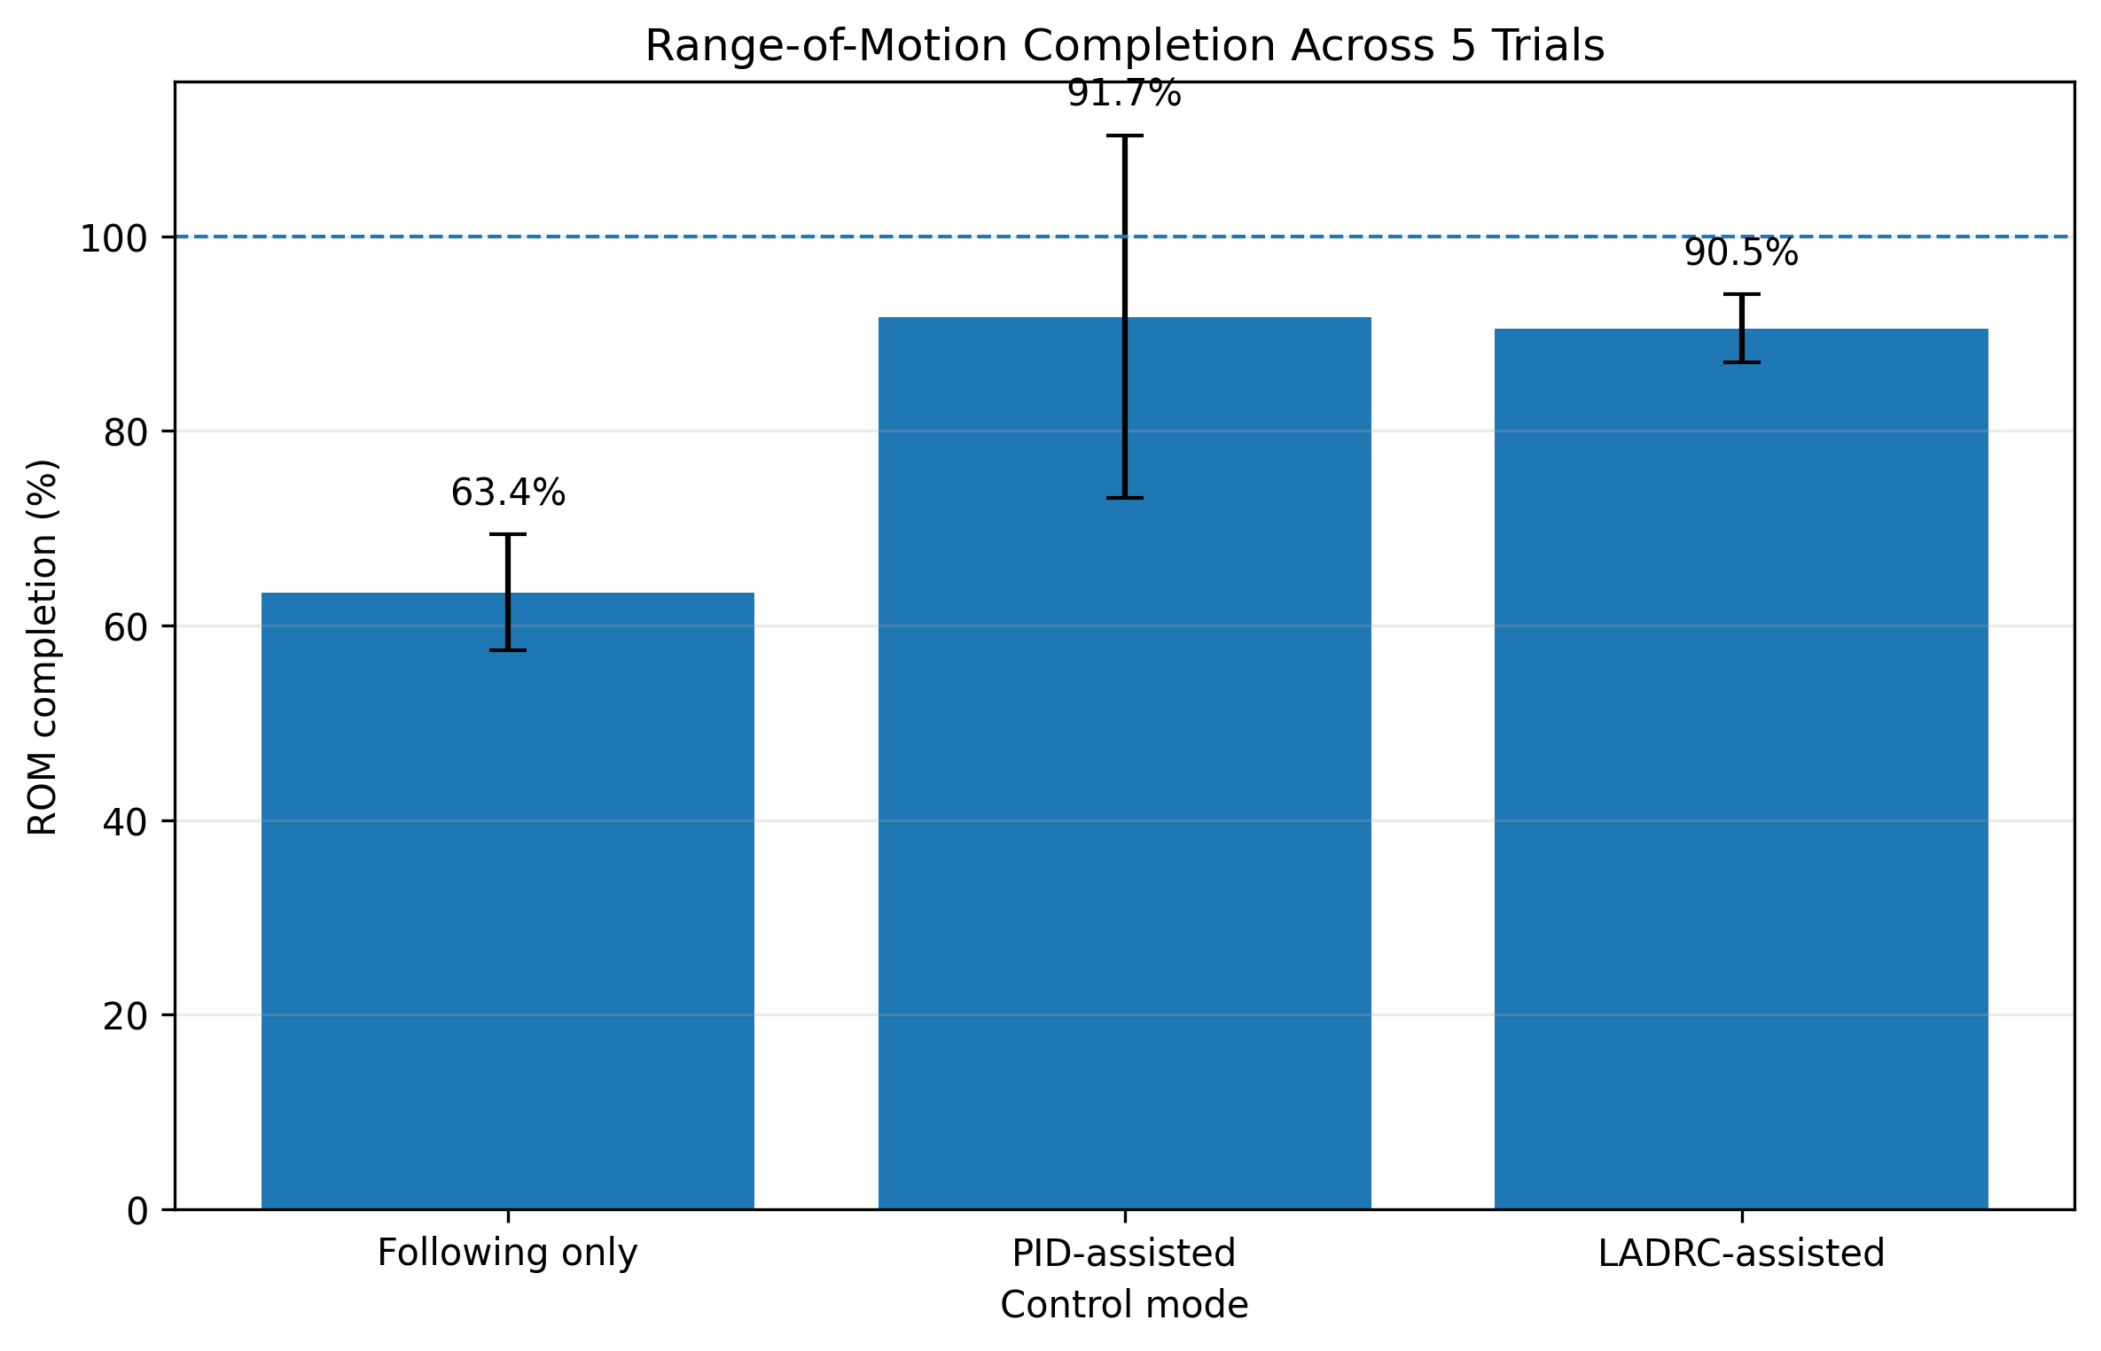
Figure 5. Range-of-motion completion across five final trials (mean ± SD).
- Following-only ROM completion was 63.4 ± 6.0%.
- PID increased ROM completion to 91.7 ± 18.6%.
- LADRC achieved 90.5 ± 3.5% ROM completion, closely matching PID while producing substantially lower error.
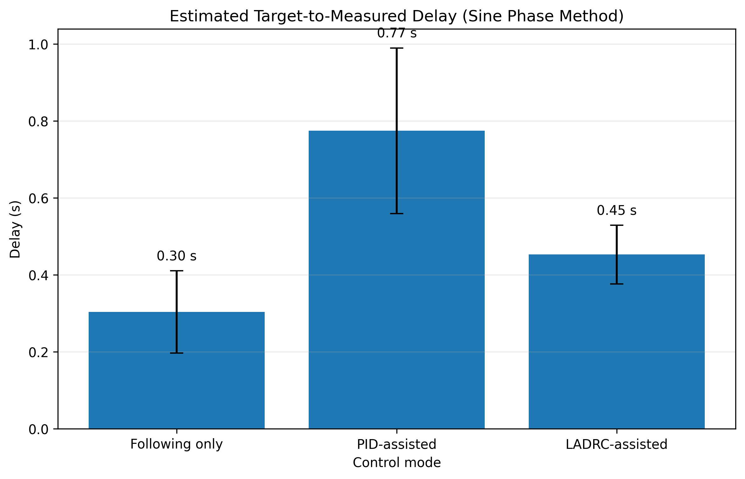
Figure 6. Estimated target-to-measured delay based on the phase difference of the fitted 5-s sine responses.
- PID exhibited the largest average phase delay (0.774 ± 0.215 s).
- LADRC reduced delay to 0.453 ± 0.076 s, approximately 41.5% lower than PID.
- Following-only showed the shortest delay (0.304 ± 0.107 s), but this occurred together with much lower ROM completion.

6. Repeated-Trial Variability
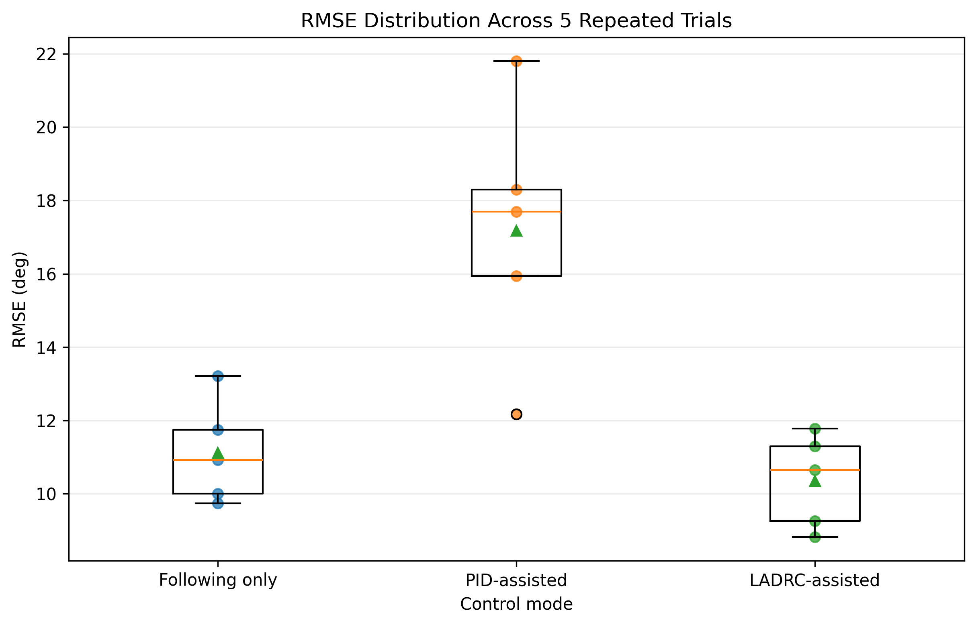
Figure 7. RMSE distribution across the five repeated trials of each mode.
Variability. LADRC showed the smallest RMSE standard deviation (1.28°), followed by Following only (1.41°), whereas PID had the largest variability (3.52°). This suggests that LADRC produced the most consistent tracking accuracy within the final-session dataset.

7. Actuator PWM Behavior
The biceps and triceps PWM plots below show the phase-aligned mean motor commands over one reference cycle. These plots describe how the antagonistic cable-driven actuators were recruited under each control strategy.
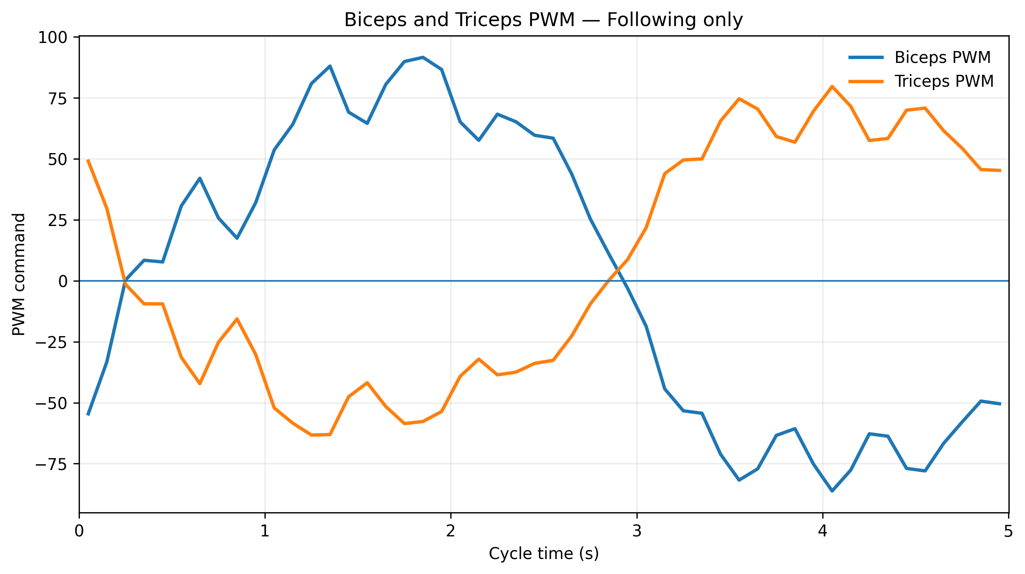
Figure 8 — Following only. Phase-aligned biceps and triceps PWM commands.
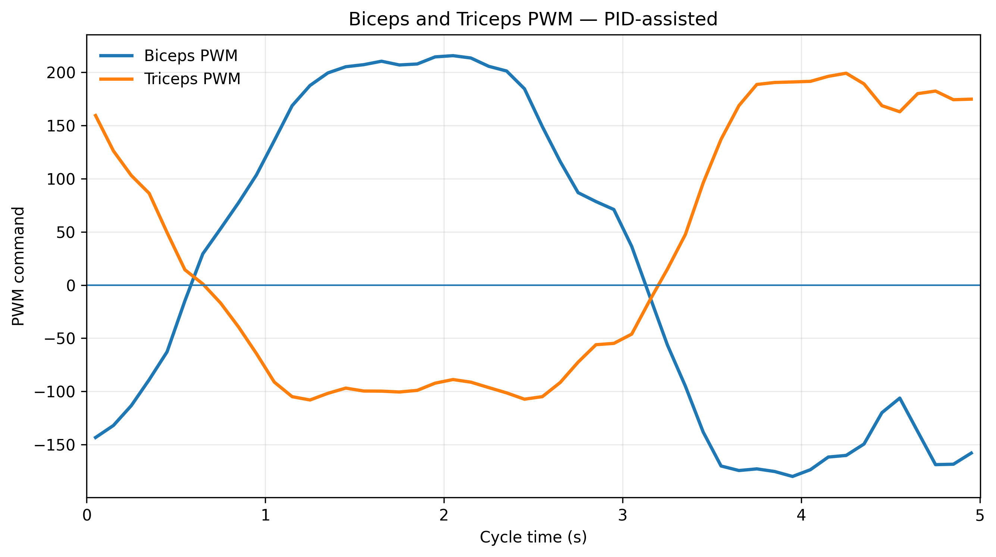
Figure 8 — PID-assisted. Phase-aligned biceps and triceps PWM commands.
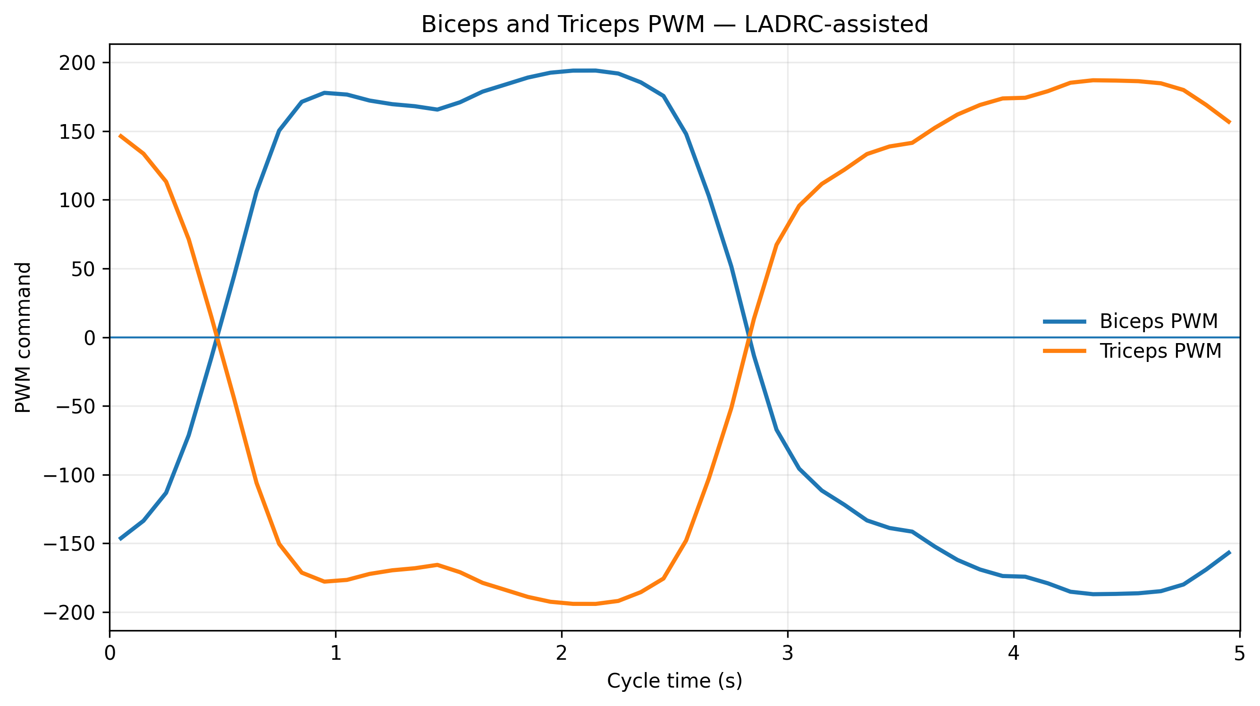
Figure 8 — LADRC-assisted. Phase-aligned biceps and triceps PWM commands.

8. Controller Compensation Behavior
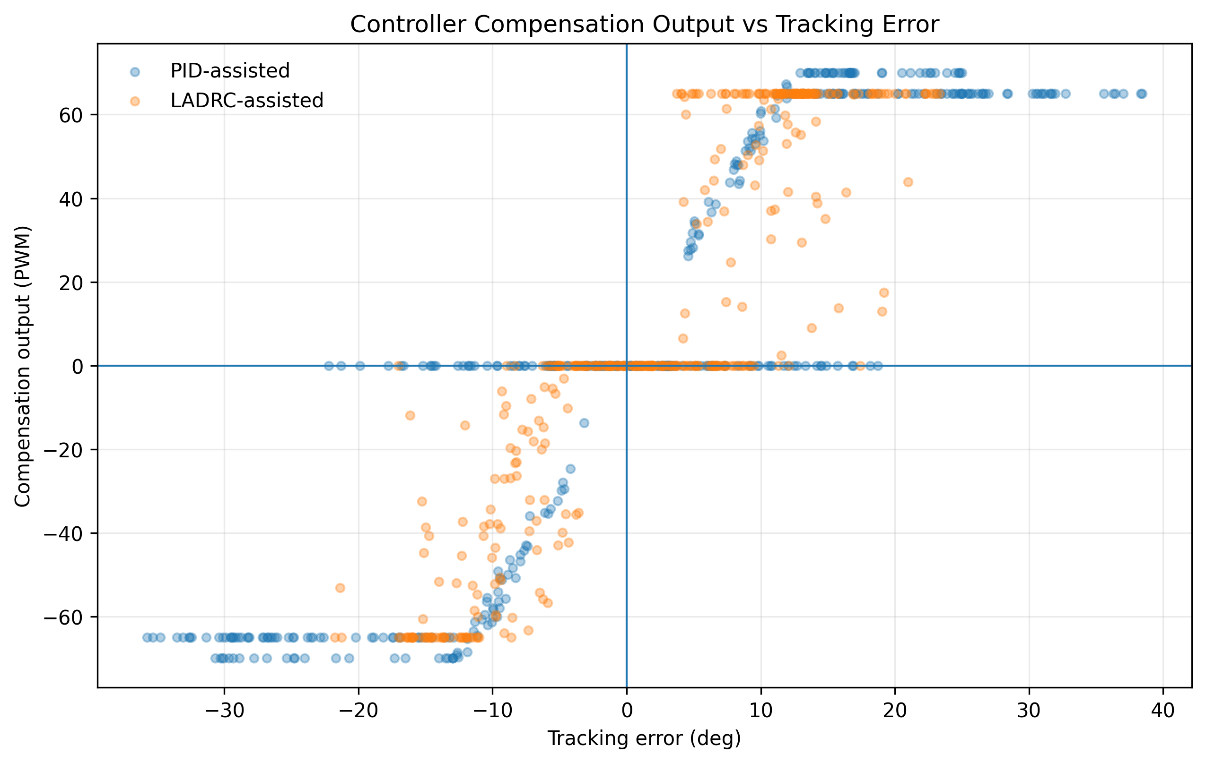
Figure 9. Controller compensation output as a function of instantaneous tracking error for PID and LADRC trials.
The compensation-output distribution reflects the gated assist-as-needed architecture: controller output is activated only under the configured lag/assistance logic and then combined with the baseline following command. The plot should therefore be interpreted as controller behavior inside the complete rehabilitation-control architecture rather than as a standalone classical feedback loop.

9. Sensitivity to Extreme Error Samples
To verify that the main conclusion was not driven only by a small number of large-error samples, a secondary analysis removed the largest 5% of |tracking error| values within each trial. These trimmed values were not used for the primary figures or claims.
Mode | Trimmed RMSE (°) | Trimmed MAE (°) | Trimmed max error (°) | Trimmed ±5° rate (%)
Following only | 10.17 ± 1.41 | 8.48 ± 1.42 | 20.13 ± 1.65 | 34.6 ± 7.0
PID-assisted | 16.05 ± 3.52 | 13.74 ± 3.03 | 29.36 ± 5.53 | 18.6 ± 6.2
LADRC-assisted | 9.46 ± 1.22 | 8.20 ± 1.28 | 18.17 ± 2.34 | 30.5 ± 6.9
Table 2. Secondary 5% trimmed sensitivity analysis (mean ± SD across trials).
Sensitivity conclusion. The ranking of the main error metrics remained unchanged after trimming: LADRC retained the lowest trimmed RMSE and MAE, PID remained highest, and Following-only remained intermediate. The principal interpretation is therefore not explained solely by isolated extreme errors.

10. Controller-Setting Audit and Interpretation Limit
Important methodological limitation. The five PID trials in the final session were not recorded under one perfectly identical output setting. Trials 1–2 used an observed following PWM of 130 with a maximum compensation output of 70, whereas trials 3–5 used following PWM 140 with a maximum compensation output of 65. The Following-only and LADRC trials were internally consistent.
Mode | Trials | Observed following PWM | Observed max |compensation|
Following only | 1, 2, 3, 4, 5 | 130 | 0
PID-assisted | 1, 2 | 130 | 70
PID-assisted | 3, 4, 5 | 140 | 65
LADRC-assisted | 1, 2, 3, 4, 5 | 130 | 65
Table 3. Observed control-output settings recorded in the final-session files.
- Accordingly, the five-trial PID average should be described as final-session PID performance, not as five strictly identical repetitions of one fixed tuning condition.
- The report does not claim that PID is intrinsically inferior to Following-only or LADRC; the results are specific to the tested controller configuration and rehabilitation-assistance architecture.
- The LADRC comparison is nevertheless meaningful as a system-level result: under the recorded final-session settings, LADRC achieved high ROM completion with substantially lower tracking error than PID.

11. Discussion

11.1 Following-only mode
Following-only achieved an RMSE of 11.13° and the shortest estimated delay (0.304 s), but ROM completion was only 63.4%. This indicates that intent-following assistance alone preserved relatively responsive movement but did not consistently complete the full desired range of motion.

11.2 PID-assisted mode
PID-assisted control increased ROM completion to 91.7%, confirming that feedback assistance helped complete the rehabilitation movement. However, the average delay increased to 0.774 s and RMSE to 17.18°. The results support the observed trade-off: the PID condition produced stronger/more complete motion but suffered from overall phase lag, which is heavily penalized by time-synchronized RMSE.

11.3 LADRC-assisted mode
LADRC achieved RMSE 10.36°, MAE 8.88°, maximum error 20.43°, and ROM completion 90.5%. Its error metrics were the best of the three final-session modes while its ROM remained close to PID. This combination is consistent with the intended role of active disturbance rejection in a cable-driven, human-in-the-loop system affected by variable human effort, cable mechanics, friction, and other uncertain disturbances.

11.4 System-level interpretation
The primary contribution of this project is system integration rather than the proposal of a new control law. The results demonstrate that the implemented platform can sense motion, infer movement intent, provide antagonistic cable-driven assistance, execute multiple feedback strategies, and generate quantitative performance metrics. The controller comparison therefore serves as a validation of system capability and illustrates the trade-offs among assistance strength, temporal synchronization, and movement completion.

12. Conclusion
- The integrated rehabilitation system successfully executed repeated sinusoidal trajectory-following tests in three assistance modes.
- LADRC achieved the lowest primary tracking-error metrics (RMSE 10.36°, MAE 8.88°) while maintaining approximately 90.5% ROM completion.
- PID produced the highest mean ROM completion (91.7%) but also the largest phase delay and tracking error in the final session.
- Following-only preserved lower delay but provided only 63.4% ROM completion.
- Within the tested configuration, LADRC provided the best overall balance between trajectory accuracy and rehabilitation movement completion.

12.1 Poster-ready Experimental Results
EXPERIMENTAL RESULTS
LADRC achieved the lowest tracking error: RMSE = 10.36°, MAE = 8.88°.
Assistance improved movement completion: ROM = 63.4% (Following) → 91.7% (PID) / 90.5% (LADRC).
PID showed larger phase lag, while LADRC provided the best overall tracking–assistance balance.

Appendix A. Per-Trial Final Metrics
Mode | Trial | RMSE | MAE | Max error | ±5° rate | Delay | ROM | Amplitude ratio | N
Following only | 1 | 13.21 | 11.50 | 22.58 | 22.6% | 0.382 | 54.4% | 38.8% | 84
Following only | 2 | 10.00 | 8.27 | 23.09 | 32.2% | 0.262 | 70.2% | 60.7% | 87
Following only | 3 | 9.74 | 7.80 | 20.60 | 40.7% | 0.134 | 63.5% | 57.3% | 81
Following only | 4 | 10.93 | 9.08 | 21.06 | 31.8% | 0.369 | 61.9% | 56.0% | 85
Following only | 5 | 11.75 | 9.40 | 26.02 | 36.0% | 0.372 | 67.0% | 47.2% | 86
PID-assisted | 1 | 12.17 | 10.50 | 24.87 | 22.1% | 0.502 | 70.8% | 61.9% | 86
PID-assisted | 2 | 15.94 | 13.17 | 30.67 | 25.3% | 0.690 | 90.4% | 72.6% | 87
PID-assisted | 3 | 18.30 | 15.58 | 34.76 | 13.9% | 0.749 | 120.5% | 103.5% | 79
PID-assisted | 4 | 17.69 | 15.25 | 29.53 | 15.2% | 0.842 | 81.3% | 66.9% | 79
PID-assisted | 5 | 21.80 | 18.78 | 38.44 | 11.5% | 1.089 | 95.7% | 90.3% | 78
LADRC-assisted | 1 | 11.78 | 10.51 | 21.78 | 21.0% | 0.551 | 90.1% | 82.3% | 81
LADRC-assisted | 2 | 8.82 | 7.58 | 16.20 | 32.6% | 0.346 | 85.4% | 76.1% | 86
LADRC-assisted | 3 | 11.29 | 9.76 | 23.35 | 22.9% | 0.443 | 89.5% | 82.0% | 83
LADRC-assisted | 4 | 9.26 | 7.64 | 18.53 | 35.5% | 0.432 | 94.5% | 82.0% | 62
LADRC-assisted | 5 | 10.65 | 8.90 | 22.31 | 31.7% | 0.492 | 93.0% | 87.2% | 82
Table A1. Individual final-trial metrics after removal of the first 1.5 s.

Appendix B. Per-Trial 5% Trimmed Sensitivity Results
Mode | Trial | Trimmed RMSE | Trimmed MAE | Trimmed max error | Trimmed ±5° rate | N
Following only | 1 | 12.40 | 10.81 | 22.14 | 24.1% | 79
Following only | 2 | 9.07 | 7.57 | 18.01 | 34.1% | 82
Following only | 3 | 8.87 | 7.16 | 19.28 | 42.9% | 77
Following only | 4 | 10.07 | 8.38 | 19.86 | 33.8% | 80
Following only | 5 | 10.45 | 8.47 | 21.35 | 38.3% | 81
PID-assisted | 1 | 11.06 | 9.68 | 21.15 | 23.5% | 81
PID-assisted | 2 | 14.63 | 12.14 | 29.34 | 26.8% | 82
PID-assisted | 3 | 17.13 | 14.63 | 31.73 | 14.7% | 75
PID-assisted | 4 | 16.85 | 14.50 | 28.28 | 16.0% | 75
PID-assisted | 5 | 20.61 | 17.77 | 36.28 | 12.2% | 74
LADRC-assisted | 1 | 11.09 | 9.96 | 19.20 | 22.1% | 77
LADRC-assisted | 2 | 8.24 | 7.10 | 14.74 | 34.6% | 81
LADRC-assisted | 3 | 10.11 | 8.92 | 20.72 | 24.4% | 78
LADRC-assisted | 4 | 8.27 | 6.90 | 16.94 | 37.9% | 58
LADRC-assisted | 5 | 9.56 | 8.10 | 19.24 | 33.8% | 77
Table B1. Per-trial sensitivity results after removing the largest 5% of |tracking error| values.

