**第二周开发文档**

本周实现了Manage模块下SystemManagementController中的除addUserAction之外的其他方法，Setting模块下的方法实现还未验证，并对Manage\src\Manage\Model\下的ManageTime，ManageTimeTable，TBaseCollege等文件进行了一定程度上的适应性修改，并在view模块下add-college，add-time等视图模块进行的相应的书写和修改。

Manage->src->Manage->Controller->SystemManagementController.php

1. addCollegeAction的实现(剩余模块类似)

$form = new CollegeAddForm();

$request = $this->getRequest();

if ($request->isPost()) {

$uni = new TBaseCollege();

$formdata = array(

'college_id' => $_POST['college_id'],

'college_name' => $_POST['college_name'],

'phone' => $_POST['phone'],

'ip_address' => $_POST['ip_address'],

'address' => $_POST['address']

);

$uni->exchangeArray($formdata);

if($this->getTBaseCollegeTable()->saveCollege($uni))

echo "<script>alert('设置成功')</script>";

}

$college = $this->getTBaseCollegeTable()->fetchAll();

$column = array(

'college_id' =>'学院编号',

'college_name'=>'学院名称',

'phone'=>'电话',

'ip_address'=>'网址',

'address'=>'办公楼地址',

);

$view = new ViewModel(array(

'column' => $column,

'college' => $college,

'form' => $form,

));

return $view;

1. git的使用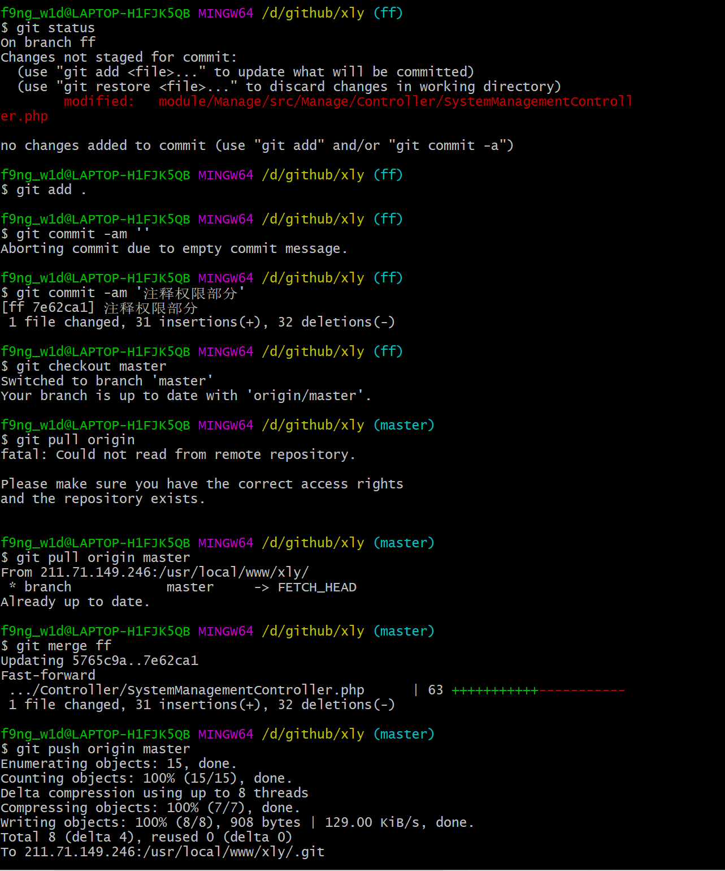
2. 网页内容

setTime

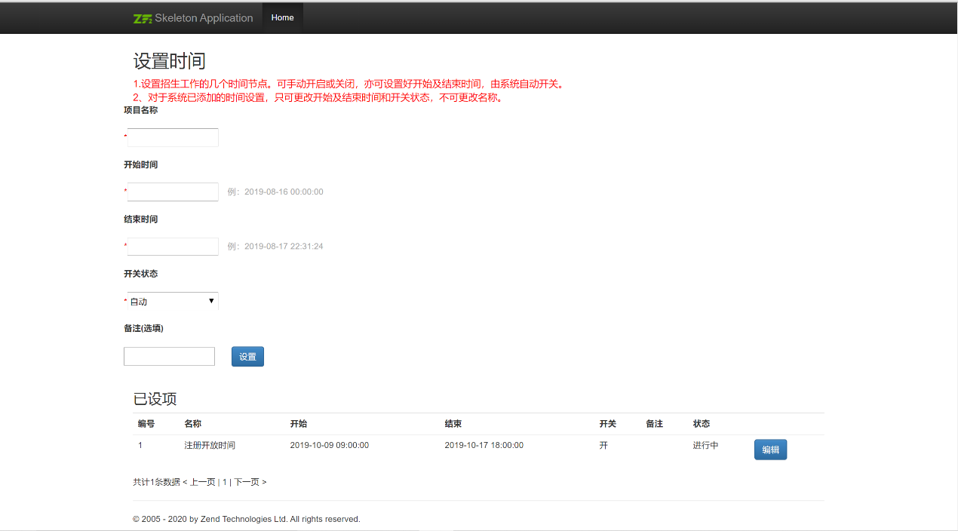

uniSearch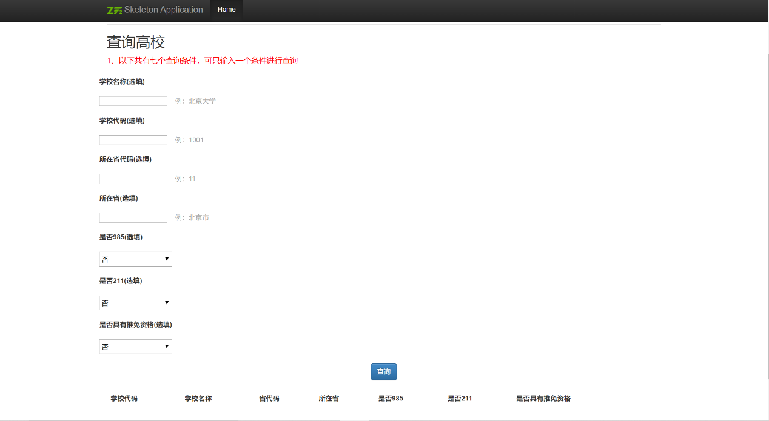

uniSet

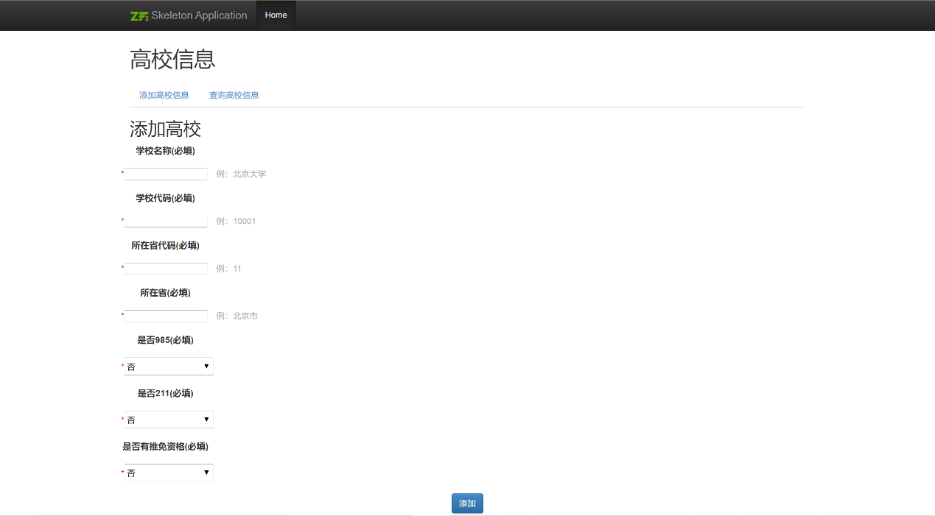

addCollege

