Investigating the impact of vascular risk factors on the progression of white matter hyperintensities

Frauke Beyer, PhD [1][2]

Laurenz Lammer [2]

Markus Loeffler [4][5]

Steffi Riedel-Heller [5][6]

Stéphanie Debette [1]

Arno Villringer, Prof. [2][7]

A. Veronica Witte, PhD [2][3][7]

1 Bordeaux Population Health Research Center, University of Bordeaux, Inserm, UMR 1219, Bordeaux, France Department of Neurology, Max Planck Institute for Human Cognitive and Brain Sciences, Leipzig CRC 1052 “Obesity Mechanisms”, Subproject A1, University of Leipzig Institute for Medical Informatics, Statistics and Epidemiology; University of Leipzig Leipzig Research Centre for Civilisation Diseases (LIFE), Leipzig Institute of Social Medicine, Occupational Health and Public Health, University of Leipzig , Leipzig Day Clinic for Cognitive Neurology, University Hospital Leipzig, University of Leipzig

# Results

## Flowchart

After applying exclusion criteria, the sample included 596 individuals with two timepoints (see Figure 1 for details on the exclusion and Table 1 for demographic characteristics at baseline).

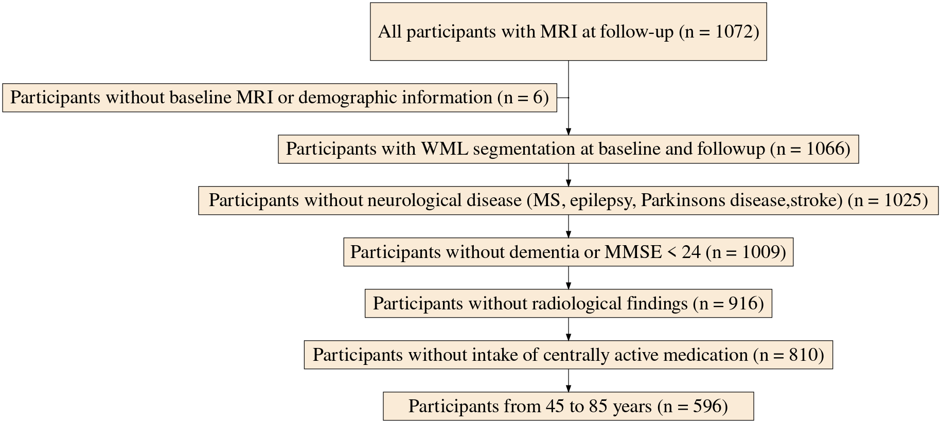

Figure 1: Flowchart of the study

Table 1: Baseline demographic characteristics of participants included in the study

|  | N | Mean | SD |
| --- | --- | --- | --- |
| Age (y) | 596 | 63.2 | 8.94 |
| Gender | 596 |  |  |
| ... female | 263 | 44.1% |  |
| ... male | 333 | 55.9% |  |
| Education | 593 |  |  |
| ... No tertiary education | 280 | 47.2% |  |
| ... Tertiary education | 313 | 52.8% |  |
| DBP (mmHg) | 590 | 76.3 | 9.33 |
| WHR | 595 | 0.941 | 0.0855 |
| CESD | 554 | 2.64 | 0.8 |
| BP medication | 595 |  |  |
| ... 0 | 334 | 56.1% |  |
| ... 1 | 261 | 43.9% |  |
| WMH volume (cm³) | 596 | 1.88 | 3.87 |

## Confirmatory analyses

### H1: Baseline DBP and WMH progression

Table 2: Results of Model M1 testing the association of baseline DBP with WMH progression

|  | Estimate [95 % CI] | p-value |
| --- | --- | --- |
| Age at baseline | 0.056 [0.049, 0.062] | <0.001 |
| Time | 0.026 [-0.030, 0.083] | 0.360 |
| Baseline DBP | 0.012 [0.005, 0.018] | <0.001 |
| DBP change | 0.006 [0.003, 0.009] | <0.001 |
| Baseline WHR | 0.843 [-0.117, 1.802] | 0.085 |
| WHR change | -0.084 [-0.682, 0.515] | 0.784 |
| DBP x Time | 0.000 [-0.001, 0.000] | 0.612 |
| WHR x Time | 0.029 [-0.017, 0.076] | 0.218 |

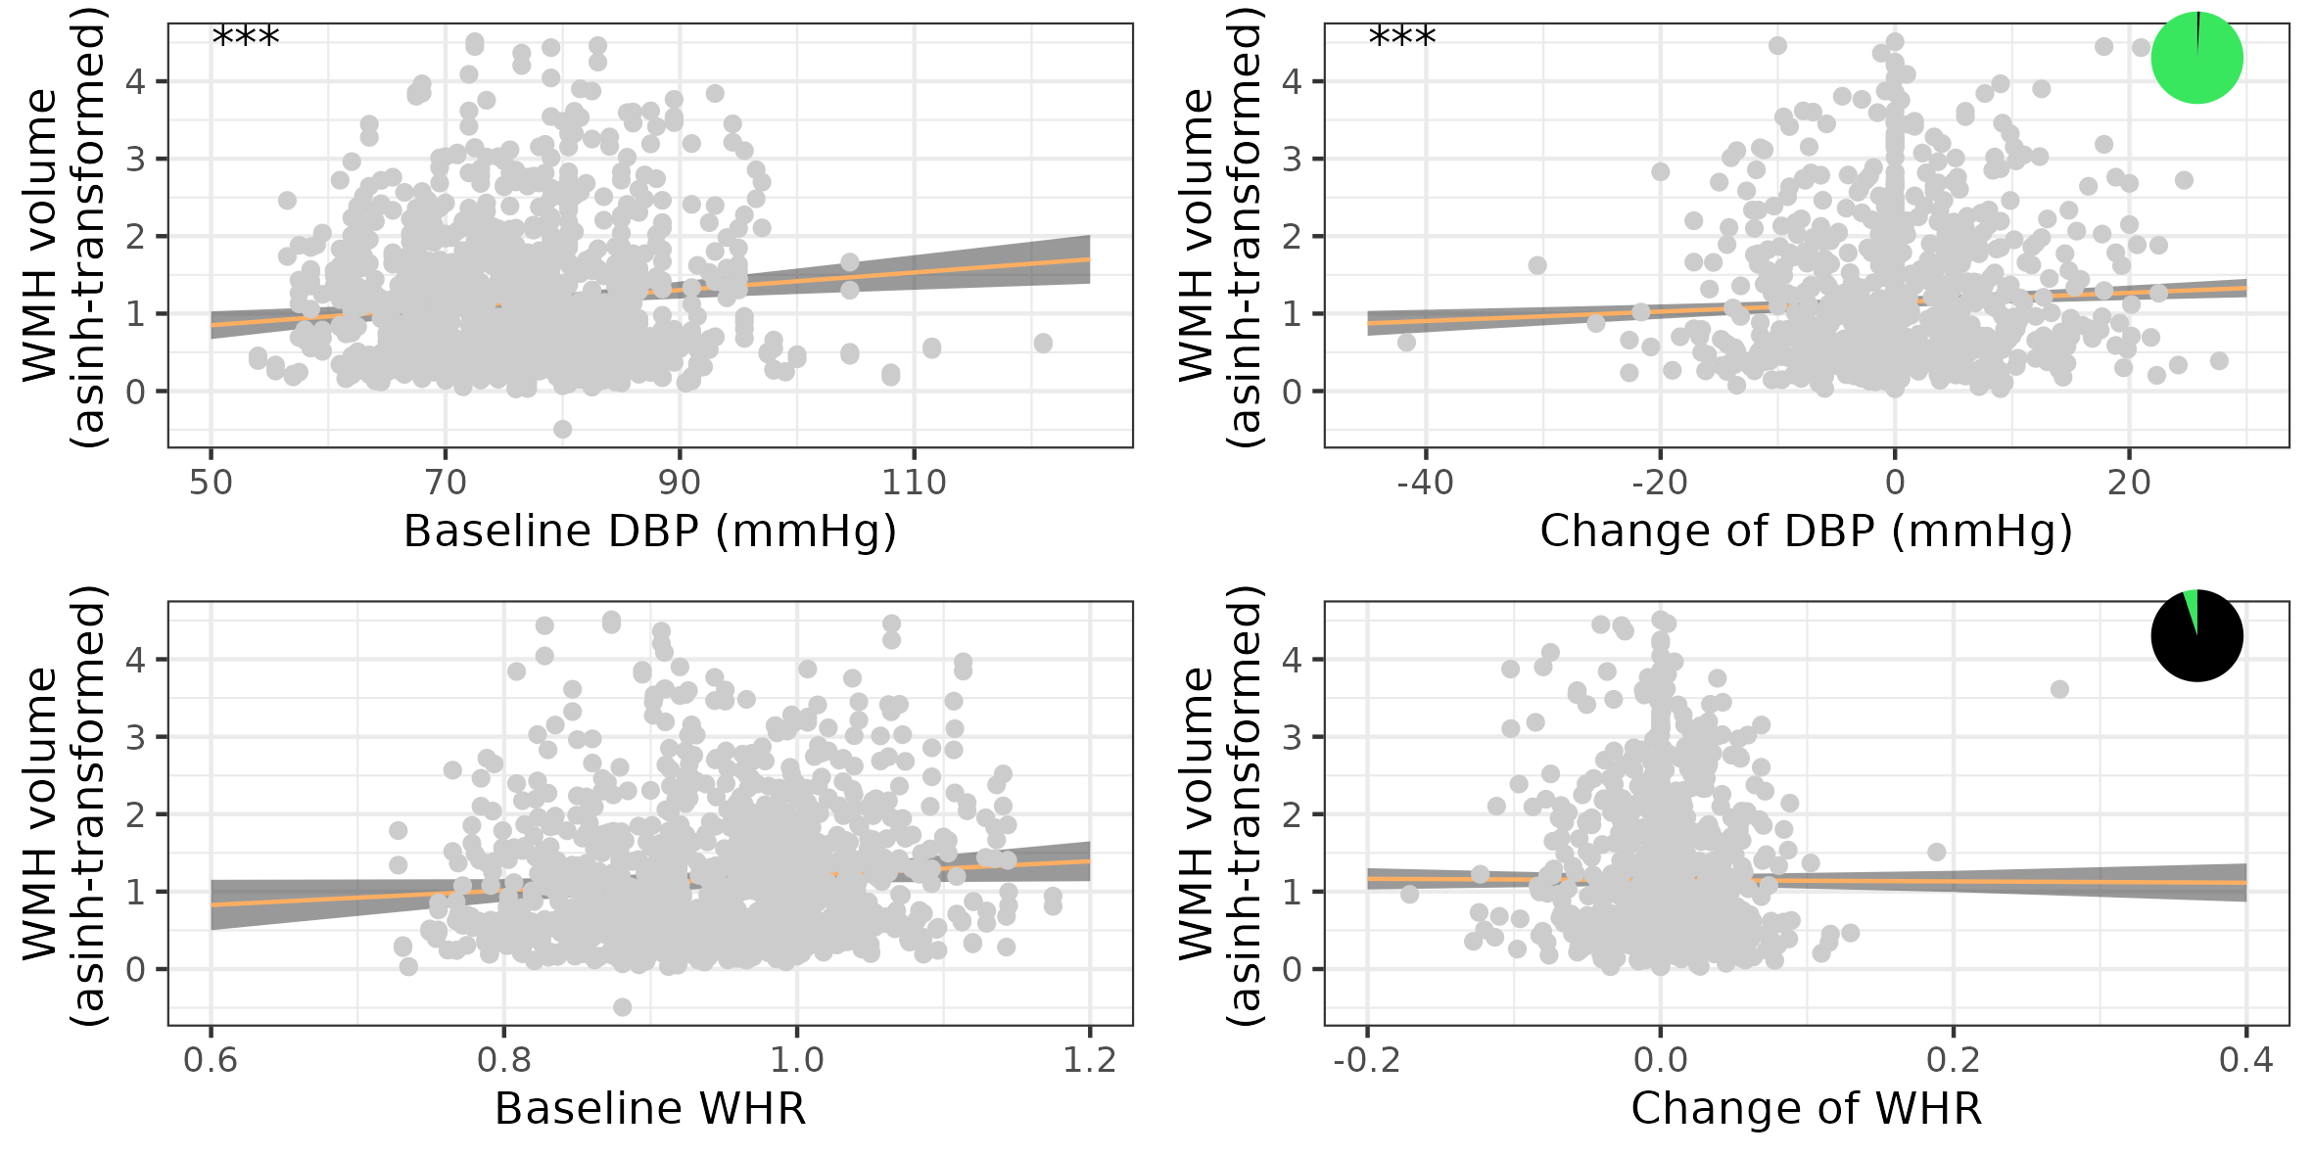

Figure 2: Results from M1 on the association of DBP and WHR and WMH progression model. Shown are scatter plots for associations of baseline and change in CVR factors with WMH volume. The pizza chart illustrates the Bayes factor in favour of the alternative hypothesis.

In model M1, we tested whether higher baseline DBP was associated with stronger WMH progression over time. There was no interaction of baseline DBP and time (one-sided corrected p-value = 0.41 and BF = 0.04 with moderate evidence against this hypothesis. The multivariate Wald test comparing a model with and without the interaction of baseline DBP and time, pooled across multiple imputations, yielded a p-value of 0.43. Table 2 shows two-sided uncorrected p-values for all CVR factors.  
Figure 2 shows the scatter plot and Bayes factor representations.

#### H2: WMH progression and executive function

Table 3: Association of WMH progression and executive function

|  | Estimate [95 % CI] | p-value |
| --- | --- | --- |
| Age at baseline | -0.017 [-0.026, -0.008] | <0.001 |
| Time | -0.047 [-0.061, -0.033] | <0.001 |
| Baseline WMH volume | -0.017 [-0.116, 0.082] | 0.740 |
| Change in WMH volume | -0.159 [-0.360, 0.041] | 0.120 |

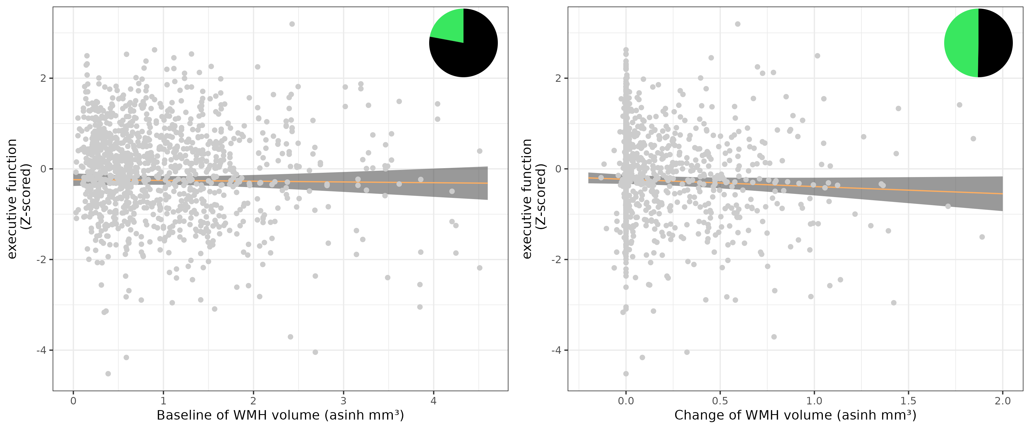

Figure 3: Results from M2 associating WMH progression and executive function. Shown are scatter plots for associations of baseline and change in CVR factors with WMH volume. The pizza chart illustrates the Bayes factor in favour of the alternative hypothesis.

In model M2, we investigated the association of higher WMH progression and executive function. There was no association of change in WMH volume with executive function (change in WMH volume: est(sd) = -0.16(0.1), corrected one-sided p-value = 0.08 and BF = 0.99 (see Table 3). The multivariate Wald test comparing a model with and without the change in WMH volume, pooled across multiple imputations, yielded a p-value of 0.13. Based on the BF between 0.3 and 3, these results are inconclusive.  
Figure 3 shows the scatter plots of the associations.

#### H3: WMH progression and global cognitive function

With Model 3 we investigated the association of higher WMH progression and global cognitive function.

Table 4: Association of WMH progression and global cognitive function

|  | Estimate [95 % CI] | p-value |
| --- | --- | --- |
| Age at baseline | -0.045 [-0.053, -0.037] | <0.001 |
| Time | -0.040 [-0.052, -0.028] | <0.001 |
| Baseline WMH volume | -0.044 [-0.135, 0.047] | 0.344 |
| Change in WMH volume | -0.326 [-0.497, -0.154] | <0.001 |

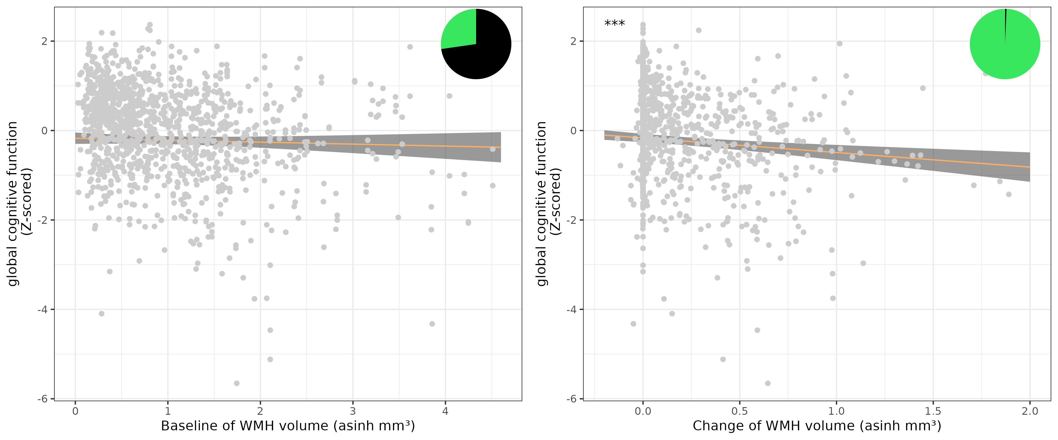

Figure 4: Results from WMH progression and executive function model

In model M3, we investigated the association of higher WMH progression and global cognition. Change in WMH volume was associated with stronger decline in global cognition (est(sd) = -0.33(0.09), corrected one-sided p-value = 10^{-4} and BF = 153.38). The multivariate Wald test comparing a model with and without the change in WMH volume, pooled across multiple imputations, yielded a p-value of 0.01. Table 4) shows uncorrected two-sided p-values and Figure 4 shows the scatter plots of the associations.

### Model Assumptions

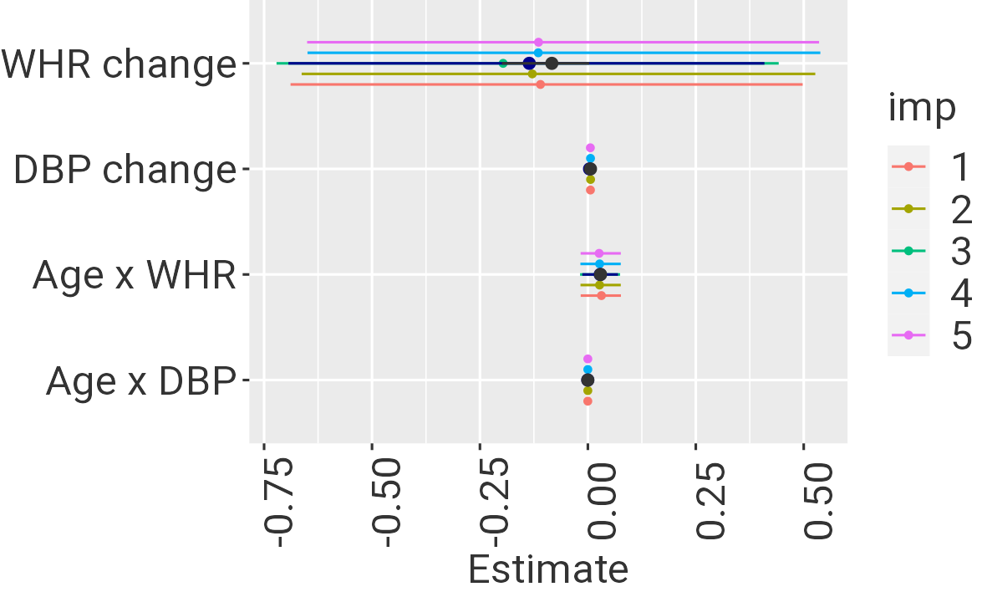

Figure 5: Original estimate (black) with minimum and maximum estimate derived from random effect stability analysis (black line), estimate and 95% CI from robust LMM and estimates and 95% CI without 13 influential cases (colours indicate imputation).

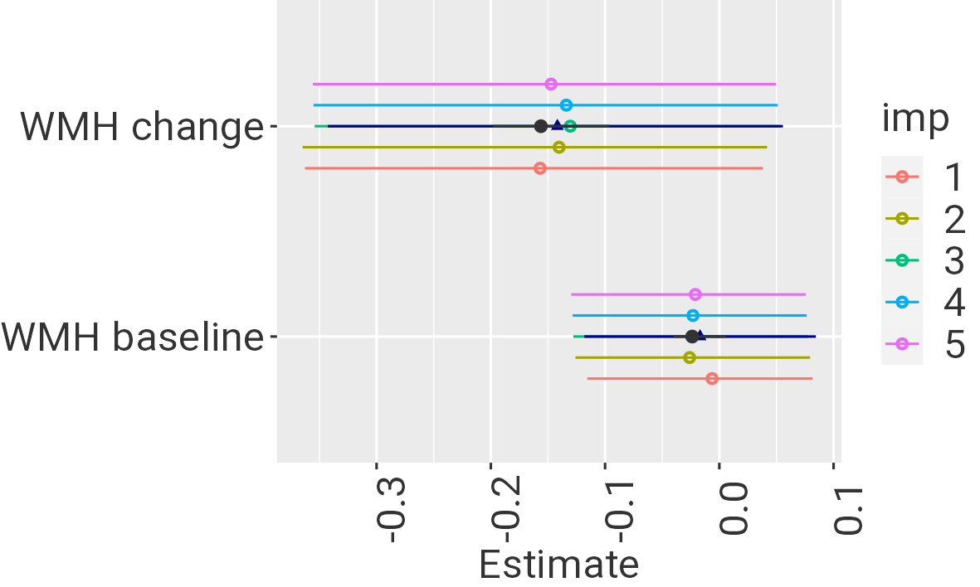

Figure 6: Executive function models: Original estimate (black) with minimum and maximum value derived from stability analysis (black line) and estimates derived from models excluding 13 influential cases (colours).

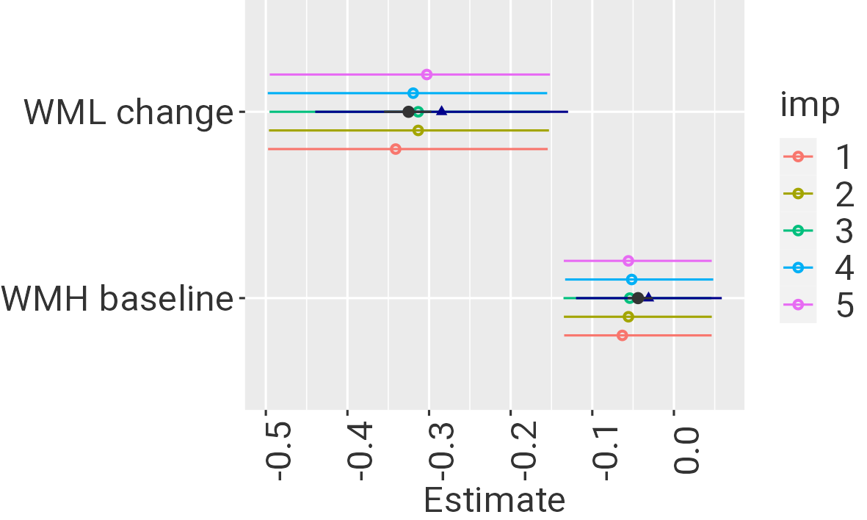

Figure 7: Global cognition models: Original estimate (black) with minimum and maximum value derived from stability analysis (black line) and estimates derived from models excluding 13 influential cases (colours).

Residuals and random effects were normally distributed for all models (see Supplementary Material). All VIF were below 10.  
There were 7, 27 and 20 unique influential cases across the five imputations for model M1, M2 and M3, respectively. Figures 5, 6 and 7 show original estimates, minimal and maximal estimates from random effect stability tests across imputations, robust LMM estimate and 95% CI and estimates and 95% CI from models without influential cases for each imputed dataset.  
In M1, estimates for WHR change came with high uncertainty while all other estimates agreed well between the original model and models without influential cases, individual random effects and robust LMM.  
In Model M2, influential cases biased the estimates towards higher values for WML change. Robust estimates showed a similar trend.  
In Model M3, this bias for WML change was smaller. Still, the robust estimates were somewhat smaller than the original ones.

### Exploratory Analyses

#### E1a-E1c (DBP change, WHR baseline, WHR change)

We hypothesized that higher WHR at baseline, and increases in WHR and DBP would be associated with stronger increase of WMH volume over time.

We used model 1 for exploring these associations. We found that higher change in DBP was associated with stronger progression of WML volume (est(sd) = 0.006 (0.002), p-value = 2.7^{-4} and BF = 110.71. There were no significant associations for WHR change or the interaction of age and WHR (see Table 2).

#### E2a - E3b: Interactions of gender, CVR risk, WMH progression and cognition

While men had significantly lower WMH volume at baseline (est(sd) = -0.28 (0.09), p-value = 0.002, there was no significant interaction of gender and WMH progression, gender and DBP change on WMH progression or any interaction with DBP or WHR at baseline and WHR change. Men performed worse in executive function (est(se) = -0.24 (0.08), p-value = 0.002) and global cognitive function (est(se) = -0.3 (0.07), p-value = 10^{-4}) than women.  
There was no significant interaction of gender and change in WMH volume on executive function or global cognitive function change (see supplements and Tables 5, 6 and 7 for gender-stratified results).

Table 5: Gender-stratified results for Model M1 on CVR factors

|  | Females: Estimate  [95 % CI] | Females: p-value | Males: Estimate  [95 % CI] | Males: p-value |
| --- | --- | --- | --- | --- |
| Age at baseline | 0.058 [0.046, 0.069] | <0.001 | 0.054 [0.045, 0.063] | <0.001 |
| Time | 0.019 [-0.085, 0.124] | 0.716 | 0.032 [-0.071, 0.135] | 0.541 |
| Baseline DBP | 0.016 [0.005, 0.026] | 0.003 | 0.009 [0.000, 0.017] | 0.044 |
| DBP change | 0.009 [0.004, 0.014] | <0.001 | 0.004 [0.000, 0.008] | 0.076 |
| Baseline WHR | 0.671 [-0.867, 2.210] | 0.392 | 0.945 [-0.307, 2.197] | 0.139 |
| WHR change | 0.132 [-0.685, 0.949] | 0.751 | -0.472 [-1.424, 0.481] | 0.331 |
| DBP x Time | 0.000 [-0.001, 0.001] | 0.653 | 0.000 [-0.001, 0.000] | 0.234 |
| WHR x Time | 0.013 [-0.091, 0.116] | 0.808 | 0.046 [-0.042, 0.134] | 0.304 |

Table 6: Gender-stratified results for Model M2 on executive function

|  | Females: Estimate  [95 % CI] | Females: p-value | Males: Estimate  [95 % CI] | Males: p-value |
| --- | --- | --- | --- | --- |
| Age at baseline | -0.019 [-0.032, -0.007] | 0.003 | -0.015 [-0.027, -0.003] | 0.016 |
| Time | -0.037 [-0.058, -0.015] | <0.001 | -0.055 [-0.075, -0.036] | <0.001 |
| Baseline WMH volume | 0.096 [-0.037, 0.229] | 0.155 | -0.127 [-0.273, 0.019] | 0.087 |
| Change in WMH volume | -0.208 [-0.517, 0.100] | 0.185 | -0.111 [-0.375, 0.154] | 0.413 |

Table 7: Gender-stratified results for Model M3 on global cognitive function

|  | Females: Estimate  [95 % CI] | Females: p-value | Males: Estimate  [95 % CI] | Males: p-value |
| --- | --- | --- | --- | --- |
| Age at baseline | -0.040 [-0.053, -0.028] | <0.001 | -0.048 [-0.059, -0.037] | <0.001 |
| Time | -0.028 [-0.046, -0.010] | 0.003 | -0.050 [-0.067, -0.034] | <0.001 |
| WMH volume baseline | 0.022 [-0.104, 0.149] | 0.728 | -0.113 [-0.244, 0.017] | 0.089 |
| Change in WMH volume | -0.371 [-0.636, -0.107] | 0.006 | -0.284 [-0.510, -0.058] | 0.014 |

### E4: Association of SBP and WMH progression

Table 8: Results of an exploratory model testing the association of baseline and change in SBP with WMH progression

|  | Estimate [95 % CI] | p-value |
| --- | --- | --- |
| Age at baseline | 0.0504 [0.0438, 0.0571] | <1e-04 |
| Time between baseline and followup | -0.0331 [-0.0870, 0.0208] | 0.2290 |
| Systolic BP at baseline | 0.0051 [0.0013, 0.0089] | 0.0082 |
| Change in Systolic BP | 0.0050 [0.0033, 0.0067] | <1e-04 |
| Waist-to-hip ratio at baseline | 0.9273 [-0.0327, 1.8872] | 0.0583 |
| Change in WHR | -0.1219 [-0.7154, 0.4717] | 0.6871 |
| Interaction of time and SBP at baseline | 0.0005 [0.0002, 0.0007] | 0.0017 |
| Interaction of time and WHR at baseline | 0.0148 [-0.0318, 0.0613] | 0.5338 |

We also explored the association of SBP at baseline, change of SBP and WMH progression and found that baseline SBP predicted WMH progression (Wald p-value = 0.03, see Table 8). Similar to DBP change, SBP change was also associated with WMH progression.

# Discussion

In this registered report, we studied the progression of WMH with respect to risk factors and cognitive outcomes. We pre-registered three confirmatory hypotheses of which one was accepted. We found a significant association of WMH progression and global cognitive decline over 6 years. There was no significant effect of baseline DBP on WMH progression nor an association of WMH progression and executive function decline, with Bayes Factors indicating inconclusive results.  
In exploratory analyses, we found that increase in DBP was a significant predictor of WMH progression, independent of baseline DBP. WHR at baseline or change in WHR did not predict WMH progression. SBP at baseline and increase of SBP also predicted WMH progression. There was no significant interaction with gender for any of the effects. Descriptively, women had higher WMH volume than men and performed better in executive function and global cognitive function at baseline.

The mean annual WMH progression in this study was 0.17 cm3/y. This was comparable to the estimation in our power analysis (0.32 cm3/y) but lower than the figure reported by Brown, Low, and Markus (2021) (0.7 cm3/y) who also included stroke and dementia patients. Against our hypotheses, we did not find an interaction effect of baseline DBP with time since baseline on the progression of WMH. Previous studies mostly investigated annual change in WMH volume as outcome in a linear model, while we took the more flexible approach of using a mixed model. Both approaches should yield equivalent results (Walker (2018)). In additional analyses, we found stronger effects of both baseline and change in DBP when using annual change in WMH volume as outcome in a linear model like in Debette et al. (2011) (both p<10⁻5). However, these models did not satisfy the assumptions of the linear model (non-normal distribution of residuals), possibly due to the zero-inflated and left-bounded distribution of WMH change (see Supplementary Figure). When using change based on asinh-transformed WMH volumes at baseline and followup as outcome in a linear model, the association of baseline DBP with WMH change was reduced.  
In our confirmatory analysis, we found higher DBP increase related to increase in WMH volume, independent of baseline DBP. This was seen in both the preregistered mixed model analysis and in the change score models. Additionally, in an exploratory analyses, we found that both higher SBP at baseline and increase in SBP were associated with WMH progression in line with the literature.  
DBP reflects the balance between peripheral vascular resistance and large artery stiffness while SBP increases with both vascular resistance and large artery stiffness (Pinto (2007)). In the course of aging, SBP and DBP increase in parallel, driven by both vascular resistance and large arterial stiffness until around 55 years. After that, large artery stiffness dominates and leads to further increases of SBP while DBP levels off or slightly decreases (Kaess et al. (2012); Franklin et al. (1997)). Previous studies have stressed the stronger association of concurrent SBP with WMH volume in the elderly, and a stronger effect of mid-life DBP on WMH in late-life (Wartolowska and Webb (2021)). While this was a cross-sectional study, our results supported the stronger effect of baseline SBP compared to baseline DBP but similar effects of BP change (Wilkinson and Webb (2022)).  
Previous studies have focused on SBP reduction due to its strong age-related increase and greater importance for cardiovascular events in the elderly (Wang et al. (2005)). In the SPRINT-MIND trial, the intensive SBP group (mean after intervention of 120 mm Hg) vs the standard SBP control group (mean of 135 mm Hg) showed significantly less WMH progression (0.92 cm3 vs 1.45 cm3) (Nasrallah et al. (2019)). DBP also reduced in the main SPRINT trial but no data was reported in relation to WMH progression (SPRINT Research Group et al. (2015)). Intensive BP control did not induce hypoperfusion in Croall et al. (2018) but excessively low DBP might be associated with an increased risk for stroke and cardiovascular disease (Somes et al. (1999)).  
We did not find evidence for an association of abdominal obesity with WMH progression. Despite obesity being a risk factor for dementia, its association with imaging markers of cSVD is relatively small compared to hypertension (Arnoldussen et al. (2019); Dearborn et al. (2015); Livingston et al. (2020); Debette et al. (2011)). In line with previous studies, we found that WMH progression was associated with global cognitive decline (Hamilton et al. (2021); Kloppenborg et al. (2014)). This association amounted to a reduction of -0.03 in the normalized global cognition score per 1 cm3 of WMH volume increase (while adjusting for age and time elapsed). A year elapsed accounted for -0.048 decrease in global cognition, or -0.044 when simultaneously adjusting for WMH change.  
We did not find a statistically significant evidence of an association for executive function, yet the estimate was negative as expected and the BF of 0.86 indicated that no conclusive evidence could be drawn. Yet, the notion that WMH predominantly affect executive function dependent on frontal brain networks was not supported by our data which is rather in line with a more universal negative effect of WMH volume on cognitive function (Hamilton et al. (2021)).  
We did not find any gender-specific associations of risk factors or cognitive outcomes with WMH progression. While females had higher WMH volumes at baseline, progression was similar in line with previous studies (Lohner et al. (2022);Brown, Low, and Markus (2021)). We could not provide evidence for a differential association of cardiovascular risk factors and WMH progression between genders as suggested in (Alqarni et al. (2020); Sachdev et al. (2009)). These studies, however, mostly investigated cross-sectional WMH volume and did not investigate the interaction of risk factors, gender and time. Also regarding the cognitive consequences of WMH progression, no differences between genders were seen. Still, we cannot rule out that we were underpowered to detect these effects.  
Taken together, these results indicate that strict control of DBP in both men and women is recommended in order to limit WMH progression and related global cognitive decline.

# References

Alqarni, Abdullah, Jiyang Jiang, John D. Crawford, Forrest Koch, Henry Brodaty, Perminder Sachdev, and Wei Wen. 2020. “Sex Differences in Risk Factors for White Matter Hyperintensities in Non-demented Older Individuals.” *Neurobiology of Aging*. <https://doi.org/10.1016/j.neurobiolaging.2020.11.001>.

Arnoldussen, Ilse A. C., Deborah R. Gustafson, Esther M. C. Leijsen, Frank-Erik de Leeuw, and Amanda J. Kiliaan. 2019. “Adiposity Is Related to Cerebrovascular and Brain Volumetry Outcomes in the RUN DMC Study.” *Neurology* 93 (9): e864. <https://doi.org/10.1212/WNL.0000000000008002>.

Brown, Robin, Audrey Low, and Hugh S. Markus. 2021. “Rate of, and Risk Factors for, White Matter Hyperintensity Growth: A Systematic Review and Meta-Analysis with Implications for Clinical Trial Design.” *Journal of Neurology, Neurosurgery & Psychiatry* 92 (12): 1271–77. <https://doi.org/10.1136/jnnp-2021-326569>.

Croall, Iain D., Daniel J. Tozer, Barry Moynihan, Usman Khan, John T. O’Brien, Robin G. Morris, Victoria C. Cambridge, et al. 2018. “Effect of Standard Vs Intensive Blood Pressure Control on Cerebral Blood Flow in Small Vessel Disease: The PRESERVE Randomized Clinical Trial.” *JAMA Neurology* 75 (6): 720–27. <https://doi.org/10.1001/jamaneurol.2017.5153>.

Dearborn, Jennifer L., Andrea L. C. Schneider, A. Richey Sharrett, Thomas H. Mosley, Daniel C. Bezerra, David S. Knopman, Elizabeth Selvin, Clifford R. Jack, Laura H. Coker, and Alvaro Alonso. 2015. “Obesity, Insulin Resistance, and Incident Small Vessel Disease on Magnetic Resonance Imaging: Atherosclerosis Risk in Communities Study.” *Stroke* 46 (11): 3131–36.

Debette, S., S. Seshadri, A. Beiser, R. Au, J. J. Himali, C. Palumbo, P. A. Wolf, and C. DeCarli. 2011. “Midlife Vascular Risk Factor Exposure Accelerates Structural Brain Aging and Cognitive Decline.” *Neurology* 77 (5): 461–68. <https://doi.org/10.1212/WNL.0b013e318227b227>.

Franklin, Stanley S., William Gustin, Nathan D. Wong, Martin G. Larson, Michael A. Weber, William B. Kannel, and Daniel Levy. 1997. “Hemodynamic Patterns of Age-Related Changes in Blood Pressure.” *Circulation* 96 (1): 308–15. <https://doi.org/10.1161/01.CIR.96.1.308>.

Hamilton, O., S. R. Cox, J. A. Okely, F. Conte, L. Ballerini, M. E. Bastin, J. Corley, et al. 2021. “Cerebral Small Vessel Disease Burden and Longitudinal Cognitive Decline from Age 73 to 82: The Lothian Birth Cohort 1936.” *Translational Psychiatry* 11 (1): 1–12. <https://doi.org/10.1038/s41398-021-01495-4>.

Kaess, Bernhard M., Jian Rong, Martin G. Larson, Naomi M. Hamburg, Joseph A. Vita, Daniel Levy, Emelia J. Benjamin, Ramachandran S. Vasan, and Gary F. Mitchell. 2012. “Aortic Stiffness, Blood Pressure Progression, and Incident Hypertension.” *JAMA* 308 (9): 875–81. <https://doi.org/10.1001/2012.jama.10503>.

Kloppenborg, Raoul P., Paul J. Nederkoorn, Mirjam I. Geerlings, and Esther van den Berg. 2014. “Presence and Progression of White Matter Hyperintensities and Cognition.” *Neurology* 82 (23): 2127. <https://doi.org/10.1212/WNL.0000000000000505>.

Livingston, Gill, Jonathan Huntley, Andrew Sommerlad, David Ames, Clive Ballard, Sube Banerjee, Carol Brayne, et al. 2020. “Dementia Prevention, Intervention, and Care: 2020 Report of the Lancet Commission.” *The Lancet* 396 (10248): 413–46. <https://doi.org/10.1016/s0140-6736(20)30367-6>.

Lohner, Valerie, Gökhan Pehlivan, Gerard Sanroma, Anne Miloschewski, Markus D. Schirmer, Tony Stöcker, Martin Reuter, and Monique M. B. Breteler. 2022. “Relation Between Sex, Menopause, and White Matter Hyperintensities: The Rhineland Study.” *Neurology* 99 (9): e935–43. <https://doi.org/10.1212/WNL.0000000000200782>.

Nasrallah, I. M., N. M. Pajewski, A. P. Auchus, G. Chelune, A. K. Cheung, M. L. Cleveland, L. H. Coker, et al. 2019. “Association of Intensive Vs Standard Blood Pressure Control With Cerebral White Matter Lesions.” *JAMA* 322 (6): 524–34. <https://doi.org/10.1001/jama.2019.10551>.

Pinto, Elisabete. 2007. “Blood Pressure and Ageing.” *Postgraduate Medical Journal* 83 (976): 109–14. <https://doi.org/10.1136/pgmj.2006.048371>.

Sachdev, P. S., R. Parslow, W. Wen, K. J. Anstey, and S. Easteal. 2009. “Sex Differences in the Causes and Consequences of White Matter Hyperintensities.” *Neurobiology of Aging* 30 (6): 946–56. <https://doi.org/10.1016/j.neurobiolaging.2007.08.023>.

Somes, Grant W., Marco Pahor, Ronald I. Shorr, William C. Cushman, and William B. Applegate. 1999. “The Role of Diastolic Blood Pressure When Treating Isolated Systolic Hypertension.” *Archives of Internal Medicine* 159 (17): 2004–9. <https://doi.org/10.1001/archinte.159.17.2004>.

SPRINT Research Group, Jackson T. Wright, Jeff D. Williamson, Paul K. Whelton, Joni K. Snyder, Kaycee M. Sink, Michael V. Rocco, et al. 2015. “A Randomized Trial of Intensive Versus Standard Blood-Pressure Control.” *The New England Journal of Medicine* 373 (22): 2103–16. <https://doi.org/10.1056/NEJMoa1511939>.

Walker, Jeffrey A. 2018. *Applied Statistics for Experimental Biology*.

Wang, Ji-Guang, Jan A. Staessen, Stanley S. Franklin, Robert Fagard, and François Gueyffier. 2005. “Systolic and Diastolic Blood Pressure Lowering as Determinants of Cardiovascular Outcome.” *Hypertension* 45 (5): 907–13. <https://doi.org/10.1161/01.HYP.0000165020.14745.79>.

Wartolowska, Karolina Agnieszka, and Alastair John Stewart Webb. 2021. “Midlife Blood Pressure Is Associated with the Severity of White Matter Hyperintensities: Analysis of the UK Biobank Cohort Study.” *European Heart Journal* 42 (7): 750–57. <https://doi.org/10.1093/eurheartj/ehaa756>.

Wilkinson, Imogen, and Alastair John Stewart Webb. 2022. “Consistency of Associations of Systolic and Diastolic Blood Pressure with White Matter Hyperintensities: A Meta-Analysis.” *International Journal of Stroke* 17 (3): 291–98. <https://doi.org/10.1177/17474930211043364>.