Homework 1 (due before next class)

You are welcome to work in a group, but you should submit your own solutions.

1. Symptoms vector. A 20-vector s records whether each of 20 diﬀerent symptoms is present in a medical patient, with si = 1 meaning the patient has the symptom and si = 0 meaning she does not. Express the following using vector notation.

(a) The total number of symptoms the patient has.

(b) The patient exhibits ﬁve out of the ﬁrst ten symptoms.

2. Calculate the inner product between two vectors:

a)((1, 2, −3),(1, 1, 1))

b) ((1, −2, 1),(2, −1, 3))

3. X= and X= , find the dot product of x∙y

4. f(x) = 3−2.4\*x1 + 1.8\*x2 −3.1\*x3, is this affine function, what is a and b?

5. Regression model. Consider the regression model ŷ = xTβ + v, where ŷ is the predicted response, x is an 8-vector of features, β is an 8-vector of coeﬃcients, and v is the oﬀset term. Determine whether each of the following statements is true or false.

(a) If β3 > 0 and x3 > 0, then ŷ ≥ 0.

(b) If β2 = 0 then the prediction ŷ does not depend on the second feature x2.

(c) If β6 = −0.8, then increasing x6 (keeping all other xis the same) will decrease ŷ

6. Sparse regression weight vector. Suppose that x is an n-vector that gives n features for some object, and the scalar y is some outcome associated with the object. What does it mean if a regression model ŷ = xTβ +v uses a sparse weight vector β? Referring to ŷ as our prediction of outcomes.

7.

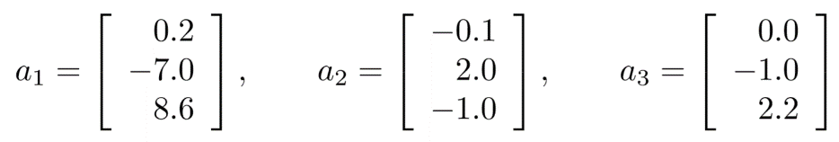

Evaluate these three vectors are linearly dependent or independent?

8.

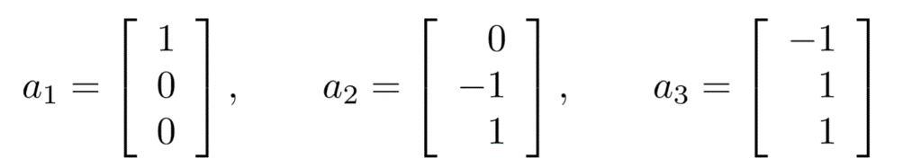

Evaluate these three vectors are linearly dependent or independent?

9. (1,2,−1)∗(2,2,−1) , calculate this vector convolution?

10.

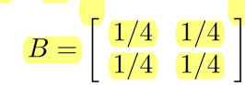

B is the convolution kernel, X is the input image or matrix,

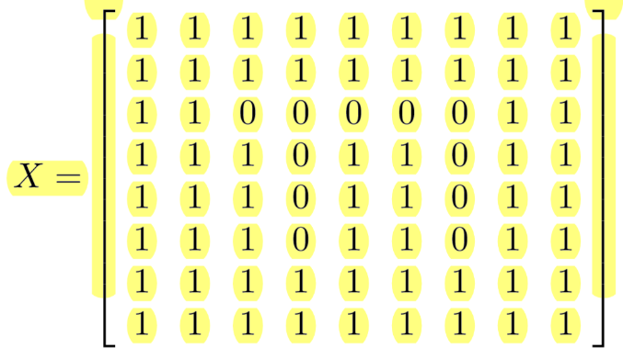

X =

What is X’s convolution with B? please list any five elements calculation in detail.