OASIS INFOBYTE
WEB DEVELOPMENT INTERNSHIP
LEVEL 2 — TASK 1
CALCULATOR
Project Documentation
Intern: Meerab Asif
Track: Web Development
Level: Level 2
Task: Task 1 — Calculator
Technologies: HTML5, CSS3, Vanilla JavaScript

1. Project Overview
The Calculator is a browser-based web application developed as part of the Oasis Infobyte Web Development Internship, Level 2, Task 1.
The purpose of this project is to create a functional and user-friendly calculator capable of performing basic arithmetic operations. The application provides an interactive button-based interface and uses JavaScript to process user input and calculate results.
The project was developed using HTML5 for structure, CSS3 for styling and responsive layout, and Vanilla JavaScript for functionality and event handling.

2. Objective
The main objective of this project is to develop a fully functional browser-based calculator that can perform basic mathematical operations through an easy-to-use interface.
The project also demonstrates practical knowledge of:
- HTML5 structure
- CSS3 styling
- CSS Grid layout
- JavaScript functions
- DOM manipulation
- Event listeners
- Conditional statements
- Switch statements
- Number parsing
- Error handling
- Responsive web design

3. Technologies Used
HTML5
HTML5 was used to create the structure of the calculator, including the display area and calculator buttons.
CSS3
CSS3 was used to design the calculator interface, arrange the buttons using CSS Grid, add visual effects, and make the application responsive.
Vanilla JavaScript
Vanilla JavaScript was used to implement the calculator's functionality, handle button events, process user input, perform calculations, and handle errors.

4. Features Implemented
The calculator includes the following features:
- Numeric buttons from 0 to 9
- Decimal point button
- Addition operation
- Subtraction operation
- Multiplication operation
- Division operation
- Equals button
- Clear button
- Backspace/Delete button
- Division-by-zero error handling
- Operator chaining
- Expression display
- Responsive layout
- CSS Grid button arrangement
- JavaScript event listeners
- No inline onclick attributes
- No use of the eval() function

5. User Interface
The calculator provides a simple and modern interface.
The main interface contains:
- An expression display area
- A current value/result display
- Numeric buttons
- Arithmetic operator buttons
- Clear button
- Backspace button
- Decimal button
- Equals button
The layout is designed to make the calculator easy to understand and operate.

6. Project Structure
The project is organized into separate files for structure, styling, functionality, documentation, and screenshots.
WebDev-L2-Calculator/
- index.html
- style.css
- script.js
- README.md
- Task1_Calculator_Documentation.docx
- Screenshots/
The HTML file contains the calculator structure, the CSS file controls the visual appearance, and the JavaScript file handles the calculator logic.

7. Implementation Details
7.1 HTML Implementation
HTML5 is used to create the calculator interface.
The page contains a display section and a button grid. Each button is assigned appropriate data attributes so that JavaScript can identify numbers, operators, and other actions.

7.2 CSS Implementation
CSS3 is used to create the visual design of the calculator.
The project uses CSS Grid to arrange calculator buttons in an organized layout.
The styling includes:
- Gradient background
- Calculator card layout
- Rounded buttons
- Hover effects
- Button interaction effects
- Responsive sizing
- Mobile-friendly layout

7.3 JavaScript Implementation
JavaScript controls the calculator's behaviour.
Event listeners are attached to the calculator buttons so that user interactions are handled without using inline onclick attributes.
The application maintains values such as:
- Current value
- Previous value
- Selected operator
- Display state
Arithmetic operations are handled using conditional logic and a switch statement.
The project uses parseFloat() to convert input strings into numerical values.
The calculator intentionally does not use eval().

8. Expression Display
The calculator displays the entered expression while the user is performing a calculation.
For example, when the user enters:
5 + 3
the expression is displayed while the current input is shown separately.
After pressing the equals button, the calculator displays:
5 + 3 =
and the result:
8
This makes the calculation process easier for the user to understand.

9. Error Handling
The calculator includes protection against division by zero.
For example:
10 ÷ 0
does not cause the application to crash.
Instead, the calculator displays an appropriate error message indicating that division by zero is not allowed.
This provides a safer and more user-friendly experience.

10. Testing
The calculator was tested during development to verify its major functionality.
The following areas were checked:
Test Area | Expected Result
Addition | Correct addition result
Subtraction | Correct subtraction result
Multiplication | Correct multiplication result
Division | Correct division result
Decimal input | Decimal calculations work correctly
Division by zero | Error message is displayed
Expression display | Entered expression remains visible
Operator chaining | Sequential operations can be performed
The tests confirmed that the implemented calculator functions correctly for the tested operations.

11. Screenshots
Screenshots are included as visual evidence of the completed project.
Screenshot 1 — Basic Calculation
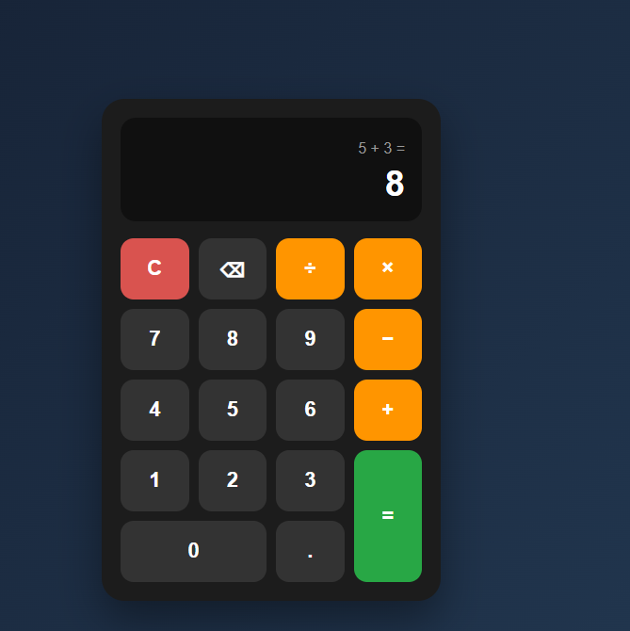
Caption:
Figure 1: Calculator performing a basic arithmetic calculation

Screenshot 2 — Division by Zero
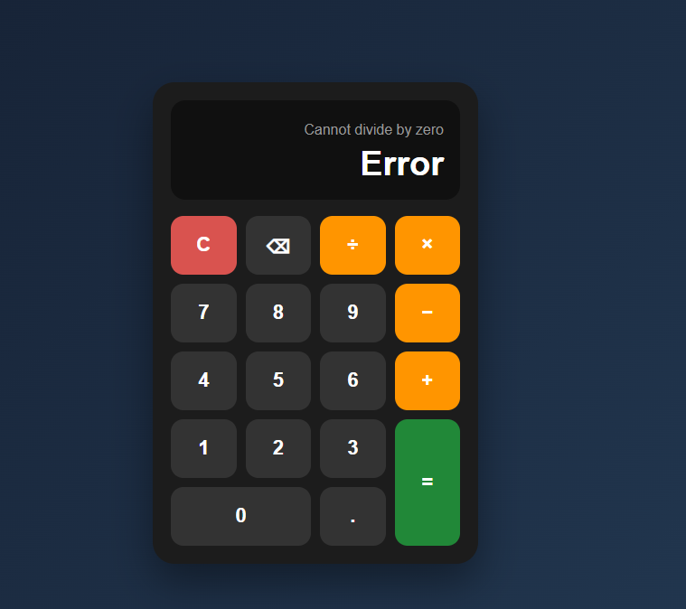
Caption:
Figure 2: Calculator displaying an error when division by zero is attempted.

Screenshot 3 — Expression Display
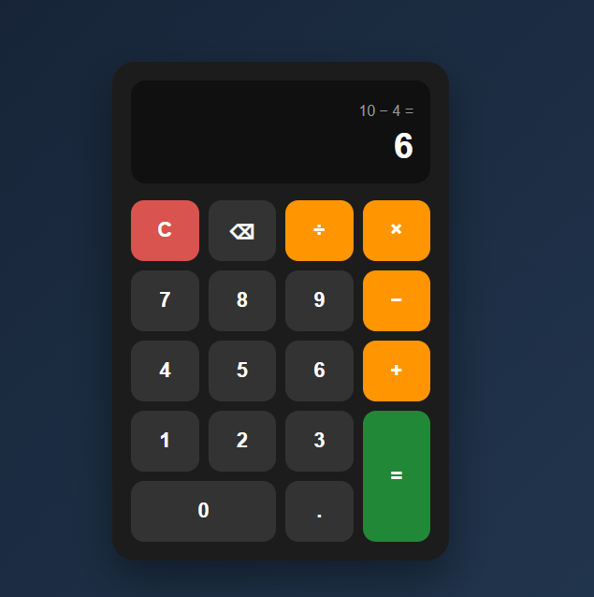
Caption:
Figure 3: Calculator displaying the complete expression and result.

12. Responsive Design
The calculator interface is designed to adapt to different screen sizes.
CSS media queries are used to adjust the calculator dimensions, button sizes, spacing, and typography on smaller screens.
The responsive design helps maintain usability across desktop, tablet, and mobile devices.

13. Challenges and Solutions
Challenge 1: Managing Calculator State
The calculator needs to keep track of the current number, previous number, and selected operator.
Solution: JavaScript variables were used to maintain the calculator state throughout the calculation process.
Challenge 2: Division by Zero
Division by zero can produce an invalid mathematical operation.
Solution: A conditional check was implemented before division so that the calculator displays an error message instead of producing an invalid result.
Challenge 3: Expression Display
The calculator needed to display the entered expression while also showing the current input or result.
Solution: Separate display elements and JavaScript state variables were used to maintain and update the expression and result.
Challenge 4: Button Layout
The calculator required a clean and aligned button interface.
Solution: CSS Grid was used to create an organized and responsive button layout.

14. Learning Outcomes
This project provided practical experience with front-end web development.
The main learning outcomes include:
- Creating structured web pages using HTML5
- Designing interfaces using CSS3
- Using CSS Grid for layouts
- Creating responsive designs
- Selecting DOM elements with JavaScript
- Using addEventListener()
- Creating reusable JavaScript functions
- Managing application state
- Using conditional statements
- Using switch statements
- Using parseFloat()
- Implementing error handling
- Building interactive browser applications

15. Conclusion
The Calculator project successfully demonstrates the development of an interactive browser-based application using HTML5, CSS3, and Vanilla JavaScript.
The application provides the required arithmetic operations along with additional functionality such as expression display, backspace, clear, division-by-zero handling, and operator chaining.
The project also demonstrates important front-end development concepts including DOM manipulation, event handling, CSS Grid, responsive design, and JavaScript logic.
Overall, this task provided practical experience in designing and developing a complete interactive web application from scratch.

16. Internship Information
Organization: Oasis Infobyte
Internship: Web Development Internship
Level: Level 2
Task: Task 1 — Calculator
Intern: Meerab Asif

17. Project Files
The completed project contains:
- index.html
- style.css
- script.js
- README.md
- Task1_Calculator_Documentation.docx
- Screenshots folder
The project is maintained as part of the required OIBSIP GitHub repository structure.

