QUANTUM DATA ANALYZER PRO
Comprehensive System Architecture, Technical Design, and Verification Guide
Prepared by: Lead Systems Engineer & Data Analyst
Target System: Desktop GUI Statistics Application (Python/CustomTkinter)
Date: June 2026
Version: 1.1.0 (Stable release)

1. Executive Summary
Quantum Data Analyzer Pro is a desktop-based statistics, modeling, and visualization suite. Built on Python's advanced numeric stack (CustomTkinter, Pandas, SciPy, NumPy, and Matplotlib), the application simplifies raw data ingest, clean-up, descriptive statistical computing, hypothesis testing, and regression analysis, and features a dual-theme UI built on a clean architecture.
The system has been engineered to provide robust diagnostic reporting. Beyond computing standard descriptive metrics (mean, variance, CI), the application performs normality validation using the Shapiro-Wilk test, executes one-sample t-tests, establishes linear regression models complete with standard errors and R-squared, and renders high-fidelity Matplotlib diagrams directly inside Tkinter canvases with interactive scaling tools.
Purpose of this Document: This manual provides a deep-dive reference detailing the system's architecture, module dependencies, logical schema, graphical user manual, and the automated unit testing protocol deployed to verify mathematical calculations and plotting pipelines.

2. System Architecture & Logical Design
The system adheres to a structured, modular design pattern closely aligned with Model-View-Controller (MVC) principles, decoupling the UI display (View) from computation (Model) and graphing modules (Plotter):
- • DataModel (Model): Handles loaded datasets, missing value preprocessing, categorical string auto-encoding, descriptive calculations, Shapiro-Wilk test, one-sample t-tests, Pearson correlation, regression equations, and multi-sheet Excel generation.
- • DataAnalyzerApp (View): A CustomTkinter-based desktop interface. Houses the top ribbon tabview, target dropdowns, action buttons, side statistical panels, and embedded Matplotlib canvas widgets.
- • Plotter (Utility): Translates Pandas series and correlation matrices into styled figures. Manages color palettes across light and dark modes to guarantee legibility and modern design language.
- • Theme (Utility): Centralizes styling color-codes for plots and grids so the visualizations blend into CustomTkinter's dark/light modes dynamically.
- • DataCleaner (Pre-processor): Standalone script to pre-process raw survey files, renaming columns to standardized names, and converting categorical intervals to numeric midpoints.

2.1 Class Diagram
The class diagram details the structural relationships. The DataAnalyzerApp acts as the controller, holding references to the Theme, the DataModel, and the Plotter, which in turn depends on the active Theme.
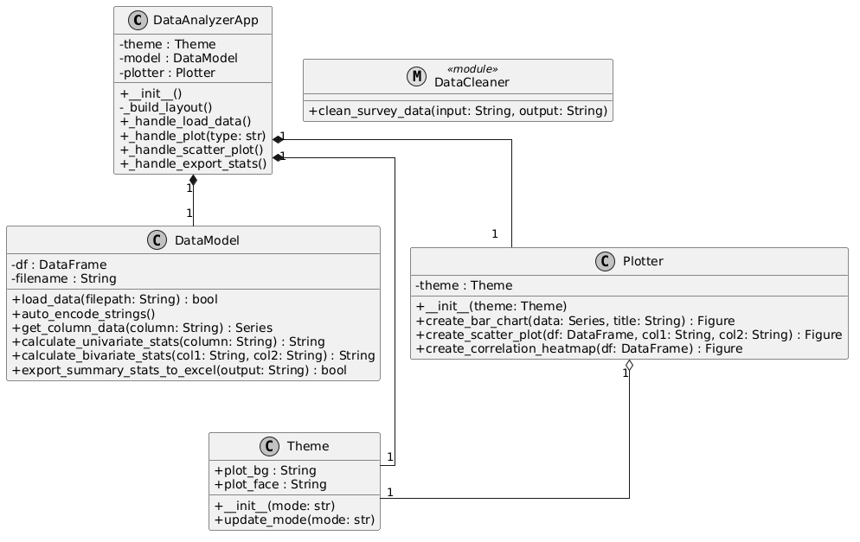
Figure: Static Class Hierarchy showing controller composition and theme dependencies.

2.2 Use Case Diagram
The use case diagram highlights the system interaction boundaries. A Data Analyst can load files, clean & encode string variables, calculate univariate or regression summaries, render plots, export tabular spreadsheets, and toggle visual themes.
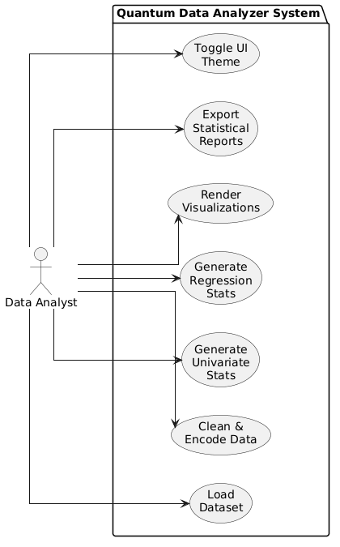
Figure: System interaction boundaries mapping user actions to execution use cases.

2.3 Sequence Diagram
The sequence diagram depicts the chronological message exchange between system objects during file loading and subsequent bar chart generation.
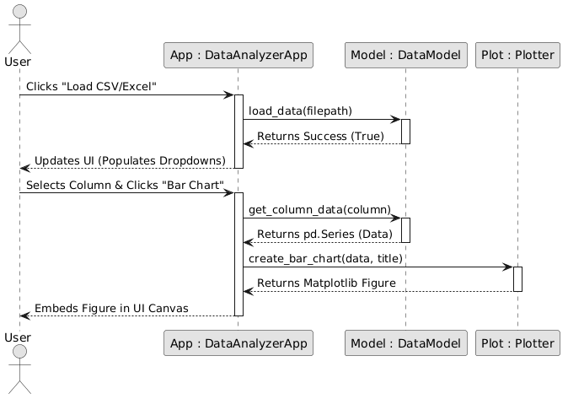
Figure: Sequence of messages showing decoupled query patterns between App, Model, and Plotter.

2.4 Entity Relationship Diagram (ERD)
The ERD illustrates the logical structure of variables and computed statistical items. A Dataset contains multiple Variables, which can produce Univariate Statistics or serve as Independent/Dependent axes in Bivariate Regression models.
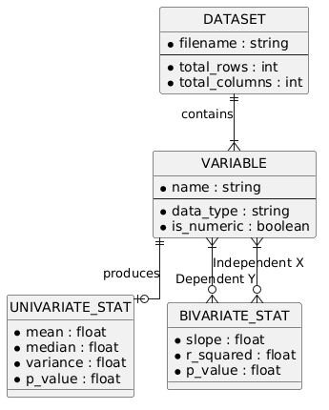
Figure: Logical data model representing variable dimensions and statistical outputs.

2.5 Activity Diagram
The activity diagram details the logical workflows. Analysts can branch between univariate analysis and bivariate regression, customize visual widgets, and finalize reports.
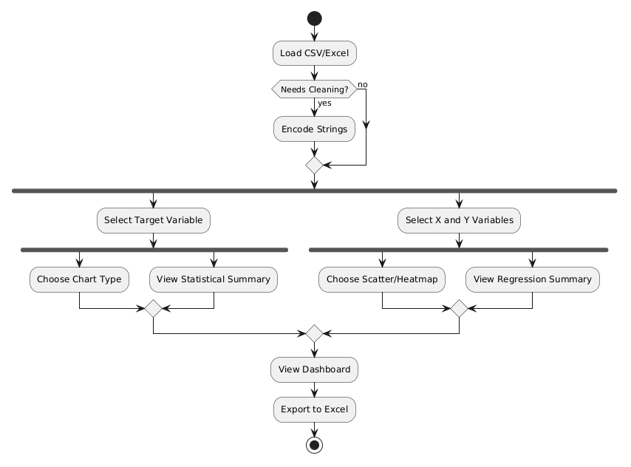
Figure: Workflow logic spanning data clean-up, bivariate modeling, and report exportation.

3. Functional Specifications & User Guide
This section details the operational capability of the Quantum Data Analyzer Pro suite, providing instructions on utilizing each GUI element.

3.1 Ingestion & Manual Entry
Under the Data Management tab, users can load files via file dialogs or enter data manually:
- 1. Load CSV/Excel: Triggers a system file picker. Accepts `.csv`, `.xlsx`, and `.xls` files. Upon loading, column menus are populated automatically.
- 2. Manual CSV Input: Opens a top-level window containing a syntax-highlighted editor. Analysts can paste raw comma-separated text directly and click 'Save & Load Data' to ingest without saving external files first.

3.2 Pre-processing & String Encoding
Statistical procedures require numeric formats. The suite implements automated and rule-based cleaning tools:
- • Categorical Midpoint Conversion: Uses regular expressions to extract number boundaries from strings like '5-6 hours' or 'more than 9' and computes midpoint values (e.g. 5.5 and 10.0 respectively). Converted columns are cast to numeric series.
- • Text Auto-Encoding: For columns containing arbitrary text strings (like name labels or text classifications), clicking the 'Convert Strings' button automatically triggers categorical numeric code mapping (`pd.Categorical.codes`), replacing null codes with appropriate NaN representations.

3.3 Descriptive & Univariate Analysis
Selecting any column in the Univariate Analysis tab automatically updates the statistical summary textbox with details:
- • Count (N): The total count of non-null records.
- • Central Tendencies: Arithmetic average and median values.
- • Dispersion Metrics: Standard deviation and variance measures.
- • Confidence Interval (95% CI): Calculates a 95% Confidence Interval for numeric variables using Student-T distribution parameters.
- • Normality Hypothesis Testing: Runs a Shapiro-Wilk test to examine the null hypothesis that data is normally distributed. P-value < 0.05 rejects normality, prompting standard warning logs.
- • Frequency Distributions: Outputs count and percentage splits for the top 10 values, covering categorical and discrete ranges.

3.4 Bivariate Regression Analysis
Selecting X and Y variables in the Bivariate Analysis tab enables linear modeling. Clicking 'Calculate Regression' runs `scipy.stats.linregress` and prints:
=== Regression Analysis ===
Dependent (Y) : Stress_Level
Independent (X) : Sleep_Hours
📈 [Linear Regression Results]
Equation : Y = -0.4521 * X + 9.1235
Pearson r : -0.6724
R-squared : 0.4521
P-value : 3.4210e-04
Std Error : 0.1102
Conclusion: There is a statistically significant linear relationship (p < 0.05).

3.5 Visualizations Dashboard
The suite features an embedded plotting engine. Clicking on plot commands renders styled graphs inside the GUI canvas:
- • Bar and Pie Charts: Visualizes frequencies of categorical values.
- • Line Charts: Plots continuous series trends over time or row indices.
- • Histograms: Renders numerical density distributions across custom bin widths.
- • Confidence Interval Plots: Plots the sample mean flanked by 95% confidence interval boundaries.
- • Scatter Plots: Displays individual data points along with a dashed regression trendline and Pearson r value.
- • Heatmaps: Renders a multi-dimensional correlation matrix map, complete with text coefficients shaded dynamically for legibility.
All visual components include scaling and zooming widgets. Clicking 'Pop Out Graph' clones the figure into an expanded, standalone window for detail analysis.

3.6 Summary Exporting
To share analytical findings, two exporters are integrated:
- • Export Stats: Generates an Excel workbook containing Descriptive Statistics (mean, variance, mode, missing values), Hypothesis Testing (T-test, Shapiro-Wilk), Regression Analysis (all pair-wise regression options), and a complete Correlation matrix.
- • Export All Charts: Recursively processes all columns in the active dataset, generating Bar, Pie, Line, Histogram, and CI charts, and saving them to segregated directories under a target folder.

4. Interface Styling & Theme System
To ensure a modern, luxury look, the application utilizes segmented controls, rounded cards, and synchronized themes. The styling is controlled by CustomTkinter appearance settings and matched in Matplotlib graphs:
Visual Element | Dark Mode Hex | Light Mode Hex
App Main Background | #090A0F (Futuristic Black) | #F0F2F5 (Off-White)
Cards / Frames | #12141E (Deep Navy/Gray) | #FFFFFF (Pure White)
Borders / Grids | #222639 (Muted Slate) | #D1D5DB (Light Slate)
Accent Cyan Highlight | #00E5FF (Neon Cyan) | #00A8B5 (Ocean Teal)
Trendline / Hist | #FF007F (Neon Magenta) | #D8006B (Deep Pink)
Scatter / Gold Highlight | #D4AF37 (Metallic Gold) | #B5952F (Bronze Gold)

5. Setup & Execution
Follow these steps to deploy and run the system locally.

5.1 Local Installation
Ensure Python 3.10+ is installed on your workstation. Run the command to install all packages:
pip install -r requirements.txt
Execute the GUI application:
python Stats/analyzer_gui.py

5.2 Docker Containerization
A Dockerfile and docker-compose.yaml are provided. Build and run the image:
# Build the docker image
docker compose build
# Run the application container
docker compose up

6. Testing & Mathematical Verification
To ensure mathematical accuracy and system reliability, the suite includes a unit test pipeline. All calculations and plotting operations are verified using automated test fixtures.
Test Class | Method / Target | Verification Criteria
TestTheme | test_theme_initialization_dark | Verifies Dark mode plot_bg is #090A0F and text is #E0E5FF.
TestTheme | test_theme_initialization_light | Verifies Light mode plot_bg is #F0F2F5 and text is #000000.
TestTheme | test_theme_update_mode | Validates dynamic mode switches refresh theme color attributes.
TestDataModel | test_load_from_csv_string | Checks CSV parsing, file renaming, and row count checks.
TestDataModel | test_get_columns | Ensures loaded columns match expected metadata headers.
TestDataModel | test_get_column_data | Verifies non-null series extraction and ignores missing entries.
TestDataModel | test_get_column_data_invalid | Ensures querying non-existent columns returns an empty series gracefully.
TestDataModel | test_get_bivariate_data | Ensures overlapping non-null pairs are extracted for regression.
TestDataModel | test_is_numeric | Verifies Boolean checks correctly distinguish numbers from text categories.
TestDataModel | test_auto_encode_strings | Validates text columns convert to categorical numeric integers.
TestDataModel | test_calculate_univariate_stats_numeric | Verifies Mean, Median, Std Dev, CI, and Shapiro-Wilk run on numeric data.
TestDataModel | test_calculate_univariate_stats_categorical | Validates frequency tables are computed for string columns.
TestDataModel | test_calculate_bivariate_stats_numeric | Checks linear regression equation coefficients, R-sq, and p-val outputs.
TestDataModel | test_calculate_bivariate_stats_non_numeric | Asserts warning returned if variables are non-numeric.
TestDataModel | test_export_summary_stats_to_excel | Verifies workbook saves with Descriptive, Hypo, Reg, and Corr worksheets.
TestPlotter | test_create_bar_chart | Asserts Matplotlib Bar Figure returns correctly without GUI warnings.
TestPlotter | test_create_pie_chart | Asserts Matplotlib Pie Figure returns correctly.
TestPlotter | test_create_line_chart_numeric | Asserts Matplotlib Trend Line Figure returns correctly.
TestPlotter | test_create_line_chart_categorical | Asserts Matplotlib Freq Line Figure returns correctly.
TestPlotter | test_create_histogram | Asserts Matplotlib Density Histogram Figure returns correctly.
TestPlotter | test_create_scatter_plot | Asserts Matplotlib Scatter Figure + Trendline returns correctly.
TestPlotter | test_create_ci_plot | Asserts Matplotlib Mean + CI Error Bar Figure returns correctly.
TestPlotter | test_create_correlation_heatmap | Asserts Matplotlib Correlation Matrix Heatmap Figure returns correctly.
TestDataCleaner | test_clean_survey_data | Verifies rename mapping, Regex range parsing (7-8 -> 7.5), and empty coercions.

Execute the test suite using the following command:
python -m unittest Stats/test_analyzer.py

