LAB#08

Neha-e-Noor

FA17-BECE-0007

EXERCISE:01

a=input("Enter number:")

if (a<50)

disp("Number is less")

elseif (a==50)

disp("Number is equal")

else

disp("Number is greater")

end

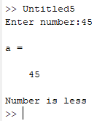

EXERCISE:02

x=input("Enter number:")

if (x<5)

y=2*x+1

else

y=2*x

end

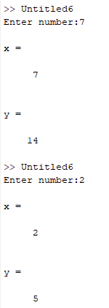

EXERCISE:03

x=input("Enter number:")

y=input("Enter number:")

z=input("Enter number:")

if ((x>y) & (x>z))

fprintf("%d is greater",x)

elseif ((y>x) & (y>z))

fprintf("%d is greater",y)

else

fprintf("%d is greater",z)

end

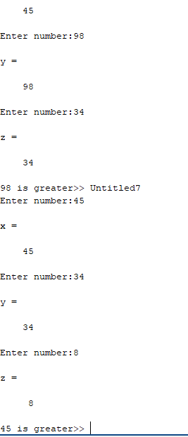

EXERCISE:04

n= input("enter max_value");

for a=1:n

a=a^2

disp (a);

end

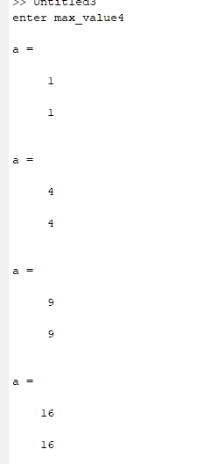

EXERCISE:05

n=10;

a=1;

fact=1;

while(a<=n)

fact=fact*a;

a=a+1;

end

disp(fact);

