**Lab# 10**

**NEHA-E-NOOR**

**FA17-BECE-0007**

**TASK-1**

x=(0:pi/100:2*pi);

y1=sin(x);

y2=cos(x);

plot(x,y1,'oy',x,y2,'*b')

legend('sin(x)','cos(x)')

xlabel("x");

ylabel("sin and cosx waves");

title(waves);

grid on

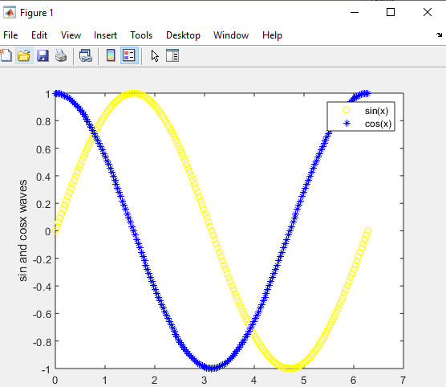

**TASK-2**

x=(0:pi/100:2*pi);

y1=sin(x);

y2=cos(x);

plot(x,y1,'--',x,y2,'g')

legend('sin(x)','cos(x)')

xlabel("x");

ylabel("sin and cosx waves");

title(waves);

grid on

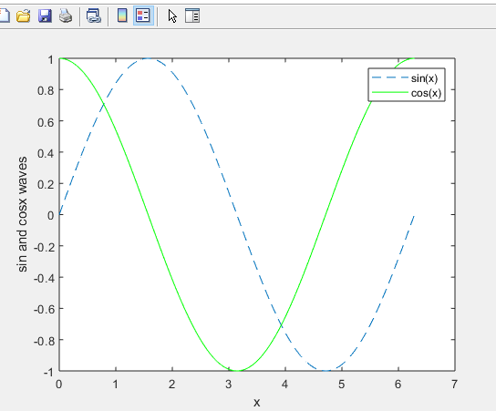

**TASK-3**

x=(0:pi/100:2*pi);

y1=sin(x);

y2=cos(x);

subplot(2,2,1)

plot(x,y1,'--g')

subplot(2,2,2)

plot(x,y2,':r')

legend('sin(x)','cos(x)')

xlabel("x");

ylabel("sin and cosx waves");

title(waves);

grid on

