Task#01:
Zombie Process:
Code:
#include<stdio.h>
#include<stdlib.h>
#include<sys/types.h>
#include<unistd.h>

int main()
{
pid_t c=fork();
if(c>0)
{
sleep(5);
printf("---Welcome--- \n");
}
else
{
exit(0);
}
return 0;
}

Output:
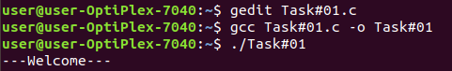

Task#02:
Orphan Process:
Code:
#include<stdio.h>
#include<sys/types.h>
#include<unistd.h>

int main()
{
int k=fork();
if(k>0)
{
printf("Parent process \n");
}
else if(k==0)
{
sleep(5);
printf("Child process \n");
}
return 0;
}

Output:
