Operating System
Lab#04

Task1:

#!/bin/bash
echo "What is your name?"
read name
echo "My name is $name..!"
echo "What is your age?"
read age
echo "I am $age years old..!"
Output:
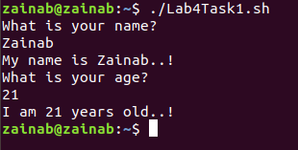

Task2(a):

#include <stdio.h>
int main()
{
printf("I love Operating System \n");
retuern 0;
}

(b)

#include <stdio.h>
int main()
{
printf("I love linux \n");
return 0;
}

(c)

#include <stdio.h>
int main()
{
printf("I love Operating System \n");
return 0;
}

#include <stdio.h>
int main()
{
printf("I love linux \n");
return 0;
}

Output:

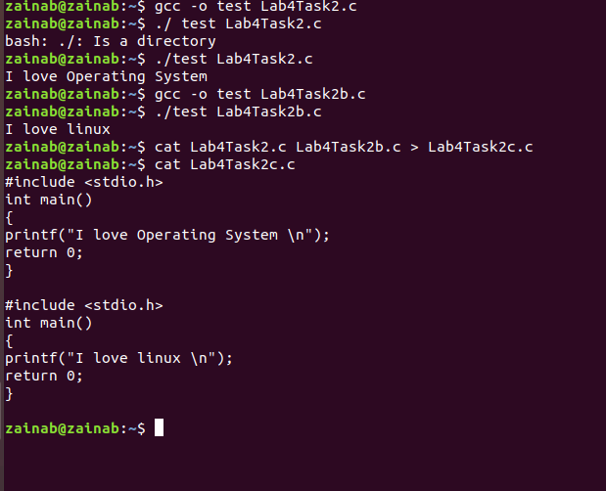
Task3:

#!/bin/bash
echo "Welcome to Shell Scripting.!"

Output:
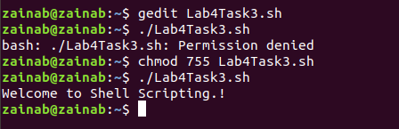

Task4:

#!/bin/bash
name="$USER"
echo "User name is: $name"
D=$(date)
echo "Current Date and Time: $D"

Output:
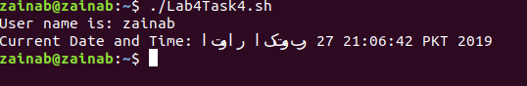

Task5:

#!/bin/bash
echo "Enter your Name?"
read Name
echo "Enter your Degree Program?"
read DP
echo "Enter your Batch Number?"
read BN
echo "Enter your Course Title?"
read CT
echo "$Name"
echo "$DP"
echo "$BN"
echo "$CT"

Output:
