ORPHAN:
#code:

#include<stdio.h>
#include <sys/types.h>
#include <stdlib.h>
#include <unistd.h>
int main()
{
int orp = fork();

if (orp > 0)
{
printf("Parent class \n");
exit(0);

}
else
{
printf("Child class \n");
sleep(50);

}
return 0;
}
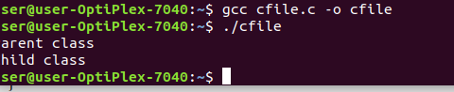

ZOMBIE:
#code2:

#include<stdio.h>
#include <sys/types.h>
#include <stdlib.h>
#include <unistd.h>
int main()
{
int orp = fork();

if (orp > 0)
{
printf("Parent class \n");
sleep(50);

}
else
{
printf("Child class \n");
exit(0);

}
return 0;



