LAB 08 OS
NAME: SHAHERYAR SIDDIQUI ID: FA17-BECE-0023

TASK:
CODE:
//name: shaheryar siddiqui id: fa17-bece-0023s

#include<stdio.h>
#include<pthread.h>
void *shary(void * var);
int main()
{
pthread_t tid1, tid2, tid3, tid4;
char *msg1= "initial thread:\n";
char *msg2= "second thread:\n";
char *msg3= "third thread:\n";
char *msg4= "final thread:\n";
pthread_create(&tid1,NULL,shary,(void *) msg1 );
pthread_create(&tid2,NULL,shary,(void *) msg2 );
pthread_create(&tid3,NULL,shary,(void *) msg3 );
pthread_create(&tid4,NULL,shary,(void *) msg4 );

pthread_join(tid1,NULL);
pthread_join(tid2,NULL);
pthread_join(tid3,NULL);
pthread_join(tid4,NULL);
return 0;
}
void *shary(void * var)
{
char *msg;
msg=(char *)var;
printf("%s\n",msg);
}

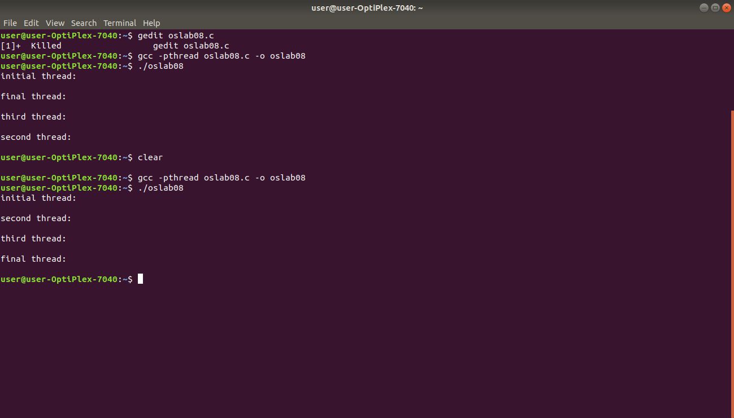
RESULT:

