# Guidelines

* Challenge may require 2 to 3 hours of research.
* Challenge may require 3-4 hours of actual coding time depending on your experience
* **Do not get discouraged if you get stuck. Feel free contact HPA for assistance.**

# Background

HPA specializes in providing Automation-as-a-Service. Our robotic software is able to act just like a person – interacting with applications, typing, clicking, and more. Our capabilities go beyond our competitors due the extensive capabilities, speed and redundancies we build around our automation.

**The primary goal of this challenge is to assess your ability to research and not strictly your solution.**

# Goal

This challenge has three key goals:

1. Assess a candidate’s abilities to research new technologies.
2. Assess a candidate’s ability to put together a working solution.
3. Provide a candidate insight into HPA’s day-to-day operations and the daily challenges.

# Challenge Requirements:

* Build a **console application** that **automates** Notepad on your windows machine.
* **Log each step** that the application is doing in your console output.
* The **console application** should:

1. **Check to see if notepad application is already open**
2. **If not open, Lunch** the Notepad application
3. **Click** on File Menu Item followed by **New** menu item.

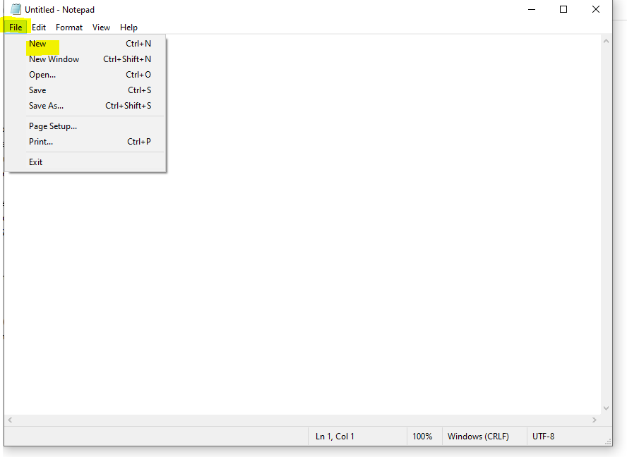

4) **Enter** “Hello World” into the Text Area.

5) **Click** on Save and Save as… Menu Items.

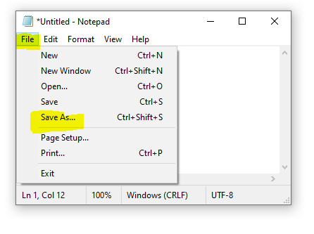

6) **Detect and handle** Windows Save as dialog – **Enter file path** and **Click save** on the dialog.

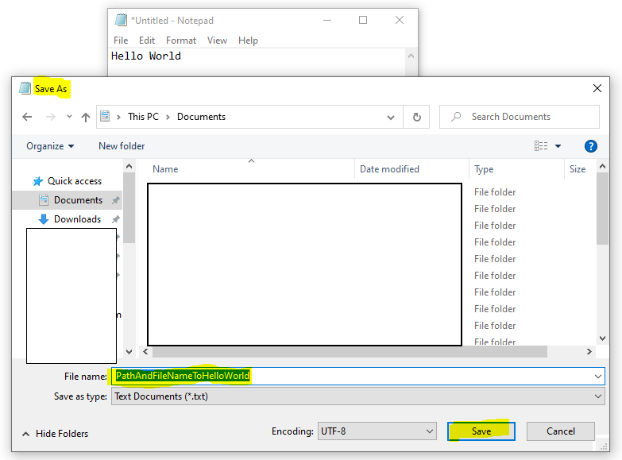

7) **Check** to see if “Confirm Save As “Dialog shows up. If it does, **click yes** to rewrite the file and save to the specified path.

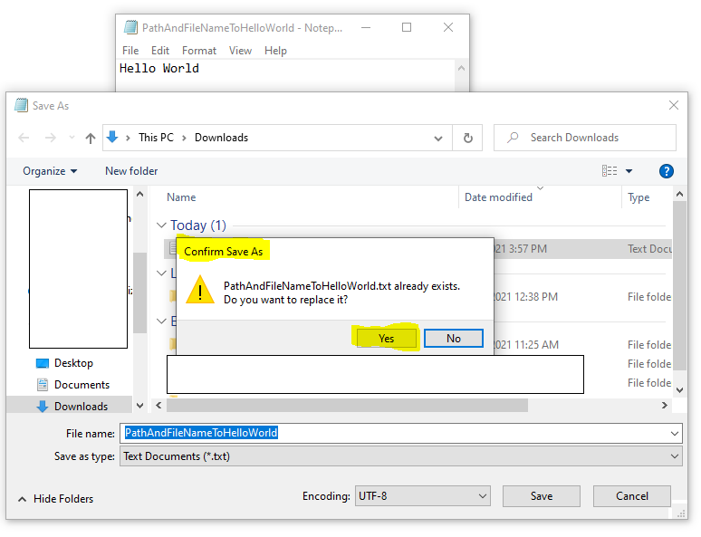

7) **Check** to make sure file was stored successfully in the specified location.

7) **Report** task was completed successfully.

* The application must be written using C#.
* Both source code and a compiled version should be submitted.
* While 3rd party libraries may be used, **the more you can achieve without relying on 3rd party libraries the better.**

# Additional Information

* Consider building in error handling to account for unexpected outcomes.
* Consider having the automation self-validate its own actions.
* If applicable, demonstrate the use of loops, functions, classes, etc. in your solution.

# Importantly

* This may be your first encounter with this type of challenge and technologies.
* Though this challenge is difficult, do not get discouraged. Try things, research, talk to mentors, even ask HPA for tips!