
COMSATS University Islamabad
Sahiwal Campus
Department of Computer Sciences

Smart Healthcare Project Management and Monitoring System
Software Project Management Implementation Report

Course Information | Details
Course Title | Software Project Management
Course Code | CSE-494

Submitted By
Student Information | Details
Student Name | Amna Khan
Registration Number | FA23-BSE-015
Program | Bachelor of Software Engineering (BSE)
Semester | 7th
Batch | FA23
Section | A

Submitted To
Mr. Bilal Shabbir Qaisar

Table of Contents
1. Introduction 6
1.1 Project Background and Case Constraints 6
1.1.1 Contract Baseline and Change 6
1.1.2 System Purpose and Stakeholders 6
1.1.3 Scope Boundary and Intended Outcome 6
1.2 Sample Dates and Operating Rules 7
1.2.1 Planning Assumptions 7
1.3 Report Organization 7
1.4 Stakeholder Needs and Success Conditions 7
2. Planning 8
2.1 Project Objectives and Success Criteria 8
2.2 Scope and Work Breakdown Planning 8
2.3 Time Management Plan 8
2.4 Resource Management Plan 8
2.5 Cost Management and EVM Plan 9
2.6 Quality and Risk Planning 9
2.7 Monitoring and Communication Plan 9
3. Design 10
3.1 Application Architecture 10
3.1.1 Two Runnable Application Clients 10
3.2 Database Design and ERD 11
3.2.1 Entity Relationship Diagram 11
3.2.2 Relationship Legend and Integrity Rules 11
3.3 Interface Design and Screenshots 12
3.3.1 Project Dashboard 12
3.3.2 Change-Control Interface 13
3.3.3 Scope and WBS Interface 14
3.3.4 Schedule and Cost Interface 15
3.3.5 Quality and Risk Interface 16
3.3.6 Initiation and Integrated Report 17
3.3.7 Responsive React Dashboard 18
4. Implementation 19
4.1 Project Initiation and Integration Management 19
4.2 Scope Management and WBS 19
4.3 Schedule and Resource Management 20
4.4 Cost Management and Earned Value Analysis 20
4.5 Quality Management and Risk Control 21
4.6 System Integration, Validation, and Reporting 21
4.7 Approved Change Request Demonstration 22
4.7.1 Dashboard Status at the Approved State 22
4.8 Source Code and GitHub Repository 22
5. Testing 23
5.1 Schedule and EVM Verification Scenarios 23
5.1.1 Representative Scenario-Based Test Cases 23
5.1.2 Plan and Forecast Verification 23
5.2 Automated Regression Summary 24
6. Deployment and Project Structure 25
6.1 Source Repository 25
6.2 Project Structure 25
6.3 Run the Local Applications 25
6.4 Vercel Deployment 25
6.5 Release Readiness and Handover 26
7. Report Close 27
8. References 28

List of Tables
Table 1.1: Project Baseline and Approved Change Summary 6
Table 2.1: Project Roles and Planning Responsibilities 8
Table 3.1: Application Layers and Responsibilities 10
Table 3.1: Database Relationships and Cardinalities 11
Table 4.1: Initiation and Governance Records 19
Table 4.1: Earned-Value Indicators and Sample Results 20
Table 4.1: Risk Scores and Response Actions 21
Table 4.1: Change Request Approval Evidence 22
Table 5.1: Representative Scenario-Based Test Cases 23
Table 5.2: Baseline, Approved Plan and Forecast Verification 23
Table 5.3: Earned-Value Scenario Results 24
Table 5.1: Automated Regression Test Summary 24

List of Figures
Figure 3.1: The Python desktop and React web clients, their control layers, and their separate databases. 10
Figure 3.1: Entity groups, key fields and foreign-key cardinalities in the CarePlan database. 11
Figure 3.1: Dashboard before approval with the original budget and pending CR-001. 12
Figure 3.2: Dashboard after approval with the revised budget and forecast. 12
Figure 3.3: Change request and linked scope while approval is pending. 13
Figure 3.4: Approval confirmation after the single combined change is applied. 13
Figure 3.5: Baseline requirements and work breakdown before approval. 14
Figure 3.6: Approved AI and mobile requirements and WBS work packages. 14
Figure 3.7: Dependency-driven dates and Gantt forecast after approval. 15
Figure 3.8: Activity budgets and EVM indicators at 10 February 2026. 15
Figure 3.9: Critical defects and deliverable inspection outcomes. 16
Figure 3.10: Risk matrix, ranked risks and preventive/corrective responses. 16
Figure 3.11: Project charter and management-plan fields. 17
Figure 3.12: Integrated project metrics and module traceability report. 17
Figure 3.13: Responsive React dashboard at desktop width. 18
Figure 3.14: Responsive React dashboard at 390 × 844 mobile viewport. 18

1. Introduction

1.1 Project Background and Case Constraints
The supplied case describes a software-development contract for a five-hospital network. The target hospital software is expected to support appointments, laboratory reports, doctor schedules, online consultations, and billing. The management application plans and controls that software project.
The project manager must coordinate a mixed technical team, organize work across interdependent modules, control the budget and delivery date, and communicate progress to hospital stakeholders. A change to scope affects both estimates and the schedule, so the team needs a recorded approval decision and an updated forecast rather than informal task additions.

1.1.1 Contract Baseline and Change
Table 1.1: Project Baseline and Approved Change Summary
Case item | Baseline | Approved case impact | Current approved plan
Budget | PKR 5,000,000 | + PKR 800,000 once | PKR 5,800,000
Duration | 16 weeks | + 3 weeks once | 19 weeks
Added scope | Original healthcare modules | AI preliminary diagnosis and mobile application | Both added requirements and WBS items approved
Team | 1 PM, 2 backend, 2 frontend, 1 database, 1 QA | No team-size change assumed | 7 named responsibilities in the project roster

1.1.2 System Purpose and Stakeholders
CarePlan is the management system used to plan and monitor the development project; it is not the clinical hospital product itself. Its main users are the project manager, software developers, database specialist and quality-assurance engineer. Hospital representatives supply priorities and review the planned capabilities, while the project manager maintains the approved baseline and reports delivery status.

1.1.3 Scope Boundary and Intended Outcome
The project plan covers project initiation, requirements, work breakdown, activity dependencies, resources, cost, quality, risk, change approval and reporting. The proposed AI preliminary-diagnosis and mobile application additions are treated as software-development scope only. No patient records, clinical diagnoses or real hospital operations are included in the demonstration dataset.

1.2 Sample Dates and Operating Rules

1.2.1 Planning Assumptions
- Project start date: 5 January 2026. EVM status date: 10 February 2026. These are documented sample-data assumptions, not dates stated in the examination case.
- Schedule durations use Monday-Friday working days. The sample does not model public holidays. A successor begins on the next working day after its latest predecessor finishes.
- Baseline and forecast are kept distinct. Approved changes update the current plan; actual delay moves affected forecast successors but does not rewrite baseline dates.
- The change request combines the two additions into the case total. The application does not apply PKR 800,000 or three weeks separately to each deliverable.
- The AI item is managed as project scope only. The application contains no clinical diagnostic model.
The persistent schema contains 14 application tables: activities, change_items, change_requests, closure_records, defects, dependencies, expenditures, milestones, project, quality_checks, requirements, risks, team_members, wbs.

1.3 Report Organization
Chapter 1 introduces the case and its constraints. Chapter 2 presents scope, objectives, schedule, resources, cost, quality, and risk planning; Chapter 3 documents the system architecture, database ERD, and interface screenshots. Chapter 4 explains implementation, Chapter 5 records scenario-based tests, and Chapter 6 explains project structure and deployment; the conclusion and references close the report.

1.4 Stakeholder Needs and Success Conditions
Hospital representatives need a clear view of planned capabilities, delivery dates, and approved scope changes. The project manager needs one record that links requirements to work packages, activities, costs, and status evidence. Developers need assigned responsibilities and predecessor information so integration follows the agreed sequence. Quality assurance needs observable acceptance outcomes and a place to record defects and release checks. CarePlan supports these coordination needs with linked project records and a dashboard summary; it does not replace clinical, billing, or patient-record systems.
For this demonstration, success means that the application preserves the baseline, shows the approved change separately, calculates schedule and earned-value indicators from sample data, and retains updates after restart. The web interface must also remain readable at desktop and mobile widths. These conditions make project-management behavior reviewable without claiming that the sample data represents a production hospital deployment.

2. Planning
This chapter defines how the five-hospital healthcare software case is planned before implementation. The project-management application records an agreed scope baseline, a dated dependency schedule, a named delivery team, and cost and quality controls. The plan keeps original baselines distinct from approved changes and actual performance.

2.1 Project Objectives and Success Criteria
- Deliver a coordinated software solution for appointments, laboratory reports, doctor schedules, online consultations, and billing across five hospitals.
- Plan and monitor initiation, scope, schedule, resources, costs, quality, risk, changes, and reporting through one persistent project record.
- Preserve the PKR 5,000,000 / 16-week original baseline and record the combined AI and mobile addition as a separately approved PKR 800,000 / 3-week change.

2.2 Scope and Work Breakdown Planning
The baseline scope contains seven approved requirements and nine scheduled activities. The hierarchical WBS connects requirements to work packages and activities; pending change items stay outside approved scope until the change-control gate is passed. The approved sample adds preliminary AI diagnosis and a mobile application as two linked requirements, two WBS items, and two scheduled activities.

2.3 Time Management Plan
The sample begins on 5 January 2026 and uses Monday-Friday working days without a public-holiday calendar. Activities contain estimates and predecessor links; the schedule calculates dates programmatically and moves forecast successor dates after a delay while retaining the baseline. The original sample target is 24 April 2026; the approved three-week extension sets 15 May 2026 as the revised target.

2.4 Resource Management Plan
Table 2.1: Project Roles and Planning Responsibilities
Role | Planning responsibility
Project Manager | Charter, integration, approval decisions, milestones, status, and closure.
Backend Developers 1 and 2 | Service/API work, patient records, appointment and consultation flows.
Frontend Developers 1 and 2 | Browser/mobile interfaces, user journeys, and accessibility.
Database Developer | Schema design, persistence, constraints, and data migration.
Quality Assurance Engineer | Test planning, inspections, defect triage, and release evidence.

2.5 Cost Management and EVM Plan
The nine baseline activities total PKR 5,000,000. Change estimates add PKR 500,000 for AI work and PKR 300,000 for mobile work, producing a PKR 5,800,000 current approved budget. The system calculates planned value, earned value, actual cost, CPI, and SPI at the selected status date and flags threshold breaches. Forecast cost is compared with the approved budget while the original baseline remains available for variance analysis.
For the worked sample, the status date is 10 February 2026. Planned value uses activity budget allocations and planned progress at that date; earned value uses the same allocations multiplied by recorded completion. Actual cost comes from dated expenditure. Chapter 5 presents the formulas and sample result so reviewers can follow the figures back to the scenario inputs.

2.6 Quality and Risk Planning
Quality planning pairs acceptance checks with recorded inspection outcomes. Risks are scored on a five-by-five likelihood-impact matrix and ranked with preventive and corrective actions. Critical defects and failed inspections remain visible to support an explicit release decision. A failed check stays in the project record with its status and notes after correction.
The demonstration risk register includes schedule, integration, data integrity, and requirement-change concerns. Each item has an owner, likelihood, impact, response, and status. The project manager reviews high-scoring risks at each status update and links mitigation work to the schedule where practical. This makes risk response part of the plan rather than a detached checklist.

2.7 Monitoring and Communication Plan
The project manager reviews schedule progress, expenditure, open risks, defects, and pending change requests at each status date. A concise dashboard supports stakeholder review; detailed records remain available in their respective modules for follow-up. Any baseline change is recorded with its rationale, approval state, and estimated impact before the revised forecast is treated as current. This review cycle gives the team a consistent checkpoint for discussing progress and deciding corrective action.

3. Design

3.1 Application Architecture

3.1.1 Two Runnable Application Clients
The Python Tkinter interface calls domain functions for validation, change approval, schedule calculation, EVM, quality and risk control, and reporting. The additional React/Next.js interface calls server-side API routes for the same project-control areas. Each local application variant uses a persistent SQLite-compatible database; the desktop and web demo databases are separate and are not synchronized.
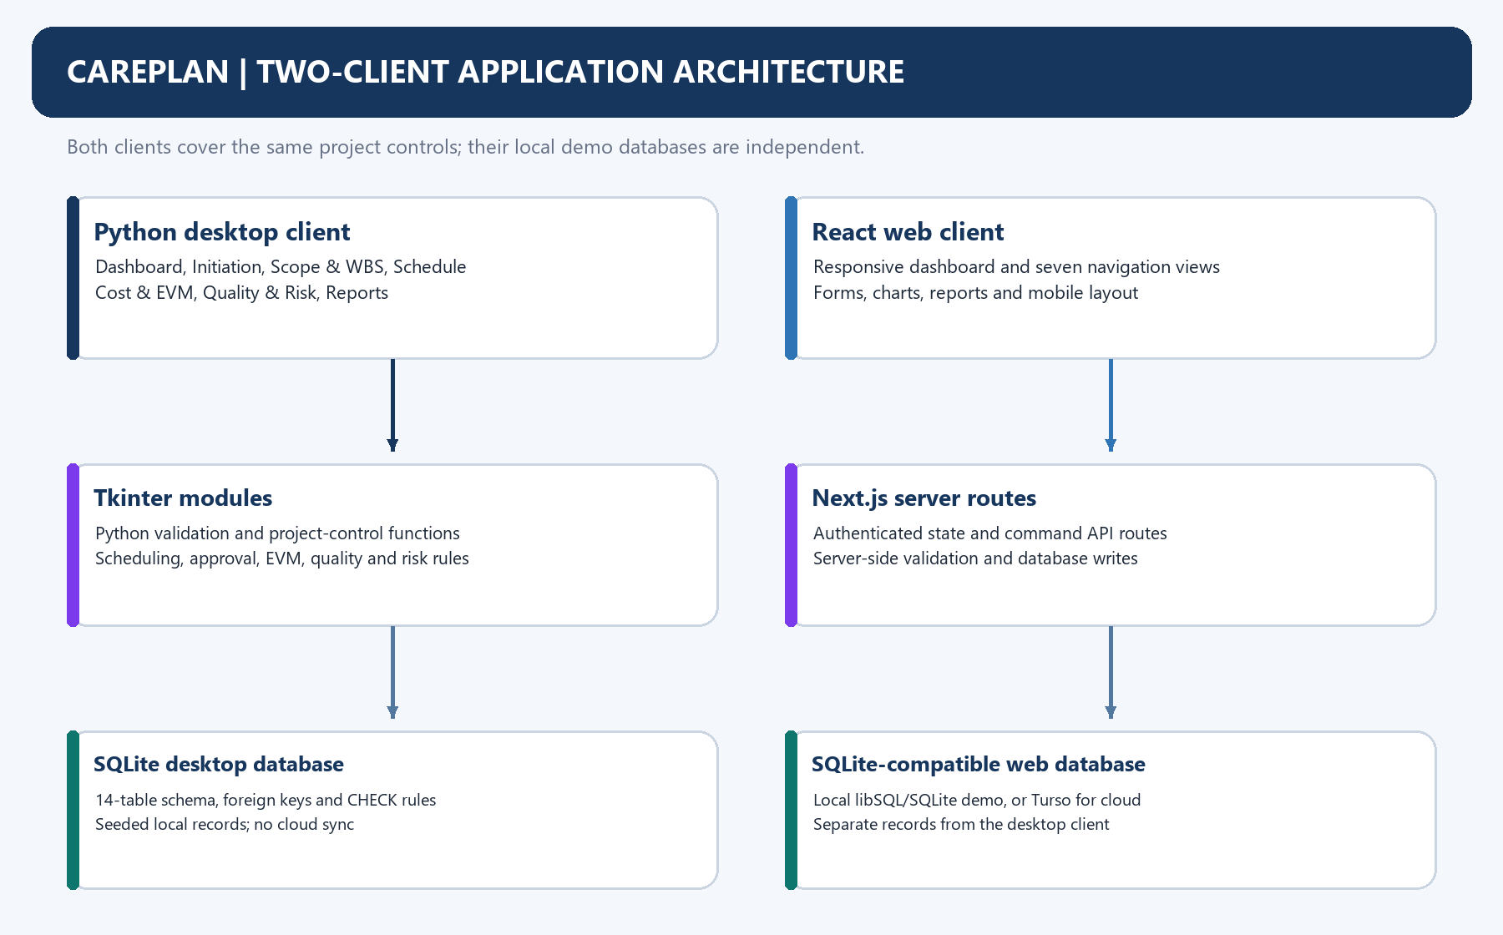
Figure 3.1: The Python desktop and React web clients, their control layers, and their separate databases.
Table 3.1: Application Layers and Responsibilities
Layer | Implementation responsibility
Interface | Python Tkinter desktop tabs plus a responsive React/Next.js browser interface.
Business logic | Python domain functions and Next.js server routes validate input, apply changes atomically, calculate schedules and EVM, and refresh module data.
Persistence | SQLite for the desktop demo and local libSQL/SQLite for the web demo; both use the 14-table model, with independent files.

3.2 Database Design and ERD

3.2.1 Entity Relationship Diagram
The schema defines fourteen entities for the single-project case study. The diagram labels each primary key (PK), foreign key (FK) and unique key (UQ); FK labels name the referenced table and column. This is the SQLite-compatible table model used by both local application variants.
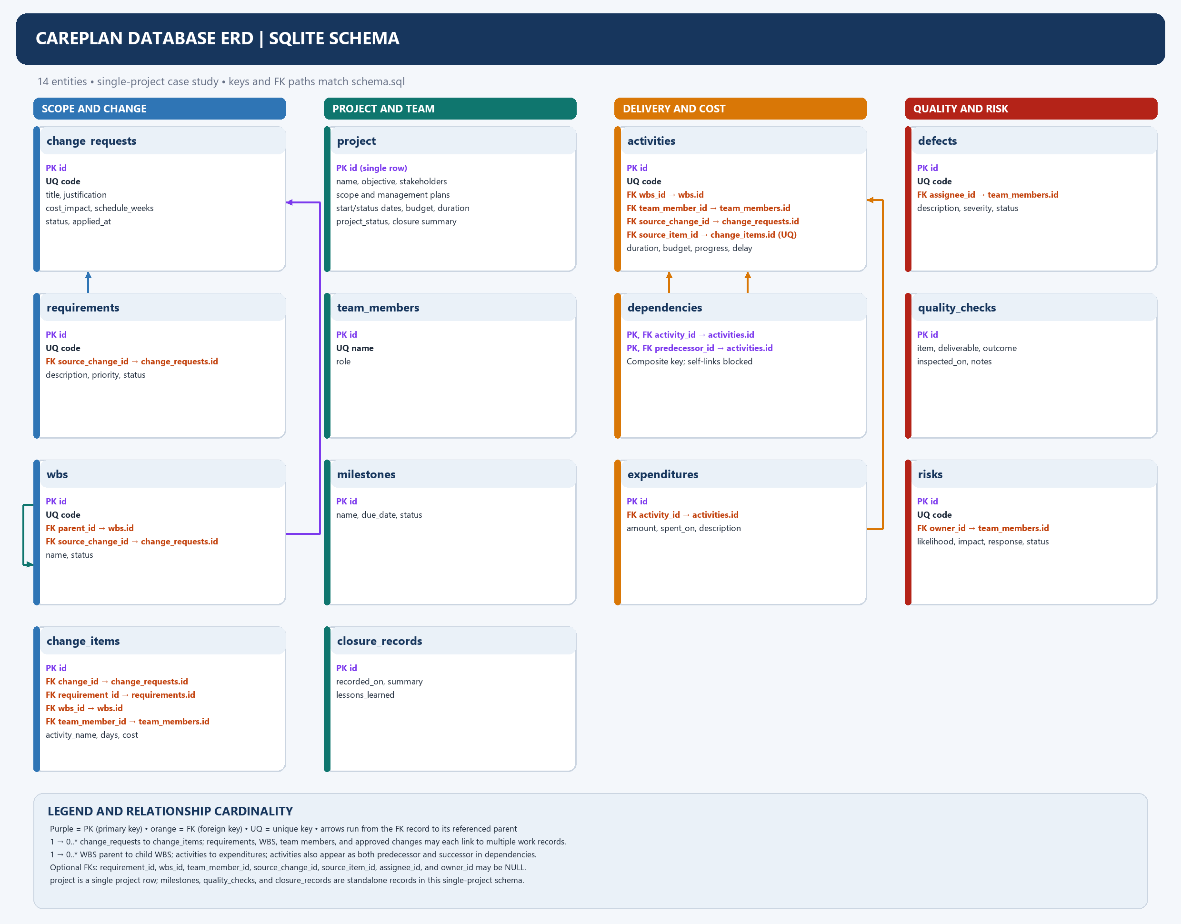
Figure 3.1: Entity groups, key fields and foreign-key cardinalities in the CarePlan database.

3.2.2 Relationship Legend and Integrity Rules
A one-to-many relationship means a parent can be referenced by zero or more child records. Optional foreign keys may be empty until an item is assigned or approved. The WBS parent key forms a self-referencing hierarchy, while dependencies use a composite key to link two different activities. The project row, milestones, quality checks and closure records do not use project_id because this schema stores one project per database.
Table 3.1: Database Relationships and Cardinalities
Relationship | Cardinality and purpose
change_requests → change_items | One request may own zero or more change items; deleting a request cascades to its items.
requirements / wbs → change_items | Each change item may optionally reference one requirement and one WBS record.
wbs → wbs / activities | A WBS parent may have multiple child packages; an activity may optionally reference one WBS item.
team_members → assigned work | A member may own multiple activities, change items, defects or risks; each owner reference is optional.
activities → dependencies / expenditures | Activities may have dated costs and dependency links; dependency pairs cannot point to the same activity.

3.3 Interface Design and Screenshots

3.3.1 Project Dashboard
The dashboard places progress, approved budget, schedule forecast and open controls in one view. The before-state retains the original PKR 5,000,000 baseline while CR-001 is pending. The after-state shows the approved PKR 5,800,000 plan and revised forecast.
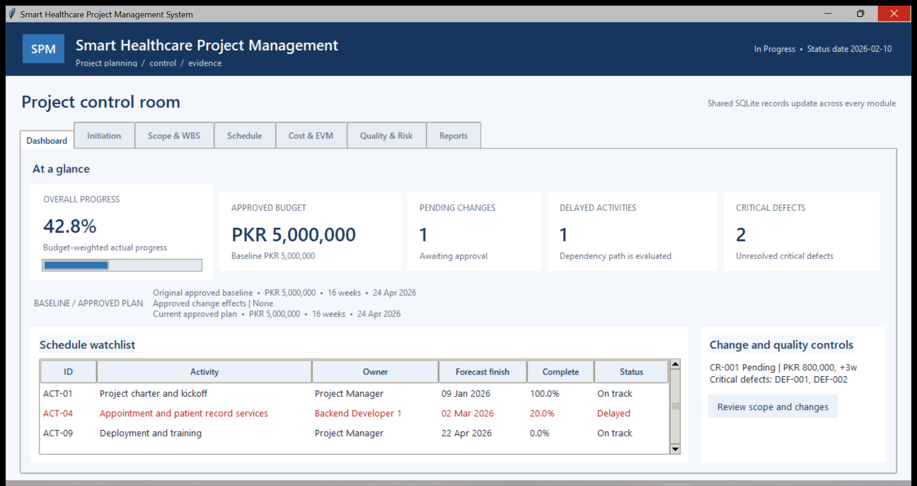 | 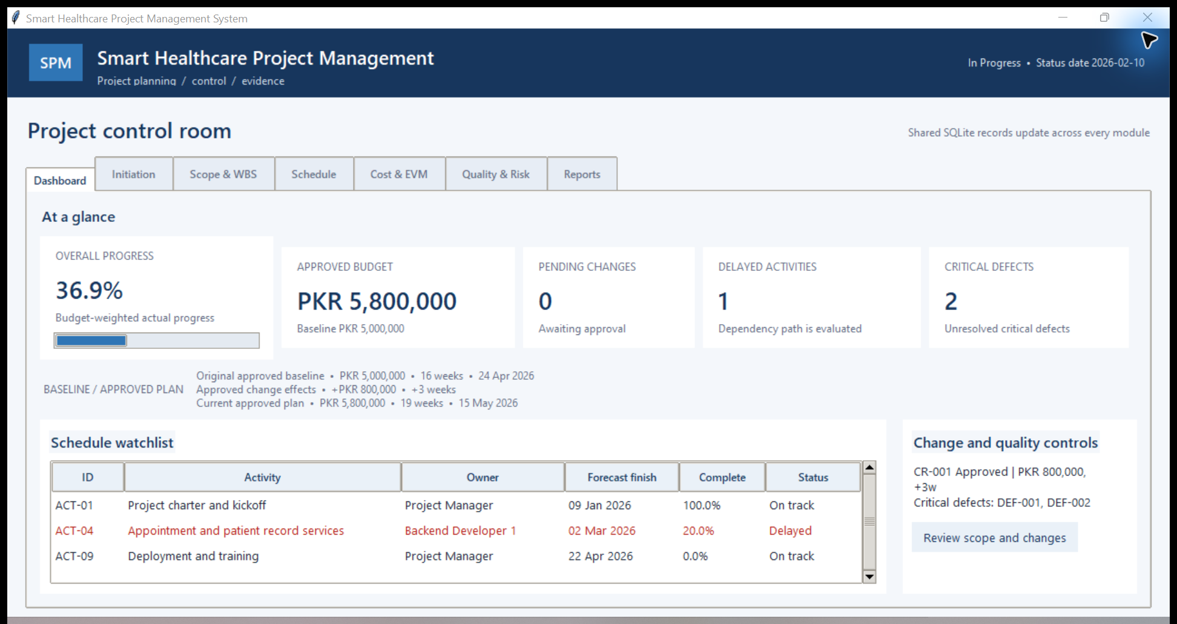
Figure 3.1: Dashboard before approval with the original budget and pending CR-001. | Figure 3.2: Dashboard after approval with the revised budget and forecast.

3.3.2 Change-Control Interface
The change screen records justification, linked requirements and work packages, and cost and time impact. Pending work remains outside the approved plan. The approval result applies the combined PKR 800,000 and three-week change once.
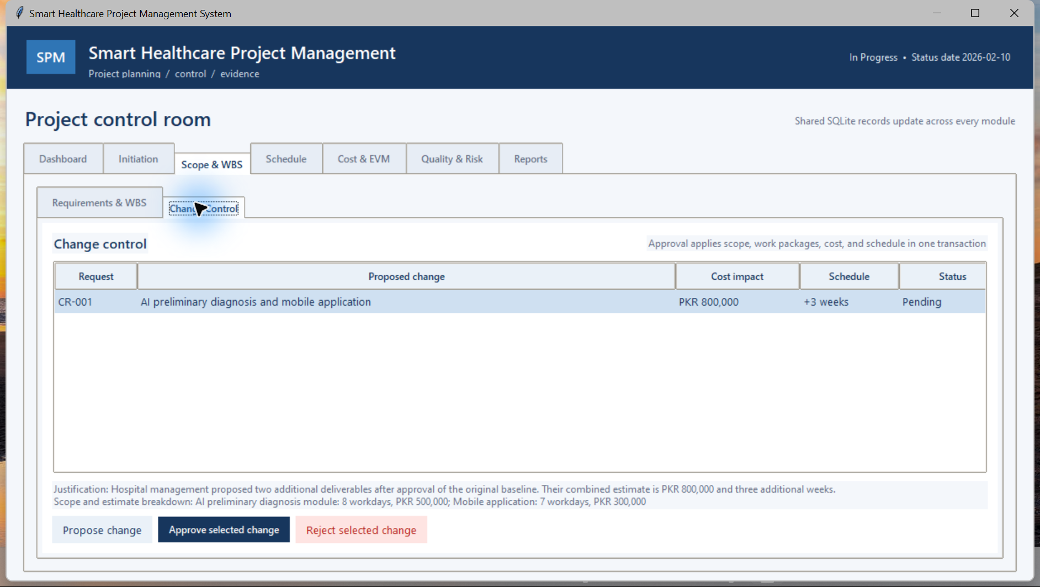 | 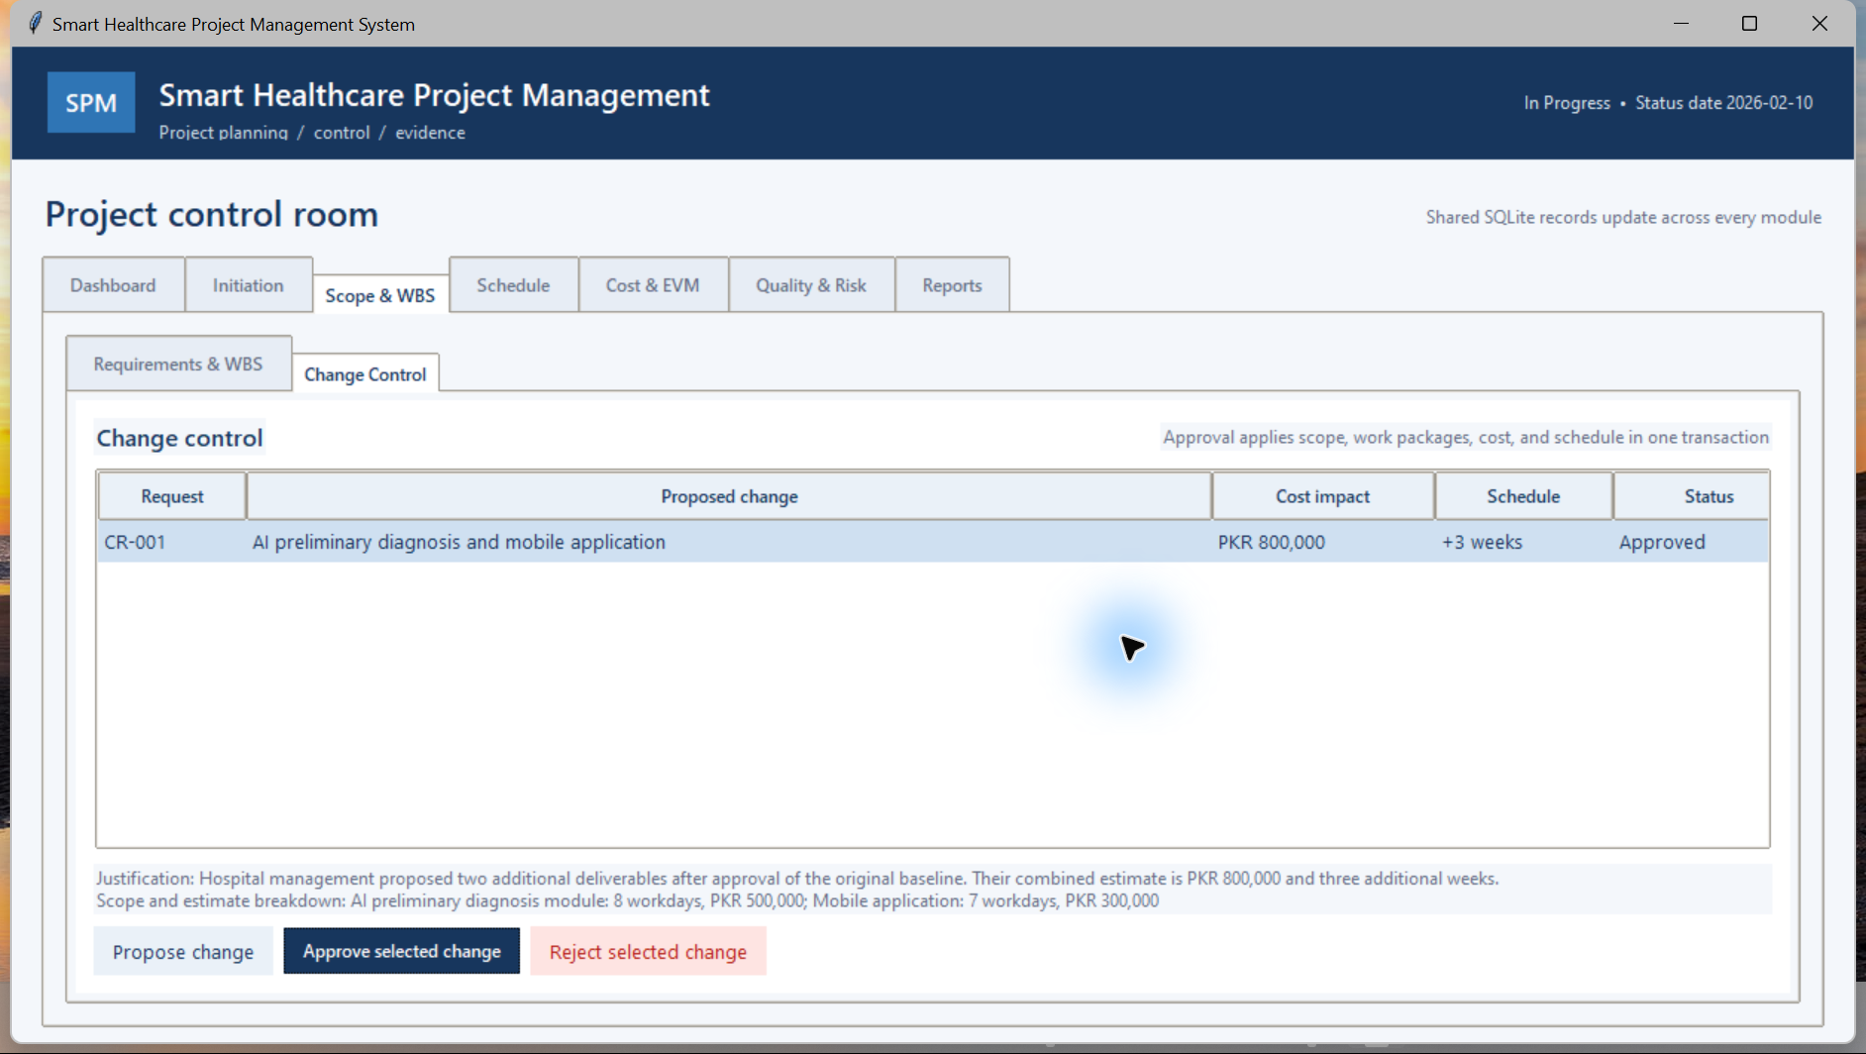
Figure 3.3: Change request and linked scope while approval is pending. | Figure 3.4: Approval confirmation after the single combined change is applied.

3.3.3 Scope and WBS Interface
The scope screen organizes requirements and work packages by approval status. The baseline view contains seven approved requirements and nine activities. The approved view includes the AI and mobile additions as linked, traceable scope.
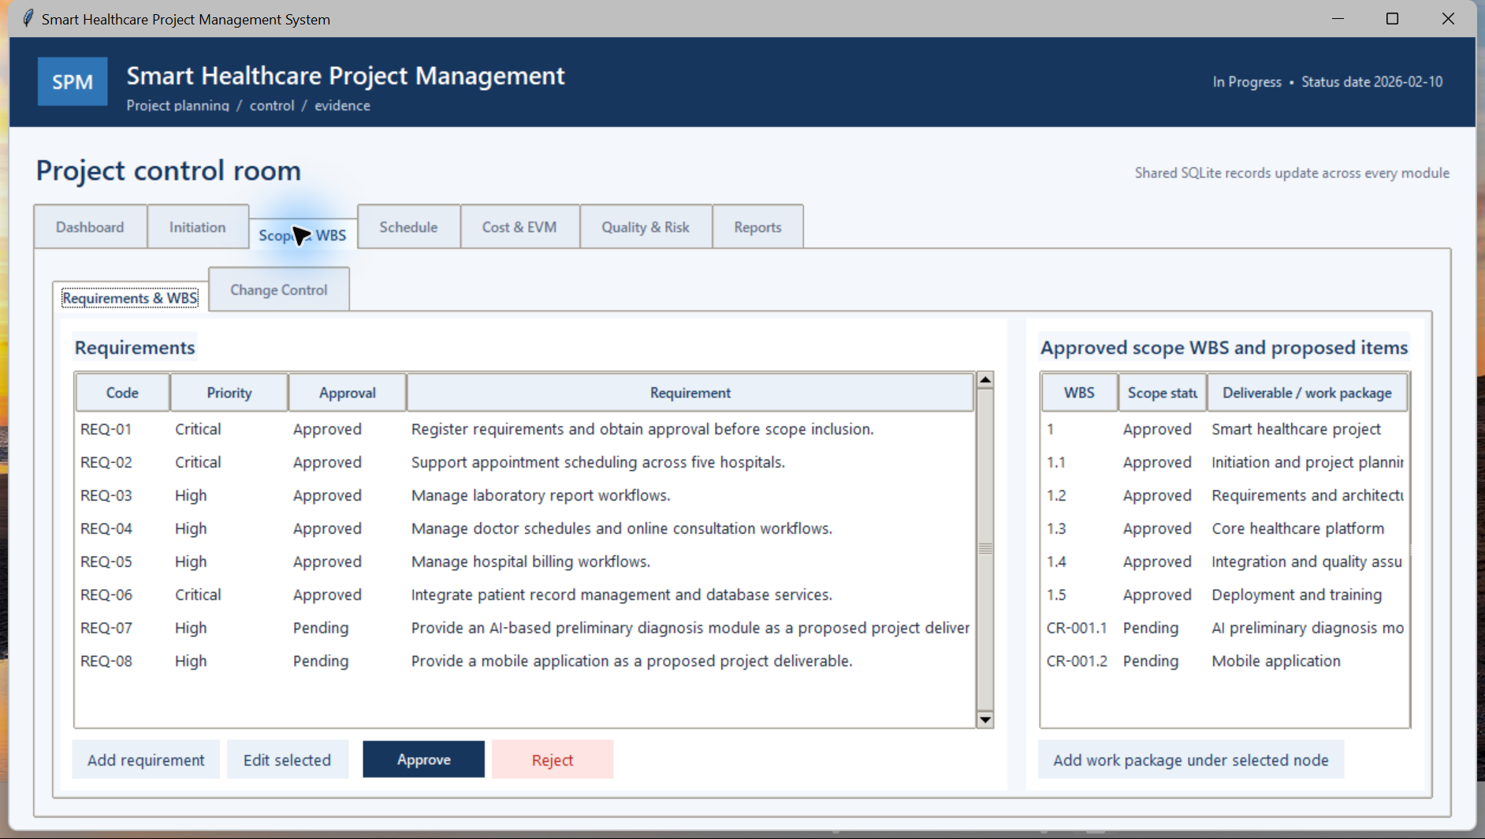 | 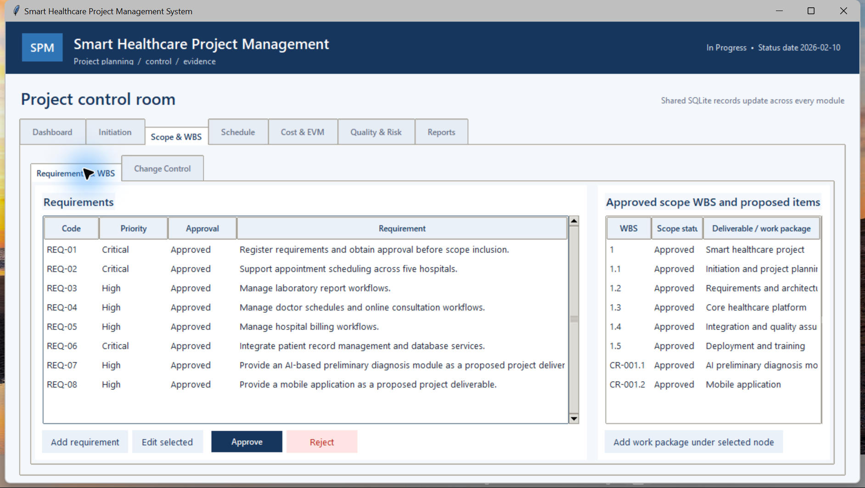
Figure 3.5: Baseline requirements and work breakdown before approval. | Figure 3.6: Approved AI and mobile requirements and WBS work packages.

3.3.4 Schedule and Cost Interface
The schedule view presents activity dates, dependencies and the Gantt forecast. The cost view shows estimates and earned-value indicators at the sample status date. These screens expose how a delay and approved change affect delivery monitoring.
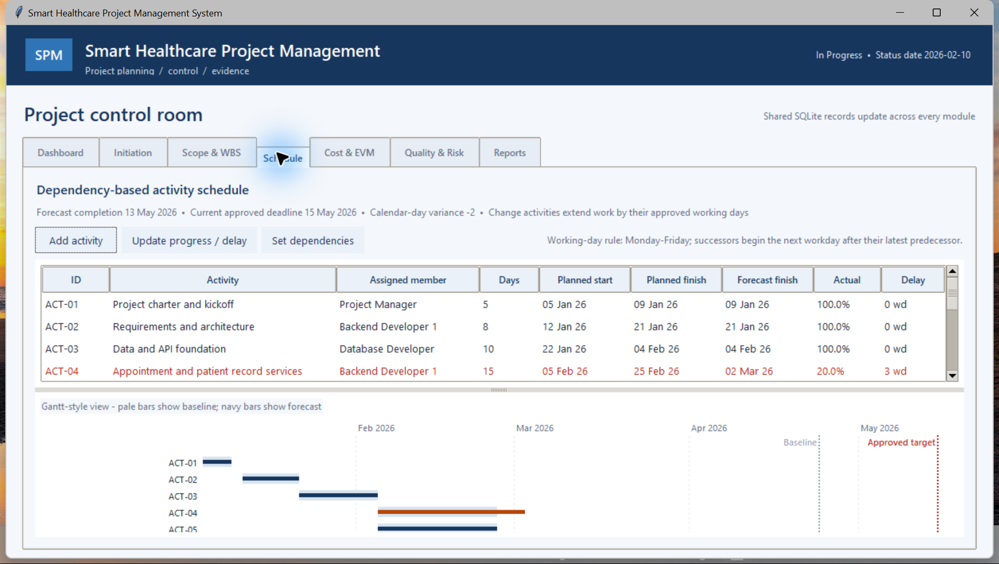 | 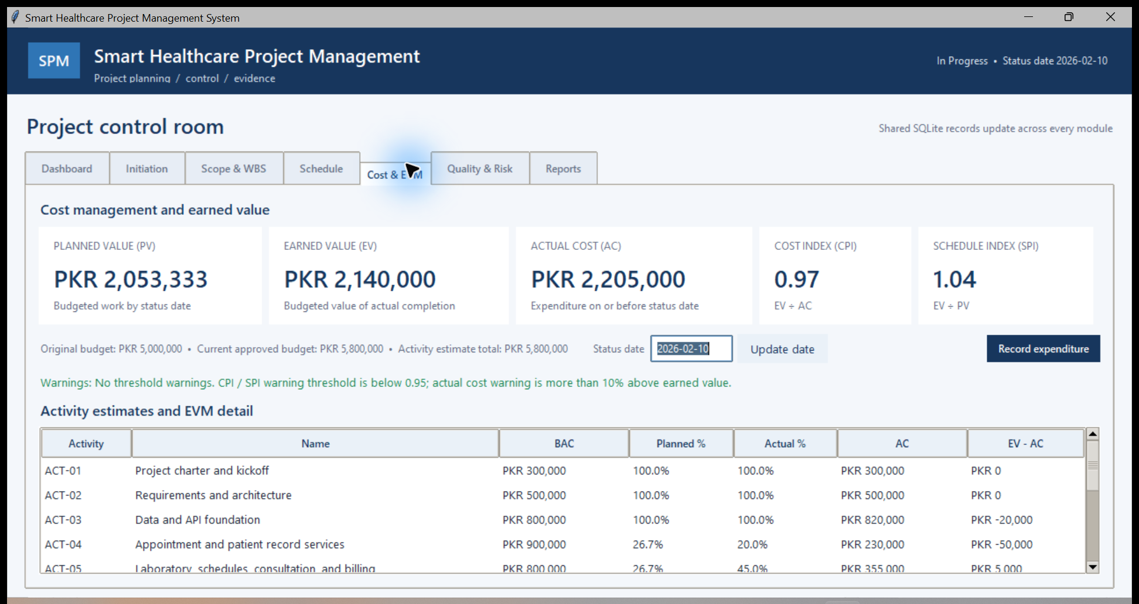
Figure 3.7: Dependency-driven dates and Gantt forecast after approval. | Figure 3.8: Activity budgets and EVM indicators at 10 February 2026.

3.3.5 Quality and Risk Interface
Quality controls show defect severity and inspection results for project deliverables. The risk screen scores likelihood and impact, ranks the risks and presents response actions. The sample intentionally keeps two critical defects open to demonstrate release visibility.
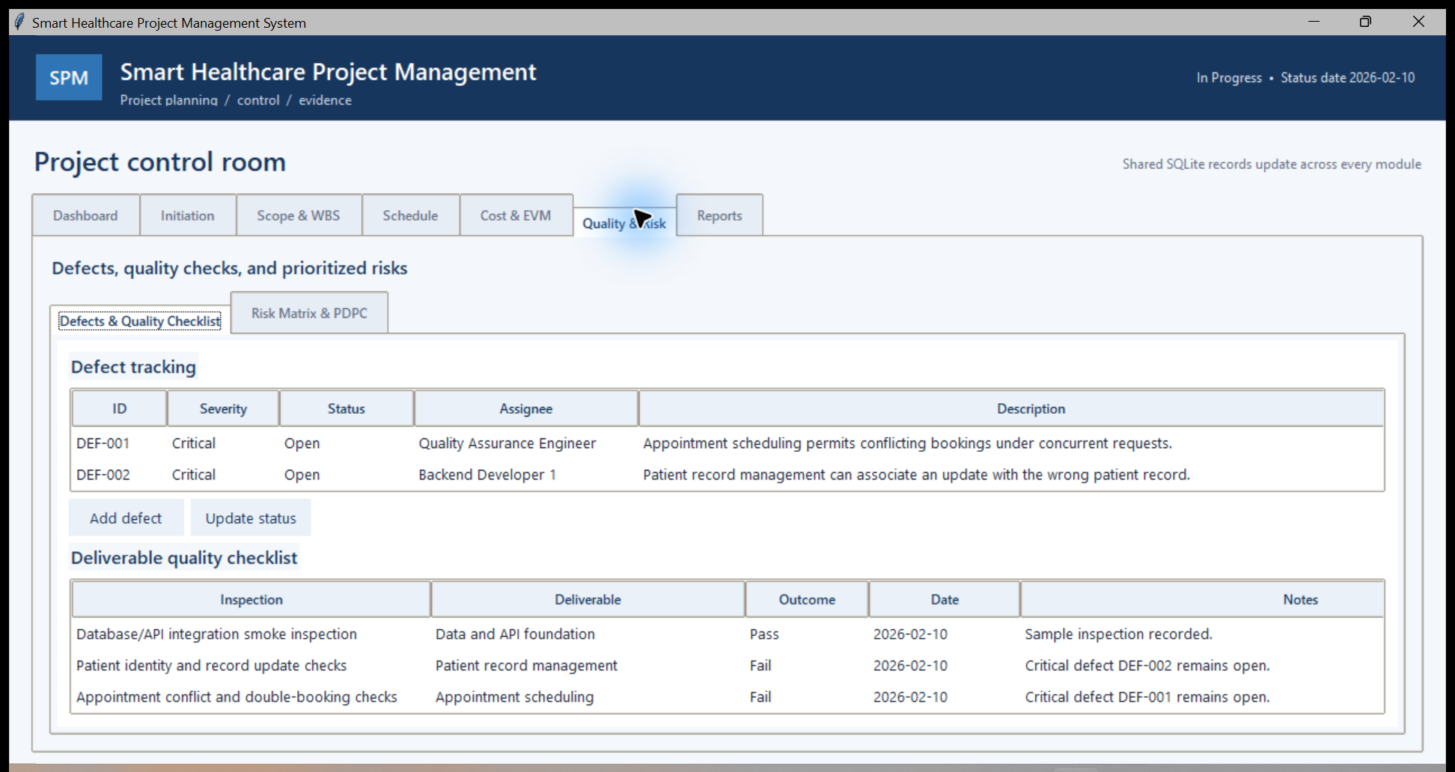 | 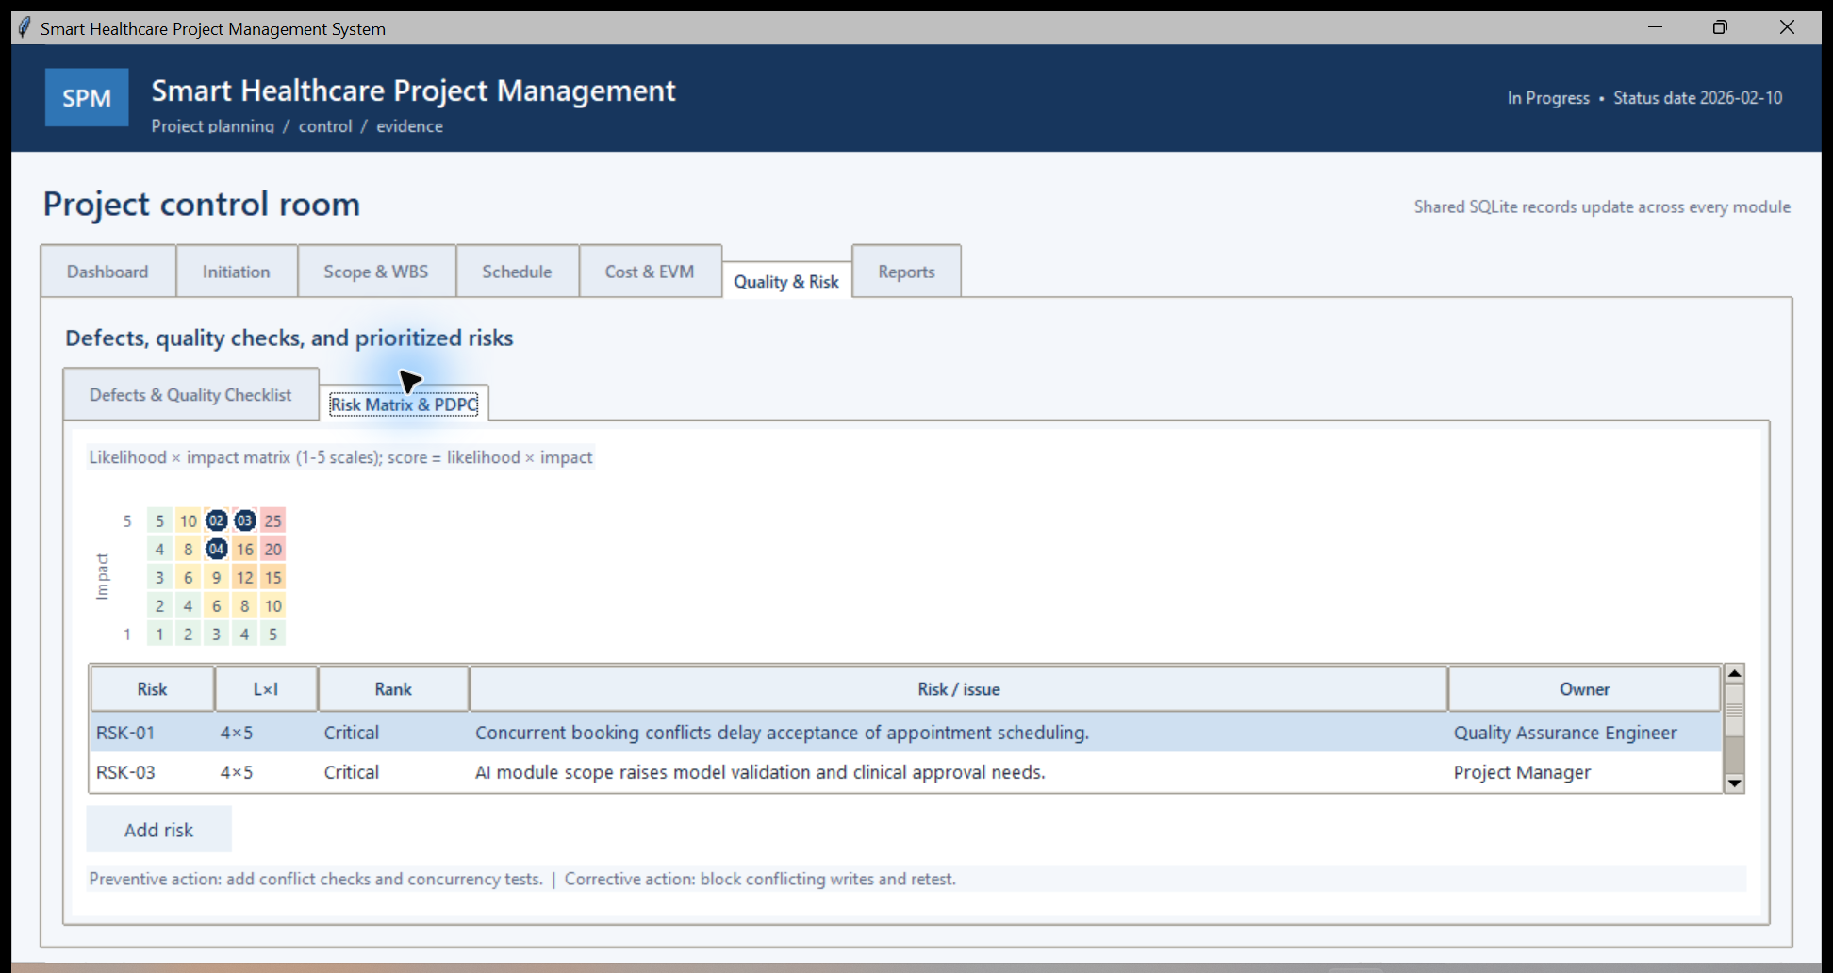
Figure 3.9: Critical defects and deliverable inspection outcomes. | Figure 3.10: Risk matrix, ranked risks and preventive/corrective responses.

3.3.6 Initiation and Integrated Report
Initiation captures the project charter and management-plan fields used by the team. The integrated report gathers status, schedule, cost and control information across the modules. Both screens use synthetic case-study records.
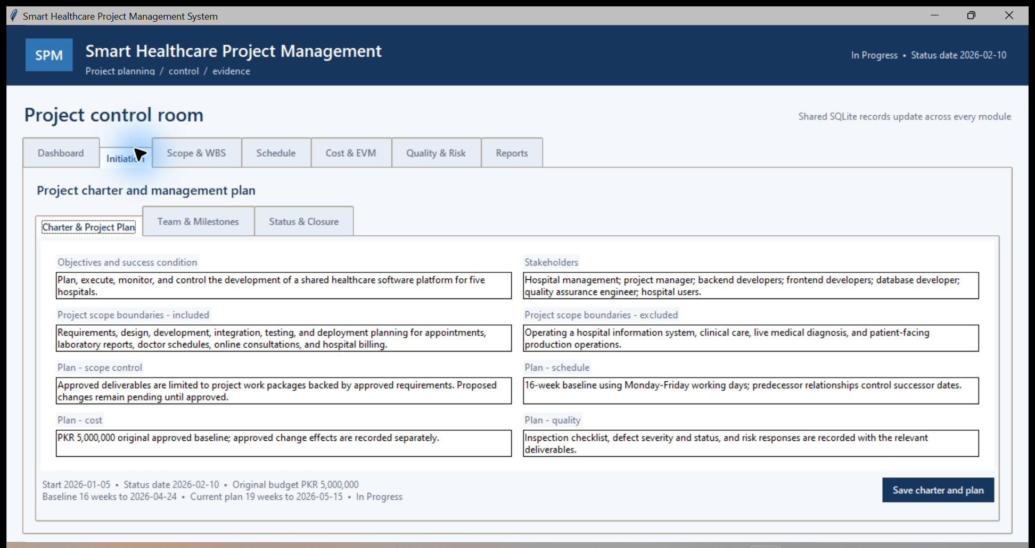 | 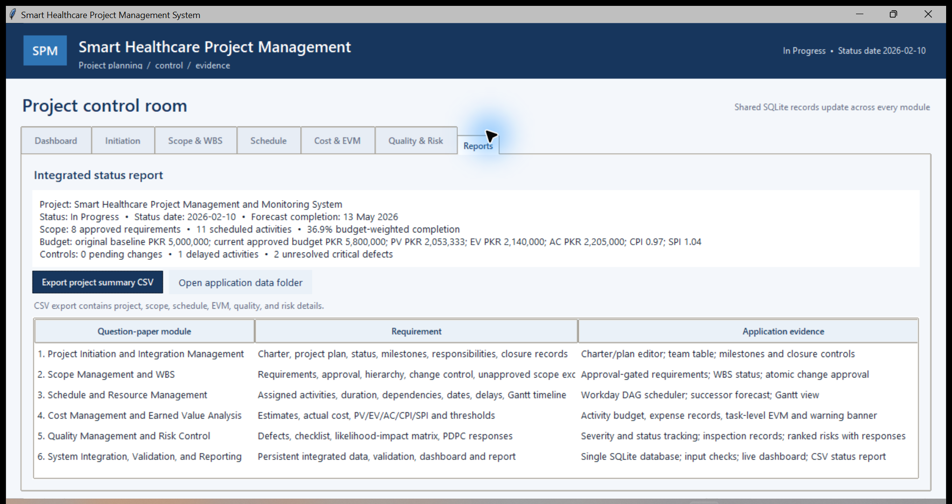
Figure 3.11: Project charter and management-plan fields. | Figure 3.12: Integrated project metrics and module traceability report.

3.3.7 Responsive React Dashboard
The React dashboard adjusts its navigation and cards to a phone-sized screen while preserving the same live project metrics. The desktop capture shows the expanded workspace navigation and dashboard. The mobile capture shows the compact layout, readable cards and phone navigation.
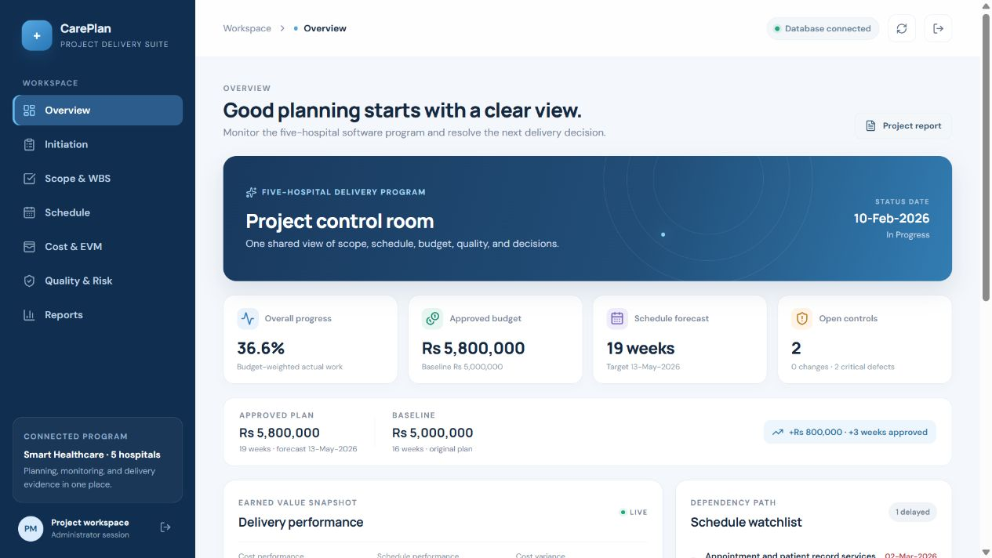 | 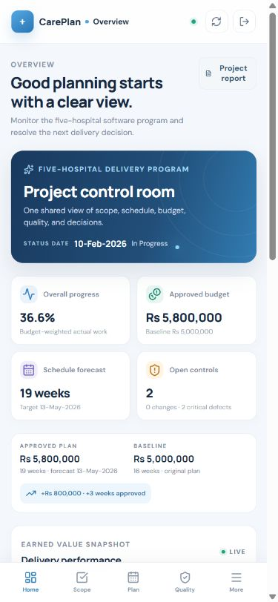
Figure 3.13: Responsive React dashboard at desktop width. | Figure 3.14: Responsive React dashboard at 390 × 844 mobile viewport.

4. Implementation
This chapter explains the application modules and the implementation decisions that connect the user interface, business rules, API routes, and persistent database. The Python desktop and React web clients are separate runnable versions with independent local demo databases. Each version supports the same six project-management areas and validates state changes before saving them.

4.1 Project Initiation and Integration Management
The Initiation tab provides an editable project charter and scope, schedule, cost and quality management-plan fields. Separate views maintain the seven team responsibilities, milestones and project status; a closure view records a closure summary and lessons learned. The project record stores the original approved budget and deadline separately from changes.
Table 4.1: Initiation and Governance Records
Initiation record | Demonstration evidence
Charter | Objective, stakeholders, in-scope and out-of-scope boundaries.
Management plan | Scope, schedule, cost and quality controls saved to the project record.
Integration controls | Project status and status date; team assignments; dated milestone records; closure and lessons-learned records.

4.2 Scope Management and WBS
Requirements carry a priority and Pending, Approved or Rejected status. WBS records use parent identifiers to support hierarchy. Change requests store justification, cost and schedule impacts, status and linked change items. Unapproved requirements and WBS items remain outside the approved scope. Approval validates that linked item cost and workdays equal the request totals, then applies every linked item in one SQLite transaction.
- CR-001 records the combined AI preliminary-diagnosis and mobile application scope. Its two activities are estimated at PKR 500,000 / 8 workdays and PKR 300,000 / 7 workdays.
- Together the additions equal PKR 800,000 and 15 workdays. A second approval attempt is rejected; no duplicate impact can be applied.

4.3 Schedule and Resource Management
The schedule has nine baseline activities assigned to the project team, with estimated working days and costs. Dependencies are stored as activity-to-predecessor links. The application topologically sorts the dependency graph and rejects missing, self-referential or circular links before it saves a changed dependency set.
- Monday-Friday calendar dates are calculated programmatically. Baseline planned dates and delay-adjusted forecast dates remain separately visible.
- A three-working-day delay on ACT-04 moves its dependent chain. The baseline forecast completes on 22 April 2026; an independent work path retains its original dates.
- The approved 15-workday addition is linked after the terminal baseline work and represented by two new activities. The current forecast completes on 13 May 2026, before the revised 15 May target.
A Gantt-style timeline shows baseline bars, forecast bars, month boundaries and separate baseline/approved target markers. A schedule watchlist highlights delayed activities and displays forecast finish dates.

4.4 Cost Management and Earned Value Analysis
Each activity has a budget baseline and actual percent complete. Expenditure records contain an amount, date and activity reference. At the status date, PV is the activity budget multiplied by scheduled progress; EV is its budget multiplied by actual progress; AC is dated expenditure summed through that date. Planned activity progress is elapsed Monday-Friday working days divided by planned duration, capped at 100%; actual progress is the recorded completion percentage.
Table 4.1: Earned-Value Indicators and Sample Results
Indicator | Formula | Sample at 10 Feb 2026
PV | Σ(activity BAC × planned %) | PKR 2,053,333
EV | Σ(activity BAC × actual %) | PKR 2,140,000
AC | Σ(actual expenditure through status date) | PKR 2,205,000
CPI | EV ÷ AC | 0.97 (0.9705 unrounded)
SPI | EV ÷ PV | 1.04 (1.0422 unrounded)

At this sample date, the cost variance is EV − AC = −PKR 65,000 and schedule variance is EV − PV ≈ +PKR 86,667. CPI below 1.00 means actual cost is slightly above earned work; SPI above 1.00 means earned work is ahead of the planned value curve. No alert threshold is crossed: CPI and SPI remain above 0.95, actual cost is less than 10% above EV, and AC is below the current approved budget.
A zero PV or AC denominator produces N/A rather than a divide-by-zero error. Warnings appear when CPI or SPI is below 0.95, AC is more than 10% above EV, or expenditure exceeds the current approved budget.

4.5 Quality Management and Risk Control
The seeded sample includes two critical, open defects: conflicting appointment bookings (DEF-001) and the risk of updating the wrong patient record (DEF-002). Each defect records severity, status, assignee, description and opened date; the status can be moved through the interface.
Three deliverable inspections are recorded: database/API integration passes, while patient-identity and appointment-conflict checks fail because their critical defects remain open. A quality check stores the inspected deliverable, result, date and notes.
Table 4.1: Risk Scores and Response Actions
Risk | Likelihood × impact | Rank | Preventive and corrective response
RSK-01 | 4 × 5 = 20 | Critical | Prevent: add conflict checks and concurrency tests.  Correct: block conflicting writes and retest.
RSK-03 | 4 × 5 = 20 | Critical | Prevent: define non-diagnostic boundaries and approval criteria.  Correct: suspend the module until review criteria pass.
RSK-02 | 3 × 5 = 15 | High | Prevent: verify identity constraints and migration mappings.  Correct: quarantine affected updates and reconcile records.
RSK-04 | 3 × 4 = 12 | High | Prevent: approve interface contracts and staged integration.  Correct: use the approved schedule reserve and reforecast.

The matrix assigns critical status to scores 20-25, high to 12-19, moderate to 6-11 and low to 1-5. Four seeded risks cover appointment concurrency, patient identity, AI review, and mobile integration. A selected risk shows the potential problem and its preventive and corrective actions as a Process Decision Program Chart equivalent.

4.6 System Integration, Validation, and Reporting
The Python desktop application's seven modules operate against one SQLite file. The React web app has equivalent server-side routes backed by its own local SQLite-compatible file; records do not sync between variants. In either app, the dashboard calculates budget-weighted progress, approved budget, pending changes, delayed activities and unresolved critical defects. Reports show status date, forecast completion, PV/EV/AC/CPI/SPI and module traceability; CSV export includes project metrics and activity, requirement, change, defect and risk records.
- Input checks reject invalid dates, empty required text, invalid estimates, negative expenditure, out-of-range progress, duplicate change application, and invalid schedule dependencies.
- SQLite constraints add a second validation layer for required fields, relationships, uniqueness, statuses, costs and risk ratings.
- The test suite creates isolated temporary databases for approval, rejection and persistence scenarios so its state does not overwrite the delivered sample.

4.7 Approved Change Request Demonstration
The case requires a visible demonstration of how an approved change updates scope, budget and duration. CR-001 is first stored as Pending, then applied once to its linked requirements, WBS items and schedule activities.
Table 4.1: Change Request Approval Evidence
Control item | Before approval | Single approved effect | After approval
Approved budget | PKR 5,000,000 | + PKR 800,000 | PKR 5,800,000
Approved duration | 16 weeks | + 3 weeks | 19 weeks
Requirements | 7 baseline approved; CR-001 addition Pending | Approve AI and mobile requirements | 8 approved requirements in sample
WBS / activities | 9 baseline activities; CR WBS Pending | Create AI (8 wd) and mobile (7 wd) tasks | 11 scheduled activities
Schedule target | 24 Apr 2026 baseline deadline | Extend approved horizon by 15 workdays | 15 May 2026 revised deadline
Forecast completion | 22 Apr 2026 with ACT-04 delay | Link approved tasks after terminal baseline work | 13 May 2026

Activity estimates reconcile to the approved budget: nine baseline activity budgets total PKR 5,000,000; the AI activity adds PKR 500,000 and the mobile activity adds PKR 300,000. Thus total activity BAC is PKR 5,800,000. The approval is atomic; scope statuses, tasks, dependencies and approved change record commit together.

4.7.1 Dashboard Status at the Approved State
- Budget-weighted actual progress: 36.9% across PKR 5,800,000 of approved activity estimates.
- Pending change requests: 0. Delayed activities: 1. Unresolved critical defects: 2.
- Forecast finish: 13 May 2026 versus the revised deadline of 15 May 2026.
Sample progress, cost and dates are scenario data chosen to demonstrate monitoring and exception handling; they are not estimates supplied by the case paper.

4.8 Source Code and GitHub Repository
The source code for both application clients is published in this public repository: https://github.com/fa23-bse-015/careplan-healthcare-pms

5. Testing

5.1 Schedule and EVM Verification Scenarios
The schedule uses Monday-Friday working days, without a public-holiday calendar. Each successor starts on the next working day after its latest predecessor finishes. ACT-04's three-workday delay shifts its dependent path; an independent path remains unchanged. The delayed baseline forecast finishes on 22 April 2026, and the approved AI/mobile work extends the current forecast to 13 May against the revised 15 May target.

5.1.1 Representative Scenario-Based Test Cases
Four end-to-end scenarios cover the primary approval, scheduling and earned-value risks. Expected outcomes are compared with the executed local sample; Section 5.2 summarizes the supporting automated regression suites.
Table 5.1: Representative Scenario-Based Test Cases
Scenario | Action | Expected result | Observed result
SC-01 Approval gate | Review CR-001 while Pending. | Keep the PKR 5,000,000 / 16-week baseline and exclude its linked work. | PASS: baseline remains unchanged; approval is required.
SC-02 Single change approval | Approve CR-001, then attempt a second application. | Add PKR 800,000 and 15 working days once; create two linked activities. | PASS: PKR 5,800,000 / 19 weeks / 11 activities; duplicate apply rejected.
SC-03 Delay propagation | Add three workdays of delay to ACT-04. | Move successor forecasts while leaving an independent path unchanged. | PASS: dependent forecast moves; independent dates remain stable.
SC-04 EVM edge case | Calculate BAC 1,000/500, 40% actual, and AC 450; also evaluate zero denominators. | PV 500, EV 400, AC 450, CPI 0.89, SPI 0.80; zero denominators return N/A. | PASS: numeric results match and N/A is returned without division errors.

5.1.2 Plan and Forecast Verification
Table 5.2: Baseline, Approved Plan and Forecast Verification
Verification | Calculated result
Original baseline | PKR 5,000,000; 16 weeks; 24 Apr 2026 sample target
Combined approved change | + PKR 800,000; + 15 workdays (3 weeks), once
Revised approved plan | PKR 5,800,000; 19 weeks; 15 May 2026 target
Forecast after linked delay and approved work | 13 May 2026; no change to the original baseline dates

Table 5.3: Earned-Value Scenario Results
Status-date check | Formula | Result at 10 Feb 2026
PV | Σ(activity BAC × planned progress) | PKR 2,053,333
EV | Σ(activity BAC × actual progress) | PKR 2,140,000
AC | Σ(dated expenditure through status date) | PKR 2,205,000
CPI / cost variance | EV ÷ AC; EV − AC | 0.9705; −PKR 65,000
SPI / schedule variance | EV ÷ PV; EV − PV | 1.0422; +PKR 86,667

A separately executed numerical check uses activity BAC values 1,000 and 500, 40% actual progress on the first task, and AC 450: PV 500, EV 400, AC 450, CPI 0.89, and SPI 0.80. The test suite also confirms that zero PV or AC produces an N/A index instead of a divide-by-zero error.

5.2 Automated Regression Summary
The four representative scenarios above are supported by the full automated regression logs. The Python suite covers database persistence, approval and rejection, schedule propagation, validation and EVM. The React/API/UI suite covers authenticated changes, persistence, module navigation and responsive behavior.
Table 5.1: Automated Regression Test Summary
Test suite | Cases | Passed | Failed | Result
Python desktop | 13 | 13 | 0 | PASS
React web and API | 28 | 28 | 0 | PASS
Total | 41 | 41 | 0 | PASS

The detailed case-by-case execution log is included as CarePlan_Web_Test_Cases.csv and SmartHealthcarePMS_Complete_Test_Cases.csv in the instructor demo package.

6. Deployment and Project Structure
The project contains a Python desktop application and a responsive React/Next.js web application. The React app is running locally in production mode at http://127.0.0.1:3000, and its dashboard responds with the local database connected. The Vercel address currently displays a Vercel team-login page and is not an instructor-accessible deployment; production database and authentication settings are still required.

6.1 Source Repository
Public source repository: https://github.com/fa23-bse-015/careplan-healthcare-pms

6.2 Project Structure
CarePlan_Project/
├── healthcare_pms/ Python desktop app, SQLite schema, seed data, tests
├── healthcare_pms_web/ React + Next.js client, API routes, schema, seed script
├── docs/ Word report, architecture diagram and database ERD
│ └── screenshots/ Desktop, web and mobile UI evidence
└── README.md Project overview and local run instructions

6.3 Run the Local Applications
1. Open the healthcare_pms_web folder in Visual Studio Code. Open its integrated PowerShell terminal from Terminal > New Terminal.
2. Run npm install once to install the dependencies, then npm run db:setup to initialize the local SQLite-compatible demo data.
3. Run npm run dev and wait for Next.js to display its local URL. Open http://localhost:3000 in Chrome.
4. Sign in with the local demo password provided to the student, then present Overview, Initiation, Scope & WBS, Schedule, Cost & EVM, Quality & Risk, and Reports. Stop the server with Ctrl+C when finished.
5. For the Python desktop version, double-click SmartHealthcarePMS.exe in the deliverables folder, or open healthcare_pms in VS Code and run python app.py.

6.4 Vercel Deployment
The previous Vercel address is https://careplan-healthcare-mns2ol9lz-ak-289c.vercel.app/. A live check showed the Vercel team-login page rather than the application, so it is not a public instructor demo link. Cloud operation still requires a persistent Turso database and the Production environment variables TURSO_DATABASE_URL, TURSO_AUTH_TOKEN, APP_ADMIN_PASSWORD, and SESSION_SECRET. The public GitHub repository excludes .env.local and credentials.
1. Create or select a persistent Turso database and keep the database URL and token private.
2. Add the database URL, token, a unique production password of at least 12 characters, and a random session secret of at least 32 characters to the Vercel project settings.
3. Initialize the schema and synthetic seed data, redeploy the production branch, then verify public sign-in, database connection, all seven modules, and save-and-refresh behavior before presenting the hosted application.

6.5 Release Readiness and Handover
A production handover should name the person responsible for Vercel access, database credentials, backups, and future releases. Before sharing the public URL, confirm that the deployment uses the persistent cloud database rather than local SQLite storage, that sign-in is required, and that no secret is present in the public repository. The demonstration password must remain separate from the production administrator password.
After release, retain a copy of the schema and migration procedure with the project records, and confirm that a recent database backup can be restored. Record the deployment URL, release date, commit, and known limitations in the handover notes. A later update should be deployed from a reviewed commit and checked against the same login, module-navigation, and persistence workflow used for acceptance.

7. Report Close
I developed CarePlan to make the five-hospital software case easier to plan and review. It brings scope, schedule, resources, budget, quality and risk controls together in a Python desktop version and a responsive React web version. The application preserves the original PKR 5,000,000 and sixteen-week baseline, and records the approved PKR 800,000 and three-week change once.
The public GitHub repository contains both application clients, their schemas and seed data, and colored screen captures. For the instructor demonstration, the local React app is available in Chrome at http://127.0.0.1:3000, and the packaged desktop app is available in the deliverables folder. The Vercel URL still requires team access and production database configuration; it should not be presented as a public live demo until those steps are complete.
The sample AI requirement is tracked as project scope only; the application does not give medical advice or diagnose patients. The project is ready for a local walkthrough, while cloud access remains the next deployment task.

8. References
[1] COMSATS University Islamabad, Sahiwal Campus, Department of Computer Sciences. Software Project Management (CSE-494), Mid-term Examinations Fall 2026, Question 1: Smart Healthcare Project Management and Monitoring System case study and implementation requirements.
[2] Meta Open Source. React Documentation, Quick Start. https://react.dev/learn (accessed 27 October 2026).
[3] Vercel. Next.js Documentation, App Router. https://nextjs.org/docs/app (accessed 27 October 2026).
[4] SQLite Consortium. SQLite Foreign Key Support. https://www.sqlite.org/foreignkeys.html (accessed 27 October 2026).
[5] Vercel. Next.js on Vercel. https://vercel.com/docs/frameworks/full-stack/nextjs (accessed 27 October 2026).
[6] Turso. Turso Documentation. https://docs.turso.tech/ (accessed 27 October 2026).
[7] COMSATS University Islamabad. Official institutional website. https://islamabad.comsats.edu.pk/ (accessed 27 October 2026).

