Muhammad Uqba
Fa23-BSE-044
Section- (A)
Submitted to:
Madam Komal Hassan

Operating System Lab: 1
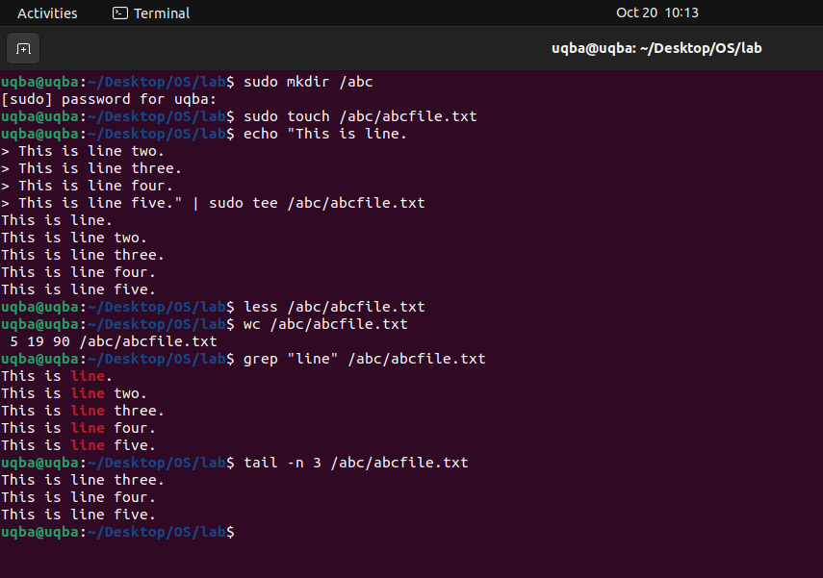

Operating System Lab: 2
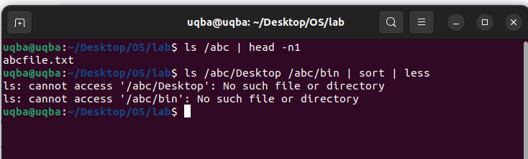

Operating System Lab:3

