The Relationship Between Evidence Score and Public Interest in Cannabis Health Benefits
  - 7COM1079-0901-2025
  - Team Research and Development Project

Group ID: A30
Dataset number: DS064
Prepared by:
Farhan Ali - 23104223 (Submitting Student)
Muhammad Ali - 24177503
Adnan Haider - 24083682
Sohrab Ali -
Mujtaba Ahmad -

University of Hertfordshire
Hatfield, 2025

Table of Contents
1. Introduction 3
1.1 Problem statement and research motivation 3
1.2 The dataset 3
1.3 Research question 3
1.4 Hypothesis: 3
2. Background research 4
2.1 Related Papers 4
2.2 Research Gap 4
3. Visualization 5
3.1 Popular Interest in Cannabis Benefits by Evidence Score 5
4. Analysis 6
4.1 Statistical test used to test the hypotheses and output 6
4.2 Result 6
5. Evaluation 7
5.1 Points for improvement 7
5.2 Group's time management 7
5.3 Project's overall judgement 7
5.4 Discussion of the GitHub log output. 7
6. Conclusions 7
6.1 Results explained 7
6.2 Discussion 8
6.3 Limitations 8
7. Reference list 9
Appendices 9
Appendix A: R code used for analysis and visualization 9
Appendix B: GitHub log output 12

1. Introduction

1.1 Problem statement and research motivation
The use of cannabis in form of treatment has attracted a lot of publicity, with a myriad of health conditions researched about the potential of using cannabis as a therapy. However, the strength of the scientific evidence in these conditions is quite different and ranges between the negative impacts and the strong supportive evidence. The relation between the strength of evidence and the interest of the population is not well comprehended, and it creates a problem of health communication and policymaking (Ishida et al., 2020). The understanding of this correlation is obligatory because an incongruence between the empirical data and societal beliefs may lead to the inadequacy of applied use, unrealistic anticipations, or a loss of treatment chances (Whiting et al., 2015). The current paper assesses the existence of the higher scientific evidence and its linkage to the popular interest in the health benefits of cannabis in a range of different medical conditions.

1.2 The dataset
The Cannabis Benefits data set has 69 health conditions that report cannabis research. The conditions are presented in terms of a score on their evidence (0 = harmful, 1 = insufficient evidence, 6 = strong evidence), a public interest index calculated via Google search volumes, and the number of scholarly citations that have been found in Google Scholar (2000-2017). Such a dataset can provide full information on the quality of scientific evidence and level of engagement of the population and thus allows conducting a quantitative analysis of the evidence-interest relationship in various health areas, such as neurological, mental health-related, immune system, and cancer diseases.

1.3 Research question
Research Question: Does the level of scientific evidence and popular interest in the health benefits of cannabis have a significant relationship? Are health conditions characterized by higher scores on the scientific evidence scale characterized by much higher levels of public interest and involvement than conditions characterized by lower or inadequately high scores?

1.4 Hypothesis:
Null Hypothesis (H₀): The popular interest between the levels of evidence scores is not significantly different. The quality of scientific evidence does not play a major role in the interest of the population in the health benefits of cannabis.
Alternative Hypothesis (H₁): The level of popular interest varies significantly between different levels of evidence scores. The scientific evidence is a strong factor that affects the interest of the population towards the health benefits of cannabis.
The Kruskal Wallis H -test will be used as a non-parametric statistical test that is appropriate in comparing multiple independent groups in situations where data do not follow the normality assumptions to verify that the quality of evidence has a significant influence on the quality of public attention and engagement about cannabis health information.

2. Background research

2.1 Related Papers
Whiting et al. (2015) also conducted a systematic review of cannabinoids used as a treatment method, which included 79 randomized controlled trials including 6462 participants with various medical conditions. Their careful meta-analysis could find moderate-quality evidence of the effectiveness of cannabinoids in chronic pain and spasticity treatment, but it was not enough to substantiate several other conditions, despite the high levels of media coverage. It was therefore found that the gap between evidence and popular interest in the study is very pronounced, an imbalance that spurs the current quantitative study(Whiting et al., 2015).
Sarvet et al. (2018) have analyzed the trends in cannabis use in various states over time and stated that the common opinion and behavior in the population often does not coincide with the scientifically proven view and evidence-based guidelines. Their longitudinal study revealed that the liberalization of recreational laws raised the consumption rates regardless of the quality of the evidence that related to the medical use which indicated that the sociopolitical factors, other than the scientific evidence, was the main determinant of the formation of the behavior of the population and the trend of the use of cannabis(Sarvet et al., 2018).
Ishida et al. (2020) examined the 9,003 adults on cannabis information sources and health beliefs using the probability-based surveys which showed that those who used the social media, the internet, or industry-sponsored content were much more likely to support the unproven health claims. The survey revealed that forty three percent of the surveyed believed misinformation about the safety and benefit of cannabis. This result emphasizes the dire necessity to evaluate the impact of the quality of scientific evidence on population-level interest manifested in search behavior, thus providing evidence on the significant evidence-perception gap in influencing population health communication and cannabis policy formulation.(Ishida et al., 2020)

2.2 Research Gap
The available literature indicates that there is a high discrepancy between the evidence about cannabis obtained empirically and the perception of the population towards this issue. Even though evidence-based indications of cannabis have been outlined in systematic reviews (Whiting et al., 2015), survey data suggest that an impressive amount of the population believes unsubstantiated claims, particularly people who turn to non-professional sources (Ishida et al., 2020). However, there has been no extensive study that has investigated this relationship in a wide range of clinical conditions through population-level measures. The present research will address this gap by quantifying the evidence interest relationship in 69 individual medical conditions, thus educating evidence-based communication strategies (Sarvet et al., 2018). It is anticipated that the findings will guide policy makers to be aware of the nature of the inherent challenges in making evidence dissemination accurate and accessible.

3. Visualization

3.1 Popular Interest in Cannabis Benefits by Evidence Score
Boxplots are effective to provide comparisons of distributions among several groups and hence would be suitable to analyze popular interest among six evidence score categories. The overlay of the individual data points indicates sample sizes and outliers. The histograms are used to complement as they show the overall distribution features and non-parametric tests are selected because of the right skewness values of the data.
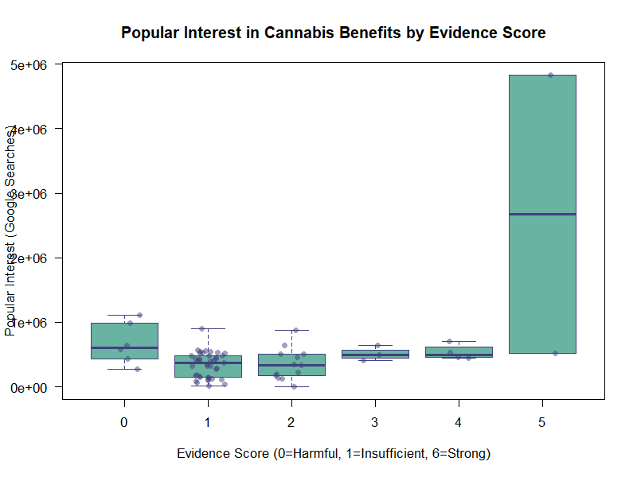
Figure 1: Popular Interest in Cannabis Benefits by Evidence Score
The boxplot indicates that there is evidence score 5 showing only popular interest of about 2.7 million searches. The similar scores of evidence at 0-4 have similar median values (300,000-600,000 searches) with a significant overlap, indicating that the differences in evidence do not have much impact on the attention of people. This trend suggests a possible threshold effect that needs the highest possible strength of evidence.
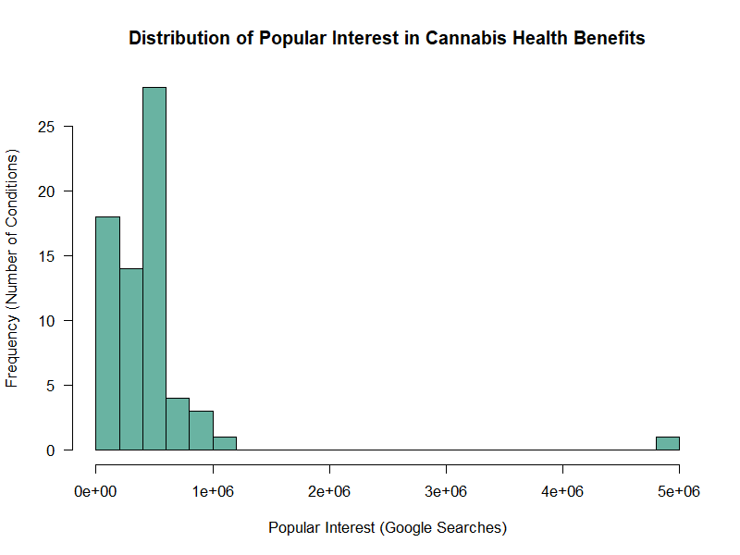
Figure 2: Distribution of Popular Interest Values
Most of the conditions (59%) lack evidence (score=1) which points to early-stage research. Popular interest is highly divergent within categories (standard deviations are larger than mean), implying that there are non-evidence factors affecting attention. The non-parametric statistical techniques are correct when the distribution is skewed towards the right. The score of 5 is obtained only under two conditions which hinders generalizability of findings.

