DEMO

1. 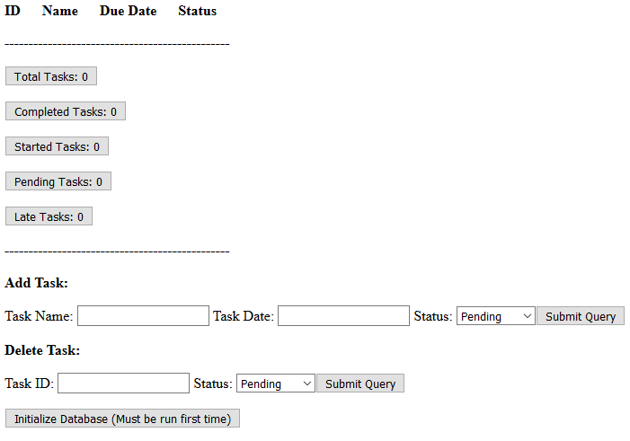This is what the application looks like with no tasks stored in it and an empty database:
2. If we want to add a task to the todo list we enter it in the Add Task field and submit

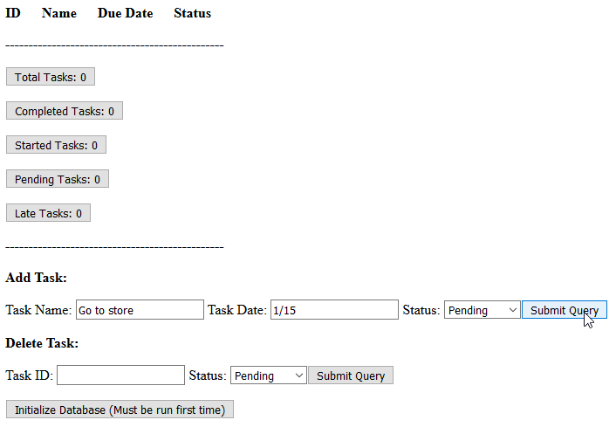

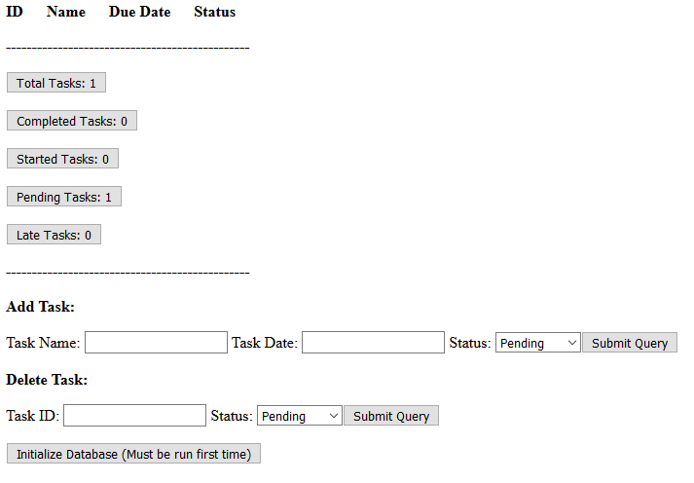

1. Now to view the task we added, you simply click on the ‘Pending Tasks’ button

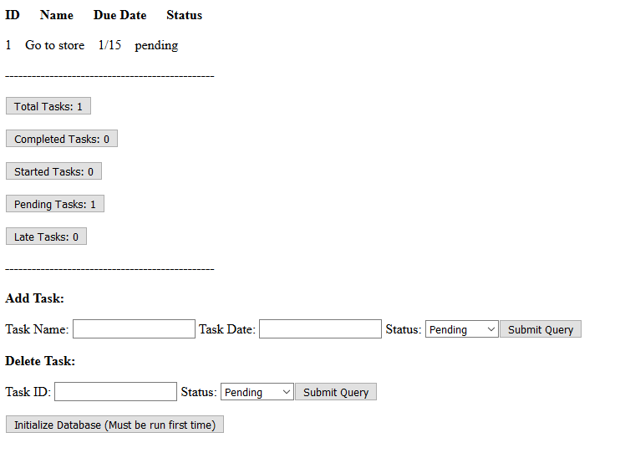

1. Now if we had tasks under every status that we wanted to view we would click the ‘Total Tasks’ button

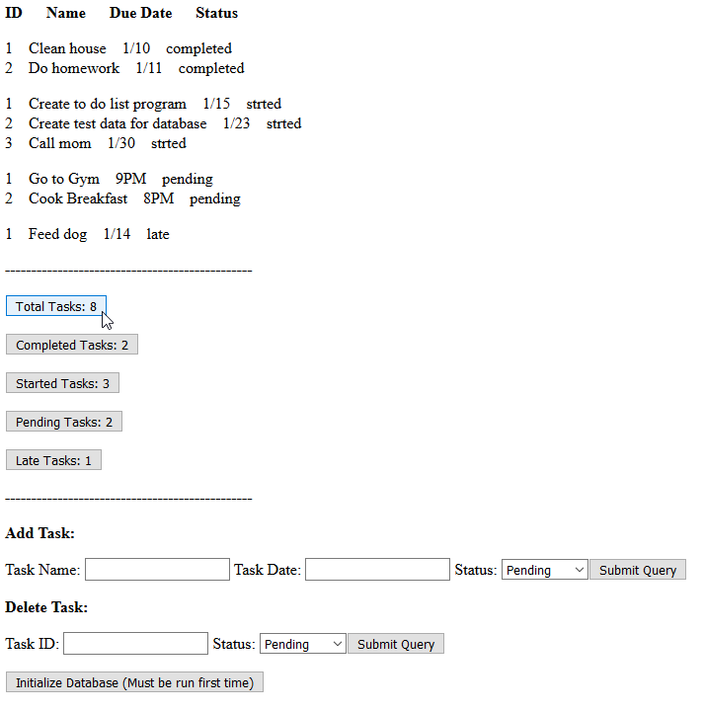

1. If we want to remove a task from this list now we enter the Task’s ID and status in the bottom field

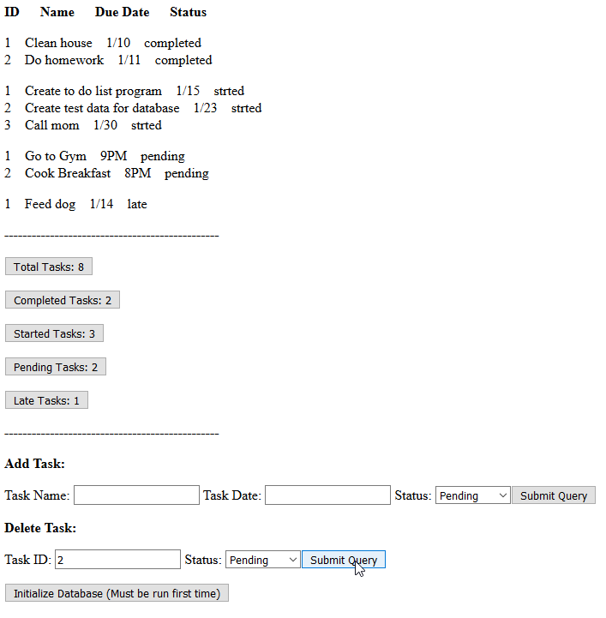

1. 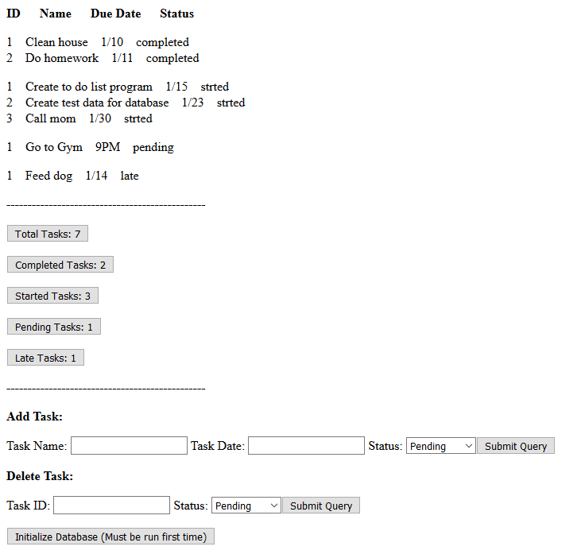And just like that its been removed from this list