DESIGNING THE USER EXPERIENCE
Team Project – Deliverable 2
BUILDING THE APPLICATION
From wireframes to a working, global, accessible product

Implementation brief and submission template — team deliverable with individually graded contribution

Course | Designing the User Experience (ISTE.260)
Instructor | Aleksander Radovan
Academic year / semester | 2026
Deliverable | Deliverable 2 – Implementation of the application (team)
Builds on | Deliverable 1 – Wireframes in Three Ways
Weight in the final grade | 13,33%
Development period | From 19.10.20206. to 14.11.2026. , with a graded commit every week
Final submission deadline | 14.11.2026. at 23:59h
Submission channel | MyCourses assignment

One document per team, submitted as PDF. Keep the .docx. Everything claimed in this document must be verifiable in the team's GitHub repository — the repository is the primary evidence, this document is the guided tour through it.

Contents
Contents 2
1. What this deliverable is 5
1.1 Learning outcomes 5
1.2 What is graded, and how often 5
2. The product you have to build 6
2.1 Scope 6
2.2 Minimum functional requirements 6
2.3 Definition of done 6
3. Repository and ways of working 8
3.1 Repository setup 8
3.2 Branching model 8
3.3 Weekly commit requirement 8
3.4 Commit messages and pull requests 8
3.5 Issues and planning 9
3.6 What we look at in the git history 9
4. Database requirement 10
5. External REST API requirement 10
5.1 Rules 10
5.2 Candidate APIs by topic area 10
6. Internationalisation and localisation 13
6.1 Required locales 13
6.2 Engineering rules (i18n) 13
6.3 Localisation rules (L10n) 14
6.4 Layout rules 14
6.5 Cultural rules 14
7. Accessibility and universal design 15
7.1 Why this is not optional 15
7.2 Required practices 15
7.3 The ten-minute check 15
8. Weekly rhythm 17
9. Submission 17
9.1 What to submit 17
9.2 README requirements 18
9.3 Assessment 18
9.4 Academic integrity and AI use 18
1. Team, product and repository 20
1.1 Identification 20
1.2 Team members 20
1.3 The product in three sentences 20
1.4 Elevator demo path 20
2. Architecture and technology 22
2.1 Stack 22
2.2 Architecture diagram 22
2.3 Repository structure 22
3. From wireframes to screens 24
3.1 Merged screen map 24
3.2 What was dropped or merged, and why 24
3.3 Screens of the finished application 24
4. Database 26
4.1 Engine and justification 26
4.2 Entity-relationship diagram 26
4.3 Entities 26
4.4 Evidence that it works 27
5. External REST API integration 28
5.1 The service 28
5.2 Endpoints used 28
5.3 Failure handling 28
5.4 Caching and data volume 29
5.5 Evidence 29
6. Internationalisation and localisation 30
6.1 Locales implemented 30
6.2 How i18n is implemented 30
6.3 Plural rules 30
6.4 Locale-aware formatting 31
6.5 Same screen, three locales 32
6.6 Text expansion and layout 32
6.7 Direction and script 33
6.8 Cultural checks 33
7. Accessibility report 35
7.1 The ten-minute check 35
7.2 Tools used 35
7.3 Screen reader walkthrough 35
7.4 Contrast evidence 36
7.5 Known accessibility issues we did not fix 36
7.6 Inclusive design decisions 36
8. Git history and teamwork 38
8.1 Our branching model 38
8.2 Repository evidence 38
8.3 Commits per member per week 38
8.4 Pull requests 39
8.5 Honest account of the collaboration 39
9. Weekly progress log 41
10. Testing, quality and known issues 43
10.1 How the product was tested 43
10.2 Known bugs and limitations 43
10.3 What we would do next 43
11. Individual contribution statements 44
Member 1 44
Member 2 45
Member 3 46
Member 4 47
Member 5 48
12. AI usage declaration 49
13. Submission checklist 49

If the list above appears empty, click inside it and press F9 (Word) to update the field.

PART A — ASSIGNMENT BRIEF (read this first)

1. What this deliverable is
In Deliverable 1 each of you produced ten wireframes individually, covering a distinct feature area of the team's topic. In Deliverable 2 the team merges those feature areas into one coherent application and builds it. The product has to run, hold its own data, talk to a real external service, work in several languages, and be usable by people who do not see, hear, move or read the way the team does.
This is a team deliverable, but the grade is not purely collective. The repository records who did what and when, and the individual part of the grade is derived from that record.

1.1 Learning outcomes
- Turn a set of wireframes into a working application without quietly abandoning the design decisions they contained.
- Work as a team in a shared repository with branches, pull requests and review, producing a history that someone else can read.
- Design a data model that serves the interaction, and integrate a third-party REST API including its failure modes.
- Externalise every user-visible string and implement real internationalisation: plural rules, locale-aware formatting, text expansion, and right-to-left layout.
- Apply the universal-design and accessibility material from Week 07 to your own product and report honestly on what still fails.

1.2 What is graded, and how often
When | What happens | Graded?
Every week | Each team member commits work to the repository on a branch and opens or reviews at least one pull request | Yes — continuously, from the git history
Mid-point | Short in-class checkpoint: the application runs, data model and external API work | Yes — formative
Final | This document plus the tagged release in the repository | Yes — the main grade

A repository where all the work appears in the last week will be graded as such, regardless of how good the application is. The weekly rhythm is part of the assessed learning outcome, not an administrative formality.

2. The product you have to build

2.1 Scope
- The application implements the team's assigned topic, and it must be recognisably the product your wireframes described.
- Start from the merged screen map: every member's feature area from Deliverable 1 must be represented in the running product. If the team drops a feature area, say so explicitly in Part B, Section 3 and explain the decision — silent disappearance is treated as unfinished work.
- Target platform: web application, or mobile application, or both, consistent with the platform stated in your topic. A responsive web application is acceptable where the topic says “mobile”, provided it is designed mobile-first and demonstrated at phone width.
- Technology choice is free. Choose a stack that the whole team can actually run, and that has a mature internationalisation library — do not write your own translation layer.
- Authentication is required only where the topic needs it. If you implement it, never store passwords in plain text and never commit secrets.

2.2 Minimum functional requirements
# | Requirement | Minimum to pass
F1 | Core user journey from the wireframes is implemented end to end | A user can complete the main task of your topic from start to finish without a dead end
F2 | Persistent data in your own database | Data created by the user survives a restart of the application
F3 | Create, read, update and delete on the main entity | All four operations reachable from the interface, with confirmation on destructive actions
F4 | Integration with an external REST API related to the topic | Real data from the external service is visible in the interface and used for something, not just displayed
F5 | Internationalization in at least three locales | The whole interface switches language, including dates, numbers and plurals
F6 | Non-ideal states | Loading, empty, error and offline/unavailable states exist for every screen that fetches data
F7 | Accessibility baseline | The ten-minute check in Section 7 passes, or every failure is documented with a plan

2.3 Definition of done
A feature counts as finished only when all of the following are true. Use this list in your pull request descriptions.
- It works for the user flow in the wireframe, not only for the happy path the developer tested.
- No user-visible string is hardcoded; every string has a translation key and exists in all locales.
- Dates, numbers, currencies and plurals go through the formatting layer, never through string concatenation.
- Loading, empty and error states are implemented.
- It is reachable and operable with the keyboard alone, and the focus indicator is visible.
- It was merged through a pull request reviewed by another team member.

3. Repository and ways of working

3.1 Repository setup
- One GitHub repository per team, created in the first week of this phase.
- Add the instructor as a collaborator (with the username “ar-rit”) in the first week, not at the end.
- Every team member commits under their own GitHub account, with their real name in the git configuration. Commits authored by a shared account cannot be attributed and will not count.
- The repository must contain a README (Section 9.2), a .gitignore, and an open-source or course license file if you choose one.
- Secrets — API keys, database passwords, tokens — are never committed. Use environment variables and commit a .env.example with empty values. A leaked key in the history costs points even if it is removed later; rotate it and say so in the README.
git config user.name "Ime Prezime" && git config user.email "your.university@email"

3.2 Branching model
Use a simple, defensible model and describe it in Part B, Section 8.1. The expected baseline:
- main is always runnable. Nobody pushes directly to main.
- develop (optional but recommended) is the integration branch.
- One branch per feature or fix, named so that the purpose is readable: feature/locale-switcher, fix/empty-state-crash, chore/ci-setup.
- Branches are short-lived: open, work, review, merge, delete. A branch that lives for six weeks is a sign the team is not integrating.
- Protect main: require a pull request and at least one approving review before merge. This is a repository setting, and we will look at whether it is switched on.

3.3 Weekly commit requirement
Who | Every team member, individually
How often | At least one meaningful commit every week of the development period
What counts | Code, tests, migrations, translation files, documentation of substance
What does not count | Whitespace-only commits, a commit that only changes the README date, committing someone else's work on their behalf, ten commits pushed in one evening to cover four empty weeks
Absence | If you cannot commit in a given week (illness, exam), say so in the weekly log in Part B, Section 9. An explained gap is treated differently from an unexplained one

3.4 Commit messages and pull requests
- Write commit messages in the imperative, describing the change, not the activity: “Add plural rules for Croatian”, not “fixes”, “update”, “work” or “asdf”.
- A conventional prefix (feat:, fix:, docs:, refactor:, test:, chore:) is recommended and makes the history readable at a glance.
- Every pull request has a description saying what changed and why, links the issue it closes, and states which definition-of-done items are met.
- Every pull request is reviewed by a team member who did not write it. A review is a comment with substance — an instant approval on a 600-line change is visible in the timeline and counts as no review at all.
- Resolve merge conflicts in your branch; never force-push over a teammate's work on a shared branch.

3.5 Issues and planning
- Use GitHub Issues for the work items, and a project board or milestones for the weekly plan.
- Each issue has an assignee. The feature areas from Deliverable 1 are the natural starting allocation.
- Link commits and pull requests to issues (Closes #12) so the history explains itself.

3.6 What we look at in the git history
We look for | What a weak history looks like
Commits spread across all weeks, from all members | One member with 80% of the commits; three members with four commits each, all in the final week
Branches that were created, worked on, reviewed and merged | Everything committed straight to main
Pull requests with real review conversation | Pull requests opened and self-merged within one minute
Readable commit messages tied to issues | “update” × 40
Steady growth of the codebase | A single initial commit containing the entire finished application
Honest history | Rewritten history and fabricated commit dates. Backdating commits is academic dishonesty, and it is trivially detectable in the push timeline

4. Database requirement
The application must own its data. A spreadsheet, a JSON file in the repository, or data held only in browser storage does not satisfy this requirement.
- Any database engine is acceptable: PostgreSQL, MySQL/MariaDB, SQLite, MongoDB, Firebase or similar. Justify the choice in one sentence in Part B, Section 4.1.
- The schema must be in the repository as migrations or as a schema file — not only inside someone's local database.
- Provide seed data so that a reviewer can run the application and see something meaningful within minutes. Seed data must be realistic and not contain real personal data of real people.
- An entity-relationship diagram is required in Part B, Section 4.2. Entities, attributes, keys and cardinalities must match what is actually in the code.
- Include at least one relationship between entities. A single flat table is below the expected level for a team project.
- Text columns that hold user-visible content must be able to store non-Latin characters — use UTF-8 (utf8mb4 on MySQL). Test with Croatian diacritics and with one non-Latin script before you claim this works.
- Store timestamps in UTC and convert for display. Store a locale preference per user if your topic has user accounts.
- No credentials in the repository; connection strings come from environment variables.

5. External REST API requirement
The application must consume at least one external REST API whose data is genuinely related to the topic. The integration has to do work in the product: enrich, validate, calculate, locate or inform. Fetching a random quote and printing it in the footer does not qualify.

5.1 Rules
- The API is called from your own backend where a key is involved, so that the key is never exposed in client-side code.
- Handle the failure modes explicitly: network error, timeout, rate limit, empty result, malformed response, and the service being down. Each one must produce a sensible interface state, not a blank screen or a raw stack trace.
- Cache responses where the data does not change every second, and respect the provider's rate limits and terms of use. Note the limits in Part B, Section 5.
- Never send personal user data to a third-party API without a reason you can defend; say in Part B what you send and why.
- If the external data is displayed to the user, attribute the source where the provider requires it.
- The API must keep working in every locale — watch out for services that return English-only text, and decide how you present it.

5.2 Candidate APIs by topic area
A starting list. Availability, limits and terms change, so verify before you commit to one, and record what you found in Part B.
API | What it gives you | Key? | Fits topics such as
Open-Meteo | Weather, forecast, historical, UV, air quality | No | Social Battery Planner, Shade & Shelter, The Interface That Disappears
Nominatim + Overpass (OpenStreetMap) | Geocoding and real-world points: benches, fountains, shops, entrances | No (strict usage policy) | Shade & Shelter, Lost in the University, Borrow Before Buying
REST Countries | Countries, languages, currencies, calling codes, formats | No | Any application with a country or locale picker
Nager.Date | Public holidays per country and year | No | Queue Without Waiting, Paper Trail, Life Admin Inbox
Frankfurter (ECB rates) | Daily and historical exchange rates | No | Cost Per Use, Repair Route, Personal Carbon Trade-Offs
HNB API (Croatian National Bank) | Official Croatian exchange rate list | No | Any product that shows money to Croatian users
Open Food Facts | Products by barcode, ingredients, packaging, nutrition | No | Expiry Radar, Object Afterlife, Cost Per Use
Wikipedia / Wikidata REST API | Articles and structured entities, multilingual labels | No | Explain My Interface, Word Keeper, First Winter
dictionaryapi.dev | Word definitions, phonetics, examples | No | Word Keeper, Plain Language Layer
OpenAlex / Crossref | Scholarly works, authors, concepts | No | Academic Uncertainty Map, Error Museum
Open Library | Books, covers, editions, subjects | No | Shared Silence, Borrow Before Buying
OpenAQ | Air-quality measurements by location | Free key | Shade & Shelter, Personal Carbon Trade-Offs
Climatiq or Carbon Interface | Emission factors and carbon estimates | Free key | Personal Carbon Trade-Offs, Object Afterlife
iFixit | Repair guides and device teardowns | No / limited | Repair Confidence, Repair Route
LibreTranslate or DeepL API Free | Machine translation | Free key | Plain Language Layer, First Winter, Word Keeper
GitHub REST API | Repositories, issues, activity | Token | The Last 10%, Error Museum, Assignment Reality Check
Transitland or a local GTFS feed | Public transport stops, routes, schedules | Free key | Micro-Decision, Lost in the University, Context Switch

If none of these fits your topic, you may use any other public API, including one you find in a directory such as publicapis.io, freepublicapis.com or the public-apis list on GitHub. Check the licence and the rate limit first, and avoid services that require a paid plan or a credit card.

6. Internationalization and localization
This section applies the Week 07 lecture, “Designing for Universal, Global & Cultural Differences”, to your own product. Internationalization (i18n) is the engineering work that makes translation and adaptation possible; localization (L10n) is the adaptation to a specific locale. Both are graded.

6.1 Required locales
Locale | Status | Why
English (en) | Required | Source language and fallback
Croatian (hr) | Required | Forces real plural rules — one / few / other — and diacritics
A third locale that stresses the system | Required — choose one | Arabic (ar) or Hebrew (he) for right-to-left; Polish (pl) or Russian (ru) for a different plural system; German (de) or Finnish (fi) for text expansion; Japanese (ja) for line breaking without spaces
A fourth locale | Optional — bonus | Only if the first three are genuinely complete

Translations may be machine-assisted, but you must check them. A machine translation that produces nonsense in the interface is still your bug. If nobody in the team speaks the third language, choose one where you can get a native speaker to look at ten screens, and say in Part B who checked it.

6.2 Engineering rules (i18n)
- Not a single user-visible string is hardcoded in a component, including button labels, placeholders, validation messages, page titles, alt text, aria-labels, e-mail templates and error pages.
- Translations live in resource files in the repository (JSON, YAML, .properties, .resx, gettext — whatever your stack uses), one file per locale, under version control.
- Keys are semantic and hierarchical: cart.checkout.button, not button_1 and not the English sentence itself used as a key.
- Never build a sentence by concatenating translated fragments; word order differs between languages. Use one message with parameters.
- No text baked into images or icons; if a graphic contains words, it needs a localised version or the text must be a text layer.
- A missing key must fall back to a defined chain (hr → en) and must be visible in development, never shown to a user as a raw key.
- The HTML lang attribute changes with the locale, and dir changes for right-to-left locales. This matters for screen readers, hyphenation and search engines.
- The chosen locale is persisted (URL segment, cookie or user profile) and survives a reload. Do not infer the language from the IP address alone — a Croatian student in Zagreb may well want the interface in English.
// one message, parameters inside — never "You have " + n + " items" inbox.unread = "{count, plural, one {# nepročitana poruka} few {# nepročitane poruke} other {# nepročitanih poruka}}"

6.3 Localization rules (L10n)
- Plurals go through the locale's real plural rules. Croatian has three forms and Arabic has six; an if (n === 1) is wrong in both.
- Dates, times, numbers, percentages and currencies are formatted by the platform's internationalisation API (Intl.DateTimeFormat, Intl.NumberFormat, Intl.PluralRules, Intl.RelativeTimeFormat, Intl.ListFormat) or the equivalent in your stack — never with manual string building.
- Sorting of names and lists uses a locale-aware collator, not byte order. Č and Ć do not sort where ASCII puts them.
- Decimal and thousands separators, first day of the week, 12- versus 24-hour clock, and currency symbol position all follow the locale, not your habits.
- Timestamps are stored in UTC and rendered in the user's time zone.
- Address, postcode and phone fields accept international formats; a validation rule that demands a five-digit postcode excludes most of the world.
- Name fields: a single full-name field, generously sized, is safer than first/middle/last. Do not require a surname, do not reject apostrophes, hyphens, spaces or non-Latin characters, and do not force capitalisation.

6.4 Layout rules
- Text expansion: translations from English can grow by roughly a third, and short labels can grow much more. No fixed-width buttons, no single-line assumptions, no truncation that hides meaning. Test the layout with the longest locale.
- Right-to-left: if your third locale is Arabic or Hebrew, the layout mirrors. Use CSS logical properties (margin-inline-start, padding-inline-end, text-align: start) rather than left and right, set dir on the document, mirror directional icons such as back arrows, and leave clocks, media controls and checkmarks unmirrored. Numbers and Latin product names stay left-to-right inside right-to-left text.
- Line breaking differs: Japanese and Chinese break without spaces, German produces very long compounds. Do not rely on a specific wrap point.
- Fonts must actually contain the glyphs of all your locales, including diacritics. Check č, ć, đ, š, ž render correctly in every weight you use.

6.5 Cultural rules
- Colour meaning is not universal — check that any colour carrying meaning in your product (status, gain and loss, warning) is not the only carrier of that meaning, and is not actively misleading in another culture.
- Emoji and icons: gestures, animals and symbols carry different meanings across cultures, and an icon that is obvious to you may be meaningless elsewhere. Pair icons with text labels.
- Imagery and examples: default example data, placeholder names and sample avatars reveal who you imagined your user to be. Make them plural.
- If your product uses AI-generated content, be aware that models carry cultural bias and tend to produce Western-default answers; state in Part B how you handled this if it applies to your topic.

7. Accessibility and universal design
The target is WCAG 2.2 level AA. You are not expected to produce a fully conformant product in one semester; you are expected to design for it deliberately, test it, fix what you can, and report honestly on what remains.

7.1 Why this is not optional
Accessibility is a legal requirement for a large part of the digital market in Europe, and the industry baseline is poor — the overwhelming majority of home pages still fail automated checks, with low contrast, missing alternative text and unlabelled form fields at the top of the list every year. Those three failures are also the easiest ones to avoid in a project of this size, which is why they are explicitly graded here.

7.2 Required practices
- Semantic HTML first: real buttons, real headings in order, real lists, real form labels. A div with a click handler is not a button and will fail the keyboard check.
- Every image has an alt attribute: descriptive when the image carries meaning, empty when it is decorative.
- Every form control has a programmatically associated label, and errors are described in text, identified clearly, and linked to the field.
- Colour contrast at least 4.5:1 for normal text and 3:1 for large text and interface components.
- Colour is never the only way information is conveyed — pair it with text, shape or an icon.
- Full keyboard operation with a visible focus indicator and a logical tab order; no keyboard traps.
- Interactive targets at least 24 by 24 CSS pixels, with spacing; 44 pixels is the comfortable size on touch.
- The interface survives 200% zoom and a 320-pixel-wide viewport without loss of content or function.
- Respect prefers-reduced-motion; nothing flashes more than three times per second.
- Accessible names on icon-only buttons, and live regions for content that updates without a page load.

7.3 The ten-minute check
Run this on the finished product, record the result in Part B, Section 7, and fix what you can.
# | Check | How
1 | Unplug the mouse | Reach and operate every feature with Tab, Shift+Tab, Enter, Space and arrow keys
2 | Focus visible | Is it always obvious where you are? Never remove the outline without replacing it
3 | Zoom to 200% | Does anything disappear, overlap or stop working?
4 | Automated scan | Run an automated checker on your main pages and record the issues, remembering it catches only a fraction of problems
5 | Contrast | Check the real colours of text, buttons, disabled states and placeholder text
6 | Images | Does every image have a sensible alt, and are decorative ones empty?
7 | Forms | Click each label — does it focus its field? Submit an empty form — is the error understandable?
8 | Headings and language | Is the heading order sensible, and does the lang attribute change with the locale?
9 | Screen reader | Complete one full task with a screen reader (NVDA, VoiceOver, TalkBack or Narrator) and write down where you got lost
10 | Targets and motion | Are controls big enough and spaced, and does the interface calm down with reduced motion enabled?

8. Weekly rhythm
Dates are filled in by the instructor. The milestones are the expected state of the repository at the end of each week; a team that is ahead may reorder them, but every week must show work from every member.
Week | Dates | Expected state of the repository | Done
1 |  | Repository created, instructor added, README skeleton, project runs locally for everyone, branching model agreed and written down
1 |  | Merged screen map agreed; data model drafted; first migrations; issues created and assigned
1 |  | First vertical slice: one screen reading and writing real data through the database
2 |  | External REST API integrated behind a service layer, with error and empty states
2 |  | i18n infrastructure in place: all strings externalised, locale switcher working, English complete
2 |  | Croatian complete, including plurals and date/number formatting
2 |  | Third locale complete; text expansion and right-to-left (or line-breaking) checked
3 |  | Feature complete against the minimum requirements; non-ideal states everywhere
3 |  | Accessibility pass: ten-minute check run, issues logged as GitHub issues, the cheap ones fixed
3 |  | Testing, bug fixing, seed data, deployment or run instructions verified on a clean machine
4 |  | Documentation, this document completed, release tagged, demo rehearsed
4 |  | Final submission and presentation

9. Submission

9.1 What to submit
This document | Completed, exported to PDF, one per team
Repository link | Public, or private with the instructor added as a collaborator
Release tag | Tag the submitted state, for example v1.0-deliverable2, so we grade the same code you demonstrated
Run instructions | In the README: prerequisites, environment variables, how to seed the database, how to start
Demo video (optional) | A short walkthrough is welcome but does not replace a running application
Deployment (optional) | A live URL is a bonus, not a requirement; a free tier is enough

9.2 README requirements
- What the application does, in three sentences, and which topic it implements.
- The team, with GitHub usernames and the feature area each person owned.
- Technology stack and prerequisites with versions.
- Setup: install, environment variables (with .env.example), database creation, migrations, seed data, start command.
- Which external API is used and how to obtain a key, if one is needed.
- Supported locales and how to add a new one.
- Known limitations, including the accessibility issues you did not manage to fix.

9.3 Assessment
Criterion | Points | What is being judged
Working application against the wireframes | 20 | The core journey runs; the product is recognisably the one that was designed; non-ideal states exist
Git history and teamwork | 20 | Weekly commits from every member, branches, reviewed pull requests, readable history, issues used
Internationalisation and localisation | 20 | Three locales complete, no hardcoded strings, real plural rules, locale-aware formatting, expansion and direction handled
Accessibility and universal design | 15 | Ten-minute check performed and reported, semantic markup, contrast, keyboard operation, honest list of remaining issues
Database design and implementation | 10 | Model fits the interaction, migrations and seed data in the repository, diagram matches the code
External REST API integration | 10 | Relevant to the topic, used for something, failure modes handled, keys kept out of the repository
Documentation and submission quality | 5 | README lets a stranger run the project; this document is complete and matches the repository
Total | 100

Individual adjustment: the team grade is the starting point for every member, and is then adjusted up or down according to the contribution visible in the git history, the pull-request record and the weekly log. A member with no traceable contribution cannot pass on the strength of the team's work.

9.4 Academic integrity and AI use
- AI assistants may be used for code, and most of you will use them. Declare them in Part B, Section 12, and be able to explain any line of code in your repository during the presentation.
- Code you did not write and do not understand is the single most reliable way to fail the oral part of this deliverable.
- Generated code that introduces an accessibility or internationalisation defect is your responsibility — that is precisely what this deliverable teaches you to catch.
- Attribute third-party code, snippets and libraries in the README. Using libraries is expected and good; passing them off as your own work is not.
- Fabricated, backdated or rewritten git history to simulate weekly work is treated as academic dishonesty.

PART B — SUBMISSION TEMPLATE (fill this in)

1. Team, product and repository

1.1 Identification
Team name / number | Team 2
Project topic (number and title) | Personal Carbon Trade-Offs (the topic number is not recorded in the team's course materials, so only the title is given)
Application name | Carbon Choices
Platform (web / mobile / both) | Web (responsive, designed mobile-first; demonstrated at 320–375 px phone width)
Repository URL | https://github.com/fa6375/personal-carbon-tradeoffs
Release tag submitted | v1.0-deliverable2 — to be tagged on main after PR #9 is approved and merged (issue #17)
Live deployment URL (if any) | None (runs locally; see README → Getting Started and "npm run demo")
Date of submission | 13 November 2026

1.2 Team members
Name | GitHub username | Feature area owned (from Deliverable 1) | Main responsibility in the build
Faraj Aliyev | fa6375 | Compare Everyday Choices (10 screens) | Frontend foundation and app shell (PR #1), Compare feature (PR #4), shared backend: Firebase Authentication, Cloud Firestore, security rules, CRUD repositories, OpenStreetMap API, data import (PR #7), final fixes, demo data and report assembly (PR #9)
Martin Mudrinić | martinmudrinic | Carbon Reduction Goals & Recommendations (10 screens) | Goals feature (PRs #2, #5), localization en/hr/de, accessibility and loading/empty/error/offline states for the whole app (PR #8)
Lazar Jovović | lj7829 | Personal Carbon Tracking (10 screens) | Tracking feature (PRs #3, #6); documentation, README and evidence: responsible for reviewing the final report, README and evidence in PR #9 before submission

1.3 The product in three sentences
Carbon Choices helps students and other everyday travellers see the carbon cost of daily choices next to what they cost in money and time, so trade-offs are visible instead of hidden. Users compare ways of making the same journey (with real route distances from OpenStreetMap), record their transport, food and home-energy activities, and turn the result into a monthly carbon budget with a plan they can follow. Unlike single-number carbon calculators, it weighs CO₂ against cost and travel time using the user's own priorities, works in English, Croatian and German, and keeps every user's data private in their own account.

1.4 Elevator demo path
The exact sequence of screens a reviewer should follow to see the product work. Be specific — this is what will be clicked during grading.
Step | Screen | What the reviewer should see | Which requirement it demonstrates
1 | Terminal: npm run demo | Emulators start, demo data is loaded, a demo e-mail and password are printed | F2 seed data, run instructions
2 | Account (#/account) → Sign in | Signed in as demo@carbon-choices.test; "Data saved in this browser" panel | Authentication
3 | Carbon tracking → Dashboard | This month: totals, daily average, largest source, recent activities | F1, F2
4 | Add activity → Transport → "Find the distance on a map" | Enter two places (e.g. Trg bana Jelačića, Zagreb → Maksimir, Zagreb), Look up distance → car/bike/foot distances from OpenStreetMap; use one and save | F4, F3 (create)
5 | History → open the activity → Edit → Delete (confirm) | Edited value shown; delete asks for confirmation; reload → data kept | F3, F2
6 | Compare journeys → Start → choose 4 options → journey (with map lookup) → priorities → results | Cards, bars, differences table, recommendation with reasons | F1, F4
7 | Breakdown / What if / Save tabs → Saved comparisons | Formulas with real numbers; scenario recalculated; saved list with Open/Delete | F1, F3
8 | Carbon goals → steps 1–5 | Budget from tracked data, monthly plan, progress against this month's target, adjustment history; "Your plan is saved in your account" | F1, F2
9 | Language selector → Hrvatski, then Deutsch; reload | Whole interface, numbers (3,05 €), dates and plurals (3 aktivnosti) switch; choice kept after reload | F5
10 | Narrow the window to 320 px; Tab through Compare | No horizontal scrolling; visible focus outline on every control | F7

2. Architecture and technology

2.1 Stack
Layer | Technology and version | Why this choice
Frontend | React 19.3.1 + TypeScript 6.0.3, built with Vite 8.3.7; plain CSS with design tokens | Mature, well-documented stack the whole team could run; TypeScript catches missing translation keys and data-shape errors at build time; Vite gives fast reloads
Backend / API | No custom server. Firebase is the managed backend: Firebase Authentication + Cloud Firestore accessed with the Firebase JS SDK 12.19.0; access control in firestore.rules | No backend code to host or secure; Firestore Security Rules enforce per-user ownership and validation; the chosen external API needs no secret key
Database | Cloud Firestore (Native mode), project personal-carbon-tradeoff, database (default) | Document model fits per-user data (activities, comparisons, one plan); real-time listener keeps Tracking and Goals in sync; free tier is enough
i18n library | Custom typed module in src/i18n (no external library) using Intl.PluralRules, Intl.NumberFormat, Intl.DateTimeFormat, Intl.Collator | Deviation from brief §2.1: see §6.2 for the reason. 903 keys per locale, checked by TypeScript and tests
Testing | Vitest 4.1.12, jsdom 26.1.0, Testing Library 16.3.3, axe-core 4.14.0, @firebase/rules-unit-testing 5.0.2, Firebase Emulator Suite (firebase-tools 15.36.0) | Unit, component, accessibility and security-rules tests run locally without touching real data
CI / automation (if any) | None (no CI); GitHub ruleset "Protect main" requires a pull request with one approval | Checks are run locally: npm run build, lint, test, test:emulator
Hosting (if any) | None (not deployed). Runs locally; firestore.rules deployed to Firebase with npm run deploy:rules | Deployment is optional in the brief

2.2 Architecture diagram
Components, where data flows, and where the external API sits. Hand-drawn and photographed is acceptable if it is legible.
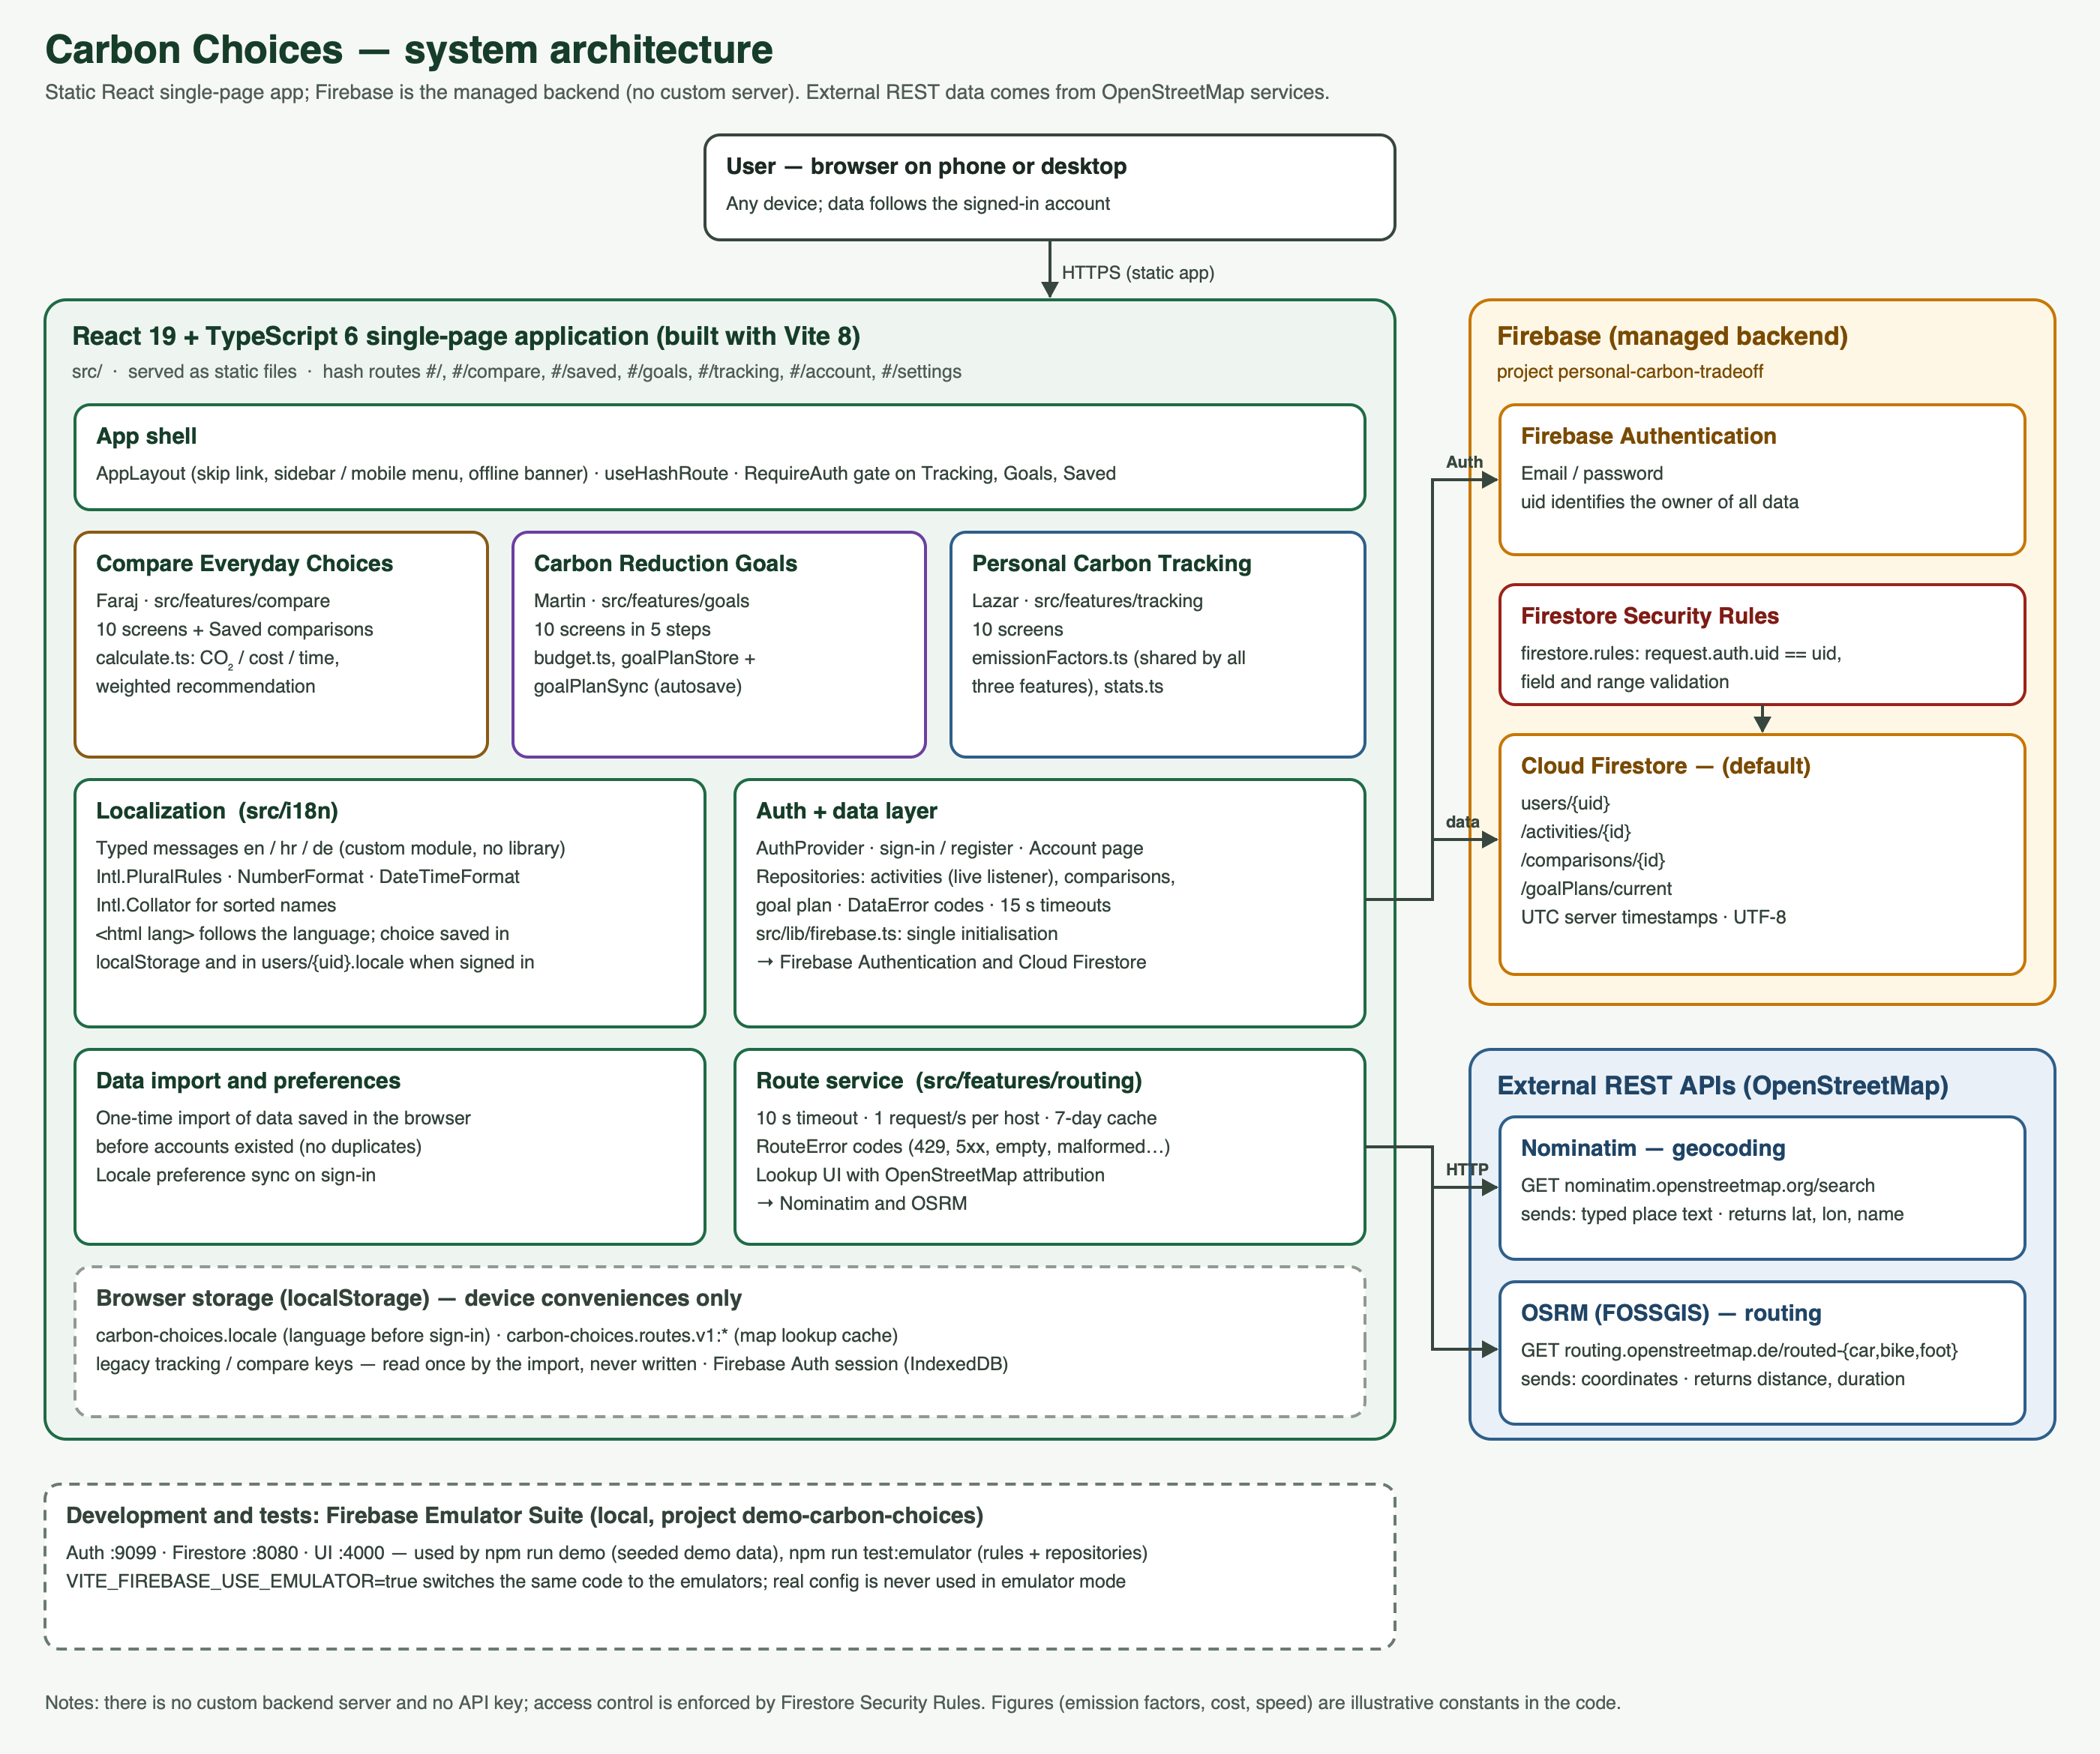
Figure 2.1 — system architecture

2.3 Repository structure
The top-level folders and what lives in each. Keep it to the level a new team member would need.
src/ — the application. components/ (shared UI: buttons, dialogs, navigation), layouts/ (app shell), pages/ (one page per route), features/compare, features/goals, features/tracking (one folder per Deliverable 1 feature area: screens, calculations, Firestore repositories), features/auth, features/account, features/routing (sign-in, data import and locale preference, OpenStreetMap service), i18n/ (translation module and locales/en|hr|de), lib/ (Firebase initialisation, error codes), styles/ (design tokens), test/ (component and accessibility tests).
tests/emulator/ — security-rules and repository tests against the Firebase emulators. tests/live/ — opt-in test against the real project.
scripts/ — seed-demo.mjs + seedDemo.ts: demo data for the emulators (npm run demo).
docs/ — this report, the requirements audit, diagrams/ (ERD and architecture: editable .svg source, generator scripts and .png) and evidence/ (screenshots and test logs).
Root — firestore.rules, firebase.json, .firebaserc, .env.example, .env.emulator, package.json, vite/vitest configs, README.md.

3. From wireframes to screens

3.1 Merged screen map
Every screen in the running application, traced back to the wireframe it came from and the person who designed it.
# | Screen in the application | From whose Deliverable 1 set | Wireframe no. | Changed since the wireframe? How?
1 | Compare: Start | Faraj | C1 | As designed
2 | Compare: Choose transport | Faraj | C2 | As designed (6 options, at least 2)
3 | Compare: Enter journey | Faraj | C3 | Changed: optional OpenStreetMap distance lookup added; typing a distance still works
4 | Compare: Set priorities | Faraj | C4 | As designed (0–3 for CO₂, cost, time)
5 | Compare: Comparison results | Faraj | C5 | As designed; cards, bars and a differences table
6 | Compare: Detailed breakdown | Faraj | C6 | As designed; shown as a result tab
7 | Compare: Recommended option | Faraj | C7 | As designed; shown as a result tab
8 | Compare: Alternative scenario ("What if") | Faraj | C8 | As designed; shown as a result tab
9 | Compare: Save comparison | Faraj | C9 | Changed: needs sign-in; saved list moved to its own page
10 | Compare: Error screen | Faraj | C10 | As designed (missing/invalid input, failed calculation, not found, storage)
11 | Goals step 1: Carbon budget setup | Martin | G1 | Combined with G2 on one step page
12 | Goals step 1: Personal carbon budget | Martin | G2 | Combined with G1
13 | Goals step 2: Budget allocation by category | Martin | G3 | Combined with G4; changed: 3 categories (goods & shopping dropped)
14 | Goals step 2: Trade-off priorities | Martin | G4 | Combined with G3
15 | Goals step 3: Monthly carbon plan | Martin | G5 | Combined with G7
16 | Goals step 4: Budget adjustment | Martin | G6 | Combined with G8 and G9
17 | Goals step 3: Reduction opportunities | Martin | G7 | Combined with G5; example ideas with calculated savings
18 | Goals step 4: Goal progress | Martin | G8 | Changed: uses real tracked activities
19 | Goals step 4: Budget adjustment details | Martin | G9 | Combined with G6 and G8
20 | Goals step 5: Carbon budget summary | Martin | G10 | As designed
21 | Tracking: Dashboard | Lazar | T1 | As designed (tab)
22 | Tracking: Add activity | Lazar | T2 | As designed
23 | Tracking: Transport activity entry | Lazar | T3 | Changed: optional map distance lookup; shares one form component with T4/T5
24 | Tracking: Food activity entry | Lazar | T4 | Shares the form component
25 | Tracking: Home energy entry | Lazar | T5 | Shares the form component
26 | Tracking: Activity history | Lazar | T6 | As designed, with search and filters (tab)
27 | Tracking: Activity details | Lazar | T7 | As designed
28 | Tracking: Edit activity | Lazar | T8 | As designed; delete with confirmation dialog
29 | Tracking: Carbon emissions breakdown | Lazar | T9 | As designed (tab)
30 | Tracking: No activities recorded | Lazar | T10 | Shown as the empty state of Dashboard, History and Breakdown
31 | Home (#/) | — (new) | — | New: entry page shared by all three areas
32 | Saved comparisons (#/saved) | Faraj (from C9) | C9 | New page: list, open and delete saved comparisons
33 | Account (#/account) and sign-in gate | — (new) | — | New: sign in / register / sign out, import of data saved in the browser
34 | Settings (#/settings) | — (new) | — | New: language selection
35 | Offline banner, Not found page | — (new) | — | New: non-ideal states for the whole app

3.2 What was dropped or merged, and why
No feature area was dropped: all 30 Deliverable 1 screens are reachable in the running app.
Merged: Martin's ten Goals screens are grouped into five steps (Set up, Allocate, Plan, Track, Summary) so a user can move through the plan in order on a phone without ten separate pages; every step can still be opened directly. Lazar's three entry screens (T3–T5) share one form component with category-specific fields. Compare screens 6–9 are tabs of the results screen.
Changed: the goods & shopping category was dropped from Goals so that Goals uses exactly the Tracking categories (transport, food, home energy) and can read real tracked data. Saving needs an account (Firebase Authentication), so sign-in and an Account page were added. An optional OpenStreetMap distance lookup was added to Compare and Tracking.
Traceability: the Deliverable 1 wireframes are kept in each member's individual Deliverable 1 submission, not in the repository; the screen map above traces every implemented screen to its wireframe by number and name.

3.3 Screens of the finished application
Add as many pairs as you need. Show the application as it actually looks, at the size a user would see it.
Screen: Home  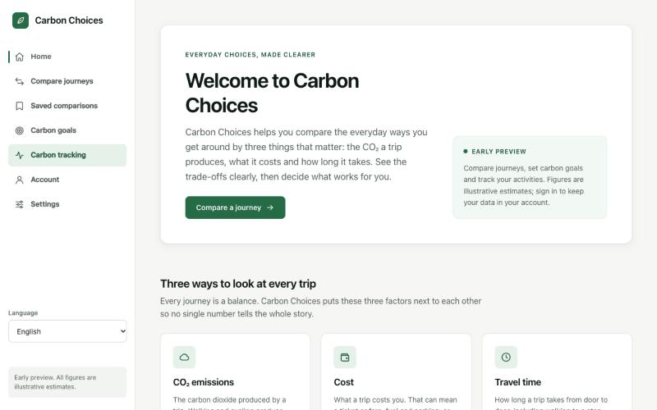 | Screen: Compare: start  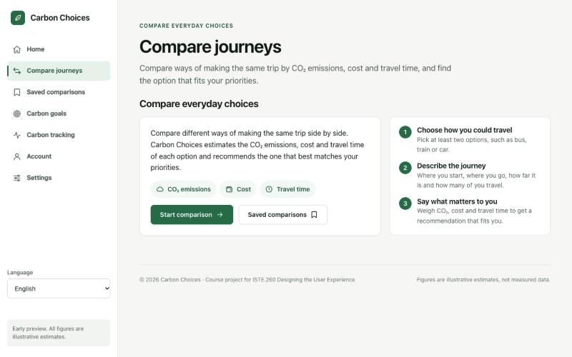
Figure 3.1 — implemented screens
Screen: Compare: choose transport  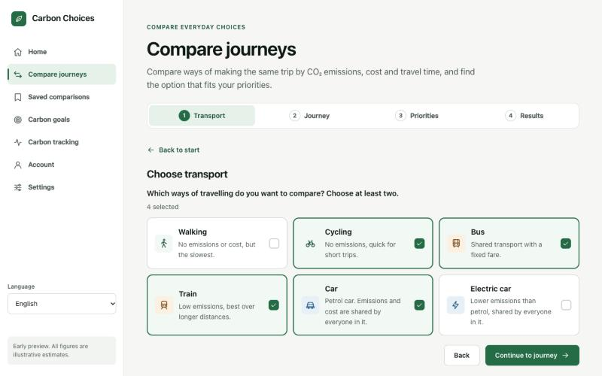 | Screen: Compare: journey + map distance  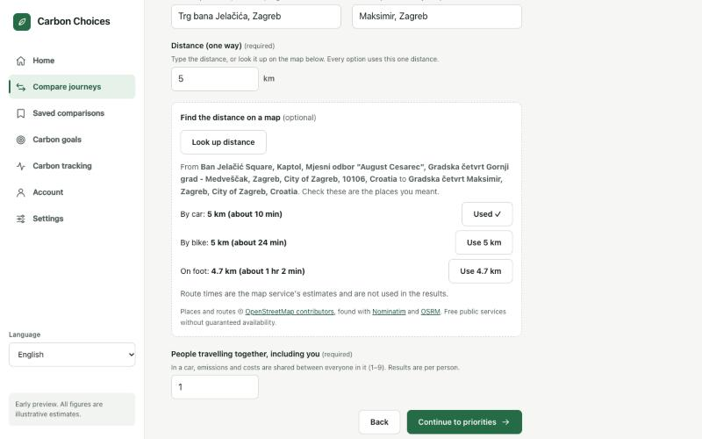
Figure 3.2 — implemented screens
Screen: Compare: results  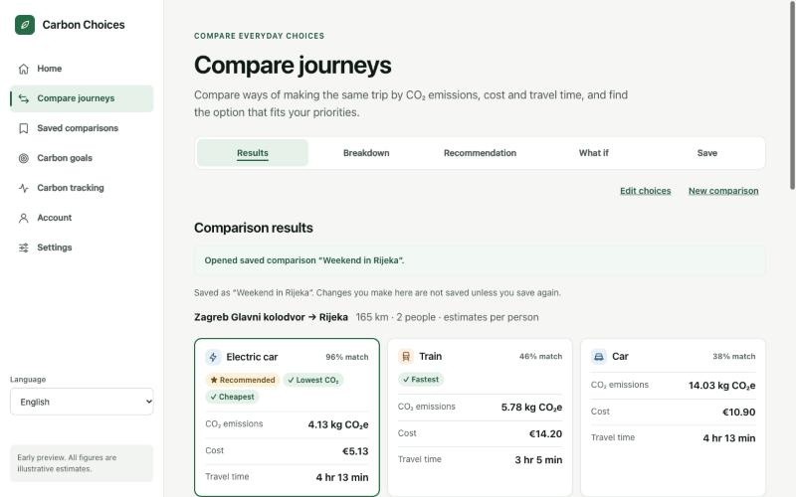 | Screen: Compare: recommendation  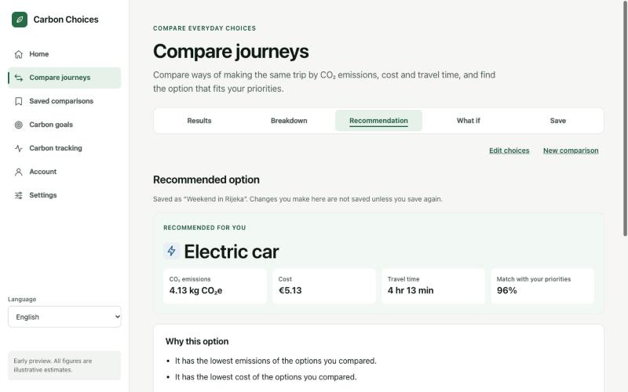
Figure 3.3 — implemented screens
Screen: Compare: detailed breakdown  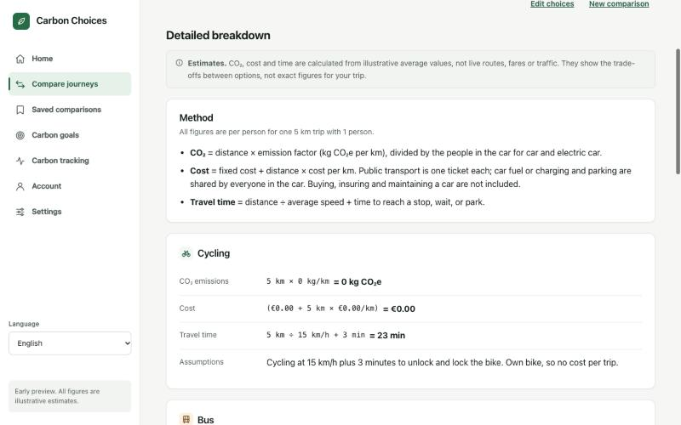 | Screen: Saved comparisons  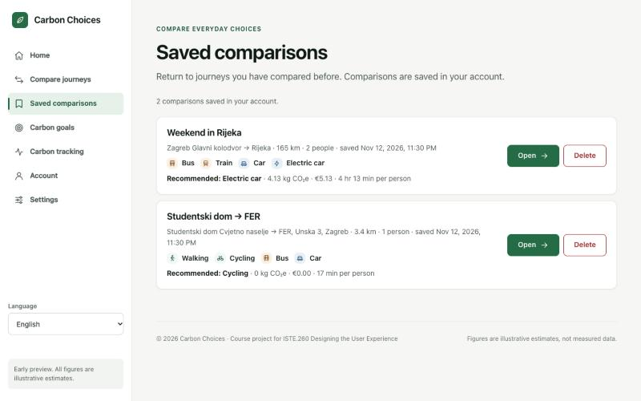
Figure 3.4 — implemented screens
Screen: Tracking: dashboard  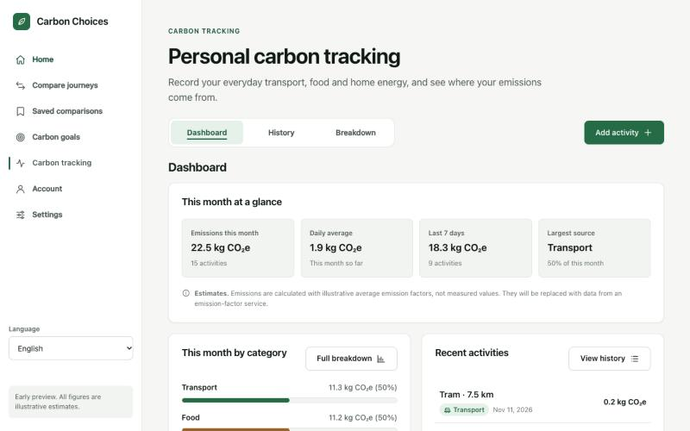 | Screen: Tracking: transport entry  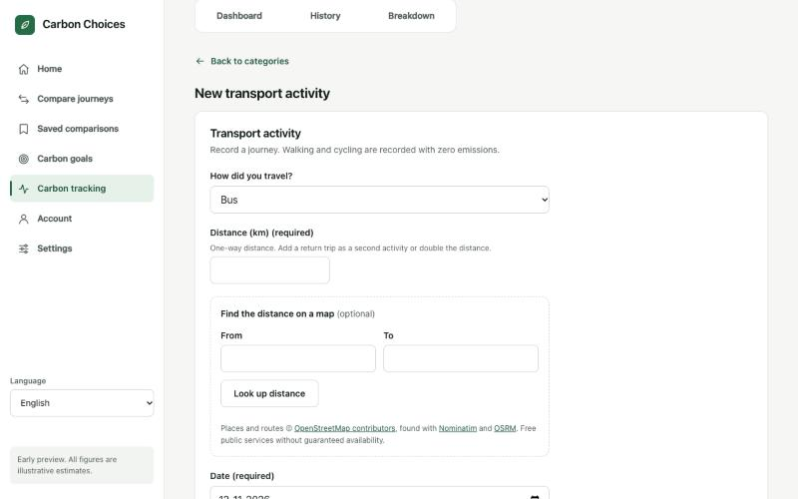
Figure 3.5 — implemented screens
Screen: Tracking: history  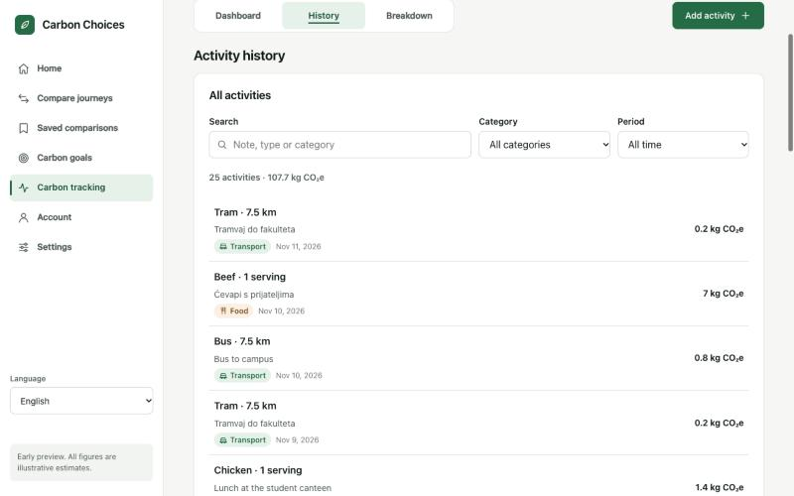 | Screen: Tracking: breakdown  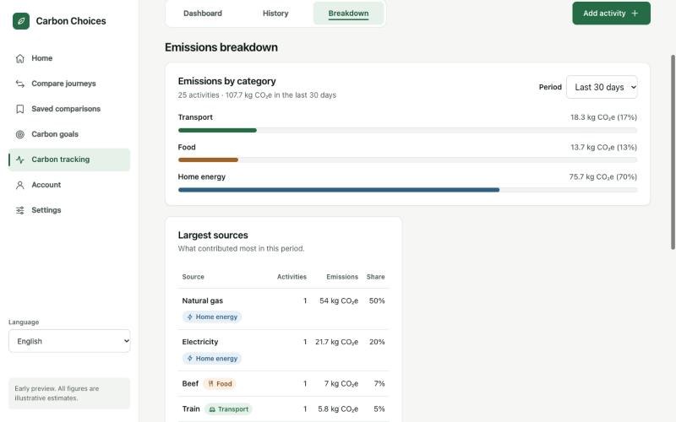
Figure 3.6 — implemented screens
Screen: Goals: step 1 set up  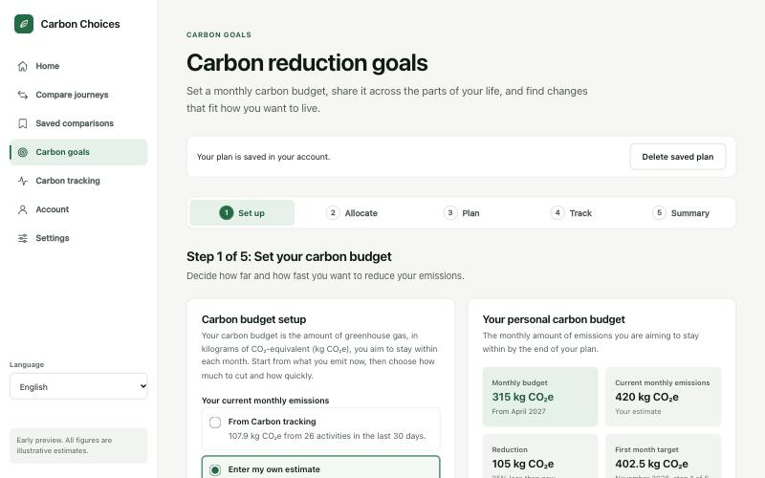 | Screen: Goals: step 3 monthly plan  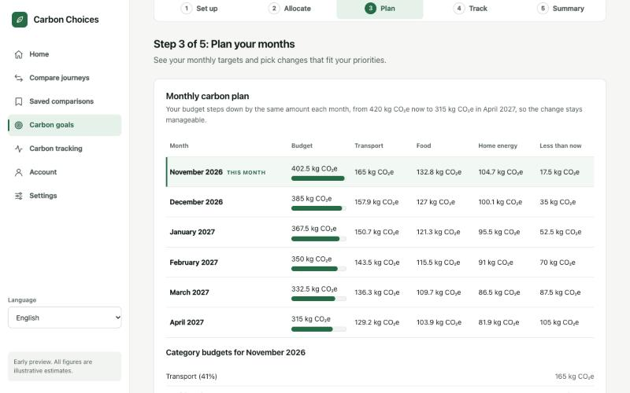
Figure 3.7 — implemented screens
Screen: Goals: step 4 progress + adjustment  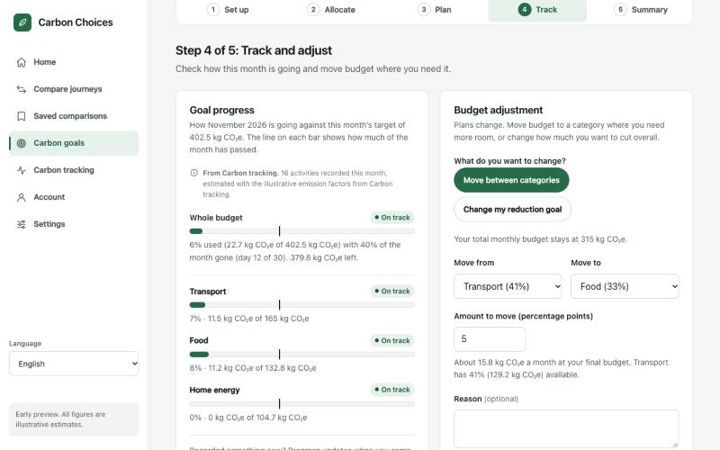 | Screen: Goals: step 5 summary  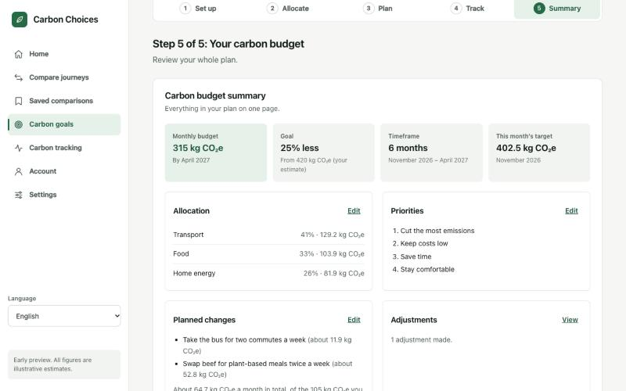
Figure 3.8 — implemented screens
Screen: Account: signed in  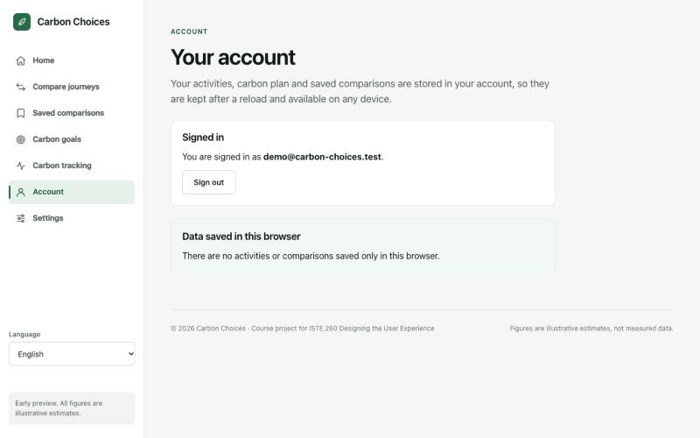 | Screen: Phone 320 px (German)  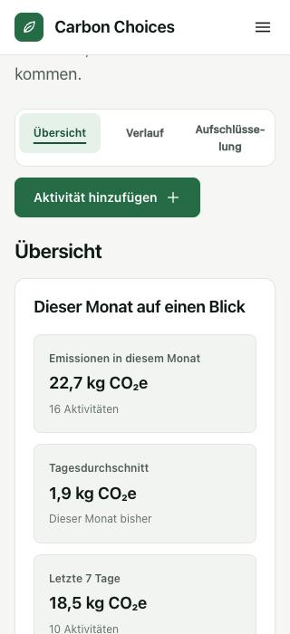
Figure 3.9 — implemented screens

4. Database

4.1 Engine and justification
Database engine and version | Google Cloud Firestore (Native mode, Firebase JS SDK 12.19.0), database (default) in project personal-carbon-tradeoff
Why this engine | A managed document database with per-user Security Rules suits private per-user data and needs no server for the team to host.
Where the schema lives in the repository | Firestore is schemaless: the schema is enforced by firestore.rules (field names, types, ranges) and described by the TypeScript types in src/features/*/types.ts; documented in README → Database and the ERD below
Migration tool / approach | No migration tool: Firestore needs no table migrations. A schemaVersion field on goal plans allows future data changes; rules are versioned in Git and published with npm run deploy:rules
How to load the seed data | npm run demo: starts the Firebase emulators, runs scripts/seed-demo.mjs (25 activities, 2 saved comparisons, 1 plan for demo@carbon-choices.test; fictional data) and starts the app. Nothing is written to the real project.
Character set / collation | UTF-8 (Firestore strings are Unicode). Tested with Croatian (č ć đ š ž), Cyrillic and Arabic text stored and read back (tests/emulator/repositories.test.ts). Timestamps are Firestore server timestamps in UTC, shown in the user's locale.

4.2 Entity-relationship diagram
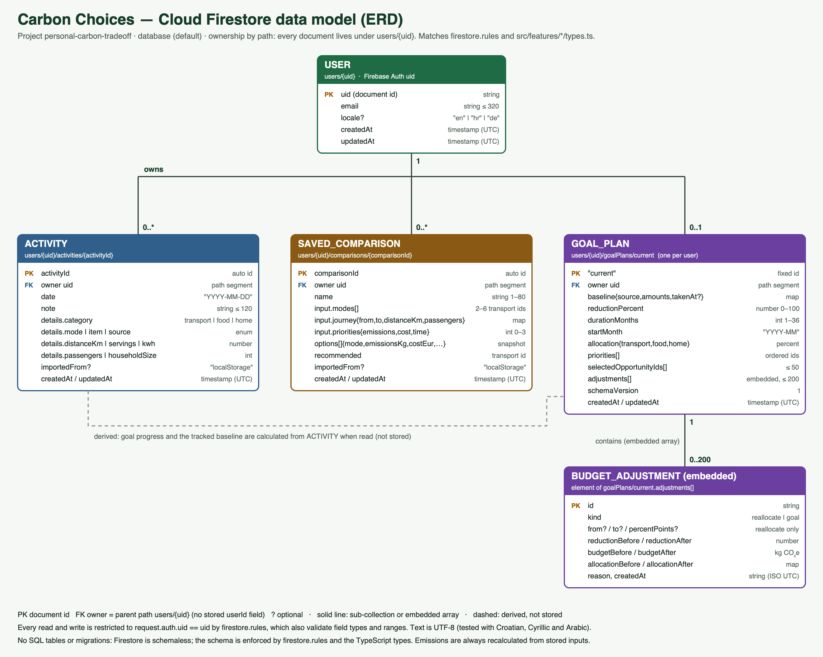
Figure 4.1 — entity-relationship diagram

4.3 Entities
Entity / table | What it holds | Key relationships | Notes (indexes, constraints, soft delete …)
USER — users/{uid} | E-mail, optional interface language (locale), created/updated time | Root of all user data; uid = Firebase Auth uid | Created on first sign-in; rules allow only the owner; locale ∈ {en, hr, de}
ACTIVITY — users/{uid}/activities/{id} | One tracked activity: date, note, category-specific details | Many per USER (sub-collection) | Queried ordered by date; emissions calculated, not stored; ranges validated in rules
SAVED_COMPARISON — users/{uid}/comparisons/{id} | A saved Compare result: name, input (modes, journey, priorities), options snapshot, recommendation | Many per USER | Cannot be edited after saving (rules allow create/read/delete only)
GOAL_PLAN — users/{uid}/goalPlans/current | The user's carbon plan: baseline, goal, duration, allocation, priorities, chosen ideas | 0..1 per USER (fixed id "current") | Autosaved; createdAt fixed by rules; schemaVersion 1
BUDGET_ADJUSTMENT (embedded) | History of budget moves and goal changes with before/after values | 0..200 inside GOAL_PLAN.adjustments[] | Embedded because always read with the plan

4.4 Evidence that it works
In the database  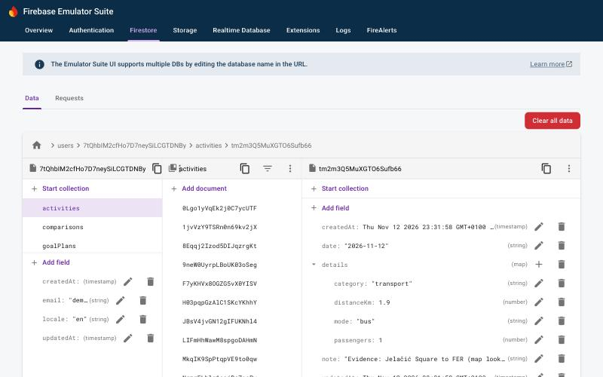  Emulator UI: users/{uid}/activities/{id} (note "Evidence: Jelačić Square to FER") | In the application  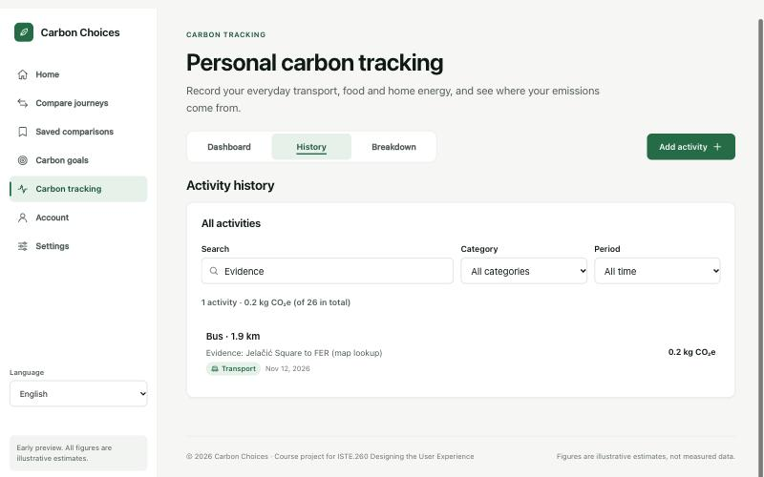  Same activity in History after a page reload
Figure 4.2 — persistence evidence

Describe one non-trivial query or operation in the application and why it is shaped that way.
Importing data saved in the browser without duplicates (src/features/account/localImport.ts). Before accounts existed, activities and comparisons were saved in localStorage. On request, the import first reads all existing document ids in users/{uid}/activities and /comparisons from the server, then writes each local record with its local id as the Firestore document id in batches of at most 450 writes, skipping ids that already exist. Using the record id as the document id makes the import idempotent: running it twice creates no duplicates, and a failed batch can simply be retried. Original timestamps are kept, which is why the rules accept createdAt values in the past but never in the future. Covered by the emulator test "imports once and skips duplicates on a second run".

5. External REST API integration

5.1 The service
API name and provider | Nominatim (geocoding) and OSRM (routing), both OpenStreetMap services; OSRM run by FOSSGIS e.V.
Documentation URL | https://nominatim.org/release-docs/latest/api/Search/ · https://project-osrm.org/docs/v5.24.0/api/
Why it is relevant to our topic | The distance of a journey drives every CO₂, cost and time figure in Compare and every transport activity in Tracking; users often do not know it. Real route distances make the carbon comparison meaningful.
Authentication (none / key / token) and where the secret lives | None — both services are free and need no key, so they are called from the browser; there is no secret to protect.
Rate limits and terms we must respect | Nominatim: max. 1 request per second, no autocomplete, cache results, identify the application (browser Referer; optional contact e-mail VITE_NOMINATIM_EMAIL). FOSSGIS OSRM: fair use, no heavy use. Both are public services without guaranteed availability.
Attribution required by the provider? | Yes: "© OpenStreetMap contributors" (ODbL) with a link, shown with every lookup, plus links to Nominatim and OSRM.
Where the integration lives in the code (file / module) | src/features/routing/routeService.ts (requests, throttle, cache, errors), routeMessages.ts (translated errors), RouteDistanceLookup.tsx (UI)

5.2 Endpoints used
Endpoint | Method | What we send | What we use from the response | Where it appears in the UI
nominatim.openstreetmap.org/search?q=…&format=jsonv2&limit=1 | GET | The place text the user typed (≤ 200 characters); no account data | lat, lon, display_name of the first match | Compare → Enter journey; Tracking → transport form ("Find the distance on a map")
routing.openstreetmap.de/routed-car/route/v1/driving/{lon},{lat};{lon},{lat}?overview=false | GET | The two coordinates only | routes[0].distance (m) and duration (s) | "By car" distance; the user can apply it to the distance field
routing.openstreetmap.de/routed-bike/route/v1/driving/… | GET | Coordinates | distance, duration | "By bike" distance
routing.openstreetmap.de/routed-foot/route/v1/driving/… | GET | Coordinates | distance, duration | "On foot" distance

5.3 Failure handling
Failure mode | What the user sees | What the system does
Network unavailable / offline | A translated message: the map service could not be reached; check the connection or type the distance. When the browser is offline the lookup is not attempted and the offline banner is shown. | RouteError "network"; typed distance stays usable
Request timeout | "The map service took too long to answer…" | Request aborted after 10 s; RouteError "timeout"
Rate limit reached (429) | "The free map service is busy (too many requests). Wait a minute…" | HTTP 429 → "rate-limited"; requests are throttled to 1/s per host to avoid it
Empty result set | "The destination could not be found on the map. Try adding the town or country…" (screenshot below) | Empty Nominatim result → "not-found" naming the start or destination; OSRM NoRoute → profile shown as "no route found"
Malformed or unexpected response | "The map service sent an answer the app could not understand…" | JSON is validated (array, numeric lat/lon in range, route distance ≥ 0) → "malformed"
Service down (5xx) | "The map service is having problems right now…" | HTTP 5xx → "server-error"
Invalid or expired key | "The map service refused the request. The service settings may be wrong." | HTTP 401/403 → "unauthorized" (no key is used today; relevant if a keyed provider is configured)

5.4 Caching and data volume
Geocoding results are cached per normalised query text and route results per profile and coordinate pair, in memory and in localStorage (carbon-choices.routes.v1:*), for 7 days. Places and road networks change slowly, so a week-old distance is still accurate for an estimate, and the cache keeps repeated lookups (for example a daily commute) from re-using the free public services. A typical lookup makes 5 requests (2 geocoding + 3 routes) the first time and 0 when repeated; requests to each host are spaced at least 1.1 s apart, so one lookup takes about 3 seconds. All of this is covered by unit tests (src/features/routing/routeService.test.ts).

5.5 Evidence
Working state  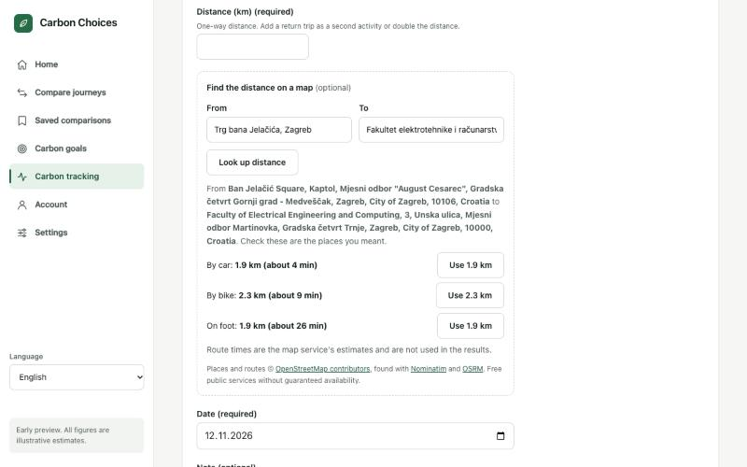  Real distances: Jelačić Square → FER, Zagreb | Failure state  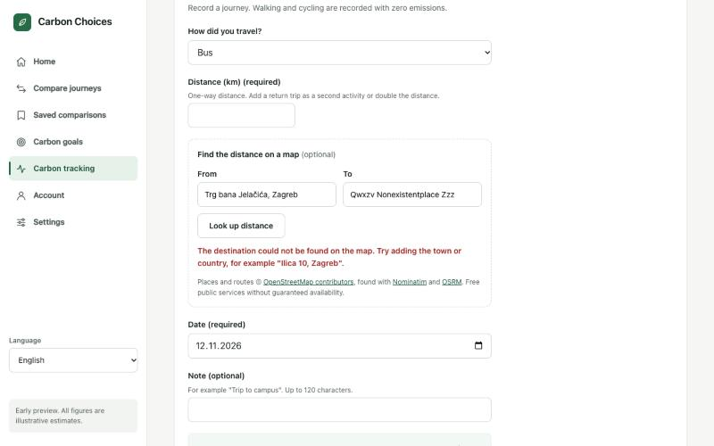  Empty result: destination not found
Figure 5.1 — external API in use, and when it is not available

6. Internationalization and localization

6.1 Locales implemented
Locale | Language | Completeness (%) | Who produced it | Who checked it | Why this locale
en | English | 100 % (903 of 903 keys) | Team (source language) | Team | Source language and fallback
hr | Croatian | 100 % (903 of 903 keys) | Martin Mudrinić (PR #8); month grammar fixed in PR #9 | Checked by the team in the running app (plurals, genitive months, 320 px layout). No review by a native speaker outside the team is recorded (issue #13) | Plural rules (one/few/other), diacritics, case inflection
de | German | 100 % (903 of 903 keys) | Martin Mudrinić (PR #8) | Checked by the team in the running app (long compounds, 320 px layout). No review by a native speaker outside the team is recorded (issue #13) | Text expansion (long compounds)

6.2 How i18n is implemented
Library / framework used | Custom typed module src/i18n (no library). Deviation from brief §2.1: the module was built in PR #8; migrating to a library (e.g. i18next or FormatJS) two days before the deadline was judged too risky for 903 keys and 166 tests. It uses the platform Intl API for all formatting and plural selection (issue #14).
Where the translation files live | src/i18n/locales/en/*.ts, hr/*.ts, de/*.ts — one folder per locale, split by area (common, compare, goals, tracking)
File format and key naming convention | TypeScript objects; semantic hierarchical keys such as tracking.activityCount, goals.monthly.description; plural messages are objects {one, few, other}; placeholders {name}
Number of translation keys | 903 per locale (identical key sets, enforced by TypeScript: a missing or extra key fails npm run build)
Fallback chain | Current locale → English → the key itself
How the locale is detected and persisted | Saved choice (localStorage carbon-choices.locale; and users/{uid}.locale for signed-in users) → first supported browser language → English. Not inferred from IP.
How a missing key behaves | Development: console warning; tests fail on any missing key (54 checks render every screen in hr and de). Users never see a raw key because TypeScript requires every key in every locale.
How lang and dir attributes are set | localeStore.ts sets document.documentElement.lang on every change; dir is not set because all three locales are left-to-right.

6.3 Plural rules
Paste the message that proves you are using real plural rules, in English and in Croatian, and show it rendering for 1, 2 and 5.
en: tracking.activityCount = { one: "{count} activity", other: "{count} activities" }
hr: tracking.activityCount = { one: "{count} aktivnost", few: "{count} aktivnosti", other: "{count} aktivnosti" }
de: tracking.activityCount = { one: "{count} Aktivität", other: "{count} Aktivitäten" }
Selected with Intl.PluralRules (src/i18n/translate.ts). Rendered by the app (formatting layer, real browser): hr 1 / 2 / 5 / 21 / 22 → 1 aktivnost / 2 aktivnosti / 5 aktivnosti / 21 aktivnost / 22 aktivnosti; en → 1 activity / 2 activities / 5 activities / 21 activities / 22 activities.

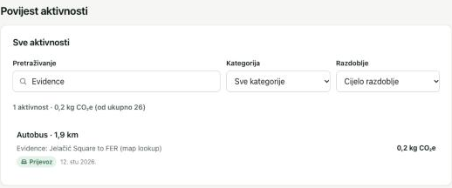
1 → "1 aktivnost" (one)
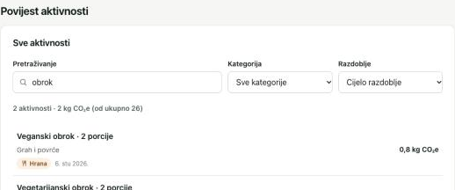
2 → "2 aktivnosti" (few)
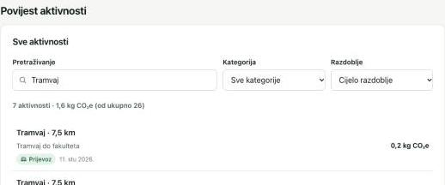
7 → "7 aktivnosti" (other; the demo data had no filter giving exactly 5)
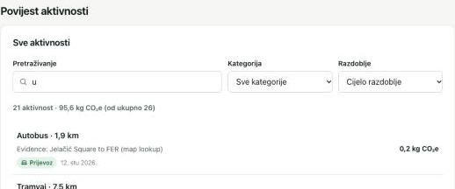
21 → "21 aktivnost" (one, as Croatian requires)
Figure 6.1 — plural forms: one / few / other

6.4 Locale-aware formatting
Fill in what your application actually renders in each locale — copy the values from the running product, not from the documentation.
What | en | hr | Third locale: de | Formatted by
Short date | Nov 12, 2026 | 12. stu 2026. | 12.11.2026 | Intl.DateTimeFormat (dateStyle medium)
Long date with weekday | Thursday, November 12, 2026 | četvrtak, 12. studenoga 2026. | Donnerstag, 12. November 2026 | Intl.DateTimeFormat (dateStyle full)
Time | Nov 12, 2026, 2:30 PM | 12. stu 2026. 14:30 | 12.11.2026, 14:30 | Intl.DateTimeFormat (timeStyle short)
Relative time ("3 days ago") | 3 days ago | prije 3 dana | vor 3 Tagen | Intl.RelativeTimeFormat — not used in the interface; values shown for reference
Large number | 1,234,567.9 | 1.234.567,9 | 1.234.567,9 | Intl.NumberFormat
Decimal number | 12.5 (kg CO₂e: 1,234.6 kg CO₂e) | 12,5 (1.234,6 kg CO₂e) | 12,5 (1.234,6 kg CO₂e) | Intl.NumberFormat
Percentage | 47% | 47 % | 47 % | Intl.NumberFormat (percent)
Currency | €1,234.50 | 1.234,50 € | 1.234,50 € | Intl.NumberFormat (currency EUR)
List of three items | bus, train, and car | bus, train i car | bus, train und car | Intl.ListFormat — not used in the interface; values shown for reference
Sorted list of names with Č, Ć, Š | Čakovec, Cres, Ćuprija, Đakovo, Dubrovnik, Šibenik, Split, Zadar | Cres, Čakovec, Ćuprija, Dubrovnik, Đakovo, Split, Šibenik, Zadar | Čakovec, Cres, Ćuprija, Đakovo, Dubrovnik, Šibenik, Split, Zadar | Intl.Collator (used on the Tracking breakdown)

6.5 Same screen, three locales
English  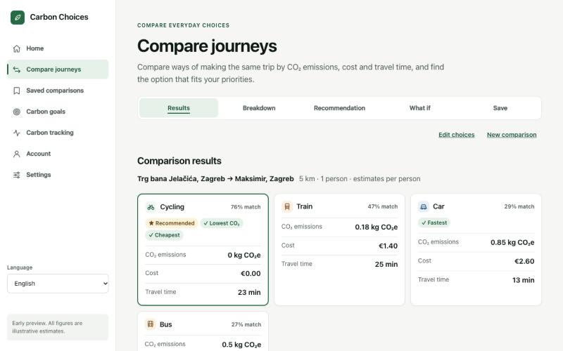 | Croatian  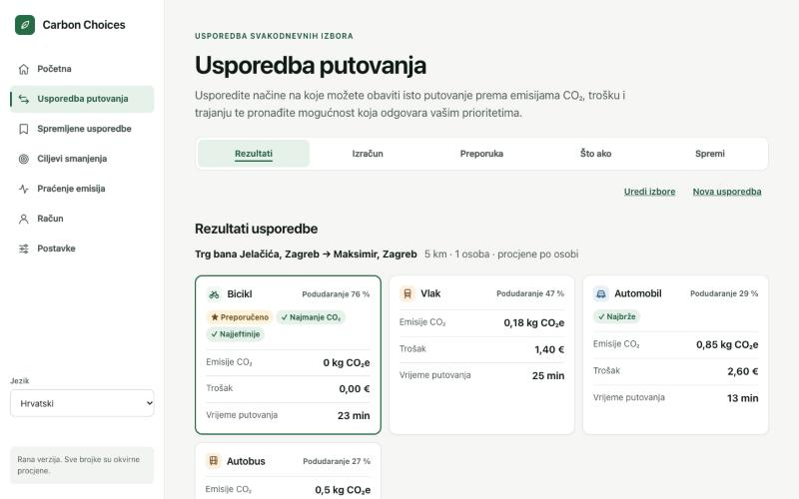
Figure 6.2 — the same screen in English and Croatian
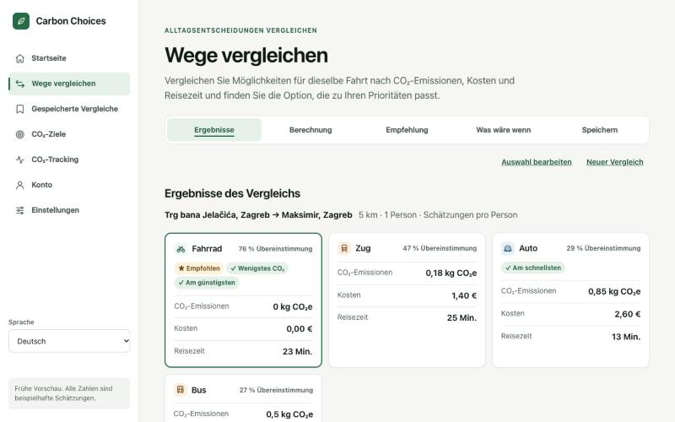
Figure 6.3 — the same screen in the third locale

6.6 Text expansion and layout
Longest locale in our interface | German (de)
Worst expansion found (label, before → after, % growth) | Tracking tab "Breakdown" → "Aufschlüsselung": 9 → 15 characters (+67 %)
What broke, and how it was fixed | At 320 px the German tab label overflowed and made the page scroll sideways (found in the requirements audit). Fixed in PR #9: tab items may shrink and long labels wrap with hyphenation ("Aufschlüsse-lung"). Checked with no horizontal scrolling at 320, 375, 640 px and desktop in all three languages.
Where truncation is still used, and why it is safe there | No truncation is used anywhere (no text-overflow/ellipsis in the CSS); long text wraps.

Shortest | Longest
Figure 6.4 — the same layout under text expansion

6.7 Direction and script
Complete this section if your third locale is right-to-left. If it is not, state which script or line-breaking challenge you handled instead, and show the evidence.
Right-to-left locale implemented? | No
How direction is switched | Not applicable (en, hr and de are left-to-right)
Logical CSS properties used instead of left/right? | No — the CSS uses physical left/right properties (27 places) and no logical properties; this would have to change before adding an RTL locale
Which icons are mirrored, and which are deliberately not | None mirrored; arrows point in the reading direction for LTR
How numbers and Latin names behave inside RTL text | Not applicable
If not RTL: what script or line-breaking issue was handled instead | Text expansion in German (see 6.6) and Croatian morphology: month names after prepositions need the genitive ("do travnja 2027.", "od studenoga 2026."), produced with Intl.DateTimeFormat; Croatian diacritics render in all font weights (system font).

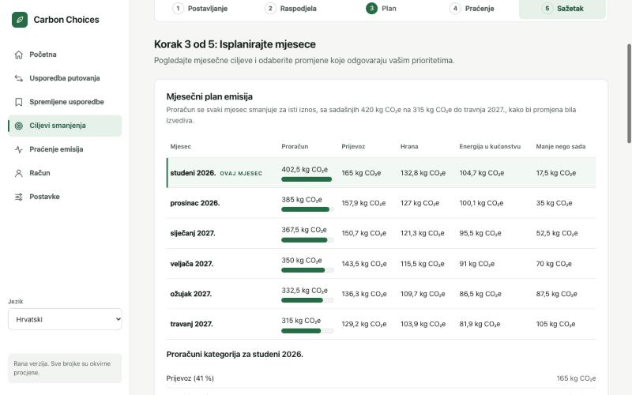
Croatian genitive month forms in Goals ("…do travnja 2027.")
Figure 6.5 — direction and script handling

6.8 Cultural checks
Element | What we checked | What we changed
Colours that carry meaning | Status colours (green/orange/red), best-option badges, progress bars: meaning is always also given in text or a symbol (✓ Lowest CO₂, ★ Recommended, "On track") | No change needed
Icons and emoji | Every icon (transport modes, categories) is paired with a text label and hidden from screen readers | No change needed
Example data, placeholder names, avatars | Demo data uses Croatian and English notes and places (Zagreb, Rijeka, Samobor); no real people; no avatars | Added mixed-language demo data
Name, address and phone fields | The app asks only for an e-mail and free-text place names (≤ 200 characters, any script; Cyrillic and Arabic tested) | No name, address or phone fields
Anything AI-generated in the product | The product contains no AI-generated content at run time | Not applicable

7. Accessibility report

7.1 The ten-minute check
# | Check | Result | Issues found | Fixed?
1 | Keyboard only — everything reachable and operable | Pass | Whole Compare journey completed with Tab, Space, arrows and Enter; delete dialog opened with Enter, closed with Esc; menu covered by tests. After a step change focus moves to the step container (no ring on that non-interactive container, by design) | n/a
2 | Focus indicator always visible | Pass | 2 px outline measured on every control reached in check 1 | n/a
3 | 200% zoom / 320 px width | Pass after fix | German Tracking tab overflowed at 320 px (fixed in 18d3363); 320/375/640 px checked in en/hr/de with no horizontal scrolling. Real 200% browser zoom checked manually by the team: passed (team confirmation, 13.11.2026) | Yes (overflow, fixed)
4 | Automated scan | Pass after fix | axe-core 4.14 in the browser on 7 pages + 5 Goals steps: 1 contrast violation; 0 after the fix. axe in jsdom on 27 screens: 0 | Yes
5 | Colour contrast | Pass after fix | Goals highlight hint 4.34:1 → 6.06:1. Placeholder and disabled states not measured separately | Yes
6 | Images and alt text | Pass | No <img> elements; all SVG icons aria-hidden; every button and link has an accessible name | n/a
7 | Form labels and error messages | Pass | Clicking each label focuses its field; empty submit → alert summary, field error linked with aria-describedby, aria-invalid, focus on the field | n/a
8 | Heading order and lang attribute | Pass | One h1 per page, no skipped levels; <html lang> switches en/hr/de | n/a
9 | Screen reader — one complete task | Pass | VoiceOver on macOS: the team completed a task with the screen reader and confirmed it passed (13.11.2026). Detailed step-by-step observations were not recorded | No
10 | Target size, spacing and reduced motion | Pass | Targets ≥ 44 × 44 px (CSS review); prefers-reduced-motion rules checked in styles.test.ts and with the operating-system setting by the team (team confirmation, 13.11.2026) | No

7.2 Tools used
Tool | Where it was run | Summary of result
axe-core 4.14.0 (WCAG 2.0–2.2 A/AA rules) | Real Chromium-based browser on every page and all Goals steps (2026-11-12) | 1 colour-contrast violation, fixed; then 0
Vitest + jsdom + axe-core | src/test/accessibility.test.tsx: 27 rendered screens | 0 violations (contrast excluded in jsdom)
Contrast calculation (WCAG formula) | src/styles/styles.test.ts on design tokens; script on the measured colours | All token text pairs ≥ 4.5:1; fixed hint 6.06:1
Manual keyboard test | Compare journey, Saved delete dialog | Pass
Manual team checks | VoiceOver (macOS), real 200% browser zoom, operating-system reduced-motion setting | Pass (team confirmation, 13.11.2026)

7.3 Screen reader walkthrough
Which screen reader, which task, and what actually happened. Where did you get lost, and what did you change?
Screen reader: VoiceOver on macOS. The team carried out a complete task in the running app using VoiceOver and confirmed on 13.11.2026 that it passed: the task could be completed without sighted help. Detailed step-by-step observations (exact announcements, timings) were not written down at the time, so none are reported here. What supports the result in the code: every page has one h1 and landmark regions with a skip link; all controls have accessible names; form errors are linked with aria-describedby and announced through role="alert"; loading and saved states use role="status"; the language of the page (<html lang>) follows the selected locale so VoiceOver reads Croatian and German with the right voice. Not covered: NVDA, JAWS and mobile screen readers (iOS VoiceOver, Android TalkBack) were not tested.

7.4 Contrast evidence
Measured  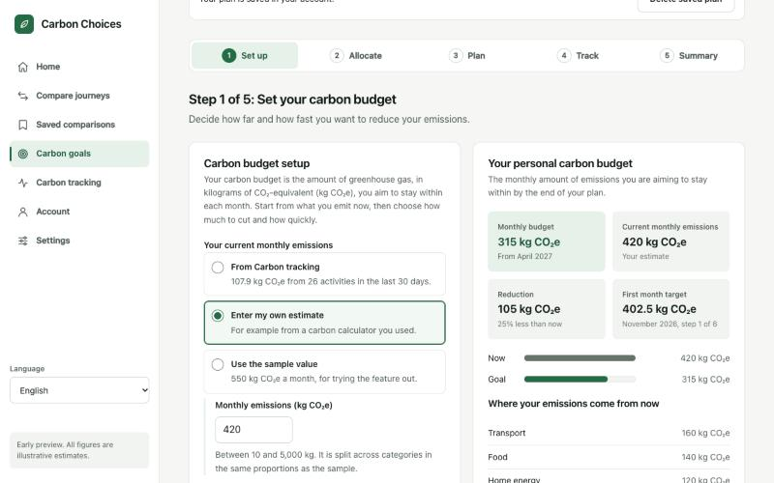  Measured in the browser: hint text was #66726a on #e6f1ea = 4.34:1 (fails 4.5:1) | Fixed  Fixed (commit 18d3363): the hint in the highlighted stat ("From April 2027" in the screenshot) now uses the muted text colour #4f5c54 on #e6f1ea = 6.06:1. axe-core in the browser reports 0 violations after the fix.
Figure 7.1 — contrast checks

7.5 Known accessibility issues we did not fix
An honest list scores better than an empty one. Link each to a GitHub issue.
Issue | Who it affects | Severity | Why it is still open | Issue link
Only VoiceOver on macOS tested; no NVDA, JAWS or mobile screen reader | Blind and low-vision users on other platforms | Medium | Test with NVDA and a phone screen reader in the next iteration | #10
Placeholder and disabled-state contrast not measured separately | Low-vision users | Low | Design tokens pass 4.5:1; axe-core reports 0 violations | —
Translations not reviewed by a native speaker outside the team | Croatian and German users | Medium | Team-checked; English always available | #13
No full WCAG 2.2 AA audit | All users with disabilities | Low | Ten-minute check and automated scans only; no conformance claim | —

7.6 Inclusive design decisions
Where did the persona spectrum, the social model of disability or the curb-cut effect change a decision in this product? Name the decision, not the concept.
Never colour alone (social model / curb-cut): best-option badges, Goals pace status and Tracking categories always carry text or a symbol, which also helps users on bright phone screens.
Plain-language estimates: every figure is labelled as an estimate with the formula shown (Compare breakdown, Tracking details), so users with low numeracy or low trust can check the reasoning.
Typing always works: the map lookup is optional; users who cannot or do not want to send place names to a third party, or who are offline, can type the distance.
Persona spectrum — temporary limitation: 44 px targets and a 320 px layout work for one-handed phone use on a tram as well as for users with motor impairments.
Language follows the person: the chosen language is saved in the account, so a Croatian student using a shared English computer gets their own language after signing in.

8. Git history and teamwork

8.1 Our branching model
main is protected by the GitHub ruleset "Protect main": changes only through a pull request with 1 approving review (stale approvals dismissed, the last push must be approved), no force pushes, no deletion. Each piece of work had its own branch: feature/frontend-setup, feature/carbon-reduction-goals, feature/personal-carbon-tracking, feature/compare-everyday-choices, feature/goals-integration-polish, feature/tracking-integration-polish, feature/shared-backend-database-api, feature/localization-accessibility, docs/deliverable-2-requirements-audit. There was no develop branch. The PR author merged after another member's approval. Merge conflicts were avoided by giving each member their own feature folder (src/features/<area>) and keeping shared-file changes small. Weaknesses: the reviews were approvals without comments, and PRs were merged minutes after opening (see 8.4 and 8.5).

8.2 Repository evidence
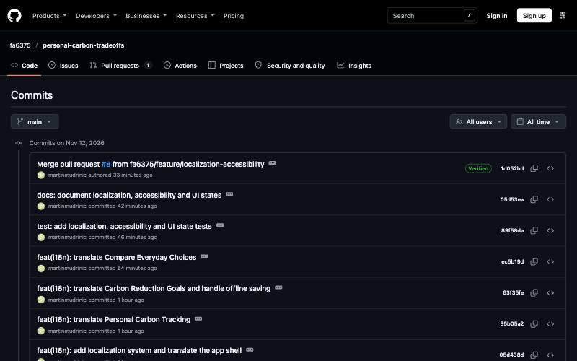
Figure 8.1 — branch and merge history
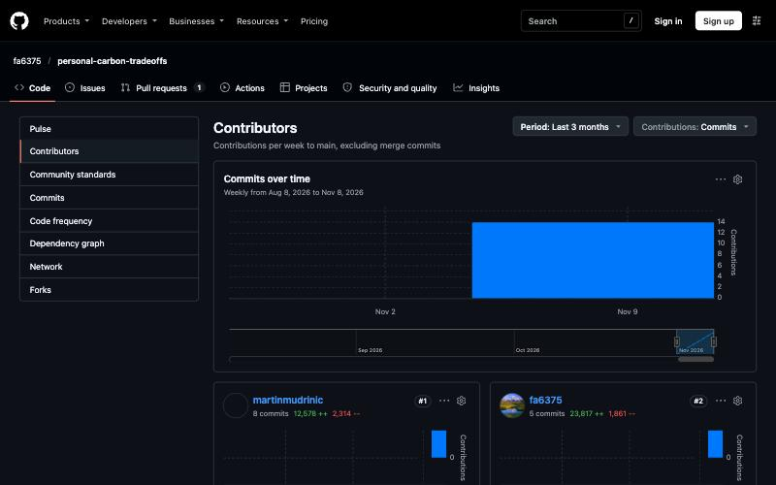
Figure 8.2 — contribution over time

8.3 Commits per member per week
Fill from the repository insights (Insights → Contributors, or git shortlog). Write each member's name in the header.
Week | Faraj Aliyev | Martin Mudrinić | Lazar Jovović | — (team of 3) | —
W1 (19.10–25.10) | 0 | 0 | 0 | — | —
W2 (26.10–01.11) | 0 | 0 | 0 | — | —
W3 (02.11–08.11) | 0 | 0 | 0 | — | —
W4 (09.11–14.11) | 5 on main + 9 in open PR #9 | 8 | 2 | — | —
W5 | — | — | — | — | —
W6 | — | — | — | — | —
W7 | — | — | — | — | —
W8 | — | — | — | — | —
W9 | — | — | — | — | —
W10 | — | — | — | — | —
W11 | — | — | — | — | —
W12 | — | — | — | — | —
Total | 14 (5 merged) | 8 | 2 | — | —

8.4 Pull requests
PR # | Title | Author | Reviewer | What the review changed
#1 | feat: set up frontend foundation and project README | fa6375 | martinmudrinic | Approved without comments; no changes
#2 | feat: implement carbon reduction goals feature | martinmudrinic | fa6375 | Approved without comments; no changes
#3 | feat: implement personal carbon tracking | lj7829 | martinmudrinic | Approved without comments; no changes
#4 | feat: implement Compare Everyday Choices | fa6375 | martinmudrinic | Approved without comments; no changes
#5 | fix: polish goals feature integration | martinmudrinic | fa6375 | Approved without comments; no changes
#6 | fix: improve tracking state and sync activities across tabs | lj7829 | fa6375 | Approved without comments; no changes
#7 | feat: integrate shared Firebase database and external API | fa6375 | martinmudrinic | Approved without comments; no changes
#8 | Feature/localization accessibility | martinmudrinic | fa6375 | Approved without comments; no changes
#9 | Deliverable 2: audit, fixes, diagrams, evidence and Part B report | fa6375 | martinmudrinic, lj7829 (review requested) | Open, awaiting review before merge

8.5 Honest account of the collaboration
What happened: the shared repository was created only on 9 November 2026, in the last week of the development period, so weeks 1–3 have no repository commits from anyone. All implementation was done between 9 and 12 November. We do not present any earlier work as commits, and no commit has been backdated.
What worked: one feature folder per member meant parallel work without merge conflicts; protecting main from the start forced every change through a pull request; integration PRs (#5, #6, #7, #8) connected the three areas into one product.
What did not work: reviews were approvals without comments, often within minutes of opening, which the brief counts as no review; the load was uneven (commit counts 14/8/2 including the open PR); GitHub Issues were only created at the end (#10–#17).
AI assistance: a large share of Faraj's code (and the Tracking implementation handed to Lazar for PR #3) was produced with Claude Code (see §12).
What we would set up differently: create the repository and issues in week 1, commit small pieces weekly, require a written review comment on every PR, and run the accessibility and locale checks continuously instead of at the end.
All three members confirm this account by signing the team declaration in §12.

9. Weekly progress log
One row per week per member, filled in during the week rather than reconstructed at the end. Keep it short: what was built, and the branch or pull request where it lives.
Week | Member | What was built or decided | Branch / PR | Blocked by
W1 | Faraj Aliyev | No repository activity: the shared repository was created on 9.11.2026. No other verifiable record of work this week is claimed | — | —
W1 | Martin Mudrinić | No repository activity: the shared repository was created on 9.11.2026. No other verifiable record of work this week is claimed | — | —
W1 | Lazar Jovović | No repository activity: the shared repository was created on 9.11.2026. No other verifiable record of work this week is claimed | — | —
W2 | Faraj Aliyev | No repository activity: the shared repository was created on 9.11.2026. No other verifiable record of work this week is claimed | — | —
W2 | Martin Mudrinić | No repository activity: the shared repository was created on 9.11.2026. No other verifiable record of work this week is claimed | — | —
W2 | Lazar Jovović | No repository activity: the shared repository was created on 9.11.2026. No other verifiable record of work this week is claimed | — | —
W3 | Faraj Aliyev | No repository activity: the shared repository was created on 9.11.2026. No other verifiable record of work this week is claimed | — | —
W3 | Martin Mudrinić | No repository activity: the shared repository was created on 9.11.2026. No other verifiable record of work this week is claimed | — | —
W3 | Lazar Jovović | No repository activity: the shared repository was created on 9.11.2026. No other verifiable record of work this week is claimed | — | —
W4 | Faraj Aliyev | Repository, frontend foundation and README (9.11); Compare Everyday Choices, 10 screens (10.11) | feature/frontend-setup #1; feature/compare-everyday-choices #4 | —
W4 | Faraj Aliyev | Firebase Auth + Firestore, rules (deployed), CRUD repositories for all features, OpenStreetMap API, browser-data import, emulator and live tests (12.11) | feature/shared-backend-database-api #7 | —
W4 | Faraj Aliyev | Requirements audit; contrast, German overflow and Croatian grammar fixes; locale saved in profile; non-Latin test; demo seed; ERD, architecture, evidence; this report (12.11) | docs/deliverable-2-requirements-audit #9 (open) | —
W4 | Martin Mudrinić | Carbon Reduction Goals, 10 screens (10.11); goals integration with Tracking data (11.11) | feature/carbon-reduction-goals #2; feature/goals-integration-polish #5 | —
W4 | Martin Mudrinić | Localization en/hr/de, accessibility, UI states and 145 tests (12.11) | feature/localization-accessibility #8 | —
W4 | Lazar Jovović | Personal Carbon Tracking, 10 screens (10.11); tracking state and cross-tab sync (12.11) | feature/personal-carbon-tracking #3; feature/tracking-integration-polish #6 | —
W4 | Lazar Jovović | Review of the final report, README and evidence before submission (13.11) | docs/deliverable-2-requirements-audit #9 (review requested) | —

10. Testing, quality and known issues

10.1 How the product was tested
Type | What was covered | Where it lives / how to run it
Automated tests (if any) | npm test: 166 tests in 11 files (unit, localization, components, axe, UI states, CSS). npm run test:emulator: 20 tests (11 security-rules, 9 auth/repository incl. Croatian, Cyrillic and Arabic text). npm run test:live: 7 tests against the real project (rules deployed). All passed again on 13.11.2026 (00:15 CET) on commit 799016b; build and lint pass; a fresh clone also installs, builds and passes npm test. | src//*.test.ts(x), tests/emulator, tests/live; logs in docs/evidence/19a–19f
Manual test pass | Every screen of all three features with demo data: create/edit/delete activity, save/open/delete comparison, goal plan autosave and delete, data import, distance lookup (working and failing), reload persistence, second user cannot see first user's data | Real browser; screenshots in docs/evidence
Cross-browser / device check | Chromium-based browser at 320, 375, 640 px and 1280 px; VoiceOver check on macOS by the team. Firefox and a real phone were not tested | docs/evidence/13-…
Locale check | All features in en, hr, de: plurals (1/2/7/21), formatting, persistence after reload, profile language after sign-in, no overflow at 320 px | docs/evidence/09–12
Accessibility check | Ten-minute check, all 10 items (see §7.1); items 9 and 10 and real 200% zoom confirmed manually by the team | §7

10.2 Known bugs and limitations
Issue | Impact on the user | Workaround | Issue link
Screen reader tested with VoiceOver on macOS only | Possible problems with NVDA or phone screen readers | — | #10
Translations not reviewed by a native speaker | Possible unnatural Croatian/German phrasing | English is always available | #13
Custom i18n module instead of a library | None for users; maintenance risk | — | #14
Bundle about 1.1 MB (325 kB gzipped) | Slower first load on slow mobile networks | Cached after first load | #15
No password reset or e-mail verification | A user who forgets the password cannot recover the account | Create a new account | #16
Public OpenStreetMap services without uptime guarantee; ambiguous names find the first match | Lookup may fail or pick the wrong place | Type the distance; check the place names shown | —

10.3 What we would do next
1. Native-speaker review and wider screen-reader testing (#13, #10) — an outside Croatian and German reviewer, plus NVDA and phone screen readers, test what the team could only check itself.
2. Move to an established i18n library and split the bundle by page and locale (#14, #15) — lowers the maintenance risk of the translation layer and halves first-load time on phones.
3. Replace illustrative factors with an emission-factor API behind a Cloud Function (e.g. Climatiq), plus password reset (#16) — makes the numbers trustworthy once the core is verified.

11. Individual contribution statements
One block per team member, written by that member. The claims here must be traceable in the repository.

Member 1
Name | Faraj Aliyev
GitHub username | fa6375
What I built (features, files, modules) | I set up the repository and the shared frontend foundation (app shell, hash routing, layout, navigation, design tokens and reusable components) and built Compare Everyday Choices: all ten screens, the emissions, cost and travel-time calculations, the priority-weighted recommendation and saved comparisons (src/features/compare). I built the shared backend: Firebase Authentication with email and password, Cloud Firestore repositories with create, read, update and delete for activities, comparisons and goal plans, the owner-only security rules and their deployment (firestore.rules, src/features/*/repository.ts, src/lib/firebase.ts), and the import of data saved in the browser. I integrated the external OpenStreetMap API (Nominatim geocoding and OSRM routing) with throttling, caching and typed error handling (src/features/routing). I wrote the emulator and live test suites, debugged the integration of the three features, and in PR #9 fixed the contrast, German overflow and Croatian grammar issues, stored the locale in the user profile, added the non-Latin test, the emulator demo seed, the ERD and architecture diagram, and assembled this report.
My commits / PRs that show it | PRs #1, #4, #7 (merged) and #9 (open). Commits c43097e, 4508455, 4d3e610, a103487, 877dfcb, 18d3363, 5cffb49, f04557a, 1d9b96b, 7e47321, 704bc5a, 799016b and the final report commit in PR #9. Much of this code was produced with Claude Code and checked by me (see §12).
What I learned that I did not know before | Writing Firestore security rules that validate field names, types and ranges, and testing them against the emulator before deploying; handling the failure modes of a free public API (rate limits, timeouts, empty and malformed answers) so the user always has a way forward; and keeping a real project and a demo project strictly apart.
Weeks I could not contribute, and why | The shared repository was created on 9 November 2026, so weeks 1–3 of the development period (19.10–08.11) show no repository work from me or anyone else in the team. I do not claim any work in those weeks that the record cannot show. All of my repository work is from week 4.
Signature / date | Signature: ______________________ Date: ______________

Member 2
Name | Martin Mudrinić
GitHub username | martinmudrinic
What I built (features, files, modules) | I built Carbon Reduction Goals & Recommendations: the ten screens grouped into five steps, the monthly carbon budget and allocation arithmetic, the reduction ideas and plan adjustments, and the integration with Carbon tracking data for the baseline and progress (src/features/goals). I built the localization of the whole application in English, Croatian and German: the typed message catalogues, plural selection with Intl.PluralRules, Intl number and date formatting, the language selector and the <html lang> switch (src/i18n). I improved accessibility across the app and added the shared loading, empty, error and offline states, with localization, accessibility and UI-state tests (src/test).
My commits / PRs that show it | PRs #2, #5, #8. Commits 6684837, f07a1b1, 05d438d, 35b05a2, 63f35fe, ec5b19d, 89f58da, 05d53ea.
What I learned that I did not know before | Handling Croatian plural categories (one, few, other) and month forms correctly through the Intl API instead of string concatenation; structuring translations so that a missing key fails the build; and designing interface states (loading, empty, error, offline) that remain understandable in three languages and for screen-reader users.
Weeks I could not contribute, and why | The shared repository was created on 9 November 2026, so weeks 1–3 of the development period (19.10–08.11) show no repository work from me or anyone else in the team. I do not claim any work in those weeks that the record cannot show. All of my repository work is from week 4.
Signature / date | Signature: ______________________ Date: ______________

Member 3
Name | Lazar Jovović
GitHub username | lj7829
What I built (features, files, modules) | I am responsible for Personal Carbon Tracking: the ten screens (dashboard, transport, food and home-energy entry forms, history, activity details, edit, emissions breakdown and empty state), the tracking state and the synchronisation of activities across browser tabs (src/features/tracking). I am also responsible for the documentation side of the deliverable: reviewing the README, the evidence in docs/evidence and this report in PR #9 before submission.
My commits / PRs that show it | PRs #3 and #6. Commits 54b98fa and 50c20e2. The Tracking implementation in PR #3 was prepared with AI assistance (Claude Code) on Faraj's computer and handed to me; I committed it and made the follow-up changes in PR #6 (see §12). The README, evidence and report files were committed from Faraj's account in PR #9, where I am a requested reviewer.
What I learned that I did not know before | Modelling activities in three categories with category-specific fields and illustrative emission factors, keeping state consistent across browser tabs, and documenting a project so that someone outside the team can run it.
Weeks I could not contribute, and why | The shared repository was created on 9 November 2026, so weeks 1–3 of the development period (19.10–08.11) show no repository work from me or anyone else in the team. I do not claim any work in those weeks that the record cannot show. All of my repository work is from week 4.
Signature / date | Signature: ______________________ Date: ______________

Member 4
Name | Not applicable — the team has three members
GitHub username | —
What I built (features, files, modules) | —
My commits / PRs that show it | —
What I learned that I did not know before | —
Weeks I could not contribute, and why | —
Signature / date | —

Member 5
Name | Not applicable — the team has three members
GitHub username | —
What I built (features, files, modules) | —
My commits / PRs that show it | —
What I learned that I did not know before | —
Weeks I could not contribute, and why | —
Signature / date | —

12. AI usage declaration
Declare every AI assistant used for code, translation, documentation or design during this deliverable. Declaring use costs nothing; undeclared use that surfaces during the presentation costs a great deal.
Tool / model | Used for what | Who used it | How the output was verified
Claude Code (Anthropic; Claude Opus model) | Coding: frontend foundation (PR #1), Compare Everyday Choices (PR #4), Firebase Authentication, Firestore repositories, security rules, OpenStreetMap integration and data import (PR #7), final fixes and the emulator demo seed (PR #9) | Faraj Aliyev | Faraj reviewed every change; build, lint and all test suites run locally (166 unit/component, 20 emulator, 7 live); manual checks in the browser
Claude Code (Anthropic) | Coding: implementation of the Personal Carbon Tracking feature, prepared on Faraj's computer and handed to Lazar, who committed it as PR #3 | Faraj Aliyev, for Lazar Jovović | Build, lint and browser checks at the time; Lazar committed and later changed the code (PR #6) and is responsible for being able to explain it
Claude Code (Anthropic) | Debugging and testing: Firebase package conflicts, emulator configuration, rules tests, the non-Latin and profile-locale tests, the browser axe-core scans and keyboard checks | Faraj Aliyev | Tests run and their logs saved in docs/evidence/19a–19f; failures reproduced before and after each fix
Claude Code (Anthropic) | Localization fixes: Croatian genitive month names, rewritten Croatian goal sentences and Intl.Collator sorting (PR #9) | Faraj Aliyev | Checked in the running app in Croatian (screenshot 06e) and by unit tests; no outside native-speaker review (#13)
Claude Code (Anthropic) | Documentation, diagrams and report: README updates, requirements audit, ERD and architecture diagram (generated from Python sources), evidence screenshots, and drafting this report and the contribution statements | Faraj Aliyev | Every figure in the report traced to code, test logs, screenshots or GitHub records; statements reviewed and signed by each member
None recorded | No AI tool use is recorded in Martin's pull requests (#2, #5, #8) or Lazar's follow-up pull request (#6). Each member confirms by signing below that this declaration is complete for their own work | Martin Mudrinić, Lazar Jovović | Signature of the team declaration

We confirm that every member of the team can explain any part of the submitted code, that the git history has not been fabricated or backdated, that no secrets are committed to the repository, and that third-party code and libraries are attributed in the README.

Name | Signature | Date
Faraj Aliyev
Martin Mudrinić
Lazar Jovović

13. Submission checklist
☐ Repository link works, instructor has access, release tagged — the repository is public and the link works; the invitation to ar-rit is still waiting for the instructor to accept it; tag v1.0-deliverable2 is created on main after PR #9 is merged
☒ README lets a stranger run the project on a clean machine — verified on a fresh clone: npm install, build, lint and 166 tests pass; npm run demo needs no Firebase account
☒ No secrets in the repository; .env.example present
☐ Every member has commits in most weeks of the development period — no: weeks 1–3 have no commits (see §8.5)
☐ Branches used, pull requests reviewed by someone other than the author — feature branches and approval by another member on every PR, but the reviews had no written comments (see §8.5)
☒ Database schema and migrations in the repository, seed data loads — schema = firestore.rules + TypeScript types (Firestore needs no migrations); seed data loads with npm run demo
☒ ERD matches the implemented schema
☒ External API integrated, failure modes handled, attribution where required
☒ All user-visible strings externalised; no hardcoded text anywhere
☒ Three locales complete, including plurals and locale-aware formatting — team-checked; no outside native-speaker review (#13)
☒ Text expansion and direction (or script) handled, with screenshots — expansion handled at 320 px; all three locales are left-to-right
☒ Ten-minute accessibility check completed and reported, remaining issues logged
☒ Screen map traces every screen back to a Deliverable 1 wireframe
☐ Weekly log filled in, individual contribution statements signed — log filled in; each member signs their statement in §11 before submission
☒ AI usage declared
☒ Exported to PDF, named Team02_UX_Deliverable2.pdf — in the repository at docs/Team02_UX_Deliverable2.pdf

