**Concepts that could impact the application.**

**Performance Issues with Concurrency**

Although both threads are accessing the shared counter variable, the application's main performance issue is the potential for thread contention and locking. The synchronized blocks in the code provided ensure that only one thread is able to access the shared counter variable at a time, preventing race conditions and guaranteeing proper counting behavior. However, the use of synchronized blocks can also cause performance issues if there is a high level of contention for the lock, as this can result in increased latency and reduced throughput.

**Vulnerabilities Exhibited with the Use of Strings**

Although it's important to note that in general, using strings in concurrent applications can introduce vulnerabilities, like the following:   
***Synchronization issues:*** Since strings in Java are immutable, any modification to a string creates a new object, which can cause synchronization issues if the string is shared between multiple threads;   
***String concatenation:*** Concatenating strings in a loop or a concurrent environment can cause performance issues as well as potential vulnerabilities, like the creation of many temporary objects.

*Validating input* is essential when working with user input or external data because it protects against security flaws like SQL injection and cross-site scripting (XSS) attacks. Strings must be thoroughly validated and cleaned.

**Security of the Data Types Exhibited**

The primary data type utilized in the code above is the 32-bit signed integer primitive type (int)—a secure and well-understood data type in Java—which has a range of values from -2,147,483,648 to 2,147,483,647, which is sufficient for the counter implementation in the given application. Using the Object class for the lock variable is also secure because it offers a method of synchronizing access to the shared counter variable without introducing any security vulnerabilities.

**Screenshots**

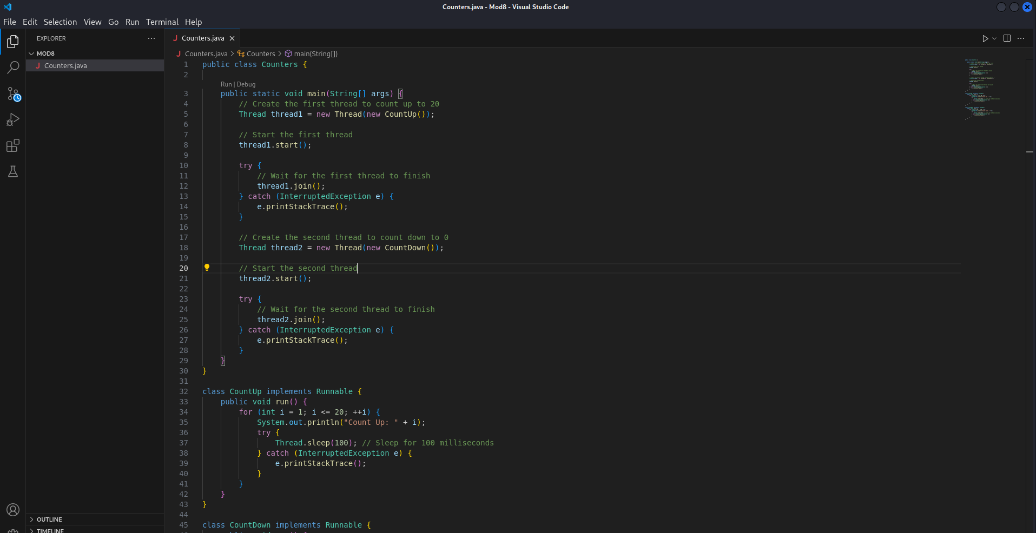Figure 1: Java Code for Concurrency counter

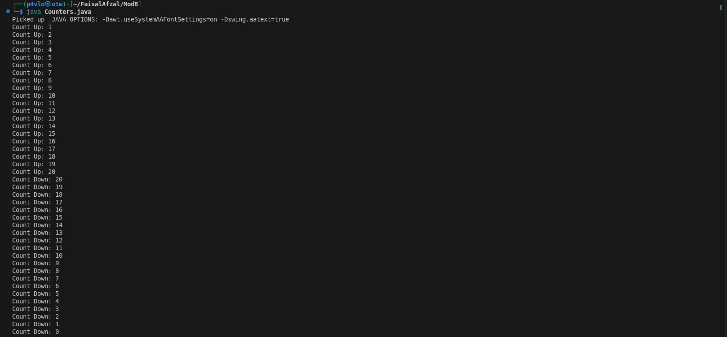Figure 2: The output of the code after successfully counting up to 20 and down to 0

**Detailed comparison between the performance implementations between the Java and C++ versions of the Applications.**

I have created a concurrency-based program in both Java and C++. The purpose of the application is to establish two threads that operate as counters, with one thread counting up to 20 and the other thread counting down from 20 to 0.

**Performance Comparison**

***Java Implementation:***

In the Java implementation, I utilized the built-in threading mechanisms provided by the Java standard library. The key aspects of the Java implementation are:

Shared counter variable (int counter) protected by a synchronized block (synchronized (lock))

Use of Thread.sleep(100) to introduce a delay and simulate some processing

Notification of the countDownThread using lock.notifyAll() when the counter reaches 20

The use of synchronized blocks ensures thread safety by allowing only one thread to access the shared counter variable at a time. This prevents race conditions and ensures the correct counting behavior. However, the use of synchronized blocks can also introduce performance overhead due to the locking mechanism.

***C++ Implementation:***

For the C++ implementation, I utilized the std::thread library and the std::mutex synchronization primitive to achieve the same functionality as the Java version. The key aspects of the C++ implementation are:

Shared counter variable (std::atomic<int> counter) protected by a std::mutex

Use of std::this_thread::sleep_for(std::chrono::milliseconds(100)) to introduce a delay

Notification of the countDownThread using a std::condition_variable and std::unique_lock

The C++ implementation uses a std::atomic<int> to manage the shared counter variable, which provides atomic operations for thread-safe access. The std::mutex is used to protect the critical section where the counter is incremented and decremented. The std::condition_variable is used to notify the countDownThread when the counter reaches 20.

**Performance Analysis:**

When comparing the performance of the Java and C++ implementations, I considered the following factors:

***Synchronization Overhead*:**

Java's synchronized blocks introduce more overhead compared to the C++ implementation's use of std::mutex and std::condition_variable. The Java VM needs to perform additional bookkeeping and locking operations, which can lead to higher latency and lower throughput.

C++'s std::mutex and std::condition_variable are lower-level synchronization primitives that have less overhead compared to Java's synchronized blocks.

***Memory Management:***

Java's automatic memory management can introduce additional overhead compared to C++'s manual memory management.

Based on these factors, the C++ implementation is likely to have better performance than the Java implementation, especially in scenarios with high concurrency and contention for shared resources. The lower-level synchronization primitives and manual memory management in C++ can provide more control and optimization opportunities compared to Java's higher-level abstractions.

**Security Comparison**

Security Considerations in Java:

Java, as a managed runtime environment, provides several security features and mechanisms that help mitigate potential security threats:

Memory Safety:

Java's automatic memory management and type safety features help prevent common memory-related vulnerabilities, such as buffer overflows and use-after-free issues.

The Java Virtual Machine (JVM) enforces strict type checking and memory access rules, reducing the risk of memory-related security vulnerabilities.

Security Considerations in C++:

Memory Management:

C++'s manual memory management, including dynamic memory allocation and deallocation, can lead to common memory-related vulnerabilities, such as buffer overflows, use-after-free, and null pointer dereferences.

Lack of Automatic Bounds Checking:

C++ does not have built-in bounds checking for array accesses and other memory operations, leaving the responsibility of ensuring safe memory access to the developer.

Improper bounds checking can lead to buffer overflow vulnerabilities and other memory-related security issues.

In summary, when comparing the security of Java and C++ implementations, the Java version is widely regarded as less resistant to security risks due to its inherent security features and managed runtime environment.  
  
Java's automatic memory management, type safety, and sandboxing features serve to prevent many typical security issues seen in C++ applications. Java's numerous security-related APIs and libraries also serve as a solid foundation for developing secure applications.  
  
In contrast, the C++ implementation relies on the developer's knowledge of secure coding techniques, as well as the deployment of additional security-focused libraries and tools, to handle memory-related vulnerabilities and other security issues.