

Name of Student: Bilal Ahmed

Roll Number: 20i-1788

Submitted to: Miss Laiba Imran

**Step 1**

First of fall, to implement our project, we used a simple MERN Stack Application that runs okay.





Screenshot has been attached for the justification.

**Step 2**

Now, as everything was working fine so, we proceeded towards building Docker images and containers. We created a Docker file, each for frontend and backend. Then one compose file for the whole project. After that, we ran the appropriate commands:

*docker compose up build*

*docker ps -a*

In addition, then we got the following output:

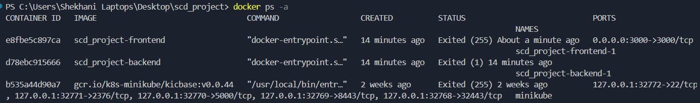

**Step 3**

After the Docker containers were locally deployed, we pushed them over Docker Hub using *docker tag, docker login and then finally docker push* commands.

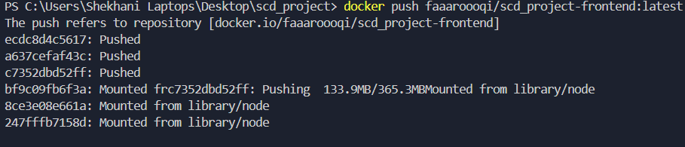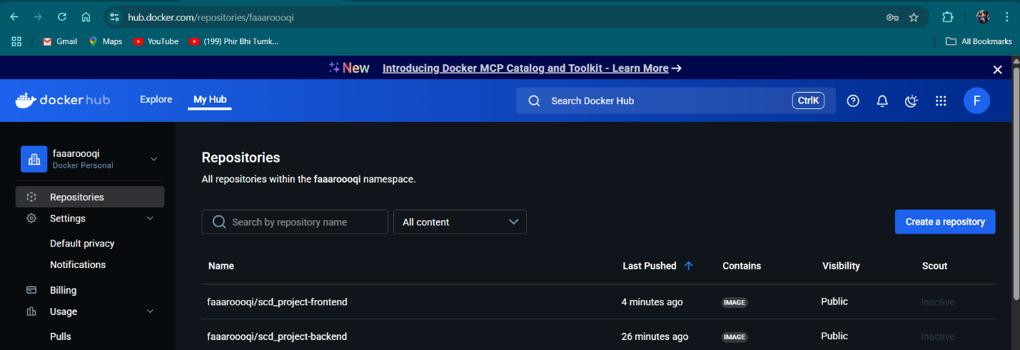

**Step 4**

After successful deployment of docker containers locally and remote, we checked versions of Docker, Minikube and Kubectl (as all of them were already installed on my laptop).

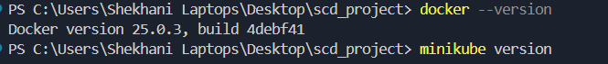

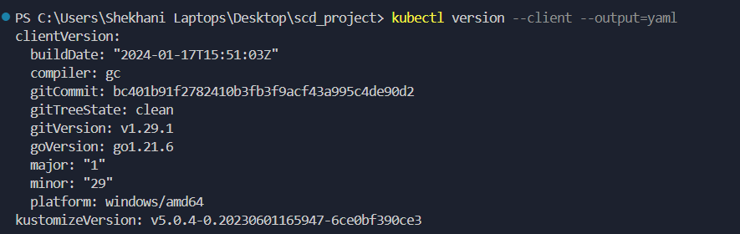

**Step 5**

Now, we need to deploy our docker containers on k8s cluster. For that, first of all we created service.yaml and deployment.yaml file in our project structure. Then, we ran the appropiate commands to run our k8s cluster.

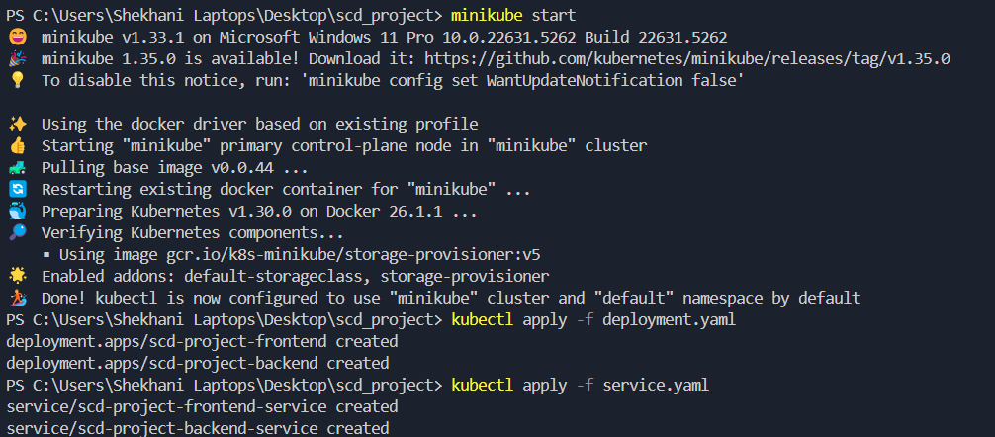

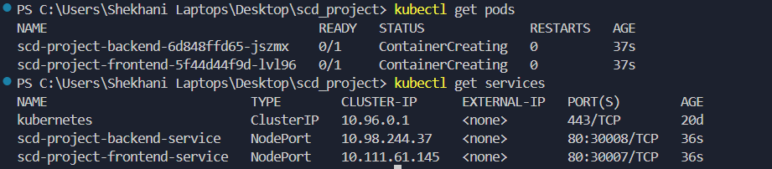

After sometime, we ran the command of get pods again to ensure whether they have been deployed or not.

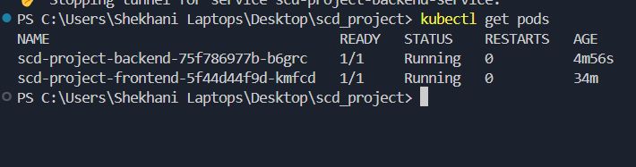

Then, we executed the service to finally check:

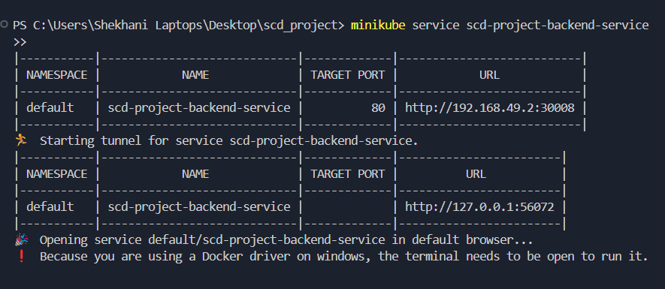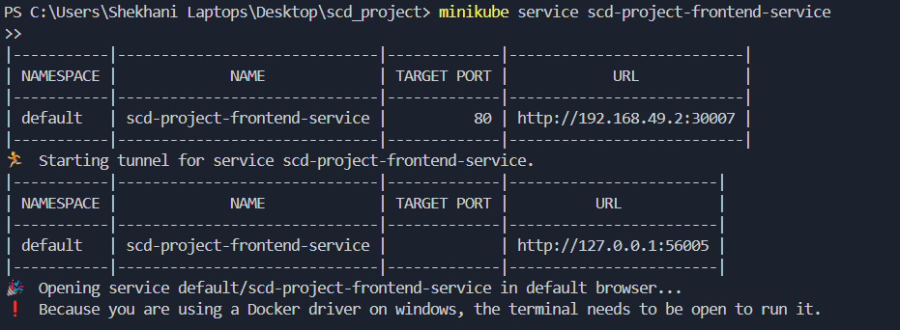

In addition, then we got in our browser:

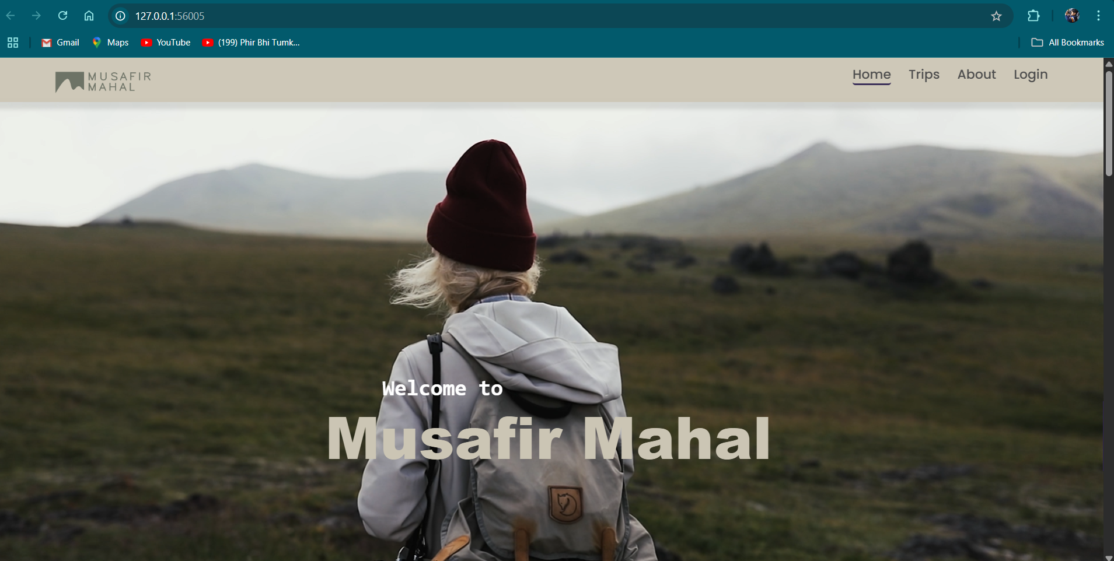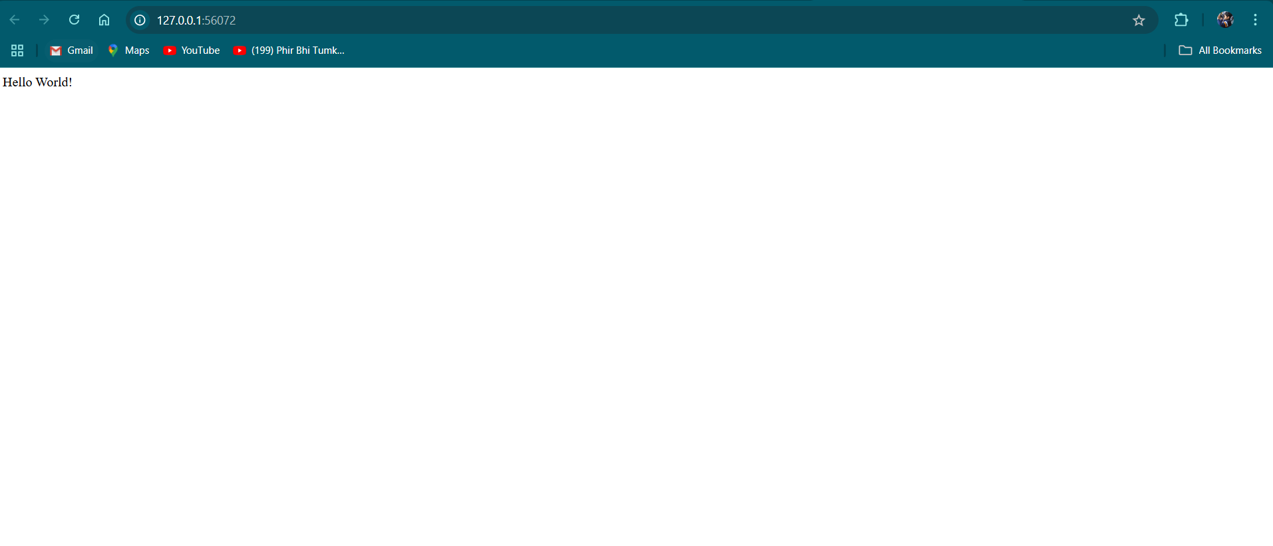

**Step 6**

Last but not the least; we created a repository on our GitHub. Then, we locally initialized git using *Git init* command. Then, we gave git the link of our remote repository using *git remote* command. And, then finally added all the files and code on Github.

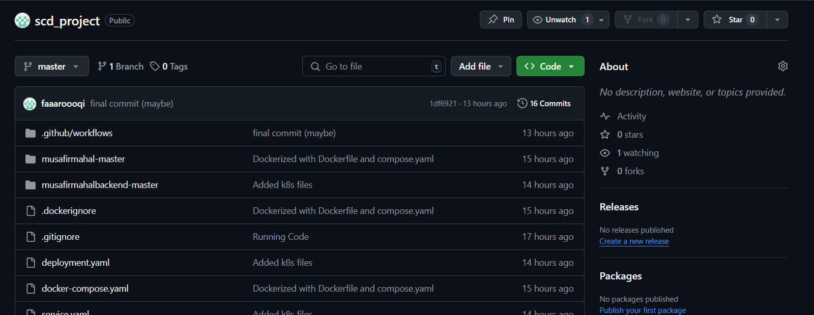

**Isssues Faced in the Project:**

1. When we deployed pods, backend pod was not running which was a result of a silly mistake. The backend root file was index.js, however, in the Docker file I gave it as server.js, which led pod to fail. Then, we checked the logs, troubleshoot the issue, reran the docker container after fixes and then delete the backend pod. Kubectl automatically generates one after deletion. 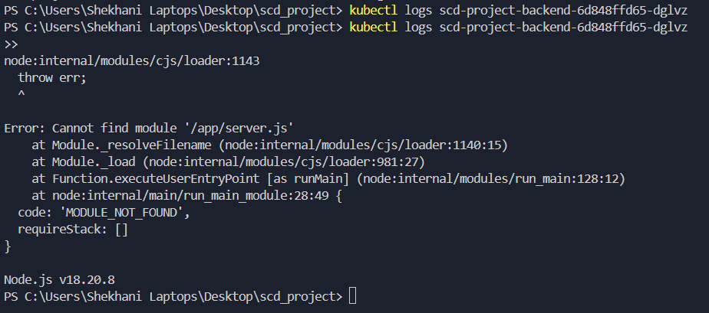
2. In CI/CD Pipeline, there was an issue while GitHub Actions fail to run it.

Reason*: Minikube is not installed on GitHub-hosted runners by default.*

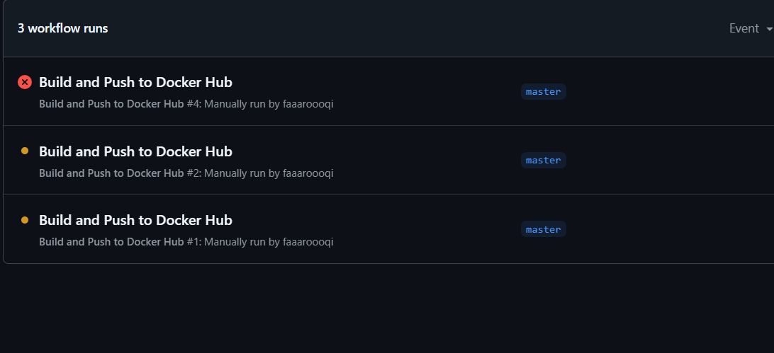

**Operating System Selection:**

I have chosen Windows 11 for all my deployment because I am familiar with it and all of the dependencies were previously installed on my Windows laptop, so it was more convenient and easier for me to use Windows.