Documentation

Supply Chain Visibility System with Optimization Analytics

Tool Used Microsoft Power BI

Dataset AIS Data Complete Weather

Milestones 1-4

Prepared by Faaiz Hamid

Milestone 1 – Data Modelling & KPI Foundation
The project titled “Supply Chain Visibility System with Optimization Analytics” focuses on using data analytics to improve the visibility of supply-chain transportation activities.
Supply chains involve the movement of goods from one location to another. Monitoring transportation activities such as vessel location, speed, destination, estimated arrival time and weather conditions can help organizations understand transportation operations and identify areas for improvement.
For this project, an AIS (Automatic Identification System) dataset was used. AIS is a system used by ships to transmit information such as vessel identification, location, speed, course and other operational information.
Microsoft Power BI was used to transform the raw dataset into an interactive analytical dashboard.

- Dataset Description

The dataset used for this milestone is AIS Data Complete Weather.
The dataset contains approximately 1.1 million AIS observations and information about approximately
13,000 unique vessels.
Each row represents an observation of a vessel at a particular point in time. Some important fields in the dataset are:

Field | Description
MMSI | Unique identification number of a vessel
VesselName | Name of the vessel
BaseDateTime | Date and time of the observation
LAT | Latitude of the vessel
LON | Longitude of the vessel
SOG | Vessel speed
SOG_kmh | Vessel speed in kilometres per hour
VesselType | Vessel type / category code
Status | Vessel operational / navigation status
Cargo | AIS cargo classification / code
dist_km | Distance-related information
ETA_hours | Estimated time of arrival
dest_cluster | Destination grouping
weather_wind_kph | Wind speed
weather_visibility_km | Visibility
weather_temp_c | Temperature

The dataset combines vessel movement information with weather information, making it useful for transportation and supply-chain visibility analysis.

- Data Preparation

The dataset was imported into Microsoft Power BI and prepared using Power Query.

  - Data Type Checking
The data types of important columns were checked and adjusted where required, for example:
    - MMSI → identification field
    - BaseDateTime → date/time
    - LAT and LON → numerical
    - SOG and SOG_kmh → numerical
    - ETA_hours → numerical
    - Weather fields → numerical

  - Data Transformation
The dataset was transformed to make it easier to analyze in Power BI. Two derived fields were created:
Operational_Status
This categorizes vessel observations into operational states such as:
    - Moving
    - Stopped
Speed_Category
The vessel speed was grouped into categories:

    - Stopped
    - Slow
    - Moderate
    - Fast

These categories make the dashboard easier to understand than displaying only raw speed values.
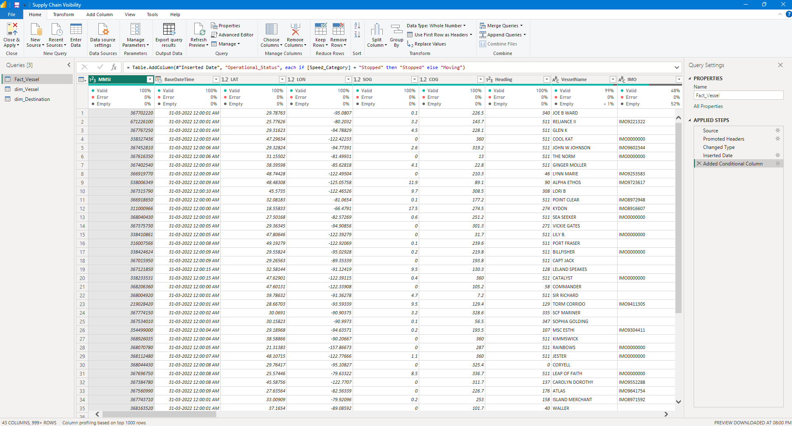

- Data Model

A simple dimensional data model was created in Power BI. The main tables used were:
- Fact_Vessel
- dim_Vessel
- dim_Destination

Fact_Vessel
Fact_Vessel acts as the central table containing the main AIS observations. It contains information such as:
- Vessel
- Time
- Location
- Speed
- Destination
- ETA
- Weather
- Operational status

dim_Vessel
dim_Vessel provides descriptive information about vessels and allows vessel-related filtering and analysis.

dim_Destination
dim_Destination provides destination-related information and allows the data to be grouped according to destination clusters.

Relationships
The model follows a simple star-schema-style structure:
dim_Vessel → Fact_Vessel ← dim_Destination
One vessel can have multiple AIS observations. Therefore, the relationship between the vessel dimension and the fact table is based on a one-to-many relationship. This structure makes filtering and aggregation easier within Power BI.
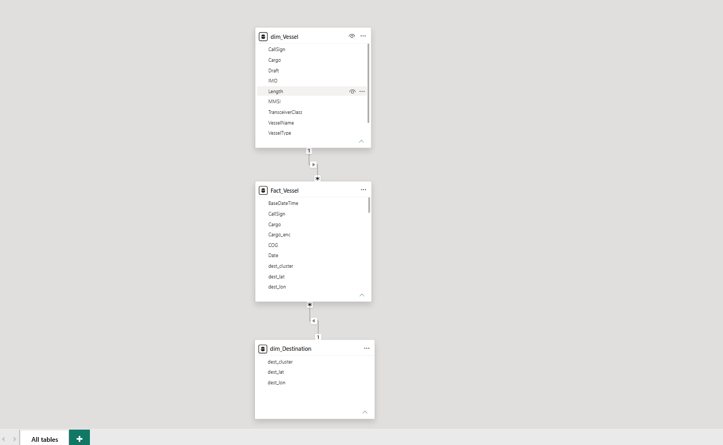

- KPI Development

KPIs, or Key Performance Indicators, are important summary values used to understand the overall condition of the data. Several DAX measures were created in Power BI.

Total AIS Records
This measures the total number of observations in the dataset.
Total AIS Records = COUNTROWS(Fact_Vessel)

Unique Vessels
This calculates the number of different vessels.
Unique Vessels = DISTINCTCOUNT(Fact_Vessel[MMSI])

Average Speed
This calculates the average vessel speed.
Average Speed = AVERAGE(Fact_Vessel[SOG_kmh])

Total Distance
This calculates the total distance represented by the available records.
Total Distance = SUM(Fact_Vessel[dist_km])

Average ETA
This calculates the average estimated arrival time.
Average ETA = AVERAGE(Fact_Vessel[ETA_hours])

Stopped Records
This calculates the number of observations where the vessel was classified as stopped.
Stopped Records = CALCULATE(
COUNTROWS(Fact_Vessel), Fact_Vessel[Operational_Status] = "Stopped"
)

Stopped Percentage
This calculates the percentage of AIS observations classified as stopped.
Stopped % =
DIVIDE(
[Stopped Records], [Total AIS Records], 0
)

- Dashboard – Page 1: Supply Chain Visibility Dashboard

The first dashboard page provides an overall view of vessel and transportation activity. The page contains KPI cards, charts and interactive slicers.

  - KPI Cards
The dashboard contains the following major KPIs:

KPI | Result
Total AIS Records | ~1.1 Million
Unique Vessels | ~13,000
Average Speed | 4.36 km/h
Total Distance | 277.88 Million km
Average ETA | 59.89 hours
Stopped Percentage | 79.64%

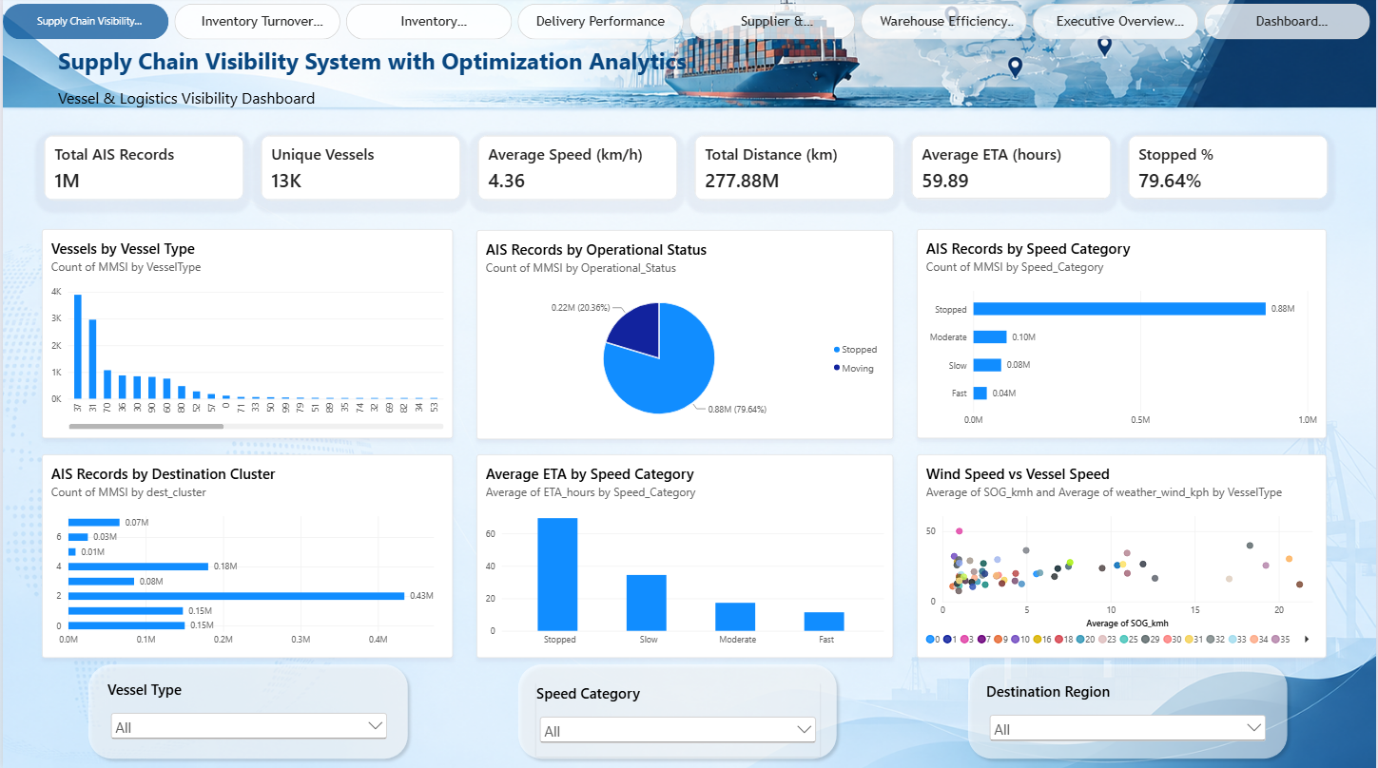
These KPIs provide a quick summary of the transportation activity represented in the dataset.

Dashboard Visualizations

Vessels by Vessel Type
This chart shows the distribution of AIS activity across different vessel-type codes. It helps identify which vessel categories are most represented in the dataset.

AIS Records by Operational Status
A donut chart was used to show the proportion of vessel observations classified as Stopped or Moving. The dashboard shows approximately:
    - 79.64% Stopped
    - 20.36% Moving
This indicates that a large proportion of the recorded observations were classified as stopped.

AIS Records by Speed Category
This visualization divides vessel observations into speed categories: Stopped, Slow, Moderate and Fast. It provides a simple overview of the movement characteristics of vessels.

AIS Records by Destination Cluster
This chart groups AIS observations according to destination clusters. It can be used to understand where vessel activity is concentrated.

Average ETA by Speed Category
This visualization compares the average estimated arrival time across different speed categories. It provides an operational view of the relationship between vessel movement category and estimated arrival time.

Wind Speed vs Vessel Speed
A scatter chart was created to compare Wind Speed vs Vessel Speed. The purpose of this visualization is exploratory. It allows the user to observe whether vessel speeds vary under different wind conditions. The chart should not be interpreted as proving a direct causal relationship between wind and vessel speed.

Interactive Slicers

Interactive slicers were added to make the dashboard easier to explore. The main slicers include:
- Vessel Type
- Destination Cluster
- Speed Category
When a user selects a particular value, the relevant charts and KPI cards automatically update. For example, selecting one vessel type allows the user to analyze only the activity associated with that vessel category. This makes the dashboard interactive rather than static.

- Dashboard – Page 2: Inventory Turnover Analysis

The second dashboard page focuses on cargo-flow and inventory-turnover-related operational analysis.
The available AIS dataset does not contain conventional inventory information such as:
- Inventory quantity
- Cost of goods sold (COGS)
- Average inventory value
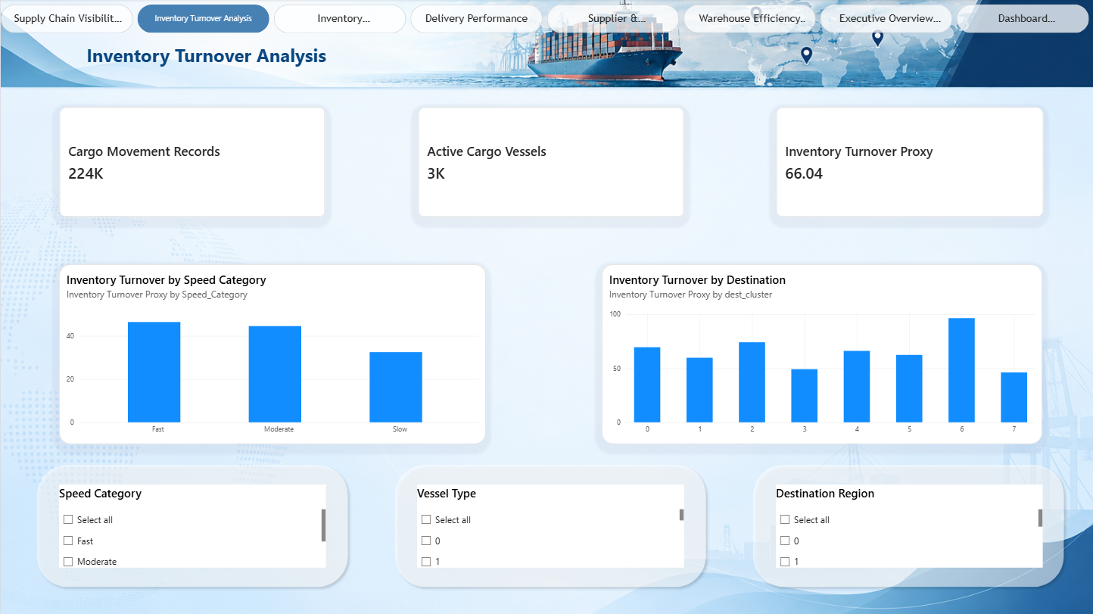
Therefore, a standard accounting inventory turnover ratio could not be calculated directly from this dataset. Instead, an Inventory Turnover Proxy was developed.

- Inventory Turnover Proxy

Three measures were created for the operational analysis.

Moving AIS Records
Cargo Movement Records = CALCULATE(
COUNTROWS(Fact_Vessel), Fact_Vessel[Operational_Status] = "Moving"
)
Active Moving Vessels
Active Cargo Vessels = CALCULATE(
DISTINCTCOUNT(Fact_Vessel[MMSI]),
Fact_Vessel[Operational_Status] = "Moving"
)

- Inventory Turnover Proxy

Three measures were created for the operational analysis.

Moving AIS Records
Cargo Movement Records = CALCULATE(
COUNTROWS(Fact_Vessel), Fact_Vessel[Operational_Status] = "Moving"
)
Active Moving Vessels
Active Cargo Vessels = CALCULATE(
DISTINCTCOUNT(Fact_Vessel[MMSI]),
Fact_Vessel[Operational_Status] = "Moving"
)

Inventory Turnover Proxy
Inventory Turnover Proxy = DIVIDE(
[Cargo Movement Records], [Active Cargo Vessels],
0
)
The resulting proxy value in the dashboard is approximately 66.04.
This value should not be interpreted as an accounting inventory turnover ratio. Instead, it represents an operational cargo-flow indicator, calculated from the relationship between moving AIS observations and active moving vessels. This approach was used because the supplied AIS dataset does not contain the financial/inventory fields required for a conventional inventory turnover calculation.

- Page 2 Visualizations

The second page contains:

Moving AIS Records Card
Shows the number of AIS observations associated with moving vessels.

Active Moving Vessels Card
Shows the number of unique vessels classified as moving.

Inventory Turnover Proxy Card
Displays the calculated operational proxy value.

Inventory Turnover by Speed Category
Shows how the operational turnover proxy varies across different vessel speed categories.

Inventory Turnover by Destination
Shows the operational cargo-flow indicator across different destination clusters.
These visualizations provide another perspective on vessel activity and cargo movement.

- Key Dashboard Results

The major results obtained from the dashboard are:
- Approximately 1.1 million AIS observations were analyzed.
- Approximately 13,000 unique vessels were identified.
- The average vessel speed was approximately 4.36 km/h.
- The total recorded distance was approximately 277.88 million km.
- The average ETA was approximately 59.89 hours.
- Approximately 79.64% of observations were classified as stopped.
- Approximately 20.36% were classified as moving.
- The operational inventory-turnover proxy was approximately 66.04.

These results provide a high-level understanding of the transportation activity contained in the dataset.

- Business Insights

- Vessel Activity
The dashboard provides an overview of the number and types of vessels represented in the dataset.

- Movement Status
The stopped/moving analysis provides visibility into vessel operational status.

- Transportation Speed
Speed categories make it easier to identify different levels of vessel movement.

- Destination Activity
Destination clusters help identify areas with relatively higher AIS activity.

- ETA Monitoring
Average ETA provides an overview of expected arrival duration.

- Weather Context
Combining weather information with vessel movement provides additional context for transportation analysis.

- Cargo Flow
The operational turnover proxy provides an additional indicator of cargo-flow activity when conventional inventory data is unavailable.

- Tools and Technologies Used

Microsoft Power BI
Used for:
- Data import
- Data transformation
- Data modelling
- DAX calculations
- Dashboard development
- Interactive filtering
- Data visualization

Power Query
Used for:

- Data preparation
- Data type checking
- Data transformation
- Creating derived fields

DAX
DAX (Data Analysis Expressions) was used to create calculated measures and KPIs. Examples include:
- Total AIS Records
- Unique Vessels
- Average Speed
- Total Distance
- Average ETA
- Stopped %
- Inventory Turnover Proxy

- Milestone 1 Workflow

The overall workflow followed during Milestone 1 was:

Raw AIS Dataset ↓
Data Import into Power BI ↓
Data Cleaning & Transformation using Power Query ↓
Creation of Derived Fields ↓
Data Modelling ↓
Creation of DAX Measures ↓ KPI Development ↓ Dashboard Visualization ↓
Interactive Supply Chain Analysis

Milestone 2 – Inventory & Delivery Analytics

1. Dashboard – Page 3: Inventory Performance
This page presents Cargo Flow Analysis with Regional and Product-Level Insights, focusing on cargo movement volume, vessel activity and inventory turnover across speed categories and destinations.

1.1 KPI Cards
KPI | Result
Cargo Records (Moving Records) | 224K
Active Vessels (Unique Vessels) | 13K
Average ETA (Average Delivery Time) | 59.89
Turnover (Inventory Turnover Proxy) | 66.04

1.2 Inventory Turnover by Speed Category
A column chart shows the Inventory Turnover Proxy broken down by Speed_Category. Fast-moving vessels show the highest turnover value (approximately 46), followed by Moderate (approximately 43) and Slow (approximately 34), indicating that vessels moving at higher speeds are associated with higher cargo-flow turnover.

1.3 Inventory Turnover by Destination
A horizontal bar chart shows the Inventory Turnover Proxy across the eight destination clusters (dest_cluster 0–7). Turnover values range from approximately 46 to 96 across clusters, with cluster 6 showing the highest turnover (96) and cluster 7 the lowest (46), highlighting variation in cargo-flow activity by destination region.

1.4 Interactive Slicers
The page includes the following slicers, allowing the report to be filtered dynamically:
- Vessel Type (VesselType)
- Speed Category (Speed_Category)
- Destination Region (dest_cluster)

2. Dashboard – Page 4: Delivery Performance
This page presents Regional & Product-Level Analysis with Trend and Variance, focusing on on-time delivery performance, delivery trends over time, and regional/product-level drill-downs.

2.1 KPI Cards
KPI | Result
On-Time Delivery % | 25.56%
Delayed Deliveries | 818K
Average Delivery Time | 59.89
Count of dest_cluster | 8
ETA Variance | 0.00

2.2 Delivery Trend Over Time
A line chart plots Average Delivery Time by Hour across the 24-hour cycle. Delivery times remain relatively stable at around 55–60 hours through the early hours, rise to a peak of approximately 70 hours around hour 10, and then gradually decline to approximately 45 hours by hour 20–21, before levelling off. This highlights time-of-day variance in delivery performance.

2.3 Regional Delivery Performance
A column chart shows Average Delivery Time by dest_cluster across the eight destination regions (0–7). Delivery times vary between approximately 20 and 60, with cluster 4 showing the highest average delivery time and cluster 5 the lowest, indicating regional differences in delivery performance.

2.4 Product-Level Drill Down
A ribbon/area-style chart shows Average Delivery Time by VesselType, with a slider control to filter the range of vessel types shown. Most vessel types cluster around an average delivery time of 72, providing a product-level (vessel-type-level) view of delivery consistency.

2.5 Interactive Slicers
The page includes the following slicers, allowing the report to be filtered dynamically:
- Speed Category (Speed_Category)
- Date
- Vessel Type (VesselType)

3. Key Dashboard Results
- Cargo movement records (moving observations) totalled approximately 224K.
- Active moving vessels totalled approximately 13,000.
- Average ETA / average delivery time was approximately 59.89 hours.
- The inventory turnover proxy was approximately 66.04, varying by speed category (34–46) and by destination cluster (46–96).
- On-time delivery stood at approximately 25.56%, with approximately 818K delayed deliveries.
- Delivery time by hour peaked at approximately 70 hours around hour 10 and dipped to approximately 45 hours by hour 20.
- Regional delivery performance varied from approximately 20 to 60 across the 8 destination clusters.
- ETA variance was recorded at 0.00 for the current filter context.

4. Business Insights

1. Cargo Flow by Speed
Higher vessel speed categories are associated with higher inventory turnover, suggesting faster-moving vessels contribute more to cargo throughput.

2. Regional Variation
Both inventory turnover and delivery time vary noticeably across destination clusters, pointing to specific regions that may need closer operational attention.

3. Delivery Timing Patterns
The hourly delivery trend reveals a mid-cycle peak in delivery time, useful for identifying potential congestion windows.

4. On-Time Performance
An on-time delivery rate of 25.56%, alongside 818K delayed deliveries, highlights a significant opportunity area for delivery performance improvement in later milestones.

5. Product-Level Consistency
Average delivery time is broadly consistent across vessel types, indicating delivery delays are more strongly linked to region and timing than to vessel type.

5. Dashboard Output
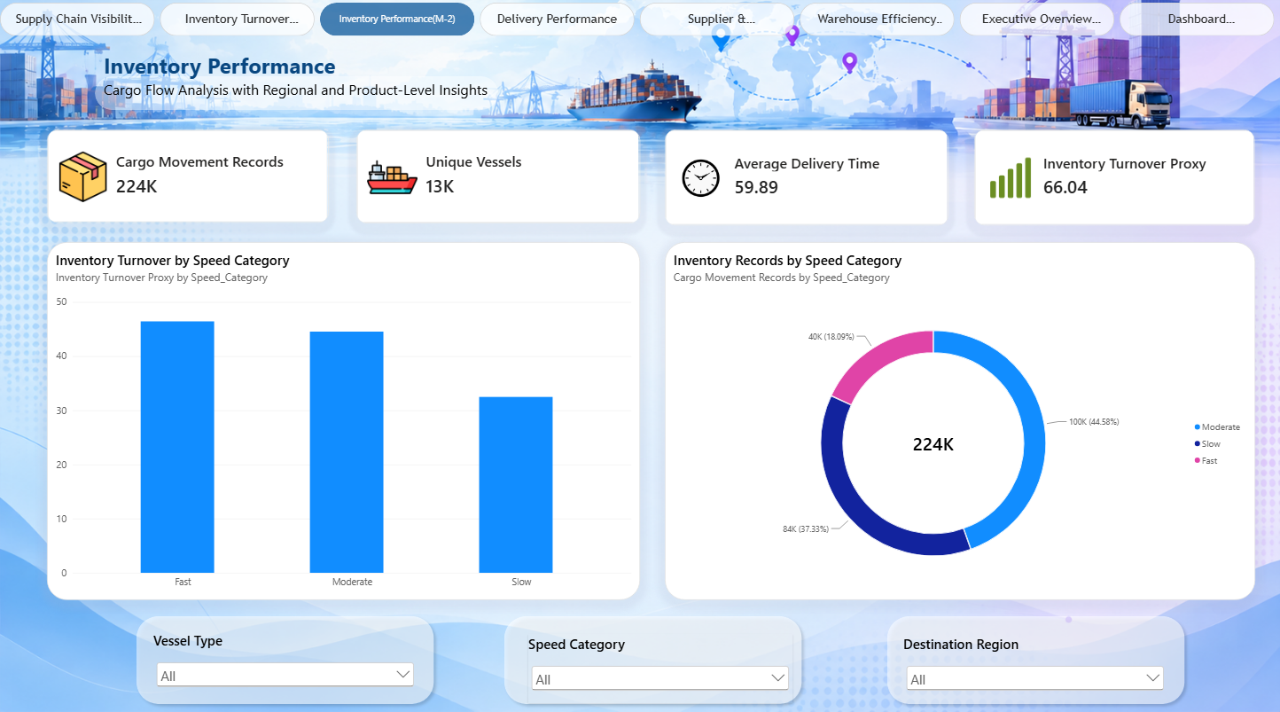

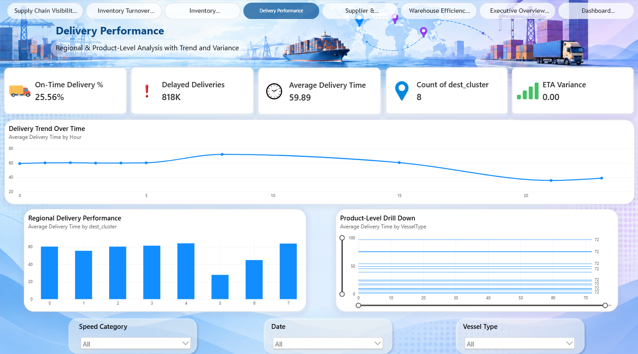
Milestone – 3 Supplier & Transportation Analytics

This milestone builds on the work completed so far in the project. The earlier milestones focused primarily on overall supply-chain visibility, inventory-related analysis, and delivery performance analysis.

Having established that foundation, this milestone extends the analysis to a new area of the supply chain - supplier and transportation activity - using the same underlying AIS (Automatic Identification System) dataset used throughout the project.

The main objective of Milestone 3 is to analyze:
- Supplier-level activity
- Transportation performance
- Carrier performance
- Route-wise transportation distribution
- Overall fulfillment and on-time performance

This provides a consolidated analytical view of the supplier and transportation side of the supply chain, complementing the inventory and delivery analysis produced in the previous milestones.

1. Dashboard Structure

The Milestone 3 dashboard, “Supplier & Transportation Analytics,” is organized into three sections:
- KPI Cards (top) - four key performance indicators summarizing overall transportation and fulfillment performance.
- Visualizations (middle) - four charts covering supplier activity, transportation cost, route distribution, and supplier quality.
- Slicers (bottom) - four interactive filters (Supplier, Region, Carrier, Route) that filter the entire dashboard.

The intended usage flow is for a user to first review the high-level KPIs, then drill down using the charts and slicers for more detailed analysis.

1.1 KPI Cards
KPI | Result
Total Transportation Cost Proxy | 277.88M
Average Shipment Cost Proxy | 252.86
Fulfillment Rate | 20.36%
On-Time Rate | 25.56%

Fulfillment Rate note: since the dataset lacks a conventional order-fulfillment field, this figure should be read as an operational fulfillment / movement proxy rather than a traditional fulfillment percentage.
On-Time Rate note: this is an ETA-based indicator; records with an ETA above a defined threshold are treated as delayed.

1.2 Visualizations
Supplier-wise Shipment Count
Since a conventional supplier-name field is not available, Vessel Name is used as a supplier proxy. The chart shows the top 10 vessel names by record count, showing that some vessels have a considerably larger operational presence than others. In a real supplier dataset, this same approach could help identify high-volume suppliers for further review.

Route-wise Transportation Cost
A donut chart shows how the transportation-distance proxy is distributed across destination clusters, with the center displaying the overall total. The largest segment accounts for approximately 108.39M (≈39%) of total transportation distance, with the remaining clusters contributing smaller shares. This helps visualize how transportation activity is distributed geographically and highlights destinations with disproportionately high activity.

Carrier-wise Transportation Cost

Since the dataset lacks a dedicated carrier field, Vessel Type is used as a carrier proxy. The chart shows that transportation activity is unevenly distributed across vessel types, with certain types contributing significantly more than others. If real carrier and cost data were available, this same visualization structure could be used to compare carriers directly on cost and performance.

Supplier-wise Quality Score

Because no real supplier quality score exists in the dataset, an operational quality-score proxy based on ETA performance was created: lower average ETA results in a higher score, and the score is normalized to a 0–100 scale. This is explicitly a simplified operational proxy, not a genuine supplier-quality rating - a real system would incorporate factors such as delivery accuracy, product quality, rejection rate, lead time, and service-level compliance.

1.3 Interactive Slicers
A horizontal bar chart shows the Inventory Turnover Proxy across the eight destination clusters (dest_cluster 0–7). Turnover values range from approximately 46 to 96 across clusters, with cluster 6 showing the highest turnover (96) and cluster 7 the lowest (46), highlighting variation in cargo-flow activity by destination region.

1.4 Interactive Slicers
Slicer | Based On | Purpose
Supplier | Vessel Name (supplier proxy) | Filter by supplier
Region | Destination Cluster | Filter by destination region
Carrier | Vessel Type (carrier proxy) | Filter by carrier / vessel type
Route | Destination Cluster | Filter by route (no separate route field available)

These slicers make the dashboard interactive - for example, selecting a specific vessel type or destination cluster instantly updates the KPI cards and all four visualizations.

2. Purpose and Value
The purpose of this dashboard is to bring supplier activity and transportation performance into a single analytical view. Instead of examining individual records, the dashboard converts raw AIS data into KPIs and visualizations covering:

- Transportation activity
- Shipment volume
- Destination distribution
- Vessel-type transportation contribution
- Operational ETA performance
- Supplier / vessel-level performance

This supports supply-chain teams in identifying high-activity suppliers, understanding transportation patterns, and investigating destinations or transportation categories that warrant further analysis.

3. Limitations and Assumptions
The AIS dataset does not contain several conventional business fields typically required for a supplier and transportation dashboard, including actual supplier name, carrier name, shipment cost, fulfilment status, and actual delivery timestamp.
Business Concept | Proxy Used
Supplier | Vessel Name
Carrier | Vessel Type
Region / Route | Destination Cluster
Transportation Cost | Distance
To address this, clearly defined operational proxies were used based on the fields that are available:

4. Tools Used
Microsoft Power BI – Used to build the interactive dashboard, KPI cards, charts, slicers, and data visualizations.
Power Query – Used for data import, cleaning, transformation, and preparation.
DAX (Data Analysis Expressions) – Used to create calculated measures and KPI calculations such as Transportation Cost Proxy, Fulfillment Rate, On-Time Rate, and Supplier Quality Score.
Kaggle – Used to obtain the AIS Data Complete Weather dataset.
Data Visualization – Power BI charts such as bar/column charts and donut charts were used for supplier, carrier, route, and transportation analysis.

5. Summary
Milestone 3 extends the project from inventory and delivery analysis (Milestones 1 and 2) into supplier and transportation analytics. The dashboard delivers KPI monitoring, supplier-level analysis, transportation distribution, carrier / vessel-type analysis, and interactive filtering - providing a consolidated view that helps identify transportation patterns and operational performance areas.

6. Dashboard Output
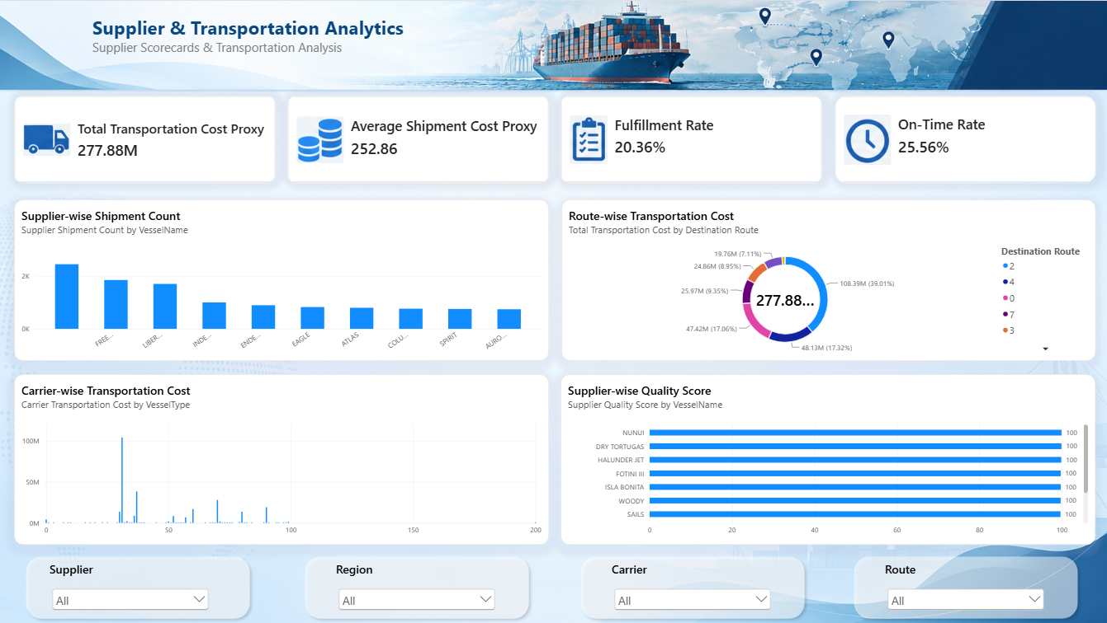
Milestone 4 – Warehouse Analytics & Final Dashboard
The main objectives of Milestone 4 were:
- Develop warehouse efficiency reports.
- Create an executive overview dashboard.
- Optimize dashboard performance.
- Carry out final testing, documentation, and deployment.
This milestone consolidates the data model, KPIs and dashboards built in Milestones 1–3 into a warehouse-efficiency view and a final executive-level summary, and closes out the project with performance optimization, testing and deployment.

1. Dashboard – Page 5: Warehouse Efficiency Reports
This page, titled “Warehouse & Operational Efficiency Report”, presents operational performance across the eight destination regions (dest_cluster 0–7).

1.1 KPI Cards
KPI | Result
Total AIS Records | 1M
Cargo Movement Records | 224K
Operational Utilization Proxy | 20.36%
On-Time Rate | 25.56%
Average ETA (hours) | 59.89

1.2 Total Records by Destination
A horizontal bar chart shows the total AIS record count by destination cluster. Cluster 0 has the highest volume (296K), followed by cluster 6 (244K) and cluster 4 (204K), while cluster 3 has the lowest (58K).

1.3 Operational Utilization by Destination
A column chart shows the Operational Utilization Proxy (%) by destination. Clusters 4 and 6 show markedly higher utilization (54.43% and 50.75%) compared to the remaining clusters, which range from under 1% to around 19%.

1.4 Average Vessel Speed by Destination
A bar chart shows average vessel speed (km/h) by destination cluster. Most clusters average around 189 km/h on the chart’s scale, with cluster 6 lower at 159, indicating relatively consistent speed profiles across destinations with one notable exception.

1.5 On-Time Performance by Destination
A donut chart breaks down on-time performance by destination cluster, with an overall On-Time Rate of 25.56% shown at the centre. Cluster 5 contributes the largest on-time share (30.08%), followed by cluster 4 (18.61%) and cluster 6 (14.82%).

1.6 Cargo Movement Records by Destination
A bar chart shows cargo movement (moving AIS) records by dest_cluster. Cluster 2 leads with 97K records, followed by cluster 6 (34K) and cluster 4 (27K), while cluster 1 has the fewest (3K).

1.7 Average ETA by Destination
A bar chart shows average ETA (in the report’s scaled units) by destination, ranging from 0.14 (cluster 1) to 0.81 (cluster 0), highlighting destinations with comparatively longer estimated arrival times.

1.8 Operational Records by Vessel Type
A donut chart shows the distribution of operational records across vessel types, totalling 1M records. The largest vessel-type segment accounts for 36.43% (400K records), followed by 18.14% (199K) and 8.05% (88K), with several smaller vessel-type segments making up the remainder.

2. Dashboard – Page 6: Executive Overview
This page, titled “Executive Overview – Supply Chain Operational Performance at a Glance”, consolidates the project’s key metrics into a single executive-facing summary view.

2.1 KPI Cards
KPI | Result
Total Transportation Distance | 277.88M
Average Speed (km/h) | 4.36

2.2 AIS Records by Hour
A line chart shows AIS record volume by hour, peaking at 0.26M around hours 3–4, following a rise from 0.07M and a decline to near 0.00M beyond hour 5 in the displayed window.

2.3 Total Records by Destination
A column chart repeats the destination-wise record distribution, with cluster 2 dominating at 0.43M records, and clusters 5 and 6 contributing the least (0.01M and 0.03M respectively).

2.4 On-Time Rate by Destination
A line chart shows on-time rate by destination cluster, ranging from 15.26% (cluster 4) up to a peak of 85.99% (cluster 5), before falling back to 20.78% (cluster 7).

2.5 Average Vessel Speed by Destination
A bar chart shows average vessel speed by destination, ranging from 3.8–3.9 km/h for several clusters up to 8.4 km/h for cluster 6.

2.6 Total Transportation Distance by Destination
A bar chart shows total transportation distance by destination, led by cluster 2 at 108M, followed by cluster 4 (48M) and cluster 0 (47M), with cluster 6 the lowest at 0M.

2.7 Records by Vessel Type
A donut chart mirrors the vessel-type distribution seen on the Warehouse Efficiency page (1M total records), reused here to give executives a consistent view of vessel-type composition.

2.8 Filters
The Executive Overview page provides four report-level filters for interactive exploration:
- Date
- Destination
- Vessel Type
- Operational Status

3. Dashboard – Page 7: Operational KPI Summary
This page, titled “Operational KPI Summary – Destination-wise Operational Performance”, presents a consolidated matrix table combining the core operational KPIs for each destination, with conditional formatting (red–yellow–green) applied to highlight relative performance.

3.1 Destination-wise KPI Table
Destination | Operational Utilization % | On-Time Rate | Avg. Vessel Speed (km/h) | Avg. ETA (hours)
0 | 22.60% | 22.34% | 5.16 | 60.27
1 | 15.71% | 42.37% | 3.88 | 55.46
2 | 22.33% | 23.70% | 3.79 | 60.25
3 | 17.66% | 22.26% | 4.80 | 61.31
4 | 15.01% | 15.26% | 4.63 | 64.00
5 | 29.37% | 85.99% | 6.22 | 27.84
6 | 32.10% | 53.20% | 8.40 | 44.81
7 | 25.16% | 20.78% | 4.28 | 63.76
Total | 20.36% | 25.56% | 4.36 | 59.89

The conditional formatting highlights destination 5 and destination 6 as the strongest performers on utilization and on-time rate, while destinations 1 and 4 show comparatively lower utilization and on-time performance, making this table a useful at-a-glance diagnostic view for stakeholders.

4. Dashboard Performance Optimization
As part of finalizing the report, the following optimization practices were applied across all dashboard pages:
- Reused pre-aggregated DAX measures (from Milestones 1–3) across pages instead of creating duplicate calculations, reducing model complexity.
- Relied on the existing star-schema data model (Fact_Vessel with dim_Vessel and dim_Destination) to keep cross-page filtering efficient.
- Limited each dashboard page to a focused set of visuals and KPI cards to keep query and rendering load manageable.
- Used consistent slicers and filters (Date, Destination, Vessel Type, Operational Status, Speed Category) across pages so filter context is predictable and reusable.
- Reused common visuals (e.g. Records by Vessel Type, Total Records by Destination) across the Warehouse Efficiency and Executive Overview pages rather than recomputing them separately.

5. Final Testing, Documentation & Deployment

5.1 Testing
Each dashboard page and its slicers were tested to confirm that KPI cards, charts and the Operational KPI Summary table respond correctly to filter selections (Date, Destination, Vessel Type, Operational Status, Speed Category), and that totals on the summary table reconcile with the KPI cards shown on other pages.

5.2 Documentation
Milestone-wise documentation (Milestones 1–4) was prepared covering the data model, DAX measures, dashboard pages, KPIs, visualizations and business insights, providing a complete technical record of the project.

5.3 Deployment
The finalized Power BI report, consisting of seven dashboard pages - Supply Chain Visibility, Inventory Turnover Analysis, Inventory Performance, Delivery Performance, Supplier & Transportation Analytics, Warehouse Efficiency Reports, Executive Overview and Dashboard/Operational KPI Summary - was published as the final deliverable for the Supply Chain Visibility System with Optimization Analytics project.

6. Key Dashboard Results
- Total AIS records analyzed: approximately 1 million, across ~13,000 unique vessels.
- Cargo movement (moving) records: approximately 224K.
- Overall operational utilization proxy: 20.36%, ranging from 15.01% to 32.10% across destinations.
- Overall on-time rate: 25.56%, ranging from 15.26% to 85.99% across destinations.
- Overall average vessel speed: 4.36 km/h, ranging from 3.79 to 8.40 km/h across destinations.
- Overall average ETA: 59.89 hours, ranging from 27.84 to 64.00 hours across destinations.
- Total transportation distance: approximately 277.88 million km, led by destination cluster 2 (108M km).
- Destination cluster 5 recorded the strongest on-time performance (85.99%); destination cluster 4 the weakest (15.26%).

7. Business Insights

1. Warehouse & Operational Utilization
Utilization varies widely by destination (15%–32%), indicating uneven operational load and potential for rebalancing across regions.

2. On-Time Performance Gaps
The gap between the best-performing destination (85.99% on-time) and the weakest (15.26%) points to specific regions that would benefit most from targeted delivery-process improvements.

3. Speed vs. ETA Trade-off
Destinations with higher average vessel speed (e.g. cluster 6 at 8.40 km/h) tend to show shorter average ETA, reinforcing the operational link between vessel speed and estimated arrival time.

4. Executive Visibility
The Executive Overview page consolidates distance, speed, hourly activity and destination-level performance into a single glanceable view suitable for leadership reporting.

5. Consolidated KPI Governance
The Operational KPI Summary table, with conditional formatting, gives stakeholders a single reference point to track destination-wise performance across all four core KPIs going forward.

8. Conclusion
Milestone 4 completed the Supply Chain Visibility System with Optimization Analytics project by adding warehouse efficiency reporting and an executive-level overview on top of the data model and KPIs established in the earlier milestones.
The Warehouse Efficiency Reports page consolidated operational utilization, on-time performance, vessel speed and ETA by destination, while the Executive Overview page brought these metrics together into a single high-level summary for leadership. The Operational KPI Summary table provided a consolidated, conditionally formatted reference view across all destinations.
With dashboard performance optimized, all pages tested against their filters and slicers, and full milestone-wise documentation completed, the final Power BI report was published as the project’s deliverable, providing an end-to-end, interactive view of supply-chain visibility, inventory turnover, delivery performance, supplier and transportation analytics, and warehouse efficiency.

9. Dashboard Output
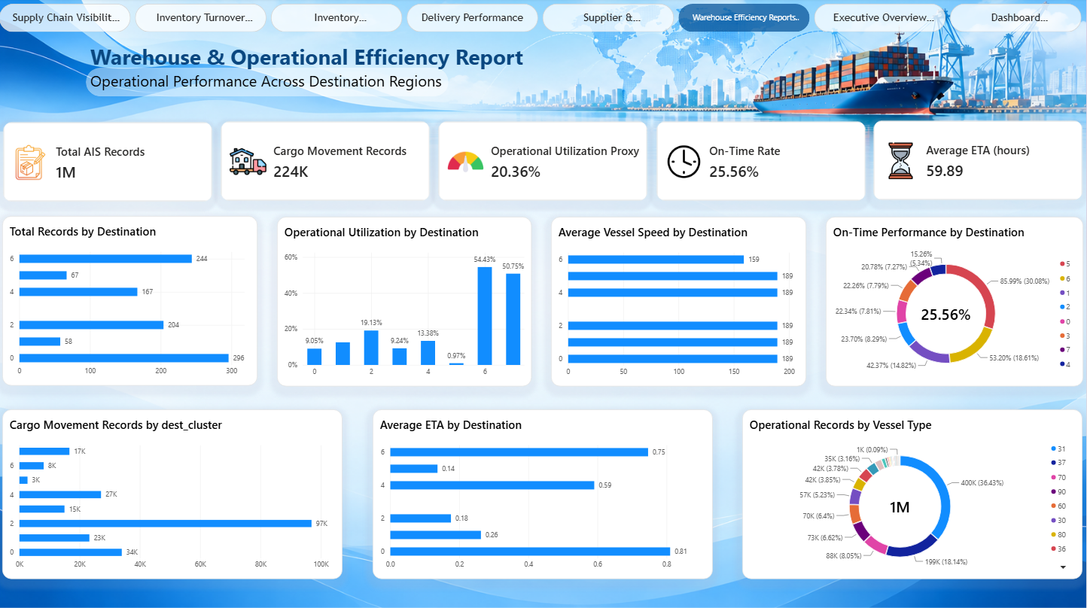
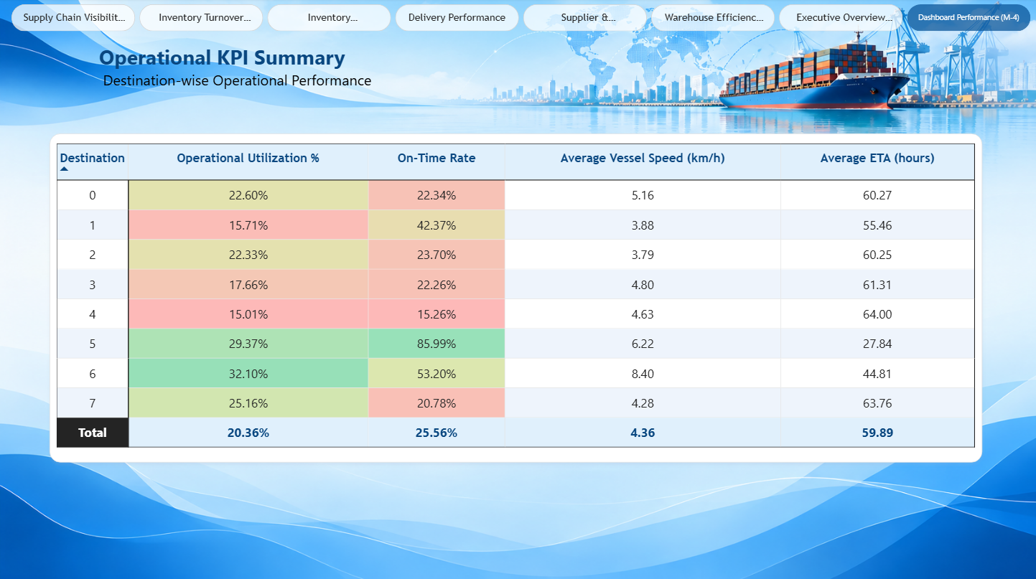
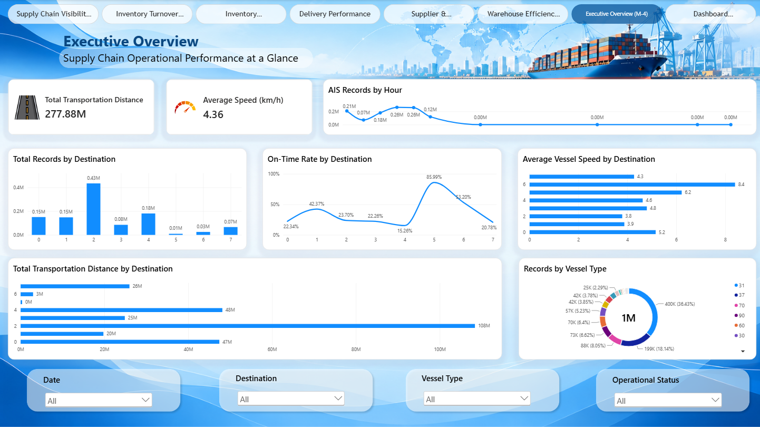
References
[1] Bureau of Ocean Energy Management (BOEM), & National Oceanic and Atmospheric Administration (NOAA). (n.d.). Vessel traffic data (Automatic Identification System, AIS). MarineCadastre.gov. https://marinecadastre.gov/ais
[2] Bureau of Ocean Energy Management (BOEM), & National Oceanic and Atmospheric Administration (NOAA). (n.d.). AIS data dictionary. MarineCadastre.gov. https://coast.noaa.gov/data/marinecadastre/ais/data-dictionary.pdf
[3] Chopra, S., & Meindl, P. (2019). Supply chain management: Strategy, planning, and operation (7th ed.). Pearson.
[4] Kaggle. (n.d.). AIS Data Complete Weather [Data set]. Kaggle. https://www.kaggle.com
[5] Kimball, R., & Ross, M. (2013). The data warehouse toolkit: The definitive guide to dimensional modeling (3rd ed.). Wiley.
[6] Microsoft. (n.d.). DAX overview. Microsoft Learn. https://learn.microsoft.com/en-us/dax/dax-overview
[7] Microsoft. (n.d.). Power BI documentation. Microsoft Learn. https://learn.microsoft.com/en-us/power-bi/
[8] Microsoft. (n.d.). Understand star schema and the importance for Power BI. Microsoft Learn. https://learn.microsoft.com/en-us/power-bi/guidance/star-schema
[9] Microsoft. (n.d.). What is Power Query? Microsoft Learn. https://learn.microsoft.com/en-us/power-query/power-query-what-is-power-query
[10] Russo, M., & Ferrari, A. (2019). The definitive guide to DAX (2nd ed.). Microsoft Press.

