FISimulation Walk-Through – ModelSim and System Verilog

File storage – Important!
You should store all files and working folders on your network drive (H: drive on Windows PCs). Do not use the C: drive (the default location), because this is unique to each PC and you may lose your work if you switch to a different PC. ModelSim creates a lot of working files, so it is also recommended that you do not use a memory stick, because that will be slow. Also, be aware that the working files may be incompatible between different versions of ModelSim. If you get warnings about incompatible versions, it is safest to delete the work folder and start again.
Don’t use folders with spaces in their names – or in any of their parent folders. This may cause problems with certain commands.

Create a new folder for your project following the advice at the beginning of this document (or skip this if you already done this on the Quartus walkthrough. Download the files FIR.sv, tb_FIR.sv and InputSignal.txt and save them in your project folder.

Start the ModelSim simulator from the Windows Start menu (All Programs -> ModelSim SE-64 10.5c -> Modelsim). You will see a window like that in Fig. 1. (You will see a “splash” screen first and you may get a “Welcome” menu, which you can close). Click on File -> New -> Project. Enter the name of the project and set the Project Location (Fig. 2) which will be the folder you created at the begging. Notice that ModelSim uses forward slashes (/) in folder paths.
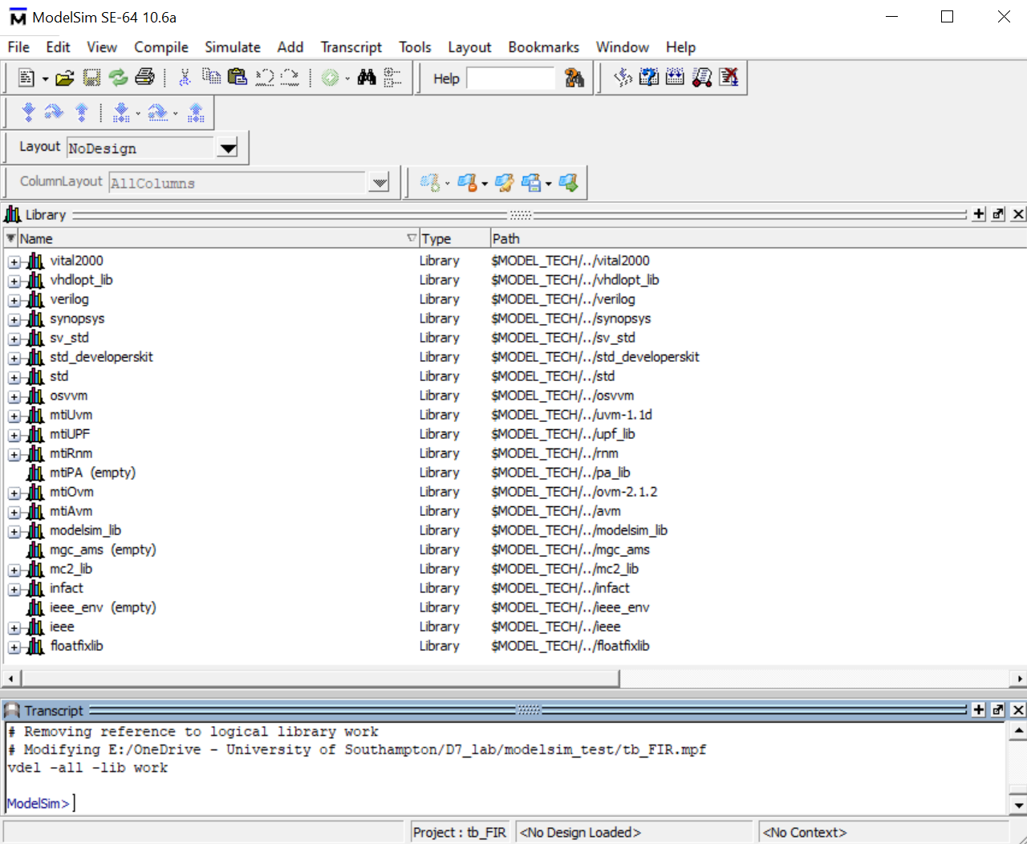
Figure 1. ModelSim welcome screen

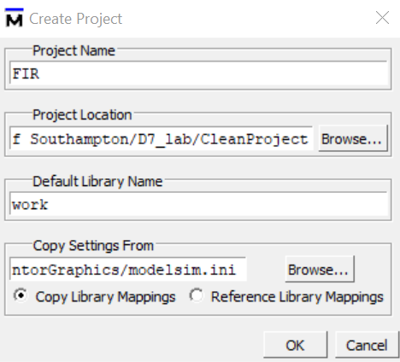
Figure 2. ModelSim new project window

Click ‘OK’. A window then opens to add items to the project, Fig. 3.

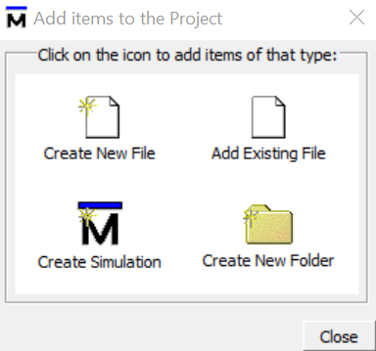
Figure 3. New project options for item addition

Click on Add Existing File and then select FIR.sv and tb_FIR.sv using the browse button in the next window. Click on OK and Close.

Compile FIR.sv and tb_FIR.sv by selecting Compile -> Compile All. Any syntax errors will be listed in the Transcript window.

Select the Library tab, click on the work library to open it and right-click on tb_FIR, Fig. 4. Select Simulate without Optimization. Several simulation windows will now open, Fig. 5. If the Wave window is not open, click View -> Wave. Click and drag the two signals in the Objects window to the Wave window.

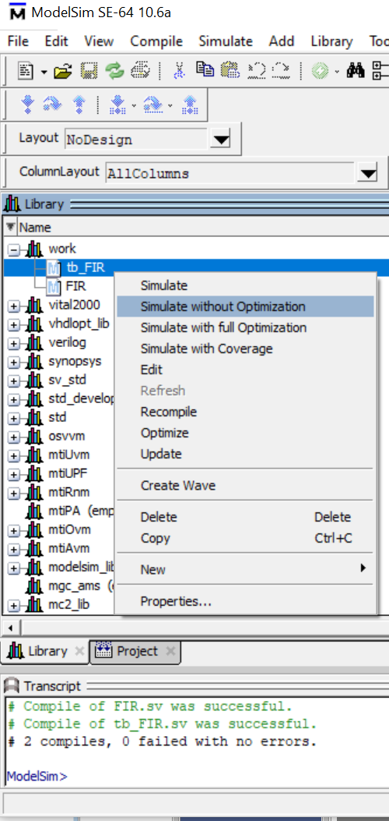
Figure 4. Starting the simulation

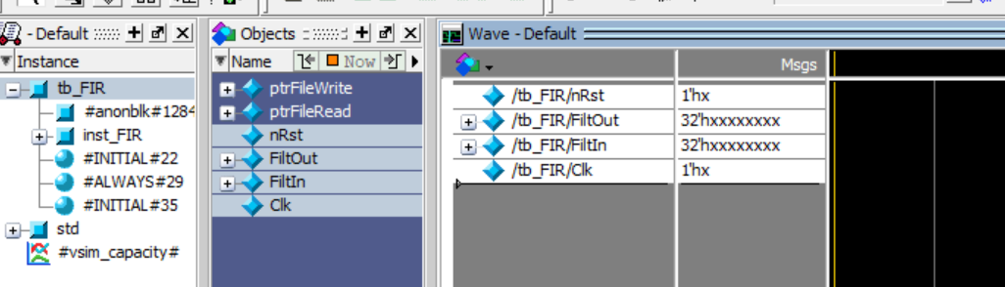
Figure 5. Adding signals to monitor on the simulation

Start the simulation from Simulate -> Run -> Run -All. When the simulation is finished it open the tb_FIR.sv and show a breakpoint on the “$stop;” command. Click on the Wave tab to see the waveforms from the simulation. Expand the waveform using Wave -> Zoom -> Zoom Full (or the solid magnifying glass icon). You should see a waveform like that in Fig. 6. Individual bits can be displayed by clicking on the + symbol on the left-hand side. The radix of the values can be changed by doing a right click on the signal and selecting the Radix option.

Figure 6. Waveform generated by the simulation

If you cannot see values on the “FiltIn” signal, make sure to have the InputSignal.txt file in the same folder of your project and it have the correct values. After the simulation is finished, a new file named OutputSignal.txt should be generated with the output of the filter. Make sure to change the InputSignal.txt file with the values of your signal, having one value per row.

21/01/22 - Version 1.0 - Rafael Gutierrez -
Version based on the “Simulation Walk-Through – ModelSim and SystemVerilog” from Mark Zwolinski.

