Synthesis Walk-Through – Quartus and System Verilog

File storage – Important!
You should store all files and working folders on your network drive (H: drive on Windows PCs). Do not use the C: drive (the default location), because this is unique to each PC and you may lose your work if you switch to a different PC. Quartus creates a lot of working files, so it is also recommended that you do not use a memory stick, because that will be slow. Also, be aware that the working files may be incompatible between different versions of Quartus. If you get warnings about incompatible versions, it is safest to delete the working files and folders and start again.
Don’t use folders with spaces in their names – or in any of their parent folders. This may cause problems with certain commands.

This tutorial is written for the DE1-SoC development board, which uses a Cyclone V
FPGA.

Create a new folder for your project following the advice at the beginning of this document. Download the files FIR.sv, tb_FIR.sv and InputSignal.txt and save them in your project folder.

Start Quartus from the Windows Start menu (All Programs -> Altera 16.1 -> Quartus II -> Quartus Prime 16.1). You will see a window like that in Fig. 1.

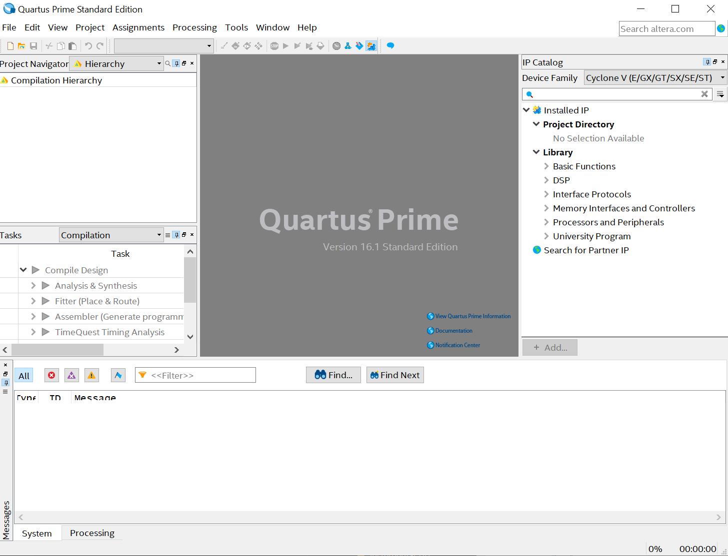
Figure 1. Quartus welcome window

Click on File -> New Project Wizard. Click next and then enter working directory, the name of the project and the name of the top-level module (FIR in this case) as in Fig. 2.

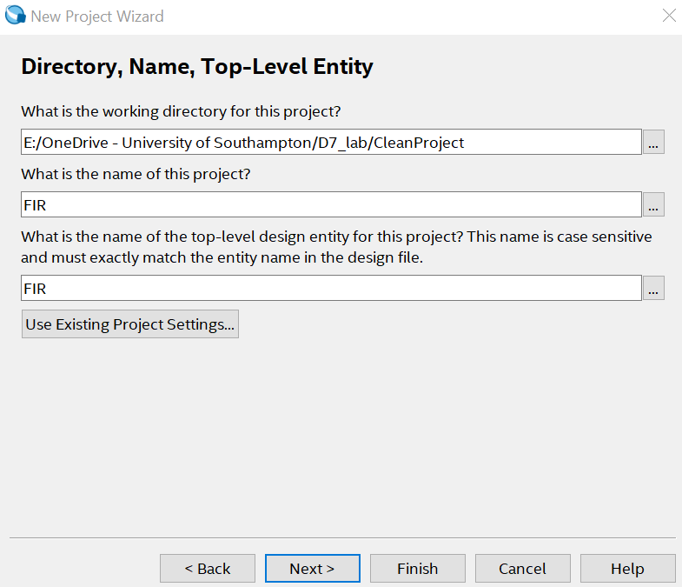
Figure 2. New Project wizard window

Click ‘Next >’, leave the project as an Empty project and click ‘Next >’ again. A window then opens to add items to the project as in Fig. 3.
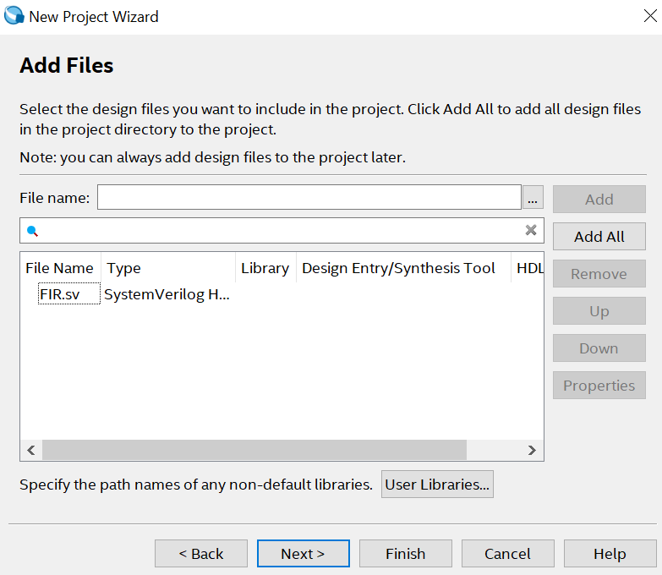
Figure 3. Adding files to the current project

Click on the browse button (...) next to the ‘Add’ button and then select FIR.sv using the browse button in the next window. Do not add the test bench. Click on ‘Open’ and then ‘Next >’ again.

In the Family, Device & Board Settings window, on the Device tab select a Cyclone V, 5CSEMA5F31C6 (Fig. 4). It is very important that you choose the correct device. Click ‘Next >’ and ‘Next >’ again. Check the details on the Summary page and click ‘Finish’.
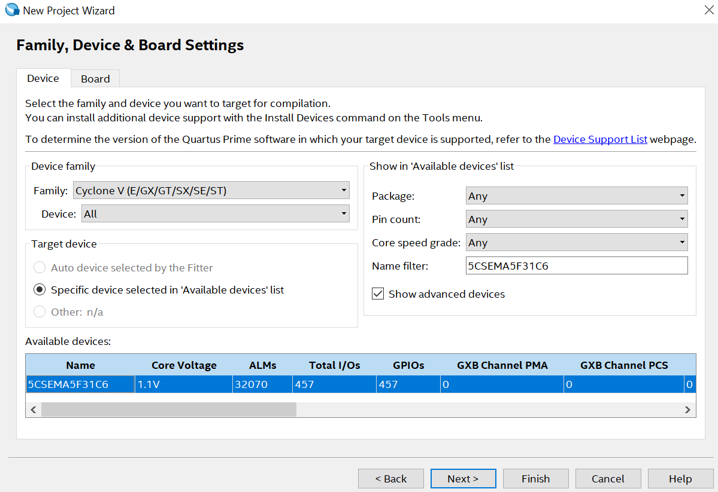
Figure 4. Selecting the FPGA chip for the project

Compile FIR.sv by selecting Processing -> Start -> Start analysis and Synthesis. Any syntax errors will be listed in the Messages window. This does not do a complete placement and routing but checks the syntax and that the design can be synthesised. Fix any errors on the code until the analysis is successful and you receive the following message: “Info: Quartus Prime Analysis & Synthesis was successful.”

One way to check if your design is correct is to use the “RTL viewer”. It can be accessed on Tools- >Netlists Viewers->RTL Viewer. You should see a window like in Fig. 5. In this figure we can see the schematic created from the compilation of FIR.sv and how it resembles the direct form of FIR filter, which is the aim of this lab.
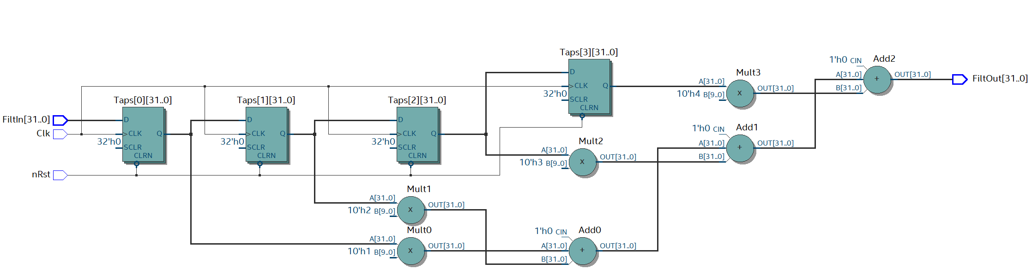
Figure 5. RTL viewer of the FIR design

After checking the code has no problems now is time to perform a complete placement and routing for the FPGA used. In Quartus, select Processing -> Start Compilation. This will do a full compilation, together with the placement and routing and may take a few minutes to complete. When the compilation view, the Task pane will have green ticks (Fig. 5).

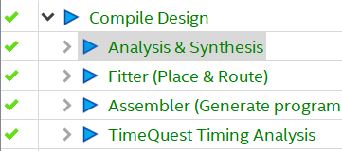
Figure 6. Full compilation finished

Then go to Processing -> Compilation Report to see a summary of the compilation results that will state the resources used in the FPGA such as number of logic elements used, memory, DSP blocks, etc.

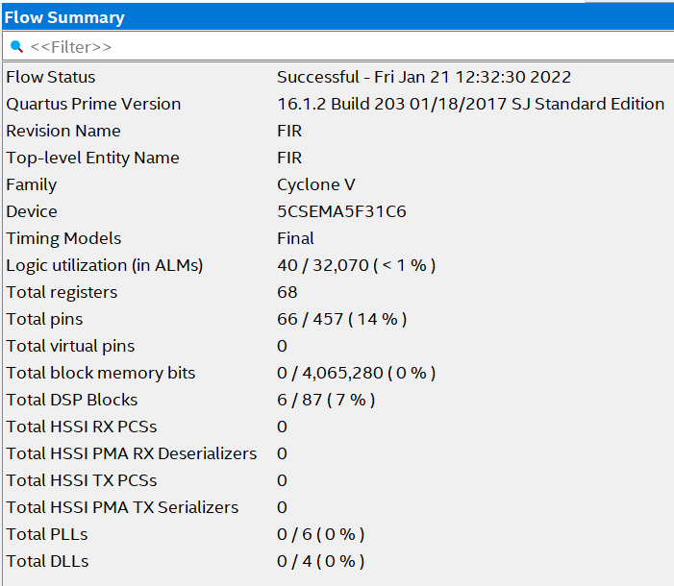
Figure 7. Compilation Report

21/01/22 - Version 1.0 - Rafael Gutierrez -
Version based on the “Synthesis Walk-Through – Quartus and SystemVerilog” from Mark Zwolinski.

