Place the webcam in the position where you will sit and play games or watch content - most likely **on the top of your sofa**. The webcam should point towards your **TV and the projection area.**

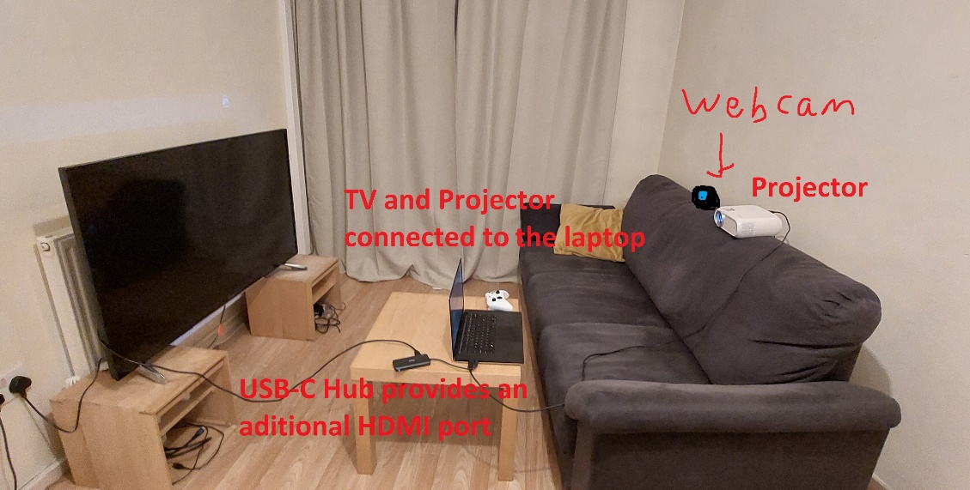

Press **Enter** when ready to continue.

Press 'y' if the correct output from the camera is shown. If not, press 'n', and select the next camera in the list, eg: 2 if you are currently on 1. \n\n Finally, allow the calibration system to run, and follow further instructions shown on screen.