

**BEACONHOUSE NATIONAL UNIVERSITY**

**Crafty Canvas**

**PRJ-F23/331**

**PROJECT PROPOSAL REPORT**

**EXTERNAL SUPERVISOR**

**INTERNAL SUPERVISORS**

**Shazia Rizwan**

**GROUP MEMBERS**

**Faarha Raza F2020-604**

**Fiza Javaid F2020-614**

**Hamza Azam F2020-705**

**SCHOOL OF COMPUTER &IT**

**September 2023**

# **Problem Statement:** There is no proper platform for Pakistani artists to sell their art online or create customized artwork for clients.

**Existing System:** Pakistani artists mostly turn to social media platforms like Instagram and Facebook to showcase and sell their artwork. These platforms are widely used but are not specifically designed for art sales.

On these platforms, Artists mostly use third-party communication tools to interact with potential buyers and manage commissioned orders. On these platforms, handling payments and transactions may often involve multiple steps such as sharing bank details or using external payment gateways. Artists have to take privacy concerns about their artwork and the potential for copyright violation issues or unauthorized use of their art when sharing their work on social media.

**Steps Taken to Get Around These Limitations:**

Artists have to be consistent in posting their artwork on their social media profiles to keep their audience interested. To build a dedicated following artists need to often engage with their followers through comments or direct messages. They may also have to invest in advertisement efforts to reach a wider audience e.g. paid advertisements, collaborations, or shout-outs from influencers. They need third-party payment platforms or have to request payments via bank transfers, which can be less convenient for buyers and also less secure. Artists need to actively monitor their work to prevent unauthorized use of their artwork and also have to file claims or complaints, especially when copyright violations occur. Artists have to manually track their commissioned orders and have to communicate progress through separate platforms, which can cause inefficiencies and potential disputes.

**Literature Survey:**

The COVID-19 pandemic has impacted the Global art market significantly as it left artists facing unusual challenges. British artist Matthew Burrows started an initiative, Artist Support Pledge, which has shown the importance of providing artists with platforms to sell their work and generate income during difficult times [1]. This highlights a captivating need for a web app tailored to Pakistani artists. This web app could help them by serving as a means for selling their art online, connecting with a global audience, and creating customized artwork for clients, eventually addressing the unique challenges faced by artists in Pakistan.

1. Supporting Artists During Challenging Times:

The Artist Support Pledge, initiated by Matthew Burrows, served as a model for supporting artists in difficult times. It has provided artists a platform, who were suddenly out of work due to the pandemic, to exhibit and sell their artwork without commission fees [1]. This emphasizes how important it is to support artists in challenging circumstances. This idea could potentially be implemented by providing a specialized web app for Pakistani artists, enabling them to make money using their artistic skills while reaching a wider audience.

2. E-commerce for Artists and Global Platforms: Online marketplaces like Shopify, Etsy, Artmo, and Artsy have transformed how artists sell their artwork and engage with a worldwide audience. These platforms have increased artists' audiences and opened up new revenue opportunities for them [5]. The current worldwide platforms, however, have restrictions for Pakistani artists, such as difficulties with foreign payment and shipping complexity, legal and tax worries, and perhaps a lack of understanding of the legal requirements of selling internationally. A platform that identifies and addresses these particular challenges is necessary for Pakistani artists.

2.1. Etsy: This is one of the most popular online marketplaces for selling handmade products and fine art items. It connects artists with the largest online audiences and art enthusiasts, across the globe [4]. It mainly focuses on handicrafts and vintage items, with limited consideration for the distinct needs and constraints faced by Pakistani artists.

2.2. Artsy: This is a leading international marketplace, that provides a wide range of fine art from all around the world. The large average transaction distance of orders and the wide range of artists, galleries, and users show its wide range of popularity [2]. However, it might not be customized to the unique difficulties and demands of Pakistani artists.

**Constraints and the Need for a Web App:**

After conducting research thoroughly, it is clear that Pakistani artists face particular difficulties when trying to sell their artworks on the various existing and currently used international e-commerce platforms. Among these difficulties are:

1. International Payment and Shipping Complexities: Global platforms demand international shipping and payment procedures, which can be time-consuming and expensive for Pakistani artists and limit their ability to reach a wider audience.

2. Legal and Taxation Concerns: There are potential legal barriers and issues for Pakistani artists who sell internationally because it involves complicated legal and tax requirements.

3. Unmet Unique Needs: The limitations and unique needs of Pakistani artists are not properly taken into account by the platforms that currently exist. They don't offer customization options to cater to Pakistan's rich cultural and artistic diversity.

Due to these limitations, a web app specifically for Pakistani artists needs to be created. In addition to giving Pakistani artists the chance to display and sell their work online, such a platform would also help them overcome the difficulties they encounter when using the various international e-commerce platforms already in use. It would give artists the means to make money, engage with a larger audience, and promote cultural variety in the art world.

# **Additional Research:**

# we have interviewed an Artist (Ms. Nida Fatima), who is a fine art expert and sells commissioned artwork in Pakistan, like paintings, sketches, and Digital Illustrations using an online Platform (Facebook). She has a Fine Arts Degree, from Government College University Lahore.

# Her Social Media Business Account's Link is mentioned below:

# Facebook Account's Link: (https://m.facebook.com/profile.php/?id=100063567257600)

# She mostly prefers to use WhatsApp as a convenient communication method to deal with her clients. She regularly posts on Facebook her completed artwork, client reviews, work-in-progress posts, and edited videos of her artwork to attract her followers and regular clients. She regularly takes client's instructions and reviews by sending updated work-in-progress pictures from time to time to ensure the satisfaction of her clients. She uses the Jazz Cash platform for a successful and convenient payment process. Some clients prefer to buy existing listed artwork and some prefer to buy customized artwork. Some clients want physical artwork products and some ask to buy digital PDFs, depending on their needs. Some clients also want to customize edited videos of their artwork, for which she also takes extra charges for additional requested work.

# We also talked to the fine arts students of the SVAD department They encountered many challenges, mainly related to not being able to engage with the arts as they wish. They find themselves in a situation where they have to find artists who offer customized art services, a process that makes them worried about of these designers' reliability and trustworthiness highlighted previously, existing web applications operate globally, posing significant legal and financial challenges, especially those related to payment and taxation, which greatly affect the Pakistani community.

# **Proposed Solution:**

# After carefully reviewing the various challenges and issues encountered by artists in our nation, we have resolved to present a solution in the form of a web application. This application is designed to address the concerns of both clients and artists, providing a comprehensive solution to their respective needs. We proposed a platform that facilitates clients and artists so they can communicate more easily and reliably. Another issue faced by the clients was that if they wanted to customize any artwork (to get the painting of their own choice made), then after all the previous research we have done, there are no such websites for the Pakistani community where they can create art of their own choice. Both clients and artists encountered a problem: the absence of a unified platform for tracking the progress of artwork and obtaining feedback from both parties. This deficiency in communication often resulted in clients not being satisfied with the final painting and artists struggling to comprehend the client's requirements. This communication gap can create a lot of hassle on both ends. So to overcome this issue, there will be a chat option where the client can discuss the requirements, progress, and issues with artists and the artists can gradually receive feedback from the client by sending them images or videos of the work done till then. The artist also faced an issue that their paintings were not being sold at fair prices so we will add an option of bidding or price on request which will allow the artist to know the different prices offered by clients and then the client can sell that painting to the client who is giving a fair price.

# **Deliverables**:

Web application for artists and clients including

* Chat functionality for communication.
* Customization features.
* Bidding/price negotiation system.

# **Technologies**:

* Front-end: HTML, CSS, React
* Back-end: Node.js
* Database: MySql
* Real-time Chat: Socket.io
* Payment Integration: Jazz cash or Easy paisa

# **Business Model**

1. **Buying:**
   * **Product Listings:** Artists can list their artworks for sale, including details like title, description and price.
   * **Customization:** Clients can request customized artwork by providing specific instructions to artists through a chat.
2. **Selling:**
   * **Artist Profiles:** Artists create profiles showcasing their portfolio, bio, and previous work.
   * **Commission:** The platform may charge a 15% commission fee for each successful sale made through the platform.
3. **Delivery Process:**
   * **Shipping Options:** Artists can choose to offer physical delivery
4. **Payment Method:**
   * **Payment Gateways:** Integrate secure payment gateways like jazz Cash or easypaisa for transactions.
5. **Return Policy/Refund Policy:**
   * **Returns and Refunds:** If the artwork arrives damaged or is not as described (e.g., wrong size, color, or style), client can return it or change it but amount doesn’t refund again.
   * **Timelines:** one day after the delivery
6. **Cost on Platforms Development and Maintenance:**
   * **Development Costs:** Initial costs for hiring developers and other technical resources.
   * **Maintenance Costs:** Ongoing expenses for server hosting, bug fixes, updates, and customer support.
   * **Marketing and Promotion:** Budget for marketing activities to attract both artists and clients to the platform.
7. **Auction process**

* **Bidding Period:** it’s about 15 to 30 days.
* **Bidding process:** Implement an bidding system where buyers can set their maximum bid.

# **Project Methodology**

1. **Understanding the Needs:**
   * Talk to Pakistani artists to understand their challenges in selling and customizing artworks online.
   * Study how they currently use social media for this purpose.
2. **Defining Core Features:**
   * Identify essential features like artist profiles, secure payments, real-time chat, and customization options.
3. **Choosing Technology:**
   * Use HTML, CSS, JavaScript, React for the frontend, and Node.js, Express.js, MongoDB for the backend.
   * Integrate secure payment gateways like Stripe or PayPal.
4. **Designing User-Friendly Interface:**
   * Create intuitive interfaces for artist profiles, artwork listings, customization, and order management.
5. **Developing Backend Logic:**
   * Set up databases for secure storage of artist profiles, artworks, and orders.
   * Develop server-side code for user authentication and transaction processing.
6. **Building Frontend:**
   * Write clean code for the user interface, focusing on simplicity and user-friendliness.
   * Ensure mobile responsiveness for a seamless experience.
7. **Testing for Reliability:**
   * Test thoroughly to find and fix any bugs or issues in the system.
   * Make sure all features work well, including real-time chat and payment processing.
8. **Deployment:**
   * Choose a reliable hosting provider and deploy the web app.
9. **Promoting the Platform:**
   * Market the platform to Pakistani artists, highlighting its benefits such as secure transactions and customization options.
10. **Listening and Improving:**
    * Gather feedback and update the platform based on user insights.

# **Timelines**:

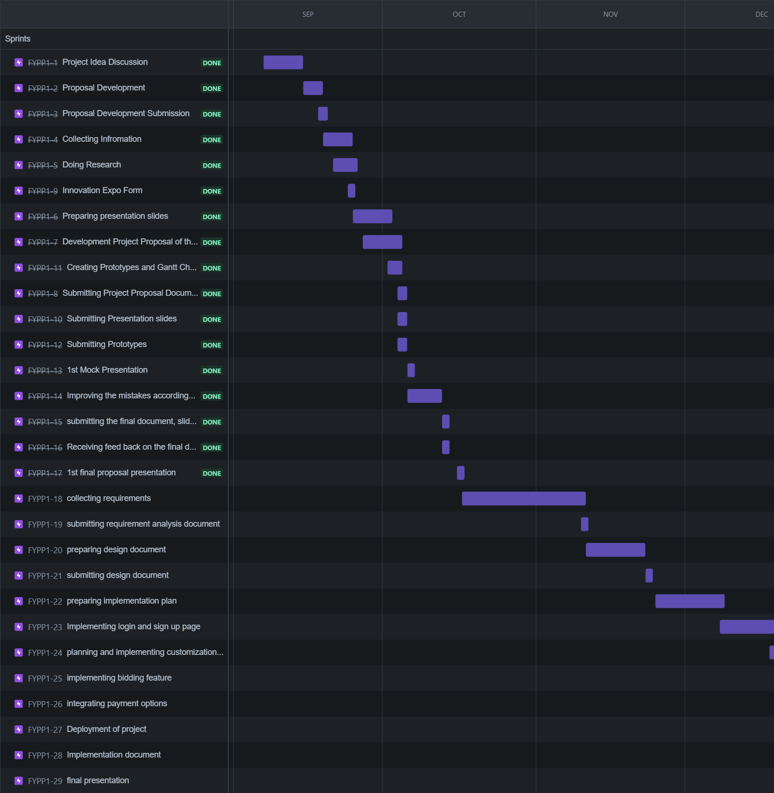

# **Expertise**

Our group has expertise in HTML, CSS, and JavaScript and currently, we are working on our skills on React. We have developed various projects using JavaScript, Java, HTML, and CSS. We are also currently gaining hands-on experience to improve our expertise for React.

# **References:**

* 1. (<https://magazine.artland.com/how-to-stay-connected-and-get-your-fix-how-virtual-initiatives-are-supporting-artists-in-times-of-social-isolation/)>).
  2. (https://bootcamp.uxdesign.cc/case-study-artsy-net-new-features-9c22717c1095)
  3. (<https://www.etsy.com/>)
  4. (<https://www.freshbooks.com/blog/websites-for-selling-art>)
  5. (<https://www.ijraset.com/research-paper/e-commerce-website-for-artisans)>).