

**BEACONHOUSE NATIONAL UNIVERSITY**

**Crafty Canvas**

**PRJ-F23/xxx 331**

**PROJECT PROPOSAL REPORT**

**EXTERNAL SUPERVISOR**

**If Any**

**INTERNAL SUPERVISORS  
  
Huda Sarfaraz**

**Amna Humayun**

**Nauman Ali Shah**

**Natash Ali Mian**

**Shazia Rizwan**

**GROUP MEMBERS**

**Faarha Raza F2020-604**

**Fiza Javaid F2020-614**

**Hamza Azam F2020-705**

**SCHOOL OF COMPUTER &IT**

**September 2023**

**Table of Contents**

# **Problem Statement:** No proper web app for Pakistani artists to sell their art online or create customized artwork for clients.

**Existing System:** Pakistani artists mostly turn to social media platforms like Instagram and Facebook to showcase and sell their artwork. These platforms are widely used but are not specifically designed for art sales.

On these platforms, artists have to create social media profiles where they mix their art with other personal and unrelated content. Artists mostly use third-party communication tools to interact with potential buyers and manage commissioned orders. On these platforms, handling payments and transactions may often involve multiple steps such as sharing bank details or using external payment gateways. Artists have to take privacy concerns about their artwork and the potential for copyright violation issues or unauthorized use of their art when sharing their work on social media.

**Steps Taken to Get Around These Limitations:**

Artists have to be consistent in posting their artwork on their social media profiles to keep their audience interested. To build a dedicated following artists need to often engage with their followers through comments or direct messages. They may also have to invest in advertisement efforts to reach a wider audience e.g. paid advertisements, collaborations, or shout-outs from influencers. They need third-party payment platforms or have to request payments via bank transfers, which can be less convenient for buyers and also less secure. Artists need to actively monitor their work to prevent unauthorized use of their artwork and also have to file claims or complaints, especially when copyright violations occur. Artists have to manually track their commissioned orders and have to communicate progress through separate platforms, which can cause inefficiencies and potential disputes.

**Literature Survey:**

Research, highlighting the need and potential for developing a web app for Pakistani artists to sell their art online and create customized artwork for clients:

1. Initiative of Supporting Artists During Challenging Times: British artist Matthew Burrows started the Artist Support Pledge initiative hoping to bring some relief to the many artists that suddenly found themselves without work due to the global pandemic by providing a platform where these technicians can showcase and sell their artworks without any commission fees. This shows the importance of supporting artists, especially during difficult circumstances like the COVID-19 crisis. [1] The web app proposed, can serve as a platform for Pakistani artists to earn income using their artistic skill and also enable them to reach a wider audience and increase their sales.

2. E-commerce for Artists: E-commerce is providing artists with platforms (e.g. Shopify, Etsy, Artmo and Artsy etc.) to showcase and sell their artwork to a global audience, creating new revenue streams and expanding their reach. [5] However, most of these platforms are not designed to fulfill specific needs and challenges faced by Pakistani artists therefore a proposed web app for Pakistani artists can enable them to reach a wider audience and increase their sales.

Most famously used apps for selling and buying artwork online, across the globe includes:

**Etsy:**

Its online marketplace gives exposure to a huge global audience of craft and art lovers—one of the largest audiences on the internet. It is one of the most popular websites to sell art and also has one of the largest groups of independent artists (established and emerging artists alike!) trying to make a living off their work, and helps get your art in front of the right people online. [4]

This American company mainly focuses on handmade or vintage items and craft supplies. These items fall under a wide range of categories, including jewelry, bags, clothing, home décor and furniture, toys, art, as well as craft supplies and tools. [2]

**Artsy:** Artsy is the leading marketplace to discover, buy, and sell fine art around the world. Artsy hosts almost 800,000 images of art, provides information for and represents 2,000 galleries, and features over 80,000 artists. Artsy’s network includes artists, galleries, and users from all over the world.

2.5 million users visit Artsy.net every month and remarkably 3,000 miles is the average transaction distance carried out for orders through Artsy.net — that is the highest average of any website on the internet. [2]

**Constraints:**

After all the research we observed that there is a clear need for the development of a web app tailored to Pakistani artists, enabling them to sell their art online and provide customized artwork to clients. Current global platforms, such as Etsy and Artsy, have limitations for Pakistani artists. These include challenges related to international payment and shipping complexities, legal and taxation concerns, and potential unfamiliarity with the legal requirements of selling internationally.

Hence, there is no proper web app specifically designed to meet the unique needs of Pakistani artists for selling their art online and creating customized artwork for clients. Developing such a platform would not only provide an opportunity for Pakistani artists but also address the challenges they face when using existing global e-commerce platforms.

**Additional Research**:

we have interview an Artist (Ms. Nida Fatima), who is a fine art expert and sells commissioned artwork in Pakistan, like paintings, sketches, and Digital Illustrations using an online Platform (Facebook). She has a Fine Arts Degree, from Government College University Lahore.

Her Social Media Business Account’s Link is mentioned below:

Facebook Account’s Link: (https://m.facebook.com/profile.php/?id=100063567257600)

She mostly prefers to use WhatsApp as a convenient communication method to deal with her clients. She regularly posts on Facebook her completed artwork, client reviews, work-in-progress posts, and edited videos of her artwork to attract her followers and regular clients. She regularly takes client's instructions and reviews by sending updated work-in-progress pictures from time to time to ensure the satisfaction of her clients. She uses the Jazz Cash platform for a successful and convenient payment process. Some clients prefer to buy existing listed artwork and some prefer to buy customized artwork. Some clients want physical artwork products and some ask to buy digital PDFs, depending on their needs. Some clients also want to customize edited videos of their artwork, for which she also takes extra charges for additionally requested work.

Secondly, we talked to few students from SVAD department. They were students of fine arts. We asked them about the issues and problems they face while selling or buy an artwork. They told that the problems faced by them were that they are unable to create the art of their own choice, they have to find and search multiple artists who do customization of artworks and they are not sure whether they are trusted or not. As mentioned earlier the existing web apps are dealing globally so there are lot of legal payment and taxation issues faced by Pakistani community.

# **Proposed Solution:**

# By looking through all the issues and problems faced by the artists of our country, we decided to propose a solution in a form of web app which will solve the problems of the clients as well as the artists. We proposed a platform through which clients and artists can communicate more easily and reliably. Another issue faced by the clients were that if they wanted to customize any artwork (to get the painting of their own choice made), then we have observed there are no such websites for Pakistani community where they can create an art of their own choice. the clients and artists also face this issue that they do not have one platform to discuss their progress of the artwork or get reviews from the clients and artists. So, due to this lack of communication among the artists and the clients, there are high chances of client do not like the painting or artists not able to understand the requirements of the client. This communication gap can create a lot of hassle on both ends. So to overcome this issue, there will be a chat option where the client can discuss the requirements and issues with artists and the artists can gradually receive feedback from the client by sending them the images or videos of the work done till then. The artist also faced an issue that their paintings were not being sold at fair prices so we will add an option of bidding or price on request which will allow the artist to know the different prices offered by clients and then the client can sell that painting to the client who is giving a fair price.

# **Deliverables**:

* Web application for artists and clients.
* Chat functionality for communication.
* Customization features.
* Bidding/price negotiation system.

# **Technologies**:

* Front-end: HTML, CSS, JavaScript, React
* Back-end: Node.js
* Database: MongoDB
* Real-time Chat: Socket.io
* Payment Integration: jazz cash or easypaisa

# **Business Model**

1. **Buying:**
   * **Product Listings:** Artists can list their artworks for sale, including details like title, description and price.
   * **Customization:** Clients can request customized artwork by providing specific instructions to artists through a chat.
2. **Selling:**
   * **Artist Profiles:** Artists create profiles showcasing their portfolio, bio, and previous work.
   * **Commission:** The platform may charge a 15% commission fee for each successful sale made through the platform.
3. **Delivery Process:**
   * **Shipping Options:** Artists can choose to offer physical delivery
4. **Payment Method:**
   * **Payment Gateways:** Integrate secure payment gateways like jazz Cash or easypaisa for transactions.
5. **Return Policy/Refund Policy:**
   * **Returns and Refunds:** If the artwork arrives damaged or is not as described (e.g., wrong size, color, or style), client can return it or change it but amount doesn’t refund again.
   * **Timelines:** one day after the delivery
6. **Cost on Platforms Development and Maintenance:**
   * **Development Costs:** Initial costs for hiring developers and other technical resources.
   * **Maintenance Costs:** Ongoing expenses for server hosting, bug fixes, updates, and customer support.
   * **Marketing and Promotion:** Budget for marketing activities to attract both artists and clients to the platform.
7. **Auction process**

* **Bidding Period:** it’s about 15 to 30 days.
* **Bidding process:** Implement an bidding system where buyers can set their maximum bid.

# **Project Methodology**

1. **Understanding the Needs:**
   * Talk to Pakistani artists to understand their challenges in selling and customizing artworks online.
   * Study how they currently use social media for this purpose.
2. **Defining Core Features:**
   * Identify essential features like artist profiles, secure payments, real-time chat, and customization options.
3. **Choosing Technology:**
   * Use HTML, CSS, JavaScript, React for the frontend, and Node.js, Express.js, MongoDB for the backend.
   * Integrate secure payment gateways like Stripe or PayPal.
4. **Designing User-Friendly Interface:**
   * Create intuitive interfaces for artist profiles, artwork listings, customization, and order management.
5. **Developing Backend Logic:**
   * Set up databases for secure storage of artist profiles, artworks, and orders.
   * Develop server-side code for user authentication and transaction processing.
6. **Building Frontend:**
   * Write clean code for the user interface, focusing on simplicity and user-friendliness.
   * Ensure mobile responsiveness for a seamless experience.
7. **Testing for Reliability:**
   * Test thoroughly to find and fix any bugs or issues in the system.
   * Make sure all features work well, including real-time chat and payment processing.
8. **Deployment:**
   * Choose a reliable hosting provider and deploy the web app.
9. **Promoting the Platform:**
   * Market the platform to Pakistani artists, highlighting its benefits such as secure transactions and customization options.
10. **Listening and Improving:**
    * Gather feedback and update the platform based on user insights.

# **Timelines**:

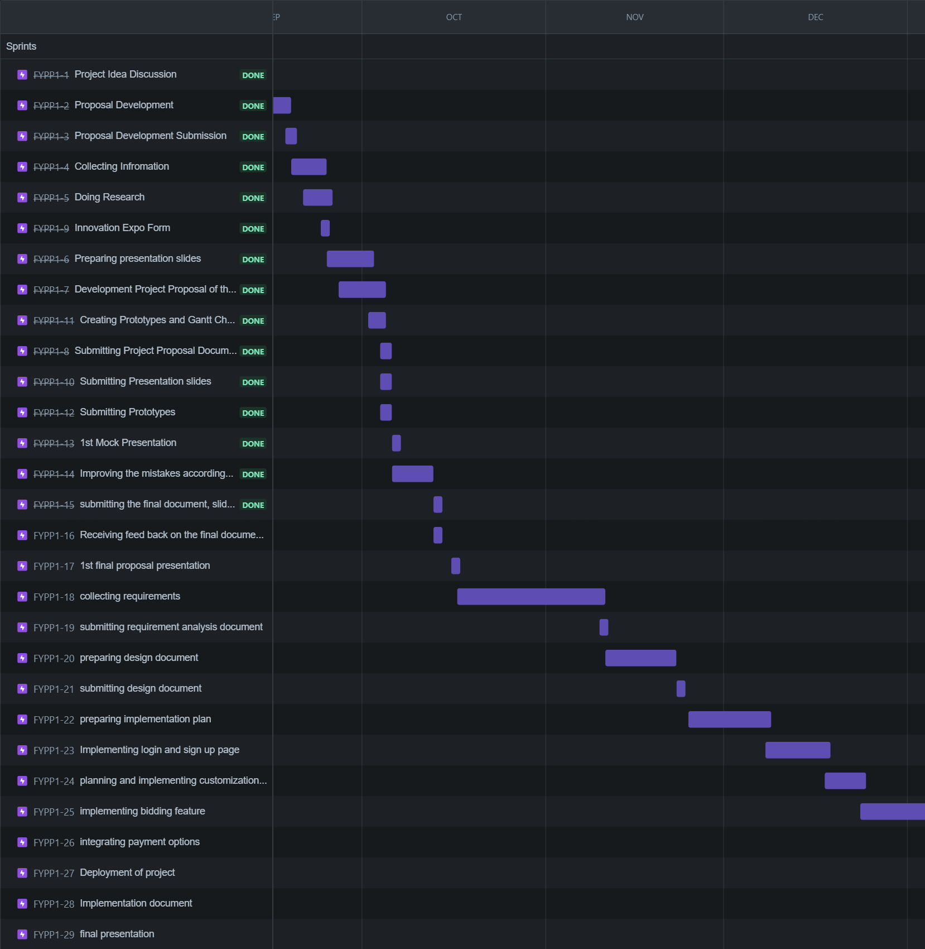

# **Expertise**

Our group has expertise in HTML, CSS, JavaScript and currently we are working on our skills on react.

# **References:**

[Reference 1](<https://magazine.artland.com/how-to-stay-connected-and-get-your-fix-how-virtual-initiatives-are-supporting-artists-in-times-of-social-isolation/)>).

[Reference 2] (https://bootcamp.uxdesign.cc/case-study-artsy-net-new-features-9c22717c1095)

[Reference 3](<https://www.etsy.com/>)

[Reference 4] (<https://www.freshbooks.com/blog/websites-for-selling-art>)

[Reference 5](<https://www.ijraset.com/research-paper/e-commerce-website-for-artisans)>).