Requirement Analysis Document

Crafty Canvas

FYP Part 1

**Group Members:**

**Faarha Raza F2020-604**

**Fizza Javaid F2020-614**

**Hamza Azam F2020-705**

**Introduction to Requirement Analysis**

The Analysis Document acts as the project's fundamental template for the following stages. This document is very important in the context of this project, which is to create a digital platform specifically for Pakistani artists. Its main goals are to outline the functionality and features that the proposed platform will have as well as to clearly comprehend the difficulties that Pakistani artists confront.

It begins by telling us the problem we're trying to solve, which is giving Pakistani artists a better way to sell their art and connect with clients. This is important because right now, many artists use social media, like Instagram and Facebook, which isn't ideal for selling art. This document will act as a guide for the construction of the Software Requirements Specification (SRS) document, which will contain a detailed description of the platform's functionality and specific requirements. This document will identify the main problems faced by Pakistani artists.

This Analysis Document serves as a clear path for the platform's development, thus laying the groundwork for the project's later stages. We are prepared to provide a customised and efficient solution that empowers Pakistani artists and strengthens their position in the international art world since we have a deep awareness of the complex issues at hand.

We'll also find out how artists are currently managing their work and the challenges they face. For instance, they have to use third-party tools to communicate with buyers, handle payments, and protect their art. It's like they're painting on a canvas with a few missing colours.

The document will show us what others have done in similar situations. It's like looking at other artists' work for inspiration. We'll learn about platforms like Etsy and Artsy, which help artists sell their work worldwide, but they may not be perfect for our Pakistani artists.

Then, we'll explore the special challenges our artists face, like international payments, taxes, and the need for customization to reflect Pakistan's culture. This is like understanding the unique brushes and colours our artists need.

This Analysis Document is crucial because it's the foundation of our project. It tells us why we're doing this, what we've learned from others, and the specific challenges we want to overcome.

**Details of Existing System**

Pakistani artists often find themselves drawn to social media platforms like Instagram and Facbook because they offer a wide range of tools and platforms for displaying and selling their artwork. These platforms are essential for artists to gain recognition and success. It's important to remember that while these platforms are popular and popular, they don't always match the purpose of art salons. This means there are lots of challenges and restrictions for artists who want to use them for their art.

Another problem that Pakistani artists face on social media is payment and transaction handling. Artists have to go through a lot of complicated steps to get paid, like sharing their bank info or sending buyers to different payment platforms. These middlemen not only mess up the sales process, but also put artists and buyers in a vulnerable spot since they have to trust someone else with their money. Plus, since there are no integrated payment solutions, it can be really annoying and sometimes even stop buyers from making their purchases.

Basically, Instagram and Facebook are great places for artists to show their stuff and reach out to more people, but they don't really cater to the needs of artists who need to sell art quickly. They often use third-party platforms for communication and have trouble handling payments safely, all while dealing with the constant struggle to protect their creative work in a world where copyright infringement is rampant. As the world changes, it's important for artists to look for new platforms and ways to solve these issues, which will make it easier for them to make art and pursue their business goals.

**Literature Survey**

The COVID-19 pandemic has impacted the Global art market significantly as it left artists facing unusual challenges. British artist Matthew Burrows started an initiative, Artist Support Pledge, which has shown the importance of providing artists with platforms to sell their work and generate income during difficult times [1]. This highlights a captivating need for a web app tailored to Pakistani artists. This web app could help them by serving as a means for selling their art online, connecting with a global audience, and creating customized artwork for clients, eventually addressing the unique challenges faced by artists in Pakistan.

**1. Supporting Artists During Challenging Times:**

The Artist Support Pledge, initiated by Matthew Burrows, served as a model for supporting artists in difficult times. It has provided artists a platform, who were suddenly out of work due to the pandemic, to exhibit and sell their artwork without commission fees [1]. This emphasizes how important it is to support artists in challenging circumstances. This idea could potentially be implemented by providing a specialized web app for Pakistani artists, enabling them to make money using their artistic skills while reaching a wider audience.

**2. E-commerce for Artists and Global Platforms:** Online marketplaces like Shopify, Etsy, Artmo, and Artsy have transformed how artists sell their artwork and engage with a worldwide audience. These platforms have increased artists' audiences and opened up new revenue opportunities for them [5]. The current worldwide platforms, however, have restrictions for Pakistani artists, such as difficulties with foreign payment and shipping complexity, legal and tax worries, and perhaps a lack of understanding of the legal requirements of selling internationally. A platform that identifies and addresses these particular challenges is necessary for Pakistani artists.

**2.1. Etsy:** This is one of the most popular online marketplaces for selling handmade products and fine art items. It connects artists with the largest online audiences and art enthusiasts, across the globe [4]. It mainly focuses on handicrafts and vintage items, with limited consideration for the distinct needs and constraints faced by Pakistani artists.

**2.2. Artsy:** This is a leading international marketplace, that provides a wide range of fine art from all around the world. The large average transaction distance of orders and the wide range of artists, galleries, and users show its wide range of popularity [2]. However, it might not be customized to the unique difficulties and demands of Pakistani artists.

**3. “The Rising E-Commerce Industry of Pakistan: An Appraisal”**

With its rising entrepreneurial culture and stabilizing digital footprint, Pakistan’s future in e-commerce reflects promising prospects with exponential growth. According to data released by Statista, a German company specialising in market and consumer data, Pakistan’s e-commerce market is projected to generate US$7.666 billion revenue in 2022. With an annual growth rate of 6.09 percent between 2022 and 2025, the projected market volume would be US$ 9.1 billion by 2025. The promotion and regulation of e-commerce will be more significant in terms of providing employment opportunities for 130 million over the next 30 years. [6]

Pakistan’s start up ecosystem has been in financial turmoil as major players like Careem, Swvl, Truck-It-In, and VavaCars have laid off employees, rolled back services and even suspended operations altogether. [7]

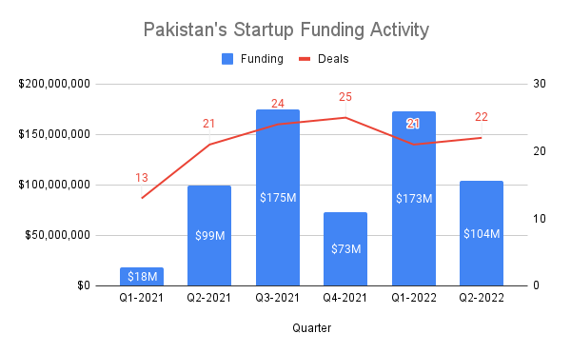

The top five rounds in April-June were conducted by ecommerce start up Dastgyr ($37m), fintech Abhi Finance ($17m), healthtech Medznmore ($11.5m), fintech Sadapay ($10.7m) and transportation startup Bykea ($10m). The sector with the highest flows in the April-June quarter was ecommerce. As many as five ecommerce deals with a total funding of $42.6m took place in the last three months. Other top sectors included fintech ($27.8m in three deals), healthtech ($13.3m in two deals) and transportation and logistics ($14.5m in six deals). [7]

In Pakistan there should be an enabling environment to provide e-commerce growth to the higher level. A huge opportunity of e-commerce is for youth and especially female entrepreneurs who want to do their online business from home. E-commerce can contribute majorly to improving livelihoods of the people and in building competitive enterprises as well as increasing the shares in global trade. Like other developing countries, Pakistan may lag in the e-commerce world if it does not technologically catch up. [6]

Additionally, we talked to the students of SVAD and asked them what platforms are they currently using for purchasing and selling their arts. Majority answered that they are using social media platforms. Then we asked them is there any problems that they face while using social media platforms, they said it is quite difficult for them to list among the top sellers because they do not get that much recognition and reach through social media. Their opinion was that there should be a medium through which small and local Pakistani artists can also gain recognition among the other artists. We also told them to fill the survey, the responses will be discussed later in the document.

**Requirement gathering and fact findings**

We did the requirement gathering by performing an online survey in which we asked questions from people with multiple age groups and got their opinions on our project.

Following are questions and the graph that display the percentage of each answer:

1. What is your age?

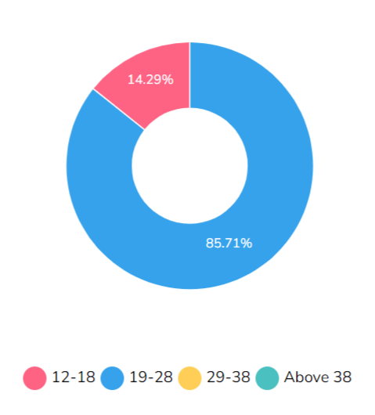

1. What is your gender?

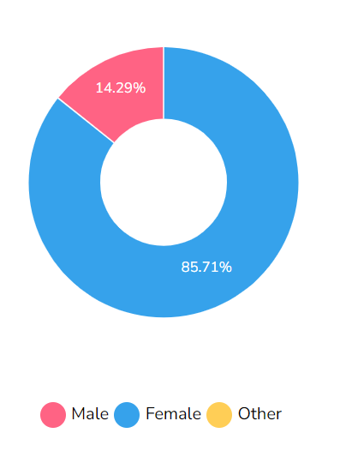

1. Have you ever visited any Art Gallery or Art Museum?

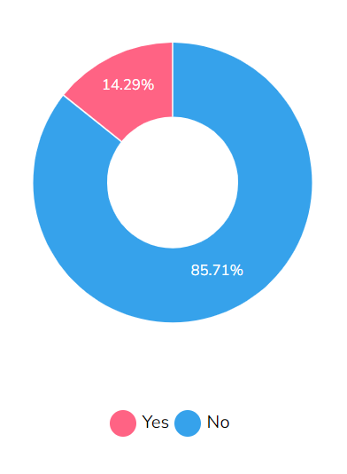

1. Do you prefer buying artworks online, by visiting galleries or by visiting shops?

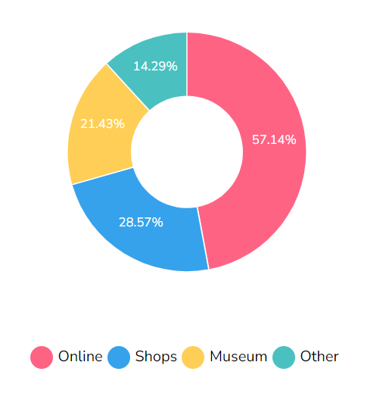

1. Do you think there is a communication gap between the artists and clients, when buying the artwork online?

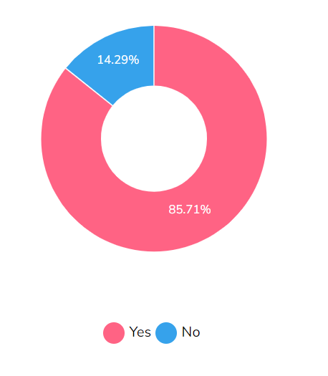

1. Have you ever experienced spam or fraud sellers while buying art work online through any websites or social media platforms?

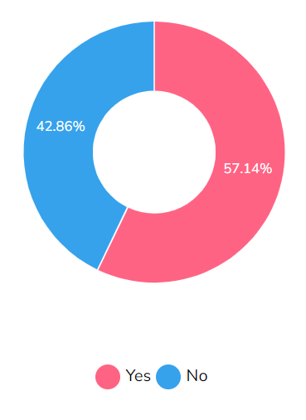

1. Do you have to pay taxes while buying art online?

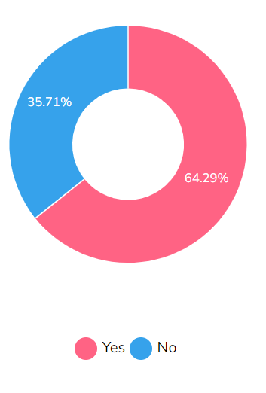

1. Do you think many small artists achieve less appreciation or recognition when they sell through social media platforms?

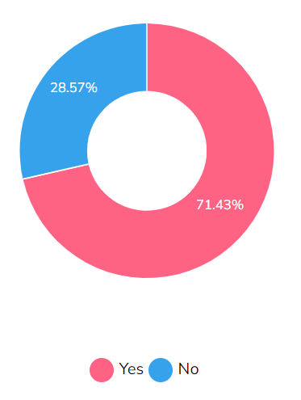

1. In your opinion, what would be the best platform for selling and buying artworks?

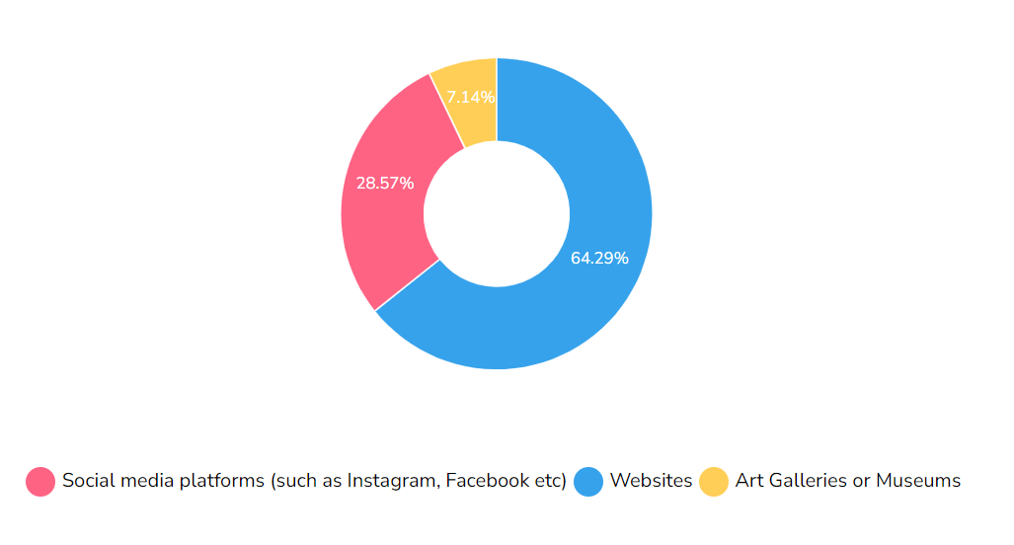

1. Have you ever experienced any customization option in the existing Art websites?

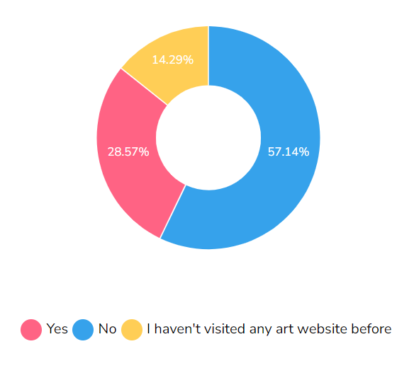

1. On a scale of 1-5 (1 being the most beneficial), tell will a website for selling and buying artworks, which will build the communication gap between the artists and the customers, be beneficial?

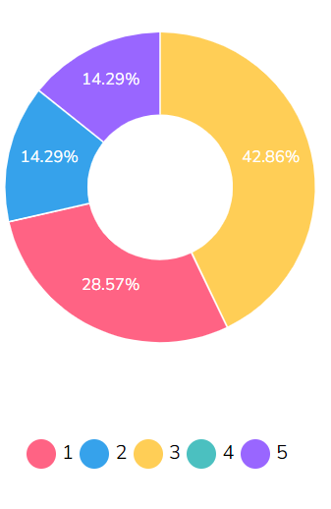

**Use Case Analysis**

* **FR1: User Registration**
* **Description**: The system shall have user registration and authentication functionality, enabling users to create accounts using their email or social media profiles, with password reset options.
* **Actor**: Artists and Clients (User)
* **Precondition**: The user is not registered in the system.
* **Postcondition**: The user is registered in the system and directed to the login screen.
* **Details**:

1. Users can provide a valid email address and password.
2. The system validates the email format and ensures it is unique.
3. User account information is securely stored in the database.

* **FR2: User Profile Management**
* **Description**: The system shall have user profile management features, allowing users to edit and update their profiles, including personal information and profile pictures.
* **Actor**: Artists and Clients (User)
* **Precondition**: The user is logged into the system.
* **Postcondition**: User profile information is updated.
* **Details**:

1. Users can edit and update their personal information.
2. Users can upload and change their profile pictures.

* **FR3: Artist Profile Support**
* **Description**: The system shall support artist profiles, enabling artists to create detailed profiles showcasing their portfolio, a bio, and contact information.
* **Actor**: Artists
* **Precondition**: The artist is registered in the system.
* **Postcondition**: Artist profile is created and visible to other users.
* **Details:**

1. Artists can create detailed profiles with portfolio information.
2. Artists can provide a biography and contact information.

* **FR4: Product Listings**
* **Description**: The system shall support product listings, permitting artists to add artworks with titles, descriptions, prices, and multiple images.
* **Actor**: Artists
* **Precondition**: The artist is registered in the system.
* **Postcondition**: Artwork listings are created and visible to users.
* **Details**:

1. Artists can create listings for artworks with titles and descriptions.
2. Artists can specify prices for their artworks.
3. Multiple images of the artwork can be uploaded.

* **FR5: Artwork Search and Filter**
* **Description:** The system shall allow users to search and filter artworks, facilitating easy discovery through keywords, categories, and artist names, with refined search options.
* **Actor:** Users
* **Precondition:** The user is logged into the system.
* **Postcondition:** Users can discover relevant artworks through search and filters.
* **Details:**

1. Users can search for artworks using keywords, categories, and artist names.
2. Users can apply refined search filters to narrow down results.

* **FR6: Real-time Chat**
* **Description:** The system shall include real-time chat functionality, facilitating instant communication between clients and artists for customization requests, price negotiations, and progress tracking.
* **Actor:** Users (Clients and Artists)
* **Precondition:** Users are logged into the system.
* **Postcondition:** Users can engage in real-time chat conversations.
* **Details:**

1. Users can engage in real-time chat with other users.
2. Chat supports text, images, and possibly video messages.

* **FR7: Bidding/Price Negotiation System**
* **Description:** The system shall implement a bidding/price negotiation system, enabling artists to set base prices and clients to place bids, leading to price negotiations.
* **Actor:** Users (Clients and Artists)
* **Precondition:** Users are interested in purchasing artworks.
* **Postcondition:** Price negotiations can take place.
* **Details:**

1. Artists can set base prices for their artworks.
2. Clients can place bids on artworks.
3. Price negotiations are facilitated.

* **FR8: Secure Payment Processing**
* **Description:** The system shall integrate secure payment processing, with trusted payment gateways like Jazz Cash or Easy Paisa, accepting various payment methods.
* **Actor:** Users (Clients)
* **Precondition:** Users are ready to make a purchase.
* **Postcondition:** Payment is securely processed.
* **Details:**

1. The system integrates trusted payment gateways.
2. Various payment methods, such as credit cards or mobile wallets, are supported.

* **FR9: Order Management**
* **Description:** The system shall provide order management capabilities, allowing users to access their order history and artists to monitor commissioned orders, updating clients on progress.
* **Actor:** Users (Clients and Artists)
* **Precondition:** Users have made or received orders.
* **Postcondition:** Users can track the progress and status of their orders.
* **Details:**

1. Users can view their order history.
2. Artists can monitor the status of commissioned orders.
3. Clients receive updates on the progress of their orders.

* **FR10: Shipping Options**
* **Description:** The system shall offer shipping options, including domestic and international delivery, with shipping costs calculated based on the destination and artwork attributes.
* **Actor:** Users (Clients)
* **Precondition:** Users are making a purchase that requires shipping.
* **Postcondition:** Shipping options are provided with calculated costs.
* **Details:**

1. Users can choose between domestic and international delivery.
2. Shipping costs are calculated based on destination and artwork attributes.

* **FR11: Return and Refund Requests**
* **Description:** The system shall support return and refund requests, allowing clients to initiate requests for damaged or misrepresented artworks, with a record of such requests.
* **Actor:** Users (Clients)
* **Precondition:** Clients receive damaged or misrepresented artworks.
* **Postcondition:** Users can initiate return and refund requests.
* **Details:**

1. Clients can initiate return and refund requests.
2. Records of such requests are maintained for reference.

* **FR12: Auction System**
* **Description:** The system shall include an auction system, enabling artists to list artworks for auction with specified starting prices and users to place bids.
* **Actor:** Users (Clients and Artists)
* **Precondition:** Users are interested in participating in auctions.
* **Postcondition:** Users can participate in auctions.
* **Details:**

1. Artists can list artworks for auction with specified starting prices.
2. Users can place bids on auctioned artworks.

* **FR13: User Notifications**
* **Description:** The system shall send user notifications, including email and in-app alerts for events like new messages, bid updates, and order status changes.
* **Actor:** Users (Clients and Artists)
* **Precondition:** Relevant events occur (e.g., new messages, bid updates).
* **Postcondition:** Users receive notifications for relevant events.
* **Details:**

1. Users receive notifications for various events through email and in-app alerts.

* **FR14: Artwork Reviews**
* **Description:** The system shall enable artwork reviews, with clients able to leave reviews and ratings for purchased artworks, visible on artist profiles and listings.
* **Actor:** Users (Clients)
* **Precondition:** Users have purchased artworks.
* **Postcondition:** Artwork reviews and ratings are displayed.
* **Details:**

1. Clients can leave reviews and ratings for purchased artworks.
2. These reviews and ratings are visible on artist profiles and artwork listings.

* **FR15: Multilingual and Cultural Diversity Support**
* **Description:** The system shall accommodate language and cultural diversity, supporting multiple languages and allowing users to customize their profiles accordingly.
* **Actor:** Users
* **Precondition:** Users want to access the system in their preferred language.
* **Postcondition:** Users can use the system in their preferred language.
* **Details:**

1. The system supports multiple languages.
2. Users can customize their profiles to reflect their cultural preferences.

* **FR16: Accessibility Features**
* **Description:** The system shall prioritize accessibility features, ensuring usability for users with disabilities, including screen reader compatibility and text-to-speech options.
* **Actor:** Users with disabilities
* **Precondition:** Users with disabilities access the system.
* **Postcondition:** The system is accessible to users with disabilities.
* **Details:**

1. The system is compatible with screen readers.
2. Text-to-speech options are available for users with visual impairments.

* **FR17: Legal and Tax Compliance**
* **Description:** The system shall adhere to legal and tax compliance requirements, providing information on taxation and compliance with local e-commerce laws.
* **Actor:** Users
* **Precondition:** Users seek information on taxation and legal compliance.
* **Postcondition:** Users have access to information on taxation and legal compliance.
* **Details:**

1. The system provides information on taxation related to art sales.
2. Information is available on compliance with local e-commerce laws.

* **FR18: Intellectual Property Protection**
* **Description:** The system shall support intellectual property protection, allowing artists to watermark their artwork images to safeguard against unauthorized use.
* **Actor:** Artists
* **Precondition:** Artists want to protect their artwork from unauthorized use.
* **Postcondition:** Artists can watermark their artwork images.
* **Details:**

1. Artists can add watermarks to their artwork images to protect them.

* **FR19: User Feedback and Improvement**
* **Description:** The system shall encourage user feedback and continuous improvement, collecting user suggestions to meet evolving user needs.
* **Actor:** Users
* **Precondition:** Users want to provide feedback and suggestions.
* **Postcondition:** User feedback is collected and considered for system improvement.
* **Details:**

1. Users can provide feedback and suggestions for system improvement.

* **FR20: Admin Panel**
* **Description:** The system shall include an admin panel, enabling monitoring and management of user accounts, listings, and reported issues, with the authority to address policy violations.
* **Actor:** System Administrators
* **Precondition:** System administrators access the admin panel.
* **Postcondition:** System administrators can monitor and manage user accounts, listings, and issues.
* **Details:**

1. The admin panel allows system administrators to manage user accounts.
2. System administrators can oversee and address reported issues.
3. The admin panel provides the authority to address policy violations.

* **FR21: Secure File Uploads**
* **Description:** The system shall ensure secure file uploads, with scans for malware and copyright issues, ensuring the safety and quality of uploaded files.
* **Actor:** Users (Artists)
* **Precondition**: Artists upload files to the system.
* **Postcondition:** Uploaded files are scanned for security and quality.
* **Details:**

1. The system scans uploaded files for malware and copyright issues.
2. Ensures the safety and quality of uploaded files.

* **FR22: Artist Verification**
* **Description:** The system shall implement artist verification, validating the authenticity of artist profiles and awarding verified artists a badge.
* **Actor:** System Administrators
* **Precondition:** Artists request verification.
* **Postcondition:** Verified artists are awarded a badge.
* **Details:**

1. Artists can request verification.
2. Verified artists are given a badge to indicate authenticity.

* **FR23: Help Centre and User Support**
* **Description:** The system shall provide a help center and user support, offering assistance, answers to common questions, and prompt issue resolution.
* **Actor:** Users
* **Precondition:** Users require assistance or have questions.
* **Postcondition:** Users receive assistance and issue resolution.
* **Details:**

1. The system offers a help centre with answers to common questions.
2. User support is available for prompt issue resolution.

* **FR24: User Password Reset**
* **Description:** The system shall offer user password reset functionality, allowing users to reset forgotten passwords for account access.
* **Actor:** Users
* **Precondition:** Users forget their passwords.
* **Postcondition:** Users can reset their passwords for account access.
* **Details:**

1. Users can initiate the password reset process.

* **FR25: User Profile Editing and Updates**
* **Description:** The system shall facilitate user profile editing and updates, enabling users to modify personal information, profile pictures, and other details.
* **Actor:** Users
* **Precondition:** Users want to update their profiles.
* **Postcondition:** User profile information is updated.
* **Details:**

1. Users can edit and update their personal information.
2. Users can change their profile pictures and other profile details.

* **FR26: Listing Details**
* **Description:** The system shall include listing details, displaying information such as the date of creation and the number of views to provide transparency about artwork history and popularity.
* **Actor:** Users
* **Precondition:** Users view artwork listings.
* **Postcondition:** Users have access to additional information about artworks.
* **Details:**

1. Listing details include the date of creation and the number of views for transparency.

**Test Cases**

* **Test Case 1: User Registration**
* **Test Scenario:** A new user registers in the system.
* **Preconditions:** The user is not registered in the system.
* **Test Steps:**

1. Open the art marketplace app.
2. Tap on the "Register" button.
3. Enter a valid, unique email address and a strong password.
4. Confirm the password.
5. Tap the "Register" button.

* **Expected Result:**

1. The user is registered, and they are directed to the login screen.
2. An email confirmation is sent to the user's registered email address.

* **Alternate Flow 1**: If the email address is already registered:

1. In step 3, enter an email address that is already registered in the system.

* **Expected Result:**

1. The system displays an error message indicating that the email is already in use.
2. The user is prompted to use a different email.

* **Test Case 5: Artwork Search and Filter**
* **Test Scenario**: A user searches for artworks using keywords and filters.
* **Preconditions:** The user is logged into the system.
* **Test Steps:**

1. Go to the search and filter section.
2. Enter keywords, select categories, and specify an artist name.
3. Apply refined search filters.

* **Expected Result:** The user can discover relevant artworks through search and filters.
* **Alternate Flow:** If no results match the search criteria:

1. In step 2, enter the keywords to search the item that does not exist.

* **Expected Result:**

1. The system informs the user that no results were found.

* **Test Case 6: Real-time Chat**
* **Test Scenario:** Users engage in a real-time chat conversation.
* **Preconditions:** Users are logged into the system.
* **Test Steps:**

1. Select a user to start a chat conversation with.
2. Send text, images, or video messages.

* **Expected Result:** Users can engage in a real-time chat conversation.
* **Alternate Flow:** If there are connectivity issues during the chat:

1. During conversation, user face connectivity issues.

* **Expected Result:**

1. The system should notify users about the connectivity issue and attempt to restore the connection.

* **Test Case 7: Bidding/Price Negotiation System**
* **Test Scenario:** A client places a bid on an artwork, leading to price negotiations.
* **Preconditions:** Users are interested in purchasing artworks.
* **Test Steps:**

1. Select an artwork with a base price.
2. Place a bid on the artwork.

* **Expected Result:** Price negotiations are facilitated.
* **Alternate Flow:** If the artist does not respond to the bid within a specified time:
* **Expected Result:**

1. The system should notify the client that the bid has not been responded to.

* **Test Case 8: Secure Payment Processing**
* **Test Scenario:** A client makes a secure payment for an artwork.
* **Preconditions:** Users are ready to make a purchase.
* **Test Steps:**

1. Select an artwork to purchase.
2. Choose a payment method (e.g., credit card, mobile wallet).
3. Enter payment information.

* **Expected Result:** Payment is securely processed.
* **Alternate Flow:** If the payment method is declined or encounters an issue:
* **Expected Result:** The system should notify the user about the payment issue and provide guidance on resolving it.
* **Test Case 10: Shipping Options**
* **Test Scenario:** A client chooses a shipping option for an artwork.
* **Preconditions:** Users are making a purchase that requires shipping.
* **Test Steps:**

1. Add an artwork to the cart.
2. Proceed to the checkout.
3. Select a shipping option (domestic or international).

* **Expected Result:** Shipping options are provided with calculated costs.
* **Alternate Flow:** If there is an issue with the shipping calculation:
* **Expected Result:** The system should notify the user of the issue and provide assistance in selecting a shipping option.

**Reference List**

1. (<https://magazine.artland.com/how-to-stay-connected-and-get-your-fix-how-virtual-initiatives-are-supporting-artists-in-times-of-social-isolation/)>).
2. (https://bootcamp.uxdesign.cc/case-study-artsy-net-new-features-9c22717c1095)
3. (<https://www.etsy.com/>)
4. <https://www.freshbooks.com/blog/websites-for-selling-art>)
5. (<https://www.ijraset.com/research-paper/e-commerce-website-for-artisans)>).
6. (https://www.dawn.com/news/1697531)
7. (https://issi.org.pk/wp-content/uploads/2022/09/IB_Salik_Sept_30_2022.pdf)