
MIDDLE EAST TECHNICAL UNIVERSITY
ELECTRICAL AND ELECTRONICS ENGINEERING DEPARTMENT

EE 463
HOMEWORK 7 REPORT

Student Name: Fatih Serdar Sağlam 2481828
Büşra Nur Koçak 1929355

Table Of Contents
INTRODUCTION 2
Solution 1a) 3
Solution 1b) 4
Solution 1c) 5
Solution 1d) 8
Solution 1e) 9
Solution 1f) 10
Solution 1g) ..11

INTRODUCTION
In this homework, a boost converter is designed for given specifications. It is modeled at discontinuous conduction mode – continuous conduction mode boundary. Required component parameters are estimated. Steady-state behavior is observed. Effect of ESR of the inductor is examined. Voltage gain and converter efficiency is observed. For hardware, proper switching components are selected, and their theoretical thermal analysis is done.

SOLUTIONS
1) Boost Converter
Solution 1a)
The schematic of boost converter is shown in the following figure:

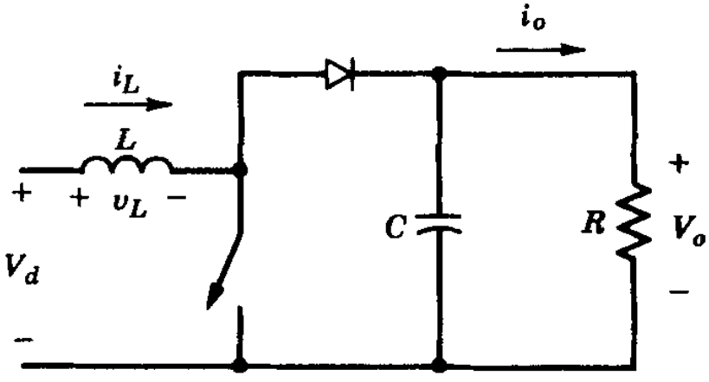
Figure 1. Schematic of Boost Converter
The voltage-second balance of the inductor is:
$$V_{d}t_{on}+\left(V_{d}-V_{o}\right)t_{off}=0$$
$$V_{d}=(1-D) V_{o}$$
At CCM_DCM boundary, the voltage and current of inductor is:
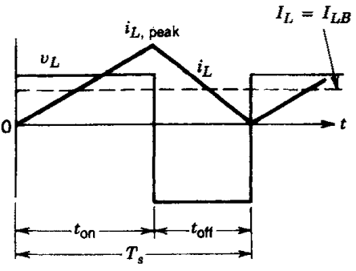
Figure 2. Inductor voltage & current graphs at CCM-DCM boundary
At CCM-DCM boundary, the average current of inductor, which is equal to input current, is:
$$I_{LB}=\frac{1}{2}i_{L,peak}=\frac{V_{d}t_{on}}{2L}=\frac{V_{o}T_{s}}{2L}D\left(1-D\right)=I_{d} (1)$$
Assuming lossless circuit,
$$P_{o}=V_{o}I_{o}=V_{d}I_{d}$$
$$I_{d}=\frac{P_{o}}{V_{d}}=\frac{P_{o}}{\left(1-D\right)V_{o}} \left(2\right)$$
Equating (1) and (2): (T_{s}=1/f_{s})
$$\frac{P_{o}}{\left(1-D\right)V_{o}}=\frac{V_{o}T_{s}}{2L}D\left(1-D\right)$$
Let us leave L in one side.
$$L(D)=\frac{{V_{o}}^{2}}{2f_{s}P_{o}}D{\left(1-D\right)}^{2}$$
Maximum of L(D) occurs at:
$$\frac{∂L(D)}{∂D}=0 → \left(1-D\right)\left(1-3D\right)=0 → D_{L,max}=\frac{1}{3}=33.33\%$$
Our range from the specifications is:
$$V_{d}=\left(10V, 20V\right)=\left(1-D\right)V_{o}=\left(1-D\right)24$$
$$D_{high}=1-\frac{10}{24}=\frac{7}{12}=58.33\%$$
$$D_{low}=1-\frac{20}{24}=\frac{1}{6}=16.67\%$$
Since $D_{low}<D_{L,max}<D_{high}$, we should choose inductor value according to $D_{L,max}$ to stay in CCM mode. At boundary, (V_{o}=24V, f_{s}=500kHz, P_{o}=10W)
$$L=L\left(D=D_{L,max}=\frac{1}{3}\right)= \frac{{V_{o}}^{2}}{2f_{s}P_{o}}\left(\frac{1}{3}\right){\left(\frac{2}{3}\right)}^{2} →L=\frac{{2V_{o}}^{2}}{27f_{s}P_{o}}=8.53 µH$$

Solution 1b)
The voltage and current of capacitor is:
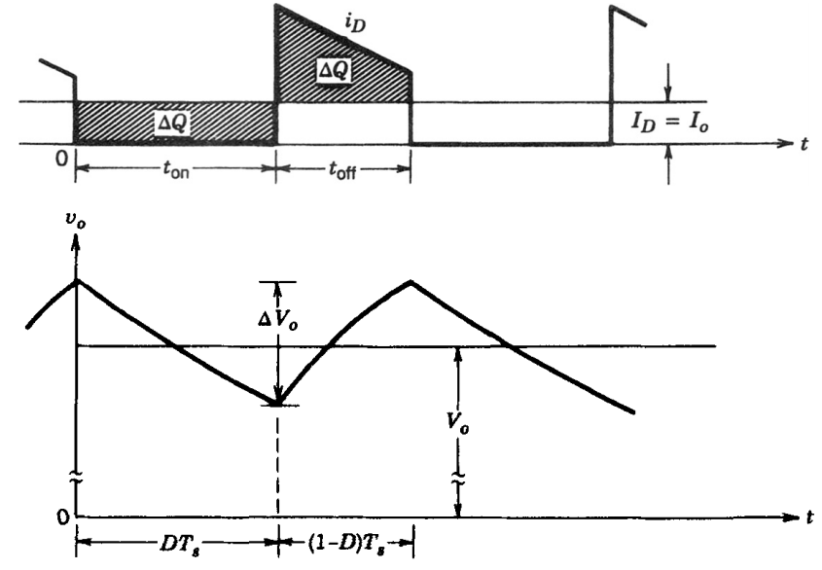
Figure 3. Capacitor voltage & current graphs
Assuming constant output power,
$$∆V_{o}=\frac{∆Q}{C}=\frac{I_{o}DT_{s}}{C}$$
At rated conditions,
$$I_{o}=\frac{P_{R}}{V_{o}}$$
Thus,
$$∆V_{o}=\frac{P_{R}D}{CV_{o}f_{s}}$$
Allowed maximum ripple is:
$${\left(\frac{∆V_{o}}{V_{o}}\right)}_{max}=2\%=\frac{P_{R}D}{CV_{o}f_{s}} → C\left(D\right)=\frac{50P_{R}D}{{V_{o}}^{2}f_{s}}$$
Capacitance should satisfy maximum duty cycle condition: (V_{o}=24V, f_{s}=500kHz, P_{r}=48W)
$$C=C\left(D=D_{high}=7/12\right)=\frac{50P_{R}7/12}{{V_{o}}^{2}f_{s}} → C=\frac{29.17P_{R}}{{V_{o}}^{2}f_{s}}=4,862 µF$$

Solution 1c)
Before simulation, we should model our output resistance value for part 1a: (V_{o}=24V, P_{o}=10W)
$$P_{o}=\frac{V_{o}^{2}}{R} → R=\frac{V_{o}^{2}}{P_{o}}=57.6 ohms$$

Then, we model the boost converter in Sİmulink and observe the corresponding waveforms.

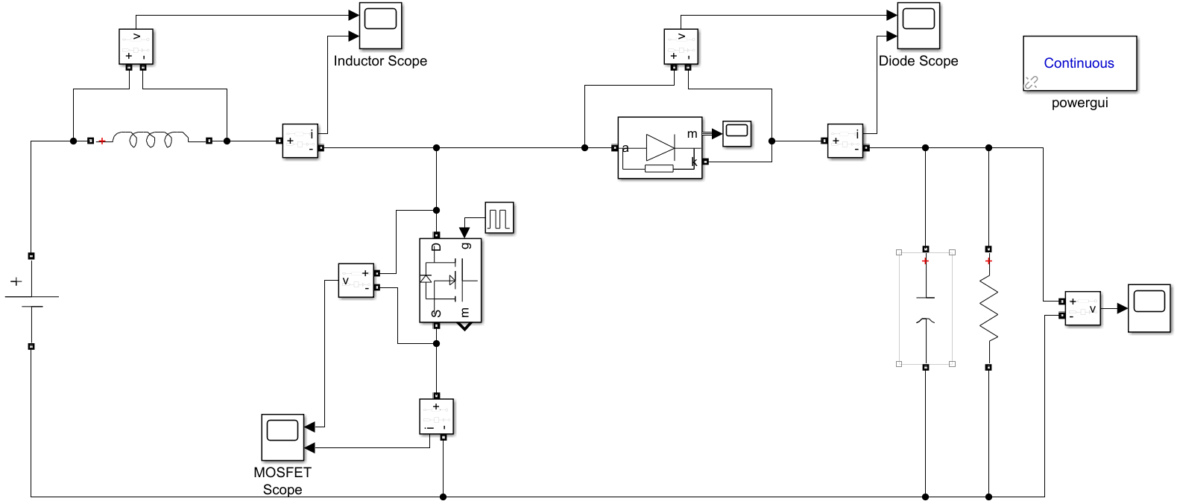
Figure 4. Simulink Model of Boost Converter

The inductor voltage and current waveforms is:

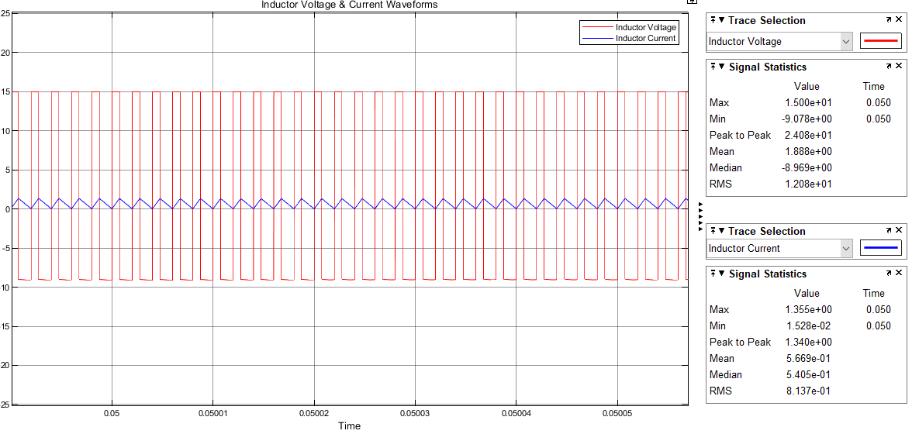
Figure 5. Inductor Current & Voltage Waveforms at boundary boost conditions
As is seen, the minimum value of the inductor current is 0.015 A which is near 0, means that we are almost at the CCM-DCM boundary.

The output voltage is:
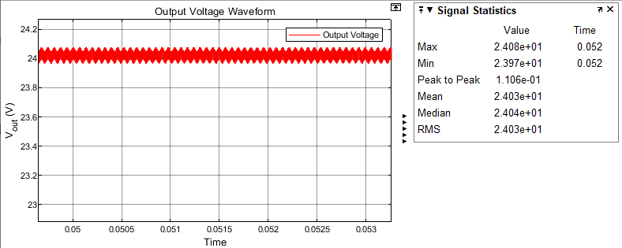
Figure 6. Output Voltage Waveform at boundary boost conditions
As expected, the mean value of the output is 24.03 V which is 0.1% more than desired value.
The peak-to-peak ripple is 0.11 V which is 0.46% of the output. This is in well below the desired 2% range since we are far blow the rated conditions (10W rather than 48W), and the ripple is proportional to the output power.

The diode voltage and current waveforms is:

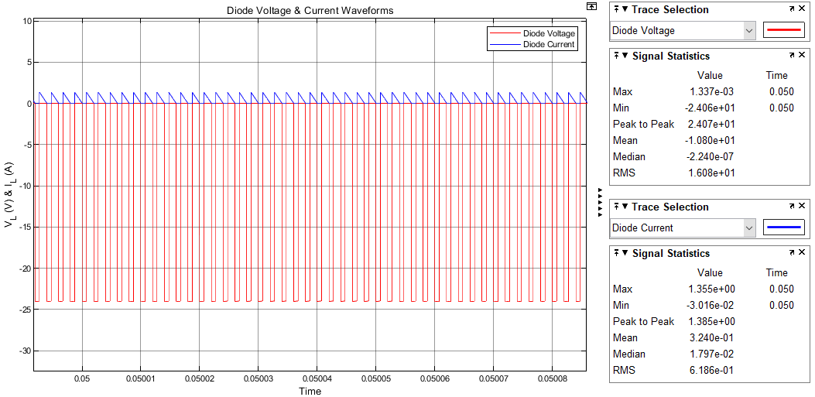 Figure 7. Diode Current & Voltage Waveforms at boundary boost conditions

We see negative voltage on diode when it is off and zero voltage when it is on, as expected.

The MOSFET voltage and current waveforms is:

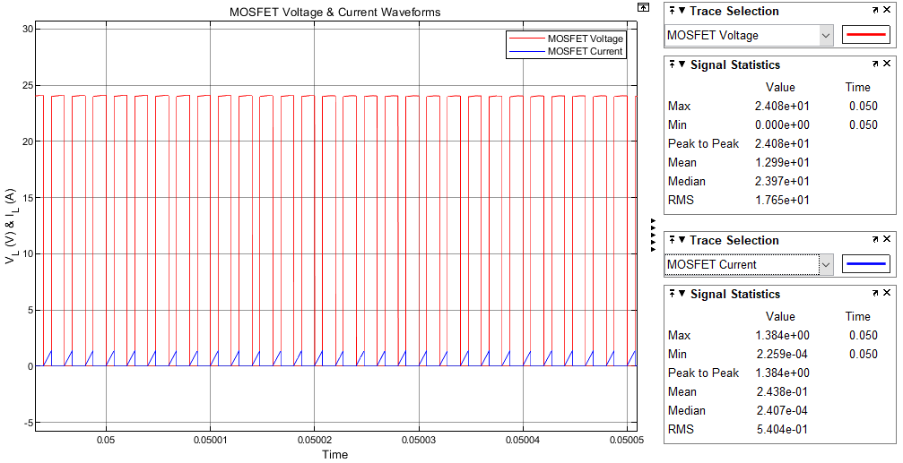
Figure 8. MOSFET Current & Voltage Waveforms at boundary boost conditions
We see 24 V voltage on MOSFET when it is not conducting and zero voltage when it is on, as expected.

Solution 1d)
The rated resistance value for the given 48 W rated output power and 24 V output voltage can be calculated as follows:
$$R= \frac{V_{o}^{2}}{P_{rated}}= \frac{{24}^{2}}{48}= 12 Ω$$
Duty cycle for the required output voltage have been calculated considering 15 V input voltage.
- charging period of the inductor -> $V_{L}+ V_{R}= V_{in}$
- discharging period of the inductor -> $V_{L}+ V_{R}= V_{in}- V_{o}$, when $V_{o}> V_{in}$ for steady state operation

Considering voltage-second balance of the inductor, charging, and discharging periods can be equated as follows:
$${(V}_{in}- V_{ESR})DT_{s}+ \left(V_{in}- V_{ESR}- V_{o}\right)\left(1-D\right)T_{s}=0$$
$$V_{in}= V_{o}\left(1-D\right)+ V_{ESR} → \frac{V_{o}}{V_{in}}= \frac{1}{1-D}, D=0.375, when V_{ESR}=0$$
$$\frac{V_{o}}{V_{in}}= \frac{1}{1-D}*\left(1-\frac{V_{R}}{V_{in}}\right)$$
$C_{out}$ for $V_{p-p}$ ripple less than 2% under rated output power can be calculated as follows:
$$C= \frac{DV_{o}}{f_{s}R\left(∆V_{o}\right)}= \frac{0.375*50}{\left(500*{10}^{3}\right)*12}=3.125 μH$$

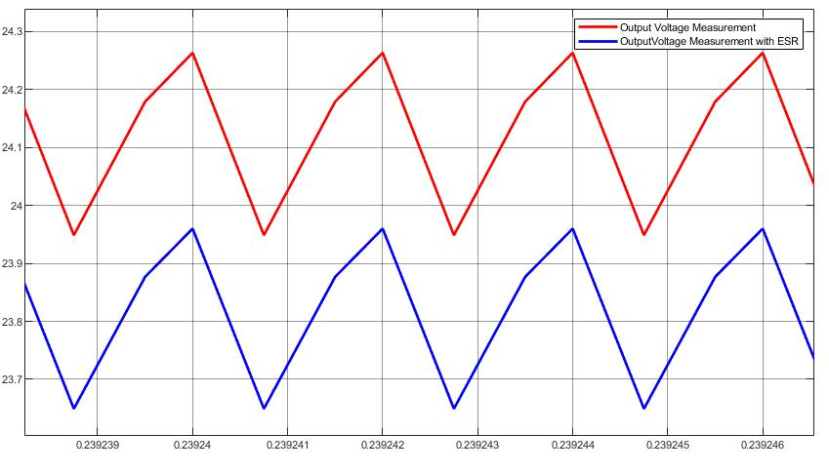
Figure 9. Output voltage waveform with and without 57 mΩ inductor ESR of the Boost Converter
The ESR value of the inductor have increased the voltage drop on top of the inductor. This voltage drop caused a decrease on both charging and discharging period equalities. Therefore, output voltage also decreased with the amount of voltage on top of the inductor ESR. This decrease can be observed with the simulations results from Figure 9, which compares output voltage waveforms for both with and without inductor ESR values given to be as 57 mΩ.

Solution 1e)
Converter efficiency can be calculated with the ratio of output power to input power.
$$η= \frac{P_{o}}{P_{i}}*100$$
Input and output currents of the converter have reverse relationship with the voltages. Therefore, ratio of input and output currents of the boost converter can be represented as:
$$\frac{I_{in}}{I_{o}}= \left(\frac{V_{in}}{V_{in}-V_{ESR}}\right)* \left(1-D\right)$$
, where ESR value of the inductor will affect both input and output voltage values and cause power loss on both input and output power, which can be also observed from Figure 11.
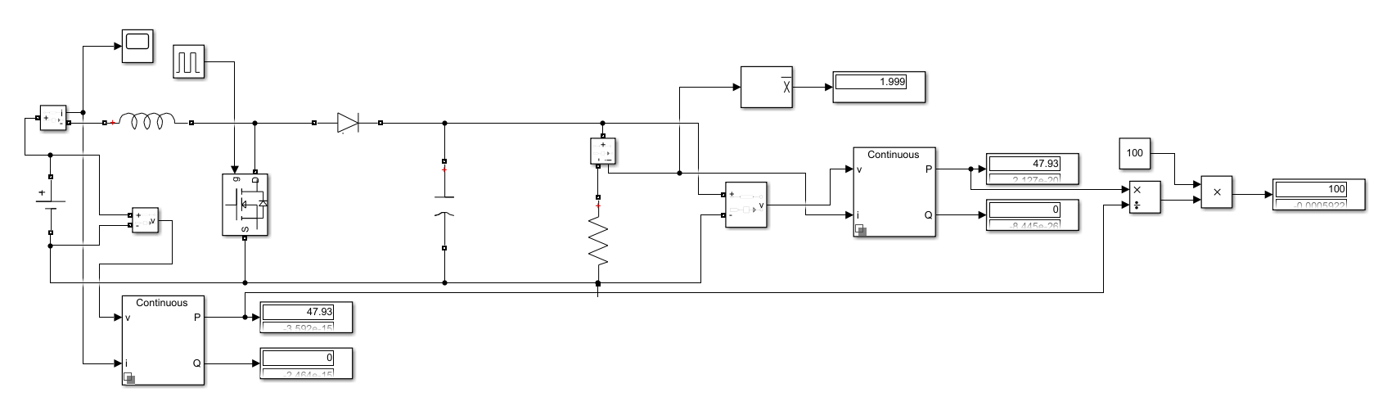
Figure 10. Efficiency in the ideal inductor case
Since components are chosen ideal, we see 100% efficiency without ESR.

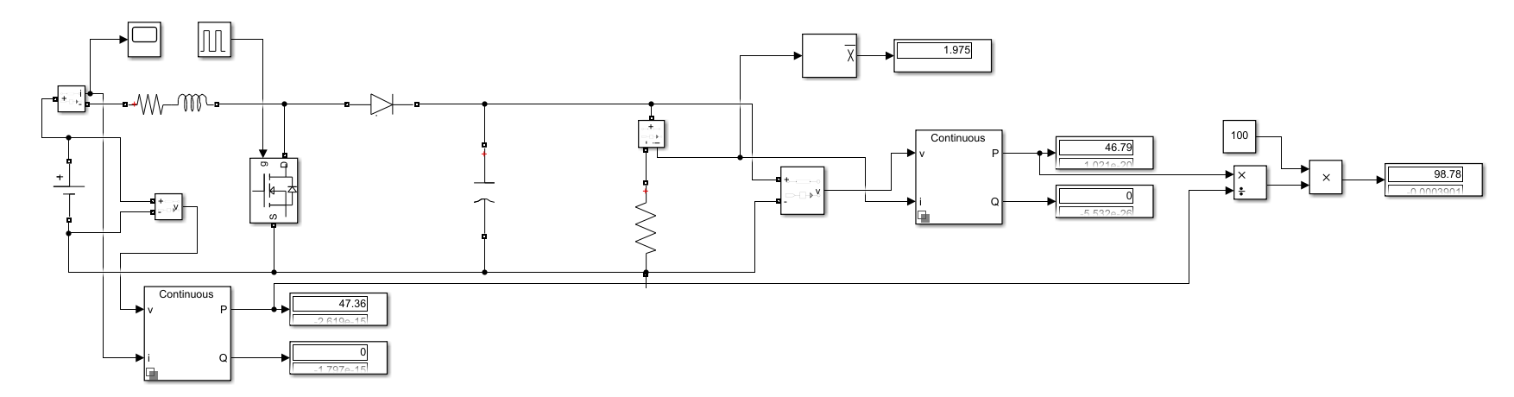
Figure 11. Efficiency with the 57 mΩ inductor ESR
The ESR of inductor decreases the efficiency from 100% to 98.78%. There is 1.22% efficiency drop.

Solution 1f)
The diode, which will be used in the boost converter, should be able to handle around 4 A current through it. Additionally, it shoud be able to block almost 25 V voltage, as can be observed from Figure 12. Moreover, MOSFET current and voltage waveforms are given in the Figure 13 and 4A current, 25 V voltage range are also the requirements for the mosfet in the design.

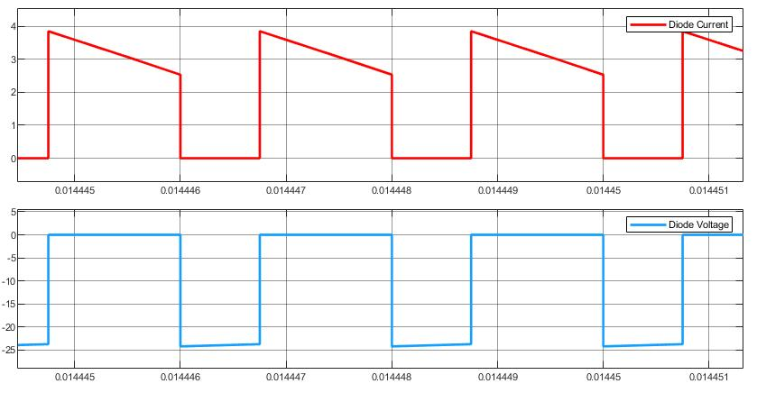
Figure 12. Diode voltage and current waveforms

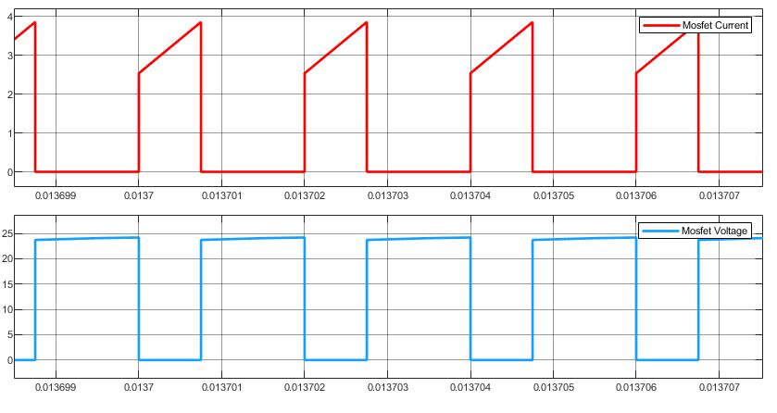
Figure 13. MOSFET voltage and current waveforms

The important parameters of chosen diode is:
Diode | I_{o} (A) | V_{RRM(max)} (V) | T_{rr} (ns) | V_{F} (V)
SBRT4M30LP | 4 | 30 | 30 | 0.51

Power loss on the diode at each switch is due to voltage drop on top of it and current flowing through it in the Forward active region. Therefore, it can be calculated as follows:
$$P_{diode}= V_{f}* I_{f}= 0.51*3.189=1.626 W$$
MOSFET both have conduction and switching loss in the converter operation.
Mosfet | I_{D} (A) | V_{RRM(max)} (V) | t_{r} (ns) | t_{f} (ns) | R_{on} (mΩ)
NTMS4840N | 4.5 | 30 | 5 | 3 | 24

Conduction loss is:
$$P_{conduction}=I_{o}^{2}*R_{on}*D={3.189}^{2}*24*{10}^{-3}*0.375 ≅0.092 W$$
Switching loss is:
$$P_{switching}=V_{in}*I_{o}*\left(t_{r}+t_{f}\right)*f_{sw}=15*3.189*\left(5+3\right)*{10}^{-9}*5*{10}^{5} ≅ 0.19 W$$

Solution 1g)
- NTMS4840N MOSFET:
Characteristic | Symbol | Value | Unit
Junction-to-Ambient | R_{QJA} | 110 | °C/W

Total power loss through the MOSFET is:
$$P_{total}=P_{conduction}+P_{switching}=0.2815 W$$
If no heatsink applied, the junction temperature of the MOSFET is:
$$T_{junc}= T_{ambient}+P_{loss}*R_{JA}=25+0.2815*110=55.97 °C$$
where ambient temperature has been assumed to be 25 °C.
Moreover, the MOSFET chosen for the Boost Converter 55.97 °C does not require an additional heatsink insertion.
- SBRT4M30LP Diode:
Characteristic | Symbol | Value | Unit | Note
Junction-to-Ambient | R_{QJA} | 72 | °C/W | Test with PC board, 1-inch sq. copper pad, 2oz.
Operating and Storage Temperature Range | T_{J}, T_{STG} | -55 to 150 | °C

If no heatsink applied, the junction temperature of the diode is:
$$T_{junc}= T_{ambient}+P_{diode}*R_{JA}=25+1.626*72=142.07 °C$$
where ambient temperature has been assumed to be 25 °C.
Since
$$T_{junc}==142.07 °C<T_{STG}=150 °C$$
The diode chosen for the Boost Converter does not require an additional heatsink insertion.

