
MIDDLE EAST TECHNICAL UNIVERSITY
ELECTRICAL AND ELECTRONICS ENGINEERING DEPARTMENT

EE 463 HOMEWORK 7 REPORT

Student Name: Fatih Serdar Sağlam 2305225
Büşra Nur Koçak 1929355

Table of Contents
3
d) 9
e) 11
f) 15
g) 16

Q1a)

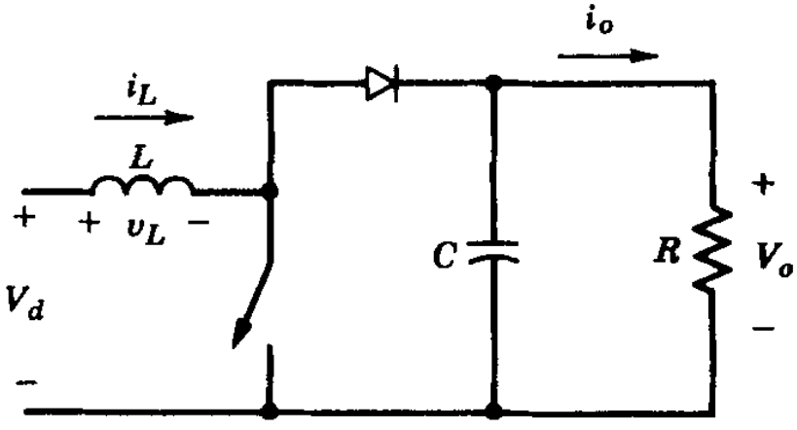
The voltage-second balance of the inductor is:
$$V_{d}t_{on}+\left(V_{d}-V_{o}\right)t_{off}=0$$
$$V_{d}=(1-D) V_{o}$$
At CCM-DCM boundary, the average current of inductor, which is equal to input current, is:
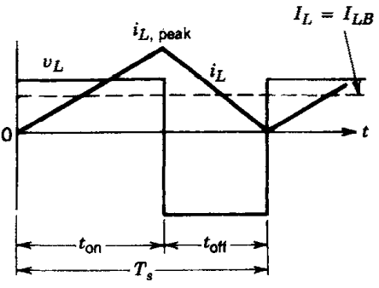

$$I_{LB}=\frac{1}{2}i_{L,peak}=\frac{V_{d}t_{on}}{2L}=\frac{V_{o}T_{s}}{2L}D\left(1-D\right)=I_{d} (1)$$
Assuming lossless circuit,
$$P_{o}=V_{o}I_{o}=V_{d}I_{d}$$
$$I_{d}=\frac{P_{o}}{V_{d}}=\frac{P_{o}}{\left(1-D\right)V_{o}} \left(2\right)$$
Equating (1) and (2): (T_{s}=1/f_{s})
$$\frac{P_{o}}{\left(1-D\right)V_{o}}=\frac{V_{o}T_{s}}{2L}D\left(1-D\right)$$
Let us leave L in one side.
$$L(D)=\frac{{V_{o}}^{2}}{2f_{s}P_{o}}D{\left(1-D\right)}^{2}$$
Maximum of L(D) occurs at:
$$\frac{∂L(D)}{∂D}=0 → \left(1-D\right)\left(1-3D\right)=0 → D_{L,max}=\frac{1}{3}=33.33\%$$
Our range from the specifications is:
$$V_{d}=\left(10V, 20V\right)=\left(1-D\right)V_{o}=\left(1-D\right)24$$
$$D_{high}=1-\frac{10}{24}=\frac{7}{12}=58.33\%$$
$$D_{low}=1-\frac{20}{24}=\frac{1}{6}=16.67\%$$
Since $D_{low}<D_{L,max}<D_{high}$, we should choose inductor value according to $D_{L,max}$ to stay in CCM mode. At boundary, (V_{o}=24V, f_{s}=500kHz, P_{o}=10W)
$$L=L\left(D=D_{L,max}=\frac{1}{3}\right)= \frac{{V_{o}}^{2}}{2f_{s}P_{o}}\left(\frac{1}{3}\right){\left(\frac{2}{3}\right)}^{2} →L=\frac{{2V_{o}}^{2}}{27f_{s}P_{o}}=8.53 µH$$

Q1b)
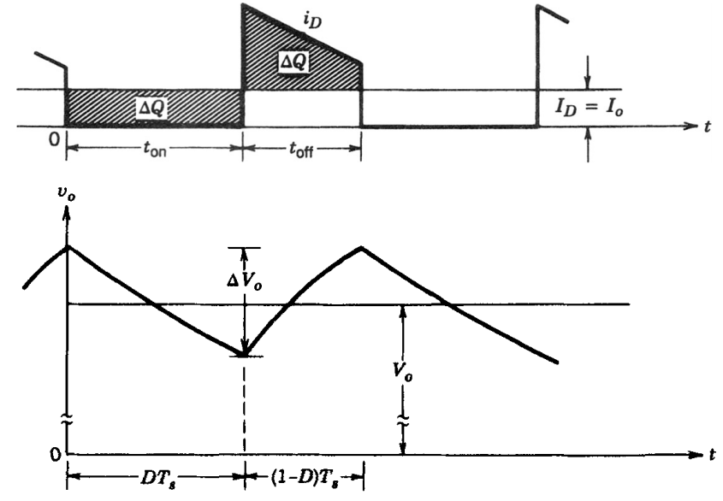
Assuming constant output power,
$$∆V_{o}=\frac{∆Q}{C}=\frac{I_{o}DT_{s}}{C}$$
At rated conditions,
$$I_{o}=\frac{P_{R}}{V_{o}}$$
Thus,
$$∆V_{o}=\frac{P_{R}D}{CV_{o}f_{s}}$$
Allowed maximum ripple is:
$${\left(\frac{∆V_{o}}{V_{o}}\right)}_{max}=2\%=\frac{P_{R}D}{CV_{o}f_{s}} → C\left(D\right)=\frac{50P_{R}D}{{V_{o}}^{2}f_{s}}$$
Capacitance should satisfy maximum duty cycle condition: (V_{o}=24V, f_{s}=500kHz, P_{r}=48W)
$$C=C\left(D=D_{high}=7/12\right)=\frac{50P_{R}7/12}{{V_{o}}^{2}f_{s}} → C=\frac{29.17P_{R}}{{V_{o}}^{2}f_{s}}=4,862 µF$$

Q1c)
Before simulation, we should model our output resistance value for part 1a: (V_{o}=24V, P_{o}=10W)
$$P_{o}=\frac{V_{o}^{2}}{R} → R=\frac{V_{o}^{2}}{P_{o}}=57.6 ohms$$

Q1d)
The rated resistance value for the given 48 W rated output power and 24 V output voltage can be calculated as follows:
$$R= \frac{V_{o}^{2}}{P_{rated}}= \frac{{24}^{2}}{48}= 12 Ω$$
Duty cycle for the required output voltage have been calculated considering 15 V input voltage.
charging period of the inductor -> $V_{L}+ V_{R}= V_{in}$
discharging period of the inductor -> $V_{L}+ V_{R}= V_{in}- V_{o}$, when $V_{o}> V_{in}$ for steady state operation
Considering voltage-second balance of the inductor, charging and discharging periods can be equated as follows:
$${(V}_{in}- V_{ESR})DT_{s}+ \left(V_{in}- V_{ESR}- V_{o}\right)\left(1-D\right)T_{s}=0$$
$$V_{in}= V_{o}\left(1-D\right)+ V_{ESR} → \frac{V_{o}}{V_{in}}= \frac{1}{1-D}, D=0.375, when V_{ESR}=0$$
$$\frac{V_{o}}{V_{in}}= \frac{1}{1-D}*\left(1-\frac{V_{R}}{V_{in}}\right)$$
$C_{out}$ for $V_{p-p}$ ripple less than 2% under rated output power can be calculated as follows:
$$C= \frac{DV_{o}}{f_{s}R\left(∆V_{o}\right)}= \frac{0.375*50}{\left(500*{10}^{3}\right)*12}=3.125 μH$$
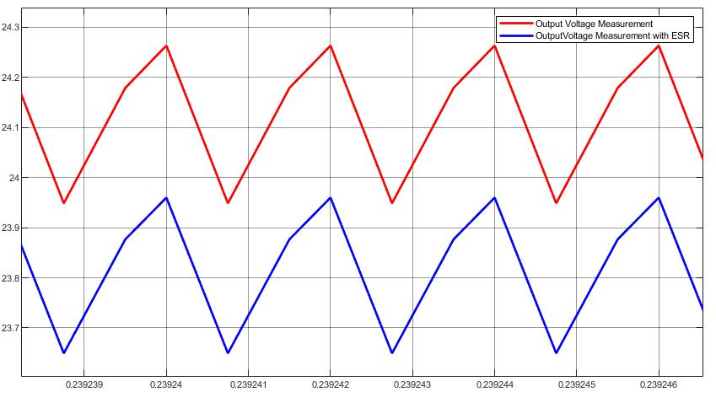
Figure 1: Output voltage waveform with and without 57 mΩ inductor ESR of the Boost Converter
The ESR value of the inductor have increased the voltage drop on top of the inductor. This voltage drop caused a decrease on both charging and discharging period equalities. Therefore, output voltage also decreased with the amount of voltage on top of the inductor ESR. This decrease can be observed with the simulations results from Figure 1, which compares output voltage waveforms for both with and without inductor ESR values given to be as 57 mΩ.

Q1e)
Converter efficiency can be calculated with the ratio of output power to input power.
$$η= \frac{P_{o}}{P_{i}}*100$$
Input and output currents of the converter have reverse relationship with the voltages. Therefore, ratio of input and output currents of the boost converter can be represented as:
$$\frac{I_{in}}{I_{o}}= \left(\frac{V_{in}}{V_{in}-V_{ESR}}\right)* \left(1-D\right)$$
, where ESR value of the inductor will affect both input and output voltage values and cause power loss on both input and output power, which can be also observed from Figure 3.

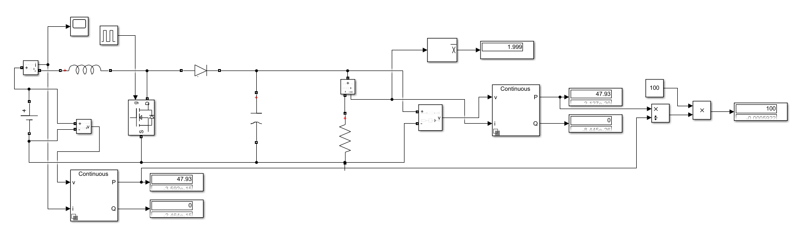
Figure 2: Efficiency in the ideal inductor case

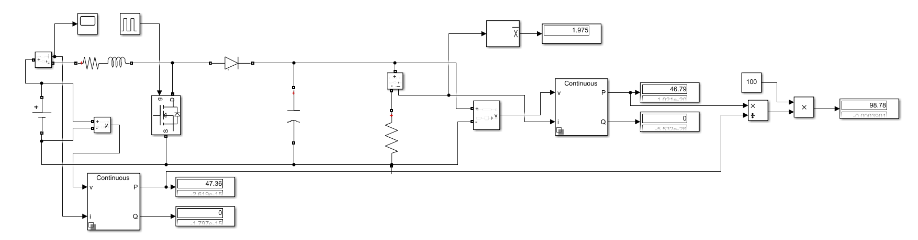
Figure 3: Efficiency with the 57 mΩ inductor ESR

