AMERICAN INTERNATIONAL UNIVERSITY-BANGLADESH (AIUB)
Faculty of Science and Technology
Department of Computer Science
CSC 2210 — Object Oriented Programming 2
Project Assignment 01: System Design & Report Submission
Project Title
RESORTIFY
A Multi-Hotel & Resort Booking Marketplace Management System
Semester: Summer 2025–2026
Section: R
Group No.: 3
Supervised By: Dr. Md. Iftekharul Mobin
Submitted By
Name | Student ID
FAATIN MUHAIMIN | 24-59717-3
SEPAT CHOWDHURY SAMI | 24-59733-3
SAMAUN CHOWDHURY RAAHIM | 24-59757-3
ABDULLA AL FAHAD | 24-59807-3
Date of Submission: 18 August 2026

Course Outcome Mapping & Marking Rubric

CO2 — Display and verify the meaning of a real-life project using C# GUI concepts with database integration (15 marks)
Criterion | Marks | Description | Marks Obtained
Requirement fulfillment | 5 | Case study describes a genuine, detailed real-life scenario; all three roles are meaningful; every mandatory feature is present and traceable to a form.
Validation | 5 | Every user story states what is validated and how the system responds; validation states are visible in mockups; database constraints enforce the same rules.
Verification | 5 | The navigation diagram, schema and SQL queries agree with each other end-to-end.

CO3 — Prepare and explain a real-life desktop application synthesizing C# components and development tools (15 marks)
Criterion | Marks | Description | Marks Obtained
Organization of the application | 5 | Repo follows the required folder structure; README and PDF report are complete with all 8 chapters; work distribution is honest and specific.
Representation and Integration of Database | 5 | 6+ tables correctly normalised to 3NF with justification; all PK/FK relationships drawn and labelled; junction table present; SQL uses JOIN, GROUP BY, HAVING and aggregates.
Graphical User Interface | 5 | 12+ form designs, visually consistent and coherent; navigation diagram complete with labelled arrows and role-decision branch; every form is reachable with a way back.

Bonus
Item | Marks | Marks Obtained
Correct ER Diagram (entities, attributes, relationships, cardinality) | +2
Working login + role routing already implemented in C# | +3

Table of Contents
Course Outcome Mapping & Marking Rubric2
Chapter 1 — Introduction & Case Study4
Chapter 2 — Functional Requirements & User Stories5
2.1 Functional Requirement List5
2.2 User Stories6
Chapter 3 — UI Navigation Diagram10
Chapter 4 — Database Design11
4.1 Table-by-Table Design11
4.2 Entity-Relationship Diagram (Bonus)14
4.3 Normalisation Justification (3NF)14
Chapter 5 — SQL Queries15
5.1 Database & Table Creation15
5.2 Sample Data17
5.3 Feature Queries18
Chapter 6 — User Interface Design21
Chapter 7 — Work Distribution28
Chapter 8 — Conclusion & Future Work29

Chapter 1 — Introduction & Case Study
Booking a hotel or resort in Bangladesh today usually means calling around, messaging Facebook pages, or trusting a travel agent's word of mouth, because most independently owned hotels and resorts — especially outside Dhaka, in places like Cox's Bazar, Bandarban, Sylhet and Saint Martin's — have no reliable way to list real-time room availability online or take secure payments. Guests waste hours comparing properties across scattered pages, arrive to find rooms double-booked, or overpay because there is no transparent price comparison in one place. Small hotel and resort owners, on the other hand, lack the budget and technical skill to build and maintain their own booking website, so they lose bookings to larger international platforms that either charge steep commissions or refuse to onboard small properties at all. Resortify solves this by acting as a neutral marketplace that lets any hotel or resort list its rooms, and lets any traveller browse, compare and book across all of them from a single application.
Three actors operate within Resortify. The Super Admin is the platform owner — the company running Resortify itself. The Super Admin does not own any hotel; instead, the Super Admin approves new hotel owners before they can list rooms, monitors platform-wide sales and the commission earned from every booking, suspends properties that misbehave or collect too many low ratings, and keeps the master list of room categories (Standard, Deluxe, Suite, Villa, Cottage) consistent across the platform. The Admin is an individual hotel or resort owner — for example, the owner of Blue Lagoon Resort in Saint Martin's or Cox's Bazar Breeze. Each Admin manages only their own property: registering their hotel profile, adding and updating the rooms or packages they offer, watching an availability dashboard so they never oversell a room type, running seasonal discount offers, and reading — but never deleting — the reviews guests leave about their stay. The Customer is the traveller — the guest who signs up, searches and filters hotels by price, location and star rating, reads reviews from previous guests, adds a room to a booking cart, pays at checkout, and later rates the stay.
Several entities describe this world. A Hotel is uniquely identified by its HotelId and carries a name, category, city, address, star rating and the OwnerId of the Admin who registered it. A Room belongs to exactly one Hotel and is described by its RoomId, room type, price per night, total rooms of that type, and a minimum-availability threshold used to trigger low-availability alerts. A Booking is created when a Customer checks out; it groups one or more BookingItems together, each BookingItem recording the specific room, check-in and check-out dates, number of nights and subtotal, because a single booking may combine several room types across a trip. A Review links one Customer, one Hotel, a star rating from 1 to 5 and a written comment. An Offer attaches a percentage discount with a start and end date to a specific room.
These entities relate to one another in clear one-to-many patterns: one Hotel offers many Rooms, one Room appears in many BookingItems, one Booking contains many BookingItems, one Customer places many Bookings and writes many Reviews, and one Hotel receives many Reviews. Each Admin owns exactly one Hotel, which keeps data isolation simple — a Hotel Owner's queries are always filtered by their own HotelId, so Owner A can never see Owner B's rooms, bookings or earnings. Money flows from the Customer's card at checkout into a Booking's TotalAmount; Resortify calculates a fixed commission percentage (for example 10%) on that amount and credits the remainder to the Hotel Owner's earnings, which is what the Admin sees on their Earnings & Booking Report and what the Super Admin sees, summed across every hotel, on the Platform Sales & Commission Report.

Chapter 2 — Functional Requirements & User Stories

2.1 Functional Requirement List

Super Admin
1. Approve or reject new hotel owner registrations
2. Suspend or delete a hotel owner account
3. View all users (Admins and Customers) with search and filter
4. View a platform-wide sales dashboard showing total bookings, revenue and commission earned per hotel
5. View a low-rated hotel report (average rating below 2.5)
6. Manage the master room / package category list
7. Moderate (delete) abusive or fake reviews

Admin (Hotel / Resort Owner)
1. Register a hotel and manage the hotel profile
2. Add, view, update and delete rooms / packages (full CRUD)
3. View an availability dashboard with low-availability alerts
4. View an earnings and booking report
5. Create discount offers / packages with start and end dates
6. View (read-only) reviews and ratings left on their hotel
7. Update their own profile and password

Customer (Guest)
1. Sign up and sign in
2. Browse hotels and resorts from all owners
3. Search hotels / rooms by name or location keyword
4. Filter using dropdowns (price range, star rating, location, room type)
5. View hotel details and read reviews
6. Add a room to the booking cart, update dates / quantity, or remove it
7. Checkout and pay, generating a bill / invoice
8. View booking history with a printable invoice
9. Give a rating (1–5) and a written review after a stay
10. View special packages and discount offers
11. Update their own profile and password

2.2 User Stories

Super Admin
As a Super Admin, I can approve or reject new hotel owner registrations, so that only genuine businesses can list rooms on the platform.
Details: When an Admin signs up, their account is inserted into the Users table with Status = 'Pending'. The Super Admin opens the Manage Hotel Owners screen, which lists pending accounts in a DataGridView with Approve and Reject buttons. Approve updates Status to 'Approved' and Reject updates it to 'Rejected'; the Admin cannot log in and list rooms until Status = 'Approved'.
As a Super Admin, I can suspend or delete a hotel owner, so that properties with poor service or fraudulent listings are removed from the platform.
Details: From the Manage Hotel Owners grid, selecting a hotel and clicking Suspend sets its Status to 'Suspended', which immediately hides all of that hotel's rooms from Customer search results without deleting historical booking data. Delete permanently removes the hotel row only if it has no active bookings; otherwise a validation message blocks the delete.
As a Super Admin, I can view all users with search and filter, so that I can investigate any account on the platform.
Details: The View All Users screen loads every row from the Users table into a DataGridView with columns for name, email, role and status. A search textbox filters by name or email, and a role dropdown filters between Admin and Customer. No edit controls are shown — this view is read-only for oversight.
As a Super Admin, I can view a platform-wide sales dashboard, so that I can track total revenue and the commission Resortify earns from every hotel.
Details: The dashboard runs a query that joins Bookings, BookingItems, Rooms and Hotels, grouping by hotel and summing TotalAmount to show bookings, revenue and calculated commission per hotel. A date-range picker narrows the report to a specific period, and totals update immediately.
As a Super Admin, I can view a low-rated hotel report, so that I can identify properties that risk damaging guest trust in the platform.
Details: The report runs a query that joins Hotels and Reviews, groups by hotel, and filters with HAVING AVG(Rating) < 2.5. The resulting DataGridView highlights hotels below the threshold in red, with a Suspend button next to each row.
As a Super Admin, I can manage the master room / package category list, so that every hotel describes its rooms using a consistent, searchable vocabulary.
Details: The Manage Room Categories screen shows existing categories (Standard, Deluxe, Suite, Villa, Cottage) in a DataGridView with Add, Edit and Delete buttons. The category name cannot be empty or duplicate an existing category, and deleting a category still in use by a Room is blocked.
As a Super Admin, I can moderate reviews, so that abusive or fake reviews do not mislead other guests.
Details: The Moderate Reviews screen lists every review with hotel name, reviewer, rating and comment. A Delete button removes a row from the Reviews table permanently after a confirmation dialog, since it directly affects a hotel's average rating.

Admin (Hotel / Resort Owner)
As a Hotel Owner, I can register my hotel and manage its profile, so that guests can find and recognise my property on the platform.
Details: The Hotel Profile form collects hotel name, category (dropdown), city, full address, contact number and a logo/photo upload. Hotel name and address cannot be empty, and the Save button stays disabled until required fields are filled; on Save the row is inserted into Hotels with Status = 'Pending' for Super Admin approval.
As a Hotel Owner, I can add, update and delete rooms in my own hotel, so that guests can book the exact room types I offer.
Details: The Room / Package Management screen shows a DataGridView filtered by the logged-in owner's HotelId only. The form validates that price per night and total rooms are positive numbers and that room type is not empty; on Save a row is inserted or updated in Rooms and the grid refreshes. Delete is blocked if the room has upcoming bookings.
As a Hotel Owner, I can view an availability dashboard with low-availability alerts, so that I never oversell a room type.
Details: The dashboard queries Rooms and BookingItems to calculate rooms booked versus rooms available for each room type, comparing available rooms against MinAvailability. Any room type at or below that threshold is flagged with a red "LOW STOCK" badge.
As a Hotel Owner, I can view an earnings and booking report, so that I know exactly how much I have earned and from which bookings.
Details: The report joins BookingItems, Bookings, Rooms and Users, filtered to the owner's HotelId, listing each booking's guest, room, check-in date, nights and subtotal. A running total sums earnings for the selected date range using SUM(Subtotal).
As a Hotel Owner, I can create discount offers on my rooms, so that I can attract bookings during low-occupancy periods.
Details: The Create Offer form lets the owner pick a room from a dropdown, enter a discount percentage between 1 and 100, and choose a start and end date. The end date must be after the start date; on Save a row is inserted into Offers, and Customers automatically see the discounted price on any room whose offer window includes today.
As a Hotel Owner, I can view reviews and ratings left on my hotel, so that I can understand guest feedback and improve my service.
Details: The Reviews screen lists every review for the owner's hotel in a read-only DataGridView with reviewer name, rating and comment. No Edit or Delete button is shown to the Admin — only the Super Admin can remove a review.
As a Hotel Owner, I can update my own profile and password, so that my account details stay current and secure.
Details: The Update Profile form pre-fills the owner's current name, phone and address; the Change Password section requires the current password plus a new password entered twice, which must match before Save is enabled. The password is stored as a hash, never in plain text.

Customer (Guest)
As a Customer, I can sign up and sign in, so that I can access booking features under my own account.
Details: The Sign Up form collects full name, email, phone, address and password, validating that the email is not already registered (UNIQUE constraint on Users.Email) and that password and confirm-password match. The Login form validates email and password against Users and routes the guest to Customer Home only when UserType = 'Customer' and Status = 'Approved'.
As a Customer, I can browse hotels and resorts from all owners, so that I can compare options before deciding where to stay.
Details: The Customer Home screen loads all hotels with Status = 'Approved' into a card list showing photo, name, city and starting price, pulled with a query that joins Hotels and Rooms. Clicking a card opens Hotel Details for that property.
As a Customer, I can search hotels and rooms by name or location keyword, so that I can quickly find a specific property I already have in mind.
Details: A search textbox above the hotel list runs a LIKE query against HotelName and City as the guest types, filtering results live. Search is available on every screen with a hotel list.
As a Customer, I can filter hotels using dropdowns, so that I only see rooms that match my budget and preferences.
Details: Three ComboBox dropdowns — Price Range, Star Rating and Location — sit above the hotel list; selecting any combination re-runs the query with WHERE conditions on PricePerNight, StarRating and City. Filters combine with AND logic and can be cleared with one Reset button.
As a Customer, I can view hotel details and read reviews, so that I can judge the quality of a property before booking.
Details: The Hotel Details screen shows the hotel's description, photo, amenities and a dropdown of available room types with prices, alongside a DataGridView of reviews joined from Reviews and Users. An "Add to Cart" button next to the selected room type starts the booking flow.
As a Customer, I can add a room to my booking cart, update dates or quantity, or remove it, so that I can plan a multi-room or multi-night stay before paying.
Details: Add to Cart inserts a row into Cart with CustomerId, RoomId, check-in/check-out dates and quantity; the Cart screen lists items in a DataGridView with editable date and quantity columns and a Remove button. Check-out date must be after check-in date, validated before saving.
As a Customer, I can check out and pay, so that my booking is confirmed and I receive a bill.
Details: The Checkout screen summarises the cart total, lets the guest pick a payment method and enter card details, and on Confirm & Pay inserts one row into Bookings and one row per cart item into BookingItems inside a single transaction, then clears the Cart for that customer. An invoice is generated immediately.
As a Customer, I can view my booking history with a printable invoice, so that I have a record of every stay I have booked.
Details: The Booking History screen lists past and upcoming bookings in a DataGridView; selecting a row opens the same invoice layout used at checkout with a Print button. Only bookings belonging to the logged-in CustomerId are shown.
As a Customer, I can give a rating and written review after a stay, so that I can share feedback and help other travellers choose confidently.
Details: From Booking History, a "Rate this stay" button opens a modal with a 1–5 star selector and a comment textbox; the rating cannot be submitted as 0 stars and the comment has a 500-character limit shown live. On Submit, a row is inserted into Reviews.
As a Customer, I can view special packages and discount offers, so that I can save money on my stay.
Details: The View Special Offers screen queries Offers joined with Rooms and Hotels, filtered to WHERE today's date is between StartDate and EndDate, and displays the discounted price alongside the original price with a strikethrough style.
As a Customer, I can update my own profile and password, so that my account information stays accurate and secure.
Details: Identical in structure to the Hotel Owner's profile screen: pre-filled profile fields, a password-change section requiring the current password, and matching new-password fields validated before Save is enabled.

Chapter 3 — UI Navigation Diagram
The diagram below shows every form in Resortify and every arrow between them. The flow always begins at the Login Form (reachable also from Sign Up once an account is created), and every submitted credential passes through a Check UserType decision diamond. Depending on the stored UserType, the application branches into exactly one of three colour-coded dashboards: red for Super Admin, orange for Hotel Owner (Admin), and green for Customer. Every child screen is reachable from its dashboard through an [Open] arrow and returns through a dashed [Back] arrow, so no screen is ever a dead end. Modal / popup forms — the Invoice shown after payment and the Give Rating & Review pop-up — are drawn with a dashed border to distinguish them from full navigable forms. The Customer branch additionally shows the linear booking flow: Hotel Details → Booking Cart → Checkout → Invoice → Booking History, which mirrors exactly how a real guest would move through the app. Every dashboard also exposes a [Logout → Reset] arrow that returns the user to the Login Form and clears the session.
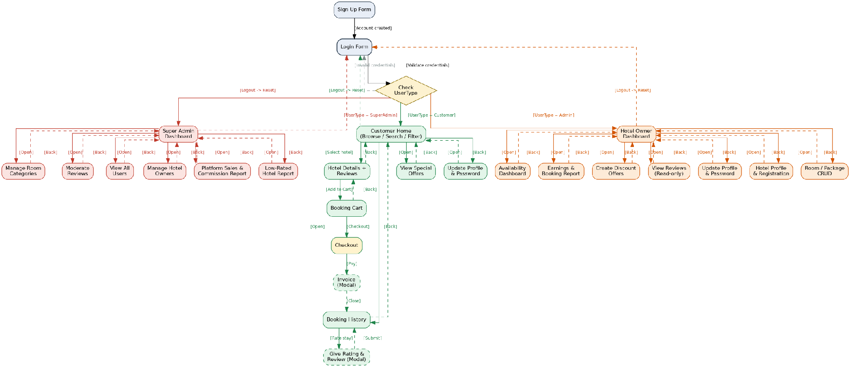
Figure 3.1 — Resortify UI Navigation Diagram

Chapter 4 — Database Design
Resortify's database is composed of eight tables, normalised to Third Normal Form (3NF). The schema diagram below shows every table, its columns, and the primary key / foreign key relationships that connect them.
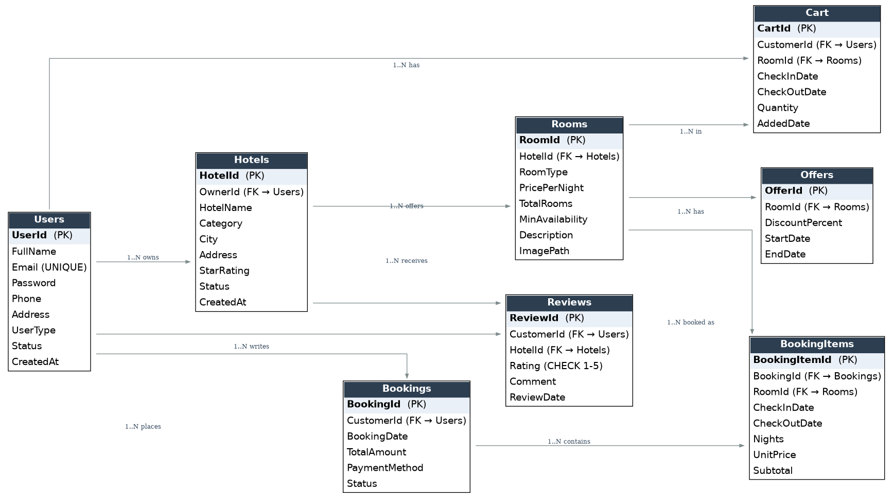
Figure 4.1 — Resortify SQL Schema Diagram

4.1 Table-by-Table Design

Users — stores all three roles in a single table
Column | Data Type | Constraint
UserId | INT, IDENTITY | PRIMARY KEY
FullName | VARCHAR(100) | NOT NULL
Email | VARCHAR(100) | NOT NULL, UNIQUE
Password | VARCHAR(255) | NOT NULL (hashed)
Phone | VARCHAR(20) | NULL
Address | VARCHAR(255) | NULL
UserType | VARCHAR(20) | NOT NULL, CHECK IN ('SuperAdmin','Admin','Customer')
Status | VARCHAR(20) | NOT NULL, DEFAULT 'Pending', CHECK IN ('Pending','Approved','Suspended','Rejected')
CreatedAt | DATETIME | NOT NULL, DEFAULT GETDATE()

Hotels — one row per hotel / resort, owned by an Admin
Column | Data Type | Constraint
HotelId | INT, IDENTITY | PRIMARY KEY
OwnerId | INT | NOT NULL, FOREIGN KEY → Users(UserId)
HotelName | VARCHAR(100) | NOT NULL
Category | VARCHAR(50) | NOT NULL
City | VARCHAR(50) | NOT NULL
Address | VARCHAR(255) | NOT NULL
StarRating | DECIMAL(2,1) | NULL
Status | VARCHAR(20) | NOT NULL, DEFAULT 'Pending', CHECK IN ('Pending','Approved','Suspended')
CreatedAt | DATETIME | NOT NULL, DEFAULT GETDATE()

Rooms — room types / packages offered by a hotel
Column | Data Type | Constraint
RoomId | INT, IDENTITY | PRIMARY KEY
HotelId | INT | NOT NULL, FOREIGN KEY → Hotels(HotelId)
RoomType | VARCHAR(50) | NOT NULL
PricePerNight | DECIMAL(10,2) | NOT NULL, CHECK (> 0)
TotalRooms | INT | NOT NULL, CHECK (>= 0)
MinAvailability | INT | NOT NULL, DEFAULT 1
Description | VARCHAR(500) | NULL
ImagePath | VARCHAR(255) | NULL

Cart — a customer's active booking basket
Column | Data Type | Constraint
CartId | INT, IDENTITY | PRIMARY KEY
CustomerId | INT | NOT NULL, FOREIGN KEY → Users(UserId)
RoomId | INT | NOT NULL, FOREIGN KEY → Rooms(RoomId)
CheckInDate | DATE | NOT NULL
CheckOutDate | DATE | NOT NULL, CHECK (> CheckInDate)
Quantity | INT | NOT NULL, DEFAULT 1, CHECK (> 0)
AddedDate | DATETIME | NOT NULL, DEFAULT GETDATE()

Bookings — one row per completed booking
Column | Data Type | Constraint
BookingId | INT, IDENTITY | PRIMARY KEY
CustomerId | INT | NOT NULL, FOREIGN KEY → Users(UserId)
BookingDate | DATETIME | NOT NULL, DEFAULT GETDATE()
TotalAmount | DECIMAL(10,2) | NOT NULL, CHECK (>= 0)
PaymentMethod | VARCHAR(30) | NOT NULL
Status | VARCHAR(20) | NOT NULL, DEFAULT 'Confirmed', CHECK IN ('Confirmed','Cancelled','Completed')

BookingItems — junction table — line items of a booking
Column | Data Type | Constraint
BookingItemId | INT, IDENTITY | PRIMARY KEY
BookingId | INT | NOT NULL, FOREIGN KEY → Bookings(BookingId)
RoomId | INT | NOT NULL, FOREIGN KEY → Rooms(RoomId)
CheckInDate | DATE | NOT NULL
CheckOutDate | DATE | NOT NULL
Nights | INT | NOT NULL, CHECK (> 0)
UnitPrice | DECIMAL(10,2) | NOT NULL
Subtotal | DECIMAL(10,2) | NOT NULL

Reviews — ratings and comments left by customers
Column | Data Type | Constraint
ReviewId | INT, IDENTITY | PRIMARY KEY
CustomerId | INT | NOT NULL, FOREIGN KEY → Users(UserId)
HotelId | INT | NOT NULL, FOREIGN KEY → Hotels(HotelId)
Rating | INT | NOT NULL, CHECK (BETWEEN 1 AND 5)
Comment | VARCHAR(500) | NULL
ReviewDate | DATETIME | NOT NULL, DEFAULT GETDATE()

Offers — percentage discounts on a specific room
Column | Data Type | Constraint
OfferId | INT, IDENTITY | PRIMARY KEY
RoomId | INT | NOT NULL, FOREIGN KEY → Rooms(RoomId)
DiscountPercent | DECIMAL(5,2) | NOT NULL, CHECK (BETWEEN 1 AND 100)
StartDate | DATE | NOT NULL
EndDate | DATE | NOT NULL, CHECK (> StartDate)

4.2 Entity-Relationship Diagram (Bonus)
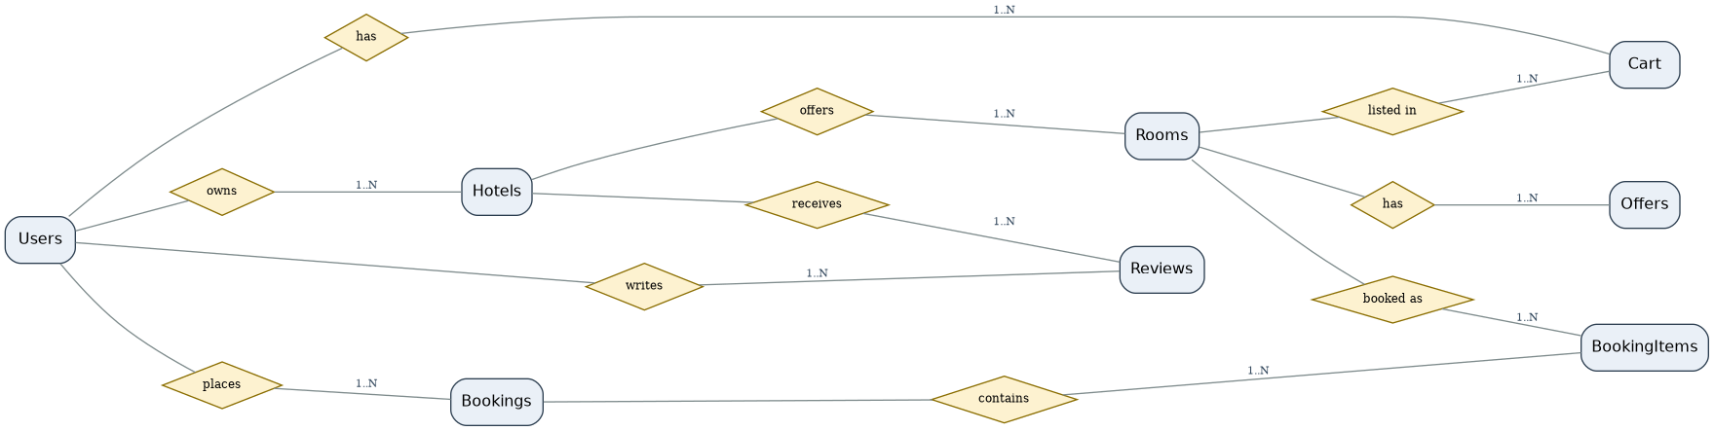
Figure 4.2 — Resortify Entity-Relationship Diagram

4.3 Normalisation Justification (3NF)
First Normal Form (1NF): every column holds a single atomic value and there are no repeating groups. The many-to-many relationship between Bookings and Rooms — a booking can contain several room types, and a room type appears in many bookings — is broken into the BookingItems junction table instead of being stored as a comma-separated list inside Bookings, which would have violated 1NF.
Second Normal Form (2NF): every table uses a single-column surrogate primary key (an IDENTITY integer), so there are no composite keys and therefore no partial dependencies — every non-key column depends on the whole of the primary key by construction.
Third Normal Form (3NF): no non-key column depends on another non-key column. For example, HotelName is stored only once, in Hotels; Rooms stores HotelId and looks up the name through a JOIN rather than duplicating it. Likewise, BookingItems stores RoomId and UnitPrice at the time of booking (a deliberate historical snapshot, not a transitive dependency) rather than re-deriving the current room name or the owner's hotel name, which are reached only through their proper foreign keys.

Chapter 5 — SQL Queries
This chapter presents the complete database creation script, sample data, and one query per major feature. Together they demonstrate JOIN, GROUP BY, HAVING and aggregate functions (COUNT, SUM, AVG) as required.

5.1 Database & Table Creation
CREATE DATABASE Resortify;
GO
USE Resortify;
GO

CREATE TABLE Users (
UserId INT IDENTITY(1,1) PRIMARY KEY,
FullName VARCHAR(100) NOT NULL,
Email VARCHAR(100) NOT NULL UNIQUE,
Password VARCHAR(255) NOT NULL,
Phone VARCHAR(20),
Address VARCHAR(255),
UserType VARCHAR(20) NOT NULL CHECK (UserType IN ('SuperAdmin','Admin','Customer')),
Status VARCHAR(20) NOT NULL DEFAULT 'Pending'
CHECK (Status IN ('Pending','Approved','Suspended','Rejected')),
CreatedAt DATETIME NOT NULL DEFAULT GETDATE()
);

CREATE TABLE Hotels (
HotelId INT IDENTITY(1,1) PRIMARY KEY,
OwnerId INT NOT NULL FOREIGN KEY REFERENCES Users(UserId),
HotelName VARCHAR(100) NOT NULL,
Category VARCHAR(50) NOT NULL,
City VARCHAR(50) NOT NULL,
Address VARCHAR(255) NOT NULL,
StarRating DECIMAL(2,1),
Status VARCHAR(20) NOT NULL DEFAULT 'Pending'
CHECK (Status IN ('Pending','Approved','Suspended')),
CreatedAt DATETIME NOT NULL DEFAULT GETDATE()
);

CREATE TABLE Rooms (
RoomId INT IDENTITY(1,1) PRIMARY KEY,
HotelId INT NOT NULL FOREIGN KEY REFERENCES Hotels(HotelId),
RoomType VARCHAR(50) NOT NULL,
PricePerNight DECIMAL(10,2) NOT NULL CHECK (PricePerNight > 0),
TotalRooms INT NOT NULL CHECK (TotalRooms >= 0),
MinAvailability INT NOT NULL DEFAULT 1,
Description VARCHAR(500),
ImagePath VARCHAR(255)
);

CREATE TABLE Cart (
CartId INT IDENTITY(1,1) PRIMARY KEY,
CustomerId INT NOT NULL FOREIGN KEY REFERENCES Users(UserId),
RoomId INT NOT NULL FOREIGN KEY REFERENCES Rooms(RoomId),
CheckInDate DATE NOT NULL,
CheckOutDate DATE NOT NULL CHECK (CheckOutDate > CheckInDate),
Quantity INT NOT NULL DEFAULT 1 CHECK (Quantity > 0),
AddedDate DATETIME NOT NULL DEFAULT GETDATE()
);

CREATE TABLE Bookings (
BookingId INT IDENTITY(1,1) PRIMARY KEY,
CustomerId INT NOT NULL FOREIGN KEY REFERENCES Users(UserId),
BookingDate DATETIME NOT NULL DEFAULT GETDATE(),
TotalAmount DECIMAL(10,2) NOT NULL CHECK (TotalAmount >= 0),
PaymentMethod VARCHAR(30) NOT NULL,
Status VARCHAR(20) NOT NULL DEFAULT 'Confirmed'
CHECK (Status IN ('Confirmed','Cancelled','Completed'))
);

CREATE TABLE BookingItems (
BookingItemId INT IDENTITY(1,1) PRIMARY KEY,
BookingId INT NOT NULL FOREIGN KEY REFERENCES Bookings(BookingId),
RoomId INT NOT NULL FOREIGN KEY REFERENCES Rooms(RoomId),
CheckInDate DATE NOT NULL,
CheckOutDate DATE NOT NULL,
Nights INT NOT NULL CHECK (Nights > 0),
UnitPrice DECIMAL(10,2) NOT NULL,
Subtotal DECIMAL(10,2) NOT NULL
);

CREATE TABLE Reviews (
ReviewId INT IDENTITY(1,1) PRIMARY KEY,
CustomerId INT NOT NULL FOREIGN KEY REFERENCES Users(UserId),
HotelId INT NOT NULL FOREIGN KEY REFERENCES Hotels(HotelId),
Rating INT NOT NULL CHECK (Rating BETWEEN 1 AND 5),
Comment VARCHAR(500),
ReviewDate DATETIME NOT NULL DEFAULT GETDATE()
);

CREATE TABLE Offers (
OfferId INT IDENTITY(1,1) PRIMARY KEY,
RoomId INT NOT NULL FOREIGN KEY REFERENCES Rooms(RoomId),
DiscountPercent DECIMAL(5,2) NOT NULL CHECK (DiscountPercent BETWEEN 1 AND 100),
StartDate DATE NOT NULL,
EndDate DATE NOT NULL CHECK (EndDate > StartDate)
);

5.2 Sample Data
-- Sample data: 1 Super Admin, 2 Hotel Owners, 3 Customers (minimum)
INSERT INTO Users (FullName, Email, Password, Phone, Address, UserType, Status) VALUES
('Faatin Muhaimin', 'admin@resortify.com', 'hashed_pw_1', '01710000001', 'Dhaka', 'SuperAdmin', 'Approved'),
('Rahim Uddin', 'rahim@bluelagoon.com', 'hashed_pw_2', '01710000002', 'St. Martin''s', 'Admin', 'Approved'),
('Karim Sheikh', 'karim@coxsbazarbreeze.com', 'hashed_pw_3', '01710000003', 'Cox''s Bazar', 'Admin', 'Approved'),
('Rafi Ahmed', 'rafi@gmail.com', 'hashed_pw_4', '01710000004', 'Dhaka', 'Customer', 'Approved'),
('Nusrat Jahan', 'nusrat@gmail.com', 'hashed_pw_5', '01710000005', 'Chattogram', 'Customer', 'Approved'),
('Tanvir Hasan', 'tanvir@gmail.com', 'hashed_pw_6', '01710000006', 'Sylhet', 'Customer', 'Approved');

INSERT INTO Hotels (OwnerId, HotelName, Category, City, Address, StarRating, Status) VALUES
(2, 'Blue Lagoon Resort', 'Resort', 'St. Martin''s', 'Beach Road, St. Martin''s Island', 4.7, 'Approved'),
(3, 'Cox''s Bazar Breeze', 'Hotel', 'Cox''s Bazar', 'Marine Drive, Cox''s Bazar', 4.3, 'Approved');

INSERT INTO Rooms (HotelId, RoomType, PricePerNight, TotalRooms, MinAvailability, Description) VALUES
(1, 'Deluxe Sea View', 120.00, 10, 2, 'Beachfront room with private balcony'),
(1, 'Family Suite', 180.00, 6, 1, 'Two-bedroom suite for up to 5 guests'),
(2, 'Standard Twin', 70.00, 20, 4, 'Twin bed room with city view');

INSERT INTO Bookings (CustomerId, TotalAmount, PaymentMethod, Status) VALUES
(4, 360.00, 'Credit Card', 'Confirmed'),
(5, 280.00, 'Mobile Banking', 'Confirmed'),
(6, 360.00, 'Credit Card', 'Completed');

INSERT INTO BookingItems (BookingId, RoomId, CheckInDate, CheckOutDate, Nights, UnitPrice, Subtotal) VALUES
(1, 1, '2026-08-20', '2026-08-23', 3, 120.00, 360.00),
(2, 3, '2026-09-01', '2026-09-03', 2, 70.00, 280.00),
(3, 2, '2026-07-10', '2026-07-12', 2, 180.00, 360.00);

INSERT INTO Reviews (CustomerId, HotelId, Rating, Comment) VALUES
(4, 1, 5, 'Amazing beach view, great service!'),
(5, 2, 4, 'Clean rooms, friendly staff.'),
(6, 1, 5, 'Best family vacation ever.');

INSERT INTO Offers (RoomId, DiscountPercent, StartDate, EndDate) VALUES
(1, 15.00, '2026-08-01', '2026-08-31'),
(3, 10.00, '2026-09-01', '2026-09-30');

5.3 Feature Queries

1. LOGIN
Verifies credentials and returns the role used to route the user to the correct dashboard after login.
SELECT UserId, FullName, UserType, Status
FROM Users
WHERE Email = 'rafi@gmail.com' AND Password = 'hashed_pw_4';

2. FILTER — price range
Powers the Price Range dropdown filter on the Customer Home screen.
SELECT r.RoomId, r.RoomType, r.PricePerNight, h.HotelName
FROM Rooms r
JOIN Hotels h ON r.HotelId = h.HotelId
WHERE r.PricePerNight BETWEEN 50 AND 150;

3. FILTER — category + availability
Powers the category filter, only showing room types that currently have stock.
SELECT r.RoomId, r.RoomType, r.TotalRooms, h.HotelName, h.Category
FROM Rooms r
JOIN Hotels h ON r.HotelId = h.HotelId
WHERE h.Category = 'Resort' AND r.TotalRooms > 0;

4. SEARCH — keyword
Backs the search textbox available on every hotel-list screen.
SELECT h.HotelName, h.City, r.RoomType, r.PricePerNight
FROM Hotels h
JOIN Rooms r ON h.HotelId = r.HotelId
WHERE h.HotelName LIKE '%Lagoon%' OR h.City LIKE '%Lagoon%';

5. CART — view / add / delete
The Booking Cart screen: view all items with a computed subtotal, add a new item, and remove an item.
-- View cart with computed total
SELECT c.CartId, ro.RoomType, h.HotelName, c.CheckInDate, c.CheckOutDate,
c.Quantity, ro.PricePerNight,
(DATEDIFF(day, c.CheckInDate, c.CheckOutDate) * c.Quantity * ro.PricePerNight) AS Subtotal
FROM Cart c
JOIN Rooms ro ON c.RoomId = ro.RoomId
JOIN Hotels h ON ro.HotelId = h.HotelId
WHERE c.CustomerId = 4;

-- Add item
INSERT INTO Cart (CustomerId, RoomId, CheckInDate, CheckOutDate, Quantity)
VALUES (4, 2, '2026-10-01', '2026-10-04', 1);

-- Delete item
DELETE FROM Cart WHERE CartId = 5;

6. CHECKOUT
Runs as a single transaction: create the Booking, create its BookingItems, decrement room stock, and clear the cart.
BEGIN TRANSACTION;

INSERT INTO Bookings (CustomerId, TotalAmount, PaymentMethod, Status)
VALUES (4, 360.00, 'Credit Card', 'Confirmed');

INSERT INTO BookingItems (BookingId, RoomId, CheckInDate, CheckOutDate, Nights, UnitPrice, Subtotal)
VALUES (SCOPE_IDENTITY(), 1, '2026-08-20', '2026-08-23', 3, 120.00, 360.00);

UPDATE Rooms SET TotalRooms = TotalRooms - 1 WHERE RoomId = 1;

DELETE FROM Cart WHERE CustomerId = 4 AND RoomId = 1;

COMMIT TRANSACTION;

7. HOTEL EARNINGS
Aggregate query behind both the Admin Earnings Report and the Super Admin Platform Sales Report.
SELECT h.HotelName, COUNT(bi.BookingItemId) AS TotalBookings, SUM(bi.Subtotal) AS TotalRevenue
FROM Hotels h
JOIN Rooms r ON h.HotelId = r.HotelId
JOIN BookingItems bi ON r.RoomId = bi.RoomId
GROUP BY h.HotelName;

8. LOW AVAILABILITY ALERT
Flags any room type whose remaining stock has fallen below its configured minimum.
SELECT RoomId, RoomType, TotalRooms, MinAvailability
FROM Rooms
WHERE TotalRooms < MinAvailability;

9. REVIEWS for one hotel
Feeds the read-only Reviews grid shown to both Customers (on Hotel Details) and the hotel's own Admin.
SELECT u.FullName AS Reviewer, rv.Rating, rv.Comment, rv.ReviewDate
FROM Reviews rv
JOIN Users u ON rv.CustomerId = u.UserId
WHERE rv.HotelId = 1
ORDER BY rv.ReviewDate DESC;

10. LOW-RATED HOTELS
Powers the Super Admin's Low-Rated Hotel Report.
SELECT h.HotelName, AVG(rv.Rating) AS AvgRating
FROM Hotels h
JOIN Reviews rv ON h.HotelId = rv.HotelId
GROUP BY h.HotelName
HAVING AVG(rv.Rating) < 2.5;

11. SUSPEND / DELETE hotel owner
Used from Manage Hotel Owners; delete only succeeds when there are no dependent rows.
-- Suspend a hotel
UPDATE Hotels SET Status = 'Suspended' WHERE HotelId = 2;

-- Delete a hotel owner account
DELETE FROM Users WHERE UserId = 3 AND UserType = 'Admin';

12. ACTIVE OFFERS
Shows only offers whose date window includes today, with the discounted price calculated in-query.
SELECT r.RoomType, h.HotelName, r.PricePerNight,
o.DiscountPercent,
ROUND(r.PricePerNight * (1 - o.DiscountPercent / 100.0), 2) AS DiscountedPrice
FROM Offers o
JOIN Rooms r ON o.RoomId = r.RoomId
JOIN Hotels h ON r.HotelId = h.HotelId
WHERE GETDATE() BETWEEN o.StartDate AND o.EndDate;

Chapter 6 — User Interface Design
All twelve required form mockups are shown below. Every form shares the same navy header bar, role-coloured title bar, button style and typography for visual consistency; every form carries a Back or Logout control so no screen is a dead end; data lists use a DataGridView rather than a concatenated ListBox; and filter controls use ComboBox dropdowns rather than free-text boxes. Validation states are visibly demonstrated on the Login form (password length) and the Sign Up form (password mismatch).

1. Login
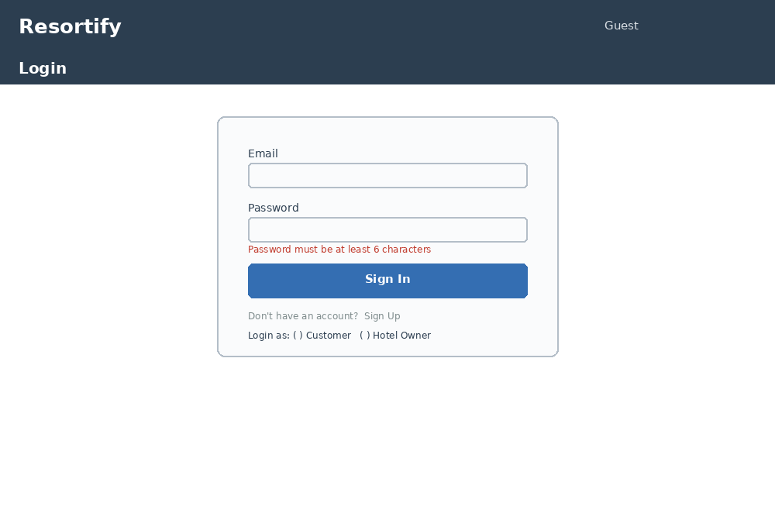
Figure 6.1 — Login. Email and password fields with inline validation; a visible error label demonstrates the minimum-password-length rule. Includes a link to Sign Up and a role selector.

2. Sign Up / Registration
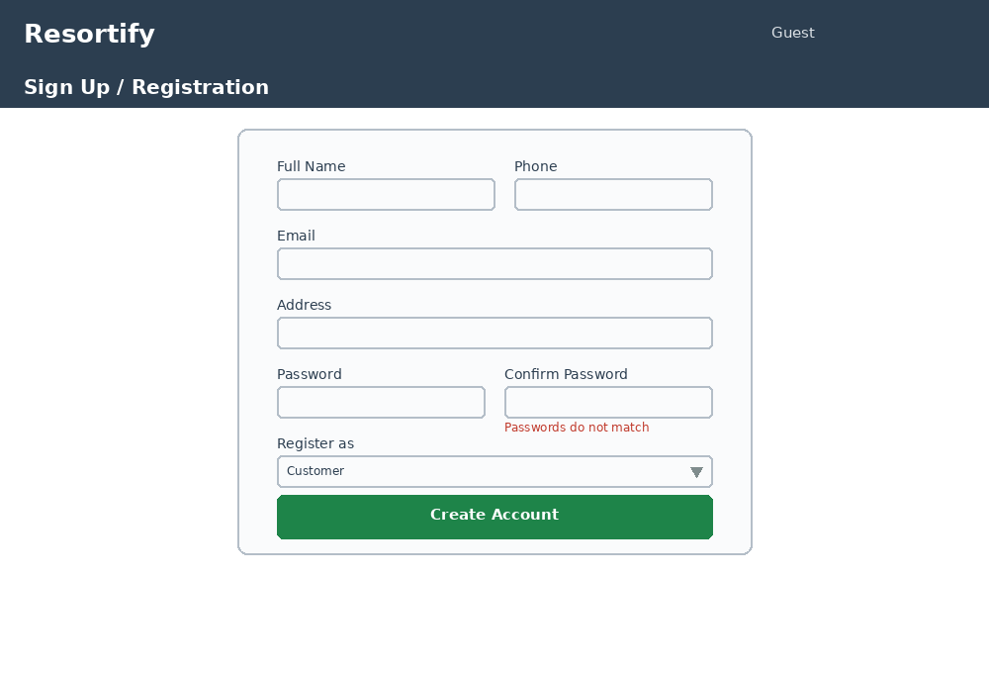
Figure 6.2 — Sign Up / Registration. Collects full name, phone, email, address and password with a Confirm Password field; shows the password-mismatch validation state and a Register As dropdown (Customer / Hotel Owner).

3. Super Admin Dashboard
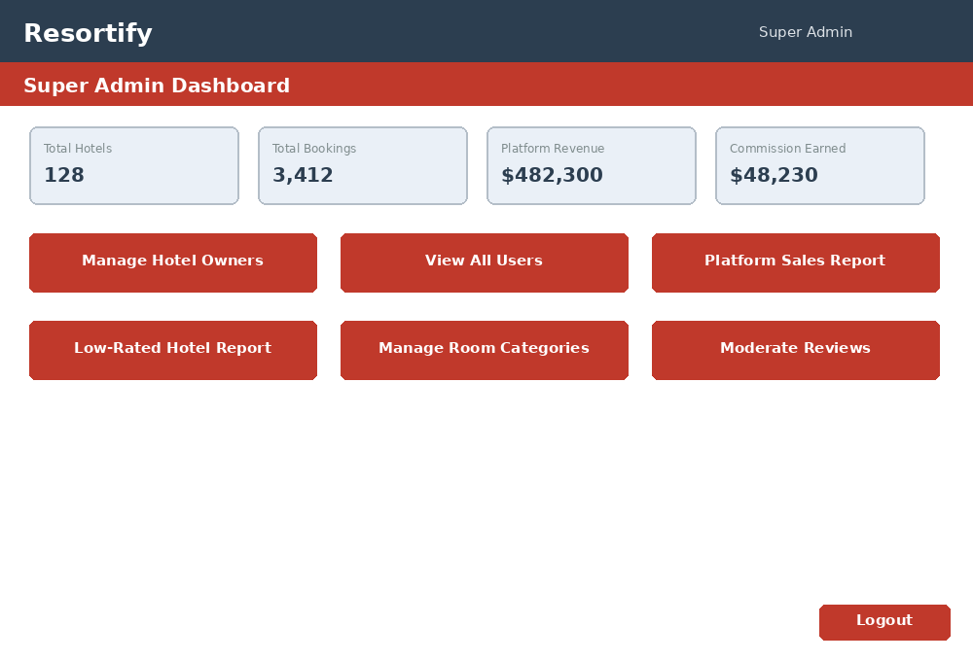
Figure 6.3 — Super Admin Dashboard. Landing screen after Super Admin login. Summary cards show platform-wide totals; six navigation buttons lead to every Super Admin sub-screen. Logout is always visible.

4. Super Admin—Manage Hotel Owners
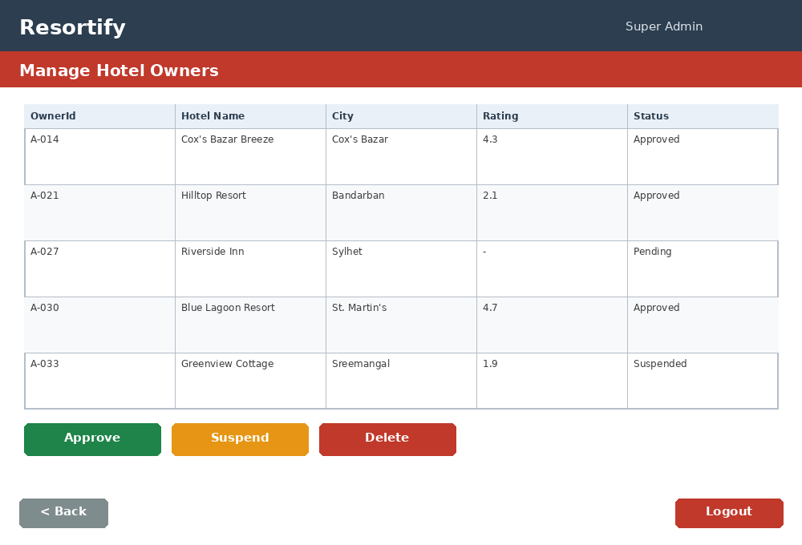
Figure 6.4 — Super Admin — Manage Hotel Owners. A DataGridView of every hotel with Approve, Suspend and Delete actions — the screen behind SA1 and SA2.

5. Super Admin — Platform Sales & Commission Report
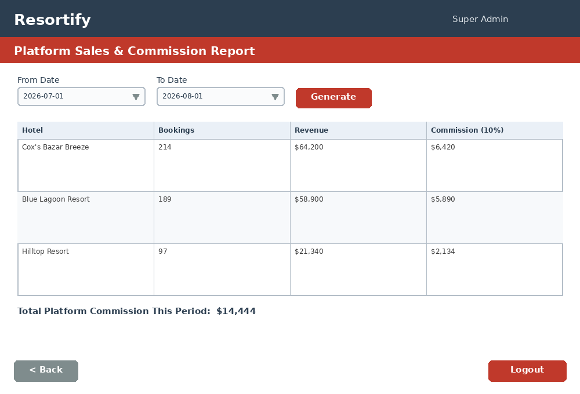
Figure 6.5 — Super Admin — Platform Sales & Commission Report. Date-range filter plus a DataGridView grouped by hotel showing bookings, revenue and commission (Query 7).

6. Admin — Room / Package CRUD
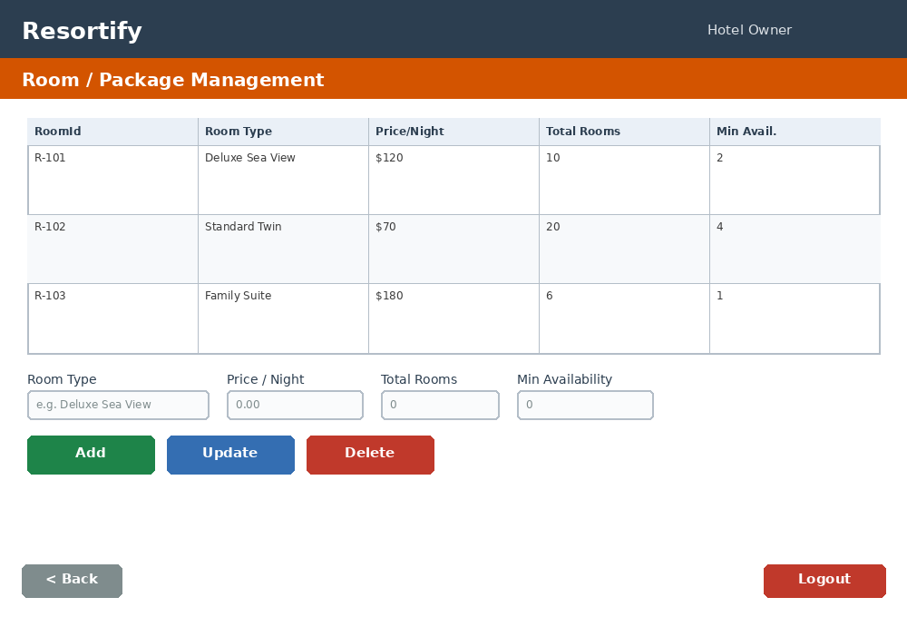
Figure 6.6 — Admin — Room / Package CRUD. Full DataGridView CRUD screen for a Hotel Owner's own rooms only, with an Add/Update form and Add, Update and Delete buttons.

7. Admin — Availability Dashboard
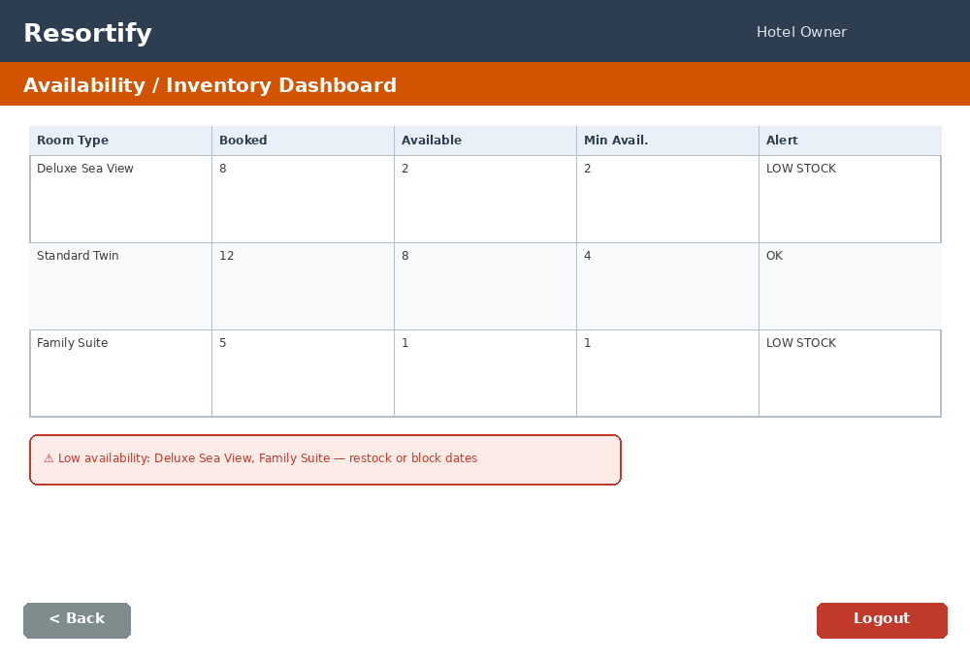
Figure 6.7 — Admin — Availability Dashboard. Shows booked vs. available rooms per room type with a red low-stock alert banner when availability drops below the configured minimum (Query 8).

8. Admin — Earnings & Booking Report
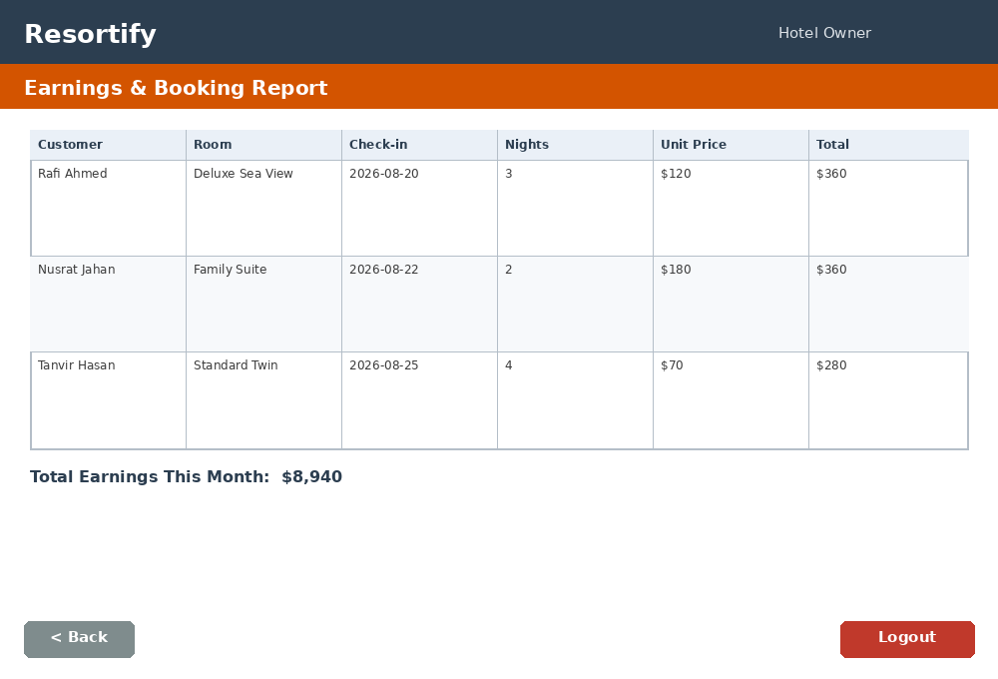
Figure 6.8 — Admin — Earnings & Booking Report. Lists every booking for the owner's hotel with guest, room, dates and subtotal, plus a running monthly total.

9. Customer — Home / Browse
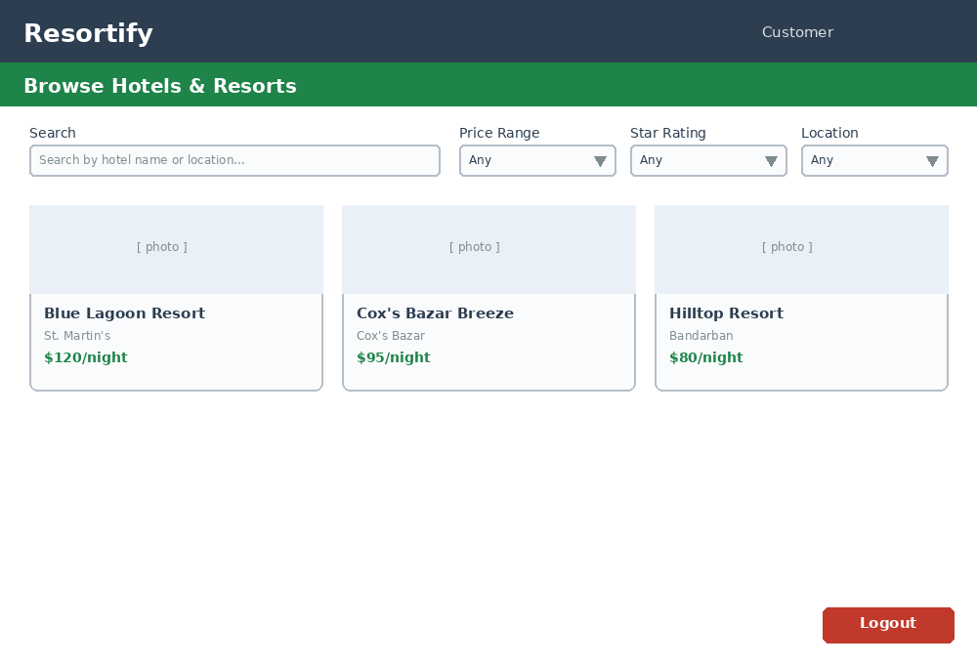
Figure 6.9 — Customer — Home / Browse. Search box plus three ComboBox dropdown filters (Price Range, Star Rating, Location) above a browsable card list of hotels from every owner.

10. Customer — Hotel Details + Reviews
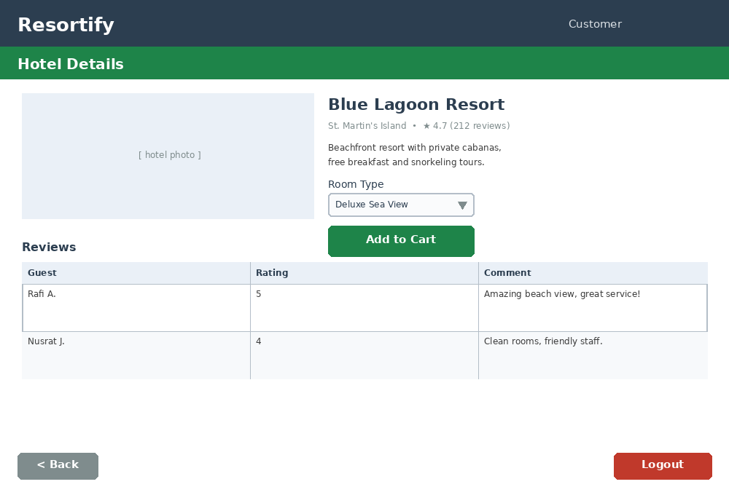
Figure 6.10 — Customer — Hotel Details + Reviews. Hotel description and room-type dropdown with an Add to Cart button, alongside a read-only reviews DataGridView (Query 9).

11. Customer — Booking Cart
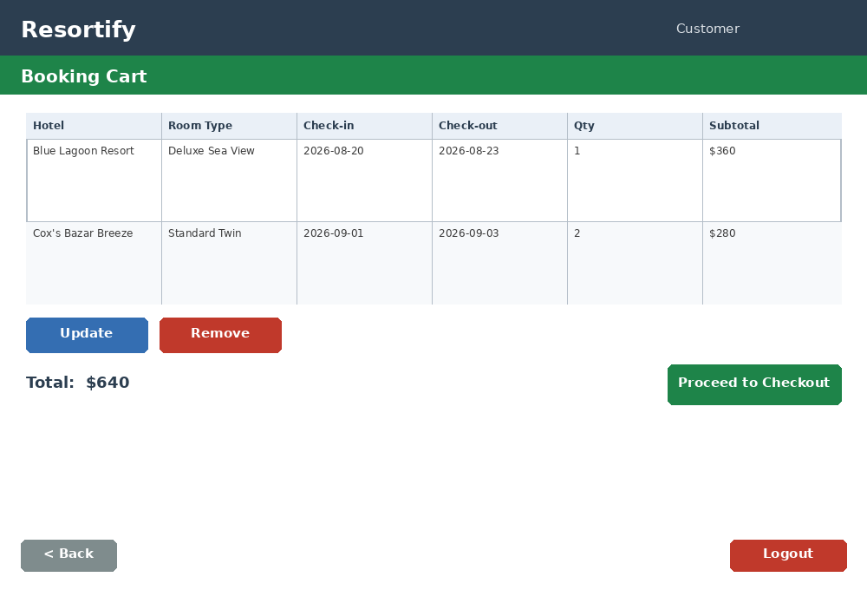
Figure 6.11 — Customer — Booking Cart. DataGridView of cart items with Update and Remove actions and a computed total, leading into Checkout.

12. Customer — Checkout / Invoice
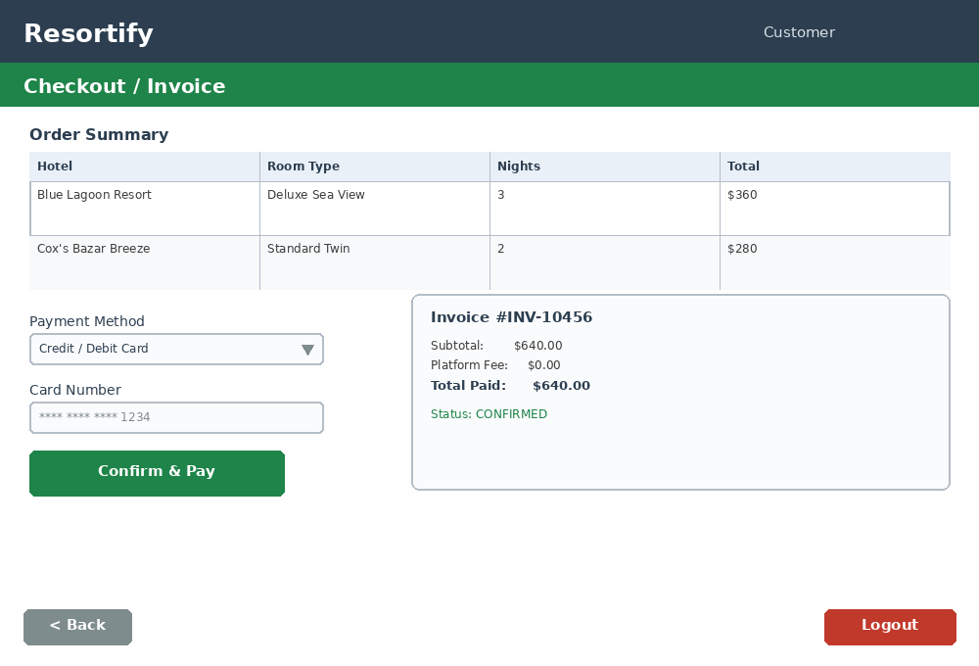
Figure 6.12 — Customer — Checkout / Invoice. Order summary, payment method dropdown and card field on the left; the generated invoice with a CONFIRMED status appears on the right after payment.

Chapter 7 — Work Distribution
The table below records each member's specific contribution to this deliverable.
Name | Student ID | Contribution
Faatin Muhaimin | 24-59717-3 | Group lead; wrote the case study (Chapter 1), functional requirements and user stories (Chapter 2), and compiled/formatted the final report.
Sepat Chowdhury Sami | 24-59733-3 | Designed the database schema (Chapter 4), built the SQL schema and ER diagrams, and wrote the full SQL script (Chapter 5).
Samaun Chowdhury Raahim | 24-59757-3 | Designed and built the Super Admin and Hotel Owner UI mockups (forms 1–8), and set up the GitHub repository structure.
Abdulla Al Fahad | 24-59807-3 | Designed and built the Customer UI mockups (forms 9–12), drafted the UI navigation diagram (Chapter 3), and wrote the README.md.

Chapter 8 — Conclusion & Future Work
This document is the complete blueprint for Resortify: a 3-tier hotel and resort booking marketplace connecting a platform-owning Super Admin, independent Hotel Owner Admins, and travelling Customers. Every mandatory feature from the assignment brief has a corresponding functional requirement, user story, navigation node, database table and SQL query, so the design is verifiable end-to-end before a single line of C# is written.
In the next phase, the team will implement Resortify as a C# Windows Forms desktop application using ADO.NET against a SQL Server database that mirrors the schema in Chapter 4. Planned work includes wiring every mockup in Chapter 6 to real DataGridView controls bound to live queries, implementing password hashing (e.g. BCrypt) instead of the placeholder hashed values used in the sample data, adding a real payment gateway integration (such as SSLCommerz or bKash, common in Bangladesh) at checkout, enforcing the role-based data isolation described in Chapter 1 in every query the Admin dashboard runs, and adding image upload handling for hotel and room photos.
The team expects a few concrete challenges during implementation. First, preventing double-booking will require careful transaction handling around the checkout query in Chapter 5, since two customers could attempt to book the last available room in the same room type at nearly the same time. Second, keeping the Availability Dashboard's low-stock alert accurate in real time will require either polling or an event-driven refresh whenever a booking is confirmed or cancelled. Third, enforcing strict data isolation for each Hotel Owner — so that Owner A can never see Owner B's rooms, bookings or earnings — must be tested deliberately with at least two Admin accounts once login and role routing are implemented, since a single missed WHERE HotelId = @OwnerHotelId clause would be a serious security defect. Finally, translating twelve static mockups into a visually consistent set of live WinForms screens, while keeping every form reachable and every form leaving a way back as shown in the navigation diagram, will require disciplined use of a shared base form and a common colour/style constants file across the whole team.

