anOperating systems lab two

bscs23154

1.4 Exercises
- Create a directory lab1 and inside create two files a.txt and b.txt with sample text.
2. Use diff and vimdiff to compare them.

Vimdiff output:
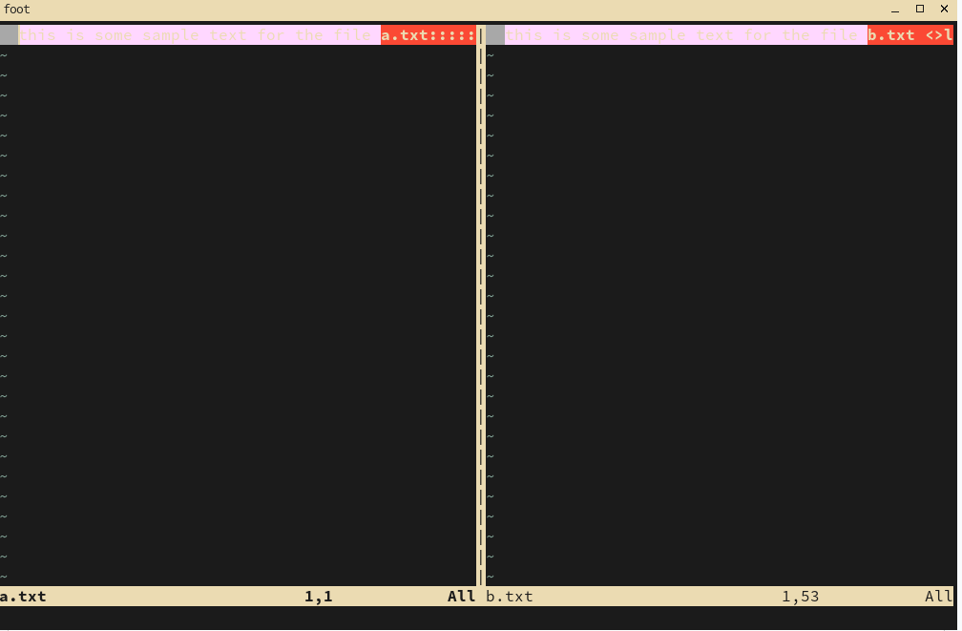
output of diff a.txt b.txt

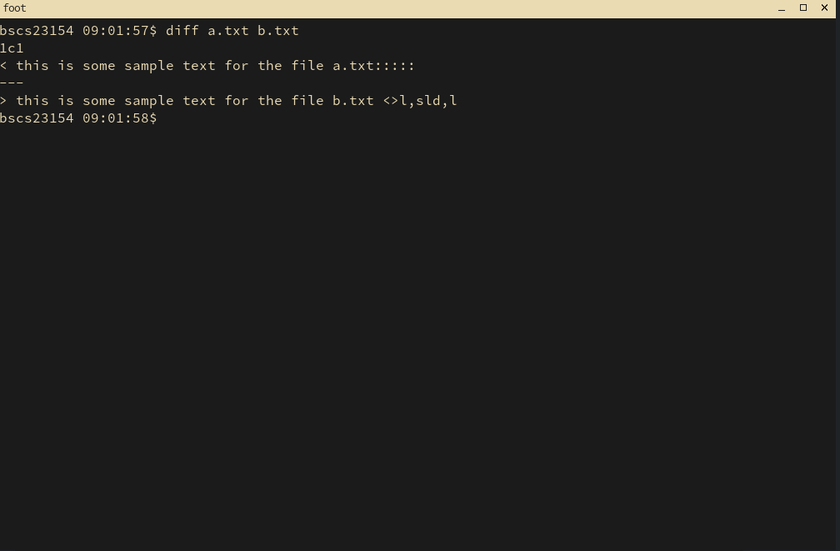

grep -n “something” -R
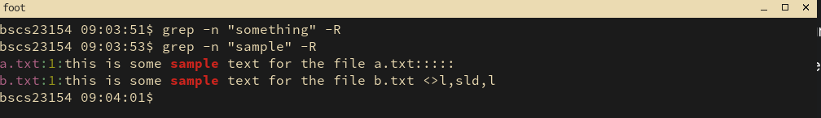

output of head that will show first 5 lines (by default it shows 10)

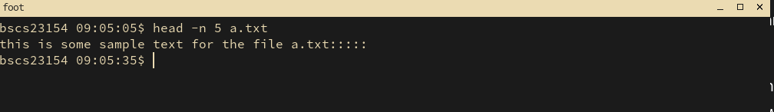
output of tail to show last 10 lines
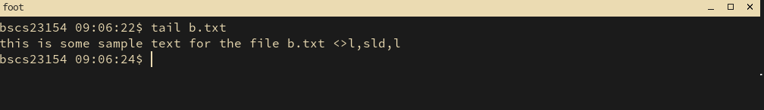
output of nl:
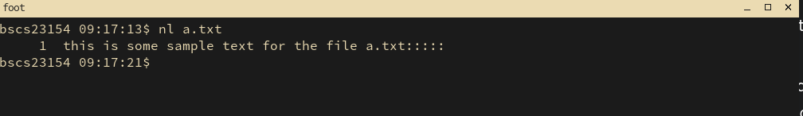
chmod +x exe.cpp
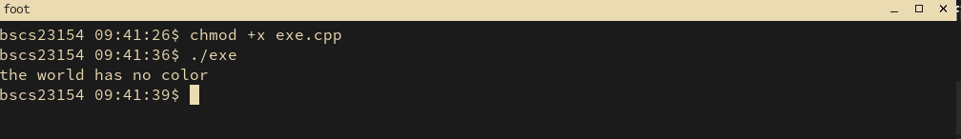

strace output to show system calls:
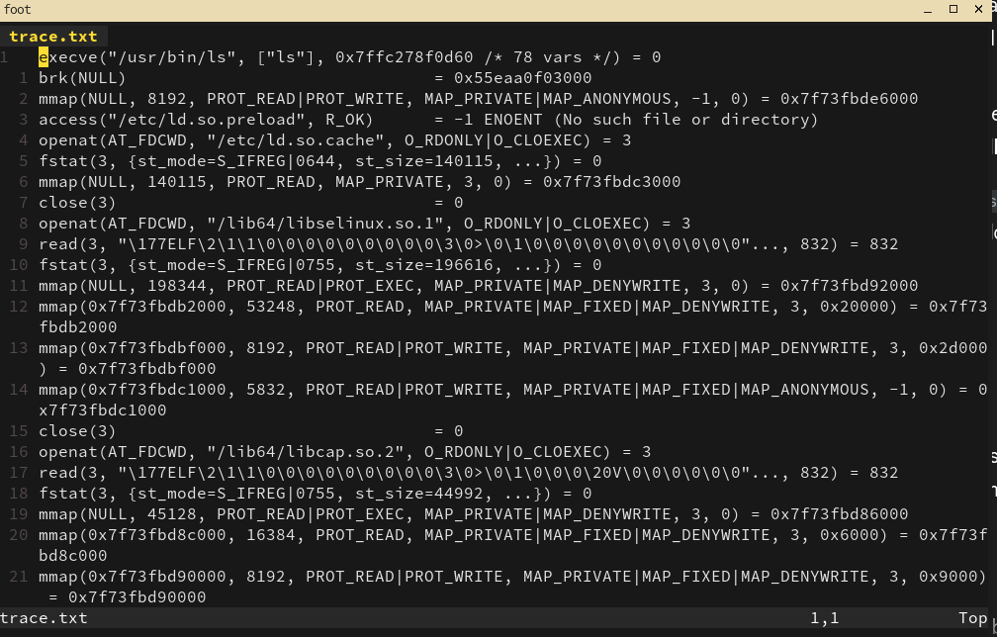

gcc -E main.c -o main.i
less main.i # inspect the expanded source

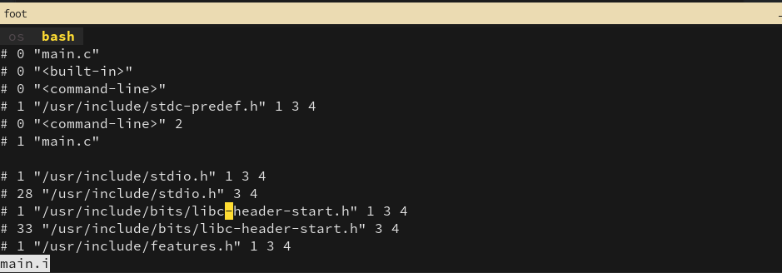

gcc -S main.i -o main.s
less main.s

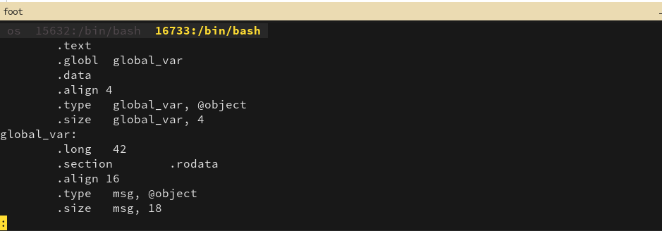
gcc -c main.s -o main.o

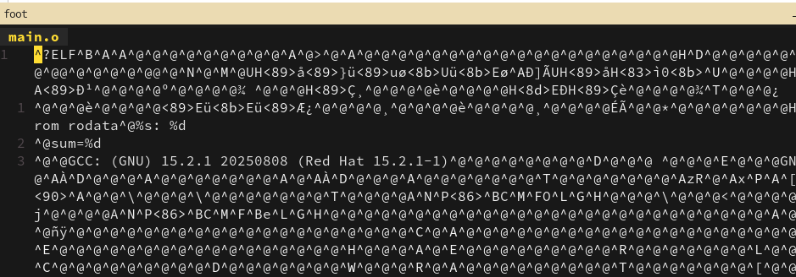

Inspect object file sections:
objdump -h main.o # shows section headers (.text, .data, .bss, .rodata etc.)
readelf -S main.o # alternative view with section names and attributes
nm -n main.o # symbol table (sorted) — shows defined symbols
objdump -d main.o | less # disassemble .text

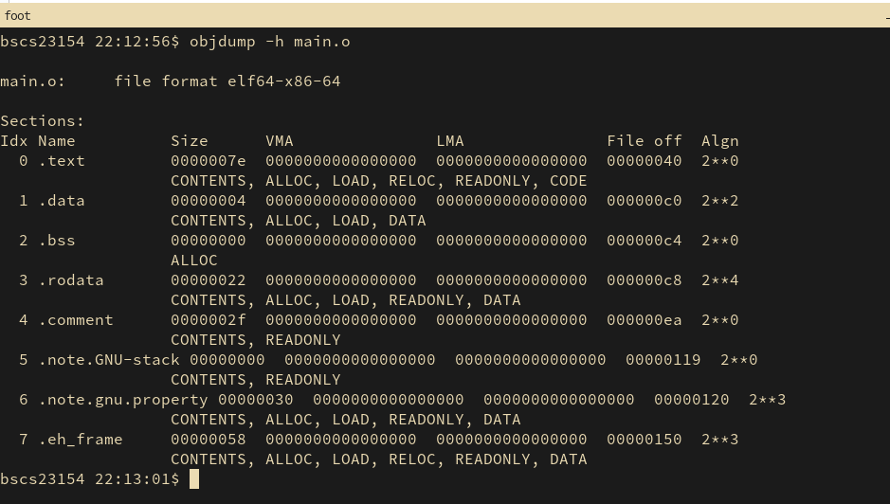

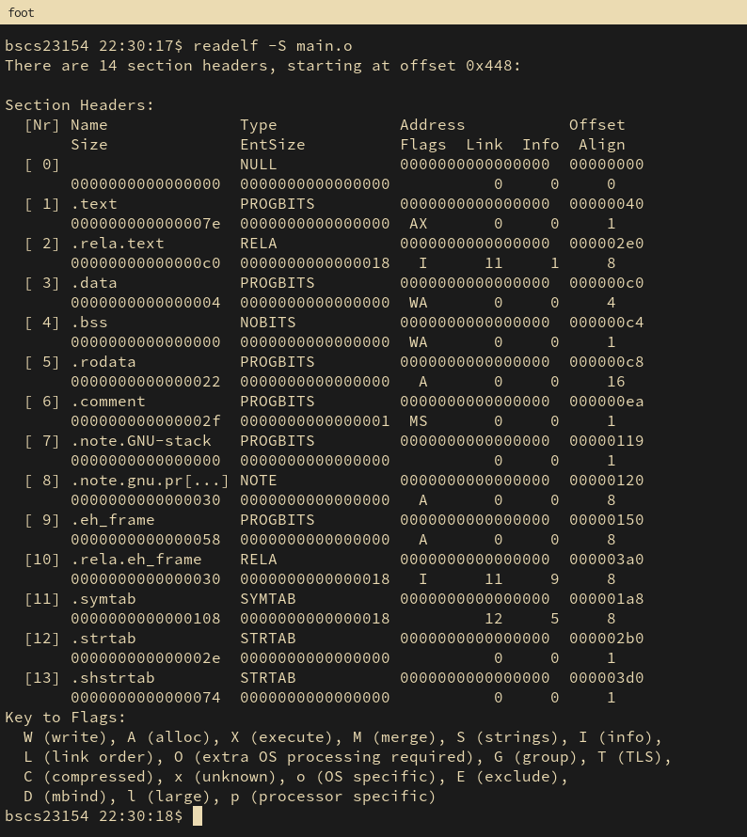
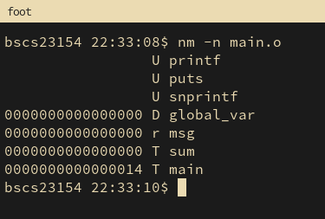

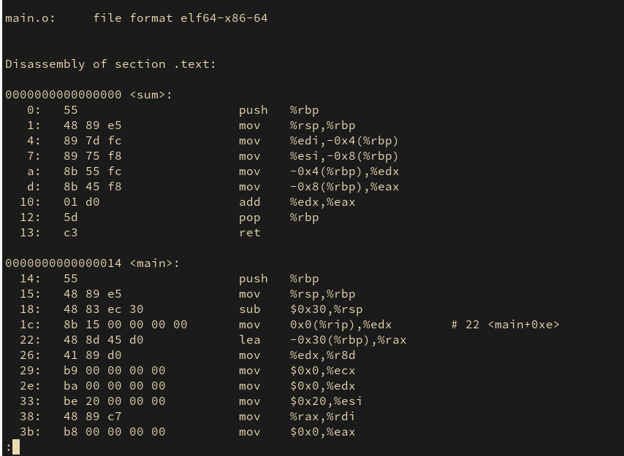

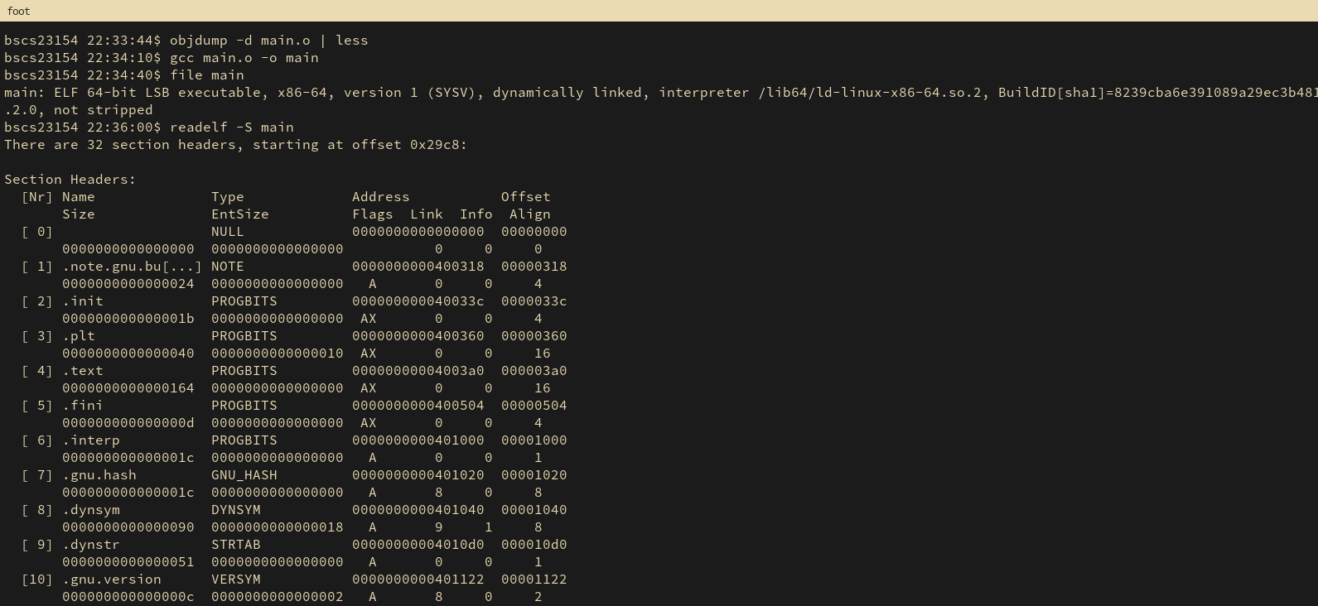

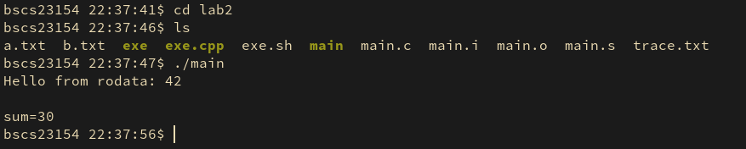

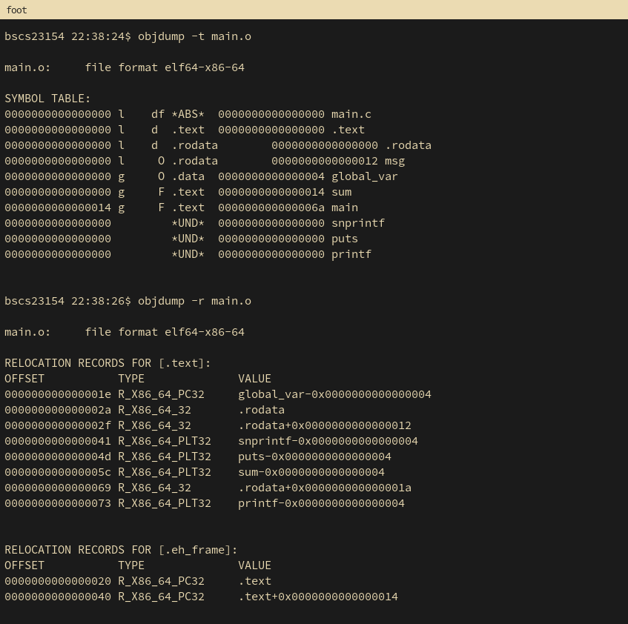

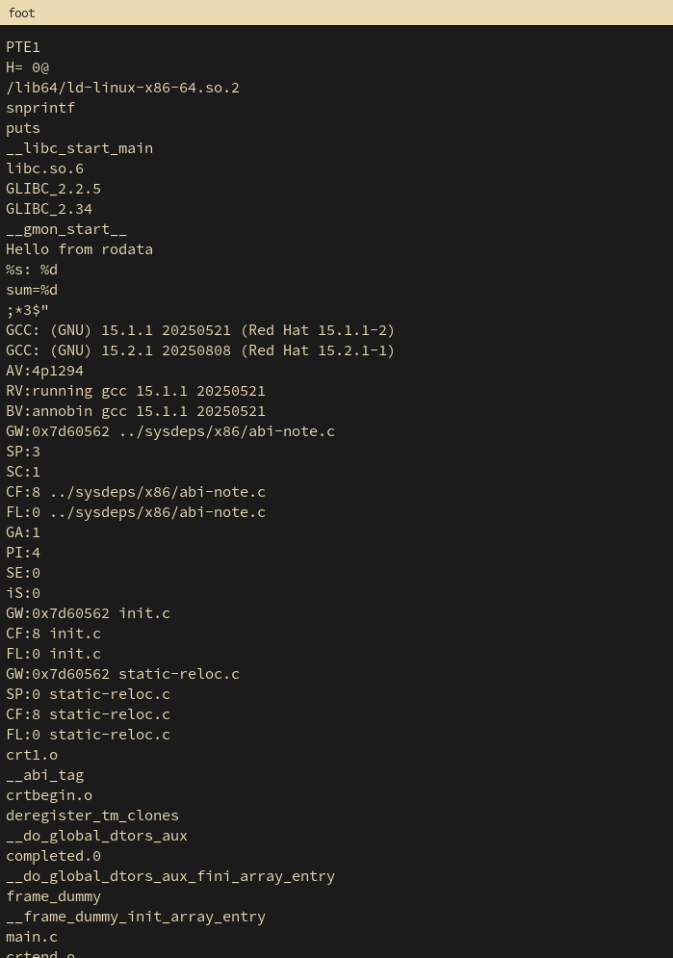

output of
gcc -E main.c -o main.i
less main.i
after adding ifndef
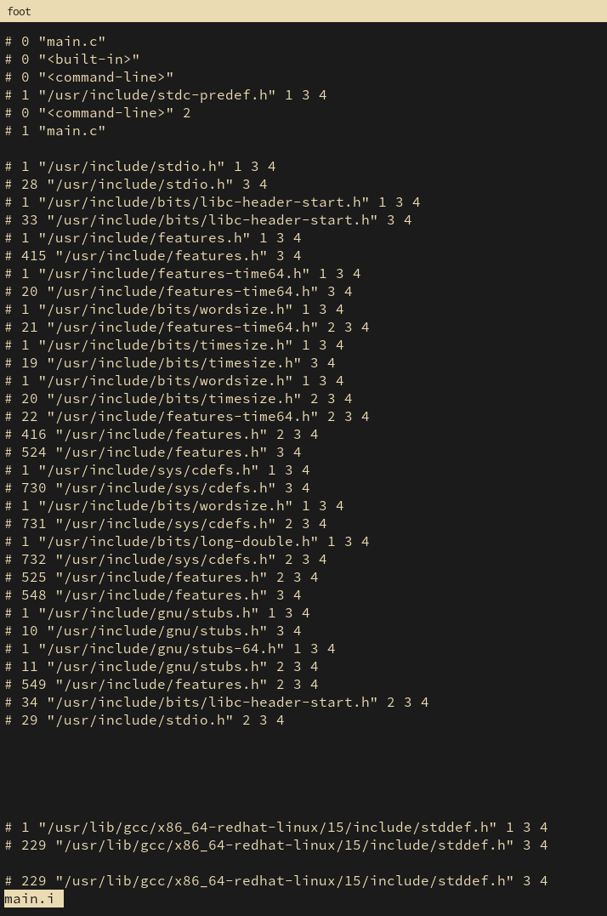

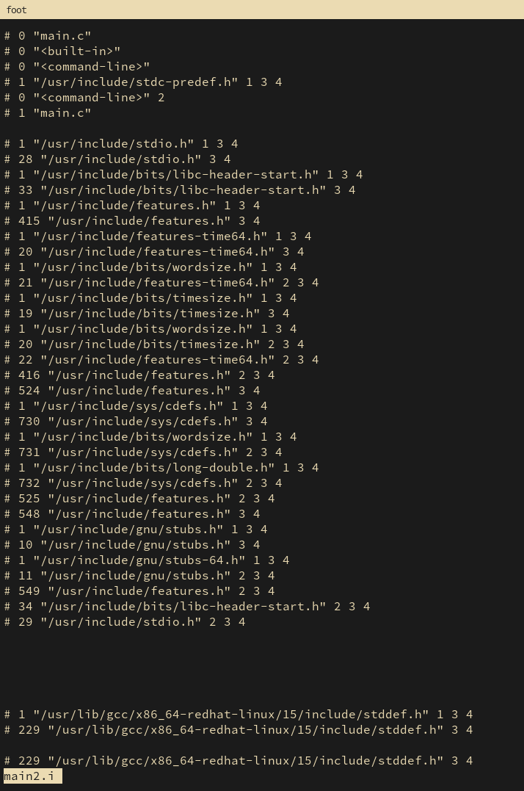

Since we didn't pass the -DDEBUG flag, the preprocessor handled the #ifdef block and removed the macro call completely. The compiler never even sees that line of code. he preprocessor, because of the -ddebug flag, replaced the macro call with the full function call from the #ifdef block

