Movie Recommendation System
Design Document

Authors:
Seif Otefa
Faaz Shaikh
Zeeshan Bombaywala
Homayun Karimi

Group: 47

The purpose of this document is to provide you with a guideline for writing the software design document for your project.

Points to remember:
- Content is important, not the volume. Another team should be able to develop this system from only this document.
- Pay attention to details.
- Completeness and consistency will be rewarded.
- Readability is important.

This page intentionally left blank.
Document Revision History

Date | Version | Description | Author
11/10 | 0.0 | Initial draft | Zeeshan
10/25/2012 | 0.1 | Update sections 1 | Faaz
11/14 | 0.2 | Update section 4 | Zeeshan
11/14 | 0.3 | Update Section 5 | Homayun
11/15 | 0.4 | Update Section 3 | Seif
11/18 | 1.0 | Finalize and submit | Seif, Faaz, Zeeshan and Homayun

This page intentionally left blank.
Contents
1 Introduction 6
1.1 Purpose 6
1.2 System Overview 6
1.3 Design Objectives 6
1.4 References 6
1.5 Definitions, Acronyms, and Abbreviations 6
2 Design Overview 7
2.1 Introduction 7
2.2 Environment Overview 7
2.3 System Architecture 7
2.3.1 Top-level system structure of Fuel level controller 7
2.3.2 Level Monitoring Sub-system 7
2.3.3 Fuel Subsystem 8
2.4 Constraints and Assumptions 8
3 Interfaces and Data Stores 9
3.1 System Interfaces 9
3.1.1 Pressure Sensor Interface 9
3.1.2 Pump Valve Controller Interface 9
3.2 Data Stores 9
4 Structural Design 9
4.1 Class Diagram 9
4.2 Class Descriptions 10
4.3 Classes in the Fuel Subsystem 10
4.3.1 Class: Tank 10
5 Dynamic Model 11
5.1 Scenarios 11
6 Non-functional requirements 11
7 Supplementary Documentation 11

Introduction

1.1 Purpose:

The purpose of this document is to produce and complete the entire blueprint for the Movie Recommendation System. More specifically, the SDD document is shown to depict how the system will run the Movie Recommendation program, whereas the previous SRS document was focused on the overall system requirements The details of this document includes; the design of the system, the significant software interfaces and their relations, designs of internal systems, and the overall constraints and requirements regarding the project.

In a more specific manner, this document is divided into several sections:

- Introduction: Purpose and overall context of the document
- Design Overview: The overall system structure
- Interfaces and Data Stores: System interfaces and data storing
- Structural Design: UML class diagrams and descriptions
- Dynamic Model: Depicting different scenarios with sequence diagrams
- Non-Functional Requirements
- Supplementary Documentation

1.2 System Overview:

The purpose of the Movie Recommendation system is a desktop application seen through a command-line interface (CLI) which reads movie data and user ratings from specific CSV files to allow users to rate movies, and be provided with personalized movie recommendations. The predominant users for this system will be for individuals who

The system flow is seen through input and output operations being conducted through the two text files, movies.txt and my_raitings.txt. Since no network abilities are required, the program can simply run a local computer. These local computers can be Windows, macOS or anything suitable for running java programs

1.3 Design Objectives:

The predominant design objectives for this system is the following:
- Parsing files without errors
  - The ability to correctly read and ensure data correctness from CSV files
- User Rating
  - The ability to allow users to correctly add and update movie rating with the proceding satisfaction of file storage
- More Recommendations
  - [Explain movie recommendation and how its done]

The above list of design objectives is the primary goal for the system. Although there may be other suggested goals, such as a graphical GUI, external database, or machine learning. Our specific Movie Recommendation System does not focus on such topics, rather prioritizes key functionally to provide the best user experience.

Moreover, there also includes specific non-functional requirements for the design, more will be seen in part 6 of the document:
- Performance
  - Loading of CSV files, updating ratings, and genre recommendations must be in a quick and efficient manner to produce the best user experience
- Usability
  - The systems Command-Line Interface must be easy to use, with clear and readable prompts to efficiently guide the user to perform specific operations, and clear error messages to ensure users understand on how to correctly use the system
- Reliability
  - System is able to handle incorrect data, inputs and missing files with correct error handling implementation
- Maintainability
  - Design follows the correct object-oriented principles, with ease of code readability
- Security
  - The rating information is stored locally, no external computers/networks can access the user’s local data

1.4 References:

The following are references the SDD document uses:
- Software Requirement Specification document (SRS)
  - Provides the overall system requirements of the Movie Recommendation System
- Milestone 1 Instructions
  - Given instruction document on the purpose of the overall project with specific requirements

1.5 Definitions, Acronyms, and Abbreviations:

CLI- Command Line Interface

Design Overview

Introduction
The system will use object-oriented design in java. The system will use component based architecture running as a single standalone application.

Environment Overview
The system is a standalone Java application that will run on the user's local machine. The system requires Java run Environment time to be installed on the user's device. The user will communicate with the system through a command line interface. The application is also self contained meaning it does not require external networks or servers. Its only external need will be the locally added data files, movies.txt and my_ratings.txt.

Users Laptop
System software

System Architecture
The system has 3 main components:
- User Interface
  - This component is responsible for all user interaction. It will be a Command-Line Interface (CLI) that displays options for the user, accepts inputs like movie IDs and ratings. While also displaying system output like recommendations or error messages.
- Recommendation Engine
  - This component contains the logic for the context based filtering. It implements content-based filtering that analyzes user rating history and calculates similarity scores between highly-rated movies and unwatched films, displaying recommendations sorted by relevance.
- Data Management
  - This is responsible for all file I/O. It must successfully read and parse both data files, handling any parsing errors gracefully by logging issues and continuing with valid data.
  - It consists of:
    - File Parser: Reads movies.txt and my_ratings.txt on startup.
    - Writes new or updated ratings to my_ratings.txt.
    - In-Memory Catalog: Holds the loaded Movie and Rating objects for fast access by other components

Movie recommendation on startup:

Command Line Interface
Recommendation
Algorithm
Data Reading

The system consists of three major components, a command line interface, recommendation algorithm and a file input output manager. The interaction between the systems is bi-directional. The user's requests are sent to the recommendation algorithm from the command line interface. The algorithm then reads the movie and rating files creating recommendations for the user. Recommendations are then sent back to the user.

User writes to CLI to update a rating:

Command Line Interface
Data Management

The Data Management system is responsible for updating and reading from the files. It consists of the Command Line Interface(CLI) and a File Management system. The user sends a request through the CLI, triggering the File Management system to read ratings.txt and update the desired rating.

Constraints and Assumptions
- The implementation language must be in Java. Accommodated as only java is used throughout the project.
- Must be implemented using the standard libraries for file operations such as BufferedReader, FileReader, BufferedWriter, and FileWriter. Will be accommodated as these will be the only libraries used to implement file operations.
- The system must work with two comma-separated value (CSV) text files, movies.txt and ratings.txt. Modifying these files as needed, and creating ratings.txt if it does not already exist. This will be accommodated as the system will be able to parse movies.txt and my_ratings.txt which are both CSV files.
The interface can either be command-line based or a graphical user interface.
We had the option of choosing to create the User Interface as a command line interface or a graphical user interface. We choose to keep our implementation straightforward and focused on core functionality rather than create a graphical user interface. We choose to do this due to time constraints and as the project is focused on the software design process rather than the final coded product.

Interfaces and Data Stores
This section describes the interfaces into and out of the system as well as the data stores you will be including in your system.

System Interfaces
The various interfaces provided to users and/or other external systems should be defined here. If you had included user interface descriptions in your requirements document you may refer to them here. If you provide interfaces to other systems, say export and import data to a different software, you should mention them here.
Do not include JavaDocs here. You should describe the interfaces using prose and graphics if your interface includes a GUI.

3.1.1. Movie Catalog File Interface (movies.txt)

This interface provides read-only access to the master movie catalog. It is implemented as a CSV parser that loads movie data during system initialization.

Purpose: Retrieve structured movie information including ID, title, director, release year, genre list, average rating, and rating count.

Interaction:
- The system reads from movies.txt on startup.
- Each line is parsed into a Movie object.
- The interface handles invalid or malformed lines by logging the error and skipping the entry.
Constraints:
- No writing occurs to this file.
- Genres are parsed into a list by splitting on semicolons.
This interface acts as the primary entry point for all catalog-related data the system needs to generate recommendations.

3.1.2. User Ratings File Interface (my_ratings.txt)

This interface manages persistent storage of the user’s personal movie ratings. It is implemented as a read–write CSV handler responsible for loading existing ratings and saving new or updated ones.

Purpose: Maintain a persistent record of user ratings, including movie ID, rating value, and timestamp, which is used to personalize recommendations.

Interaction:
- On startup, the system attempts to read my_ratings.txt if it exists.
- If the file does not exist, the system creates it automatically when the user submits their first rating.
- When a user rates a movie:
  - If the movie was previously rated, the system updates the corresponding entry.
  - Otherwise, the system appends a new record to the file.

Error Handling: Malformed lines (e.g., missing fields, invalid rating values, or incorrect timestamp format) are logged and skipped without interrupting system execution.

Constraints:
- Ratings must be integers from 1 to 5.
- Timestamps follow the YYYY-MM-DD format.
- This interface ensures that user behavior shapes the recommendation engine through a persistent history of ratings.

3.1.3. Recommendation Engine Interface

This interface provides access to the system’s content-based filtering logic. It analyzes the user’s rating history and computes similarity scores between previously liked movies and unwatched catalog items.

Purpose: Generate personalized movie recommendations ranked by relevance, using genre similarity and user preferences derived from rating patterns.

Interaction:
- Receives structured movie data from the Movie Catalog Data Store.
- Receives user rating data from the User Ratings Data Store.
- Computes similarity based on shared genres and other metadata.
- Produces a ranked list of recommended movies for display to the user.

Constraints:
- Only valid rated movies (rating ≥ 4, typically) contribute to preference profiling, depending on system design.
- Recommendations exclude movies the user has already rated.
- This interface separates the algorithmic recommendation logic from data management, improving modularity and supporting future enhancements.

3.1.4. User Interaction Interface (Command-Line UI)

This interface provides the text-based interaction layer through which users browse information, submit ratings, and request recommendations.

Purpose: Serve as the primary communication channel between the user and the system, enabling all core actions through a simple and accessible command-line interface.

Interaction:
- Displays menus, prompts, and results to the user.
- Accepts user commands and validates input (e.g., ensuring rating values fall within 1–5).
- Communicates with the data management modules to load data and update ratings.
- Invokes the recommendation engine to generate personalized suggestions.

Constraints:
- User input is validated to prevent crashes or invalid operations.
- The interface is text-only for Milestone 1, with no graphical components.
- This interface ensures the user can access all system features reliably through a straightforward and robust text-based UI.

Data Stores
This section describes the internal data stores used by the Movie Recommendation System.
All data stores are implemented using local files and in-memory structures.
No external databases are used.

3.2.1. Movie Catalog Data Store

This data store contains the structured representation of all movie information loaded from movies.txt at system startup.

Contents: Movie ID, title, director, release year, genre list, average rating, and rating count.
Implementation: Stored entirely in memory as a list or map of Movie objects. Populated by the Movie Catalog File Interface during initialization.
Purpose: Provide fast, structured access to movie metadata for browsing, searching, and recommendation computations.
Constraints: Read-only during execution. Invalid or malformed file entries are not included.

3.2.2. User Ratings Data Store

This data store maintains the user’s personal ratings for movies and persists them across program runs.

Contents: Movie ID, rating value (1–5), and timestamp.
Implementation: Backed by my_ratings.txt. Loaded at startup into an in-memory map keyed by Movie ID. Updates occur in memory first and are then written to the file via the User Ratings File Interface.
Purpose: Preserve the user’s rating history so the recommendation engine can personalize results based on past behavior.
Constraints: Assumes a single user profile. The ratings file is created automatically if it does not exist.

3.2.3. Recommendation Profile Data Store

This data store holds intermediate, temporary data created by the recommendation engine during similarity computation.

Contents: User preference vector, genre frequency counts, similarity scores for unwatched movies, and the final ranked recommendation list.
Implementation: Stored only in memory. Reconstructed each time the user requests recommendations. Not written to disk.
Purpose: Support efficient calculation of content-based recommendations without modifying other data stores.
Constraints: Temporary only. Reset or rebuilt as needed. Not intended for persistence.

Structural Design

Class Diagram
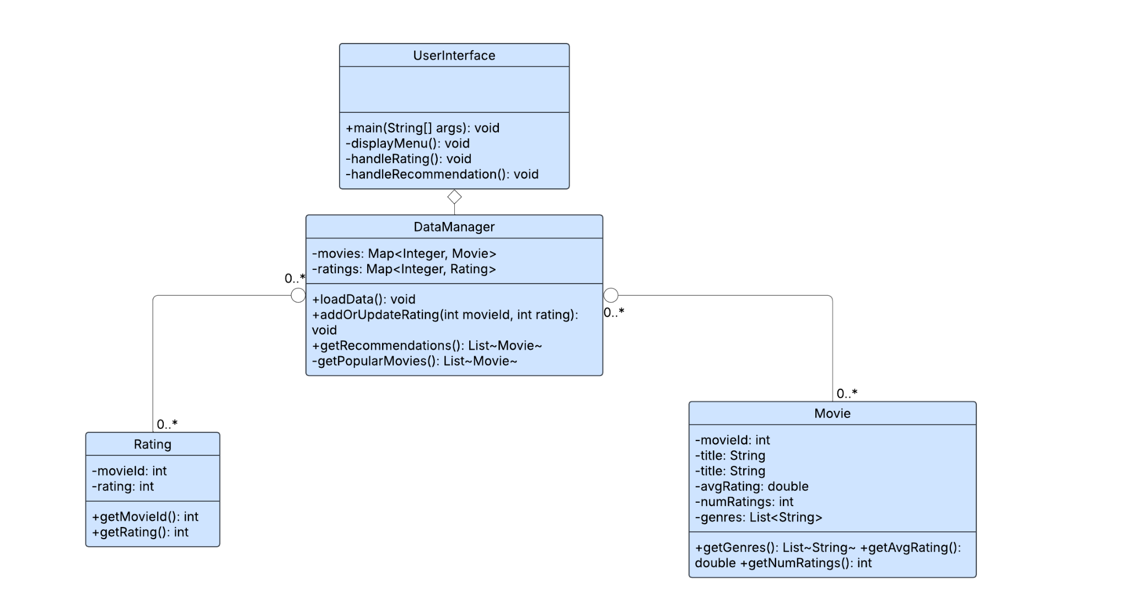

The design was chosen for simplicity and separation of conferences, to follow good
programming principles.
Relationships (Aggregation): The relationships shown are Aggregation (the open diamond), which represents a "has-a" relationship.
- MovieApp has-a RecommendationSystem: The UI (MovieApp) creates and holds onto one instance of the RecommendationSystem to do all the work.
- RecommendationSystem has-a Map of Movie objects and a Map of Rating objects: The system "has" collections of data that it manages.
Cardinality (0..*): The 0..* on the Movie and Rating associations means the RecommendationSystem can hold zero or many of these objects. For example, a new user might have zero ratings.

Class Descriptions

4.2.1:

Class: UserInterface
- Purpose: To act as the main application entry point and the command-line user interface (CLI). This class is responsible for initializing the system, handling user
- input, and displaying system output.
- Constraints: Only one instance of this class will be running

Attribute Descriptions
- Attribute: There are no attributes for the UserInterface
Type: RecommendationSystem
Description: Holds the single instance of the RecommendationSystem class, which contains all core logic.
Constraints: Should not be null after initialization

Methods:

+main(String[] args): void
  - Method Name: Main
  - Return Type: public static void main (String[] args): void
  - Purpose: Starting point of the application will initialize the User UserInterface and will begin the program for the user
  - Brief Description: Create an instance for DataManager, then call loadData() on DataManager, then in a repeated manner, call displayMenu for the specific user choices
  - Pre-conditions: Java environment is able to use
  - Post-conditions: Program will stop and the user will exist
  - Attributes Read/Modified: None
  - Other Methods Invoked: DataManager.loadData(), displayMenu(), handleRainting(), handleRecommendation()

- +displayMenu(): void
  - Method Name: displayMenu
  - Return Type: void
  - Purpose: Display available options from 1 - 5 to allow the user to choose from
  - Brief Description: Print a list of menu options from 1 - 5. Read the user’s input, ensure it is valid with error handling, and then bring the user to the appropriate option
  - Pre-conditions: Ensure dataManager has data loaded
  - Post-conditions: Ensure a valid method is called, or menu seen again after incorrect input.
  - Attributes Read/Modified: None
  - Other Methods Invoked: handleRating(), handleRecommendation()

- +handleRating(): void
  - Method Name: handleRating
  - Return Type: void
  - Purpose: Allowing the user to rate a movie by entering its ID and then their rating for the movie.
  - Brief Description: Ask the user to input a movie name/ID, then prompt for a rating value from 1–5. The program will validate both inputs and call DataManager.addOrUpdateRating(movieId, rating) to update user rating.
  - Pre-conditions: DataManager is running correctly
  - Post-conditions: A rating is added or updated with regard to user input
  - Attributes Read/Modified: None
  - Other Methods Invoked: DataManager.addOrUpdateRating(int movieId, int rating)
- +handleRecommendation(): void
  - Method Name: handleRecommendation
  - Return Type: void
  - Purpose: Provide users with a list of recommended movies.
  - Brief Description: Get recommended movies by calling DataManager.getRecommendations(). If recommendations are not available, call DataManager.getPopularMovies(). Then, the program will display the movie list to the user.
  - Pre-conditions: DataManager is initialized.
  - Post-conditions: Recommended movies are shown via the CLI
  - Attributes Read/Modified: None
  - Other Methods Invoked: DataManager.getRecommendations(), DataManager.getPopularMovies()

4.2.2:

Class: DataManager

Purpose: To encapsulate all core logic, including data parsing, memory management of the movie catalog, persistence to file, and the recommendation algorithm.

Constraints: Designed to be a single instance managed by UserInterface.

Attribute Descriptions
- Attribute: Movies
Type: Map<Integer, Movie>
Description: In memory cache of all movie objects loaded from movies.txt. Used for lookups and recommendation analysis.
Constraints: Keys (movieId) must be unique.
- Attribute: Ratings
Type: Map<Integer, Rating>
Description: In memory cache of all user ratings loaded from my_ratings.txt. Used to track updates in ratings and view user history.
Constraints: Keys for movieId must be unique.

Methods:
- LoadData()
  - Method Name: loadData
  - Return Type: void
  - Parameters: none
  - Purpose: Reads and parses movies.txt and my_ratings.txt from the disk and adds it to a data map.
  - Brief Description: Opens files using standard Java I/O libraries (like BufferedReader). Reads data line by line, creates Movie and Rating objects, and inserts them into their respective maps. Handles file errors by logging and skipping broken lines rather than crashing.
  - Pre-conditions: The Java environment is able to perform file input/output (I/O) operations. The movies.txt file must be created and in the correct location.
  - Post-conditions: The movies and ratings maps have all the required data.
  - Attributes Read/Modified: Reads file system data. Modifies movies and ratings maps.
  - Other Methods Invoked: None
- addorUpdateRating
  - Method Name: addOrUpdateRating
  - Return Type: void
  - Parameters: movieId: int, rating: int
  - Purpose: To add a new user rating or update an existing rating, and update the change to the my_ratings.txt file
  - Brief Description: Ensures a valid input ID and range for rating. Creates a new Rating object with a current timestamp. Updates the memory for ratings map, then writes the entire updated info back to my_ratings.txt
  - Pre-conditions: The rating parameter must be an integer between 1 and 5. The movieId must exist as a key in the movies map
  - Post-conditions: The ratings map is updated and my_ratings.txt file is overwritten with the updated rating data.
  - Attributes Read/Modified: Reads movies and modifies ratings map.
  - Other Methods Invoked: None
- getRecommendations
  - Method Name: getRecommendations
  - Return Type: List<Movie>
  - Parameter: None
  - Purpose: Generates a list of movie recommendations based on content based filtering logic.
  - Brief Description: Checks empty ratings map. If needed it calls getPopularMovies(). Otherwise, analyzes the user's highly rated genres, calculates similarity scores between those and unwatched films, sorts the results, and returns the list.
  - Pre-conditions: The movie map must be updated with data using loadData.
  - Post-conditions: None
  - Attributes Read/Modified: Reads movies, ratings
  - Other Methods Invoked: getPopularMovies()
- getPopularMovies
  - Method Name: getPopularMovies
  - Return Type: List<Movie>
  - Parameters: None
  - Purpose: Private helper method to solve the empty ratings info problem by providing a default list of popular movies.
  - Brief Description: Retrieves all Movie objects. Sorts them based on avgRating and uses numRatings as the tie breaker to determine the most popular films.
  - Pre-conditions: The movies map must be have data
  - Post-conditions: None
  - Attributes Read/Modified: Reads movies
  - Other Methods Invoked: None

4.2.3 Movie Class

Purpose:
To represent a single movie from the system’s master catalog. This class stores all relevant metadata used for display, filtering, and recommendation calculations.

Constraints:
Each Movie object must store valid, non-null metadata parsed from movies.txt.
All attributes are read-only after construction.

Attribute Descriptions
Attribute: movieId

- Type: int
- Description: Unique identifier corresponding to the movie’s ID in the catalog file.
- Constraints: Must be a positive integer and unique for each movie.

Attribute: title

- Type: String
- Description: The movie’s title.
- Constraints: Cannot be null or empty.

Attribute: director

- Type: String
- Description: Name of the movie’s director.
- Constraints: May be empty if the source file omits this field.

Attribute: year

- Type: int
- Description: Release year of the movie.
- Constraints: Must be a valid four-digit year.

Attribute: genres

- Type: List<String>
- Description: Collection of genres associated with the movie, parsed from semicolon-separated values.
- Constraints: May be empty, but never null.

Attribute: avgRating

- Type: double
- Description: Average rating computed from the catalog data.
- Constraints: Must be ≥ 0.

Attribute: numRatings

- Type: int
- Description: Number of ratings used to compute the average rating.
- Constraints: Must be ≥ 0.

Methods
Method: getGenres()
Return Type: List<String>
Purpose: Provide access to the list of genres associated with this movie.
Brief Description: Returns the internal list of genre strings parsed from the CSV file.
Pre-conditions: Genres list must have been successfully parsed and stored.
Post-conditions: No state changes occur; a non-null list is returned.

Attributes Read and Modified:

- Read: genres
- Modified: None

Other Invoked Methods:

- None

Method: getAvgRating()
Return Type: double
Purpose: Retrieve the precomputed average rating for this movie.
Brief Description: Returns the avgRating value associated with the movie as stored in the catalog.
Pre-conditions: Value must be initialized during movie construction.
Post-conditions: No changes to internal state.

Attributes Read and Modified:

- Read: avgRating
- Modified: None

Other Invoked Methods:

- None

Method: getNumRatings()
Return Type: int
Purpose: Retrieve the number of ratings used to compute the movie’s average rating.
Brief Description: Returns the numRatings attribute representing total ratings from the catalog.
Pre-conditions: Value must be initialized and non-negative.
Post-conditions: No state changes occur.

Attributes Read and Modified:

- Read: numRatings
- Modified: None

Other Invoked Methods:

- None

Method: getMovieId()
Return Type: int
Purpose: Retrieve the unique identifier assigned to this movie.
Brief Description: Returns the movieId attribute exactly as stored in the object, with no additional processing.
Pre-conditions: Movie object must be properly initialized.
Post-conditions: No state changes occur; returns a valid integer ID.

Attributes Read and Modified:

- Read: movieId
- Modified: None

Other Invoked Methods:

- None

4.2.4:

Class: Rating
- Purpose: Rating class will show the user’s rating for a movie. It will store the movies ID and its associated rating, which will be used by DataManager method to show recommendations to the user
- Constraints: Rating object must have the correct existing associated movieID

Attribute Descriptions
- Attribute: movieID
  - Type: int
  - Description: Holds the ID of the associated movie
  - Constraints: Must hold to an existing movieID with a positive integer

- Attribute: rating
  - Type: int
  - Description: Users rating for the movie
  - Constraints: Integer from 1 - 5

Methods:
- +getMovieId(): int
  - Method Name: getMovieId
  - Return Type: public int getMovieId()
  - Purpose: Return movieId associated with Rating object.
  - Brief Description: Method will access and return the movieId field
  - Pre-conditions: movieId is initialized
  - Post-conditions: Returns movieId value
  - Attributes Read/Modified: None
  - Other Methods Invoked: None

- +getRating(): int
  - Method Name: getRating
  - Return Type: public int getRating()
  - Purpose: Return rating value for the given movie
  - Brief Description: Method gets the rating attribute and returns it as an integer.
  - Pre-conditions: The rating value is initialized and will be from values 1–5.
  - Post-conditions: Returns stored rating
  - Attributes Read/Modified: None
  - Other Methods Invoked: None

Dynamic Model
The goal here in this section is to model the way the system responds to different events. In other words, we want to model the behavior of the system. This is represented through a collection of scenarios obtained from the main use cases, each described with a UML sequence diagram and some text explaining that.

5.1 Scenario 1: Starts the System
Scenario Description:
When the user executes the application, the UserInterface initiates the data loading process. The system must load and parse data from both movies.txt and my_ratings.txt.
In case, the system encounters an error it will log the issue and give the user feedback, to restart the system.
Upon successfully loading all valid data, the system confirms startup by displaying the main menu options to the user.
Sequence of Actions:
- The user starts the system.
- User Interface calls loadData() on the DataManager
- DataManager reads and parses both data files, checking for my_ratings.txt and logging errors
- DataManager returns control to the User Interface
- User Interface displays Display Menu: systemDisplayMenu() to the User.
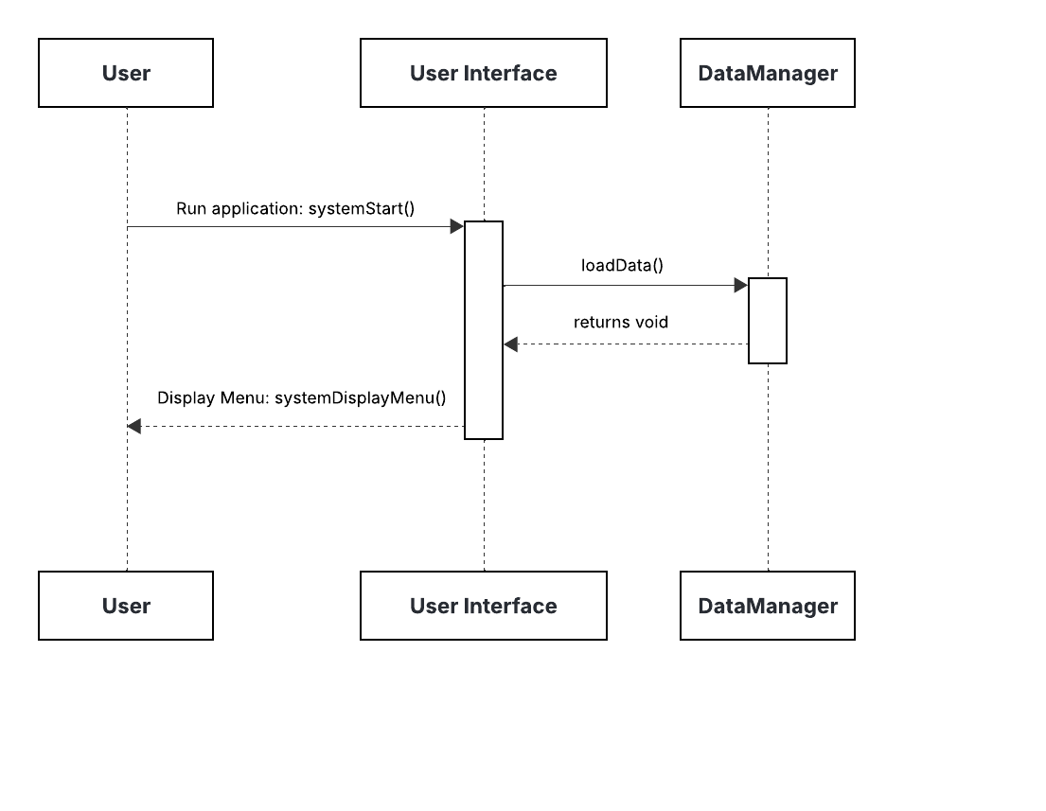
5.2 Scenario 2: Adding a Movie Rating
Scenario Description:
The user will select a movie from the list, and give a rating which is a number between 1 and 5. The system will save this rating, and then update the data file. It could have an update in its recommendations.
Sequence of Actions:
- User selects a movie and enters a rating.
- UserInterface passes this data to RecommendationManager.
- RecommendationManager updates the UserProfile.
- Updated rating is written to my_rating.txt.
- RecommendationManager recalculates recommendations.
- Updated list of recommended movies is displayed.

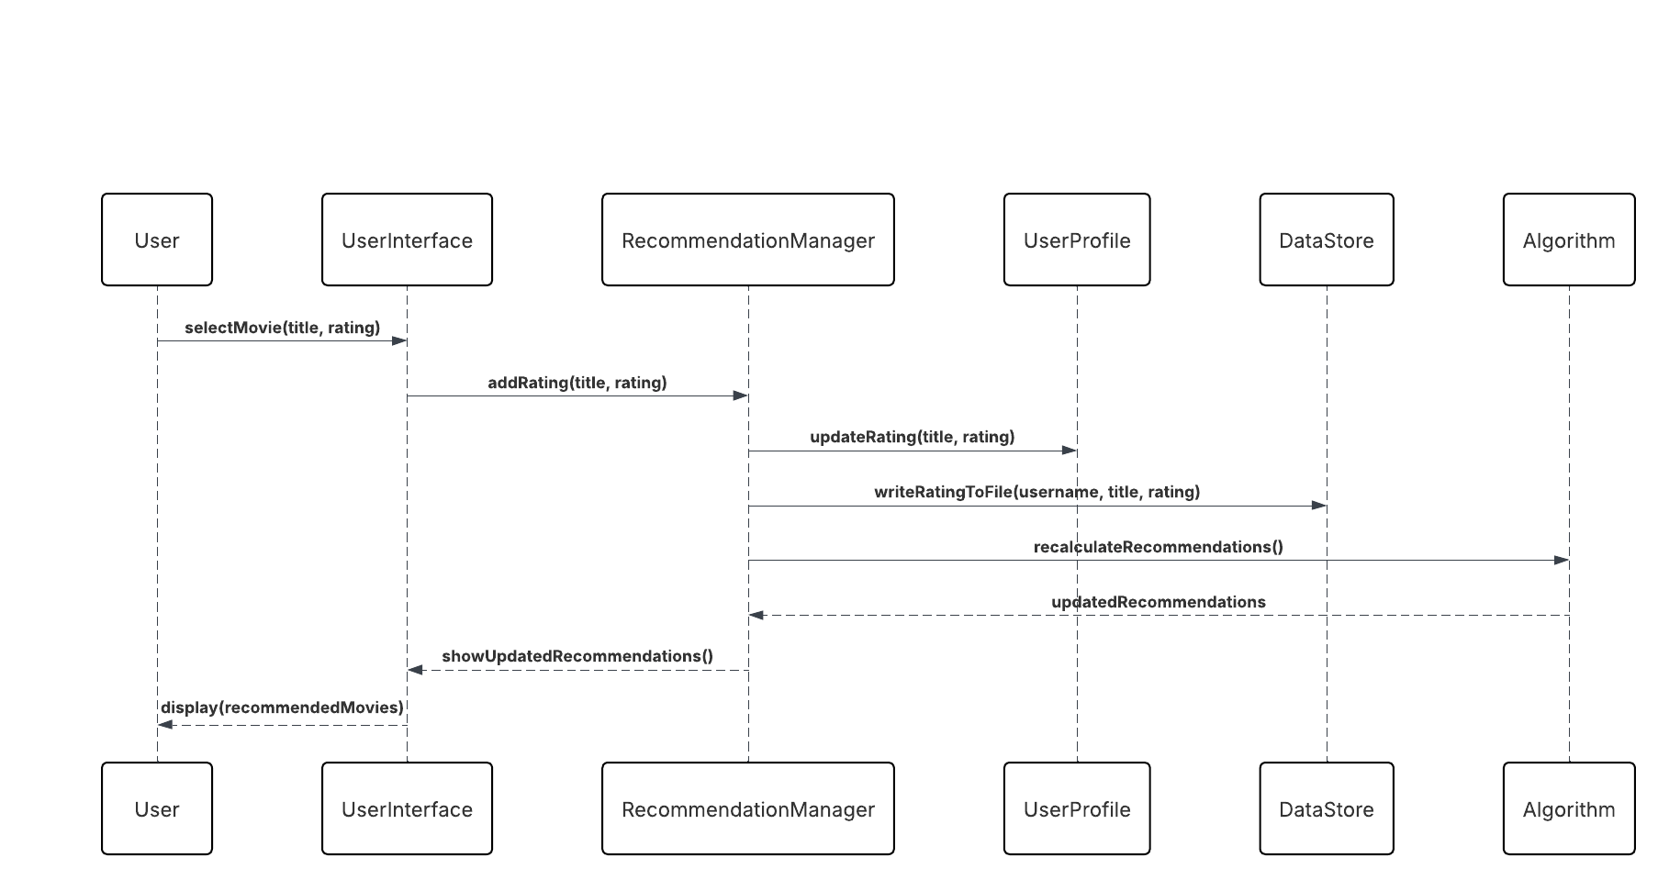

5.3 Scenario 3: Generating Movie Recommendations
Scenario Description:
After ratings are added or when the user requests, the system uses an algorithm to recommend movies based on similar movies.
Sequence of Actions:
- The user requests a recommendation.
- UserInterface requests RecommendationManager to generate recommendations.
- RecommendationManager uses an Algorithm, and computes similarity scores between movies.
- The movies which have the highest similarity scores, will be selected.
- UserInterface will show a list of recommended movies.

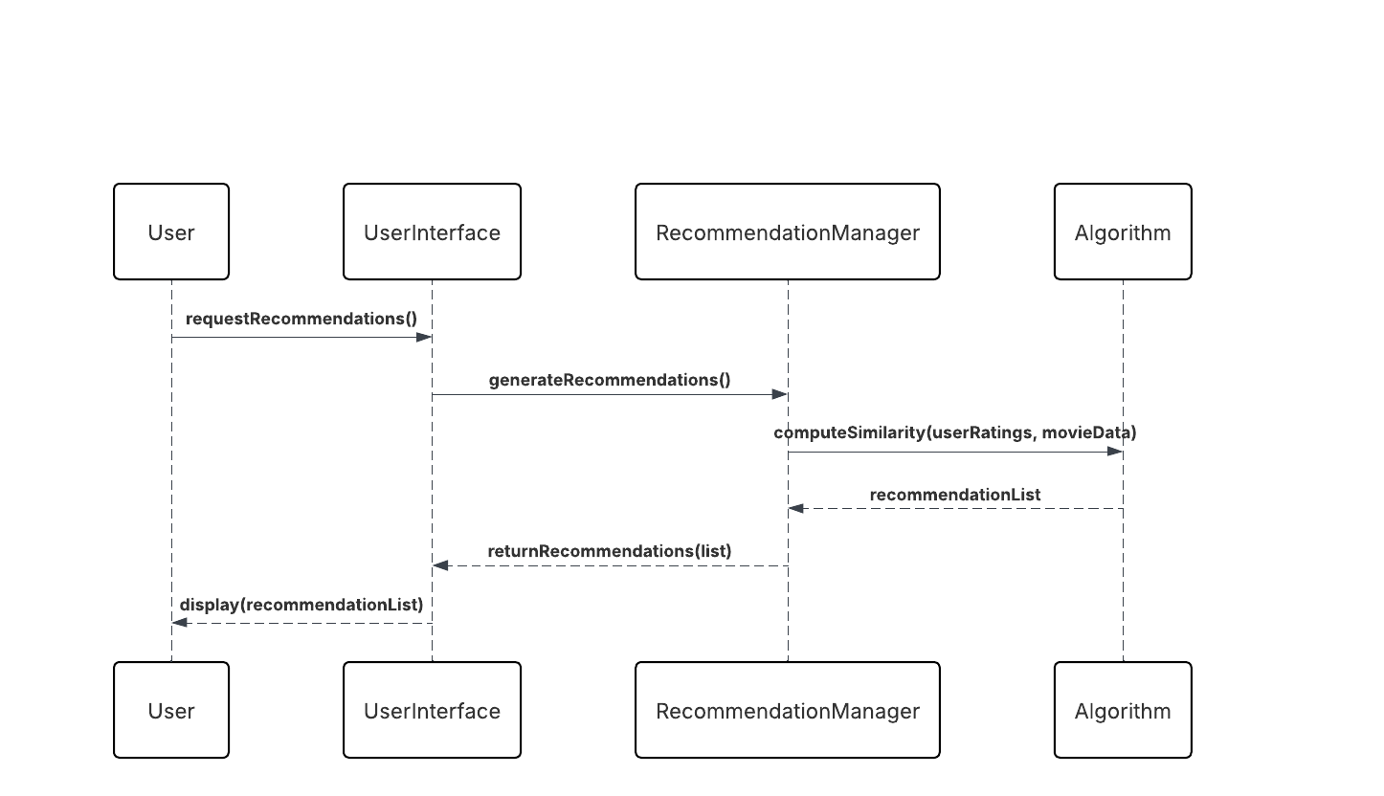

5.4 Scenario 4: Saving and Exiting the system.
Scenario Description:
When the user exits the application, all data (including new ratings or profiles) is stored to ensure no loss of information.
Sequence of Actions:
- The user decides to exit the system.
- UserInterface sends a message to UserManager.
- UserManager saves all the data including the ratings and profiles to the my_rating.txt.
- System confirms the savings and terminates the application.
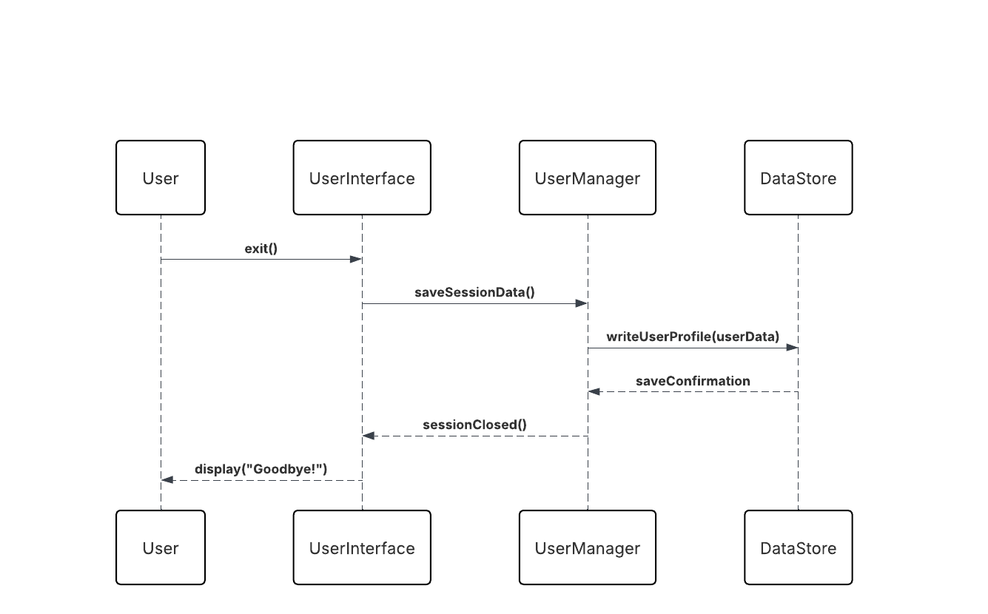

Non-functional requirements
This section measures how the non-functional requirements specified in the requirements document are used in the system. These requirements make sure the system’s effectiveness, reliability, and user satisfaction.

6.1 Performance
The system’s performance should be optimal in order to provide fast responses when loading movies, updating ratings, and generating recommendations.
- Movie data should be stored locally, say in movies.txt to avoid delays caused by the network.
- Efficient data structures should be used to reduce access time. For example we could use hash tables, since it has constant time lookups.
- Recommendation algorithms could use pre-computed similarity measurements to achieve nearly instant results for small datasets.

6.2 Usability
The system provides a simple and intuitive command-line interface.
- Clear instructions and feedback messages should help the user with all actions.
- Input validation makes sure users cannot enter invalid data.

6.3 Reliability and Accuracy
Reliability could be the result of continuously managing and validating the data.
- All read/write operations should be verified to prevent data corruption.
- User ratings are validated to remain within the 1–5 range.
- Recommendation results should be obtained using a logical base to make sure we can reproduce the results.

6.4 Maintainability
The system follows an object-oriented design that separates different applications into well-defined classes. These classes could be named UserInterface, UserManager, Datastore, and RecommendationManager.
- Each class has a single responsibility, simplifying debugging and updates.
- Future modifications for example adding new methods can be made by extending the class (say Algorithm class) which contains the main methods without altering the rest of the system.

6.5 Portability
Since the system is implemented in Java, it is platform-independent.
- It can run on any system with a Java Runtime Environment (JRE).
- No external dependencies or network services are required.

6.6 Scalability
While the current version operates as a standalone application, the specific design allows future extension to support:
- Larger datasets via database integration.
- Multi-user environments or web-based interfaces without changing the core logic.

6.7 Security
User data (ratings and preferences) is stored locally with restricted file access.
- No external transmission of data occurs.
- Input validation prevents malicious code injection.

6.8 Future Evolution
The design allows for smooth evolution by:
- Supporting the addition of new recommendation algorithms.
- Enabling integration with online movie databases for dynamic data updates.

Supplementary Documentation
Provide any other relevant documentation that may help understanding the design.

