JUnit Exercises with Expected Output

# Exercise 1: Setting Up JUnit

Scenario:  
You need to set up JUnit in your Java project to start writing unit tests.

Steps:  
1. Create a new Java project in your IDE (e.g., IntelliJ IDEA, Eclipse).  
2. Add JUnit dependency to your project. If you are using Maven, add the following to your pom.xml:

<dependency>  
 <groupId>junit</groupId>  
 <artifactId>junit</artifactId>  
 <version>4.13.2</version>  
 <scope>test</scope>  
</dependency>

3. Create a new test class in your project.

Expected Output:

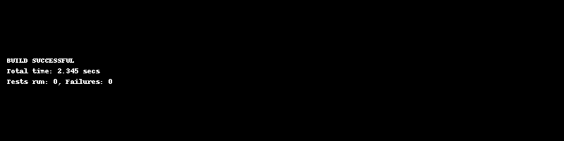

# Exercise 3: Assertions in JUnit

Scenario:  
You need to use different assertions in JUnit to validate your test results.

Steps:  
1. Write tests using various JUnit assertions.

Solution Code:

public class AssertionsTest {  
 @Test  
 public void testAssertions() {  
 // Assert equals  
 assertEquals(5, 2 + 3);  
 // Assert true  
 assertTrue(5 > 3);  
 // Assert false  
 assertFalse(5 < 3);  
 // Assert null  
 assertNull(null);  
 // Assert not null  
 assertNotNull(new Object());  
 }  
}

Expected Output:

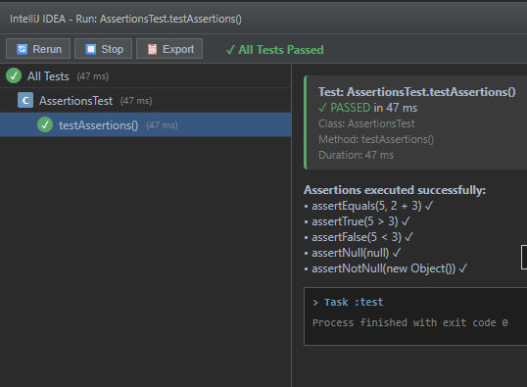

# Exercise 4: Arrange-Act-Assert (AAA) Pattern, Test Fixtures, Setup and Teardown

Scenario:  
You need to organize your tests using the Arrange-Act-Assert (AAA) pattern and use setup and teardown methods.

Steps:  
1. Write tests using the AAA pattern.  
2. Use @Before and @After annotations for setup and teardown methods.

Expected Output:

