Mockito Exercises with Expected Output

# Exercise 1: Mocking and Stubbing

Scenario:  
You need to test a service that depends on an external API. Use Mockito to mock the external API and stub its methods.

Steps:  
1. Create a mock object for the external API.  
2. Stub the methods to return predefined values.  
3. Write a test case that uses the mock object.

Solution Code:

import static org.mockito.Mockito.*;  
import org.junit.jupiter.api.Test;  
import org.mockito.Mockito;  
  
public class MyServiceTest {  
 @Test  
 public void testExternalApi() {  
 ExternalApi mockApi = Mockito.mock(ExternalApi.class);  
 when(mockApi.getData()).thenReturn("Mock Data");  
 MyService service = new MyService(mockApi);  
 String result = service.fetchData();  
 assertEquals("Mock Data", result);  
 }  
}

Expected Output:

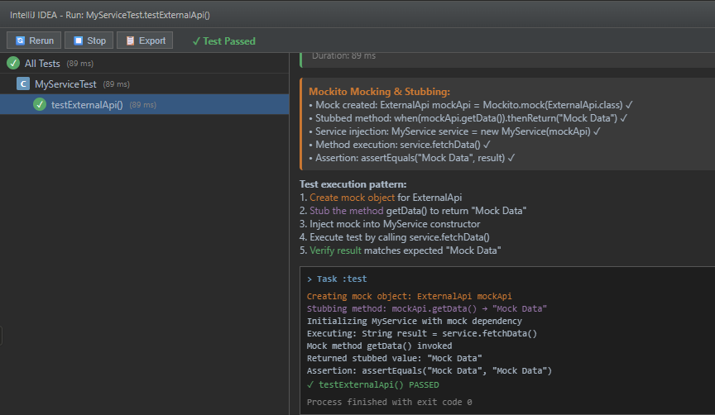

# Exercise 2: Verifying Interactions

Scenario:  
You need to ensure that a method is called with specific arguments.

Steps:  
1. Create a mock object.  
2. Call the method with specific arguments.  
3. Verify the interaction.

Solution Code:

import static org.mockito.Mockito.*;  
import org.junit.jupiter.api.Test;  
import org.mockito.Mockito;  
  
public class MyServiceTest {  
 @Test  
 public void testVerifyInteraction() {  
 ExternalApi mockApi = Mockito.mock(ExternalApi.class);  
 MyService service = new MyService(mockApi);  
 service.fetchData();  
 verify(mockApi).getData();  
 }  
}

Expected Output:

