**Day 1 Topics**

Print

Strings

Input( len function)

Variable

Band Name Generator

**Day 2 Topics**

**Data Types (primitive) .**

**For checking what is the type of data.**

*print (type (variable))*  This will show you what data type is the variable.

1. Subscripting :- Pulling out specific element from the string is called subscripting

like print (“Hello” [0]) will give answer as ‘**H’______** and print (“Hello” [4]) will give answer as ‘**o’.**

similarly print (“Hello” [1]) will give answer as ‘**e’**

2)Type Casting :- You cannot concatenate the strings and the int functions

like

* name =len(affan)
* print (“abrar has ” + name + “ letters in his name”)

This won’t work as “name” is int function so the correct one would be

* print (“abrar has ” + str (name) + “ letters in his name”)

next

* print (15 + float(“100.5”))

The above code without inverted commas will be an **int** function and the other str {100.5} is converted to a float so now the answer would be a float answer will be **115.5**

* print(str(70) +str(100))

here answer will be a str that is 70100

**Numbers**

*Operations (BODMAS/ PEDMAS) e stands for exponents*

**+**

**-**

**\***

**/**

**\*\*** power symbol

***example code for BMI calculator***

* Rounding off of numbers

till now we saw division but what if its 8/3 answer would be 2.66

so we use a round () function that will round off to an integer say print(round(8/3)) answer will be 3 and if I write print(round(8/3 ,2)) this will round off at 2 decimal point like answer is 2.67

Next

* print (8//3)

this will do the division and convert to integer instead of float, integer will be the same and the numbers after that whatever may be will be gone no round off is needed

* score =0

score += 1 { this means whatever the score is add what is given after = like here it is 1 So 1 will be added to score}

So the score now will be 1. if I say score +=2

print (score)

then it is 3

there can be different operations like

* /= 2 this will divide the score further by 2
* += 2 this will add the score further by 2
* -= 2 this will subtract the score further by 2
* *= 2 this will multiply the score further

**f Strngs :** *- This is a function that solves most of the confusions like typecasting and converting multiple times*

just use **f**  before the “ ” in the print function and write any variable [ str, int, float] in { } and this f will convert the type accordingly.

example: -

* Code

score = 20

height =1.75

winning = True

print( f “Your score is {score} and height is {height} so you will win {winning}”)

the above has mixture of str, int, float, Boolean. but the f before “ ” will convert everyone of them and removes the error.

the answer is Your score is 20 and height is 1.75 so you will win True [No syntax error nothing].

Next Exercise (To check how many days, weeks, months are left if I live till 90

age = input("What is your current age? ")

age_left = 90 - int(age)

months = int(age_left) * 12

weeks =  int(age_left) * 52

days =  int(age_left) * 365

print(f"You have {days} days, {weeks} weeks, and {months} months left").

Next Project (Tip Calculator)

print("Welcome to the tip Calculator! ")

bill = float(input ("What is your Total bill? $" ))

tip = int(input("tip in either 10, 12, 15 % \n") )

bill_with_tip = (bill + (tip *bill/100))

people = int (input("No. of people sharing \n"))

total_for_each = round(bill_with_tip/people, 2)

print (f"Each person sould pay ${total_for_each}" )

**Day 3**

* **Program to check if odd/even**

number = int(input("Which number do you want to check? "))

mod = number % 2

if mod == 1:

    print (f"{number} is an Odd number")

else:

    print (f"{number} is even")

**BMI Calculator 2.0**

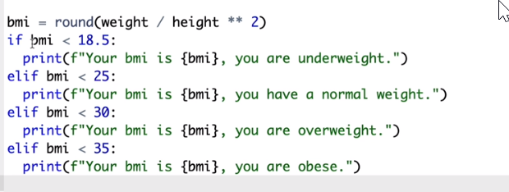

simple code is here