Infrastructure, Race, and Urban Change in Brazil: A Computational Framework for Constructing a National Database of Major Infrastructure Projects
Fabio Schreiber, Lund University; Philipp Stark, Lund University
Large-scale infrastructure investments are frequently promoted as instruments of urban development. However, it remains unclear who benefits from them. While it has been investigated under a class-based framing, racial inequality remains under-researched in this aspect (Dantzler, 2021). In Brazil, urban planning has historically contributed to the reproduction of racially segregated spaces and unequal access to urban resources, while infrastructure and development interventions have often been implemented through colour-blind approaches that overlook racialised patterns of inequality (Melgaço & Xavier Pinto Coelho, 2022; Xavier Pinto Coelho & Melgaço, 2025). Although individual case studies suggest that infrastructure investments may contribute to urban inequality, the absence of a systematic database of large infrastructure projects has prevented national-scale analysis. The availability of census tract data from 2010 and 2022 creates a unique opportunity to examine these relationships across Brazil (IBGE, 2012, 2024).
We address this limitation by developing a computational framework for building a georeferenced national database of major infrastructure projects covering the 2010 to 2022 intercensal period. Critical project attributes are often available in planning and licensing documents even when absent from structured datasets (Hyde et al., 2025). Project records will be identified from planning and licensing sources, including IBAMA environmental licensing files, PAC investment records, and ANEEL energy project databases. Large language model-based information extraction techniques will be used to convert these records into structured project data (Perot et al., 2024). The resulting records will then be geocoded, linked, and deduplicated to create a national database of infrastructure interventions across the energy, transport, sanitation, and housing sectors.
The framework further integrates Earth observation data to improve the completeness and reliability of project records. Previous research has shown that satellite imagery can provide an independent source of information on infrastructure implementation and construction progress (Behnam et al., 2016). Sentinel-2 imagery will be used to corroborate reported project locations by identifying whether documented infrastructure interventions correspond to observable land surface change at the reported site. Comparisons between administrative records and remotely sensed observations will identify cases where project locations cannot be independently confirmed. These assessments will be retained as analytical attributes of the database. This approach provides a scalable means of evaluating the spatial reliability of infrastructure records at the national scale.
The project makes two contributions. First, it develops a computational framework for constructing a georeferenced national database of major infrastructure projects in Brazil by integrating fragmented documentary, administrative, and geospatial sources. Second, it creates the foundations for examining how large-scale infrastructure development is associated with changes in the racial geography of Brazilian cities.
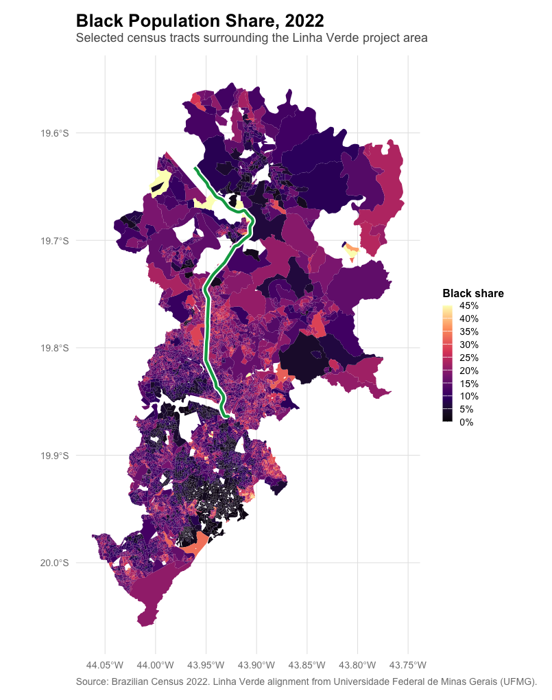
Figure 1. Illustrative example of the racial geography surrounding a major infrastructure investment. The map shows the share of residents identifying as Black in census tracts surrounding the Linha Verde transport corridor in 2022. The green line indicates the corridor linking central Belo Horizonte to Confins Airport.
References
Behnam, A., Wickramasinghe, D. C., Ghaffar, M. A. A., Vu, T. T., Tang, Y. H., & Isa, H. B. M. (2016). Automated progress monitoring system for linear infrastructure projects using satellite remote sensing. Automation in Construction, 68, 114–127. https://doi.org/10.1016/j.autcon.2016.05.002
Dantzler, P. A. (2021). The urban process under racial capitalism: Race, anti-Blackness, and capital accumulation. Journal of Race, Ethnicity and the City, 2(2), 113–134. https://doi.org/10.1080/26884674.2021.1934201
Hyde, J. L., Swanson, C., Bohlman, S. A., Athayde, S., Bruna, E. M., & Valle, D. R. (2025). A lack of open data standards for large infrastructure projects hampers social-ecological research in the Brazilian Amazon. PeerJ, 13, e19926. https://doi.org/10.7717/peerj.19926
IBGE. (2012). Censo Demográfico 2010: Agregado de Setores Censitários dos Resultados do Universo [Dataset]. https://ftp.ibge.gov.br/Censos/Censo_Demografico_2010/
IBGE. (2024). Censo Demográfico 2022: Agregado de Setores Censitários dos Resultados do Universo [Dataset]. https://ftp.ibge.gov.br/Censos/Censo_Demografico_2022/
Melgaço, L., & Xavier Pinto Coelho, L. (2022). Race and Space in the Postcolony: A Relational Study on Urban Planning Under Racial Capitalism in Brazil and South Africa. City & Community, 21(3), 214–237. https://doi.org/10.1177/15356841221087195
Perot, V., Kang, K., Luisier, F., Su, G., Sun, X., Boppana, R. S., Wang, Z., Wang, Z., Mu, J., Zhang, H., Lee, C.-Y., & Hua, N. (2024). LMDX: Language Model-based Document Information Extraction and Localization (arXiv:2309.10952). arXiv. https://doi.org/10.48550/arXiv.2309.10952
Xavier Pinto Coelho, L., & Melgaço, L. (2025). Precarious Settlement Upgrading and Racial Capitalism: Planning Authoritarianism and Its Crossroads for Democracy. Urban Planning, 10, 9674. https://doi.org/10.17645/up.9674

